Mice with deficiency in Pcdh15, a gene associated with bipolar disorders, exhibit significantly elevated diurnal amplitudes of locomotion and body temperature

Supporting Information

Table of contents
I. Supplementary Methods
II. Supplementary Figures
Figure S1. Generation of Pcdh15-deletion mice and expression profiles of PCDH15 protein.
Figure S2 General behavioral analysis of Pcdh15-het.
Figure S3 Successive data on activity and body temperature in mice implanted with nano tag in the abdominal cavity.
Figure S4 Analyses of locomotor activity using nano tag.
Figure S5 Various studies on c-Fos expression in the brain.
Table S1 Comparison of c-Fos-positive cell counts between WT and Pcdh15-null at ZT13
Table S2 Comparison of c-Fos-positive cell counts between WT and Pcdh15-null at ZT7
Movie S1 Pcdh15-null shows marked hyperlocomotion.

III. Supplementary References

I. Supplementary Methods
Generation of Pcdh15-deletion mice
(i) CRISPR/Cas plasmid
A pair of oligo DNAs (Invitrogen, USA) corresponding to the Pcdh15 single-guide RNA were hybridized and ligated using T4 DNA ligase (TOYOBO, Japan) into the linearized pSpCas9(BB)-2A-GFP (PX458) plasmid (Addgene, #48138; Feng Zhang, MIT), which was digested with BbsI (NEB), as previously described. ^{1, 2} The DNA primers utilized in this study are listed below.

PX458-gRNA construction |  | 5' to 3' sequence
mPcdh15 #1 gRNA | Forward | CACCGTTAAAGAGAGCTCTATGGTG
mPcdh15 #1 gRNA | Reverse | aaacCACCATAGAGCTCTCTTTAAC
mPcdh15 #2 gRNA | Forward | CACCGCTCTCTTTAAAGGACAACG
mPcdh15 #2 gRNA | Reverse | aaacCGTTGTCCTTTAAAGAGAGC
mPcdh15 #3 gRNA | Forward | CACCGGAAAAGCATCTGTTTAACG
mPcdh15 #3 gRNA | Reverse | aaacCGTTAAACAGATGCTTTTCC
mPcdh15 #4 gRNA | Forward | CACCGATGCTTTTCCTGAACAGTAC
mPcdh15 #4 gRNA | Reverse | aaacGTACTGTTCAGGAAAAGCATC
β-actin gRNA  (positive control) | Forward | caccGCATTATGAGTCCTTAAGTGA
β-actin gRNA  (positive control) | Reverse | aaacTCACTTAAGGACTCATAATGC
T7E1 assay and Genotyping |  | 5' to 3' sequence
mPcdh15 | Forward | GAGTATCAAATTGATCACCTCAGACTCAG
mPcdh15 | Reverse | GCCTCACTGAGTAGATTTGGTATCCTG
β-actin | Forward | GACTGGGATCATTTGTTCACACATGCAG
β-actin | Reverse | GGCCCTTGAACTTCGGTATCTACACTGAG

(ii) T7 Endonuclease I (T7E1) assay
The T7E1 assay was conducted in mouse Neuro2A cells following previously established protocols. ^{1, 2} Briefly, Neuro2A cells were transfected with Pcdh15-pX458 plasmids or empty pX458 plasmids in a 12-well plate using Lipofectamine 3000 (Life Technologies). Genomic DNAs were isolated 48 hours post-transfection by digestion with proteinase K (P2308, Sigma-Aldrich, USA) followed by ethanol precipitation. Subsequently, Pcdh15 loci were PCR amplified from the purified genomic DNA using the following primers: 5'-GAGTATCAAATTGATCACCTCAGACTCAG-3' and 5'-GCCTCACTGAGTAGATTTGGTATCCTG-3'. The PCR products were subjected to slow annealing and then digested with the T7E1 enzyme at 37°C for 30 minutes. The resulting products were analyzed through electrophoresis on a 2% agarose gel.
(iii) Chemical synthesis of crRNA and tracrRNA
Pcdh15-CRISPR RNA (crRNA) (5′- UUAAAGAGAGCUCUAUGGUGguuuuagagcuaugcuguuuug-3′) and trans activating RNA (tracrRNA) (5′- AAACAGCAUAGCAAGUUAAAAUAAGGCUAGUCCGUUAUCAACUUGAAAAAGUGGCACCGAGUCGGUGCU-3′) were chemically synthesized and purified using polyacrylamide gel electrophoresis (Fasmac, Atsugi, Kanagawa, Japan).
(iv) Injection
Injection mixtures were prepared following a previously established method. ³ To produce Pcdh15 knockout mice through protein injection, a combination of Cas9 proteins, Pcdh15-crRNA, tracrRNA, and donor single-strand DNA (ssDNA) was prepared in TE buffer, achieving working concentrations of 100 ng/μl, 0.61 pmol/μl, 0.61 pmol/μl, and 10 ng/μl, respectively. Cas9 proteins were sourced from NEB (M0386S, USA). The donor ssDNA, encoding the FLAG-tag and stop codon and targeting exon 5 of the mouse Pcdh15 gene (NM_001142746.1), was chemically synthesized by Fasmac Inc. (Japan). The mixture was then incubated at 37°C for a minimum of 15 minutes before being injected into the pronuclei of one-cell-stage zygotes obtained from the C57BL/6J strain (Charles River, USA).
(v) PCR secreening and genotyping
For the purpose of PCR screening of Pcdh15-het embryos resulting from the injection of CRISPR mix into zygotes, genomic DNAs were extracted from tails using proteinase K digestion, followed by a standard phenol extraction method. Pcdh15-het embryos were screened using PCR with KOD FX Neo (TOYOBO), and the resulting products were analyzed by electrophoresis in a 2% agarose gel. Primer sequences for gene detection were as follows: 5'-GAGTATCAAATTGATCACCTCAGACTCAG-3' and 5'-GCCTCACTGAGTAGATTTGGTATCCTG-3'. Furthermore, PCR products were further cloned using the Zero Blunt TOPO PCR Cloning Kits (Life Technologies) and subjected to sequencing analysis, as described previously. ^{1, 2} After the establishment of mouse strains, conventional screening can be carried out through PCR, followed by EcoRI restriction enzyme digestion of the PCR product, to determine whether cleavage has occurred or not.

Immunoblots
For immunoblotting, whole brain extracts or primary neuron cultures were lysed using SDS-lysis buffer (4% SDS, 20% glycerol, and 50 mM Tris-HCl, pH 6.8), and then sonicated on ice. The lysates were subsequently diluted to a concentration of 5 μg/μl. For loading purposes, an equal volume of a solution containing 0.01% bromophenol blue and 1M 2-mercaptoethanol was added to the lysates, which were then boiled at 96 °C for 3 minutes. An aliquot of 50 μg of denatured proteins was loaded for each experimental condition. Protein separation was performed using SDS gradient 5–20% polyacrylamide gels (e-PAGEL, ATTO, Japan), followed by transfer onto nitrocellulose membranes (Protran, Whatman).
The nitrocellulose membrane was subjected to immunoprobing using the PCDH15 antibody (sheep polyclonal, M&D Systems, USA) and the GAPDH antibody (mouse monoclonal, MBL, Japan). Appropriate donkey secondary antibodies, namely IRDye 680RD and 800CW (LI-COR Biosciences), were utilized for detection. An infrared imager (Odyssey, LI-COR Biosciences) was employed to visualize and quantify the signals. The resulting digital data were exported in TIFF format.

Behavioral analysis
Open ﬁeld test was carried out as described previously ⁴. Mice were placed in the center of the arena and allowed to explore the open ﬁeld (diameter: 60 cm, height: 35 cm) for the following 5 min under moderately light conditions (85 lx). The open ﬁeld was divided into an inner zone (diameter: 40 cm), and an outer zone surrounding the inner zone. The movement of mice was measured via a camera mounted above the open ﬁeld and its activity was analyzed automatically using the Ethovision automated tracking program (Brainscience Idea Co., Ltd., Osaka, Japan). Measurements included distance and time spent in the inner and outer zone.
Y-maze test was carried out as described previously ⁵. Each arm is 40 cm long, 12 cm high, 3 cm wide at the bottom, and 10 cm wide at the top. The arms converge in an equilateral triangular central area that is 4 cm at its longest axis. Each mouse was placed individually at the central area and allowed to move freely through the maze during an 8 min session. The series of arm entries was recorded visually. Definition of alternative behavior was successive entries into the three arms, on overlapping triplet sets. The percent alternation is calculated as the ratio of actual to possible alternations (defined as the total number of arm entries minus 2) multiplied by 100. Spontaneous alternation was associated with the capacity of short-term memory.
The elevated plus maze was conducted as described previously with minor modifications ⁶. The apparatus was made of plastic material and was elevated to a height of 50 cm above the ground. Each arm of the plus maze was 16 cm in length and 10 cm in width. Additionally, the closed arms had wall enclosures that were 20 cm high. The central platform was a square of 10 × 10 cm. Light intensity around the maze was set at 100–120 lux. Mouse was placed on the elevated plus maze facing the open arm opposite to the experimenter. The number of entries and the time spent in the open and closed arms were recorded over the entire 5-min duration of the test.
Locomotor activity under a novel environment was conducted as described previously ⁴. Each mouse was placed in a standard transparent rectangular rodent cage (25 × 30 × 18 cm) under moderately light conditions (15 lx). Locomotor activity was then measured for 120 min using an infrared sensor (NS-DAS-8; Neuroscience, Tokyo, Japan) placed over the cage. Locomotor activity was then measured for 120 min.
Novel object recognition test was carried out as described previously with minor modifications ⁶ . Mice were individually habituated to an open-box (30 × 30 × 35 cm) for 3 days. During the training session, two novel objects were placed in the open ﬁeld and the animals were allowed to explore for 10 min under moderately light conditions (15 lx). The time spent exploring each object was recorded. During test sessions, one of the familiar objects used during training session was replaced by a novel object. The animals were placed back into the same box 24 h after the training session, and the mice were allowed to explore freely for 5 min. The preference index in the test session, the ratio of the amount of time spent exploring the novel object over the total time spent exploring both objects, was used to measure cognitive function. In the training session, the preference index was calculated as the ratio of time spent exploring the object that was replaced by a novel object in the test session, to the total exploration time.
The procedure for the social interaction and social novelty test were performed as previously described with minor modifications. ⁵ The experiment was conducted under moderately light conditions (15 lx). The social interaction chamber is a three-chambered apparatus. Doorways built into the two dividing walls the mice can access to the each of the three chambers freely. Each chamber was 20 × 40.5 ×22 cm. In habituation session, each test mouse was individually habituated to chambers. In the sociability test, small plastic container confining an unfamiliar adult male (Stranger 1) was put one of the side chambers whereas empty small cage was placed in another side chamber. The duration of social interaction was recorded when the mouse spent within the 10 cm circle around plastic container. Subsequently the same experimental mouse was subjected to the test for social novelty, the second unfamiliar mouse being a new stranger mouse (Stranger 2) placed in the opposite side, which was previously empty during the sociability test. During social novelty test, the experimental mouse was allowed to explore all the three chambers for 10 min. The duration of social interaction with Stranger 1 or Stranger 2 was recorded in the same way as before. All stranger mice used in the experiment were WT. The entire procedures were measured automatically using the Ethovision automated tracking program (Brainscience Idea Co., Ltd., Osaka, Japan).
Prepulse inhibition (PPI) test was carried out as described previously ⁴. After the animals were placed in the chamber under moderately bright light conditions (180 lx) (San Diego Instruments, San Diego, CA), they were allowed to habituate for 10 min, during which 65 dB background white noise was present. The animals then received 10 startle trials, 10 no-stimulus trials and 40 PPI trials. The inter-trial interval was between 10 and 20 s and the total session lasted 17 min. The startle trial consisted of a single 120 dB white noise burst lasting 40 ms. PPI trials consisted of a prepulse (20 ms burst of white noise at 69, 73, 77 or 81 dB intensity) followed, 100 ms later, by the startle stimulus (120 dB, 40 ms white noise). Each of the four prepulse trials (69, 73, 77 or 81 dB) was presented 10 times. Sixty different trials were presented pseudo-randomly, ensuring that each trial was presented 10 times and that no two consecutive trials were identical. The resulting movement of the animal in the startle chamber was measured for 100 ms after startle stimulus onset (sampling frequency 1 kHz), rectiﬁed, ampliﬁed and fed into a computer, which calculated the maximal response over the 100-ms period. Basal startle amplitude was determined as the mean amplitude of the 10 startle trials. PPI was calculated according to the formula: 100 × [1 - (PPx/P120)]%, in which PPx was the mean of the 10 PPI trials (PP69, PP73, PP75 or PP80) and P120 was the basal startle amplitude.
Fear conditioning test was carried out as described previously ⁷. In the conditioning phase, each mouse is placed in the training cage (30 × 30 × 40 cm) equipped with a metal floor, and a 15-sec tone (85 dB) is delivered (conditioned stimulus). During the last 5 sec of the tone stimulus, a foot shock of 0.8 mA is delivered as an unconditioned stimulus through a shock generator. This procedure is repeated four times with 15-sec intervals. 24 hr after the conditioning, context-dependent test was carried out. For context-dependent test, mouse is placed in the training cage, and the freezing response is measured for 2 min in the absence of the conditioned stimulus. 4 hr after context-dependent test, tone-dependent test was carried out. For tone-dependent test, the freezing response was measured in the neutral cage for 1 min in the presence of a continuous-tone stimulus identical to the conditioned stimulus using mice which had been subjected to context-dependent test.
Light dark transition test was conducted as previously described with minor modifications ⁸. The apparatus used for the light/dark transition test consisted of a cage (15 × 15 × 15 cm) divided into two sections of equal size by a partition containing a door. One chamber was brightly illuminated (300 lux) whereas the other chamber was darker than 10 lux. Mice were placed into the dark side and allowed to move freely between the two chambers with the door open for 10 min. The time spent in each side and activity were recorded by using a MED-PC IV (Med Associations, Inc., St Albans City, USA).
Rotarod test was performed according to a previous report with minor modifications ⁹. In brief, Rotarod test was performed using the MK-600 (MUROMACHI KIKAI CO., LTD, Tokyo, Japan), under moderately light conditions (15 lx). The mice were trained for 3 days. During the training session, the mice were placed on a rod rotating at 6 revolutions per minute (rpm) and the time taken for them to fall from the rod was measured. If a mouse stayed on the rod until the end of the 2-min trial, a time of 120 s was recorded. Test session was carried out on day 4. The mice were placed on a rod rotating at 12 rpm and the time taken for them to fall from the rod was measured. Each mouse was subjected to 6 trials per day with a 15 min intertrial interval in the training and test session. We recorded the score the average value in a set of measurements. The apparatus was routinely cleaned with water and ethanol following each session.

HE staining
Mice were deeply anesthetized with 2,2,2-Tribromoethanol (Avertin) and perfused intracardially with Phosphate-Buffered Saline (PBS) and 4 % paraformaldehyde in PBS. The fixed brains were paraffin-embedded, 5μm-thick sections were prepared, immersed in hematoxylin-eosin solution (Muto pure chemicals Co.Ltd, Japan) and stained.

Immunohistochemistry
The mice were anesthetized with 2,2,2-Tribromoethanol and intracardially perfused on ZT7 or ZT13 with 4% paraformaldehyde/PBS, and the whole brain was removed. The brain sections (50 μm) prepared with vivratome were incubated with 20% normal donkey serum (NDS) in PBS containing 0.2% Triton-X 100 (Tx) (blocking buffer) for 1 h at room temperature (RT) and then treated with rabbit polyclonal antibody against c-Fos (1:500; CAT#2250, Cell Signaling Technology., MA, USA) diluted in blocking buffer for 1 day at 4 °C. The sections were then incubated with the Alexa 488-conjugated secondary antibody (1:2000; Thermo Fisher Scientific Inc., Suwannee, GA). diluted in Can Get Signal immunostain Solution A (TOYOBO CO., LTD., Osaka, Japan) for 2-3 h at RT. The morphology of each section was analyzed using a laser scanning confocal microscope (TiE-A1R, Nicon Solutions Co., Ltd.,Tokyo, Japan).

Phase analysis
Locomotor activity phase analysis was performed using activity data collected under LD (light-dark) cycles, following the methods based on previous research ¹⁰. Activity onsets and offsets were determined by the first upward and the last downward threshold crossings of the moving averaged (3-h window) locomotor activity data during ZT9-ZT27 for each day, respectively. The threshold was set as the time series of the moving averaged (24-h window) locomotor activity data. The candidates of activity midpoints were defined as the points at which total locomotor activity in the preceding 8 h was the same as total locomotor activity in the subsequent 8 h. Then, the first candidate during ZT9-ZT27 was defined as the activity midpoint. Activity peak was defined as the time point of the maximum value of the moving averaged (1-h window) locomotor activity during ZT9-ZT27. These calculations were conducted with custom-made Python codes.

Preparation of total RNA
Eleven-week-old Pcdh15-null and WT mice were euthanized via cervical dislocation, and their brains were swiftly extracted. The visual cortical areas were subsequently dissected and rapidly frozen using liquid nitrogen for preservation. Upon thawing, lysates were generated with Trizol (Thermofisher, US), and total RNA was dissolved in RNase-free sterile water. The quantification of RNA was performed, and 1 μg of RNA was allocated for RT-PCR.

RT-PCR
A total of 1 μg of total RNA was utilized for the Superscript III RT cDNA synthesis kit (Thermofisher, US) to carry out reverse transcription. Subsequent RT-PCR was conducted. The primer sequences employed for gene detection were as follows: mFos (c-fos): 5'- gggaatggtgaagaccgtgtcaggag -3', 5'- gcagccatcttattccgttcccttcg -3'; beta-actin (control): 5'-gactgggatcatttgttcacacatgcag-3', 5'-ggcccttgaacttcggtatctacactgag-3'.

Quantitative RT-PCR (qPCR)
Quantitative expression analysis using qPCR was performed on a QuantStudio5 instrument (Applied Biosystems) with the KAPA SYBR Fast qPCR kit (KAPA Biosystems, US) ¹¹. The primer sequences used for gene detection were as follows: mFos (c-fos): 5'- gggaatggtgaagaccgtgtcaggag -3', 5'- gcagccatcttattccgttcccttcg -3'; m18S (control): 5'- gcaattattccccatgaacg -3', 5'- ggcctcactaaaccatccaa -3'.

II. Supplementary Figures

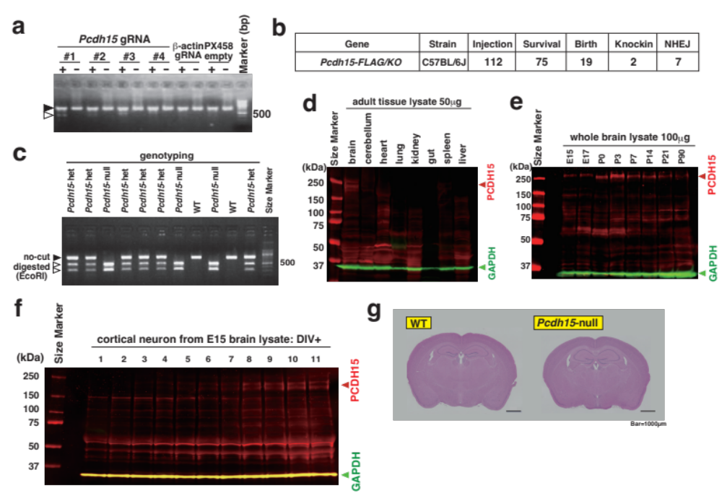
Figure S1. Generation of Pcdh15-deletion mice and expression profiles of PCDH15 protein
(a) T7E1 assay for the optimization of guide RNA in CRISPR/Cas9 cleavage. (b) Results of the number of eggs/embryos in the process of generating Pcdh15-deletion mice. Injections were performed on the nuclei of all 112 fertilized eggs, resulting in the successful obtainment of two littermates with the designed knock-in sequence. (c) Genotyping results of Pcdh15-deletion mice through PCR and EcoRI restriction enzyme digestion. PCR products from knockout alleles can be cleaved with EcoRI. (d) Immunoblot analysis utilizing 50 μg of total lysates from various organs of WT adult mice for the detection of PCDH15 protein. GAPDH was employed as an internal control. (e) Immunoblot analysis using 100 μg of total lysates prepared from various developmental stages of WT to detect PCDH15 protein. (f) Immunoblot analysis using 10 μg of total lysates from in vitro cortical cultured neurons for the detection of PCDH15 protein. (g) Hematoxylin and eosin (HE) staining of coronal sections from the adult brain of Pcdh15-null and WT.
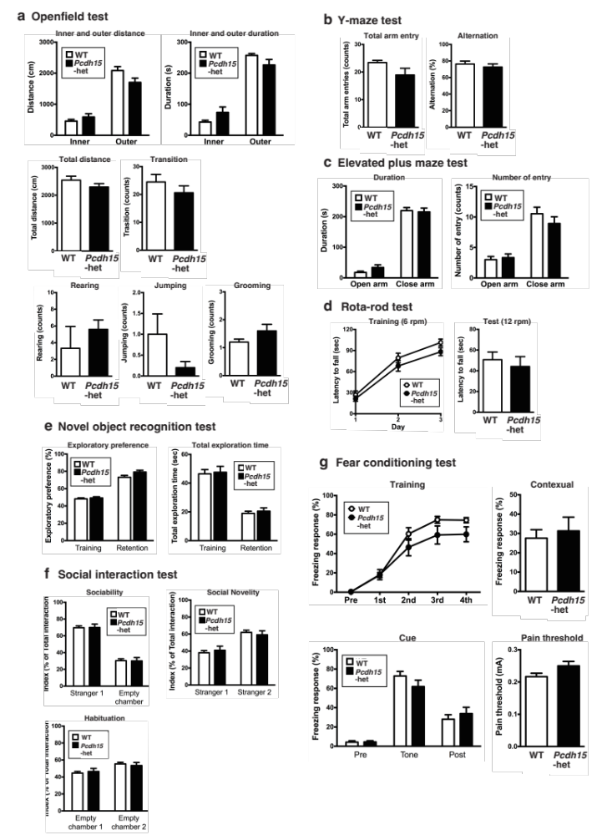
Figure S2 General behavioral analysis of Pcdh15-het
This supplementary figure complements Figure 2 and Table 1. It depicts the performance of Pcdh15-het mice in various behavioral tests: open field test (a), Y-maze test (b), elevated plus maze test (c), rota-rod test (d), novel object recognition test (e), social interaction test (f), and fear conditioning test (g). Data are expressed as mean ± SEM (WT males, n = 15; Pcdh15-het males, n = 15).

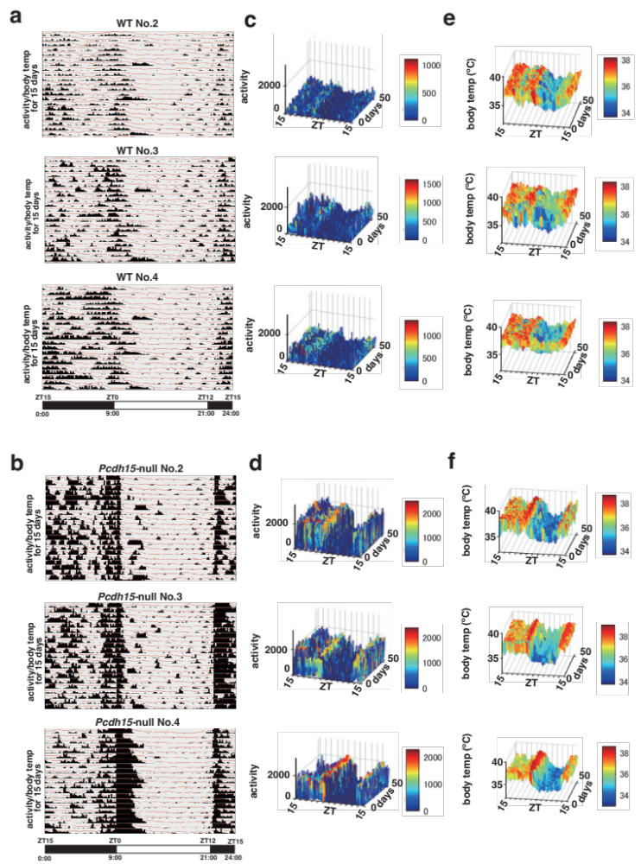

Figure S3 Continuous activity and body temperature data in mice with abdominally implanted nano tag
Individual mouse data contributing to Figure 3 are displayed. Plotted using nano tag Viewer software. The horizontal axis represents the 24-hour time frame, while the vertical axis presents the activity (histogram) and body temperature (line graph) for each day. Three-dimensional surface plots depicting changes in activity and temperature over the entire duration were generated using MATLAB software (Mathworks, Japan).

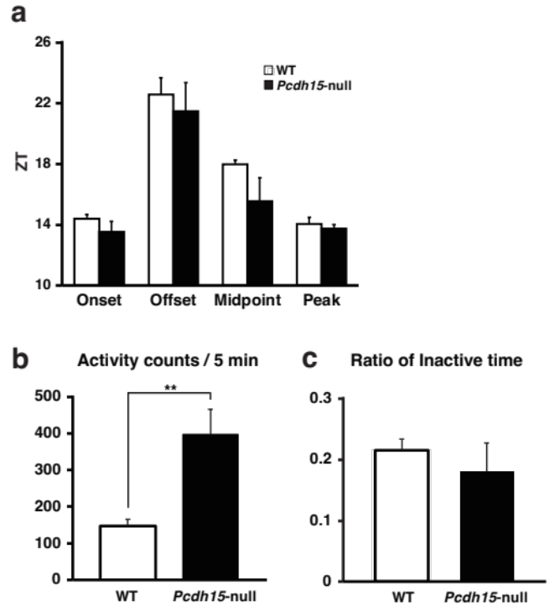
Figure S4 Phase analyses of locomotor activity using nano tag
(a) Phase analysis. Average onset, offset, midpoint and peak time (depicted in ZT) of locomotor activity phase for WT (white bar, n = 4) and Pcdh15-null (black bar, n = 4) were calculated as described in the methods. (b) Activity counts. The average of activity counts per 5 min for WT (white bar, n = 4) and Pcdh15-null (black bar, n = 4) were calculated for the entire 56-day recordings. (c) Ratio of Inactive time. The average ratio of inactive periods defined as 5 min interval with less than 5 counts of activity of WT (white bar, n = 4) and Pcdh15-null (black bar, n = 4) was calculated over the entire 56-day recordings.
Bars indicate SEM.

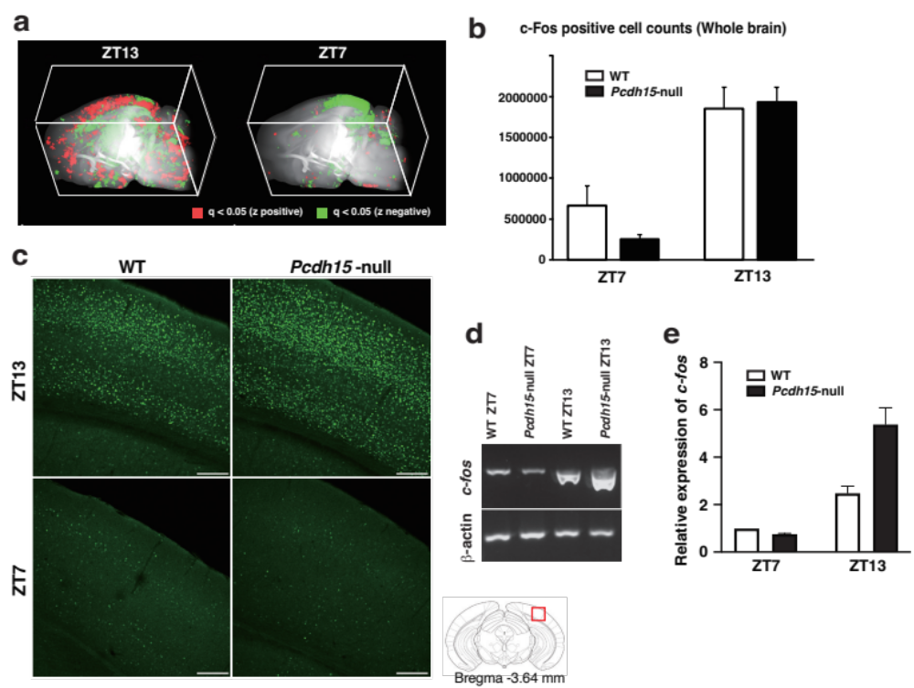
Figure S5 Various studies on c-Fos expression in the brain
(a) Three-dimensional constructed images of stacked q value voxel maps comparing WT and Pcdh15-null. Left corresponds to ZT13, and right to ZT7. Generated using ImageJ (NIH, US). (b) c-Fos positive cell counts throughout the entire brain as a result of automated analysis (N = 3 for each group). Data are presented as mean ± SEM. (∗∗p < 0.01). Two-Way Repeated Measures ANOVA analyzed the effect of Pcdh15-deletion, sampling time, and their interaction, with sampling time showing significance at p < 0.001 (Gene deletion: F(1, 8) = 0.64; Time: F(1,8) = 50.33; Time × Gene deletion: F(1,8) = 1.48). (c) Images of c-Fos immunostaining around the VISp area. Captured within the red frame of the lower right atlas image. Scale bars represent 200 μm. (d, e) Results of quantitative RT-PCR for c-fos expression (e) Relative expression of c-fos. Data represent mean ± SEM (N = 5 for each group). Two-Way Repeated Measures ANOVA analyzed the effect of Pcdh15-deletion, sampling time, and their interaction, all of which were significant at p < 0.0001 (Gene deletion: F(1, 8) = 56.6; Time: F(1,8) = 233.5; Time × Gene deletion: F(1,8) = 63.2). (a) 3D constructed image of stacked q value voxel maps comparing WT and Pcdh15-null. Left is ZT13 and right is ZT7. These are generated by ImageJ (NIH, US). (b) c-Fos positive cell counts in whole brain in result of automated analysis. (N = 3 for each group). Data represent the mean ± SEM. (∗∗p < 0.01). Two Way Repeated Measures ANOVA examined the Pcdh15-deletion, sampling time, and the interaction between the two, sampling time was significant at p < 0.001 (Gene deletion: F(1, 8) = 0.64; Time: F(1,8) = 50.33; Time × Gene deletion: F(1,8) = 1.48). (c) Images of c-Fos immunostaining around VISp. The images were captured around the red frame of the lower right atlas image. Scale bars are 200μm. (d, e) Result of quantitative RT-PCR of c-fos expression. (e) Relative expression of c-fos. Data represent the mean ± SEM. (N = 5 for each group). Two Way Repeated Measures ANOVA examined the Pcdh15-deletion, sampling time, and the interaction between the two, all of which were significant at p < 0.0001 (Gene deletion: F(1, 8) = 56.6; Time: F(1,8) = 233.5; Time × Gene deletion: F(1,8) = 63.2).

Supplementary Table 1. Comparison of c-Fos-positive cell counts between WT and Pcdh15-null at ZT13
ROIs | WT |  | Pcdh15-null |  | z | p-value | q-value
ROIs | mean | S.D. | mean | S.D. | z | p-value | q-value
MOs | 408.7 | 189.9 | 837.3 | 113.3 | 3.13 | 0.001731 | 0.027666
SSp-ll2/3 | 109.0 | 20.1 | 213.3 | 27.0 | 6.67 | 2.64E-11 | 7.93E-09
AUDp6b | 179.0 | 22.5 | 83.0 | 23.4 | -5.74 | 9.34E-09 | 0.000002
VISp | 2007.0 | 1055.6 | 5249.0 | 1752.4 | 3.13 | 0.001726 | 0.027666
PL | 87.7 | 26.5 | 178.3 | 52.8 | 3.52 | 0.000428 | 0.009879
ILA | 152.7 | 43.9 | 260.7 | 44.1 | 3.29 | 0.000997 | 0.018258
ORB | 216.7 | 40.8 | 421.3 | 91.7 | 4.85 | 0.000001 | 0.000086
LA | 574.3 | 54.4 | 360.7 | 88.1 | -3.65 | 0.000259 | 0.007666
BLAv | 165.0 | 19.1 | 119.7 | 20.6 | -3.33 | 0.000856 | 0.016556
CEA | 915.7 | 15.3 | 584.0 | 56.0 | -10.90 | 1.20E-27 | 1.44E-24
GPe | 655.3 | 344.3 | 191.0 | 77.9 | -3.43 | 0.000613 | 0.013224
BST | 278.3 | 32.7 | 503.0 | 180.4 | 3.37 | 0.000763 | 0.015003
PVZ | 270.0 | 11.5 | 381.7 | 74.4 | 3.58 | 0.000347 | 0.008864
VMH | 148.3 | 52.0 | 68.7 | 18.9 | -3.73 | 0.000193 | 0.005919
LZ | 7695.3 | 1218.5 | 5650.3 | 643.3 | -3.33 | 0.000883 | 0.016797
SNr | 1745.0 | 103.9 | 1157.0 | 267.8 | -3.56 | 0.000366 | 0.009135
NLL | 768.0 | 254.9 | 329.7 | 37.6 | -4.97 | 0.000001 | 0.000051
DTN | 77.3 | 17.0 | 119.7 | 13.3 | 4.05 | 0.000051 | 0.002038
NI | 101.3 | 13.5 | 169.7 | 39.3 | 3.97 | 0.000071 | 0.002734
CN | 656.0 | 371.3 | 218.0 | 54.6 | -3.39 | 0.000700 | 0.014226

Supplementary Table 2. Comparison of c-Fos-positive cell counts between WT and Pcdh15-null at ZT7
ROIs | WT |  | Pcdh15-null |  | z | p-value | q-value
ROIs | mean | S.D. | mean | S.D. | z | p-value | q-value
CTX | 46793.7 | 32826.4 | 12320.0 | 4534.7 | -3.64 | 0.000271 | 0.002874
AUD | 2775.3 | 2468.5 | 669.0 | 147.8 | -3.32 | 0.000886 | 0.007176
VIS | 13674.0 | 13813.5 | 1214.7 | 554.2 | -4.64 | 0.000003 | 0.000085
RSPagl | 420.3 | 287.0 | 47.0 | 8.9 | -5.32 | 1.05E-07 | 0.000004
TEa | 3777.7 | 3072.8 | 569.7 | 241.7 | -4.17 | 0.000030 | 0.000527
ECT | 4542.0 | 2632.4 | 703.3 | 262.6 | -5.79 | 0.000000 | 0.000000
PIR | 1158.3 | 687.6 | 330.7 | 191.1 | -3.31 | 0.000934 | 0.007467
PAA | 123.7 | 91.5 | 24.7 | 23.8 | -2.99 | 0.002745 | 0.017775
CA3 | 867.3 | 347.3 | 402.3 | 189.5 | -2.59 | 0.009530 | 0.046832
DG | 1989.3 | 355.7 | 927.0 | 274.8 | -4.74 | 0.000002 | 0.000058
ENT | 3843.7 | 1955.5 | 1379.3 | 626.0 | -3.11 | 0.001862 | 0.013288
LA | 293.0 | 144.9 | 55.7 | 18.8 | -5.17 | 2.34E-07 | 0.000009
BLA | 387.0 | 148.3 | 90.3 | 64.1 | -4.08 | 0.000044 | 0.000697
BMA | 391.3 | 231.8 | 64.7 | 18.0 | -5.96 | 2.47E-09 | 1.85E-07
CEA | 283.3 | 86.8 | 128.3 | 42.1 | -3.83 | 0.000128 | 0.001595
MEA | 367.7 | 69.9 | 104.3 | 47.6 | -5.20 | 1.96E-07 | 0.000008
LGv | 179.7 | 79.8 | 20.7 | 9.5 | -6.77 | 1.25E-11 | 3.76E-09
HY | 1858.3 | 1253.5 | 717.7 | 231.0 | -2.68 | 0.007357 | 0.038860
SCm | 1491.0 | 936.4 | 388.7 | 219.1 | -3.45 | 0.000553 | 0.004910
CN | 298.3 | 137.7 | 67.3 | 14.6 | -5.80 | 6.81E-09 | 4.16E-07

Movie S1 Marked Hyperlocomotion in Pcdh15-null
Video of free-moving WT, Pcdh15-het, and Pcdh15-null 12-week-old male mice are presented.

III. Supplementary References

1. Sekiguchi M, Sobue A, Kushima I, Wang C, Arioka Y, Kato H et al. ARHGAP10, which encodes Rho GTPase-activating protein 10, is a novel gene for schizophrenia risk. Transl Psychiatry 2020; 10(1): 247.

2. Sawahata M, Mori D, Arioka Y, Kubo H, Kushima I, Kitagawa K et al. Generation and analysis of novel Reln-deleted mouse model corresponding to exonic Reln deletion in schizophrenia. Psychiatry Clin Neurosci 2020; 74(5): 318-327.

3. Aida T, Chiyo K, Usami T, Ishikubo H, Imahashi R, Wada Y et al. Cloning-free CRISPR/Cas system facilitates functional cassette knock-in in mice. Genome Biol 2015; 16: 87.

4. Ibi D, Nagai T, Kitahara Y, Mizoguchi H, Koike H, Shiraki A et al. Neonatal polyI:C treatment in mice results in schizophrenia-like behavioral and neurochemical abnormalities in adulthood. Neurosci Res 2009; 64(3): 297-305.

5. Alkam T, Kim HC, Hiramatsu M, Mamiya T, Aoyama Y, Nitta A et al. Evaluation of emotional behaviors in young offspring of C57BL/6J mice after gestational and/or perinatal exposure to nicotine in six different time-windows. Behav Brain Res 2013; 239: 80-89.

6. Nagai T, Takuma K, Kamei H, Ito Y, Nakamichi N, Ibi D et al. Dopamine D1 receptors regulate protein synthesis-dependent long-term recognition memory via extracellular signal-regulated kinase 1/2 in the prefrontal cortex. Learn Mem 2007; 14(3): 117-125.

7. Ibi D, Nagai T, Koike H, Kitahara Y, Mizoguchi H, Niwa M et al. Combined effect of neonatal immune activation and mutant DISC1 on phenotypic changes in adulthood. Behav Brain Res 2010; 206(1): 32-37.

8. Matsuo N, Takao K, Nakanishi K, Yamasaki N, Tanda K, Miyakawa T. Behavioral profiles of three C57BL/6 substrains. Front Behav Neurosci 2010; 4: 29.

9. Okun E, Barak B, Saada-Madar R, Rothman SM, Griffioen KJ, Roberts N et al. Evidence for a developmental role for TLR4 in learning and memory. PLoS One 2012; 7(10): e47522.

10. Tam SKE, Brown LA, Wilson TS, Tir S, Fisk AS, Pothecary CA et al. Dim light in the evening causes coordinated realignment of circadian rhythms, sleep, and short-term memory. Proc Natl Acad Sci U S A 2021; 118(39).

11. Arioka Y, Shishido E, Kushima I, Suzuki T, Saito R, Aiba A et al. Chromosome 22q11.2 deletion causes PERK-dependent vulnerability in dopaminergic neurons. EBioMedicine 2021; 63: 103138.

