Thresher et al Little Ice Age Supplemental Material

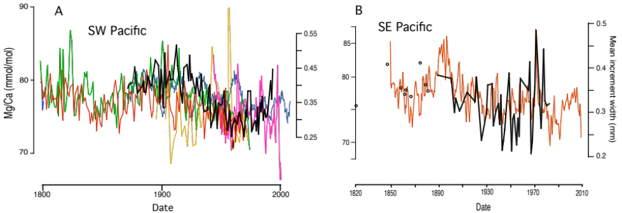

Supplemental Figure 1. Annual mean growth rates of AAIW-resident juvenile orange roughy (Hoplostethus atlanticus) (black lines and dots) collected (A) in the SW Pacific and compared with Mg/Ca ratios of co-located keratoisidid corals (coloured lines) and (B) in the SE Pacific compared with Mg/Ca of LW1, a mopseid bamboo coral from the Weddell Sea just south of South Orkney Islands (red line). For details on growth rate measurements, see Thresher et al. (2014). Black dots indicate data for sparse older fish in the SE Pacific. Indications in both fish time series of increasing growth rates in the most recent years could reflect warming trends, but more likely faster growing individuals disproportionately caught in year-classes that have not yet fully recruited into the fisheries.

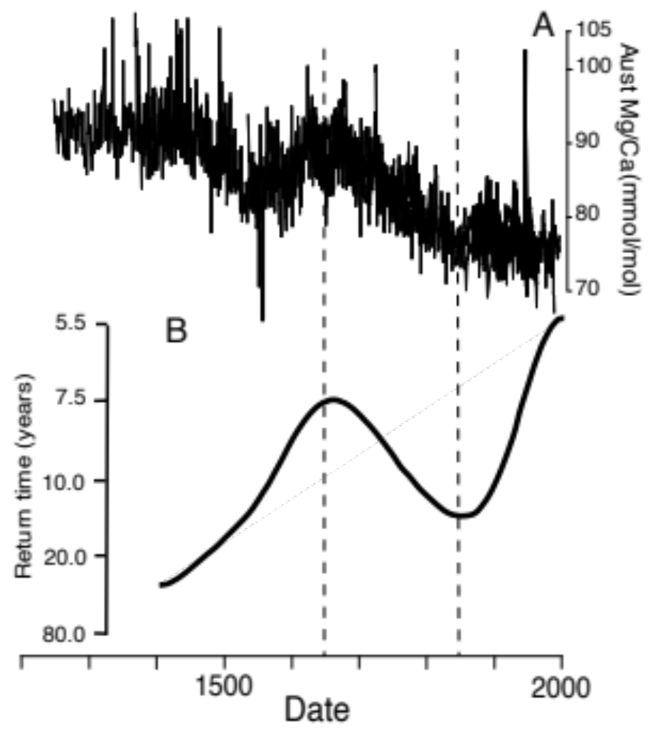

Supplemental figure 2. Comparison of (A) Mg/Ca time series for Australian bamboo corals and (B) smoothed plot of the frequency of extreme wet/dry climate events for South America, redrawn from Morales et al. (2020). The authors argue the signal is hemispheric and correlates with latitudinal shifts in the SO zonal west winds. Dashed lines indicate an apparently coincident peak and trough in the two time series.

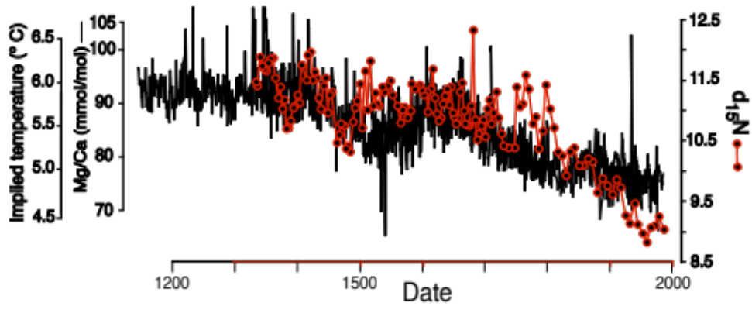

Supplemental Figure 3. Correspondence since ~1350 between an index of Central Pacific nitrate availability (d₁₅N in long-lived Hawaiian gold corals) (Sherwood et al, 2013) and the SW Pacific AAIW Mg/Ca – calculated temperature 30 years earlier. The lag matches the CFC-11 age of AAIW in the tropical central Pacific (Fine et al., 2001).

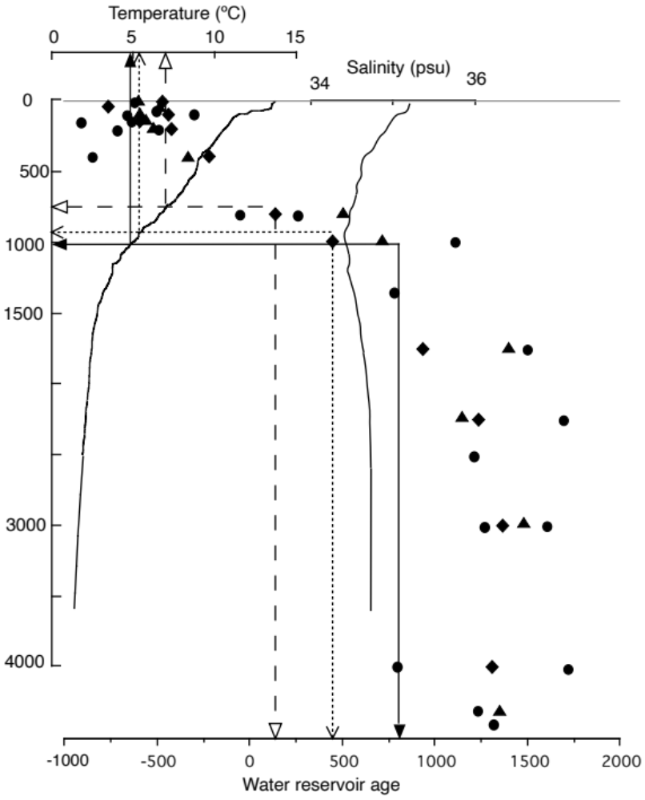

Supplemental Figure 4. Effect of shoaling on reservoir age and coral age estimates. Modern conditions for the core of the AAIW are indicated by the filled arrows and solid lines. For the AAIW at 1000 m to have cooled since 1500 by only 1º (lower end of estimated change) (open arrow, dotted lines), the AAIW would have to have shoaled by ca. 100 m. The effect on salinity would be negligible, but effects on coral age estimates are large due to the steep slope in reservoir ages around 1000 m. At a 1º C change, the reservoir-corrected ¹⁴C age of K2 would be about 525 years, and for the hypothesized mean estimate of 2.4º cooling (which would require shoaling of ca. 250 m [unfilled arrows, dashed lines]), ca. 700 years. Both exceed the 360-400 year age estimate for K2 based on alternative dating methods. The radiocarbon age for K2, the specimen dated in most detail (Thresher, 2009), (~366 years [mean ages for three innermost analyses less the mean of the three outermost]) is similar to that determined by counting nominally annual growth increments (338-340 increments) and ²¹⁰Pb dating (~400 years) (Thresher et al., 2004). Temperature and salinity data are from hydrocasts in the study area in 2008 (Thresher et al, 2010) and reservoir ages from three hydrocasts (filled symbols) in 1990 (Lassey et al., 1990).

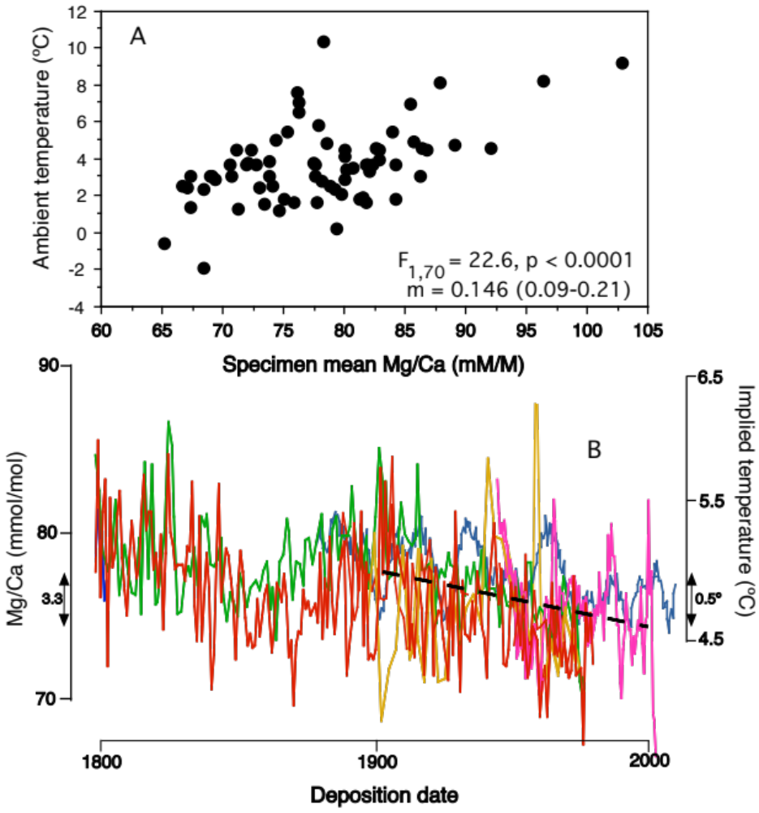

Supplemental Figure 5. A. Relationship between modern ambient temperature and specimen mean Mg/Ca ratios, as determined by ICP-MS, amongst 71 keratoisidid bamboo corals collected at sites ranging from the tropical Pacific to the Southern Ocean. See Thresher et al. (2016) for analytic details and suborder-wide results. B. Industrial era (post ~1900; see text) trend in Mg/Ca in SW Pacific keratoisids (dashed line), fitted by eye. Specimen colors as in Fig. 1. Implied temperature change is based on the mean slope in Fig. 5A.

References

- Thresher RE, et al. (2014) Parallel decadal variability of inferred water temperatures for Northern and Southern Hemisphere intermediate water masses. Geophys Res Lett 41:1232-1237.
- Morales, M.S., Cook, E.R., Barichivich, J., et al. (2020). Six hundred years of South American tree rings reveal an increase in severe hydrodynamic events since mid-20th century. Proc Nat Acad Sci USA, 117:16816-16823.
- Sherwood O.A., Guilderson TP, Batista FC, Schiff JT, McCarthy MD (2013) Increasing subtropical North Pacific Ocean nitrogen fixation since the Little Ice Age. Nature 505:78-81.
- Fine RA, Mailett KA, Sullivan KF, Willey D (2001) Circulation and ventilation flux of the Pacific Ocean. J Geophys Res 106:22,159-22,178.
- Thresher RE (2009) Environmental and compositional correlates of growth rate in deep-sea bamboo corals (Gorgonacea; Isididae). Mar Ecol Prog Ser 397:187-196.
- Thresher RE, Rintoul SR, Koslow JA, Weidman C, Adkins J, Proctor C (2004) Oceanic evidence of climate change in southern Australia over the last three centuries. Geophys Res Lett 31:L07212
- Thresher RE, Wilson NC, MacRae CM, Neil H (2010) Temperature effects on the calcite skeletal composition of deep-water gorgonians (Isididae). Geochim Cosmochim Acta, 74:4655-4670.
- Lassey KR, Manning MR, Sparks RJ, Wallace G (1990) Radiocarbon in the sub-tropical convergence east of Tasmania – an interim report. DSIR Phys Sci Rpt #11, DSIR Physical Sciences, Nuclear Sciences Group.
- Thresher RE, Fallon S, Townsend AT (2016) A “core-top” screen for trace element proxies of environmental conditions and growth rates in the calcite skeletons of bamboo corals (Isididae). Geochim Cosmochim Acta 193:75-99.

Supplemental Table 1. Specimen details. Aging methods: M = marginal growth rate; O = radiocarbon dating of the specimen’s organic node sub-samples; C = radiocarbon dating of internode calcite sub-samples; W = “wiggle mapping”; I = increment counts. Superscripts indicate aging references. Radiocarbon ages of calcite are not corrected for reservoir age.

Specimen ID | Year collected | Site | Lat | Long | Depth (m) | Core age | Margin age | Aging method
K1 | 1992 | Cascade Plateau | -45.53 | 150.25 | ~1000 | ~200 years old | Modern | O
K2 | 1992 | Cascade Plateau | -45.53 | 150.25 | ~1000 | 1435±30 | 960±30 | C
K4 | 1992 | Southern Hills, Tas | -44.20 | 147.10 | ~1000 | ~260 years old | Node analysis indicates pre-modern | O, W
K6 | 1998 | South Tasman Rise | -47.50 | 148.00 | >804 | 1665±30 | 1360±30 | C
K7 | 1990s | Southern Hills, Tas | ~-44.20 | ~147.10 | ~900 | 1510±25 | 1155±25 | C
K11 | 1992 | Southern Hills, Tas | ~-44.20 | ~147.10 | ~1000 | 1624±46 | 1468±52 | O
K18 | 1999 | Chatham Rise, NZ | -42.69 | -179.97 | 1056 | 1130±40 | 830±40  (Collected live) | C
K19 | 1982 | Chatham Rise, NZ | ~-42.5 | ~-179.1 | ? | - | - | W
K26 | 2009 | Southern Hills, Tas | -44.25 | 147.11 | 958 | 1170±30 | 1020±30  (Collected live) | C
L9 | 2008 | Southern Hills, Tas | -42 | 147 | 1160 | 105-117 | Collected live | O⁹⁰
L11 | 1990 | Cascade Plateau | -43.96 | 150.35 | ~1000 | 119 | Collected live | O⁹³
Z10909 | 2001 | Chatham Rise, NZ | -42.49 | -179.12 | 638-840 | 116 | Collected live | I⁹⁵
DW1697 | 1992 | Norfolk Ridge | 24.66 | 166.65 | 569-618 | 430±30 | Modern | C
DW1700 | 1992 | Norfolk Ridge | 24.66 | 166.65 | 505-572 | 890±30 | 710 ±25 | C
DW1701 | 1992 | Norfolk Ridge | 24.66 | 166.65 | 564-586 | 1250±25 | 1060±35 | C
LW1 | 2009 | Weddell Sea | 60.44 | 45.66 | 236-243 | ~160 | Collected live | M
Corallium 2 | 2009 | Cascade Plateau | 43.82 | 150.33 | 2173 | 329±36 | Collected live | C

