Supplementary Information
for
Effect of Na₂CO₃ on production of NaHCO₃
using desulfurized Na₂SO₄ waste
Chaehyun Lim*,‡, Youngchul Byun**,‡, Hwan Gi Kim**, Sang Sook Park*, Jung Gi Min**,†
*Dept. of Environmental Eng, Suncheon National University, Suncheon-si 57922, Korea
**Research Institute of Industrial Science and Tech(RIST), Gwangyang-si, 57801, Korea
‡These Authors contributed equally

Table S1. Simulation conditions of MINEQL+
No. | Content
1 | Conc. of Na⁺: 6.580075 mol/L
2 | Conc. of Ca²⁺: 0.16592 mol/L
3 | Conc. of K⁺: 0.87685 mol/L
4 | Conc. of Cl⁻: 0.116316 mol/L
5 | Conc. of Fe²⁺: 0.056632 mol/L
6 | Conc. of SO₄²⁻: 2.134184 mol/L
7 | Conc. of CO₃²⁻: 3.367035 mol/L
8 | pH is set as “calculated by MINEQL+”
9 | CO₂ is selected as “closed to the atmosphere”
10 | All solid are not considered
11 | Ionic strength corrections: off
12 | Temperature corrections: off
13 | No surface model

Table S2. Solubility table of possible impurities on Na₂SO₄ waste after the addition of Na₂CO₃
No. | Chemical | Soluble  & Insoluble | Solubility  (g/100 mL) | Temperature  (°C)
1 | Mg(OH)₂ | insoluble | 0.00064 | 25
2 | MgCO₃ | insoluble | 0.014 | 25
3 | MgSO₄ | soluble | 26.91 | 20
4 | Al(OH)₃ | insoluble | 0.00012 | 25
5 | Al₂(CO₃)₂ | - | - | -
6 | Al₂(SO₄)₂ | soluble | 36.41 | 25
7 | Si(OH)₄ | - | - | -
8 | Si₂(CO₃)₄ | - | - | -
9 | Si₂(SO₄)₄ | - | - | -
10 | KOH | soluble | 121.12 | 25
11 | K₂CO₃ | soluble | 110.31 | 20
12 | K₂SO₄ | soluble | 11.12 | 20
13 | Ca(OH)₂ | insoluble | 0.17 | 20
14 | CaCO₃ | insoluble | 0.0013 | 25
15 | CaSO₄ | insoluble | 0.26 | 25
16 | Fe(OH)₂ | insoluble | 0.000052 | 20
17 | FeCO₃ | insoluble | 0.00067 | 20
18 | FeSO₄ | soluble | 29.51 | 25
19 | Fe(OH)₃ | insoluble | - | -
20 | Fe₂(CO₃)₃ | insoluble | - | -
21 | Fe₂(SO₄)₃ | slowly soluble | 25.61 | 20
22 | Cu(OH)₂ | insoluble | - | -
23 | CuCO₃ | insoluble | - | -
24 | CuSO₄ | soluble | 20.52 | 20
25 | Zn(OH)₂ | insoluble | - | -
26 | ZnCO₃ | insoluble | 0.000091 | -
27 | ZnSO₄ | soluble | 57.71 | 20
28 | Se(OH)₄ | insoluble | - | -
29 | Se₂(CO₃)₄ | - | - | -
30 | Se₂(SO₄)₄ | - | - | -
31 | RbOH | soluble | 173.11 | 30
32 | Rb₂CO₃ | very soluble | - | -
33 | Rb₂SO₄ | soluble | 5.08 | -
34 | Pb(OH)₂ | insoluble | 1.615 × 10⁻⁴ | 20
35 | PbCO₃ | insoluble | 7.269 × 10⁻⁵ | 20
36 | PbSO₄ | insoluble | 0.0044 | 20

Table S3. Chemical composition data of precipitated impurities measured by XRF after the addition of Na₂CO₃
No. | Chemical formula | Value (wt%)
1 | C | 7.87
2 | Na₂O | 6.35
3 | MgO | 2.73
4 | Al₂O₃ | 1.66
5 | SiO₂ | 3.68
6 | P₂O₅ | 0.17
7 | SO₃ | 4.35
8 | Cl | 0.19
9 | K₂O | 0.32
10 | CaO | 33.4
11 | TiO₂ | 0.43
12 | Cr₂O₃ | 0.024
13 | MnO | 0.18
14 | Fe₂O₃ | 35.41
15 | CuO | 0.088
16 | ZnO | 0.20
17 | SeO₂ | 0.072
18 | Br | 0.0071
19 | SrO | 0.024
20 | Tl₂O₃ | 0.030
21 | PbO | 2.74
22 | Bi₂O₃ | 0.045

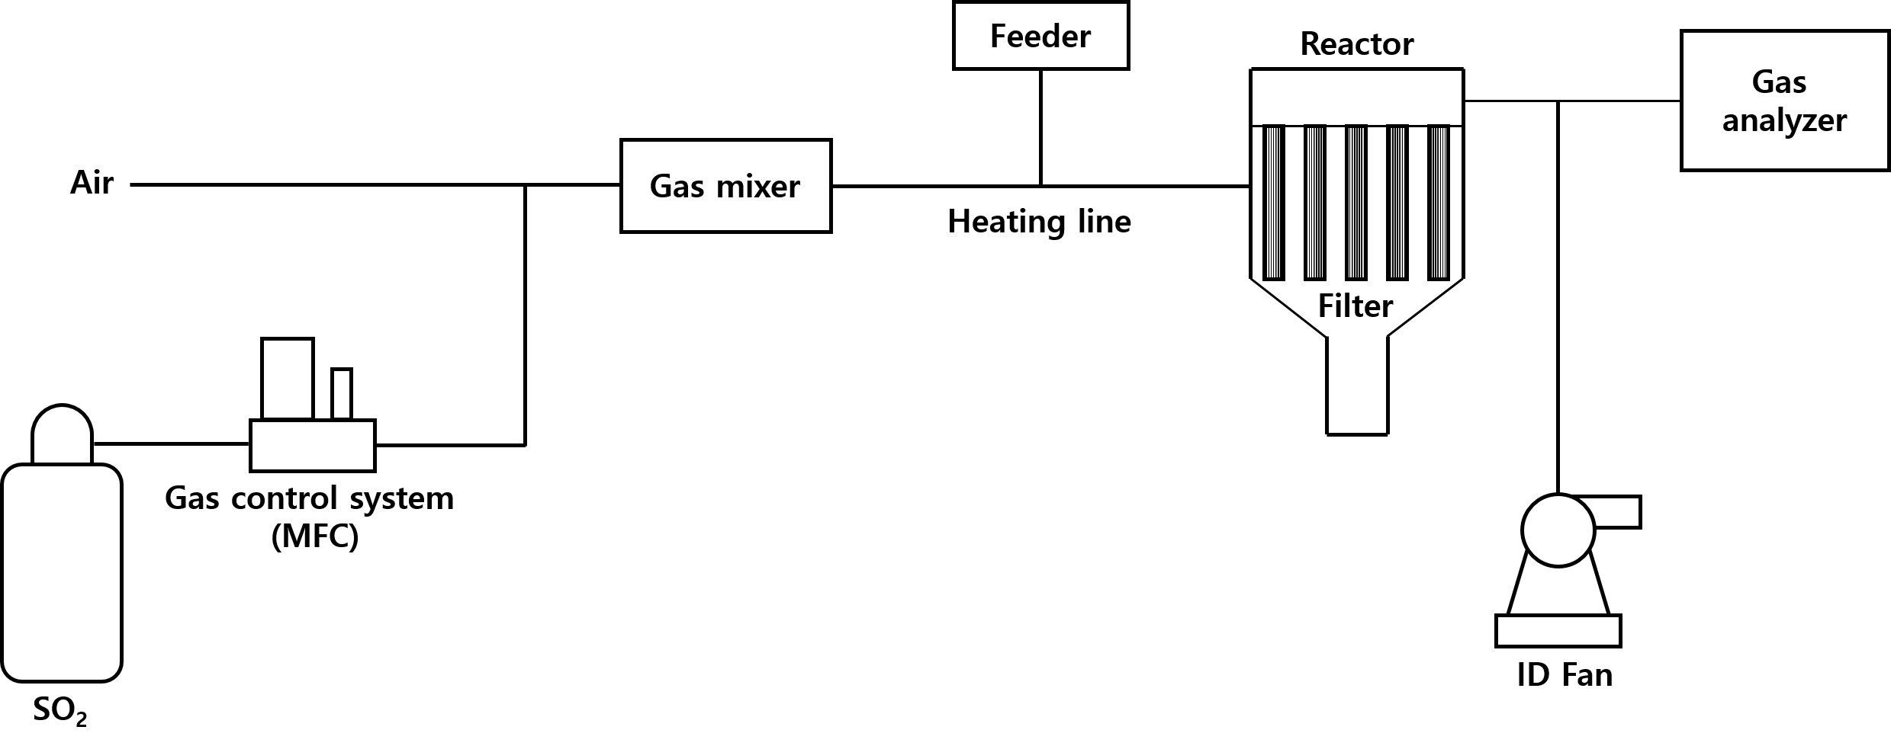

Fig. S1. Experimental schematic of SO₂ removal.
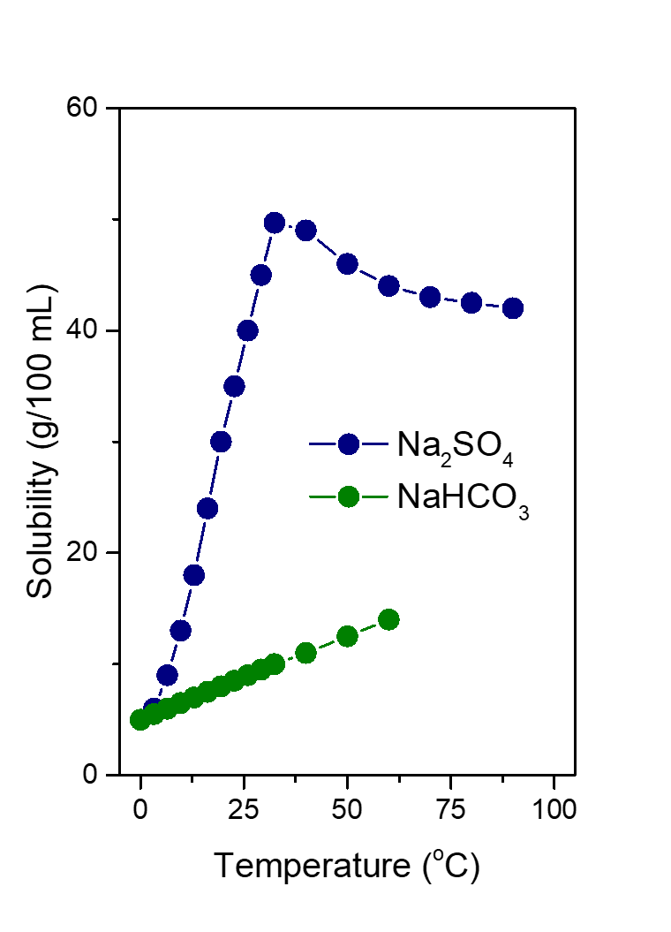
Fig. S2. Solubility curves of Na₂SO₄ and NaHCO₃ with different temperatures.

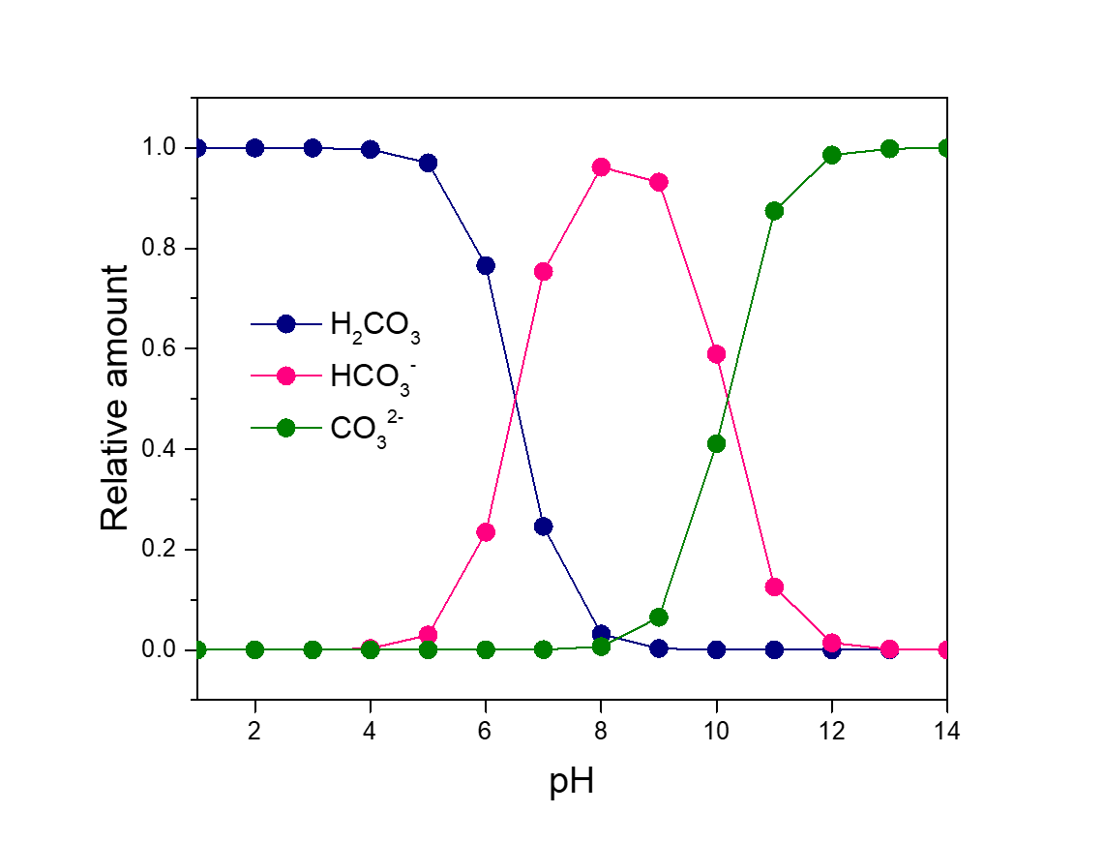
Fig. S3. Carbonate system with different pH.

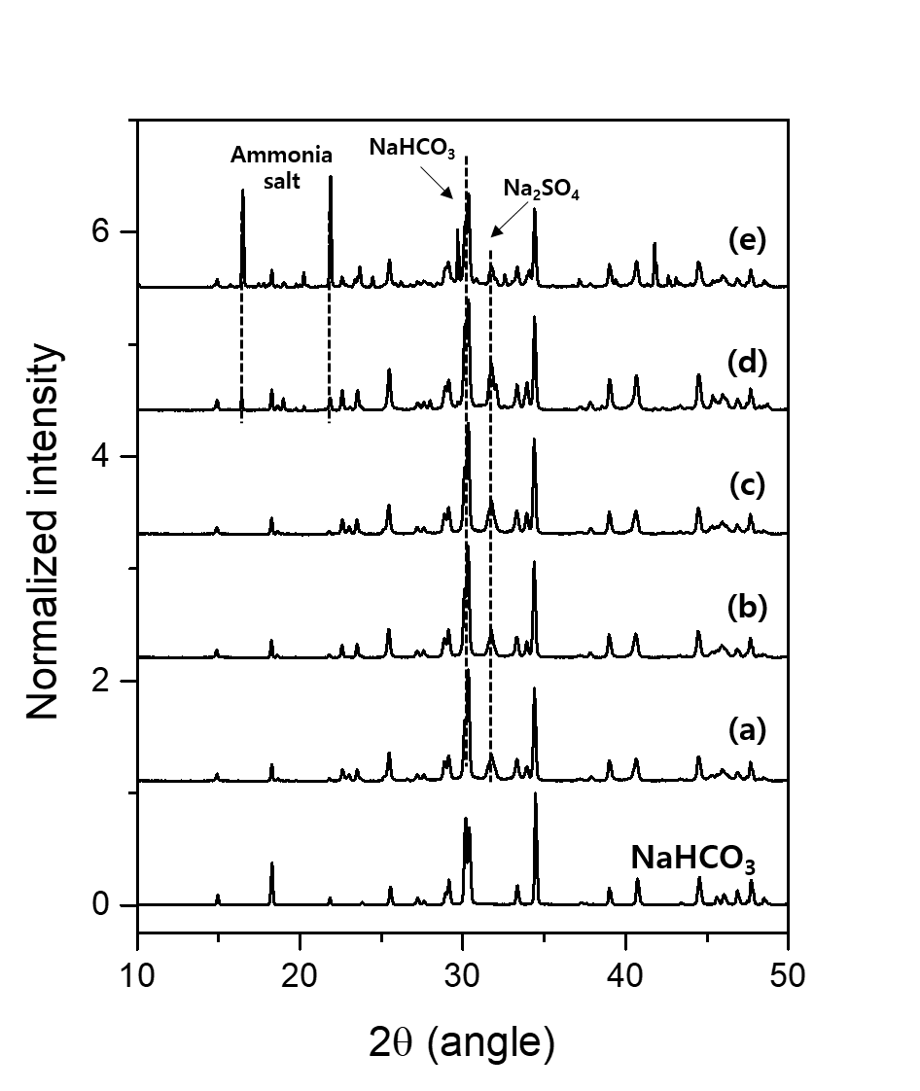

Fig. S4. XRD patterns of solid product with different NH₃:Na⁺ ratios of (a) 1.0, (b) 1.1, (c) 1.2, (d) 1.3, and (e) 1.5. The XRD pattern of pure NaHCO₃ is shown on the bottom line for comparison.
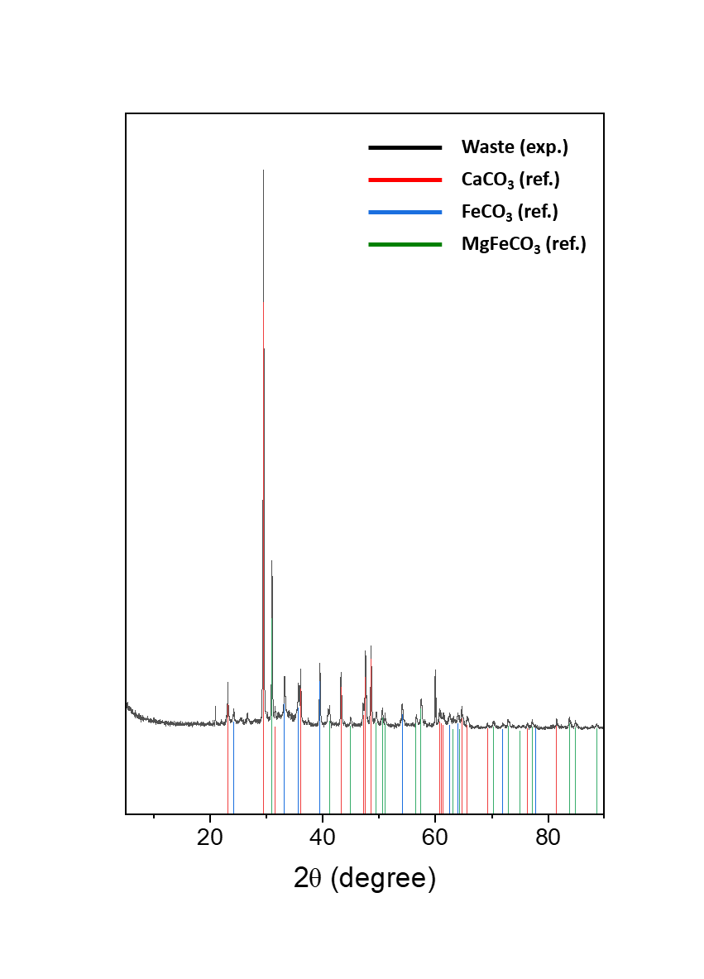
Fig. S5. XRD pattern of precipitated impurities after the addition of Na₂CO₃.

