Appendix: Methodology

A1. The GDynE model
The empirical analysis was conducted with the dynamic version of the GTAP-E model (GDynE), which is a multi-regional and multi-sector recursive dynamic computable general equilibrium model (Burniaux and Truong, 2002; Hertel, 1997). The development of the GDynE model integrates the advantages of the GDyn model and GTAP-E model, and Fig. A1 displays the structure of the GDynE model. Different from the GDyn model, the GDynE model allows substitution among energy, labour and capital (for more details, please see Fig. A2), which is particularly useful for simulating the substitution effect of energy and primary factors when the labour force is decreased from the epidemic (McDougall and Golub, 2007; Golub, 2013; Ianchovichina and McDougall, 2000). Compared with the GTAP-E model, GDynE features simulations of the fluctuating trends of energy consumption and carbon emissions in different regions by introducing several mechanisms, such as regional capital flow, capital accumulation and investment applicability expectation (Hertel, 1997). As the COVID-19 outbreak has become a global pandemic, the change in one country’s economic loss and energy consumption not only depends on the development of the epidemic but also closely relates to the prevention policies and measures taken by other countries. The GDynE model describes the economic and trade exchanges and industrial relations among countries in detail, making it particularly useful to analyse the energy and environmental impact of COVID-19.
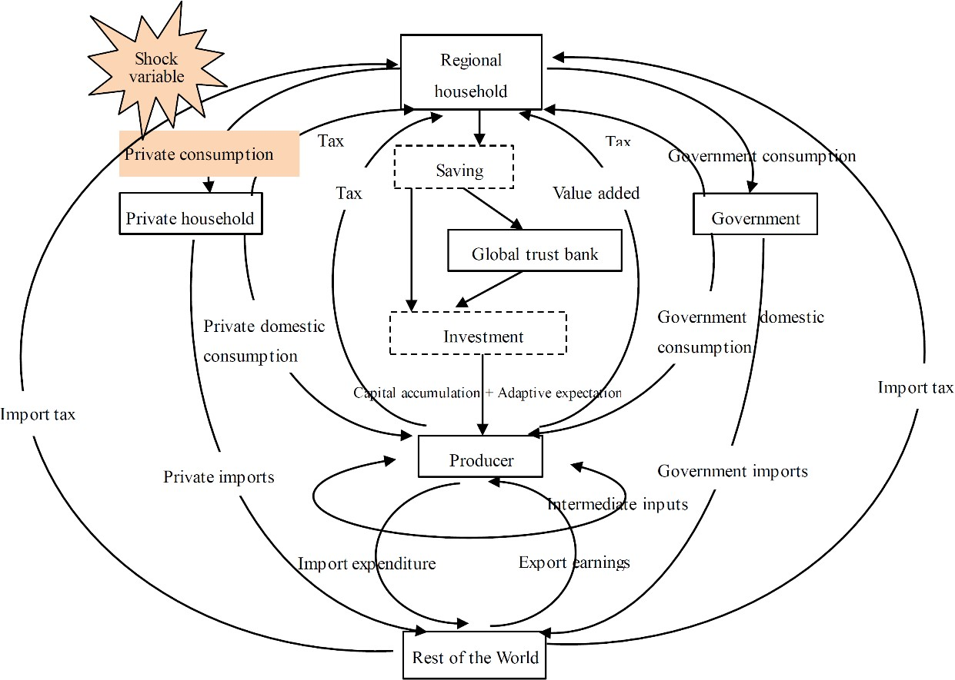
Figure A1| The structure of the GDynE model.

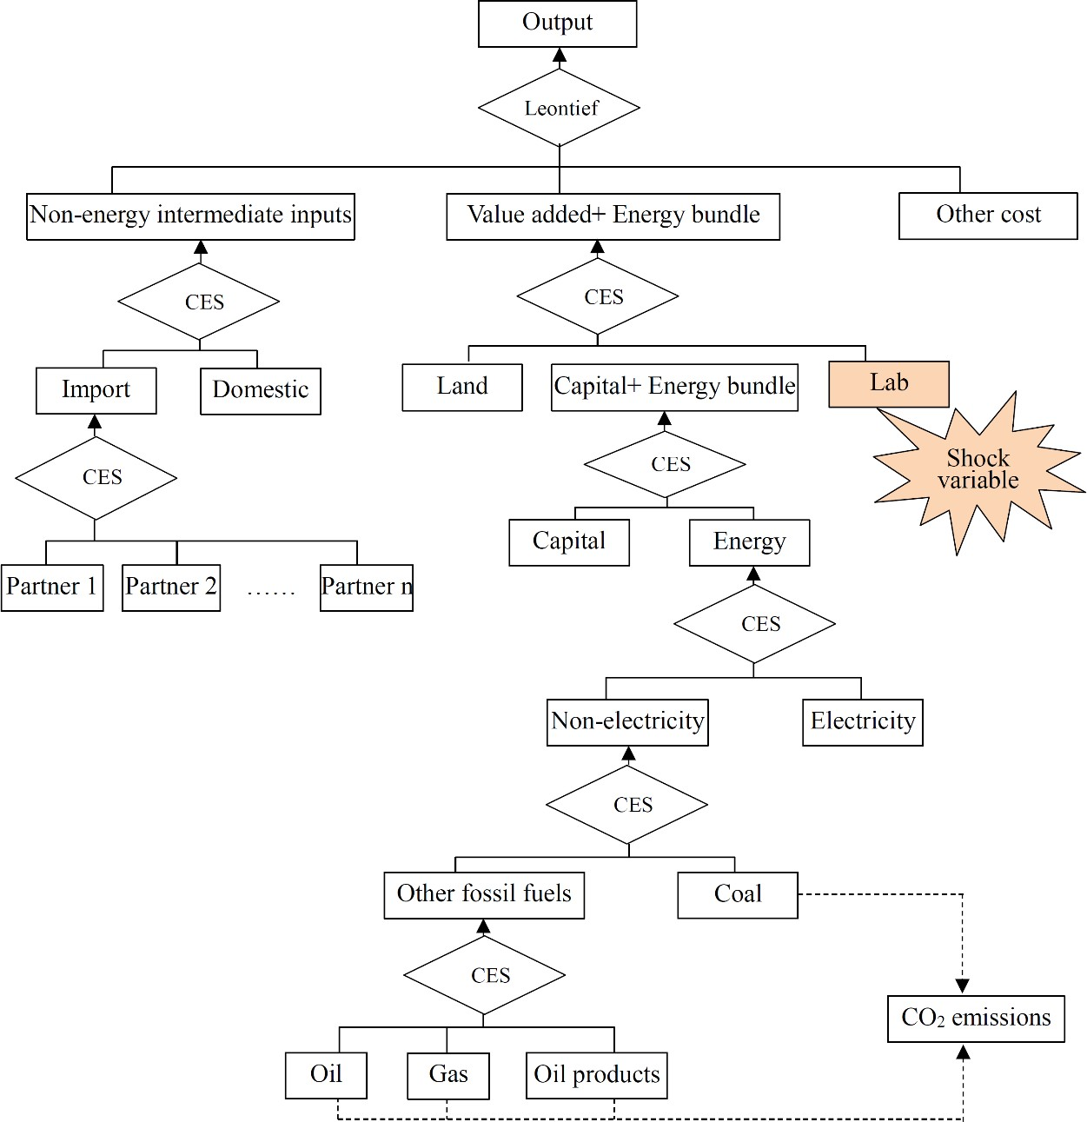

Figure A2| Production nesting in the GDynE model.

In this study, the GTAP 10 database (base year 2014) was adopted to construct the initial database for the dynamic simulation of the GDynE model. To assist our research, the 141 regions in the original database are merged into 7 categories, namely, China, USA, Japan, South Korea (SKorea), the European Union (EU), Middle East & North Africa (MES) and the rest of the world (ROW). For more details, please refer to Supplementary material 1. Regarding sectoral aggregation, the original 65 sectors were aggregated into 27 categories (see Supplementary material 2). The GDynE simulation mainly consists of two parts: the historical calibration period and the policy simulation period. The historical calibration period was from 2014 to 2019, during which time macro-economic variables were employed to calibrate the model; in other words, these variables were exogenous and set as actual change values. The “unexplainable” part (also referred to as “deviation”) of the model was determined by the endogeneity of relevant offset variables. In the prediction period, opposite operations were applied to extrapolate the historical trend. Since several studies have shown that pandemics involve short and sharp peaks in their effects (Verikios et al.,2015; McKibbin and Fernando, 2020), the policy simulation mainly explores the impact of the epidemic on the global energy and environment in 2020.
To improve the accuracy of simulations, historical calibration mainly uses two types of data: macro-economic data, including real GDP, investment, private consumption, import and export trade, population and employment, and

energy and emission data, including the production and consumption of coal, oil, natural gas, oil products, non-fossil electricity (which refers to renewables and nuclear energy), and carbon emissions. Among them, the macro-economic data of the above 7 regions are from the World Bank website, and the detailed energy production and consumption, as well as the carbon emissions, are from BP (2019).

A2. Scenario settings
With uncertainties surrounding the future development of the epidemic, this study considers three policy scenarios, as shown in Table 1. Combined with the mechanism of the impact of the epidemic on economic growth, the impact of the epidemic on the socio-economic system is quantified in two ways. First, to combat the epidemic, many countries have taken a variety of control measures, such as city closure, work stoppage and home quarantine, which have a significant negative impact on the labour supply. Second, the epidemic will cause severe damage to residents' demand, given the strict social-distancing measures, and different industries show great heterogeneity. On the one hand, home quarantine will depress private consumption, especially the consumption of entertainment services, the retail industry, the tourism industry, the accommodation and catering industry, etc. On the other hand, the epidemic may also lead to an increase in the demand for medical services, online education and information and communication services. Duan et al. (2020) calculated the impact of COVID-19 on residents’ demand in China, and this study will draw on these results. Regarding the labour productivity loss from the epidemic, we consider differentiated settings for different regions because of the diversity of epidemic situations and isolation measures. Specifically, in the Optimistic scenario, it is assumed that China's labour productivity will decrease by 2%, that in the US, Japan and SKorea will decrease by 0.5%, and that in the EU, the MES and ROW will decrease by 1%; when moving to the moderate scenario (which is also referred to as the Base-case), we assume that China's labour productivity will decrease by 4%, followed by 3.25% for the US, Japan and SKorea, and 3.5% for the EU, the MES and ROW; for the Pessimistic scenario, the decrease in labour productivity is set the same in all regions, with a value of 6%.

Table A1. Policy scenarios under the COVID-19 pandemic shocks
Scenarios | Main assumptions
Base-case scenario | China's labor productivity fell by 4%, the United States, Japan and South Korea by 3.25%, the European Union, the Middle East& North Africa and ROW by 3.5%; all region obey the same rule of private  consumption, the same as that in China
Optimistic scenario | China's labor productivity fell by 2%, the United States, Japan and South Korea by 0.5%, the European Union, the Middle East& North Africa and ROW by 1%; all region obey the same rule of private  consumption, the same as that in China
Pessimistic  scenario | All region's labor productivity fell by 6%; all regions obey the same  rule of private consumption, the same as that in China

A3. Macro-economic shocks
It is evident that the GDP growth rates of different regions will be slowed by COVID-19, and China, South Korea, the United States and Japan will be the most affected. In the Base-case scenario, the reduction in GDP growth rates in different regions ranges from 1.3% to 2.61% (Fig. A3), while the numbers will be as high as 2.13% to 4.32% in the Pessimistic scenario (Fig. A4), and the United States will take over China to become the most affected (case results

compared to 2020 projections). The real world economic growth rate of 2020 compared to 2019 is estimated to be 0.67%, and the respective growth rates are 3.05%, -0.35%, -1.80%, -0.24%, -0.20%, 0.97%, and 1.41% for China, the United States, Japan, South Korea, EU_28, MES, and ROW regions, respectively. Recessions occur in the main economies (the United States, Japan, South Korea, and EU_28), and the growth rate would be nearly half that in China (5.81% in the 2020 projection). The Base-case scenario refers to the situation in early May given that the situation is eased across the world. Although the situation is much worse than that of the optimistic case (which is in accordance with the situation in early March), the positive growth in the ROW region, as well as the relatively weak growth in China, can still make the world economy record positive and weak growth in 2020.
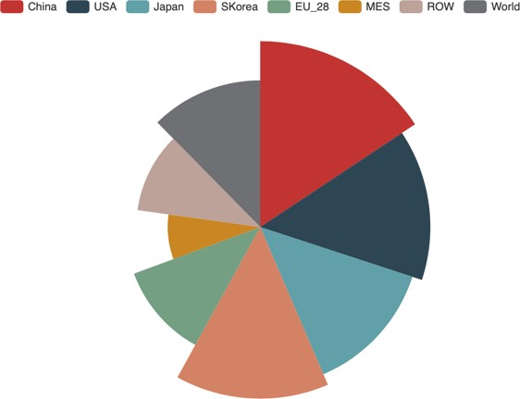
-2.61%
-2.06%
-1.74%
-2.39%
-1.3%
-1.89%
-2.25%
-2.41%

Figure A3| The impact of the COVID-19 outbreak on GDP across regions under the Base-case scenario.
Note: These impacts are represented by percentage changes in GDP relative to the 2020 projections

In the Pessimistic scenario, the real growth rate of the world economy in 2020 (compared to that in 2019) is estimated as -0.70%, and the growth rates are 2.07%, -2.33%, -3.08%, -1.65%, -1.48%, 0.12%, and 0.15% for China, the United States, Japan, South Korea, EU_28, MES, and ROW regions, respectively (Fig. A4). Deeper recessions among the main economies have directly decreased the economic growth in the ROW region. The Pessimistic scenario here is not so "pessimistic" given that we assume that COVID-19 will not spread throughout the ROW region, and if the bailout plans issued by the major countries are not able to play roles, the world economy can even record more serious negative growth in 2020. Although the economic shocks resulting from the COVID-19 outbreak might be short, many scholars believe that the pandemic could lead to long-term changes in economic structures, e.g., a persistent shift from conventional production systems toa more sustainable future (Klemes et al., 2020).

China


ROW Japan
-1.69
World
-0.76
-0.48
USA
-2.61
-2.07
-2.39
-3.40
-3.54
-1.74
-2.97
-4.33
-3.53
-2.25
-1.00
-0.54
-3.79
-2.41
-2.13
-3.16
-0.48
MES
-1.30
-1.89
-1.06
SKorea
-0.65

EU_28
Base-case Scenario Pessimistic Scenario Optimistic Scenario

Figure A4| The impact of the COVID-19 outbreak on GDP across regions under different scenarios.
Note: These impacts are measured by percentage changes in GDP relative to the 2020 projections

Supplementary materials

S1: Regional Aggregation
Regions | Members
China | China
USA | United States of America
Japan | Japan
Skorea | South Korea
EU | Austria, Belgium, Denmark, Finland, France, Germany, Greece, Ireland, Italy, Luxembourg, Netherlands, Portugal, Spain, Sweden, United Kingdom, Cyprus, Czech Republic, Estonia, Hungary, Malta, Poland, Slovakia, Slovenia , Bulgaria, Latvia,  Lithuania, Romania, Croatia
MES | Bahrain, Iran Islamic Republic of, Israel, Jordan, Kuwait, Oman, Qatar, Saudi Arabia, Turkey, United Arab Emirates, Rest of  Western Asia, Egypt, Morocco, Tunisia, Rest of North Africa
ROW | Australia, New Zealand, Rest of Oceania, Hong Kong, Mongolia, Taiwan, Rest of East Asia, Brunei, Darussalam, Cambodia , Indonesia, Laos, Malaysia, Philippines, Singapore, Thailand, Viet Nam, Rest of Southeast Asia, Bangladesh, India, Nepal, Pakistan, Sri Lanka, Rest of South Asia, Canada, Mexico, Rest of North America, Argentina, Bolivia, Brazil, Chile, Colombia, Ecuador, Paraguay, Peru, Uruguay, Venezuela, Rest of South America, Costa Rica, Guatemala, Honduras, Nicaragua, Panama, El Salvador, Rest of Central America, Dominican Republic, Jamaica, Puerto Rico, Trinidad and Tobago, Caribbean, Switzerland, Norway, Rest of EFTA, Albania, Belarus, Russian Federation,  Ukraine, Rest of Eastern Europe, Rest of Europe, Kazakhstan, Kyrgyzstan, Tajikistan, Rest of Former Soviet Union, Armenia, Azerbaijan, Georgia, Benin , Burkina Faso, Cameroon, Cote d'Ivoire, Ghana,  Guinea, Nigeria, Senegal, Togo, Rest of Western Africa, Central Africa, South Central Africa, Ethiopia, Kenya, Madagascar, Malawi, Mauritius, Mozambique , Rwanda, Tanzania, Uganda, Zambia,  Zimbabwe, Rest of Eastern Africa, Botswana, Namibia, South Africa, Rest of South African Customs, Rest of the World
Source: Author’s specification from GTAP 10 Database.

S2: Sectoral Aggregation
No. | New Sector | GTAP  Sector | Description | No. | New  Sector | GTAP  Sector | Description
1 | Agri | pdr | Paddy rice | 8 | En_Int_ind | omn | Minerals n.e.c.
1 | Agri | wht | Wheat | 8 | En_Int_ind | chm | Chemical products
1 | Agri | gro | Cereal grains n.e.c. | 8 | En_Int_ind | bph | Basic pharmaceutical products
1 | Agri | v_f | Vegetables, fruit, nuts | 8 | En_Int_ind | rpp | Rubber and plastic products
1 | Agri | osd | Oil seeds | 8 | En_Int_ind | nmm | Mineral products n.e.c.
1 | Agri | c_b | Sugar cane, sugar beet | 8 | En_Int_ind | i_s | Ferrous metals
1 | Agri | pfb | Plant-based fibers | 8 | En_Int_ind | nfm | Metals n.e.c.
1 | Agri | ocr | Crops n.e.c. | 9 | Oth_indus | fmp | Metal products
1 | Agri | ctl | Cattle,sheep,goats,horses | 9 | Oth_indus | ele | Computer, electronic and optic
1 | Agri | oap | Animal products n.e.c. | 9 | Oth_indus | eeq | Electrical equipment
1 | Agri | rmk | Raw milk | 9 | Oth_indus | ome | Machinery and equipment n.e.c.
1 | Agri | wol | Wool, silk-worm cocoons | 9 | Oth_indus | mvh | Motor vehicles and parts
1 | Agri | for | Forestry | 9 | Oth_indus | otn | Transport equipment n.e.c.
1 | Agri | fsh | Fishing | 9 | Oth_indus | omf | Manufactures n.e.c.
2 | Coal | col | Coal | 10 | Water | wtr | Water
3 | Oil | oil | Oil | 11 | Cons | cns | Construction
4 | Gas | gas | Gas | 12 | Trade | trd | Trade
4 | Gas | gdt | Gas manufacture, distribution | 13 | Accom | afs | Accommodation, Food and servic
5 | P_C | p_c | Petroleum, coal products | 14 | Land_trans | otp | Transport nec
6 | Elec | ely | Electricity | 15 | Water_trans | wtp | Water transport
7 | Light_indus | cmt | Meat: cattle,sheep,goats,horse | 16 | Air_trans | atp | Air transport
7 | Light_indus | omt | Meat products n.e.c. | 17 | Warehous | whs | Warehousing and support activi
7 | Light_indus | vol | Vegetable oils and fats | 18 | Communi | cmn | Communication
7 | Light_indus | mil | Dairy products | 19 | Financial | ofi | Financial services nec
7 | Light_indus | pcr | Processed rice | 20 | Insurance | ins | Insurance
7 | Light_indus | sgr | Sugar | 21 | Realest | rsa | Real estate activities
7 | Light_indus | ofd | Food products n.e.c. | 22 | Business | obs | Business services nec
7 | Light_indus | b_t | Beverages and tobacco  products | 23 | Recreat | ros | Recreational and other service
7 | Light_indus | tex | Textiles | 24 | PublicAdmi | osg | Public Administration and defe
7 | Light_indus | wap | Wearing apparel | 25 | Education | edu | Education
7 | Light_indus | lea | Leather products | 26 | Humanhealth | hht | Human health and social work a
7 | Light_indus | lum | Wood products | 27 | Dwelling | dwe | Dwellings
7 | Light_indus | ppp | Paper products, publishing
Source: Author’s specification from GTAP 10 Database

