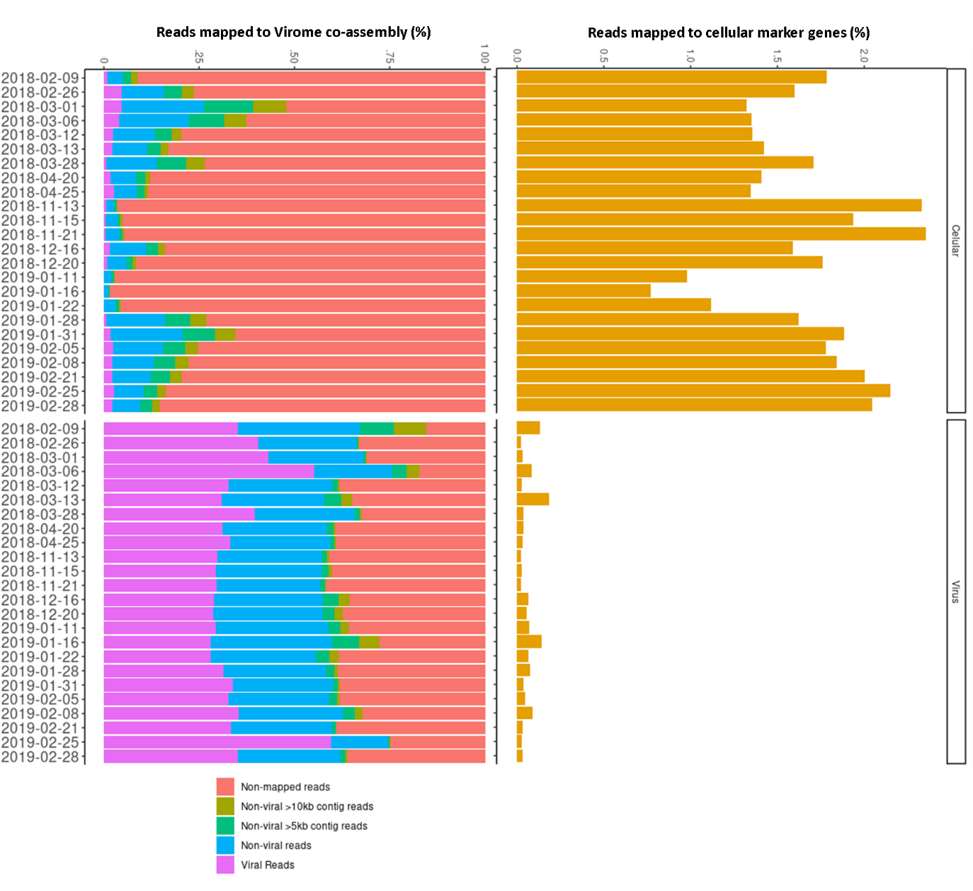
Supplementary Figure 1 – Reads that mapped to the virome co-assembly (left) and to cellular marker genes (SSU and LSU rDNA and other bacterial markers from the tool ViromeQC, ref⁸⁵) for the cellular metagenomes (>0.2µm) and viral metagenomes (<0.2µm, FeCl₃ flocculation method). On average, viromes were 44x depleted in cellular marker genes compared to the cellular fraction (>0.22 um) metagenomes.

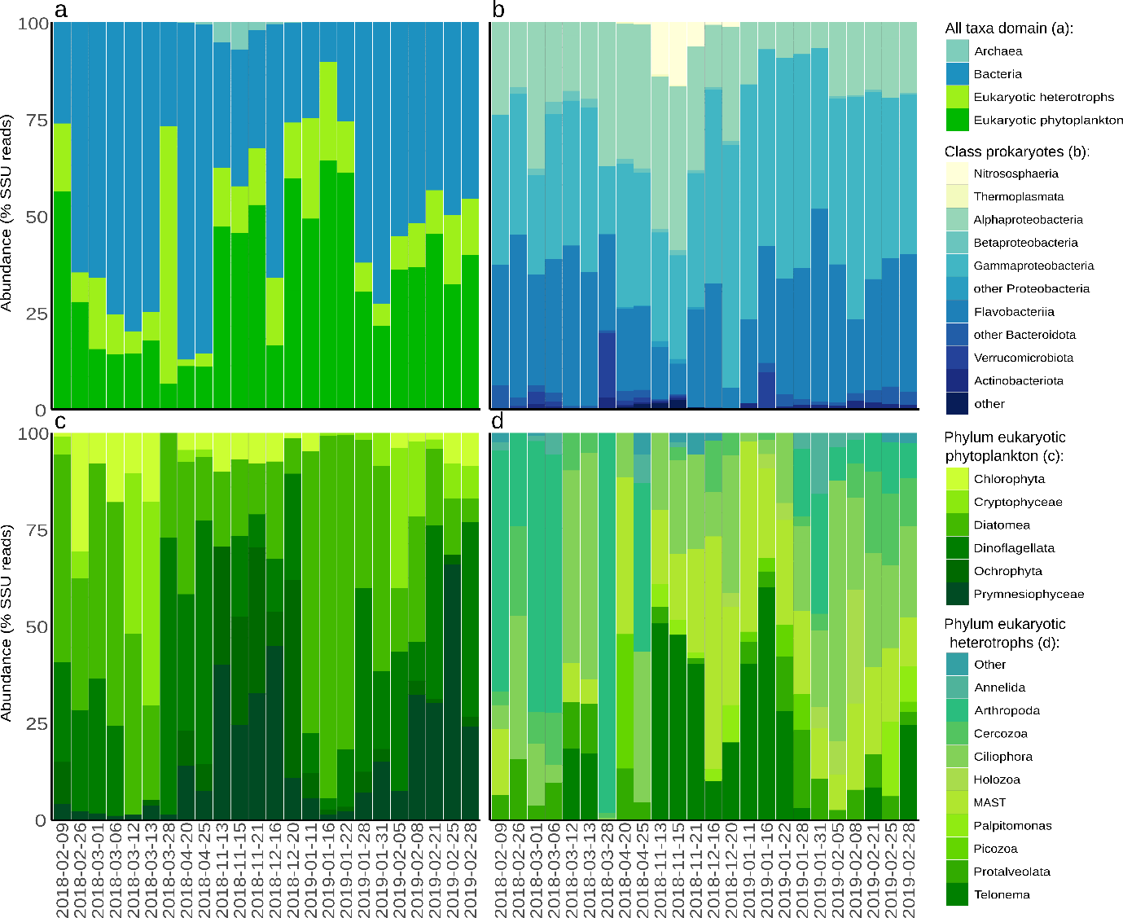
Supplementary Figure 2 – Cellular community composition over the sampling period according to the number of 16S and 18S rRNA gene reads at the domain level (a), at the Class level for Bacteria and Archaea (b), and at the Phylum level for eukaryotic phytoplankton (c) and heterotrophic Eukaryotes (d).

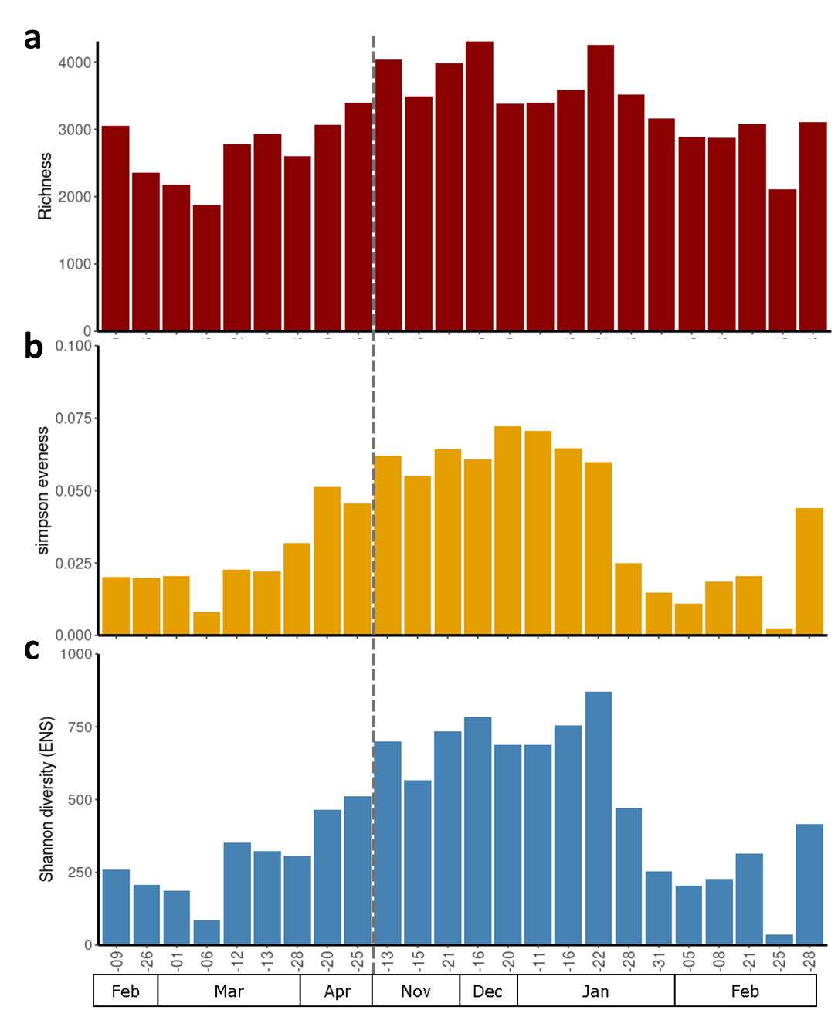
Supplementary Figure 3 – Seasonal dynamics of (A) species richness (number of viral scaffolds with abundance > 0.001 % of the reads) and (B) Simpson evenness index, and (C) Shannon diversity index in effective number of species (ENS). Sampling is irregular and squares indicate the month of the year, and the grey line indicates the winter sampling gap between April and November 2018.

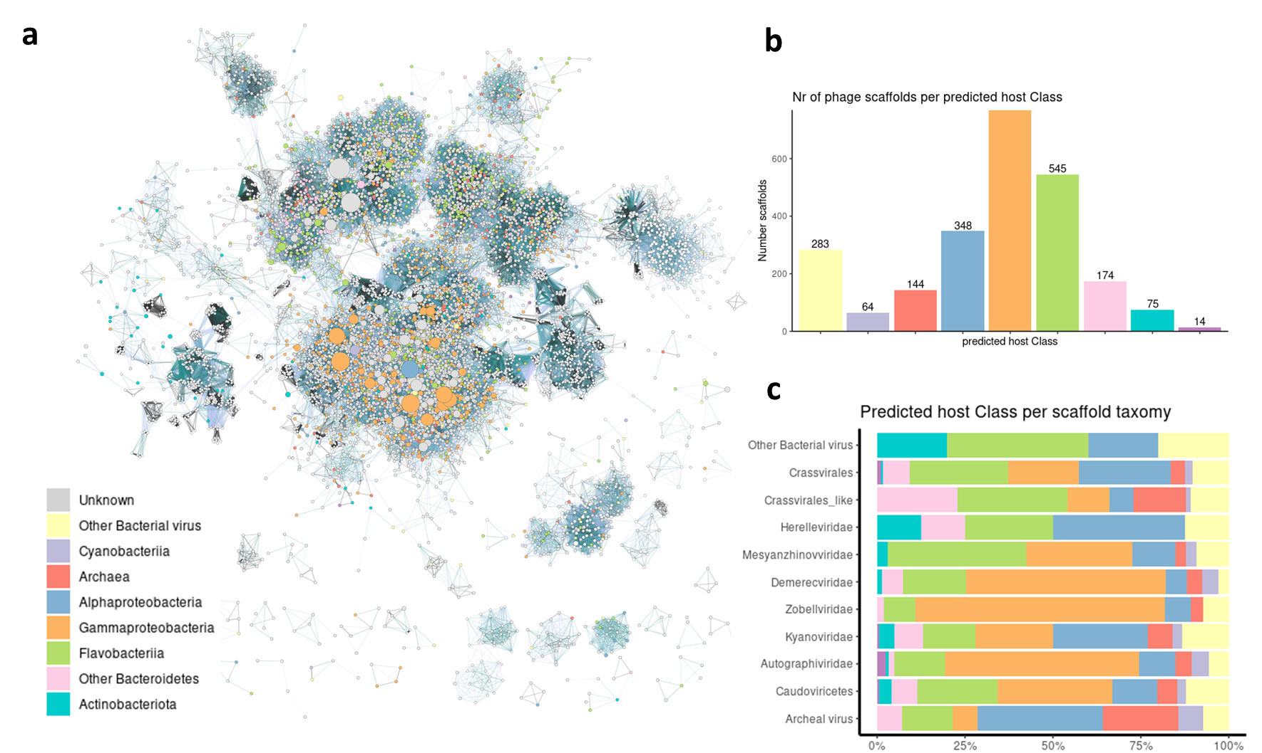
Supplementary Figure 4 – vContact2 virus gene sharing network coloured by predicted host taxa (a). Predicted host prediction per virus taxon (b) and virus taxa per host prediction (c).
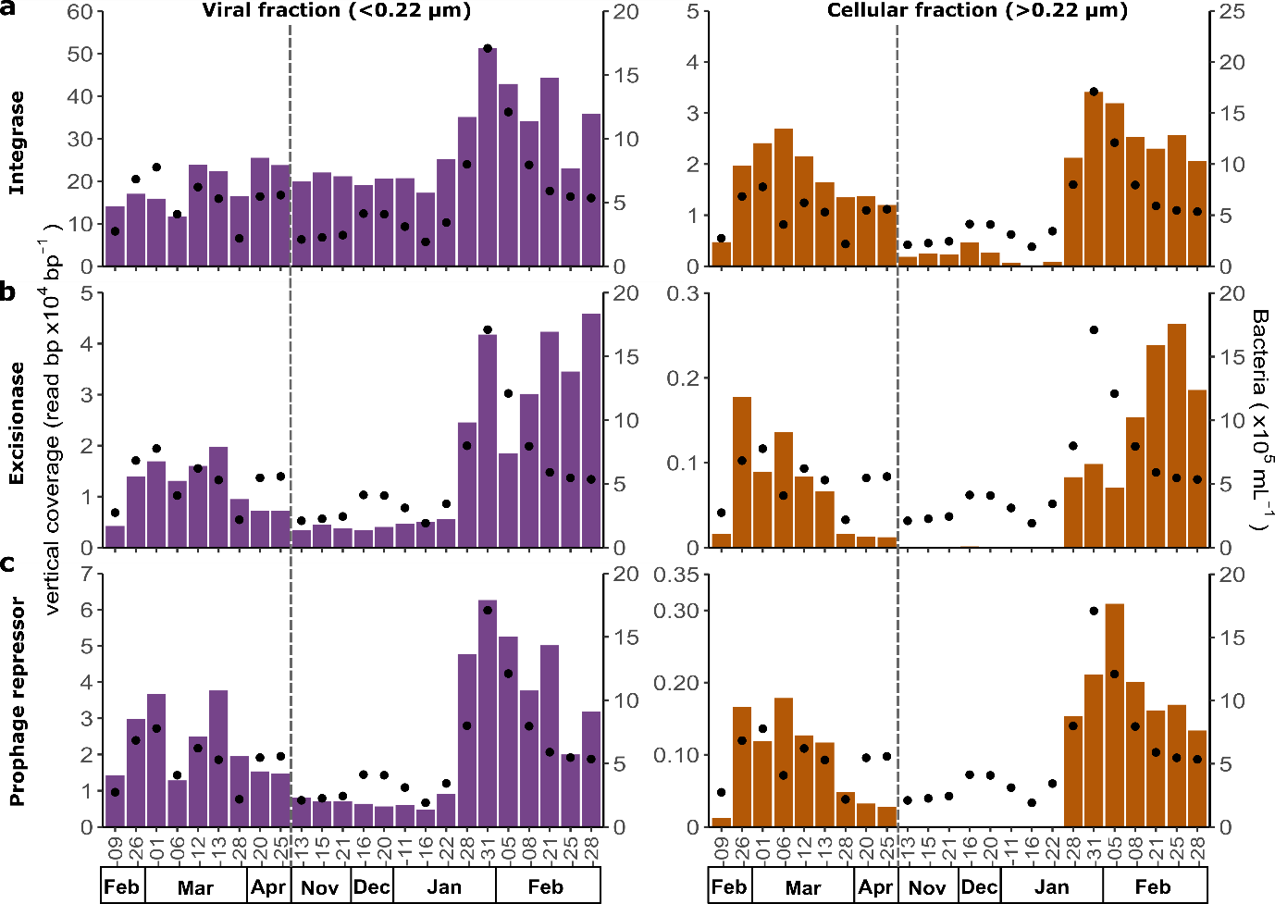
Supplementary Figure 5 – Seasonal dynamics of viral scaffolds containing markers of lysogeny. a-c, abundance of viral scaffolds containing integrase, excisionase, and prophage repressor expressed in vertical coverage (read abundance normalised by scaffold length) for the viral (<0.22 µm) and cellular (>0.22 µm) fractions. Black dots represent bacterial cell abundances determined by flow cytometry, and the grey line indicates the winter sampling gap between April and November 2018.

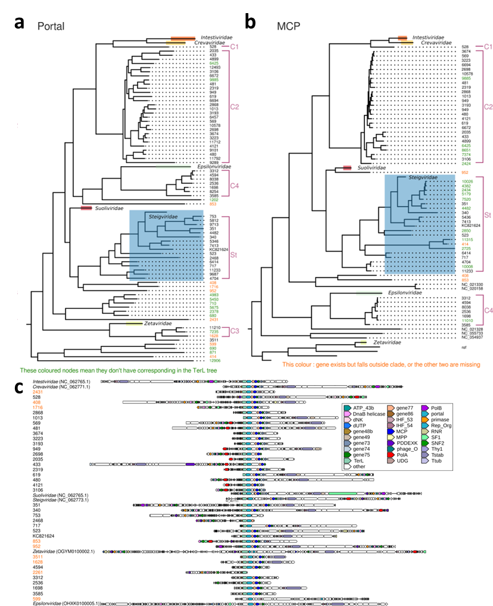
Supplementary Figure 6 – We show here the phylogenetic trees of the signature proteins from the Crassvirales, i.e., (a) the portal protein (Portal), and (b) major capsid protein (MCP). Reference sequences from the five existing families have been collapsed, with the exception of the Steigviridae that is interspersed with sequences from the Antarctic samples. Multiple clades are delineated (C1-C4, and St). The numbers on the tree leaves correspond to scaffold numbers and are coloured as follows: orange indicates clade classification is not consistent across the three trees, green indicates the sequence is not present on the TerL tree, and black represent consistent clade membership in all three trees. These nodes are considered good Crassvirales candidates. (c) genome for Antarctic crassviruses longer than 20 kb and reference phages for each family.

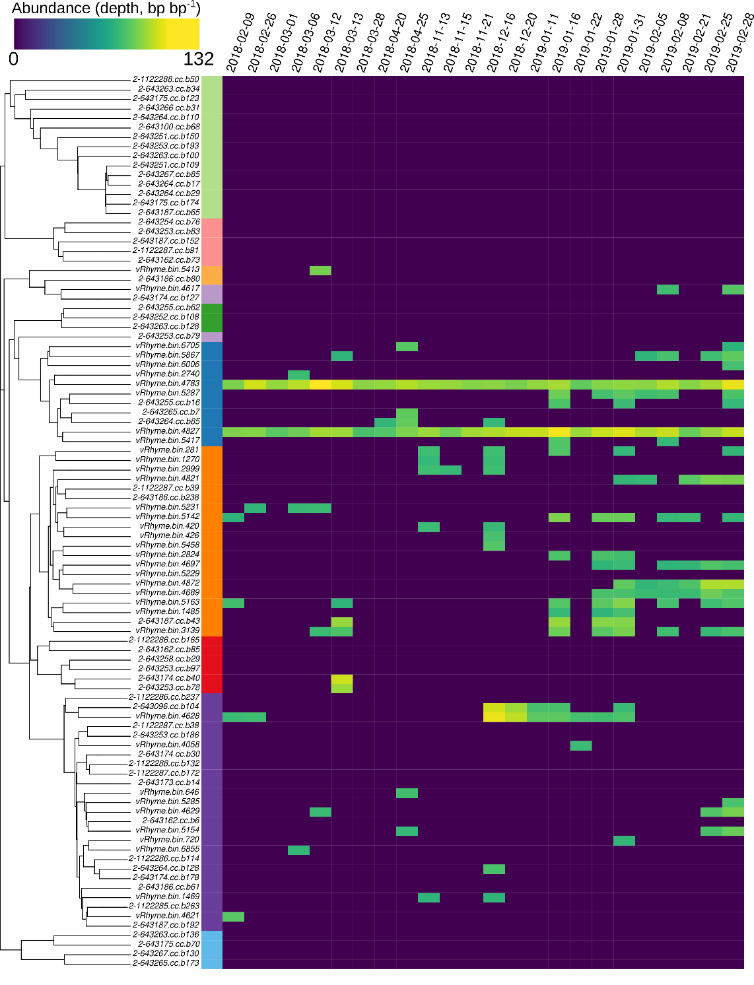
Supplementary Figure 7 – Temporal dynamics of Marguerite Bay Nucleocytoviricota viruses (NCLDVs). Sequencing depth abundance (read abundance normalised by bin length, log-scaled) for the viral fraction metagenomes (<0.22um). The heatmap is organized phylogenetically (midpoint rooted) and the first column represents the NCLDV family (see Fig. 6 panel A).

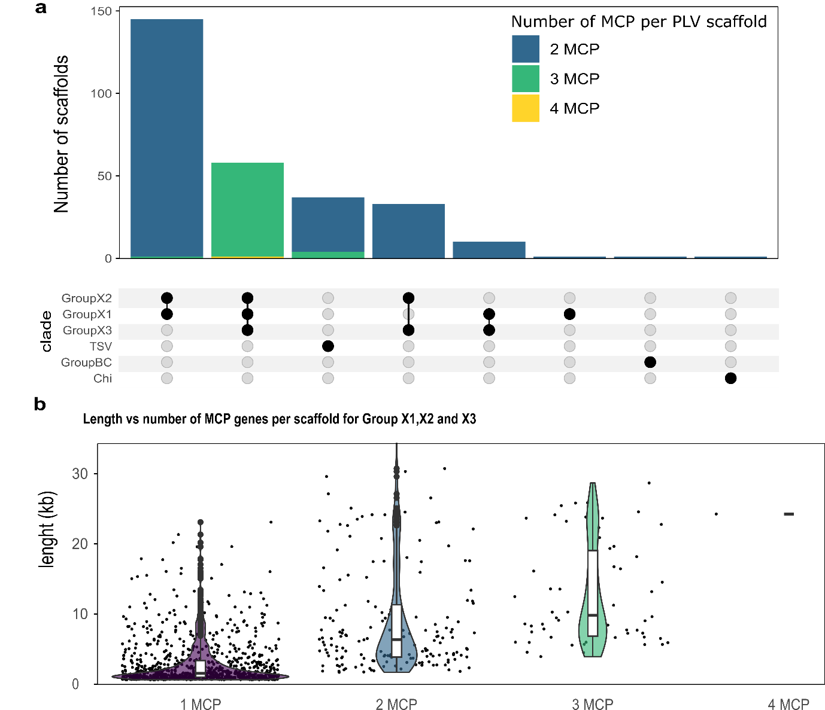
Supplementary Figure 8 – Polinton-like virus MCP duplication. (a) Upset plot showing the occurrence of PLVs with multiple MCP across phylogenetic clades. (b) Violin plot showing the number of MCP genes versus scaffold length for PLVs in groups X1,X2 and X3.

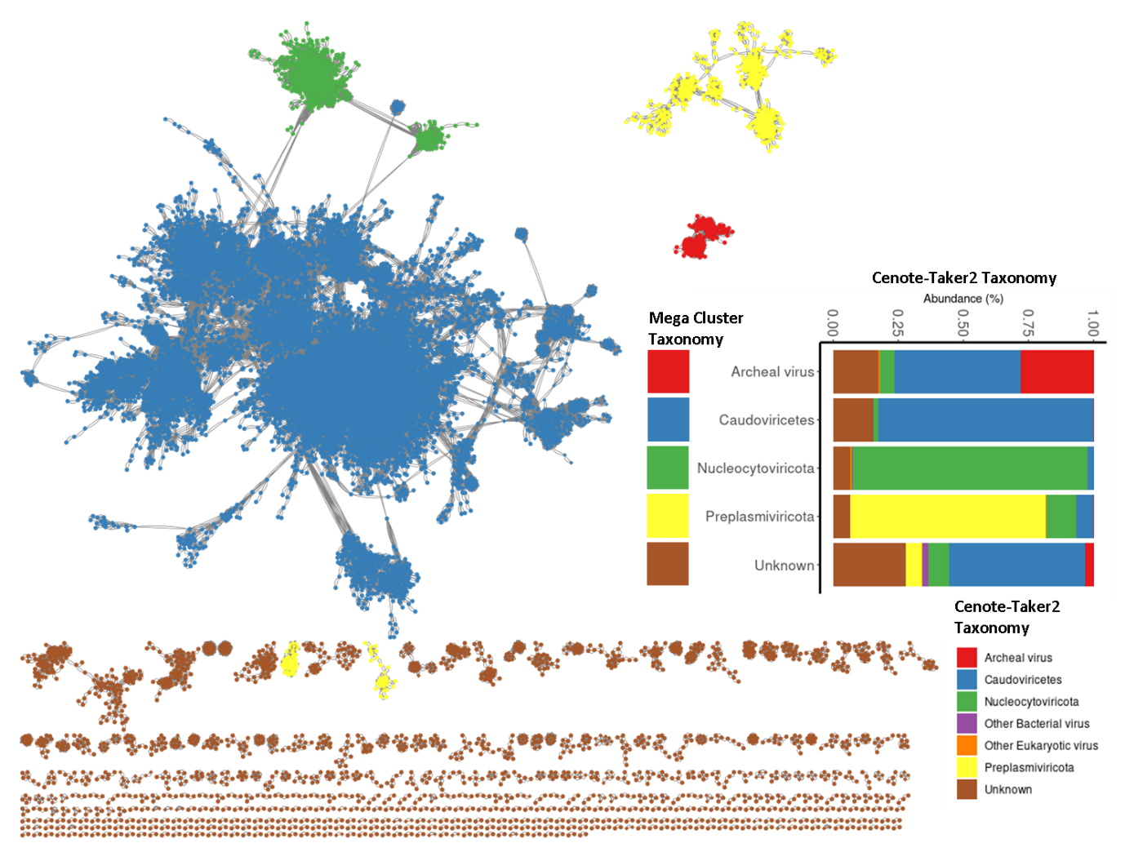
Supplementary Figure 9 – v-Contact2 gene sharing network of viral scaffolds longer than 5kb or 70% complete according to check-V coloured by mega cluster (left). The frequency of cenote-taker2 annotated taxa occurrence within each viral mega cluster (right).

