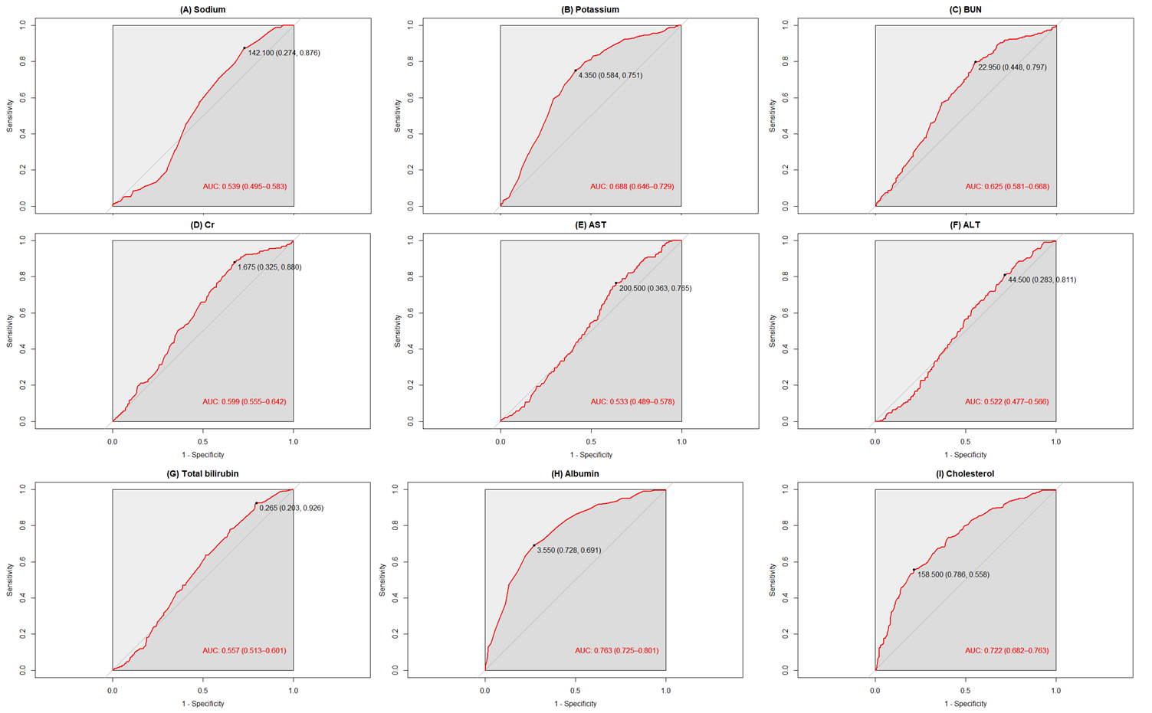
Supplementary Fig. S1. The cutoff values for each biomarker index and the corresponding area under the curves. Cr: creatinine, AST: aspartate aminotransferase, ALT: alkaline phosphatase.

