Supplementary Figures

Figure S1. Hyperspectral signatures of uninoculated and inoculated tomato plants at the beginning (A), early (B), mid (C), and late (D) stages during BLS disease progress. Plots were generated with all data sets used in leaf-level full spectra analysis.

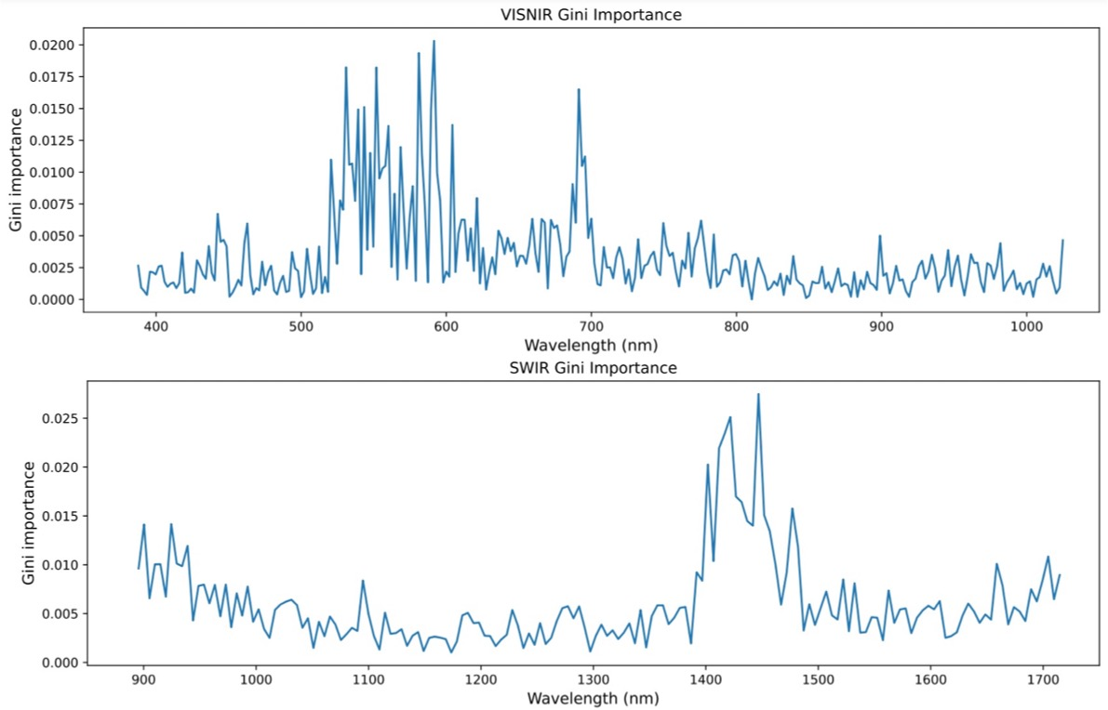

Figure S2. Important wavelength bands identified from 7dai pixel-level full spectra data analysis, based on the gini importance values generated from RF (the best) models.

Figure S3. Prediction of pixel health status on 7dai whole-plant HSI images with the best models trained with 7dai pixel-level full spectra data. A&C: VISNIR RF model. B&D: SWIR SVM model. A-B: uninoculated tomato plants with a few abiotic spots. C-D: BLS-diseased plants showing leaf symptoms.

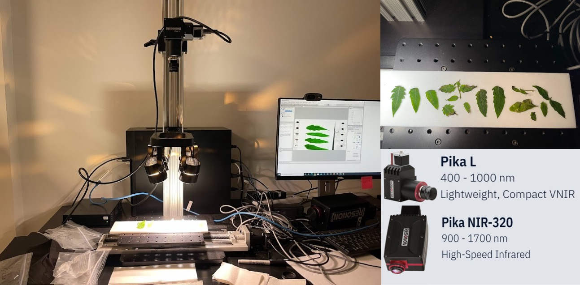

Figure S4. The benchtop hyperspectral imaging system used in this study (the camera pictures and information in the right corner were extracted from www.resonon.com).

Figure S5. Hyperparameters were tuned for different classifiers used in this study, including Linear Discriminant Analysis (LDA), Supportive Vector Machines (SVMs), K-nearest neighbors (KNN), Random Forest (RF), Gradient Boosting Machines (GBM), Extreme Gradient Boosting (XGB/XGBoost), and Multilayer Perceptron (MLP).

Supplementary Table

Table S1. The performance (testing accuracy and weighted F1 scores) of classification models trained with leaf-level full spectra data representing the beginning, early, mid, and late stages during bacterial leaf spot disease progress.
Stage | Range | Accuracy* | F1  (weighted) | Best models
Beginning | VISNIR | 0.16±0.16 | 0.20±0.19 | RF: 0.38; LDA, GB & XGB: 0.25
Beginning | SWIR | 0.18±0.21 | 0.17±0.23 | LDA: 0.63, SVM: 0.25; RF, GB&XGB: 0.13
Early | VISNIR | 0.21±0.21 | 0.24±0.20 | LDA: 0.55, GB: 0.45, RF:0.18
Early | SWIR | 0.30±0.24 | 0.31±0.31 | LDA & SVM: 0.64, RF & KNN: 0.27
Mid | VISNIR | 0.52±0.17 | 0.51±0.23 | RF, GB &XGB: 0.67; MLP:0.56
Mid | SWIR | 0.41±0.16 | 0.37±0.23 | LDA: 0.7; SVM: 0.5, RF, GB & XGB: 0.4
Late | VISNIR | 0.58±0.13 | 0.58±0.20 | LDA: 0.74; KNN:0.69; RF, GB, XGB & SVM: 0.58
Late | SWIR | 0.41±0.11 | 0.41±0.11 | LDA: 0.63; SVM&XGB: 0.42, KNN&MLP:0.37
*Accuracy values generated from seven classification models including LDA, SVM, KNN, RF, GB, XGB, and MLP.
There are four categories in the “beginning” dataset: 1) uninoculated before inoculation, 2) inoculated before inoculation, 3) uninoculated after inoculation, and 4) inoculated after inoculation. When performed a three-class before inoculation (data selected from 1 & 2)/uninoculated plants after inoculation (3)/ inoculated plants after inoculation (4) classification, the VISNIR testing accuracy was 0.21±0.06 and the F1 score was 0.23±0.14, and the SWIR testing accuracy was 0.23±0.18 and the F1 score was 0.19±0.23. When performed a binary uninoculated (data selected from 1, 2 & 3)/inoculated plants (4) classification, the VISNIR testing accuracy was 0.61±0.05 and the F1 score was 0.47±0.02, and the SWIR testing accuracy was 0.57±0.10 and the F1 score was 0.45±0.05.

Table S2. Top 20 important wavelength bands identified from leaf-level full spectra analysis
VISNIR |  |  |  |  | SWIR
0dai | early | mid | late | 0dai |  | early | mid | late
753.86 | 740.86 | 764.71 | 638.02 | 1396.8 |  | 1714.71 | 1060.77 | 1416.79
738.7 | 963.8 | 762.54 | 631.66 | 1376.83 |  | 977.91 | 1046.11 | 1302.16
1022.63 | 426.12 | 825.9 | 606.29 | 1002.23 |  | 1709.61 | 1070.54 | 1371.84
948.07 | 393.7 | 836.9 | 621.07 | 1704.52 |  | 1597.91 | 929.39 | 1406.79
997.67 | 405.83 | 753.86 | 618.96 | 1532.27 |  | 1282.31 | 939.08 | 1633.37
760.37 | 706.36 | 769.06 | 610.51 | 1075.43 |  | 924.54 | 900.35 | 1421.8
745.19 | 712.81 | 717.12 | 510.21 | 1312.1 |  | 948.78 | 1080.33 | 1366.85
655.02 | 730.06 | 771.24 | 642.26 | 1714.71 |  | 1461.88 | 934.23 | 1381.82
747.36 | 638.02 | 810.54 | 604.18 | 939.08 |  | 1648.59 | 1095.02 | 1451.85
771.24 | 473.11 | 712.81 | 608.4 | 905.19 |  | 1658.74 | 1065.65 | 895.52
689.19 | 745.19 | 497.81 | 599.97 | 973.05 |  | 1401.79 | 905.19 | 900.35
1013.54 | 727.9 | 910.02 | 616.85 | 1537.31 |  | 1633.37 | 1050.99 | 905.19
497.81 | 874.45 | 747.36 | 640.14 | 1208.1 |  | 1684.16 | 910.02 | 910.02
442.41 | 841.3 | 714.96 | 589.45 | 1426.8 |  | 895.52 | 895.52 | 914.86
762.54 | 999.93 | 861.17 | 612.62 | 1592.85 |  | 1628.3 | 1193.31 | 919.7
403.81 | 699.92 | 775.59 | 623.19 | 895.52 |  | 1411.79 | 943.93 | 924.54
732.22 | 555.93 | 847.91 | 504.01 | 900.35 |  | 1396.8 | 1055.88 | 929.39
954.8 | 395.72 | 921.19 | 514.35 | 910.02 |  | 1542.35 | 1041.23 | 934.23
830.29 | 606.29 | 695.62 | 597.86 | 914.86 |  | 1188.38 | 1222.92 | 939.08
981.8 | 387.65 | 758.2 | 489.57 | 919.7 |  | 1592.85 | 914.86 | 943.93

Table S3. The performance (testing accuracy and weighted F1 scores) of classification models trained with leaf-level VI data representing the beginning, early, mid, and late stages during bacterial leaf spot disease progress.
 | Beginning | Early | Mid | Late
LDA | 1.00/1.00 | 1.00/1.00 | 1.00/1.00 | 1.00/1.00
SVM | 1.00/1.00 | 1.00/1.00 | 1.00/1.00 | 1.00/1.00
KNN | 1.00/1.00 | 1.00/1.00 | 1.00/1.00 | 1.00/1.00
RF | 1.00/1.00 | 1.00/1.00 | 1.00/1.00 | 1.00/1.00
GB | 1.00/1.00 | 1.00/1.00 | 1.00/1.00 | 1.00/1.00
XGB | 1.00/1.00 | 1.00/1.00 | 1.00/1.00 | 1.00/1.00
MLP | 0.88/0.88 | 1.00/1.00 | 0.67/0.67 | 0.74/0.74

Table S4. Vegetation Indices Tested in This Study.
Vegetation index | Description | Formula | Reference
NDVI | Normalized Difference Vegetation Index, measuring the strong reflectance at 800 nm (red edge/far-red) and absorption at 670 nm (chlorophyll well) typically observed from plants. | (R₆₇₀-R₈₀₀)/(R₆₇₀+R₈₀₀) | ⁵³
NDVI705 | Red-Edge Normalized Difference Vegetation Index. A modified NDVI focusing more on the influence of chlorophyll content. | (R₇₅₀-R₇₀₅)/(R₇₅₀+R₇₀₅) | ⁵⁴
mNDVI705 | Modified Red-Edge Normalized Difference Vegetation Index. | (R₇₅₀-R₇₀₅)/[(R₇₅₀+R₇₀₅)-2 x R₄₄₅] | ³¹
PRI | Photochemical Reflectance Index, related to photosynthetic efficiency. | (R₅₃₁- R₅₇₀)/(R₅₃₁+ R₅₇₀) | ⁵⁵
SIPI | Structure-Insensitive Pigment Index, an indicator of light use efficiency, measuring the ratio of bulk carotenoids to chlorophyll while decreasing sensitivity to canopy structure variation | (R₈₀₀-R₄₄₅)/(R₈₀₀-R₆₈₀) | ⁵⁶
PSRI | Plant Senescence Reflectance Index, measuring the carotenoids to chlorophyll ratio, which is related to leaf senescence and fruit ripening. | (R₆₇₈-R₅₀₀)/R₇₅₀ | ⁵⁷
PSSR | (photosynthetic) Pigment Specific Simple Ratio carotenoids, measuring carotenoids | R₈₀₀ /R₅₀₀ | ⁵⁸
WI | Water Index, an indicator of canopy water content | R₉₀₀/R₉₇₀ | ⁵⁹
LLSI | Light Leaf Spot Index, detecting leaf tissues with LLS | [(R₇₂₀-R₅₃₀)/(R₇₂₀+R₅₃₀)-R₈₃₀] | ³⁰
CTR1 | Carter Index 1 an early plant stress indicator | R₇₀₀/R₄₂₀ | ³⁰
CTR2 | Carter Index 2, an early plant stress indicator | R₆₉₅/R₇₆₀ | ⁶⁰
BRI2 | Blue Red Pigment Index 2, measuring the carotenoids to chlorophyll ratio | R₄₅₀/R₇₆₀ | ⁶¹
NDWI-Hyperion | Normalized Difference Water Index-hyperion, an indicator of canopy water content | (R₁₀₇₀ – R₁₂₀₀)/(R₁₀₇₀ + R₁₂₀₀) | ⁶²
MSI | Moisture Stress Index, an indicator of canopy water content | R₁₅₉₉ / R₈₁₉ | ⁵⁶

Table S5. Correlations between the model performance trained with leaf-level full spectra data and bacterial population in leaf tissues across four stages during BLS disease progress.
 | Accuracy_VISNIR | Accuracy_SWIR | Bacterial population
Accuracy_VISNIR | 1.00 (P=0) | 0.93 (P=0.07) | 0.96 (P=0.04)
Accuracy_SWIR | 0.93 (P=0.07) | 1.00 (P=0) | 0.99 (P=0.01)
Bacterial population | 0.96 (P=0.04) | 0.99 (P=0.01) | 1.00 (P=0)
*Statistical results were generated with scipy.stats ⁶³.

