Supplementary Figures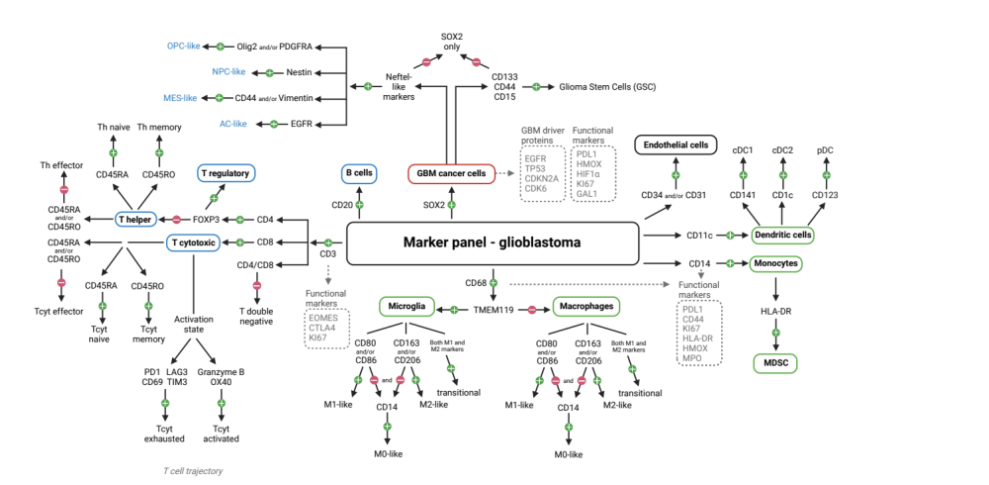
Supplementary Figure 1. Schematic panel for cell type assignment strategy
Using Bone marrow-derived macrophages and tissue resident microglia were separated based on TMEM119 (positive in microglia) expression and further subdivided into a continuum of activation states with a proinflammatory M1-like (CD80+ &/or CD86+) and a protumoral M2-like (CD163+ &/or CD206+) as both extremes. M0 resting state macrophages were also identified (CD80-, CD86-, CD206-, CD163-, CD14+). DC were subdivided into cDC1 (CD141+) and cDC2 (CD1c+). For cytotoxic T cells, in addition to the ontogeny-based division into Tcyt effector (CD45RA-, CD45RO-), Tcyt naive (CD45RA+), and Tcyt memory (CD45RO+) cells, a division was made according to a Tcyt-cell activation status using Tcyt activation (GrzB, OX40) and exhaustion markers (PD1, LAG3, CD69, TIM3). Tcyt are characteristically more exhausted in GBM, but activated Tcyt does also occur and contribute to antitumor activity. Tumor cells (SOX2+) were divided into 4 subgroups based on Neftel-like classification. GSC (strong CD133+; or weak CD133+ and either CD44+ or CD15+) were distinguished from the other tumor cells. Created with BioRender.com.
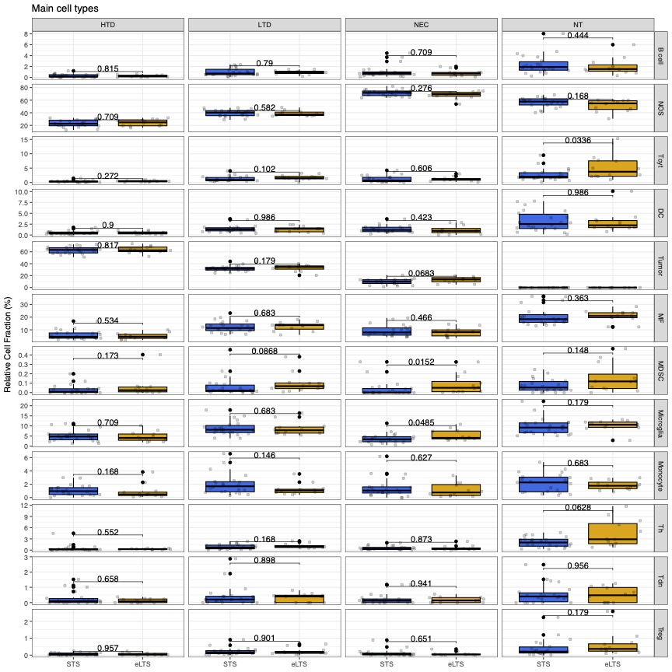

Supplementary Figure 2. Comparison of main cell types in GBM survival groups using mIHC
Comparison of relative occurrence of main cell types to all cells in GBM patients based on survival group by density region (eLTS n = 12 STS n = 22). Data as mean +- s.e.m.. Conditional logistic regression.

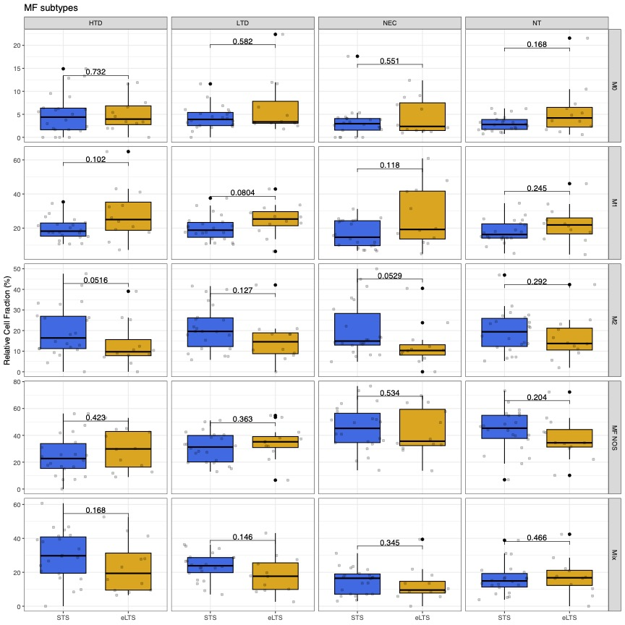

Supplementary Figure 3. Comparison of macrophage subtypes in GBM survival groups using mIHC
Comparison of relative occurrence of macrophage subtypes to all macrophages in GBM patients based on survival group by density region (eLTS n = 12 STS n = 22). Data as mean +- s.e.m.. Conditional logistic regression.

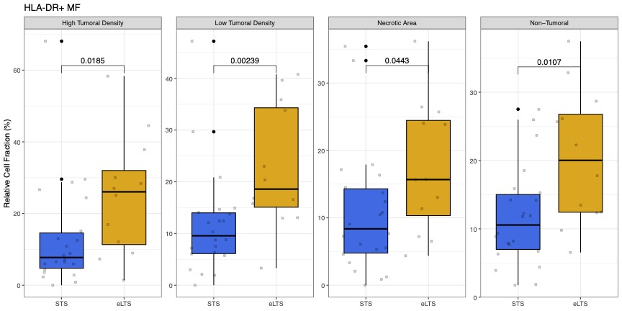

Supplementary Figure 4. Comparison of HLA-DR+ macrophages in GBM survival groups using mIHC
Comparison of relative occurrence of HLA-DR+ macrophages to all macrophages in GBM patients based on survival group by density region (eLTS n = 12 STS n = 22). Data as mean +- s.e.m.. Conditional logistic regression. Mean fluorescence intensity (MFI) values were normalized per core using z-scoring. Rescaling z-scores between -5 and +5. We set the cutoff in Z> 1 as HLA-DR positive.

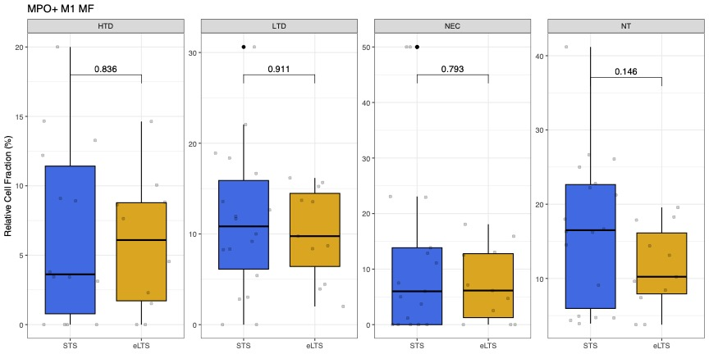

Supplementary Figure 5. Comparison of MPO+ M1 macrophages in GBM survival groups using mIHC
Comparison of relative occurrence of MPO+ M1 macrophages to all M1 macrophages in GBM patients based on survival group by density region (eLTS n = 12 STS n = 22). Data as mean +- s.e.m.. Conditional logistic regression. Mean fluorescence intensity (MFI) values were normalized per core using z-scoring. Rescaling z-scores between -5 and +5. We set the cutoff in Z > 1 as MPO positive.
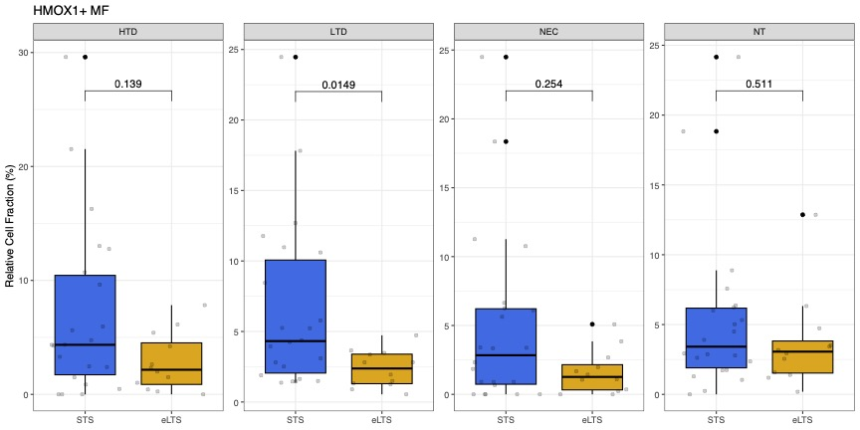

Supplementary Figure 6. Comparison of HMOX+ macrophages in GBM survival groups using mIHC
Comparison of relative occurrence of HMOX+ macrophages to all macrophages in GBM patients based on survival group by density region (eLTS n = 12 STS n = 22). Data as mean +- s.e.m.. Conditional logistic regression. Mean fluorescence intensity (MFI) values were normalized per core using z-scoring. Rescaling z-scores between -5 and +5. We set the cutoff in Z > 1 as HMOX positive.

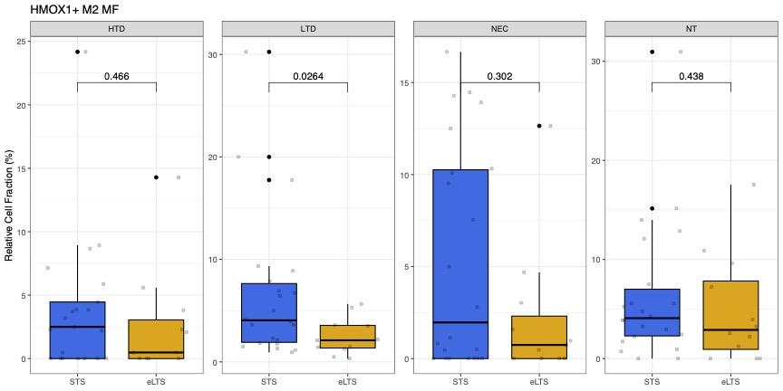

Supplementary Figure 7. Comparison of HMOX+ M2 macrophages in GBM survival groups using mIHC
Comparison of relative occurrence of HMOX+ M2 macrophages to all macrophages in GBM patients based on survival group by density region (eLTS n = 12 STS n = 22). Data as mean +- s.e.m.. Conditional logistic regression. Mean fluorescence intensity (MFI) values were normalized per core using z-scoring. Rescaling z-scores between -5 and +5. We set the cutoff in Z > 1 as HMOX+ positive.
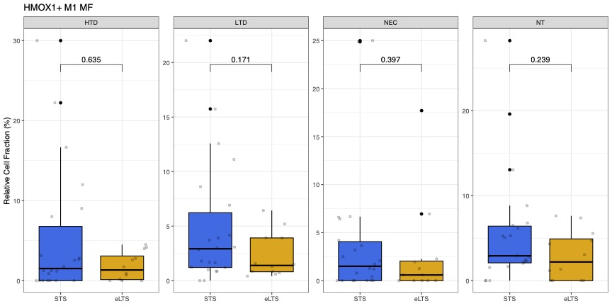

Supplementary Figure 8. Comparison of HMOX+ M1 macrophages in GBM survival groups using mIHC
Comparison of relative occurrence of HMOX+ M1 macrophages to all macrophages in GBM patients based on survival group by density region (eLTS n = 12 STS n = 22). Data as mean +- s.e.m.. Conditional logistic regression. Mean fluorescence intensity (MFI) values were normalized per core using z-scoring. Rescaling z-scores between -5 and +5. We set the cutoff in Z > 1 as HMOX+ positive.

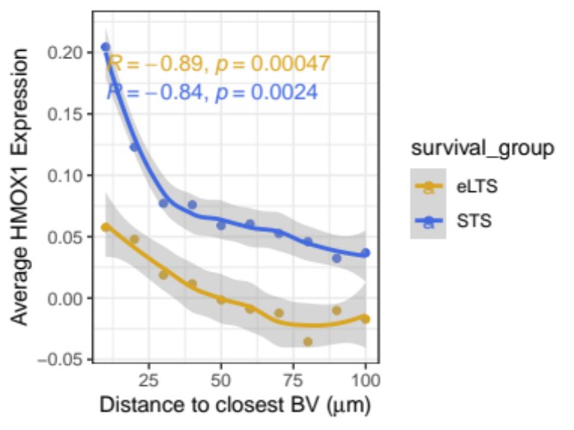

Supplementary Figure 9. HMOX+ M2 macrophages in relation to the nearest blood vessel in GBM survival groups using mIHC
The relative percentage of HMOX1+ M2 macrophages to all cells of all GBM samples (n=34) located at a given distance (in µm) from the nearest blood vessel (x-axis = 0). Values are shown by survival group (eLTS=gold and STS=blue). Data as mean+- s.e.m..

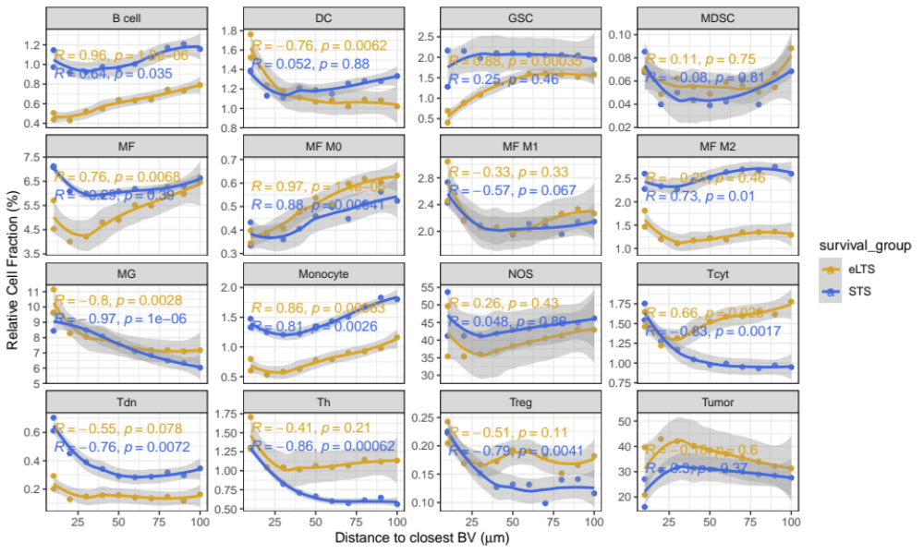
Supplementary Figure 10. Main cell types in relation to the nearest blood vessel in GBM survival groups using mIHC
The relative percentage of main cell types to all cells of all GBM samples (n=34) located at a given distance (in µm) from the nearest blood vessel (x-axis = 0). Values are shown by survival group (eLTS=gold and STS=blue). Data as mean+- s.e.m..

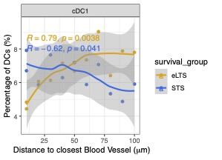

Supplementary Figure 11. cDC1 in relation to the nearest blood vessel in GBM survival groups using mIHC
The relative percentage of cDC1 to all DCs of all GBM samples (n=34) located at a given distance (in µm) from the nearest blood vessel (x-axis = 0). Values are shown by survival group (eLTS=gold and STS=blue). Data as mean+- s.e.m..

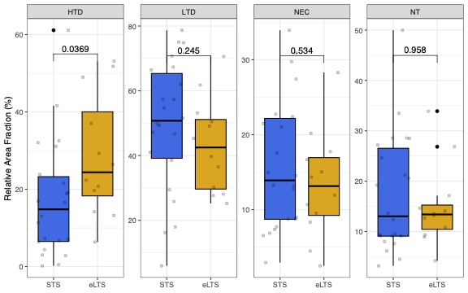Supplementary Figure 12. Comparison of tumoral density regions in GBM survival groups using mIHC
Comparison of relative occurrence of a particular tumoral density region compared to all tumoral density regions in GBM patients based on survival group by density region (eLTS n = 12 STS n = 22). Data as mean +- s.e.m.. Conditional logistic regression.

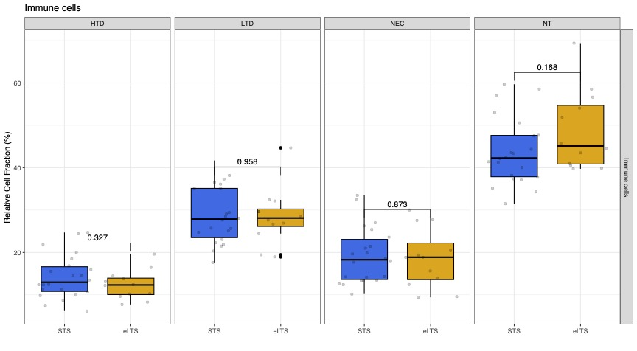

Supplementary Figure 13. Comparison of immune cells in GBM survival groups using mIHC
Comparison of relative occurrence of immune cells compared to all cells in GBM patients based on survival group by density region (eLTS n = 12 STS n = 22). Data as mean +- s.e.m.. Conditional logistic regression.

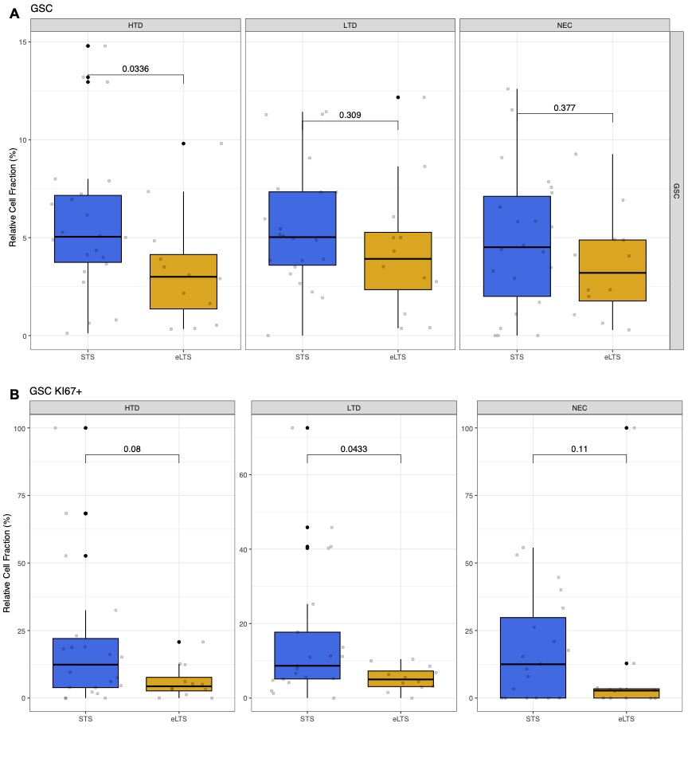

Supplementary Figure 14. Comparison of GSC (KI67+) in GBM survival groups using mIHC
A. Comparison of relative occurrence of GSC to all tumor cells in GBM patients based on survival group by density region (eLTS n = 12 STS n = 22).
B. Comparison of relative occurrence of GSC KI67+ to all GSC in GBM patients based on survival group by density region (eLTS n = 12 STS n = 22). Mean fluorescence intensity (MFI) values were normalized per core using z-scoring. Rescaling z-scores between -5 and +5. We set the cutoff in Z > 1 as KI67+ positive.
Data as mean +- s.e.m.. Conditional logistic regression.

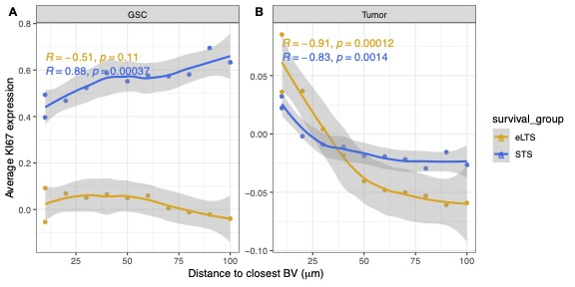

Supplementary Figure 15. KI67+ GSC and KI67+ non- GSC tumor cells in relation to the nearest blood vessel in GBM survival groups using mIHC
The relative percentage of KI67+ GSC to all GSC (A) and KI67+ non-GSC tumor cells to all non-GSC tumor cell (B) of all GBM samples (n=34) located at a given distance (in µm) from the nearest blood vessel. Values are shown by survival group (eLTS=gold and STS=blue). Data as mean+- s.e.m..
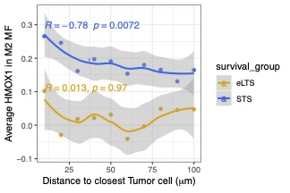
Supplementary Figure 16. HMOX1+ M2 macrophages in relation to the nearest tumoral cell in GBM survival groups using mIHC
The relative percentage of HMOX1+ M2 macrophages to all M2 macrophages of all GBM samples (n=34) located at a given distance (in µm) from the nearest tumor cell (x-axis = 0). Values are shown by survival group (eLTS=gold and STS=blue). Data as mean+- s.e.m..

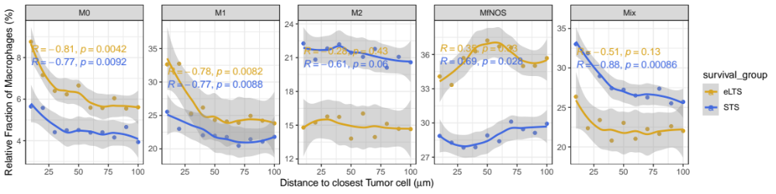

Supplementary Figure 17. Macrophage subtypes in relation to the nearest tumoral cell in GBM survival groups using mIHC
The relative percentage of macrophage subtypes to all macrophages of all GBM samples (n=34) located at a given distance (in µm) from the nearest tumor cell (x-axis = 0). Values are shown by survival group (eLTS=gold and STS=blue). Data as mean+- s.e.m..

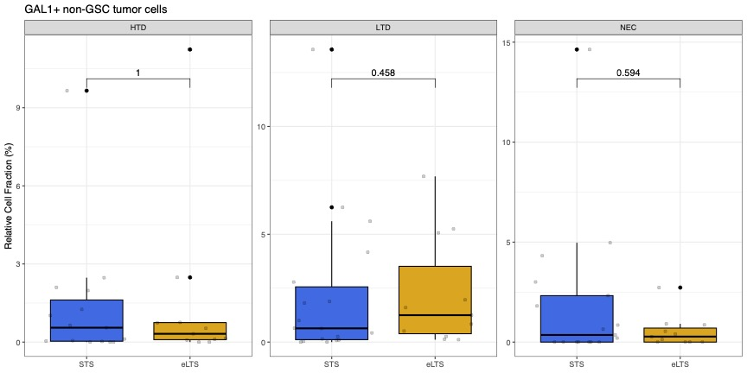

Supplementary Figure 18. Comparison of LGALS1+ non-GSC tumoral cells in GBM survival groups using mIHC
Comparison of relative occurrence of LGALS1+ non-GSC tumoral cells to all non-GSC tumoral cells in GBM patients based on survival group by density region (eLTS n = 12 STS n = 22). Data as mean +- s.e.m.. Conditional logistic regression. Mean fluorescence intensity (MFI) values were normalized per core using z-scoring. Rescaling z-scores between -5 and +5. We set the cutoff in Z > 1 as MPO positive.

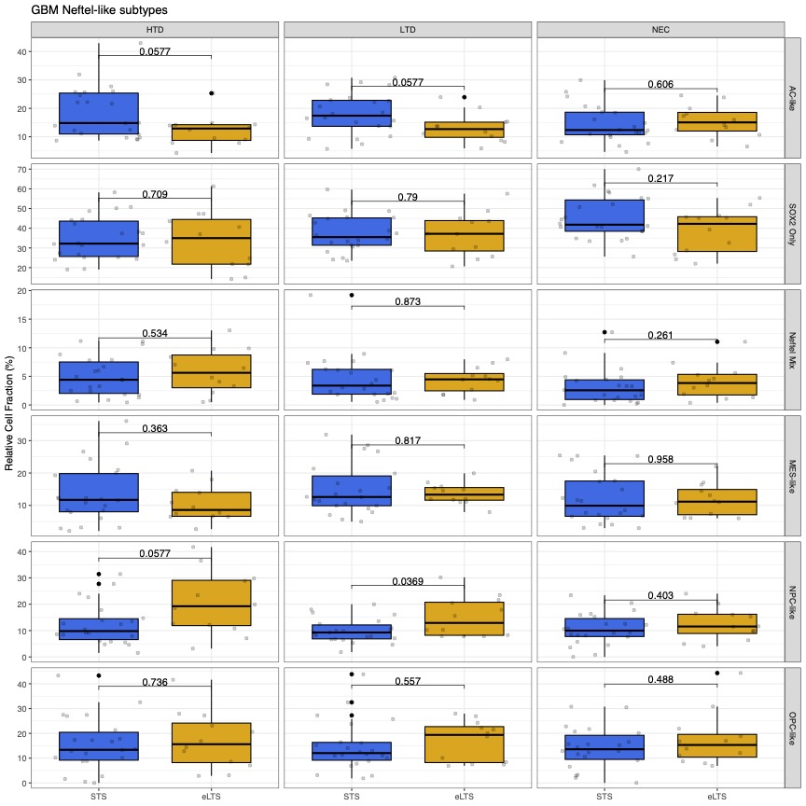

Supplementary Figure 19. Comparison of Neftel-like subtypes in GBM survival groups using mIHC
Comparison of relative occurrence of Neftel-like subtypes to all tumoral cells in GBM patients based on survival group by density region (eLTS n = 12 STS n = 22). Data as mean +- s.e.m.. Conditional logistic regression.

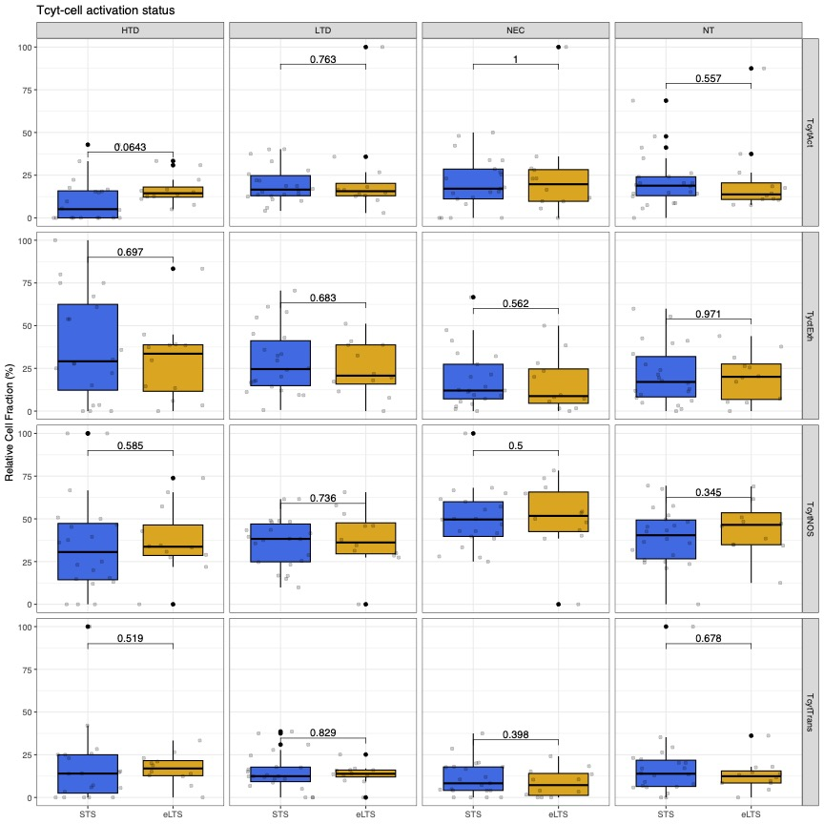

Supplementary Figure 20. Comparison of Tcyt cell activation subtypes in GBM survival groups using mIHC
Comparison of relative occurrence of Tcyt activition subtypes to all Tcyt cells in GBM patients based on survival group by density region (eLTS n = 12 STS n = 22). Data as mean +- s.e.m.. Conditional logistic regression.

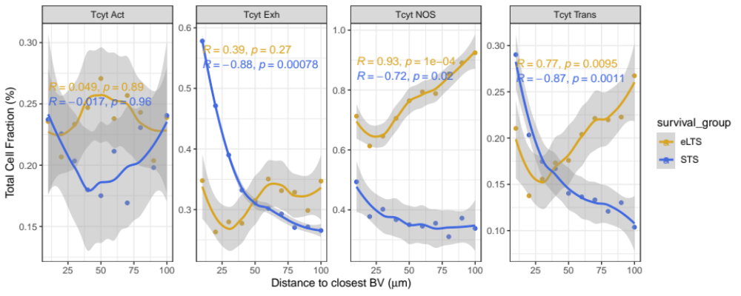

Supplementary Figure 21. Tcyt activation subtypes in relation to the nearest blood vessel in GBM survival groups using mIHC
The relative percentage of Tcyt activation subtypes to all cells of all GBM samples (n=34) located at a given distance (in µm) from the nearest blood vessel (x-axis = 0). Values are shown by survival group (eLTS=gold and STS=blue). Data as mean+- s.e.m..

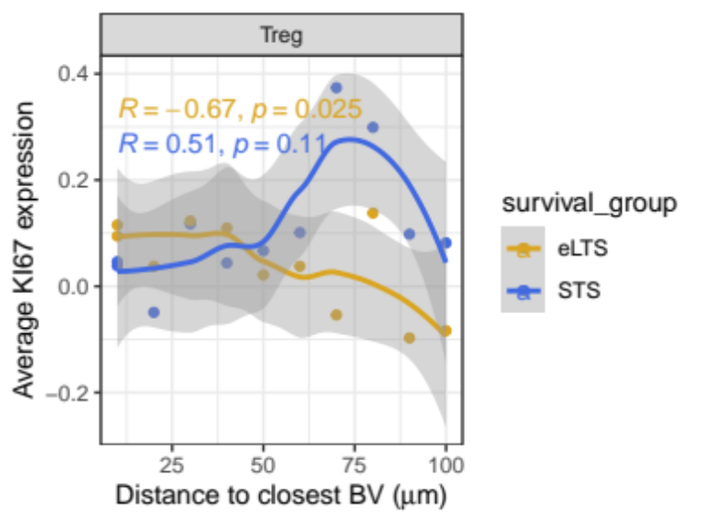

Supplementary Figure 22. Comparison of Treg KI67+ in GBM survival groups using mIHC
Values of Treg KI67+ marker intensity in GBM patients based on survival group by density region (eLTS n = 12 STS n = 22). Mean fluorescence intensity (MFI) values were normalized per core using z-scoring. Rescaling z-scores between -5 and +5.
Data as mean +- s.e.m..

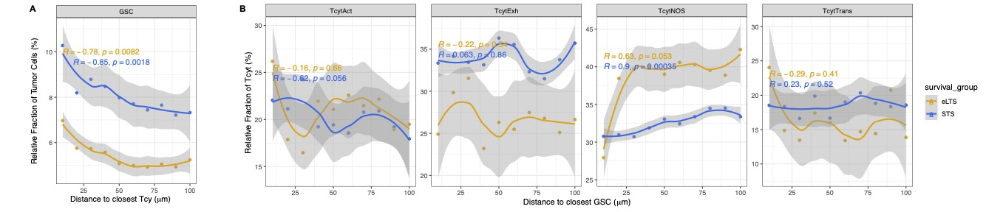

Supplementary Figure 23. Tcyt (activation subtypes) in relation to the nearest GSC in GBM survival groups using mIHC
A. The relative percentage of GSC compared to all tumor cells at a given distance (in µm) from a Tcyt (x-axis = 0) in all GBM samples (n=34).
B. The relative percentage of Tcyt activation subtype compared to all Tcyt at a given distance (in µm) from a GSC (x-axis = 0) in all GBM samples (n=34).
For A. and B. values are shown by survival group (eLTS=gold and STS=blue). Data as mean+- s.e.m..

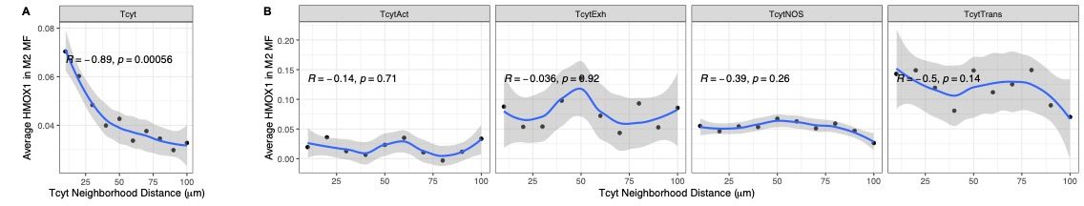

Supplementary Figure 24. Tcyt (activation subtypes) in relation to the nearest HMOX1+ M2 MF in GBM survival groups using mIHC
The relative percentage of HMOX1+M2 macrophages compared to all macrophages at a given distance (in µm) from Tcyt (A) and Tcyt activation subtypes (B) (x-axis = 0) in all GBM samples (n=34). Values are shown for all GBM combined (n = 34). Data as mean+- s.e.m..

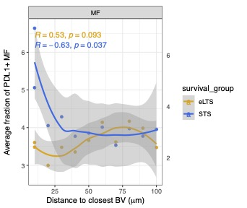

Supplementary Figure 25. PDL1+ macrophages in relation to the nearest blood vessel in GBM survival groups using mIHC
The relative percentage of PDL1+ macrophages to all cells of all GBM samples (n=34) located at a given distance (in µm) from the nearest blood vessel (x-axis = 0). Values are shown by survival group (eLTS=gold and STS=blue). Data as mean+- s.e.m..

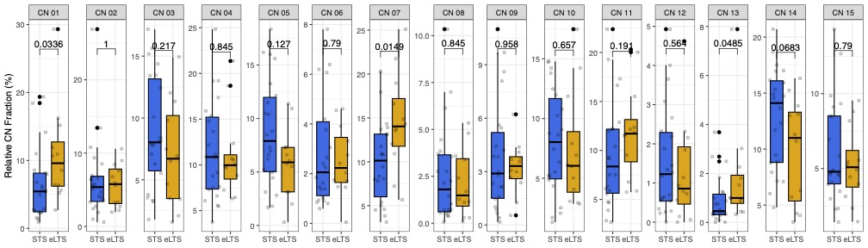

Supplementary Figure 26. Comparison of CNs in GBM survival groups
Comparison of relative occurrence of a particular CN to all CNs in GBM patients based on survival group by density region (eLTS n = 12 STS n = 22). Data as mean +- s.e.m.. Conditional logistic regression.

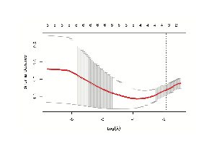

Supplementary Figure 27. Choosing the number of parameters to include in our prediction model
This plots the cross-validation curve (red dotted line) along with upper and lower standard deviation curves along the 𝜆 sequence (error bars). Two special values along the 𝜆 sequence are indicated by the vertical dotted lines. lambda.min (left vertical line) is the value of 𝜆 that gives minimum mean cross-validated error, while lambda.1se (right vertical line) is the value of 𝜆 that gives the most regularized model such that the cross-validated error is within one standard error of the minimum. Both vertical lines indicate 4 parameters.

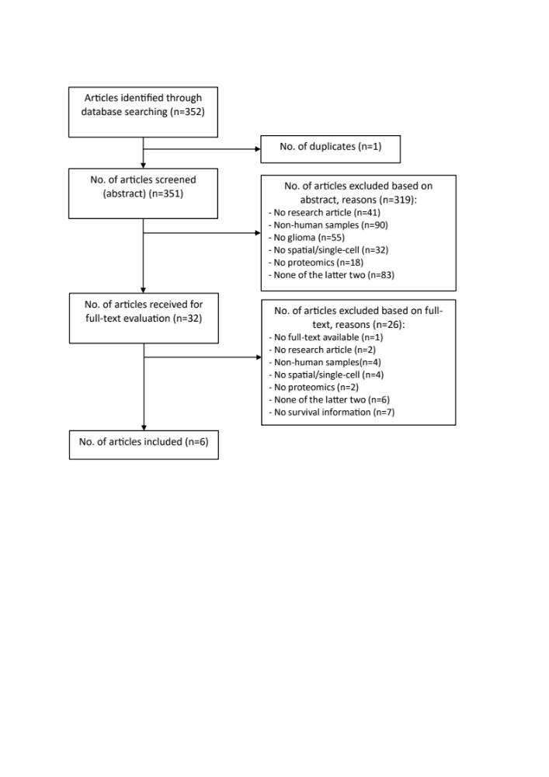

Supplementary Figure 28. Literature search strategy

Supplementary Tables

Matching criteria | Age | Gender | KPS | Treatment | IDH status | EOR | RT dose | Location | Origin GBM | Time period (diagnosis) | MMSE | Seizures | Steroids
Strata | 3 | 2 | 3 | 5 | 2 | 4 | 4 | 5 | 2 | 3 | 3 | 2 | 2
 | <=50 | F | <70 | Stupp c | IDHwt | Total | 60Gy | Unilobar -frontal | 1ary | <2005 | >27 | Yes | Yes
 | 51-60 | M | 70-80 | Stupp ic | IDHmt | Subtotal | <60Gy | Unilobar -non-frontal | 2ndary | 2005-2015 | 24-27 (or minimal cognitive deficit) | No | No
 | >60 |  | >80 | Only Chemo |  | Biopsy | Dose unknown | Multilobar |  | >2015 | <24
 |  |  |  | Only RT |  | No surgery | No RT | Deep structures
 |  |  |  | Other |  |  |  | Posterior Fossa
 |  |  |  |  |  |  |  | Other

Supplementary Table 1. Clinical matching criteria on which the selection of STS GBM controls for each eLTS was done. Strata indicates the number of options within each matching variable within which a patient's clinical value can be categorized. The possible options are shown below each one. All clinical values indicate the patient's immediate preoperative condition. The variable 'treatment diagnosis' refers to the period in which the patient was diagnosed.

Cell type | Number of cells in all GBM tissue scenes (n = 176)
B cell | 21707
Tcyt | 36096
DC | 37675
MDSC | 1471
Monocyte | 32493
Th | 35600
Tdn | 7094
Treg | 4307
GBM (non-GSC + GSC) | 867187
NOS | 1127689

Supplementary Table 2. Number of cells (main cell types) in all GBM (n = 34) based on mIHC.

 | Age | Gender | KPS | Teatment | IDH | EOR | RT dose | Location | Recurrence | Time period | MMSE | Seizures | Steroids | MGMT
This study | 3 | 2 | 3 | 5 | 2 | 4 | 4 | 6 | 2 | 3 | 3 | 2 | 2 | X
Shekarian T. et al.[5] | X | X |  |  | 2 |  |  |  |  |  |  |  | X | X
Karimi E. et al.[6] | X | X |  | 2 | 2 | 2 |  |  | 2 |  |  |  |  | X
Berens M. et al.[7] | X | X |  |  | 2
Lee A. H. et al.[8] |  |  |  | 2
Yin W. et al.[9] * |  |  |  |  | 2
Wang L. et al. [4] | X | X |  |  | 2?**

Supplementary Table 3. Matching criteria
-Color codes at the top of the table represent the relative importance with respect to survival of the clinical variable. In descending order; dark green, light green, red.
-The number in each cell represents how many categories the variable was divided into when matching. X indicates that the variable was described, but not used for matching.

* Information regarding age at diagnosis, gender, location, IDH mutation, MGMT status, KPS, EOR, and treatment regimens were shown in the supplemental data. However, not for the patient group on which survival was determined.
** It is described that only IDHwt samples are included, although Supplementary Table 1 shows that data from astrocytoma IDHmt samples (later becoming a secondary glioblastoma) were included.

 | Reconfirmation Diagnosis | Definition GBM  (IDHwt/WHO 2021) | Survival/progression cut-off  (absolute/relative) | A priori defined survival / progression cut off? | A priori definition of long survival (expressed in months) | Level of matching (individual, group) | A priori matching?
This study | Yes (Neuropathologist) | IDHwt only | Absolute | A priori | >120m; or >60m after primary recurrence | Individual | A priori
Shekarian T. et al.[5] | Yes (Neuropathologist) | IDHwt only | Relative  (OS in days of best 2 patients vs. other patients) | Post hoc | 58m (alive) and 54m | No Matching (except IDH-status) | N/A
Karimi E. et al.[6] | Yes (Neuropathologist) | IDHwt only | Absolute | A priori | >36m | Group | A priori
Berens M. et al.[7] | No | IDHwt only | Absolute  (Longest treatment naïve >1000d, but in table 1 the maximum is 541) | Post hoc | >83m  (No GBM in this group?) | No Matching (except IDH-status) | N/A
Lee A. H. et al.[8] | No | No  (Conducted before 2021, no IDH status mentioned) | Cellular response, no patient survival | N/A | N/A | No Matching | N/A
Yin W. et al.[9] | Yes (Neuropathologist) | IDHwt  (IDHmt included, but distinction is made) | Relative  (OS in months; via indirect link with non-clinically matched TCGA RNA-bulk data) | Post hoc | None  (No definition of the distinction between long and short survival was given here) | No Matching | N/A
Wang L. et al. [4] | No | IDHwt?  (But e.g., in supp. table 1 also Pt16 - IDHmt described as GBM) | Relative  (2 Kaplan Meier curves) | Post hoc | No clear cut off * | No Matching | N/A

Supplementary Table 4. Survival, matching and diagnostic criteria used.
* Longest 2 surviving patients were initially IDHmt. Survival time was counted from diagnosis of astrocytoma IDHmt, not glioblastoma (found in supplementary table 1)
N/A = Not applicable; NA = Not available; m = months

