Supplementary table
Positions of anal self-examination and preferences
Positions of ASE | Number of participants who preferred this position | Main preferred location
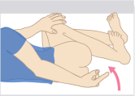 | 11 | Bedroom
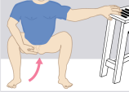 | 7 | Shower/toilet
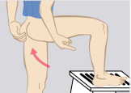 | 7 | Shower/toilet
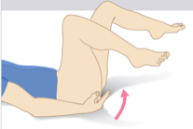 | 2 | Bedroom

NB: Some participants preferred or use multiple positions; therefore, the total would not add up to 20.

