Supporting Information

A novel approach to architecting microchannel in pressure sensor for real-time wearable gait monitoring system
Jungbin Ahn^{a, b, 1}, Byungseok Yoo^{c,1}, Naga Sai Gouthami Bejjankiª, Darryll J. Pines^{c}, and Soaram Kim^{a,b,}*

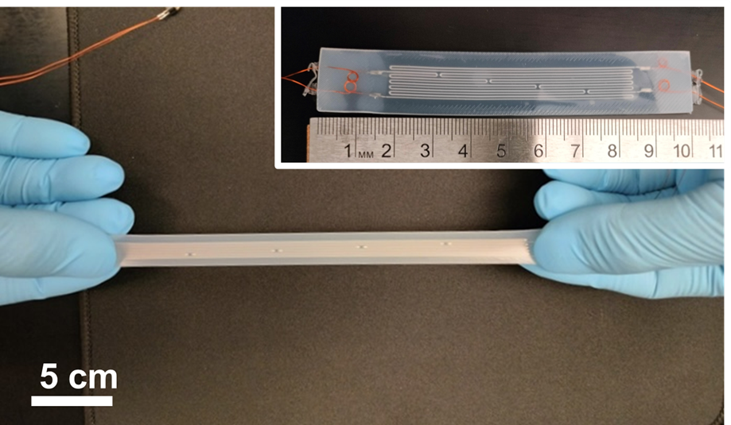

Figure S1. Digital image of pressure sensor with superior stretchability. The inset image is the original status of the sensor without stretching. The sensor showed mechanical durability under a stretch of up to 250% without any damage.

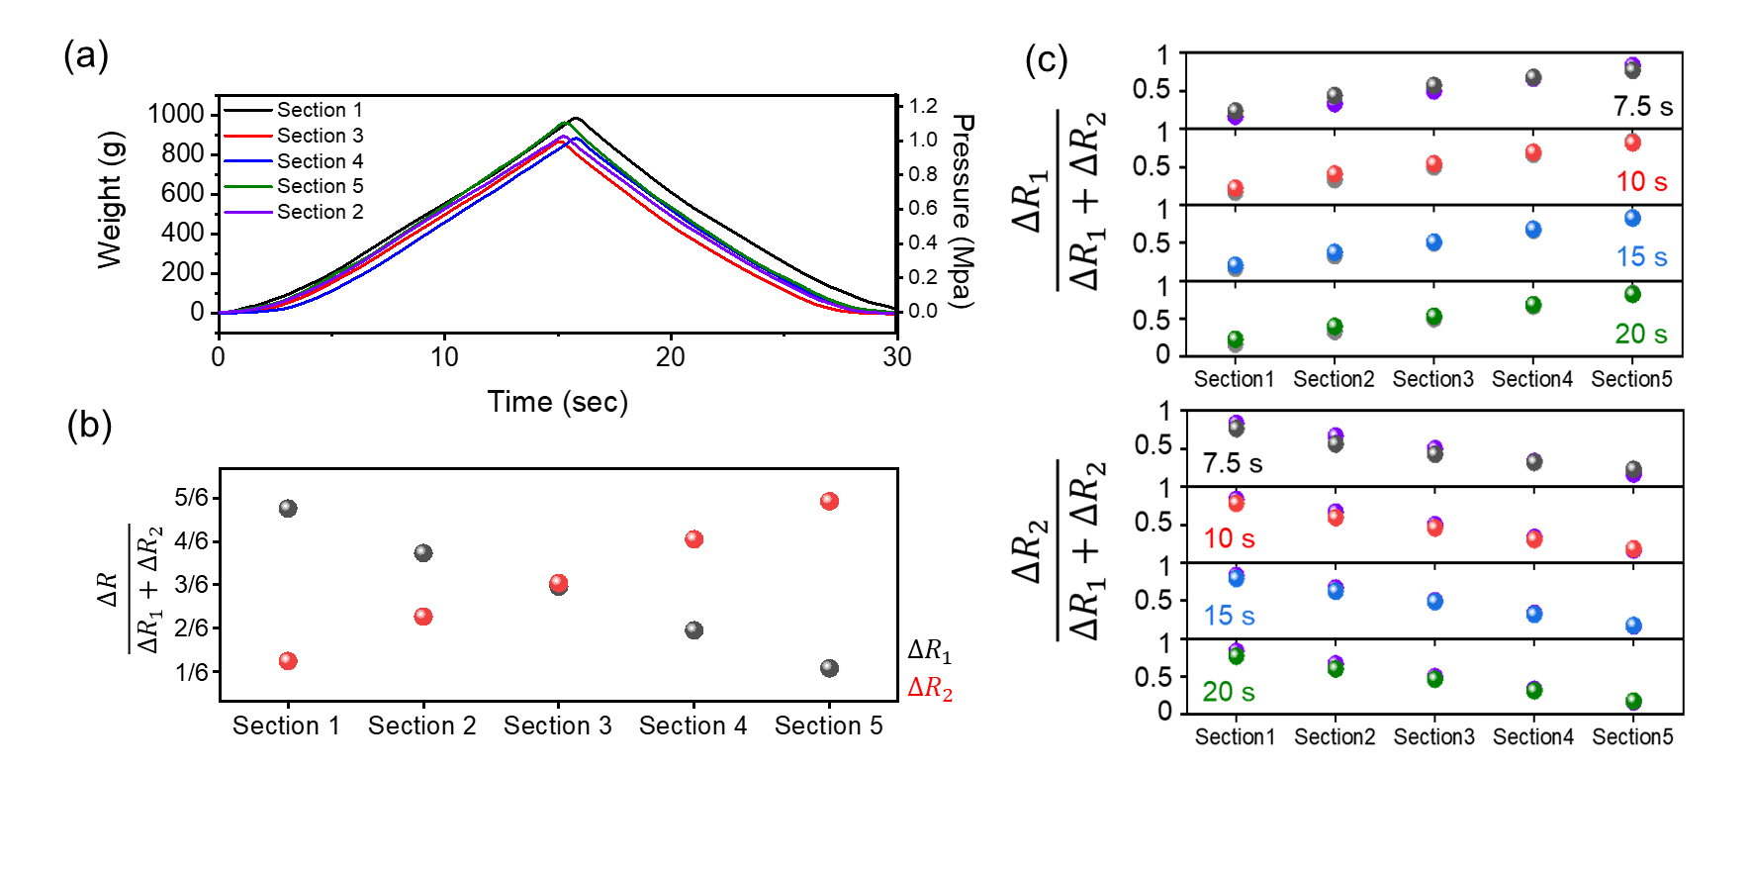
Figure S2. Variation of pressure and its corresponding resistance changes across the sections (Sections 1, 2, 3, 4, and 5) over a duration of 0 – 30 seconds. (a) Pressure (i.e., weight) was applied to each section (Sections 1, 2, 3, 4, and 5) for the initial 15 seconds and released over the subsequent 15 seconds. (b) Pressure location indexes from channels 1 and 2: The output resistance ratios of ΔR₁ (black dot) and ΔR₂ (red dot) relative to (ΔR₁ + ΔR₂) exhibited inverse trends throughout the sections, reflecting the novel sensor design. (c) Pressure location indexes for channels 1 and 2 were obtained at 7.5 (black dot), 10 (red dot), 15 (blue dot), and 20 (green dot) seconds during the pressure application and release cycle. The calculated indexes for both channels closely paralleled the theoretical predictions (purple dot), irrespective of the time or applied pressure affirming the index's ability to accurately pinpoint pressure locations.

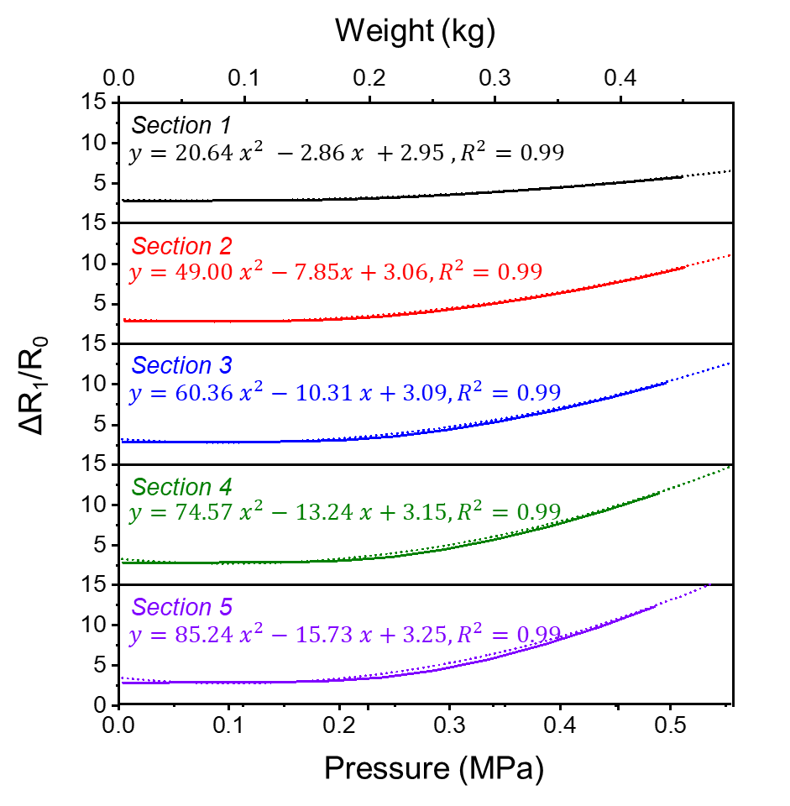
Figure S3. Resistance alterations in individual sections of channel 1 as pressure is gradually applied up to 0.5 MPa (solid line). The corresponding fitted parabolic equations (dotted line) follow the equation as $y=Ax^{2}+Bx+C$, where $y$ symbolizes relative resistance changes and $x$denotes pressure. The sensor's ability to accurately detect pressure is evident in the parabolic response of channel 1, highlighting its reliability. Conversely, channel 2 (in Figure 3) exhibits a contrasting trend across different sections, indicating the potential for utilizing a pressure location index to determine the point of pressure application.

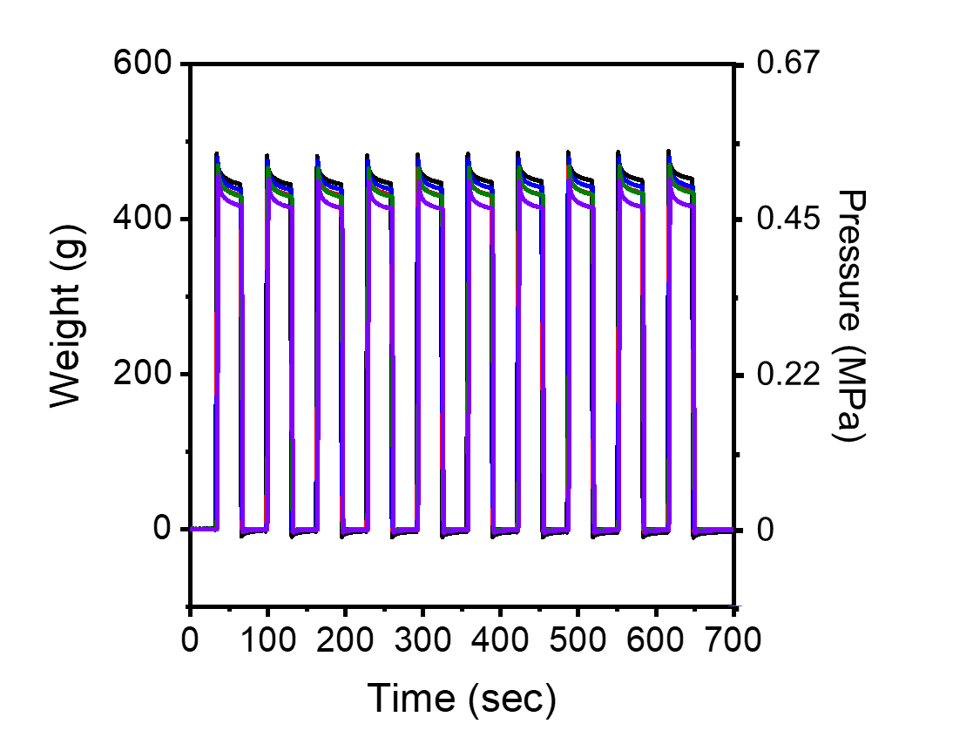
Figure S4. Applied weight (or pressure) with regard to the time for 10 test cycles. The custom-built motorized system controlled the weight (or pressure) load consistently.

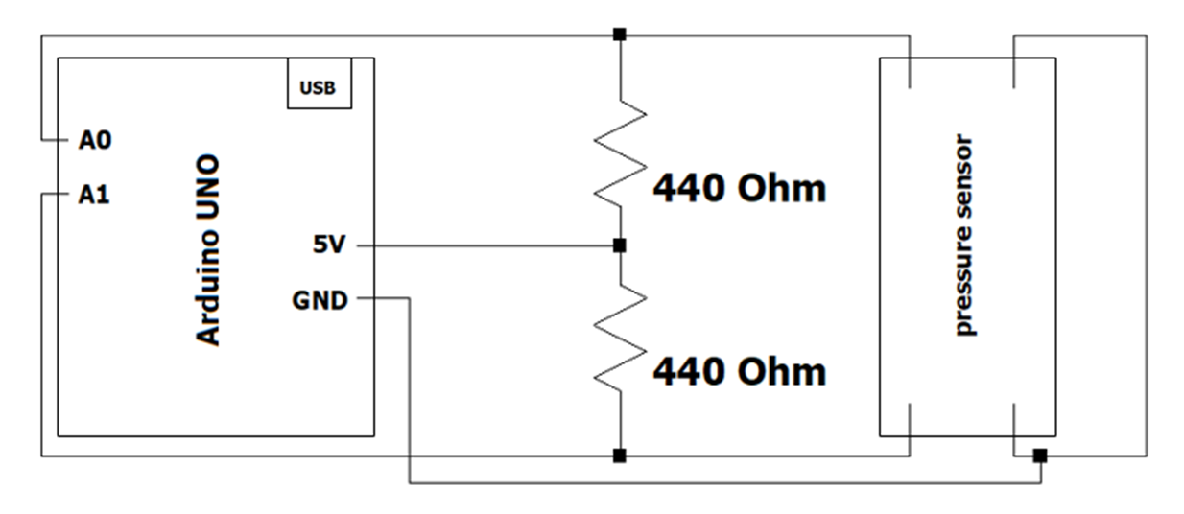
Figure S5. Electronic circuit diagram for connecting the sensor terminals to the voltage divider circuit to read signals from the pressure sensor. The module presents a real-time pressure sensing circuit employing a Wheatstone bridge configuration with 440 Ohm resistors and a pressure sensor interfaced with an Arduino microcontroller. The circuit monitors the variation in voltage across the pressure sensor pins, which directly correlates to changes in the sensor's resistance due to applied pressure. The Arduino is connected to the laptop's USB COM port via Arduino IDE and serially reads the sensor's voltage by accurately capturing real-time pressure changes at a rate of 100 ms. The analog output of the Arduino spans from 0 V to 5 V in 1023 increments, ensuring precise data acquisition.
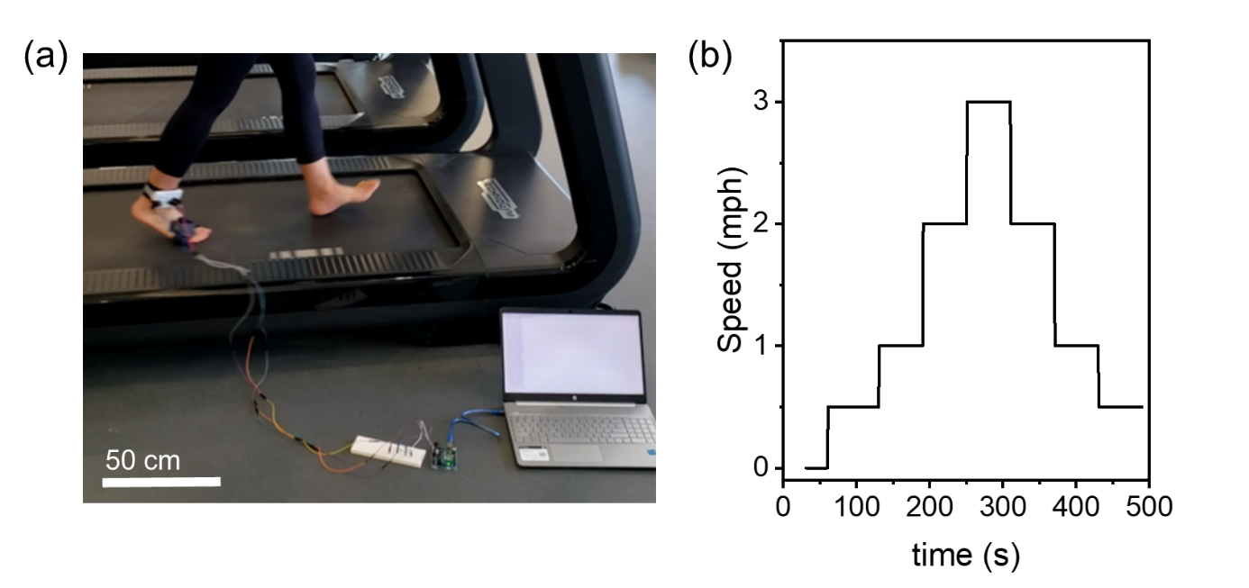
Figure S6. (a) Experimental setup for gait monitoring on a treadmill and (b) walking speed changes with time. The sensor was attached to the subject's right foot and connected to the breadboard, and Arduino collected the signal changes in real time. The walking speed of the subject was maintained for a minute for each speed, increased from 0 to 3 mph in steps of 1 mph, and decreased back to 0 mph at the same rate.

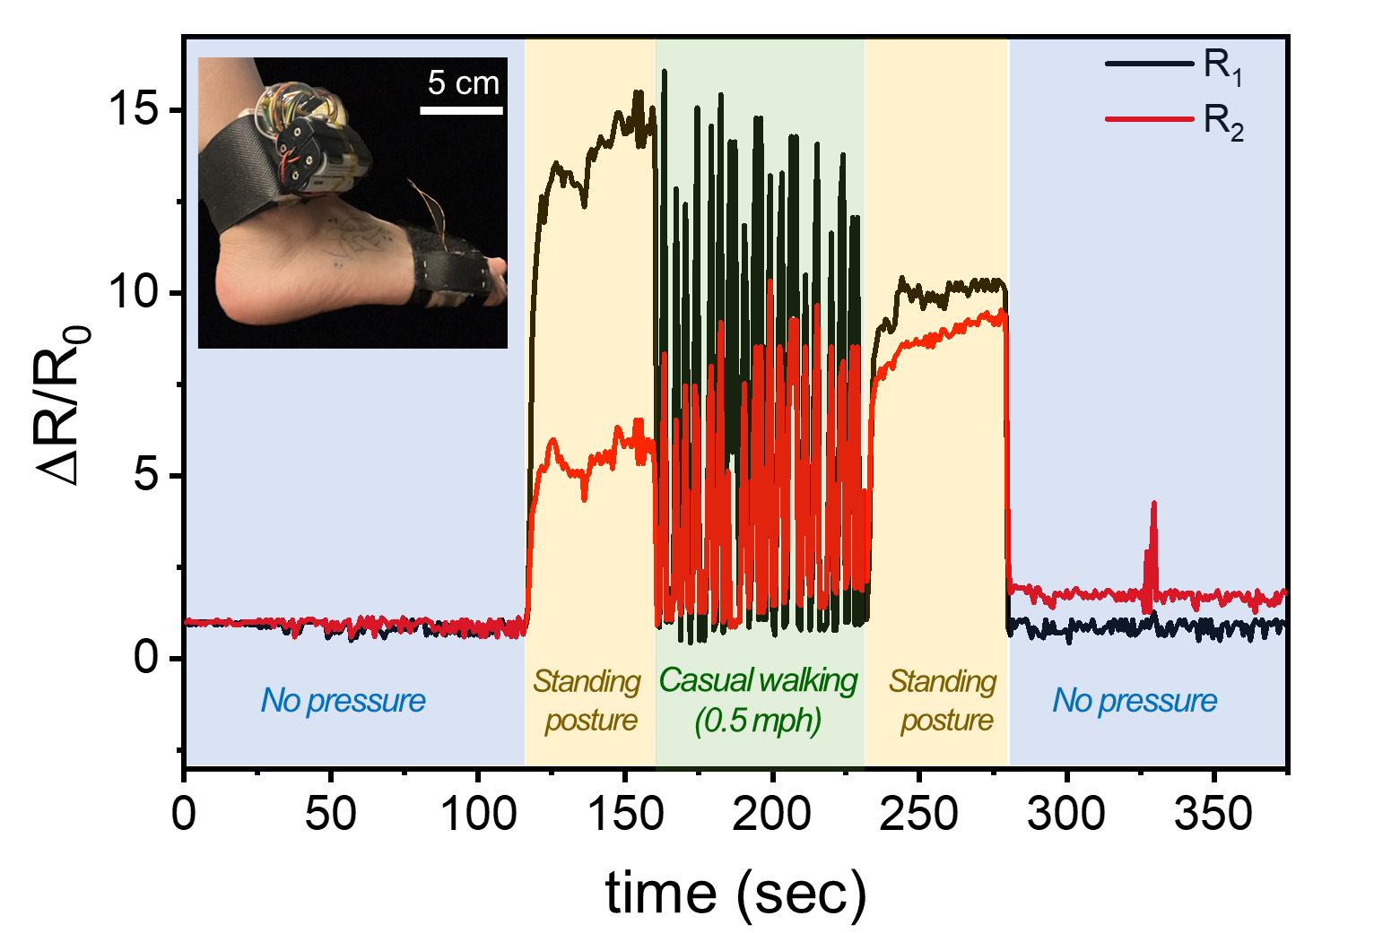

Figure S7. The gait monitoring results were obtained through a wireless system. The inset shows the wireless system attached to the subject's ankle and foot. The prepared system with the sensor clearly distinguishes the difference between various postures, such as standing posture, casual walking (0.5 mph speed), and no pressure applied to the sensor. The changes were serially read by the Raspberry Pi Pico microcontroller and wirelessly transferred to a personal computer via an IP address and WiFi connection. The results align well with the wired system results depicted in Figure 6.

