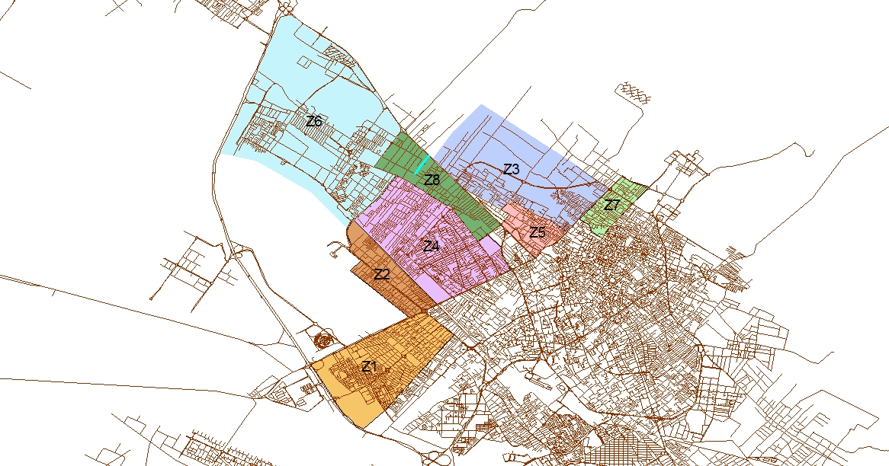
Fig.S1. Overview of eight sub-regions related to WDN case study

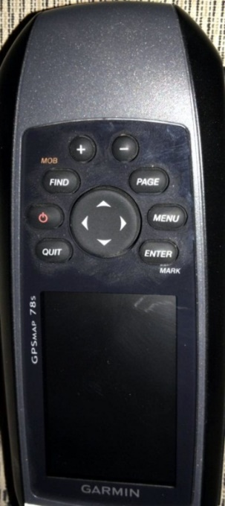  (a) | 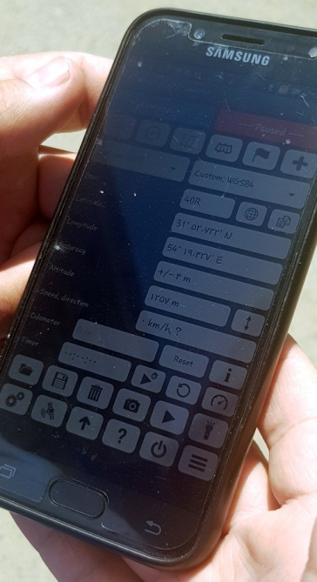  (b)

Fig.S2. Overview of apparatuses, (a) handy GPS used in this study and (b) installation of handy GPS software on the cellphone

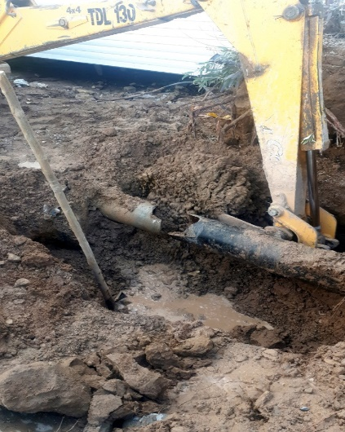
- Recorded in 2014/08/14

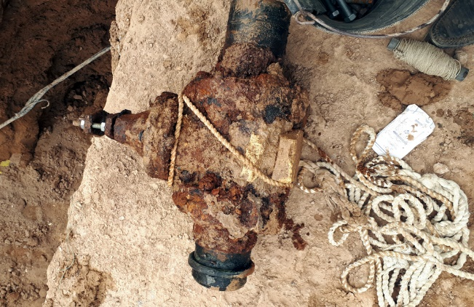
(b) Recorded in 2014/10/08

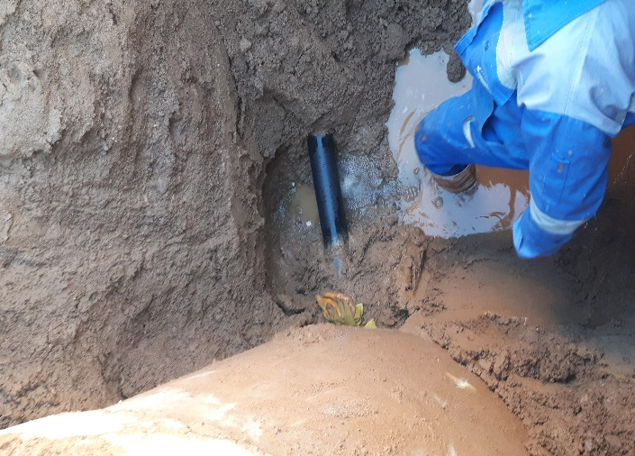
(c) Recorded in 2014/04/30

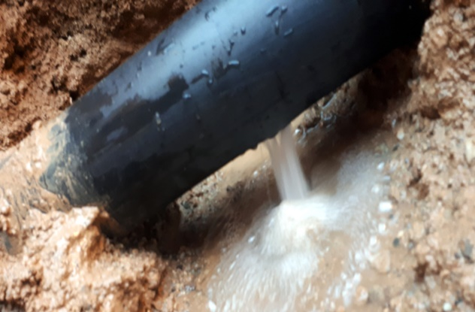
(d) Recorded in 2014/07/02

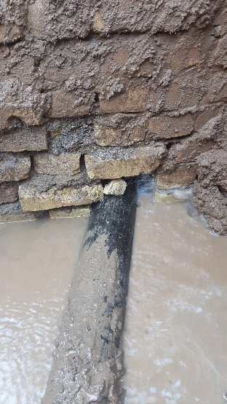
(e) Recorded in 2014/08/16

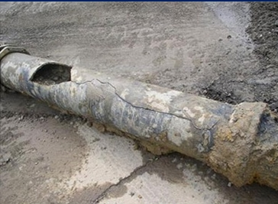
(f) Recorded in 2014/04/30

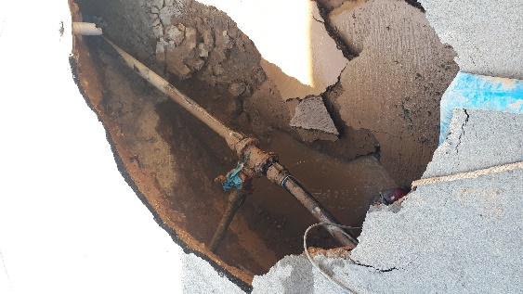
(g) Recorded in 2014/10/07

Fig.S3. Various pipe breaks observed in the Azadshahr sub-region of WDN for various reasons, (a) excavation operation, (b) rusty water pipe, (c) leak, (d) pressure fluctuation, (e) settlement, (f) heavy vehicles, and (g) inappropriate operation

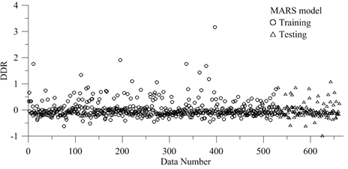

Fig.S4. Variations of DDR values against data samples for MARS model

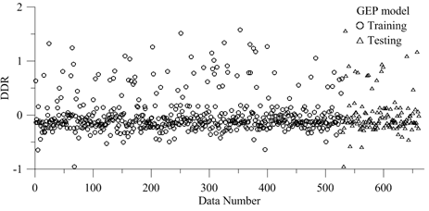
Fig.S5. Variations of DDR values against data samples for GEP model

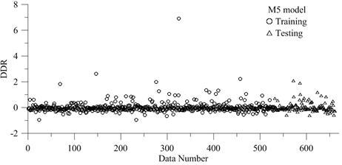
Fig.S6. Variations of DDR values against data samples for M5 technique

Table S1. Characterizations of the first region of Yazd’s WDN
Eight sub-regions of WDN case study
Zone Identification | Z1 | Z2 | Z3 | Z4 | Z5 | Z6 | Z7 | Z8
Number of Incepted Pipes | 99 | 45 | 26 | 77 | 57 | 335 | 36 | 176
Length of Incepted Pipes (km) | 10.1 | 4.264 | 6.052 | 9.53 | 9.94 | 56.32 | 6.064 | 29.329
Pipe Age  (yr) | 2-7 | 1-8 | 1-8 | 1-8 | 3-10 | 2-7 | 1,2,3,5 | 1,2,3,5,6
Nominal Pipe Diameter (mm) | 63-150 | 63-150 | 63-150 | 63-150 | 63-150 | 63-150 | 63-150 | 63-150
Depth pf Pipe Installation (m) | 1 | 1 | 1 | 1.1 | 1.2 | 1 | 1.1 | 1
Pressure (bar) | 1.5 | 2 | 1.8 | 1.8 | 2 | 2 | 1.7 | 2
Number of Failure | 123 | 90 | 29 | 89 | 44 | 408 | 44 | 206
Break Rate of Pipe | 0.46-77.7 | 0.37-21.49 | 0.03-25.31 | 0.22-20.33 | 0.024-11.90 | 0.27-2.51 | 0.49-4.21 | 0.408-4.165

Table S1. List of 17 if-then rules applied for pipes break rate
if L_{P} <= 0.0235
BR_{P}=33.174-3.913×A_{P}
else
if L_{P}<= 0.092
if A_{P}<= 4.5
if A_{P}<= 1.5
BR_{P}=17.460-132.679×L_{P}
else
BR_{P}=15.895-77.999×L_{P}-1.104×A_{P}-2.299×P_{A}
else
if L_{P}<= 0.048
if L_{P}<= 0.040
BR_{P}=11.792-94.289×L_{P}-0.464×A_{P}-1.647×P_{A}
else
BR_{P}=2.432
else
BR_{P}=4.165-23.158×L_{P}-0.174× A_{P}
else
if A_{P}<= 2.5
if P<=1.9
BR_{P}=4.420-0.966×A_{P}
else
BR_{P}=1.703
else

Table S1. (Continued)
if L_{P}<= 0.113
if A_{P}<= 4.5
BR_{P}=1.979
else
BR_{P}=2.301-0.191×A_{P}
else
if A_{P}<= 3.5
if L_{P}<= 0.148
BR_{P}=1.544
else
if L_{P}<= 0.187
if L_{P}<= 0.164
BR_{P}=1.243
else
BR_{P}=0.983
else
BR_{P}=2.600-4.761×L_{P}
else
if A_{P}<=5.5
if L_{P}<=0.128
BR_{P}=0.928
else
BR_{P}=1.934-0.087×A_{P}-0.386×P_{A}
Else
BR_{P}=1.903-0.664×P_{A}

Table S3. List of BFs used in the MARS model
Coefficients (β) | Basis Function
78.792 | BF₁ = max(0, 0.06476 –L_{P})×max(0, 2-A_{P})
-0.302 | BF₂ = max(0, A_{P}-3)
1.768 | BF₃ = max(0, 3-A_{P})
-4.253 | BF₄ = max(0, 3-A_{P})×max(0, L_{P}-0.032036)
116.099 | BF₅ = max(0, 3-A_{P})×max(0, 0.032036-L_{P})
19.423 | BF₆ = max(0, L_{P}-0.1375)
393.595 | BF₇ = max(0, 0.02148-L_{P})
-1717.432 | BF₈ = max(0, 0.02148-L_{P})×max(0, 1.2-h_{P})
2.408 | BF₉ = max(0, P_{A}-1.7)
101.444 | BF₁₀ = max(0, 1.7- P_{A})
-10598.771 | BF₁₁ = max(0, 1.7- P_{A})×max(0, L_{P}-0.02148)
4659.487 | BF₁₂ = max(0, 1.7- P_{A})×max(0, 0.02148-L_{P})
8.400 | BF₁₃ = max(0, 0.1375-L_{P})×max(0,A_{P}-5)
0.612 | BF₁₄ = max(0, P_{A}-1.7)×max(0, A_{P}-2)
-18.453 | BF₁₅ = max(0, L_{P}-0.04362)
108.287 | BF₁₆ = max(0, 0.04362-L_{P})×max(0, 4-A_{P})
21.935 | BF₁₇ = max(0, 0.1375-L_{P})×max(0, 2-A_{P})
-14835.222 | BF₁₈ = max(0, 1.7-P_{A})×max(0, 0.02886-L_{P})
206.372 | BF₁₉ = max(0, 0.03051-L_{P})
-73.898 | BF₂₀ = max(0, L_{P}-0.03051)×max(0, P_{A}-1.7)
10579.230 | BF₂₁ = max(0, L_{P}-0.03051)×max(0, 1.7- P_{A})
147.098 | BF₂₂ = max(0, 0.06476 -L)×max(0, 2- P_{A})
68.513 | BF₂₃ = max(0, P_{A}-1.7)×max(0, L_{P}-0.08654)
5331.760 | BF₂₄ = max(0, 1.7- P_{A})×max(0, 0.02435-L_{P})
-9.547 | BF₂₅ = max(0, 0.1375-L_{P})×max(0,A_{P}-4)
-31.254 | BF26 = max(0, 0.1375-L_{P})×max(0, 1.8- P_{A})

Table S4. Control parameters used in the GEP model
Parameter | Description of parameter | Setting of parameter
P1 | Function set | times, minus, plus, square, tanh, exp
P2 | Population size | 200
P3 | Mutation frequency | 0.94
P4 | Crossover frequency (%) | 50
P5 | Number of replication | 10
P6 | Block mutation rate (%) | 30
P7 | Instruction mutation rate (%) | 30
P8 | Instruction data mutation rate (%) | 40
P9 | Maximum depth of tree | 7
P10 | Program size | Initial 64, Maximum 256
P11 | Number of gene | 3

Table S5. Results of statistical distributions
Variables | Distribution Type | Mean | Coefficient of Variation
L_{P}(km) | Lognormal | 0.155 | 1.6990
h_{P}(m) | Normal | 1.030 | 0.0569
A_{P}(yr) | Normal | 4.684 | 0.3426
P_{A}(bar) | Lognormal | 1.877 | 0.0975
BR_{P} | Lognormal | 1.753 | 1.3243

