Supplementary Figure and Tables

Supplementary Figure 1:
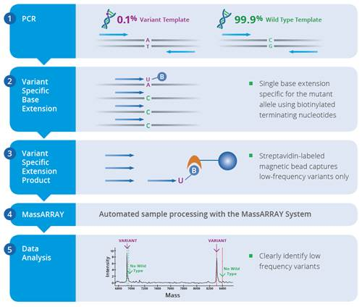
Figure 1. Workflow of the UltraSEEK mutation-detection assay. The UltraSEEK assay consists of multiplex PCR reaction (1) followed by variant-specific extension reaction (2) using biotinylated chain terminator nucleotides and streptavidin-coated magnetic beads (3) that capture the variants. The products are transferred to the automated MassARRAY System (4) that performs desalting and loading of SpectroCHIP Arrays. Data is acquired via matrix-assisted laser desorption/ionization time-of-flight mass spectrometry using the MassARRAY Analyzer (5).

Supplementary table 1: UltraSEEK Breast Cancer Panel. The UltraSEEK BC panel screens for 39 mutations across 5 common BC oncogenes.
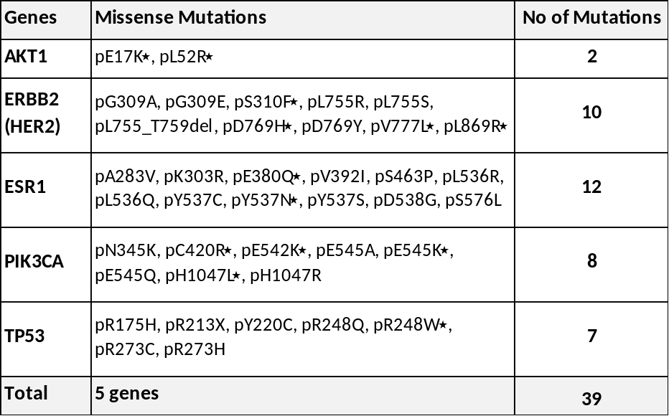
٭ Multiple assays for these mutations are included in the panel.

Supplementary table 2: Multiplex assays of the UltraSEEK® Breast Cancer Panel. The 39 mutations across 5 oncogenes present in the UltraSEEK BC are analysed in 8-plexes (W1-W8) in a 96-well plate format. Fifty-four assays are listed in the table as several gene mutations are interrogated by more than one assay.
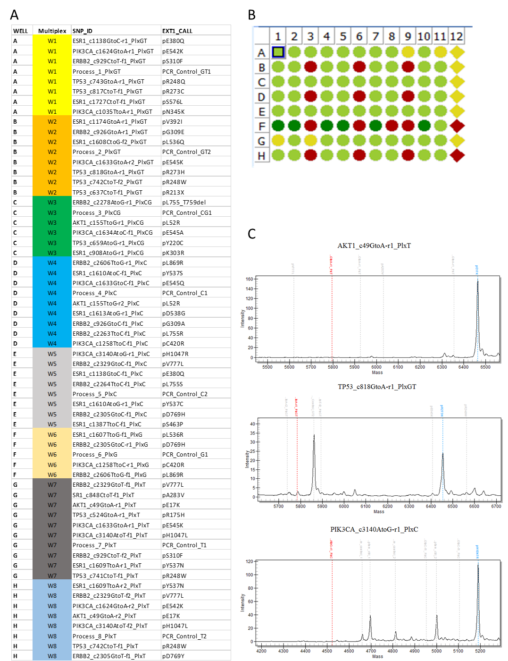
Supplementary table 3. Mutations in paired BC and BM samples according to receptor status. The number of mutations identified for each of the 5 genes according to receptor status in (A) primary breast cancer (BC) and in (B) paired brain metastases (BM). The percentages of each mutation over the total number of mutations is presented in the parenthesis.
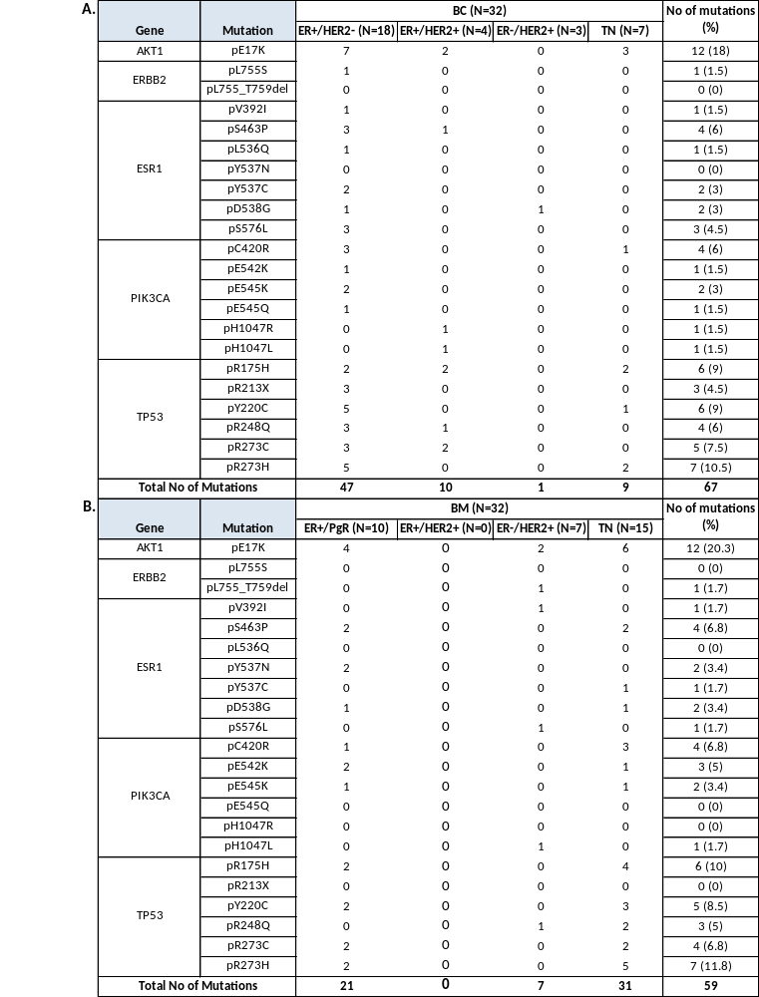
Supplementary Table 4: OncoKB database and gene actionability. A search on oncoKB (https://www.oncokb.org/actionableGenes) for the actionability of PIK3CA, AKT1, ESR1, ERBB2/HER2 and TP53 oncogenic mutations. The searches were performed for Breast Cancer and Levels of evidence: 1. FDA-approval, 2. Standard care, 3. Clinical evidence, 4. Biological evidence, R1/R2. Resistance. *NA: Not available.

Tumour type: Breast Cancer
Level | Alteration: Oncogenic Mutations | No of Mutations (%) |  | Drugs | Citations
Level | Alteration: Oncogenic Mutations | BC (N=32) | BM (N=32) | Drugs
1 | PIK3CA | 10 (15) | 10 (17) | Alpelisib  + Fulvestrant | 3 | PI3K inhibition results in enhanced estrogen receptor function and dependence in hormone receptor-positive breast cancer. Bosch A et al. Sci Transl Med. 2015 PMID: 25877889
 |  |  |  |  |  | Alpelisib Plus Fulvestrant in PIK3CA-Altered and PIK3CA-Wild-Type Estrogen Receptor-Positive Advanced Breast Cancer: A Phase 1b Clinical Trial. Juric D et al. JAMA Oncol. 2019 PMID: 30543347
 |  |  |  |  |  | Alpelisib for PIK3CA -Mutated, Hormone Receptor-Positive Advanced Breast Cancer. André F et al. N Engl J Med. 2019 PMID: 31091374
3A | PIK3CA | 10 (15) | 10 (17) | GDC-0077 | 3 | 355TiP Phase III study of GDC-0077 or placebo (pbo) with palbociclib (P) + fulvestrant (F) in patients (pts) with PIK3CA-mutant/hormone receptor-positive/HER2-negative locally advanced or metastatic breast cancer (HR+/HER2– LA/MBC). TurnerN et al. Annals Onc. 2020 DOI: https://doi.org/10.1016/j.annonc.2020.08.457
 |  |  |  |  |  | Juric D et al. Abstract# OT1-08-04, SABCS 2019
 |  |  |  |  |  | Hong R et al. Abstract# PD4-14, SABCS 2017
3A | PIK3CA | 10 (15) | 10 (17) | Copanlisib  + Fulvestrant | 7 | First-in-human phase I study of copanlisib (BAY 80-6946), an intravenous pan-class I phosphatidylinositol 3-kinase inhibitor, in patients with advanced solid tumors and non-Hodgkin's lymphomas. Patnaik A et al. Ann Oncol. 2016 PMID: 27672108
 |  |  |  |  |  | Exceptional Response to Copanlisib in a Heavily Pretreated Patient With PIK3CA-Mutated Metastatic Breast Cancer. Spathas N et al. JCO Prec Onc. 2020 https://doi.org/10.1200/PO.19.00049
 |  |  |  |  |  | Staben et al. Abstract# DDT02-01, AACR 2017
 |  |  |  |  |  | De et al. Abstract# 3438, AACR 2019
 |  |  |  |  |  | O'Brien, NA et al. Abstract P3-04-15. Cancer Research, 2017
 |  |  |  |  |  | De et al. Abstract# P2-03-08, SABCS 2018
 |  |  |  |  |  | Edgar et al. Abstract# 156, AACR 2017
3A | AKT1 | 12 (18) | 12 (20.3) | AZD5363 | 4 | Preclinical pharmacology of AZD5363, an inhibitor of AKT: pharmacodynamics, antitumor activity, and correlation of monotherapy activity with genetic background. Davies BR et al. Mol Cancer Ther. 2012 PMID: 22294718
 |  |  |  |  |  | Discovery of 4-amino-N-[(1S)-1-(4-chlorophenyl)-3-hydroxypropyl]-1-(7H-pyrrolo[2,3-d]pyrimidin-4-yl)piperidine-4-carboxamide (AZD5363), an orally bioavailable, potent inhibitor of Akt kinases. Addie M et al. J Med Chem. 2013 PMID: 23394218
 |  |  |  |  |  | AKT Inhibition in Solid Tumors With AKT1 Mutations. Hyman DM et al. J Clin Oncol. 2017 PMID: 28489509
 |  |  |  |  |  | Tumors with AKT1E17K Mutations Are Rational Targets for Single Agent or Combination Therapy with AKT Inhibitors. Davies BR et al. Mol Cancer Ther. 2015PMID: 26351323
1 | ERBB2/HER2 | 1 (1.5) | 1 (1.7) | Neratinib | 3 | Activating HER2 mutations in HER2 gene amplification negative breast cancer. Bose R et al. Cancer Discov. 2013 PMID: 23220880
 |  |  |  |  |  | The major lung cancer-derived mutants of ERBB2 are oncogenic and are associated with sensitivity to the irreversible EGFR/ERBB2 inhibitor HKI-272. Minami Y et al. Oncogene. 2007 PMID: 17311002
 |  |  |  |  |  | HER kinase inhibition in patients with HER2- and HER3-mutant cancers. Hyman DM et al. Nature. 2018 PMID: 29420467
3A | ESR1 | 13 (19.4) | 11 (18.6) | AZD9496 | 2 | Efficacy of a novel orally active SERD AZD9496 against hormone dependent post-menopausal breast cancer depends on inhibition of cellular aromatase activity. Kazi A et al. J Ster Biochem Mol Biol. 2020 ISSN: 0960-0760
 |  |  |  |  |  | A Randomized, Open-label, Presurgical, Window-of-Opportunity Study Comparing the Pharmacodynamic Effects of the Novel Oral SERD AZD9496 with Fulvestrant in Patients with Newly Diagnosed ER+ HER2− Primary Breast Cancer. Robertson JFR et al 2020 PMID: 32234755
1 | ESR1 | 13 (19.4) | 11 (18.6) | Abemaciclib + Fulvestrant | 4 | Analysis of Overall Survival Benefit of Abemaciclib Plus Fulvestrant in Hormone Receptor–Positive, ERBB2-Negative Breast Cancer. Gil-Sierra MD et al. JAMA Oncol. 2020 doi:10.1001/jamaoncol.2020.1516
 |  |  |  |  |  | The Effect of Abemaciclib Plus Fulvestrant on Overall Survival in Hormone Receptor-Positive, ERBB2-Negative Breast Cancer That Progressed on Endocrine Therapy-MONARCH 2: A Randomized Clinical Trial. Sledge GW Jr et al. JAMA Oncol. 2019 PMID: 31563959
 |  |  |  |  |  | Activating ESR1 Mutations Differentially Affect the Efficacy of ER Antagonists. Toy W et al. Cancer Discov. 2017 PMID: 27986707
 |  |  |  |  |  | Plasma ESR1 Mutations and the Treatment of Estrogen Receptor-Positive Advanced Breast Cancer. Fribbens C et al. J Clin Oncol. 2016 PMID: 27269946
NA* | TP53 | 31 (46.3) | 25 (42.4)
Total No of Mutations |  | 67 | 59

Supplementary table 5. List of BC Clinical Trials using targeted therapies. The searches were performed for Breast Cancer, applying the following filters: Recruiting, Active (not recruiting), Completed, Adult and selecting for specific gene mutations/alterations for PIK3CA, AKT1, ESR1, ERBB2/HER2 and TP53.
Altered Gene /Pathway | Clinical Trial | ClinicalTrials.gov Identifier | Phase | Targeted Therapy
PIK3CA | Phosphatidylinositol 3-kinase (PI3K) Alpha iNhibition In Advanced Breast Cancer | NCT02506556 | 2 | BYl719
PIK3CA | Study of Alpelisib (BYL719) in Combination With Trastuzumab and Pertuzumab as Maintenance Therapy in Patients With HER2-positive Advanced Breast Cancer With a PIK3CA Mutation | NCT04208178 | 3 | Alpelisib, Trastuzumab, Pertuzumab
PIK3CA | Study Assessing the Efficacy and Safety of Alpelisib Plus Fulvestrant in Men and Postmenopausal Women with Advanced Breast Cancer Which Progressed on or After Aromatase Inhibitor Treatment (SOLAR-1) | NCT02437318 | 3 | Alpelisib, fulvestrant
PIK3CA | Study Assessing the Efficacy and Safety of Alpelisib Plus Fulvestrant or Letrozole, Based on Prior Endocrine Therapy, in Patients With PIK3CA Mutation With Advanced Breast Cancer Who Have Progressed on or After Prior Treatments | NCT03056755 | 2 | Alpelisib, fulvestrant, letrozole, goserelin, leuprolide
PIK3CA | Investigating Safety, Tolerability and Efficacy of AZD5363 When Combined With Paclitaxel in Breast Cancer Patients | NCT01625286 | 1/2 | AZD5363, paclitaxel
PIK3CA | Testing the Addition of an Anti-cancer Drug, Copanlisib, to the Usual Maintenance Treatment (Trastuzumab and Pertuzumab) After Initial Chemotherapy in a Phase Ib/II Trial for Advanced HER2 Positive Breast Cancer | NCT04108858 | 1/2 | Copanlisib, Pertuzumab, Trastuzumab
PIK3CA | Testing GDC-0032 (Taselisib) as a Potential Targeted Treatment in Cancers With PIK3CA Genetic Changes (MATCH-Subprotocol I) | NCT04439175 | 2 | Taselisib
PIK3CA | Study of GDC-0941 or GDC-0980 With Fulvestrant Versus Fulvestrant in Advanced or Metastatic Breast Cancer in Participants Resistant to Aromatase Inhibitor Therapy | NCT01437566 | 2 | Fulvestrant, GDC-0941,  GDC-0980
PIK3CA | A Study of Prexasertib (LY2606368) With Chemotherapy or Targeted Agents in Participants With Advanced Cancer | NCT02124148 | 1 | Prexasertib
PIK3CA | SAFIR PI3K A Phase II Randomized Trial Comparing Alpelisib and Fulvestrant Versus Chemotherapy as Maintenance Therapy in Patients With PIK3CA Mutated Advanced Breast Cancer | NCT03386162 | 2 | Alpelisib
PIK3CA | A Study of BYL719 in Adult Patients With Advanced Solid Malignancies, Whose Tumors Have an Alteration of the PIK3CA Gene | NCT01219699 | 1 | BYL719, Fulvestrant
PIK3CA | Open-label Phase 1b Study of ARQ 092 in Combination With Anastrozole | NCT02476955 | 1 | ARQ 092
AKT1/PIK3CA/mTOR | Phase II Study of Herzuma® Plus Gedatolisib in Patients With HER-2 Positive Metastatic Breast Cancer | NCT03698383 | 2 | Herzuma®, Gedatolisib
AKT1/PIK3CA/mTOR | FUSCC Refractory TNBC Umbrella (FUTURE) | NCT03805399 | 1/2 | Pyrotinib, Capecitabine, mTOR inhibitor
AKT1/PIK3CA/ESR1 | Study of the Molecular Features of Postmenopausal Women With HR+ HER2-negative aBC on First-line Treatment With Ribociclib and Letrozole and, in Patients With a PIK3CA Mutation, on Second-line Treatment With Alpelisib Plus Fulvestrant | NCT03439046 | 3 | Ribociclib, Letrozole, Alpelisib, Fulvestrant
AKT1/PIK3CA/ESR1 | Durvalumab, With Olaparib and Fulvestrant in Advanced ER+, HER2- Breast Cancer Patients. | NCT04053322 | 2 | Durvalumab, Olaparib, Fulvestrant
AKT1/PIK3CA/PTEN | A Study of Ipatasertib in Combination With Paclitaxel as a Treatment for Participants With PIK3CA/AKT1/PTEN-Altered, Locally Advanced or Metastatic, Triple-Negative Breast Cancer or Hormone Receptor-Positive, HER2-Negative Breast Cancer | NCT03337724 | 2/3 | Ipatasertib
AKT1/PIK3CA/PTEN | Study Assessing the Efficacy and Safety of Alpelisib + Nab-paclitaxel in Subjects With Advanced TNBC Who Carry Either a PIK3CA Mutation or Have PTEN Loss Without PIK3CA Mutation | NCT04251533 | 3 | Alpelisib, nab-paclitaxel
AKT1 | AZD5363 in Patients With Advanced Solid Tumors Harboring AKT Mutations | NCT03310541 | 1 | AZD5363, Enzalutamide, Fulvestrant
AKT1 | Safety, Tolerability & Potential Anti-cancer Activity of Increasing Doses of AZD5363 in Different Treatment Schedules | NCT01226316 | 1 | AZD5363
AKT1 | Akt Inhibitor MK2206 in Treating Patients With Advanced Breast Cancer | NCT01277757 | 2 | MK2206
ESR1 | Evaluation of Lasofoxifene Versus Fulvestrant in Advanced or Metastatic ER+/HER2- Breast Cancer With an ESR1 Mutation | NCT03781063 | 2 | Lasofoxifene, Fulvestrant
ESR1 | PAlbociclib and Circulating Tumor DNA for ESR1 Mutation Detection | NCT03079011 | 3 | Palbociclib
ESR1 | Correlation of 16Î±-[18F]Fluoro-17Î²-estradiol PET Imaging With ESR1 Mutation | NCT03544762 | 3 | 18F-FES PET
ESR1 | Phase II Treatment of Metastatic Breast Cancer With Fulvestrant Plus Palbociclib or Tamoxifen Plus Palbociclib | NCT02913430 | 2 | Palbociclib, Fulvestrant, Tamoxifen
ESR1 | Evaluation of Lasofoxifene Combined With Abemaciclib in Advanced or Metastatic ER+/HER2− Breast Cancer With an ESR1 Mutation | NCT04432454 | 2 | Lasofoxifene, Abemaciclib
ESR1 | The Efficacy of Fulvestrant in ESR1 (Estrogen Receptor 1) Mutated Metastatic Breast Cancer | NCT03202862 | 2 | Fulvestrant
ERBB2/HER2 | Neratinib HER Mutation Basket Study | NCT01953927 | 2 | Neratinib
ERBB2/HER2 | Neratinib +/- Fulvestrant in Metastatic HER2 Non-amplified But HER2 Mutant Breast Cancer | NCT01670877 | 2 | Neratinib, Fulvestrant
ERBB2/HER2 | A Study of Neratinib Plus Capecitabine Versus Lapatinib Plus Capecitabine in Patients With HER2+ Metastatic Breast Cancer Who Have Received Two or More Prior HER2 Directed Regimens in the Metastatic Setting (NALA) | NCT01808573 | 3 | Neratinib, Lapatinib, capecitabine
ERBB2/HER2 | A Study of Poziotinib in Patients With EGFR or HER2 Activating Mutations in Advanced Malignancies | NCT04172597 | 2 | Poziotinib Hydrochloride
ERBB2/HER2 | A Phase II, Single-Arm Trial of Poziotinib as Salvage Treatment in Patients With Metastatic Breast Cancer Who Has HER2 or EGFR Mutation or Activated AR or EGFR Pathway | NCT02544997 | 2 | Drug: Poziotinib
ERBB2/HER2 | A Study of BDTX-189, an Orally Available Allosteric ErbB Inhibitor, in Patients With Advanced Solid Tumors. | NCT04209465 | 1/2 | BDTX-189
TP53 | The p53 Breast Cancer Trial | NCT02965950 | 2 | Cyclophosphamide
TP53 | Gene Therapy Plus Chemotherapy in Treating Patients With Breast Cancer | NCT00004038 | 1 | Ad5CMV-p53
TP53 | ALRN-6924 and Paclitaxel in Treating Patients With Advanced, Metastatic, or Unresectable Solid Tumors | NCT03725436 | 1 | ALRN-6924, Paclitaxel
TP53 | Biomarker (p53 Gene) Analysis and Combination Chemotherapy Followed by Radiation Therapy and Surgery in Treating Women With Large Operable or Locally Advanced or Inflammatory Breast Cancer | NCT00017095 | 3 | Filgrastim, Chemotherapy, Radiation
TP53 | Atezolizumab and Cobimetinib or Idasanutlin in Participants With Stage IV or Unresectable Recurrent Estrogen Receptor Positive Breast Cancer | NCT03566485 | 1/2 | Atezolizumab, Cobimetinib, Idasanutlin
TP53 | Chemotherapy Combined With Gene Therapy in Treating Patients Who Have Stage III or Stage IV Breast Cancer | NCT00044993 | 2 | Ad5CMV-p53 gene, Chemotherapy
TP53 | Safety and Efficacy of p53 Gene Therapy Combined With Immune Checkpoint Inhibitors in Solid Tumors. | NCT03544723 | 2 | Ad-p53
Mutations screening | PErsonalized TREatment of High-risk MAmmary Cancer - the PETREMAC Trial (Predictive and prognostic value of mutations in 300 cancer-related genes assessed in breast cancer tissue by next generation sequencing before starting neoadjuvant therapy). | NCT02624973 | 2 | Tamoxifen,  goserelin,letrozole, palbociclib, docetaxel,olaparib, trastuzumab, pertuzumab, epirubicin
Mutations screening | The UK Plasma Based Molecular Profiling of Advanced Breast Cancer to Inform Therapeutic CHoices (plasmaMATCH) Trial | NCT03182634 | 2 | Fulvestrant, Neratinib, AZD5363, Olaparib, AZD6738
Mutations screening | Targeted Therapy Directed by Genetic Testing in Treating Patients With Advanced Refractory Solid Tumors, Lymphomas, or Multiple Myeloma (The MATCH Screening Trial) | NCT02465060 | 2 | Adavosertib, Afatinib, Taselisib, Binimetinib, Capivasertib, Copanlisib, GSK2636771, Trametinib

