Supporting Information
Molecularly Architected Polymers Enabled by Frontal Polymerization
Justine E. Paul^{1,4}, Yuan Gao^{1,2,6*}, Yoo Kyung Go^{4*}, Luis E. Rodriguez Koett^{1,4*}, Anisha Sharma^{1,4}, Manxin Chen^{1,2}, Jacob J. Lessard^{1,3}, Tolga Topkaya^{1,5}, Cecilia Leal⁴, Jeffrey S. Moore^{1,3}, Philippe H. Geubelle^{1,2}, Nancy R. Sottos^{1,4**}
¹Beckman Institute for Advanced Science and Technology, University of Illinois at Urbana–
Champaign, Urbana, IL USA
²Department of Aerospace Engineering, University of Illinois at Urbana-Champaign, Urbana, IL, USA
³Department of Chemistry, University of Illinois at Urbana–Champaign, Urbana, IL USA ⁴Department of Materials Science and Engineering, University of Illinois at Urbana–Champaign, Urbana IL USA
⁵Mechanical Engineering Department, Engineering and Architecture Faculty, Batman University, Batman, 72100, Turkey
⁶State Key Laboratory of Digital Manufacturing Equipment and Technology, Huazhong University of Science and Technology, Wuhan, 430074, China

*These authors contributed equally to this work
** Corresponding Author n-sottos@illinois.edu

Supporting Text .................................................................................................................................... SI 2
Nuclear Magnetic Resonance (NMR) ..................................................................................................SI 2
Confocal Raman Spectroscopy ........................................................................................................... SI 9
DSC Heat of Fusion ............................................................................................................................. SI 10
X-Ray Diffraction ................................................................................................................................. SI 10
DSC Dynamic Cure Profile ..................................................................................................................SI 12
Material Domain Spacing .....................................................................................................................SI 12
Nanoindentation ....................................................................................................................................SI 14
Uniaxial Tensile Tests ...........................................................................................................................SI 14
Heat of Fusion – Tensile Specimens .....................................................................................................SI 15
Thermomechanical Characterization .................................................................................................SI 16

Supporting Text
Image Enhancements
Dog-bone images in Fig. 4a were visually enhanced to aid readers in distinguishing the material domains. All image enhancements were performed in Adobe Photoshop Lightroom Classic and were limited to color adjustments and image noise reduction. The image enhancement parameters for the A1 dog-bone image are as follows: Tone (highlights +72, shadows -23, blacks -60); Presence (texture +51, clarity +51, dehaze +25); Noise reduction (luminance 100, detail 75). The image enhancement parameters for the A2 dog-bone image are as follows: Tone (contrast +52, highlights +72, shadows -23, blacks -60); Presence (texture +82, clarity +51, dehaze +25); Noise reduction (luminance 100, detail, 100, contrast 71); Red primary (hue -70, saturation +100).

Nuclear Magnetic Resonance (NMR)

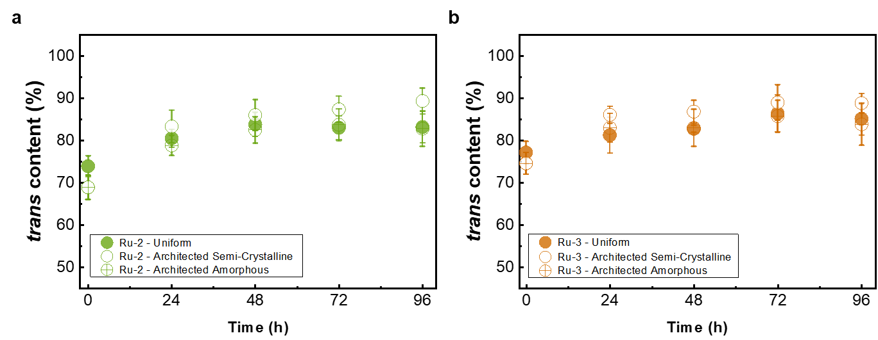
Figure S1. a, trans content as a function of time for uniform and architected polymers derived from the Ru-2 initiator. b, trans content as a function of time for uniform and architected polymers derived from the Ru-3 initiator. (a, b) Reported values and error bars represent the average and standard deviation, respectively (n = 3).
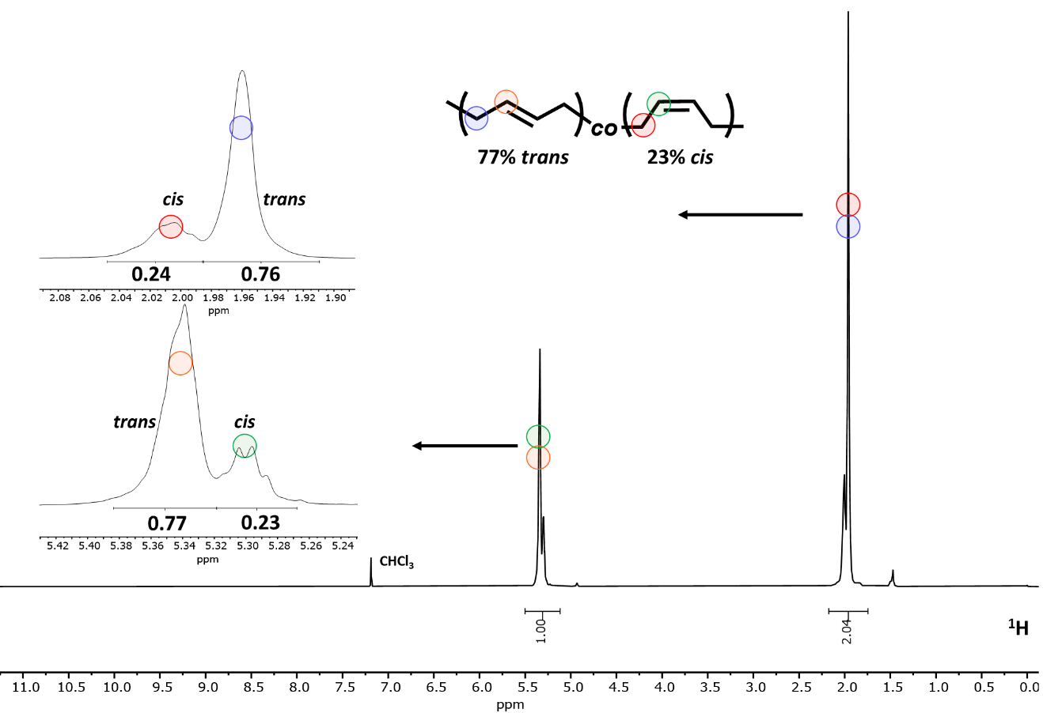
Figure S2. Representative ¹H NMR spectra in CDCl₃ of p(COD), containing 3 wt% ENB, from the Ru-1 initiator displaying both cis and trans configurations. Ratio of cis and trans configurations signals for each backbone proton (inset).

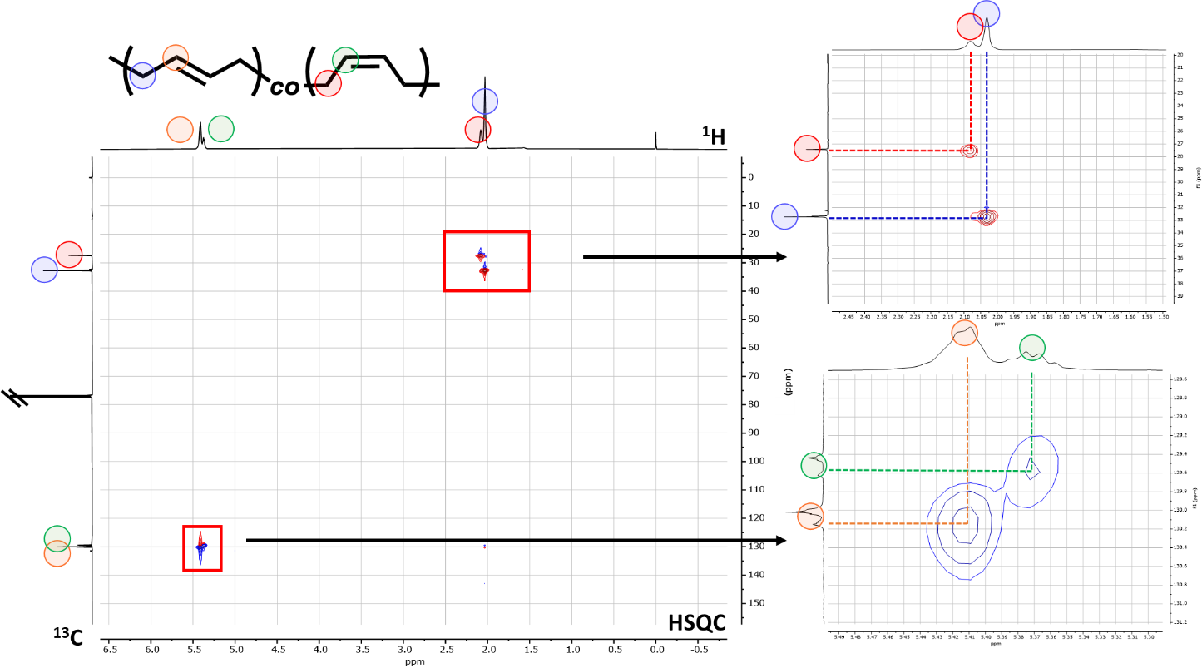
Figure S3. Representative Heteronuclear Single Quantum Coherence (HSQC) NMR spectra in CDCl₃ of p(COD) from the Ru-1 initiator displaying both cis and trans configurations. Insets of cis and trans configurations signals correlation each backbone proton and carbon.

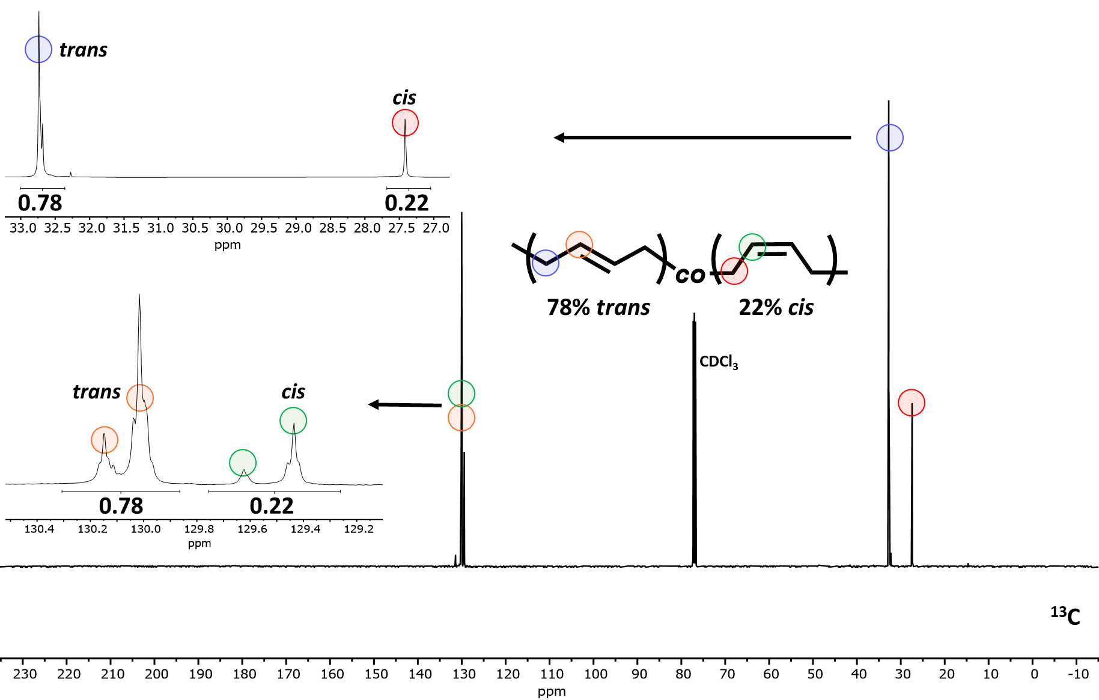
Figure S4. Representative ¹³C NMR spectra in CDCl₃ of p(COD), containing 3 wt% ENB, amorphous region from the Ru-1 initiator displaying both cis and trans configurations. Ratio of cis and trans configurations signals for each backbone carbon (inset).

Table S1. Summary of trans content for Ru-1 derived specimens as a function of time, extracted from the plots provided in Extended Data Figure 2a.
Time (h) | Initiator | Specimen Type | Domain | Trans (%)
0 | Ru-1 | Uniform | N/A | 77 ± 1
24 | Ru-1 | Uniform | N/A | 85 ± 3
48 | Ru-1 | Uniform | N/A | 88 ± 2
72 | Ru-1 | Uniform | N/A | 88 ± 3
96 | Ru-1 | Uniform | N/A | 88 ± 4
0 | Ru-1 | Architected | Semi-crystalline | 76 ± 3
24 | Ru-1 | Architected | Semi-crystalline | 80 ± 3
48 | Ru-1 | Architected | Semi-crystalline | 88 ± 2
72 | Ru-1 | Architected | Semi-crystalline | 88 ± 3
96 | Ru-1 | Architected | Semi-crystalline | 87 ± 3
0 | Ru-1 | Architected | Amorphous | 76 ± 3
24 | Ru-1 | Architected | Amorphous | 80 ± 3
48 | Ru-1 | Architected | Amorphous | 86 ± 2
72 | Ru-1 | Architected | Amorphous | 89 ± 2
96 | Ru-1 | Architected | Amorphous | 88 ± 3

Reported values and error bars represent the average and standard deviation, respectively for a n=3.

Table S2. Summary of trans content for Ru-2 derived specimens as a function of time, extracted from the plots provided in Fig. S1a.
Time (h) | Initiator | Specimen Type | Domain | Trans (%)
0 | Ru-2 | Uniform | N/A | 74 ± 2
24 | Ru-2 | Uniform | N/A | 81 ± 2
48 | Ru-2 | Uniform | N/A | 84 ± 3
72 | Ru-2 | Uniform | N/A | 83 ± 3
96 | Ru-2 | Uniform | N/A | 83 ± 4
0 | Ru-2 | Architected | Semi-crystalline | 69 ± 3
24 | Ru-2 | Architected | Semi-crystalline | 83 ± 4
48 | Ru-2 | Architected | Semi-crystalline | 86 ± 4
72 | Ru-2 | Architected | Semi-crystalline | 87 ± 3
96 | Ru-2 | Architected | Semi-crystalline | 89 ± 3
0 | Ru-2 | Architected | Amorphous | 69 ± 3
24 | Ru-2 | Architected | Amorphous | 79 ± 2
48 | Ru-2 | Architected | Amorphous | 83 ± 3
72 | Ru-2 | Architected | Amorphous | 84 ± 4
96 | Ru-2 | Architected | Amorphous | 83 ± 4

Reported values and error bars represent the average and standard deviation, respectively for a n=3.

Table S3. Summary of trans content for Ru-3 derived specimens as a function of time, extracted from the plots provided in Fig. S1b.
Time (h) | Initiator | Specimen Type | Domain | Trans (%)
0 | Ru-3 | Uniform | N/A | 77 ± 3
24 | Ru-3 | Uniform | N/A | 81 ± 4
48 | Ru-3 | Uniform | N/A | 83 ± 1
72 | Ru-3 | Uniform | N/A | 86 ± 4
96 | Ru-3 | Uniform | N/A | 85 ± 4
0 | Ru-3 | Architected | Semi-crystalline | 75 ± 3
24 | Ru-3 | Architected | Semi-crystalline | 86 ± 2
48 | Ru-3 | Architected | Semi-crystalline | 87 ± 3
72 | Ru-3 | Architected | Semi-crystalline | 89 ± 4
96 | Ru-3 | Architected | Semi-crystalline | 89 ± 2
0 | Ru-3 | Architected | Amorphous | 75 ± 3
24 | Ru-3 | Architected | Amorphous | 83 ± 3
48 | Ru-3 | Architected | Amorphous | 83 ± 4
72 | Ru-3 | Architected | Amorphous | 86 ± 4
96 | Ru-3 | Architected | Amorphous | 84 ± 5

Reported values and error bars represent the average and standard deviation, respectively for a n=3.

Confocal Raman Spectroscopy
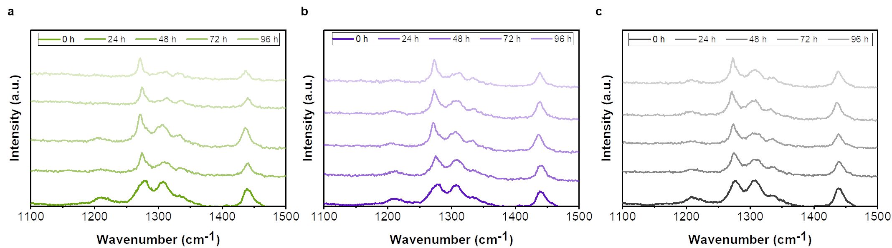
Figure S5. Representative Raman spectra taken every 24 h for specimens derived with the Ru-2 initiator. a, Spectra for a uniform polymer. b, Spectra for an architected polymer in the semi-crystalline domain. c, Spectra for an architected polymer in the amorphous domain.
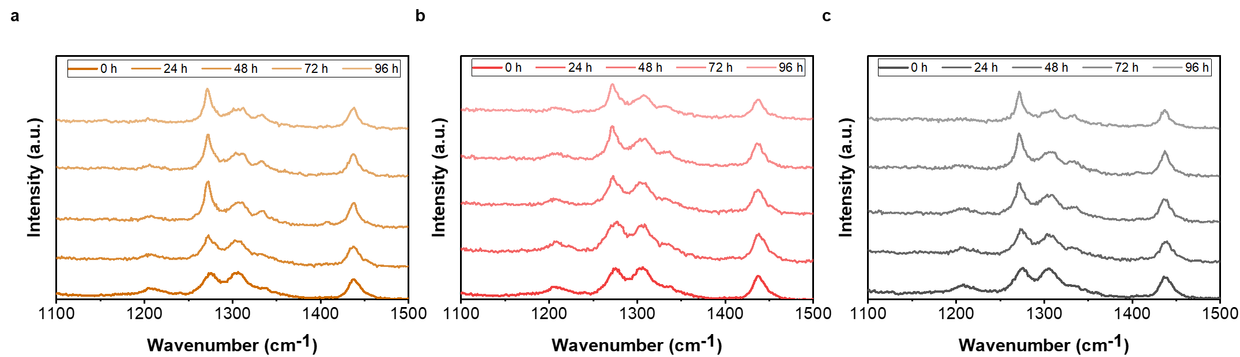
Figure S6. Representative Raman spectra taken every 24 h for specimens derived with the Ru-3 initiator. a, Spectra for a uniform polymer. b, Spectra for an architected polymer in the semi-crystalline domain. c, Spectra for an architected polymer in the amorphous domain.

DSC Heat of Fusion:
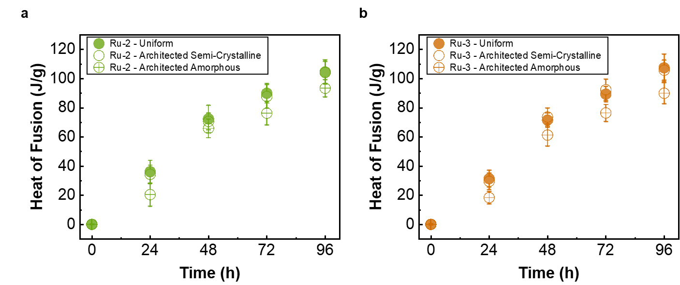
Figure S7. Heat of fusion as a function of time for uniform and architected specimens. a, Specimens derived with the Ru-2 initiator. b, Specimens derived with the Ru-3 initiator. (a, b) Reported values and error bars represent the average and standard deviation, respectively (n = 3).

X-Ray Scattering
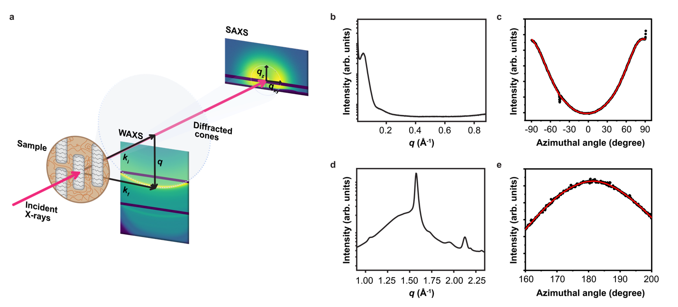
Figure S8. Representative small- and wide-angle X-ray scattering (S/WAXS) data obtained for the molecularly architected polymer sample (91:9 COD/ENB mixture in weight ratio prepared with Ru-2 initiator at 20 °C in thickness of 2.4 mm). a, Graphical illustration of SAXS and WAXS data collection set-up displaying i) the detectors with diffraction pattern and ii) a cartoon of a sample depicting the nano-/molecular structure of the lamellae and polymer chain orientations. Polymer chains align orthogonally to the lamellae orientation. b, The radially integrated 1D I(q) SAXS profile of the lamellae diffraction pattern in a. c, The 1D azimuthal profile of the 2D SAXS lamellae diffraction pattern in a. d, The radially integrated 1D I(q) WAXS profile of the polymeric chain diffraction pattern in a. e, The 1D azimuthal profile of the 2D WAXS polymeric chain diffraction pattern in a.
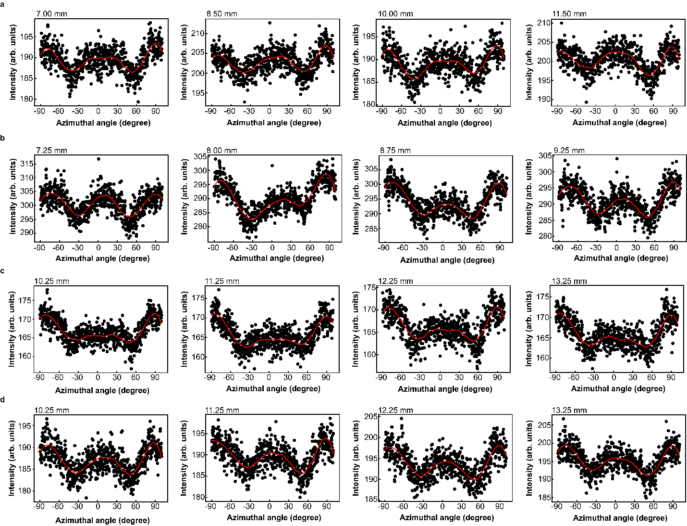
Figure S9. The 1D azimuthal profiles of the 2D SAXS lamellae diffraction patterns obtained for the samples at four representative locations along the X2 scan direction. a, Ru-1 derived architected specimen fabricated at an ambient temperature of 25 °C. b, Ru-2 derived architected specimen fabricated at an ambient temperature of 25 °C. c, Ru-3 architected specimen fabricated at an ambient temperature of 25 °C. d, Ru-3 uniform specimen fabricated at an ambient temperature of 50 °C.

DSC Dynamic Cure Profile

Figure S10. Dynamic DSC traces for Ru-3 initiator formulations that yield spin mode of front propagation. The solid curve represents the formulation that results in successful nonplanar dynamics at higher temperatures and the dashed curve represents the formulation that results in successful nonplanar dynamics at lower temperatures. The formulations for each case are presented in Extended Data Table 1.

Material Domain Spacing

Figure S11. Average spacing between material domains (d) as a function of the width of the closed mold for specimens derived from the Ru-2 and Ru-3 initiators. The ambient temperature was held constant at 25 °C for all fabricated architected specimens. Reported values and error bars represent the average and standard deviation, respectively for a n=3.

Table S4. Summary of the average domain spacing at various ambient temperatures and mold widths, extracted from the plots in Fig. 2c, Fig. 2f, Fig. 3c, and Supplementary Fig. S11.
Initiator | Width of Mold  (cm) | Ambient Temperature  (°C) | Domain Spacing  (mm)
Ru-1 | 1.5 | 15 | 1.9 ± 0.1
Ru-1 | 1.5 | 20 | 1.6 ± 0.2
Ru-1 | 1.5 | 25 | 1.3 ± 0.1
Ru-1 | 1.5 | 30 | 0.7 ± 0.1
Ru-1 | 0.5 | 20 | 1.8 ± 0.2
Ru-1 | 3 | 20 | 1.2 ± 0.1
Ru-1 | 5 | 20 | 0.9 ± 0.1
Ru-1 | 6 | 20 | 0.9 ± 0.1
Ru-2 | 1.5 | 25 | 0.8 ± 0.1
Ru-2 | 1.5 | 30 | 0.6 ± 0.1
Ru-2 | 1.5 | 35 | 0.6 ± 0.1
Ru-2 | 1.5 | 40 | 0.5 ± 0.02
Ru-2 | 0.5 | 25 | 1.1 ± 0.04
Ru-2 | 3 | 25 | 0.8 ± 0.1
Ru-2 | 5 | 25 | 0.7 ± 0.3
Ru-2 | 6 | 25 | 0.7 ± 0.1
Ru-3* | 1.5 | 25 | 0.9 ± 0.1
Ru-3* | 1.5 | 30 | 0.7 ± 0.1
Ru-3 | 1.5 | 40 | 1.0 ± 0.1
Ru-3 | 1.5 | 45 | 0.7 ± 0.1
Ru-3 | 1.5 | 50 | 0.6 ± 0.1
Ru-3 | 0.5 | 25 | 1.0 ± 0.1
Ru-3 | 3 | 25 | 0.7 ± 0.02
Ru-3 | 5 | 25 | 0.7 ± 0.04
Ru-3 | 6 | 25 | 0.6 ± 0.01

Reported values and error bars represent the average and standard deviation, respectively for a n=3.

Nanoindentation
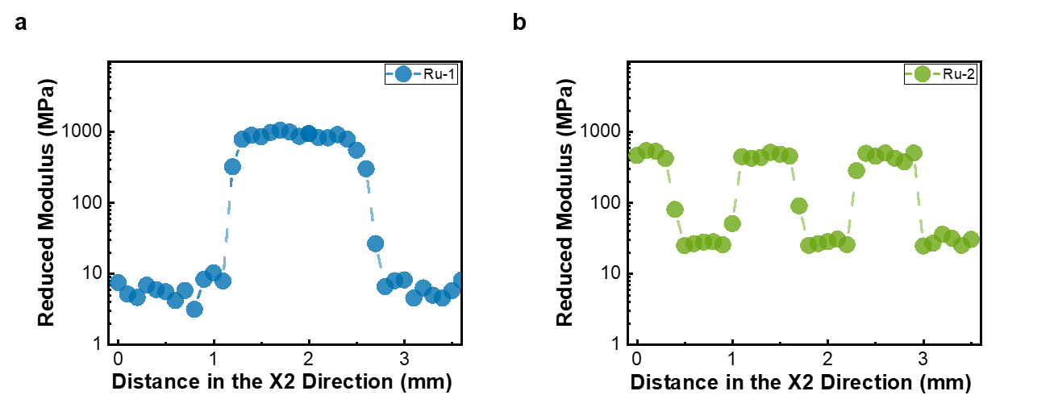
Figure S12. Reduced modulus as a function of distance in the X2 direction obtained via nanoindentation for 1.5 cm wide architected specimens 24 h post polymerization. a, Specimen derived with the Ru-1 initiator. b, Specimen derived with the Ru-2 initiator.

Uniaxial Tensile Tests
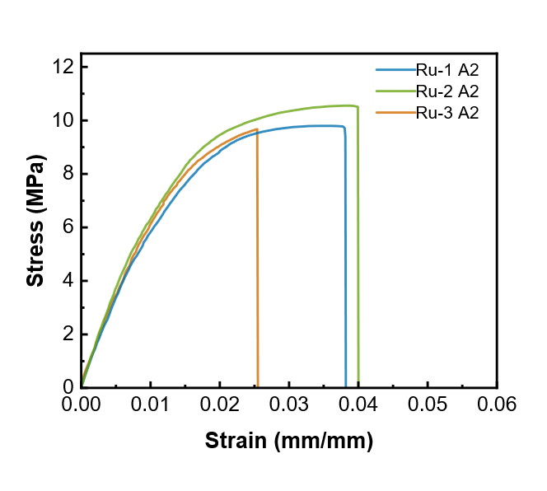
Figure S13. Representative stress-strain curve for uniform dog-bones in the A2 configuration fabricated with each ruthenium initiator.

Heat of Fusion – Tensile Specimens

Table S5. Summary of the heat of fusion for tensile specimens derived from different ruthenium initiators and by different modes of front propagation.
Initiator | Specimen Type | Time Post Polymerization  (h) | Ambient Temperature  (°C) | Heat of Fusion (J/g)
Ru-1 | Architected A1 | 144 | 20 | 84.4 ± 9.2
Ru-1 | Architected A2 | 144 | 20 | 85.7 ± 7.4
Ru-1 | Uniform A1 | 72 | 20 | 96.3 ± 5.8
Ru-1 | Uniform A1 | 72 | 20 | 93.4 ± 7.1
Ru-2 | Architected A1 | 120 | 30 | 89.9 ± 6.3
Ru-2 | Architected A2 | 120 | 30 | 90.4 ± 8.9
Ru-2 | Uniform A1 | 72 | 30 | 99.3 ± 6.4
Ru-2 | Uniform A1 | 72 | 30 | 92.5 ± 9.6
Ru-3 | Architected A1 | 120 | 40 | 94.2 ± 7.1
Ru-3 | Architected A2 | 120 | 40 | 95.8 ± 8.8
Ru-3 | Uniform A1 | 72 | 40 | 97.7 ± 6.2
Ru-3 | Uniform A1 | 72 | 40 | 95.3 ± 7.9

Reported values and error bars represent the average and standard deviation, respectively for a n=3.

Thermomechanical Characterization
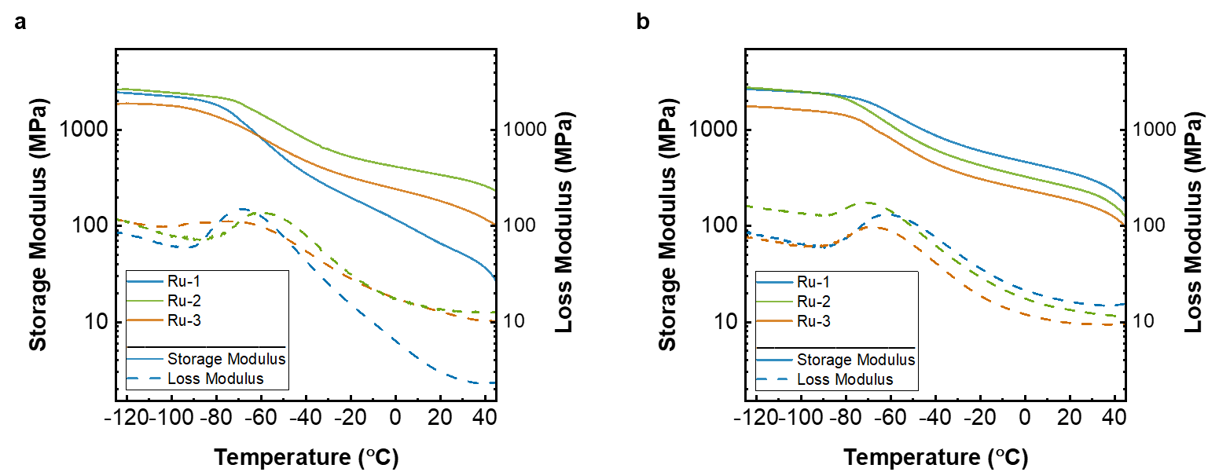
Figure S14. Representative storage and loss modulus curves 24 h post polymerization. a, Architected specimens derived with each ruthenium initiator. b, Uniform specimens derived with each ruthenium initiator.

