Extended Data Figures

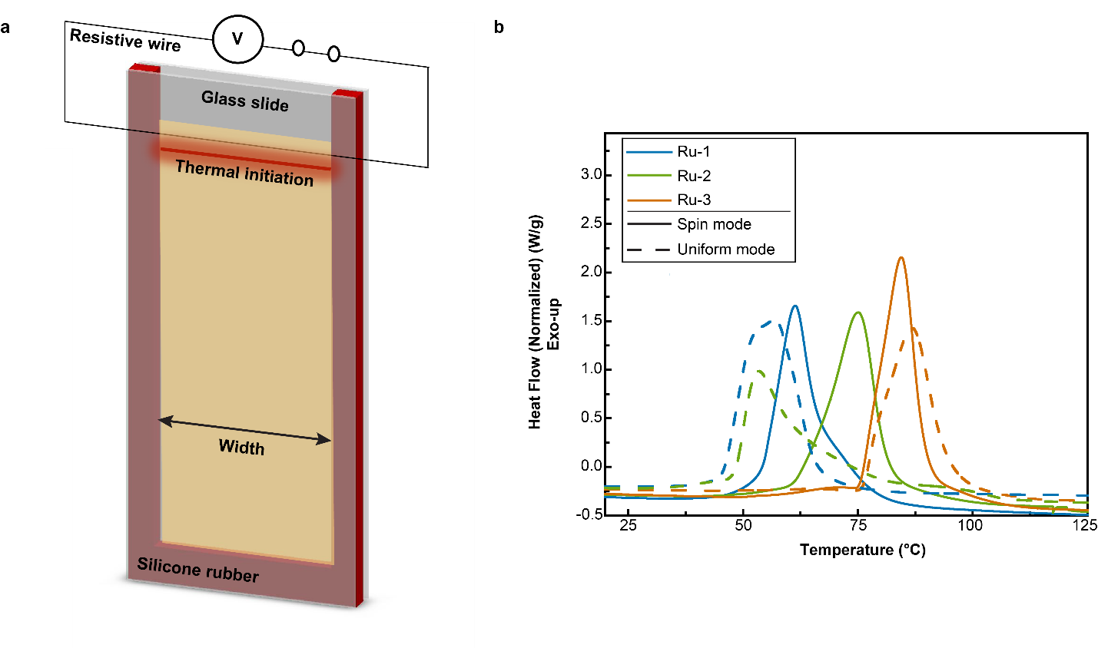
Extended Data Figure 1. Experimental setup and characterization of COD curing. a, Schematic representation of the experimental setup of the thermal frontal polymerization for both planar and nonplanar front dynamics. Initiation was achieved by powering a resistive wire in contact with one of the glass slides at the indicated location. b, Dynamic DSC traces for the three initiator formulations (Ru-1, Ru-2, and Ru-3) that yield either spin mode or uniform mode of propagation. The solid curves represent the formulations that produce spin modes, and the dashed curves represent formulations that produce uniform modes. The formulations for each initiator and mode of propagation are presented in Extended Data Table 1.

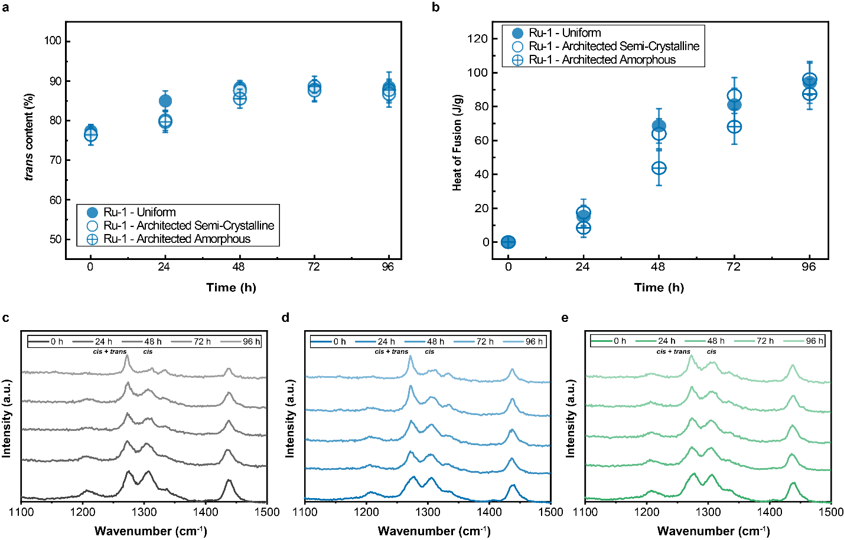
Extended Data Figure 2. Evolution of trans content of Ru-1 derived polymers. a, trans content as a function of time for uniform and architected polymers derived from the Ru-1 initiator. b, Heat of fusion as a function of time for uniform and architected specimens. (a, b) Reported values and error bars represent the average and standard deviation, respectively (n = 3). Raman spectra taken every 24 h for Ru-1 derived specimens c, Uniform polymer, d, Architected polymer in the semi-crystalline domain. e, Architected polymer in the amorphous domain.

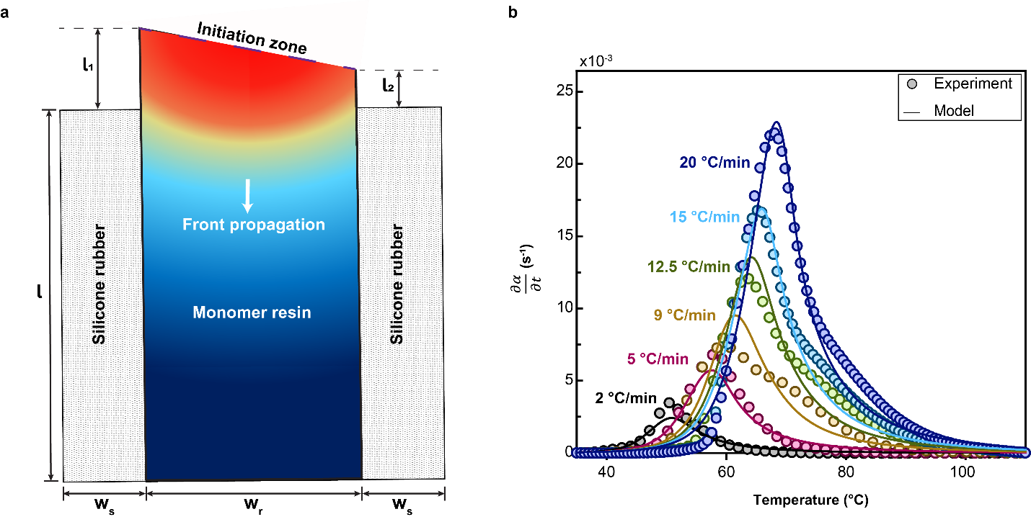
Extended Data Figure 3. Numerical simulations of COD in a closed mold geometry. a, Schematic representation of frontal polymerization in a closed mold geometry with silicone rubber and glass as boundaries. b, Cure profiles, ${dα}/{dt}$ (s⁻¹) vs temperature (°C) at various ramp rates (2, 5, 9, 12.5, 15, 20 °C/min) as measured experimentally by DSC and fit using an Arrhenius cure kinetic model that was used to extract the numerical parameters (E_{a}, n, and m) used in the simulations (Extended Data Table 2).

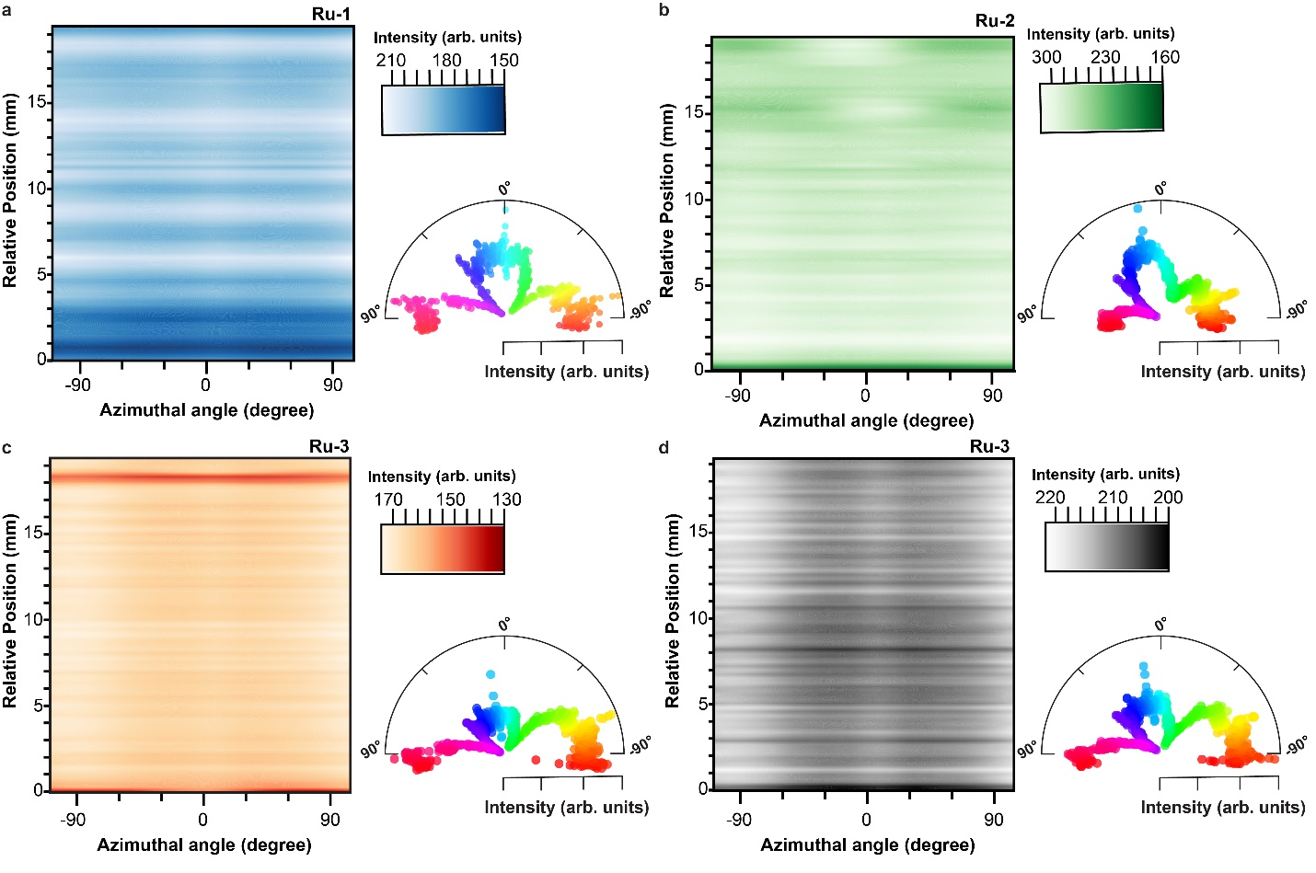
Extended Data Figure 4. X-ray scattering of architected and uniform polymers. Contour plots of the azimuthal angle as a function of the relative position in the X2 scan direction and the corresponding polar plots of the average distribution of the polymer chain orientations along the scan direction. a, Ru-1 derived architected specimen fabricated at an ambient temperature of 25 °C b, Ru-2 derived architected specimen fabricated at an ambient temperature of 25 °C c, Ru-3 architected specimen fabricated at an ambient temperature of 25 °C d, Ru-3 uniform specimen fabricated at an ambient temperature of 50 °C.

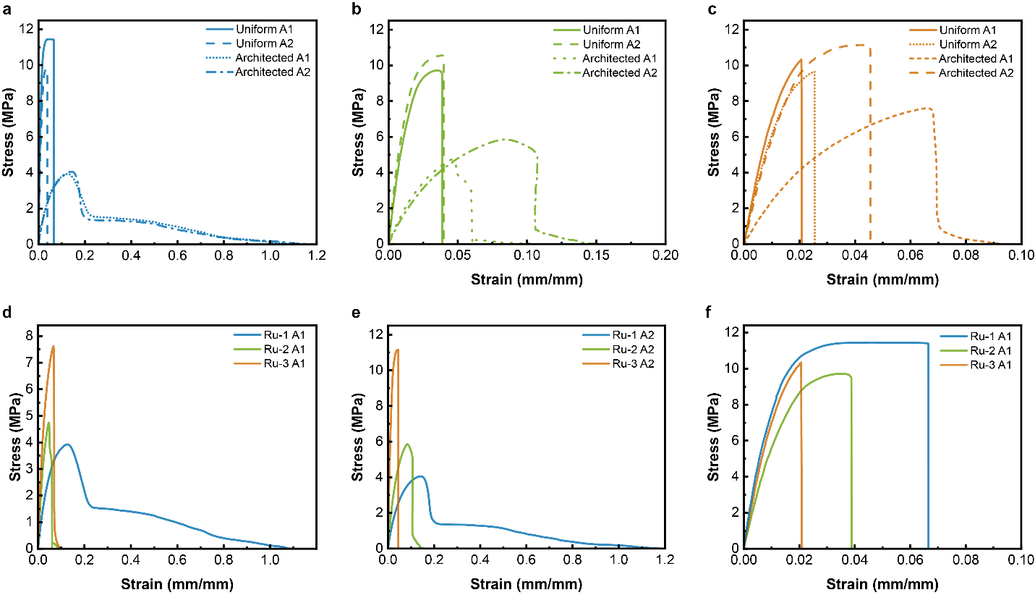
Extended Data Figure 5. Tensile measurements of architected and uniform polymers. a-f representative stress-strain curves for uniform and architected polymers derived from the three different ruthenium initiators. d, e are comparisons of the resulting architected specimens in the A1 and A2 directions and f is the comparison of the uniform specimens in the A1 direction. Corresponding values of the mechanical properties can be found in Extended Data Table 4.

