Supplementary information
Supplementary Methods

Isolation of immune cells and immunophenotyping
On the day of the analysis, mice 8-10 weeks old from each strain were first anaesthetized and then sacrificed by cervical dislocation. BM cells were obtained by flushing the marrow cavities with FACS Buffer (PBS 0.1% FBS) using an insulin syringe with 28G needle, followed by passage through a 70 µm sterile cell strainer. Splenic and lymph nodes cells were obtained by gentle pressure-dissociation of spleen using FACS buffer, and then passed through a 70 µm sterile cell strainer. For all experiments, cells were washed with FACS buffer and pelleted. Cells were re-suspended in FACS buffer and incubated with FcR blocking reagent (Miltenyi Biotec) in ice for 10 min than were divided into individual tubes for respective cell type analysis, suspended in 100 µl of FACS buffer, and stained for the designated cell type. The data were acquired with FACSCanto (BD Biosciences) and analyzed using FACSDiva software (BD Biosciences). Markers used for immune cell strategies are described in Supplemental Table S1. All gating was performed off of live cell populations. Unstained controls and isotype control antibodies were utilized to establish baseline gate settings for each respective antibody–fluorophore(s) combination used in individual experiments.

Retina and RPE/choroid immunofluorescence staining
Eyes were enucleated from PlGF-KO, PlGF-DE-Ki and C57Bl6/J mice and fixed for 3 hours in 4% paraformaldehyde (PFA). After a PBS wash, retinae and RPE/choroid were dissected, flattened, washed in PBS and permeabilized in 5% Tween-20 and 5% Triton-X-100 for 16 hours at 4°C. The fixed retinae were blocked in 1% Milk in PBS 0.1% Triton-X-100 for 16 hours at 4°C and then stained with anti-Iba1 (1:500, WAKO) for 16h at 4°C. After two washes in PBS/0.1% Triton, retinae were incubated with Alexa-Fluor 488 goat-anti-rabbit antibody (1:400; Jackson Antibodies) and mounted on slides with Vectashield (Vector Laboratories). Images were acquired on Nikon A1 confocal microscope. The extent of Iba1 positive area was evaluated using ImageJ software.

Immunostaining in retinal cryosections
Eyes were enucleated, snap-frozen in OCT, and cryosectioned. 10 μm-thick sections were fixed 20 minutes with PFA 4%. Slides were then washed three times in PBS and blocked 1 hour in 10% normal goat serum (NGS), 1% bovine serum albumin (BSA), 0.3% Triton-X-100 and then stained overnight at 4°C with the following primary antibodies: anti-Iba1 (1:500, WAKO), rabbit anti-p-VEGFR1 antibody (1:100, R&D) and rat F4/80 (1:500, Serotec). The following day, sections were washed three times and incubated with Alexa-Fluor 488 goat-anti-rabbit antibody, Alexa-Fluor 594 goat-anti-rat antibody and conjugated donkey anti-rabbit antibody (1:500; Jackson Antibodies) for 1 hour at RT. Sections were then mounted with Vectashield with DAPI (Vector Laboratories). Instead of primary antibody IgG isotype labeling was used as a negative control for all experiments. Images were acquired on Nikon A1 confocal microscope. Morphological analysis of Iba1+ mononuclear phagocytes in lasered retinae was done using a grid system conting the points of a cell that crossed the grid ²⁰. The evaluation of Iba1+ area per laser lesions was performed using ImageJ software (National Institutes of Health, U.S.A.). The average grid crossing points and Iba1+ area per laser lesion was calculated.

Quantitative real-time PCR
Total RNA was isolated using Trizol reagent (Invitrogen), DNase treated and reverse transcribed (QuantiTect, QIAGEN). The RT products (cDNA) were amplified by real-time quantitative PCR on CFX96TM Real Time PCR Detection Systems (BioRad) with SYBR green Master Mix. Oligonucleotide primers specific for mouse Amwap (forward 5’-TTTGATCACTGTGGGGATGA-3’ and reverse 5’-ACACTTTCTGGTGAAGGCTTG-3’), mouse Ccl2 (forward 5’-CATCCACGTGTTGGCTCA-3’ and reverse 5’-GATCATCTTGCTGGTGAATGAGT -3’), mouse Ccr2 (forward 5’-CACACCCTGTTTCGCTGTAG-3’ and reverse 5’- GCAGCAGTGTGTCATTCCAA-3’) and mouse actin (forward 5’-CGGTTCCGATGCCCTGAGGC-3’ and reverse 5’-CAGCAATGCCTGGGTACATGGTGG -3’) were used. The PCR cycling conditions were 50 °C for 2 minutes, 95 °C for 10 minutes followed by 40 cycles of a two-step amplification program (95 °C for 15 s and 58 °C for 1 minute). At the end of the amplification, melting curve analysis was applied using the dissociation protocol from the Sequence Detection system to exclude contamination with unspecific PCR products. The PCR products were also confirmed by agarose gel and showed only one specific band of the predicted size. For negative controls, no RT products were used as templates in the qRT-PCR and verified by the absence of gel-detected bands. Relative expressions of target genes were determined by the 2^{–DCt} method. Each point was done in triplicate.

Western blot analysis
Retinal tissues were isolated from enucleated eyes 3 days after laser injury in C57Bl6/J and PlGF-DE-Ki mice (n = 4) and homogenized with a Tissue Lyser (Qiagen) in lysis buffer (Tris-HCl 20 mM pH 8, NaCl 150 mM, Triton X-100 1%, EDTA 10 mM, Glycerol 10%, ZnAc 1 mM) supplemented with protease inhibitors (Roche), for 5 minutes at 3000 rpm. The supernatants were recovered and stored at−80°C. Western blot experiments were performed following standard procedures. 50-100μg of total protein extracts were run on 10% SDS-polyacrylamide gel and transferred to a PVDF membrane (Millipore) and incubated with antibodies against p-VEGFR-1 (R&D Systems, 1:500) and VEGFR-1 (Sigma, 1:500). The secondary antibodies were from Genetex (1:10,000). The signals were visualized by chemiluminescence using ECL substrate (Advansta) and capture by iBright image system (Thermoscientific). Densitometry analyses were performed using ImageJ software (National Institutes of Health, U.S.A.).

Supplementary Table 1

SAMPLE | CELL SUBSET
B1 | iso T cells | isotype PE-Cy™7/PE/FITC
B2 | T cells | PE-Cy™7 CD3e / PE CD4 / FITC CD8
B3 | iso B cells | isotype PE-Cy™7/PE/FITC
B4 | B cells | PE-Cy™7 CD45R/B220 / PE CD23 (FcεRII) / FITC sIgM
B5 | iso NK myeloid | isotype PE/APC
B6 | NK cells | CD335 (NKp46) PE / NK-1.1 APC
B7 | Myeloid cells | Cd11b PE / Gr1 (Ly-6G and Ly-6C) APC
B8 | iso Macrophage | isotype APC
B9 | Macrophage | F4/80 APC
B10 | iso Dendritic cell | isotype PE/FITC
B11 | Dendritic cell | Cd11b PE / Cd11c FITC
B12 | iso Treg cells | isotype FITC/ APC/ PE
B13 | Treg cells | CD4FITC/CD25APC/FoxP3PE
L1 | iso T cells | isotype PE-Cy™7/PE/FITC
L2 | T cells | PE-Cy™7 CD3e / PE CD4 / FITC CD8
L3 | iso B cells | isotype PE-Cy™7/PE/FITC
L4 | B cells | PE-Cy™7 CD45R/B220 / PE CD23 (FcεRII) / FITC sIgM
L5 | iso NK myeloid | isotype PE/APC
L6 | NK cells | CD335 (NKp46) PE / NK-1.1 APC
L7 | Myeloid cells | Cd11b PE / Gr1 (Ly-6G and Ly-6C) APC
L8 | iso Macrophage | isotype APC
L9 | Macrophage | F4/80 APC
L10 | iso Dendritic cell | isotype PE/FITC
L11 | Dendritic cell | Cd11b PE / Cd11c FITC
L12 | iso Treg cells | isotype FITC/ APC/ PE
L13 | Treg cells | CD4FITC/CD25APC/FoxP3PE
S1 | iso T cells | isotype PE-Cy™7/PE/FITC
S2 | T cells | PE-Cy™7 CD3e / PE CD4 / FITC CD8
S3 | iso B cells | isotype PE-Cy™7/PE/FITC
S4 | B cells | PE-Cy™7 CD45R/B220 / PE CD23 (FcεRII) / FITC sIgM
S5 | iso NK myeloid | isotype PE/APC
S6 | NK cells | CD335 (NKp46) PE / NK-1.1 APC
S7 | Myeloid cells | Cd11b PE / Gr1 (Ly-6G and Ly-6C) APC
S8 | iso Macrophage | isotype APC
S9 | Macrophage | F4/80 APC
S10 | iso Dendritic cell | isotype PE/FITC
S11 | Dendritic cell | Cd11b PE / Cd11c FITC
S12 | iso Treg cells | isotype FITC/ APC/ PE
S13 | Treg cells | CD4FITC/CD25APC/FoxP3PE
B= BONE MARROW L=LYMPHONODES S=SPLEEN

Supplementary Figure S1

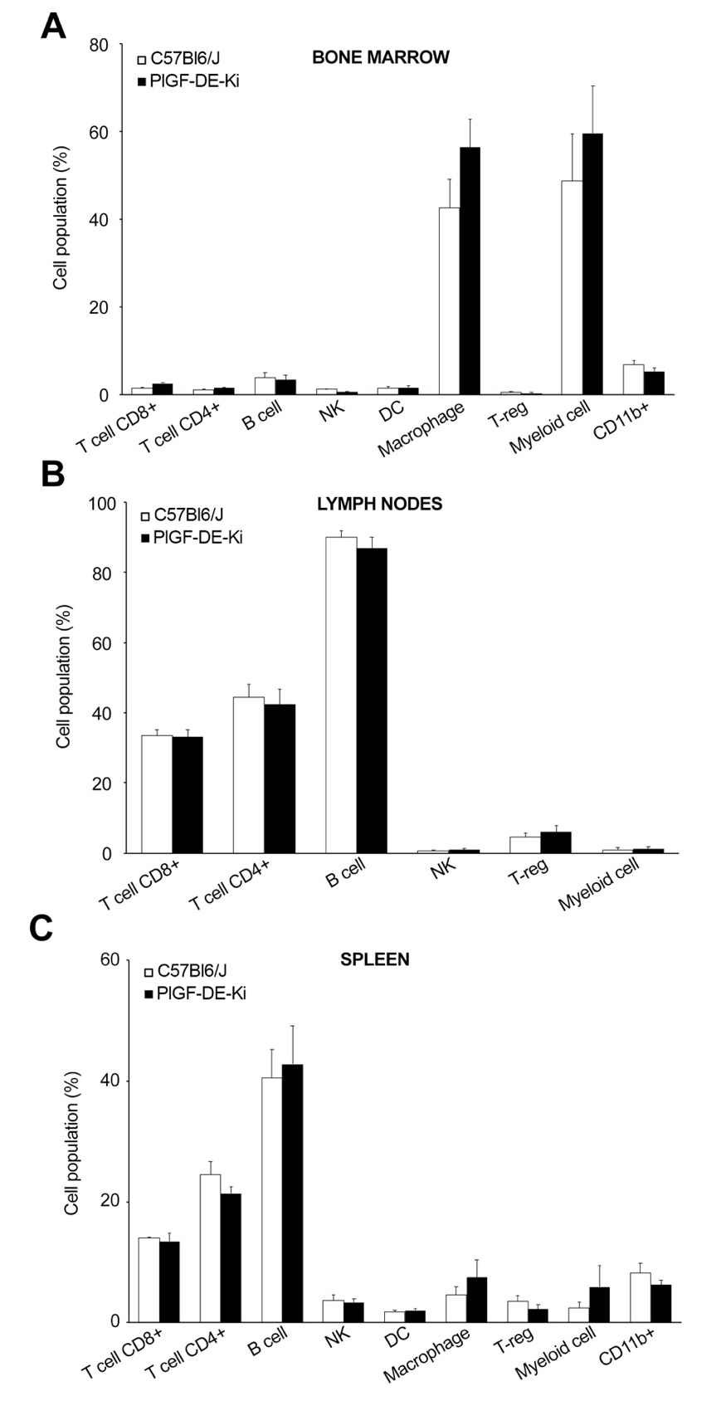

Immune cell phenotype of C57Bl6/J and PlGF-DE-Ki mice. T cells, B cells, natural killer cells, dendritic cells, Treg cells, myeloid cells and macrophage populations were analyzed by flow cytometry from bone marrow, lymph nodes and spleen. No significative differences were observed.

Supplementary Figure S2, related to Figure 3

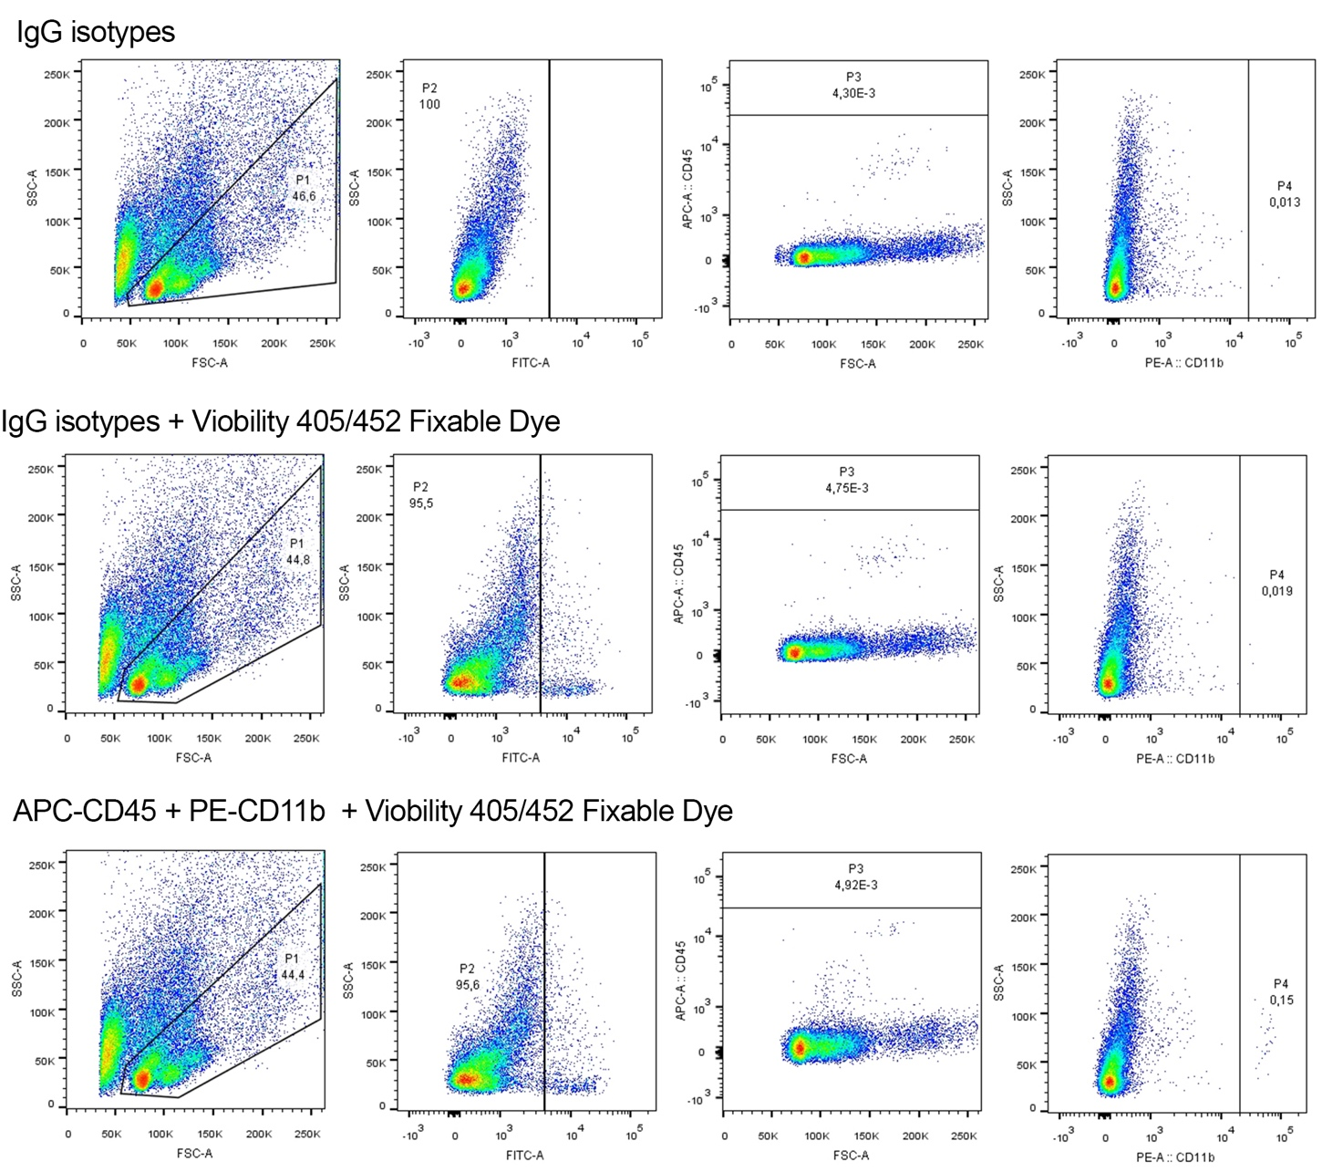

Gating strategy and isotype control antibodies for flow cytometry analysis.

Supplementary Figure S3, related to Figure 4

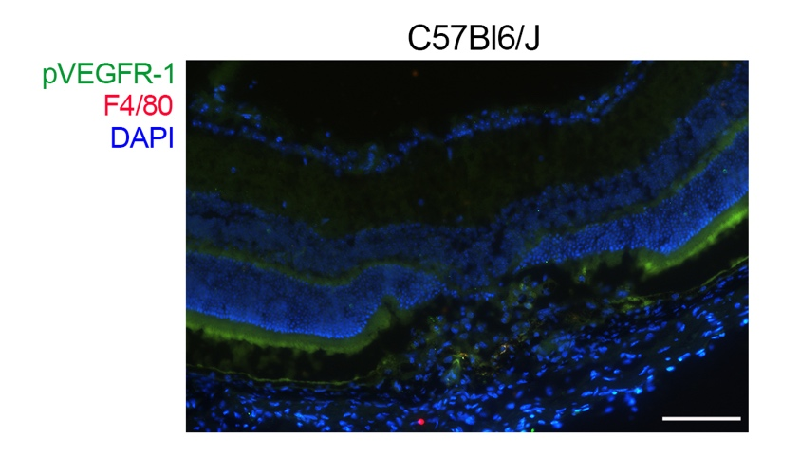

Isotype control antibodies for anti-p-VEGFR-1 and F4/80 staining. Representative image of immunostaining of isotype control antibodies on a C57Bl6/J CNV lesion. Scale bar: 100 μm.

