The distribution and drivers of tree cover in India

Supplementary Information

Supplementary Methods

Study area delineation and point sampling strategy
All union territories, except that of Jammu and Kashmir (which was treated as a state), were included as part of the state they are in (Table S4). We excluded Andaman & Nicobar and Lakshadweep islands from here onwards, due to lack of remaining spatial datasets. We do not include the disputed areas of Aksai Chin and Azad Kashmir and Gilgit- Baltistan, in the former princely state of Jammu and Kashmir in these analyses. These analyses were completed at the native resolutions of 100m and 60m of the two main datasets (Roy et al., 2016; Roy et al., 2015), WGS 1984 UTM 43N and then resampled to 250m resolution using the nearest neighbour method and WGS 1984 coordinate system.
Our sampling strategy initially included the use of 100 mm precipitation bins following Staver et al., (2011) for which we obtained similar overall results. For improved manageability of the number of bins created considering the wide range of mean annual precipitation across the final study area (Fig S1), we finally chose 150 mm precipitation bins.
Of the 9600 sampled points across the mean annual precipitation (MAP) strata in the study area, we excluded 1046 points (10.8% of total n=9600) due to lack of data of herbivory for buffalo, goat and sheep (n=926), sand fraction (n=212), heat load index (HLI) (n=30) and topographical position index and landform classes (n=136).

Processing resource and disturbance based drivers
We processed information about vapour pressure deficit, mean annual precipitation, dry season length, mean annual aridity and maximum climate water deficit (MCWD) from Terraclimate (Abatzoglou et al., 2018) (Table S3). We found that vapour pressure deficit, dry season length and mean annual aridity were significantly correlated with remaining climate variables (r>0.7, p<0.0.5). Hence, we retained mean annual precipitation and MCWD in the analyses.
We completed a correlation matrix based principal coordinate analysis to reduce redundancy of herbivory pressure of different domestic livestock (Fig S6). Three principal coordinate axes accounted for 77.5% of the cumulative explained variance, where PC1 explained 30.1%, PC2 explained an additional 26.6% and PC3 further explained an additional 20.8%. Horse and buffalo herbivory pressure were associated with PC2, and goat and cattle herbivory pressure were associated with PC1 (Table S2). See Table S3 for additional details of all drivers of tree cover.

Evaluation of drivers of potential tree cover shortfall
Only sampled points in the mixed and medium tree zones with the ratio of current tree cover to climatic maximum potential tree cover <1 were included in the evaluation of drivers of potential tree cover shortfall (n=3323). Furthermore, we excluded 5 of the remaining sampled points with human population density >10,000 people/km². Lastly, we excluded 212 of the remaining sampled points that are 2 standard deviations beyond the topographic position index (final size n=3106).
To account for the skewed distribution and kurtosis of some of the environmental drivers (Fig S5), we log transformed herbivory pressure drivers, fire intensity and fire frequency. Since buffalo herbivory pressure, burn frequency and fire intensity have 0 values in the final sample of points, we added a constant of 1/10th of the least non zero values in the respective driver, to allow for convergence of models.

Supplementary Tables

Table S1 Determinants of shortfall, considering all drivers, in the core savanna and mixed savanna forest zones (deviance explained = 52.6%, REML= -766.32)
Factor | Statistics
Factor | Effective Degrees of Freedom | χ2 | p value
FRP | 1.499 | 5.699 | 0.021
burn frequency | 2.061 | 62.635 | <2e-16
FRP, burn frequency | 1.450 | 4.008 | 0.031
sand fraction | 0.991 | 4.146 | 0.018
buffalo pressure | 0.464 | 0.647 | 0.201
goat pressure | 0.001 | 0.001 | 0.373
sheep pressure | 3.666 | 39.414 | <2e-16
human population density | 1.452 | 18.080 | <2e-16
HLI | 3.540 | 82.008 | <2e-16
TPI | 3.711 | 104.066 | <2e-16
x,y | 67.048 | 755.344 | <2e-16

Table S2 Loadings of the different herbivory pressure types against five principal coordinate axes
Herbivory pressure type | PC1 | PC2 | PC3 | PC4 | PC5
Buffalo | -0.1543 | -0.6908 | 0.0173 | 0.6843 | -0.1737
Cattle | 0.6919 | -0.0927 | -0.2429 | -0.1004 | -0.6659
Goat | 0.6976 | -0.1359 | 0.1449 | 0.1847 | 0.6630
Horse | -0.0808 | -0.7008 | -0.1036 | -0.6838 | 0.1545
Sheep | 0.0642 | -0.0665 | 0.9533 | -0.1405 | -0.2505

Table S3 Details of datasets used with information about processing
Group | Dataset and reference | Processing information | Temporal and spatial resolution information
percentage tree cover | percentage tree cover  MOD44B.006 Terra Vegetation Continuous Fields (yearly) | We calculated the mean annual percentage tree cover from annual tree cover information, using Google Earth Engine (Gorelick et al., 2017). | 2000-2020, 250m, WGS 1984 Geographic Coordinate Systems (GCS)
climate | mean annual estimates of precipitation (mmyr⁻¹) (MAP), dry season length (DSL) (months), aridity index (precipitation/potential evapotranspiration), vapor pressure deficit (VPD) (kPa) and maximum climate water deficit (MCWD) (mm) | We calculated the mean annual estimates of the climatic variables using TerraClimate monthly climate and climatic water balance product for global terrestrial surfaces (Abatzoglou et al., 2018).  We extracted yearly estimates of VPD, precipitation and potential evapotranspiration using Google Earth Engine (Gorelick et al., 2017) and we estimated MAP, DSL and aridity following Schwartz et al., 2020.  We calculated MCWD by resetting the climate water deficit to the wettest month of the year following Aragão et al., 2007 and Malhi et al., 2015. To calculate MCWD, we used potential evapotranspiration, as opposed to actual evapotranspiration, because in relatively dry areas with minimal annual precipitation, MCWD derived from actual evapotranspiration breaks down to show reverse trends of water deficit, which is ecologically nonsensical for our study. | 1981-2021, 4638.m
fire | mean annual fire radiative power (FRP) (megawatts MW) as a proxy for fire intensity and fire frequency | We estimated mean annual fire radiative power (FRP) (megawatts MW) as a proxy for fire intensity, using VIIRS 375m active fire product (Schroeder & Giglio, 2018) because it appropriately captures fire trends across south and southeast Asia (Vadrevu et al., 2019). We converted the point locations of the active fires to pixels of 375m resolution, considering only those points classified to have ‘high’ confidence (Schroeder & Giglio, 2018).  To account for the limited temporal resolution of the VIIRS 375m active fire product i.e. start date is 2012, we estimated the fire frequency as the number of times an area burned in 2000-2021, using MCD64A1.006 MODIS burned area monthly global 500m product via Google Earth Engine (Gorelick et al., 2017). | FRP (2012-2020), 375m and fire frequency (2000-2021) and 500m
soil | sand fraction (g/100g or percentage) | We used SoilGrids250m version 2.0 to estimate the sand fraction (Poggio et al., 2021). We calculated the weighted mean of sand fraction, considering bulk density (kg/dm³) across 0 - 5 cm, 5 - 15 cm and 15 - 30 cm as the sand fraction in the 0 - 30cm depth. | snapshot i.e. no temporal resolution at 250m
herbivory pressure | buffalo, goat, sheep, cattle and horse dry matter intake ( tonnes⁻¹km²yr⁻¹) | We focused on herbivory pressure from domestic livestock of buffalos, cattle, sheep, goat and horses, the prominent livestock maintained in India (Department of Animal Husbandry, Dairying and Fisheries, Ministry of Agriculture & Farmers Welfare, 2019).  We calculated herbivory pressure as the dry matter intake (tonnes⁻¹km²yr⁻¹) of each of the five livestock types. First, we used population census of each livestock type from the Gridded Livestock of the World product, which uses the latest livestock census data from the Department of Animal Husbandry, Dairying and Fisheries, Ministry of Agriculture & Farmers Welfare, Government of India (Gilbert et al., 2018). We calculated the population density as number of livestock heads per unit area (km²), where area was estimated by excluding permanent water, areas of human population density > 5,000, > 7500 and > 10,000 and core urban areas, and protected areas (Gilbert et al., 2018).  Second, we estimated the dry matter per day of each livestock type as the product of population density of each livestock type and metabolic demand (kg dry matter/day). We calculated metabolic demand using the equation 0.021*M^{0.716} , where M is the body weight (Wolf et al., 2013). We used the mean adult body weight of both male and female types for each livestock type from Singhal et al., 2005. We used this approach, as opposed to IPCC based methods, because it provides a uniform method for all types of herbivores, with limited data requirements. | snapshot i.e. no temporal resolution at 10km
topography | heat load index (HLI) and landform classification based on topographic position index (TPI) | Based on the qualitative assessment using visual imagery, we calculated two topographical indices – (1) heat load index accounting for surface (in terms of steepness of slope), moisture availability and incident solar radiation, where values close to 0 indicate north easterly cool regions and values close to 1 indicate south westerly warm regions. We calculated HLI as per (McCune & Keon, 2002) and (2) topographical position index calculated as per (De Reu et al., 2013), lower values of which represent more sheltered parts of the landscape and higher values indicate exposed areas. | snapshot i.e. no temporal resolution at 30m using
anthropogenic activities | human population density (people/km²) | We extracted the 2020 human population density from the Gridded Population of the World (v4) (Doxsey-Whitfield et al., 2015) as a proxy of anthropogenic impacts on the landscape, using Google Earth Engine (Gorelick et al., 2017). | For year 2020 at 927.67m

Table S4 Details of the state to which Indian union territories were included as part of for the analyses after estimation of maximum biophysical potential of forest restoration; Andaman and Nicobar and Lakshadweep islands have been excluded from the analyses at this point.
Chandigarh | Punjab
Dadra and Nagar Haveli and Daman and Diu | Gujarat
Puducherry | Tamil Nadu

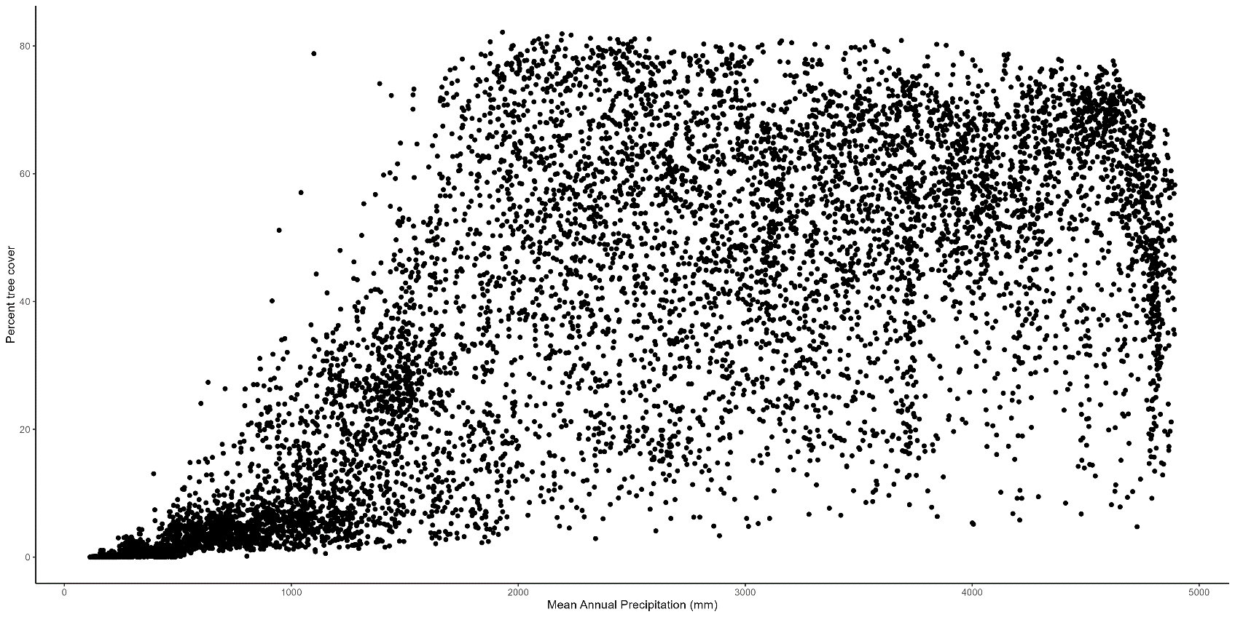
Supplementary Figures

Figure S1 Scatterplot of percent tree cover against mean annual precipitation (mm) with no discernible distributional information

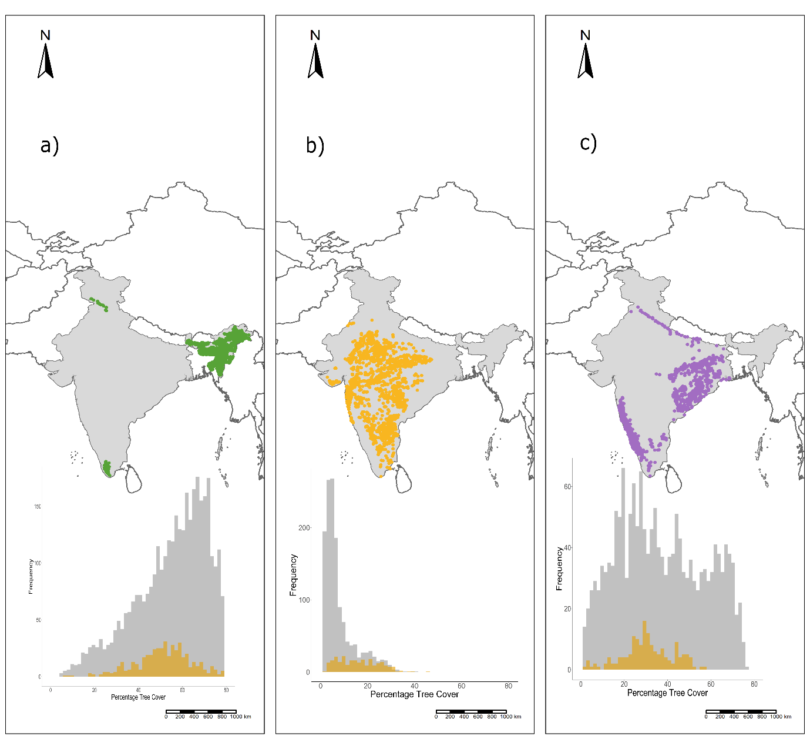 Figure S2 Sampled points in the (a) high tree cover zone in the south western (1300- 1600 mm MCWD) and north- eastern regions of India (0 – 600mm MCWD) (b) medium tree cover zone (930-1300 mm MCWD) across peninsular India (c) mixed tree cover zone (580-930 mm MCWD) dominantly present in the Western Ghats and the Eastern Central Highlands. Each respective subplot is the distribution of tree cover in burned (yellow) and unburned (grey) points in each zone. Note that this plot was generated before exclusion of outlier human population density points, considering all points irrespective of being outside 2 standard deviations of the data and artefactual effects resulting in Potential Tree Cover Shortfall >1. Note that for the statistical analyses of drivers and shortfall, points from only zones in (b) and (c) were used
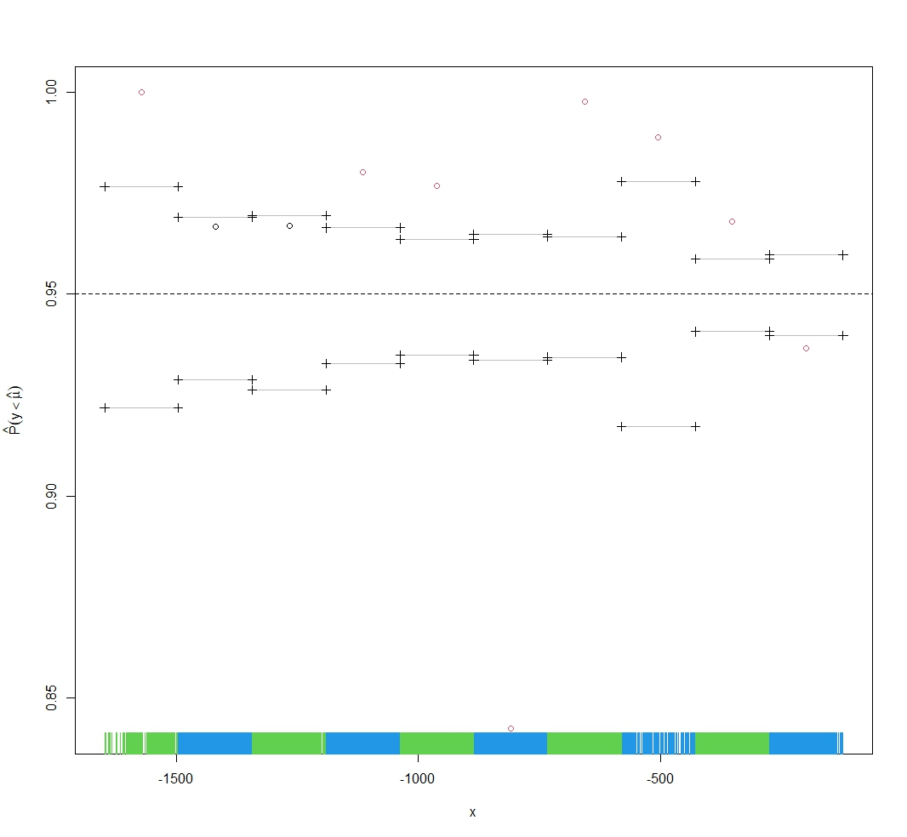
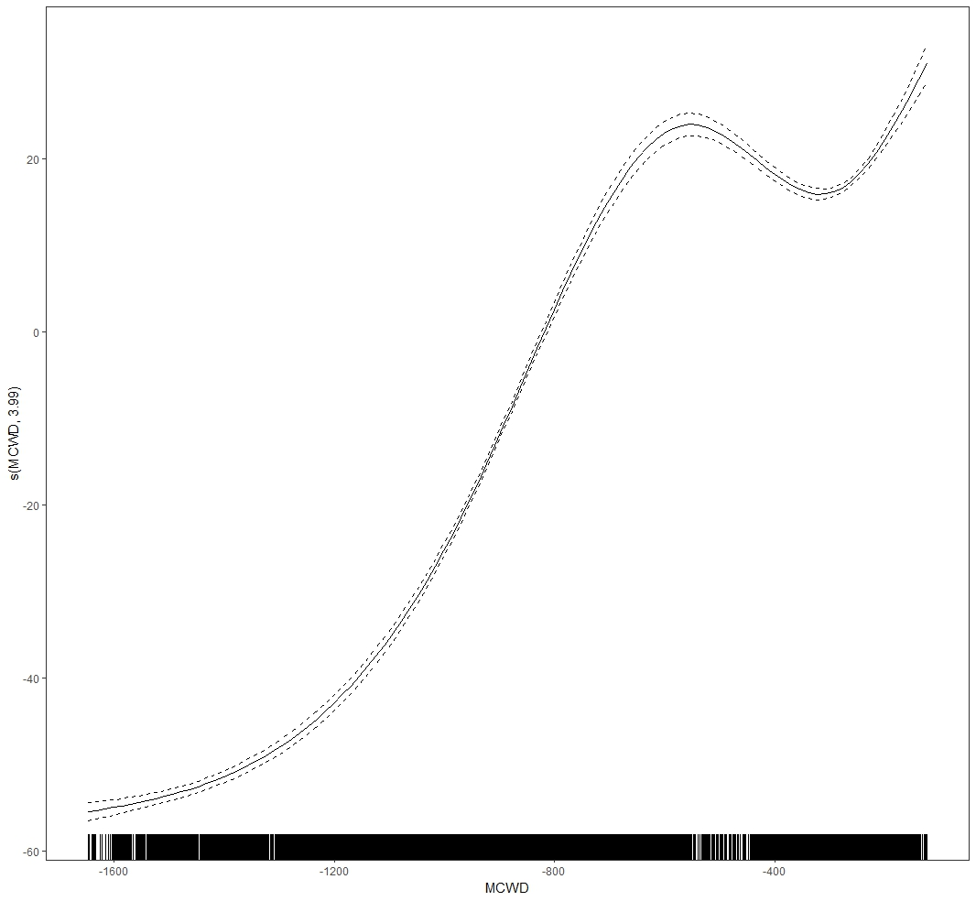
a
b
Figure S3 (a) Partial effect plot of the 95th percentile smooth additive quantile regression between percent tree cover and maximum climate water deficit (MCWD), where the rug values along the x axis represent the MCWD values such that negative sign indicates a deficit i.e. and s(MCWD, 3.99) is smooth term indicated the effective degrees of freedom of the smooth. (b) Diagnostic plot of model in (a) where bins of percent tree cover using corresponding values of MCWD is represented by the blue and green rug along the x-axis and the horizontal lines with crosses at the ends. The black hollow circles show that for those bins 95% of the points fall below the fit i.e. horizontal line with crossed ends while the red hollow circles show that this is not the case i.e. that the fraction of points varies widely along MCWD indicating a non-linear relationship between percent tree cover and MCWD.

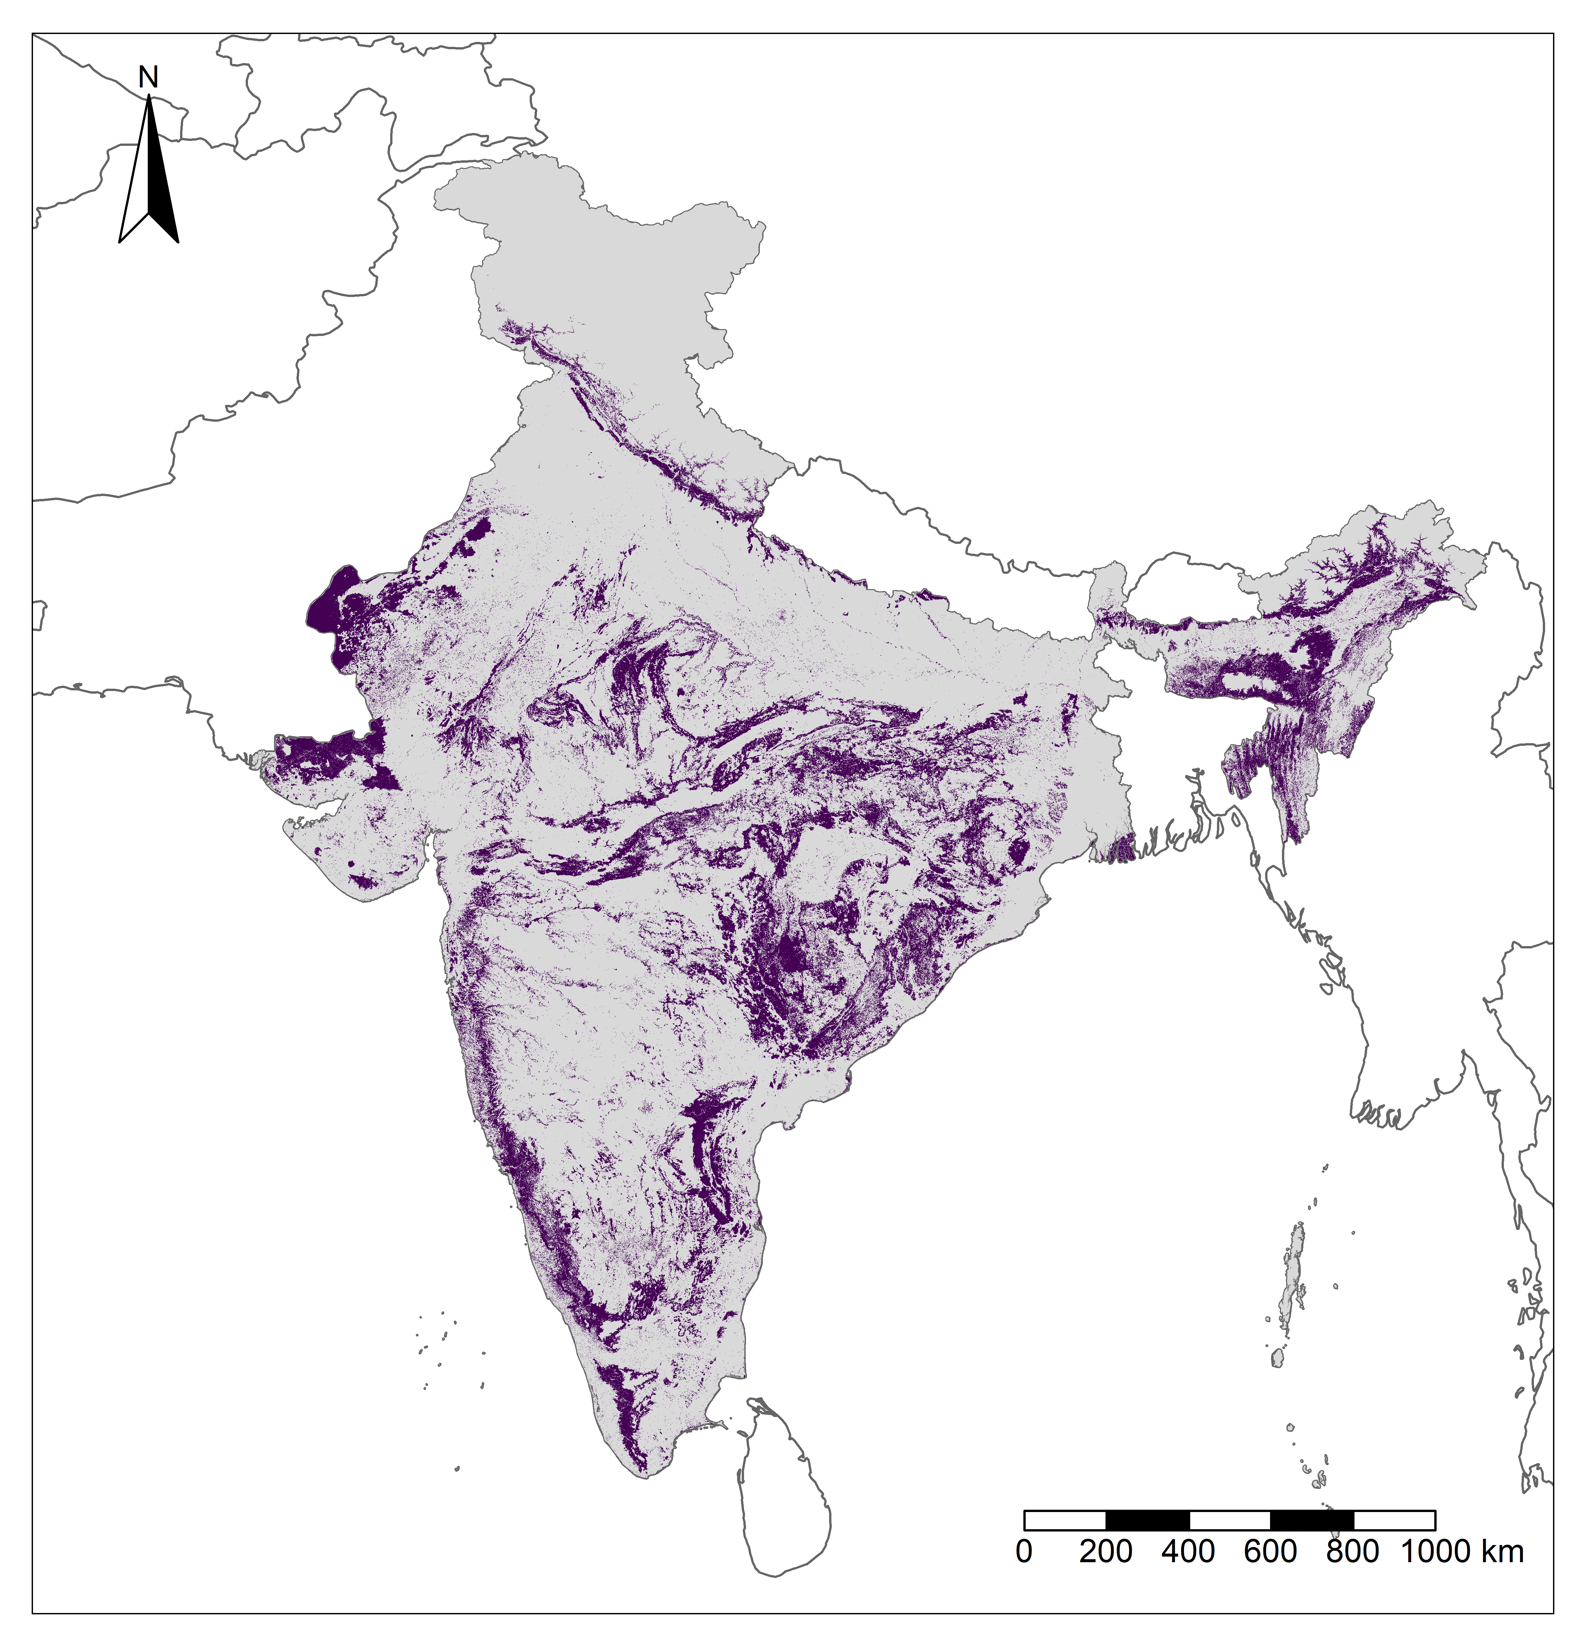
Figure S4 Study area for the analyses, shown in purple, after excluding built-up land, croplands, water bodies, aquaculture, mangroves, salt pans, permanent wetlands and snow and ice using Roy et al., 2016 and agriculture, shifting agriculture, abandoned and current jhum from Roy et al., 2015 and all lands classified as irrigated croplands from Ambika et al., 2016, to thoroughly exclude all croplands. Land area with elevations greater than 1200m was also excluded
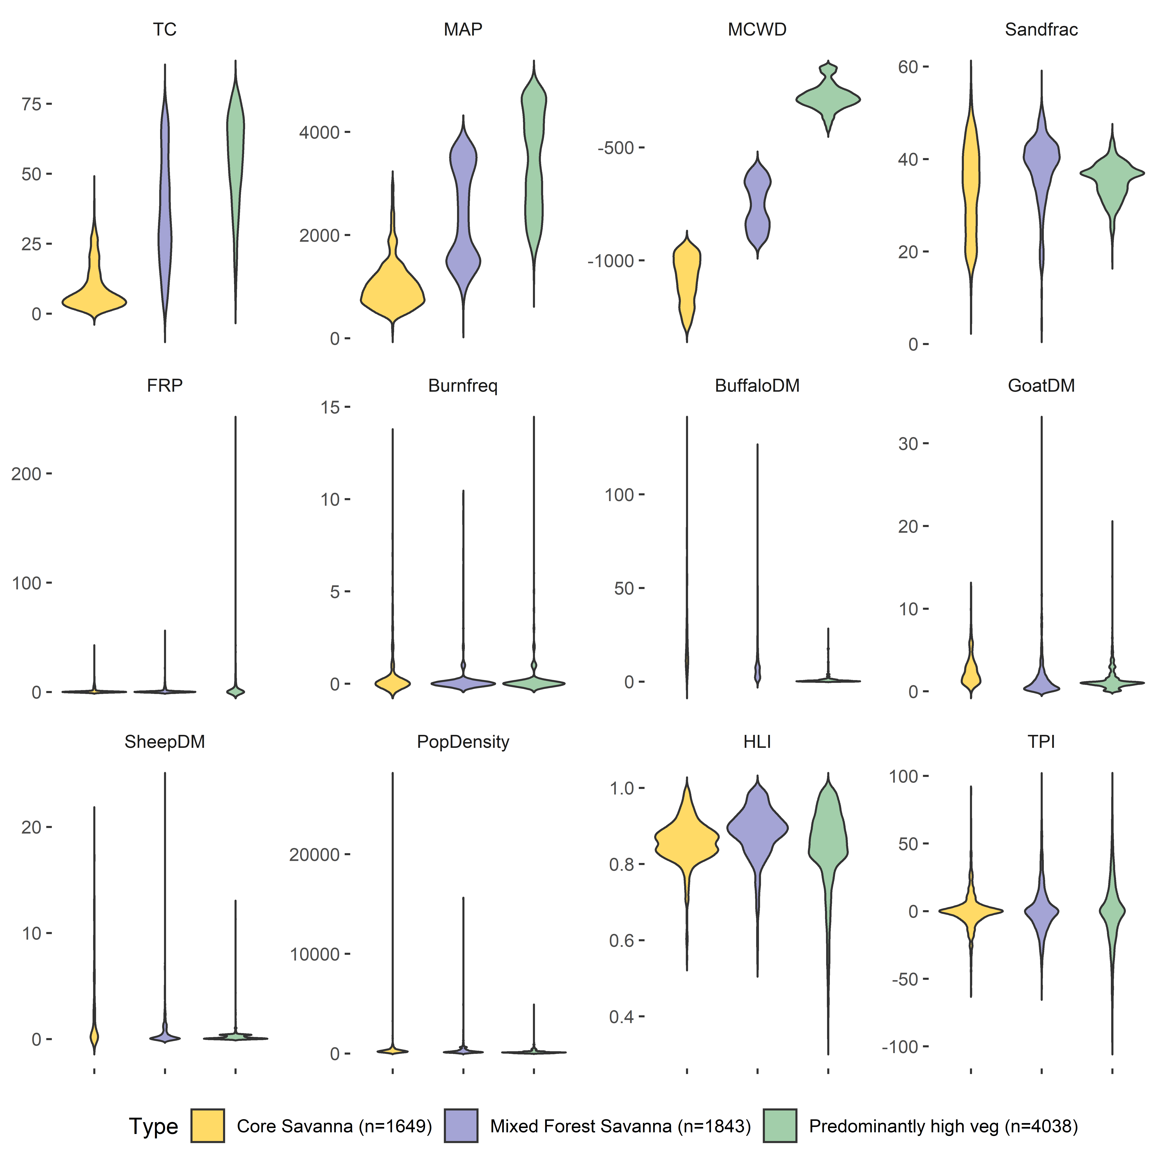
Figure S5 Summary statistics of all variables in the high (yellow), medium (lavender) and mixed (green) tree cover zones. Note that this plot was generated before exclusion of outlier human population density points, considering all points irrespective of being outside 2 standard deviation of the data and artefactual effects resulting in Potential Tree Cover Shortfall >1. Units of each variable are mentioned in Table S1
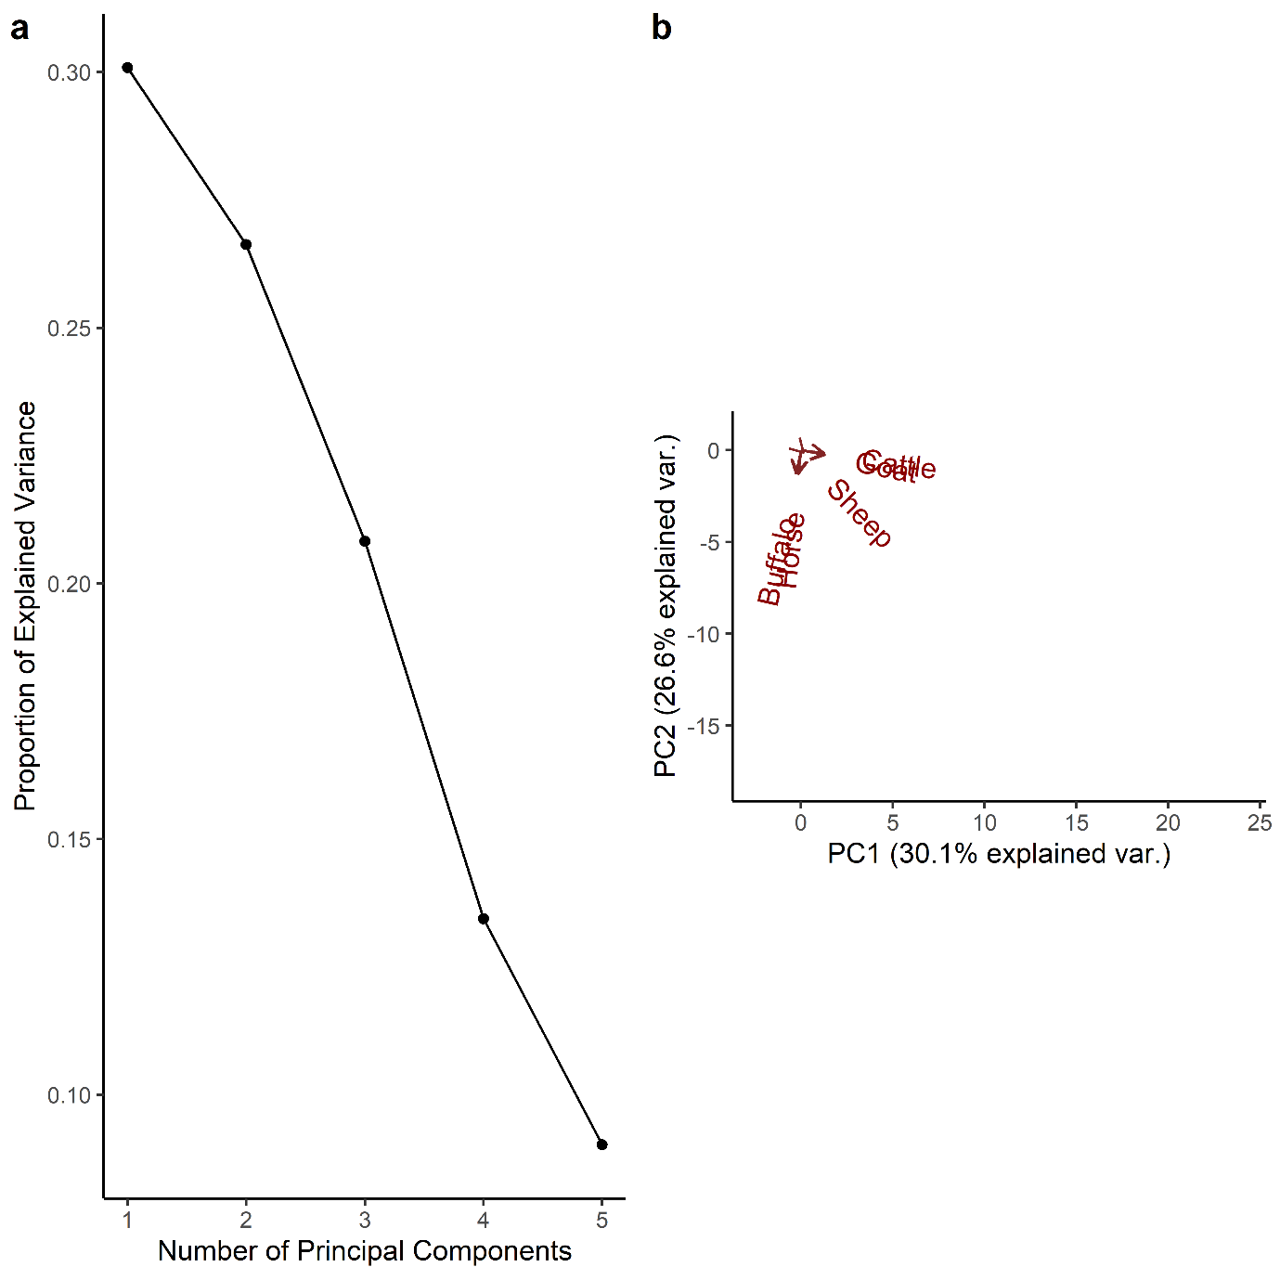
Figure S6 (a) Three axes cumulatively explained 77.5% of the variance (PC1 = 30.1%, PC2 = 26.6% and PC3 = 20.8% and (b) horse and buffalo herbivory pressure loaded onto PC2, while goat and cattle loaded onto PC1 and sheep herbivory pressure loaded onto PC3 (refer to Table S3 for loading information)

References
Abatzoglou, J. T., Dobrowski, S. Z., Parks, S. A., & Hegewisch, K. C. (2018). TerraClimate, a high-resolution global dataset of monthly climate and climatic water balance from 1958-2015. Scientific Data, 5(1), 1–12. https://doi.org/10.1038/sdata.2017.191
Ambika, A. K., Wardlow, B., & Mishra, V. (2016). Remotely sensed high resolution irrigated area mapping in India for 2000 to 2015. Scientific Data, 3(1), 1–14. https://doi.org/10.1038/sdata.2016.118
Aragão, L. E. O. C., Malhi, Y., Roman-Cuesta, R. M., Saatchi, S., Anderson, L. O., & Shimabukuro, Y. E. (2007). Spatial patterns and fire response of recent Amazonian droughts. Geophysical Research Letters, 34(7), 1–5. https://doi.org/10.1029/2006GL028946
De Reu, J., Bourgeois, J., Bats, M., Zwertvaegher, A., Gelorini, V., De Smedt, P., Chu, W., Antrop, M., De Maeyer, P., Finke, P., & others. (2013). Application of the topographic position index to heterogeneous landscapes. Geomorphology, 186, 39–49.
Department of Animal Husbandry, Dairying and Fisheries, Ministry of Agriculture & Farmers Welfare, G. of I. (2019). Annual Report. In Annual Report 2018-19. https://www.pvh.com/-/media/Files/pvh/investor-relations/PVH-Annual-Report-2020.pdf
Doxsey-Whitfield, E., MacManus, K., Adamo, S. B., Pistolesi, L., Squires, J., Borkovska, O., & Baptista, S. R. (2015). Taking advantage of the improved availability of census data: a first look at the gridded population of the world, version 4. Papers in Applied Geography, 1(3), 226–234.
Gilbert, M., Nicolas, G., Cinardi, G., Van Boeckel, T. P., Vanwambeke, S. O., Wint, G. R. W., & Robinson, T. P. (2018). Global distribution data for cattle, buffaloes, horses, sheep, goats, pigs, chickens and ducks in 2010. Scientific Data, 5, 1–11. https://doi.org/10.1038/sdata.2018.227
Gorelick, N., Hancher, M., Dixon, M., Ilyushchenko, S., Thau, D., & Moore, R. (2017). Google Earth Engine: Planetary-scale geospatial analysis for everyone. Remote Sensing of Environment. https://doi.org/10.1016/j.rse.2017.06.031
Malhi, Y., Doughty, C. E., Goldsmith, G. R., Metcalfe, D. B., Girardin, C. A. J., Marthews, T. R., del Aguila-Pasquel, J., Aragão, L. E. O. C., Araujo-Murakami, A., Brando, P., da Costa, A. C. L., Silva-Espejo, J. E., Farfán Amézquita, F., Galbraith, D. R., Quesada, C. A., Rocha, W., Salinas-Revilla, N., Silvério, D., Meir, P., & Phillips, O. L. (2015). The linkages between photosynthesis, productivity, growth and biomass in lowland Amazonian forests. Global Change Biology, 21(6), 2283–2295. https://doi.org/10.1111/gcb.12859
McCune, B., & Keon, D. (2002). Equations for potential annual direct incident radiation and heat load. Journal of Vegetation Science, 13(4), 603–606.
Poggio, L., De Sousa, L. M., Batjes, N. H., Heuvelink, G., Kempen, B., Ribeiro, E., & Rossiter, D. (2021). SoilGrids 2.0: producing soil information for the globe with quantified spatial uncertainty. Soil, 7(1), 217–240.
Roy, P.S., P. Meiyappan, P.K. Joshi, M.P. Kale, V.K. Srivastav, S.K. Srivasatava, M.D. Behera, A. Roy, Y. Sharma, R.M. Ramachandran, P. Bhavani, A.K. Jain, and Y. V. N. K. (2016). Decadal Land Use and Land Cover Classifications across India. https://doi.org/https://doi.org/10.3334/ORNLDAAC/1336
Roy, P. S., Behera, M. D., Murthy, M. S. R., Roy, A., Singh, S., Kushwaha, S. P. S., Jha, C. S., Sudhakar, S., Joshi, P. K., Reddy, C. S., Gupta, S., Pujar, G., Dutt, C. B. S., Srivastava, V. K., Porwal, M. C., Tripathi, P., Singh, J. S., Chitale, V., Skidmore, A. K., … Ramachandran, R. M. (2015). New vegetation type map of India prepared using satellite remote sensing: Comparison with global vegetation maps and utilities. International Journal of Applied Earth Observation and Geoinformation, 39, 142–159. https://doi.org/10.1016/j.jag.2015.03.003
Schroeder, W., & Giglio, L. (2018). NASA VIIRS Land Science Investigator Processing System (SIPS) Visible Infrared Imaging Radiometer Suite (VIIRS) 375 m & 750 m Active Fire Products: Product User’s Guide Version 1.4. Nasa, July, 2–23. https://viirsland.gsfc.nasa.gov/PDF/VIIRS_activefire_User_Guide.pdf
Schwartz, N. B., Lintner, B. R., Feng, X., & Powers, J. S. (2020). Beyond MAP: A guide to dimensions of rainfall variability for tropical ecology. Biotropica, May 2019, 1–14. https://doi.org/10.1111/btp.12830
Singhal, K. K., Mohini, M., Jha, A. K., & Gupta, P. K. (2005). Methane emission estimates from enteric fermentation in Indian livestock: Dry matter intake approach. Current Science, 88(1), 119–127.
Staver, C., Archibald, S., & Levin, S. (2011). The global extent and determinants of savanna and forest as alternative biome states. Science, 334(6053), 230–232. https://doi.org/10.1126/science.1210465
Vadrevu, K. P., Lasko, K., Giglio, L., Schroeder, W., Biswas, S., & Justice, C. (2019). Trends in Vegetation fires in South and Southeast Asian Countries. Scientific Reports, 9(1), 1–13. https://doi.org/10.1038/s41598-019-43940-x
Wolf, A., Doughty, C. E., & Malhi, Y. (2013). Lateral Diffusion of Nutrients by Mammalian Herbivores in Terrestrial Ecosystems. PLoS ONE, 8(8), 1–10. https://doi.org/10.1371/journal.pone.0071352

