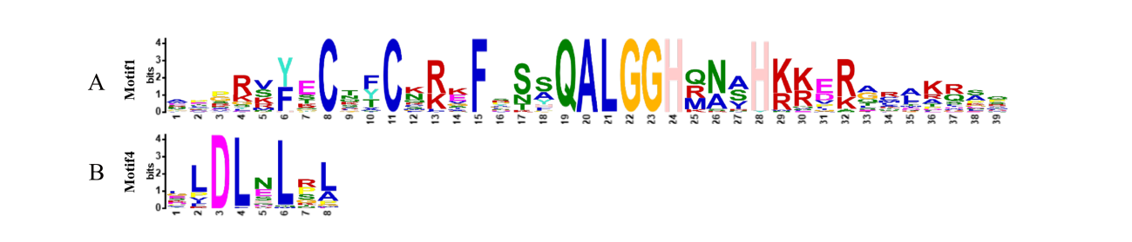

Fig S1. Main conserved motif of Q-type NnZFP genes in lotus. A. Signature of Q-type C2H2 motifs (Motif1). B. Signature of EAR motifs (Motif4).

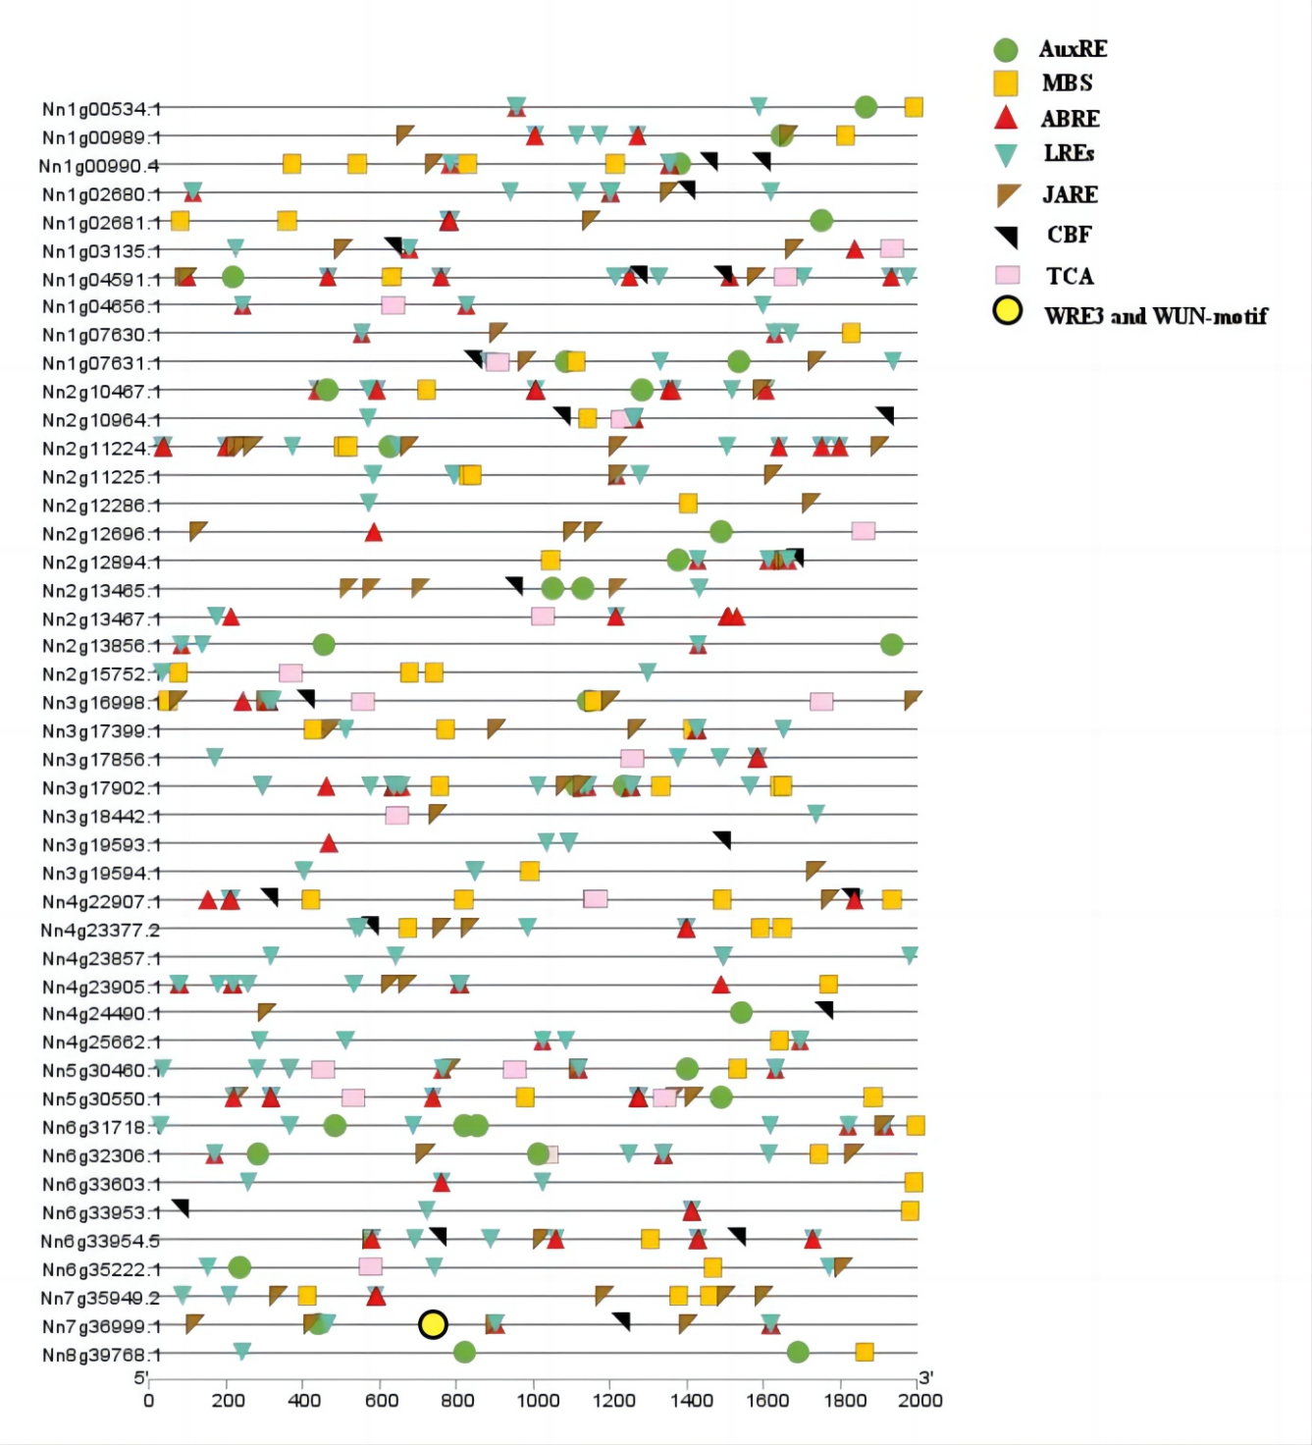
Fig S2. Analysis of Q-type NnZFP Gene Promoter Cis-Regulatory Elements. The differently coloured patterns represent the different regulatory elements.

