Author Agreement
Distinguished Editor
We the undersigned declare that this manuscript entitled “Genetically predicted causal associations between 152 blood-related exposures and pan-cancer in the framework of prediction, prevention and personalized medicine: a study integrating Mendelian randomization and bioinformatics” is original, has not been published before and is not currently being considered for publication elsewhere.
We declare that there are no known conflicts of interest associated with this
publication and there has been no significant financial support for this that could have
influenced its outcome.
We confirm that the manuscript has been read and approved by all named authors
and that there are no other persons who satisfied the criteria for authorship but are not
listed. We further confirm that the order of authors listed in the manuscript has been
approved by all of us.
We understand that the Corresponding Author is the sole contact for the Editorial
process. He/she is responsible for communicating with the other authors about
progress, submissions of revisions and final approval of proofs.
The first author is Xinhao Tang.The second author is Xinyu Tian.The third author is Jingjing Wu.The fourth author is Sainan Hao.The fifth author is Bowen Chu.The sixth author is Jun Shi.The seventh author is Zimo Li.The eighth author is Shuai Shan.The ninth author is Tinghao Dai.The tenth author is Guanmin Tang.The eleventh author is Wenbo Xu.The twelfth author is Mianhua Wu.
Xinhao Tang and Xinyu Tian contributed equally to this work.Corresponding authors are Wenbo Xu and Mianhua Wu.

Signed by all authors as follows:
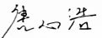(Xinhao Tang),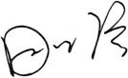(Xinyu Tian), 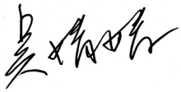（Jingjing Wu）,
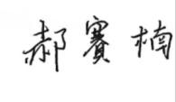(Sainan Hao),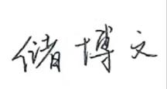(Bowen Chu), 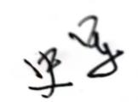 (Jun Shi)
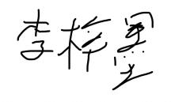(Zimo Li),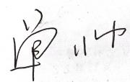(Shuai Shan),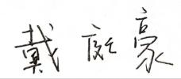(Tinghao Da)
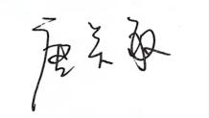(Guanmin Tang),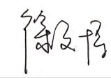(Wenbo Xu),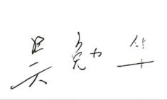(MianhuaWu)

