Supplementary Figure 1

-
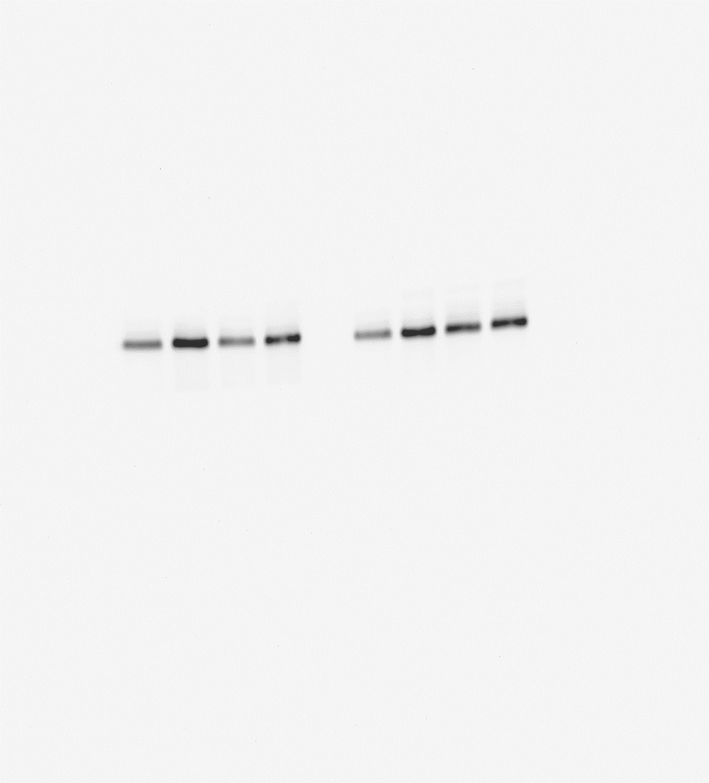
+
+
-

GAPDH

VEGF-C

VEGFR-3

si-BANCR
+
+
+
+
+
+
+
+
+
+
-
-
-
-
-
-
-
-
-
-
si-BANCR
si-BANCR

