Supplementary Information:

Reconfigurable synthetic dimension frequency lattices in an integrated lithium niobate ring cavity

Hiep X. Dinh¹, Armandas Balčytis^{1*}, Tomoki Ozawa², Yasutomo Ota³, Guanghui Ren¹, Toshihiko Baba⁵, Satoshi Iwamoto⁴, Arnan Mitchell¹, and Thach G. Nguyen¹

¹Integrated Photonics and Applications Centre, RMIT University, Melbourne, VIC 3000, Australia
²Advanced Institute for Materials Research, Tohoku University, Sendai 980-8577, Japan
³Department of Applied Physics and Physico-Informatics, Keio University, Yokohama 223-8522, Japan
⁴Department of Electrical and Computer Engineering, Yokohama National University, Yokohama 240-8501, Japan
⁵Research Center for Advanced Science and Technology, The University of Tokyo, 4-6-1 Komaba, Meguro-ku, Tokyo 153-8904 Japan

Supplementary Figure 1: Electro-optic modulator characterization
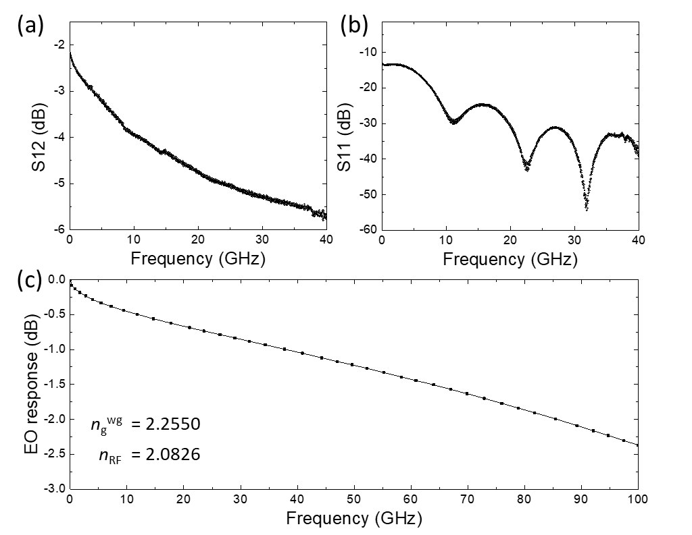
Supplementary Figure 1. Radio frequency and electrooptic response of the LNOI traveling-wave modulator in the ring resonator-based synthetic dimension device. (a) S₁₂ transmittance and (b) S₁₁ reflectance parameter spectrograms. (c) Frequency dependence of simulated modulator optical response to RF drive. The modulator exhibited a Z = 56 Ω impedance, a α_{c} = 0.93 dB/(cm·GHz^{0.5}) transmission line loss, and a V_{π}L = 8 V·cm.

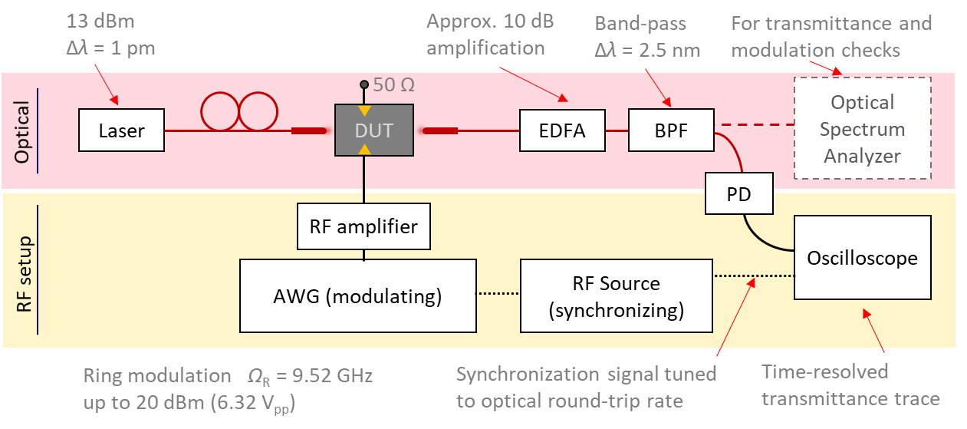
Supplementary Figure 2. Schematic of the measurement setup used to acquire the time resolved transmittance of modulated LNOI integrated ring cavities. Light is coupled into and out of the device is done via grating couplers using a fiber array, and electrical contact with the modulator is established by way of a pair of microscale probes, one of which acts as RF input and the other is connected to a 50 Ω terminator. Complex multi-dimensional tight binding model coupling can be established by using a single high sampling rate arbitrary waveform generator. An auxiliary RF Source is used to supply the oscilloscope synchronization signal.
Supplementary Figure 2: Synthetic dimension band structure measurement setup

Supplementary Figures 3-5: Synthetic 1D tight-binding model band structures
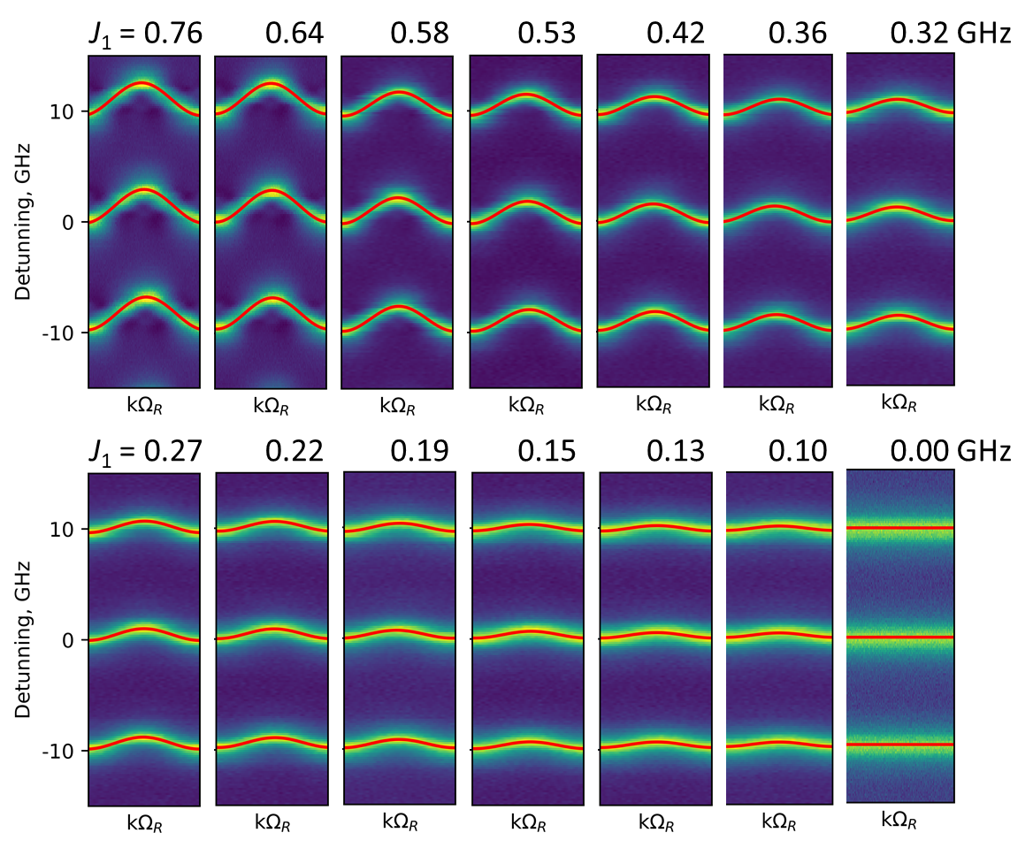
Supplementary Figure 3. Synthetic frequency dimension band structures at different on-resonance modulation powers for 1×FSR 9.52 GHz nearest-neighbor ring mode coupling. Coupling strength J₁ [GHz] increases when modulating RF power is increased, as plotted in Figure 4b of main text. Bottom right is the no modulation flat band case. Superimposed plots are the dispersion curve of 1D tight binding model, ε_{k} = 2J₁coskΩ_{R} fits.

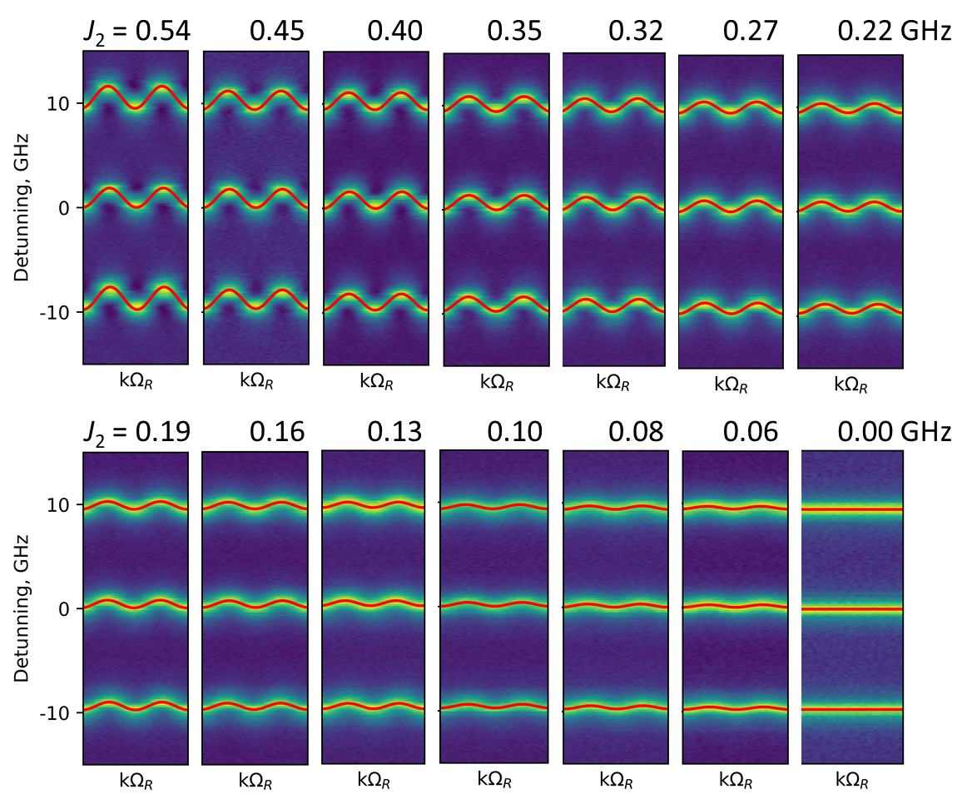
Supplementary Figure 4. Synthetic frequency dimension band structures at different on-resonance modulation powers for 2×FSR 19.04 GHz next-nearest-neighbor ring mode coupling. Coupling strength J₂ [GHz] increases when modulating RF power is increased, as plotted in Figure 4b of main text. Bottom right is the no modulation flat band case. Superimposed plots are the dispersion curve of 1D tight binding model, ε_{k} = 2J₂cosk2Ω_{R} fits.

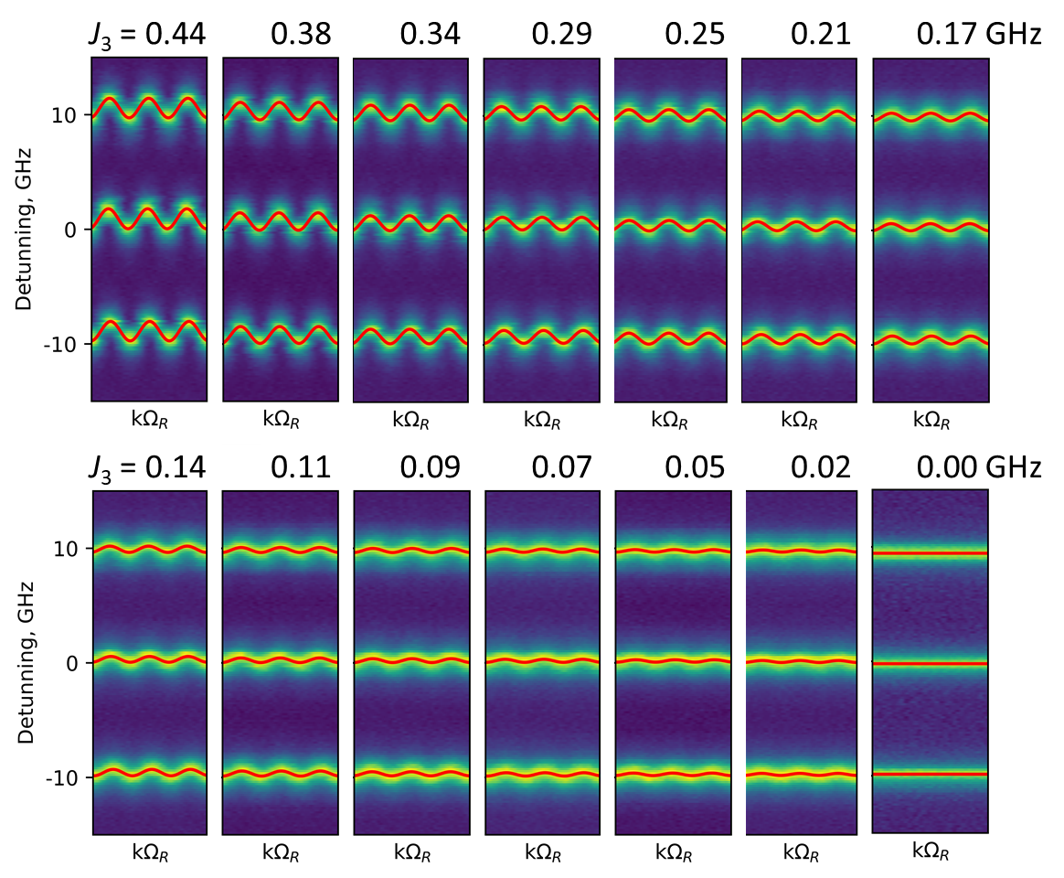
Supplementary Figure 5. Synthetic frequency dimension band structures at different on-resonance modulation powers for 3×FSR 28.56 GHz third-nearest-neighbor ring mode coupling. Coupling strength J₃ [GHz] increases when modulating RF power is increased, as plotted in Figure 4b of main text. Bottom right is the no modulation flat band case. Superimposed plots are the dispersion curve of 1D tight binding model, ε_{k} = 2J₃cosk3Ω_{R} fits.

Supplementary Figure 6: Non-reciprocal synthetic dimension band structures
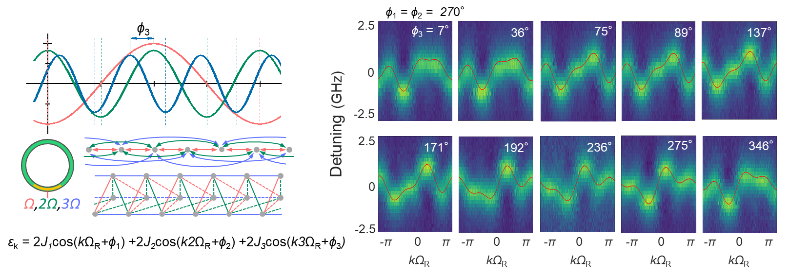
Supplementary Figure 6. Band-structure engineering in 3D tube-lattice tight-binding model, connected using 1×FSR, 2×FSR, and 3×FSR RF modulation-induced frequency dimension coupling. Left panel shows the modulating signal components with phase shift notation, frequency mode coupling and effective tight-binding lattice structure schematics. A set of different non-reciprocal band structures are shown on the right. Variation of modulation phase delay ϕ₃ induces gradual band structure changes. Superimposed red curves are the respective tight-binding model dispersion curve ε_{k}(k) fits.

Supplementary Figure 7: Extended set of optical frequency comb output spectra
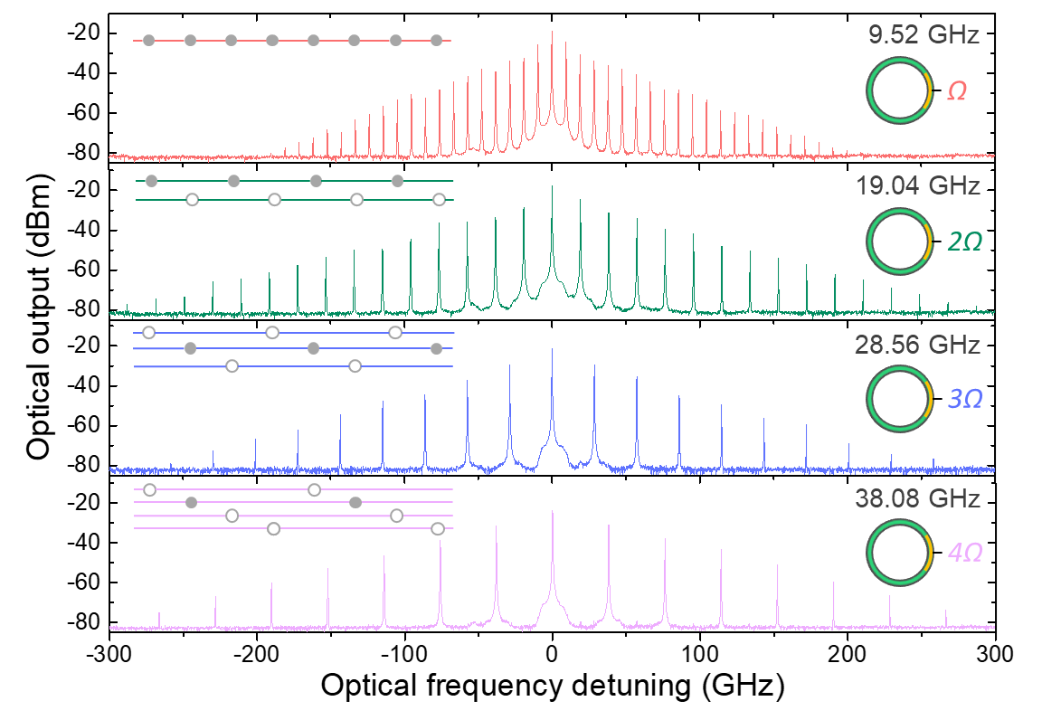
Supplementary Figure 7. Steady-state response of the cavity to different FSR range modulation. Optical frequency comb output of the resonantly pumped resonator is compared when driven at 1×FSR, 2×FSR, 3×FSR and 4×FSR RF frequencies, representing different partitioning of the frequency lattice, sketched in the inset.

