Supplementary Materials

Figures
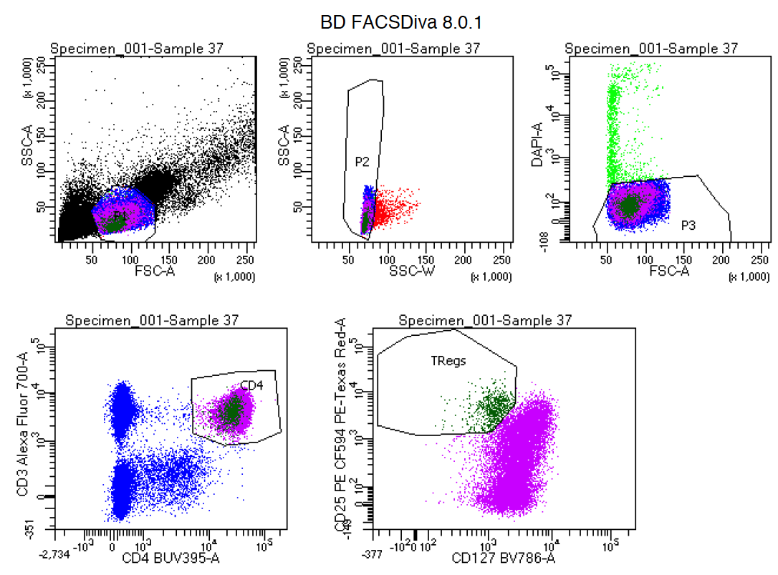
Figure S1. Gating strategy used for sorting CD4+ T cells and Tregs using the BD FACS Aria III.
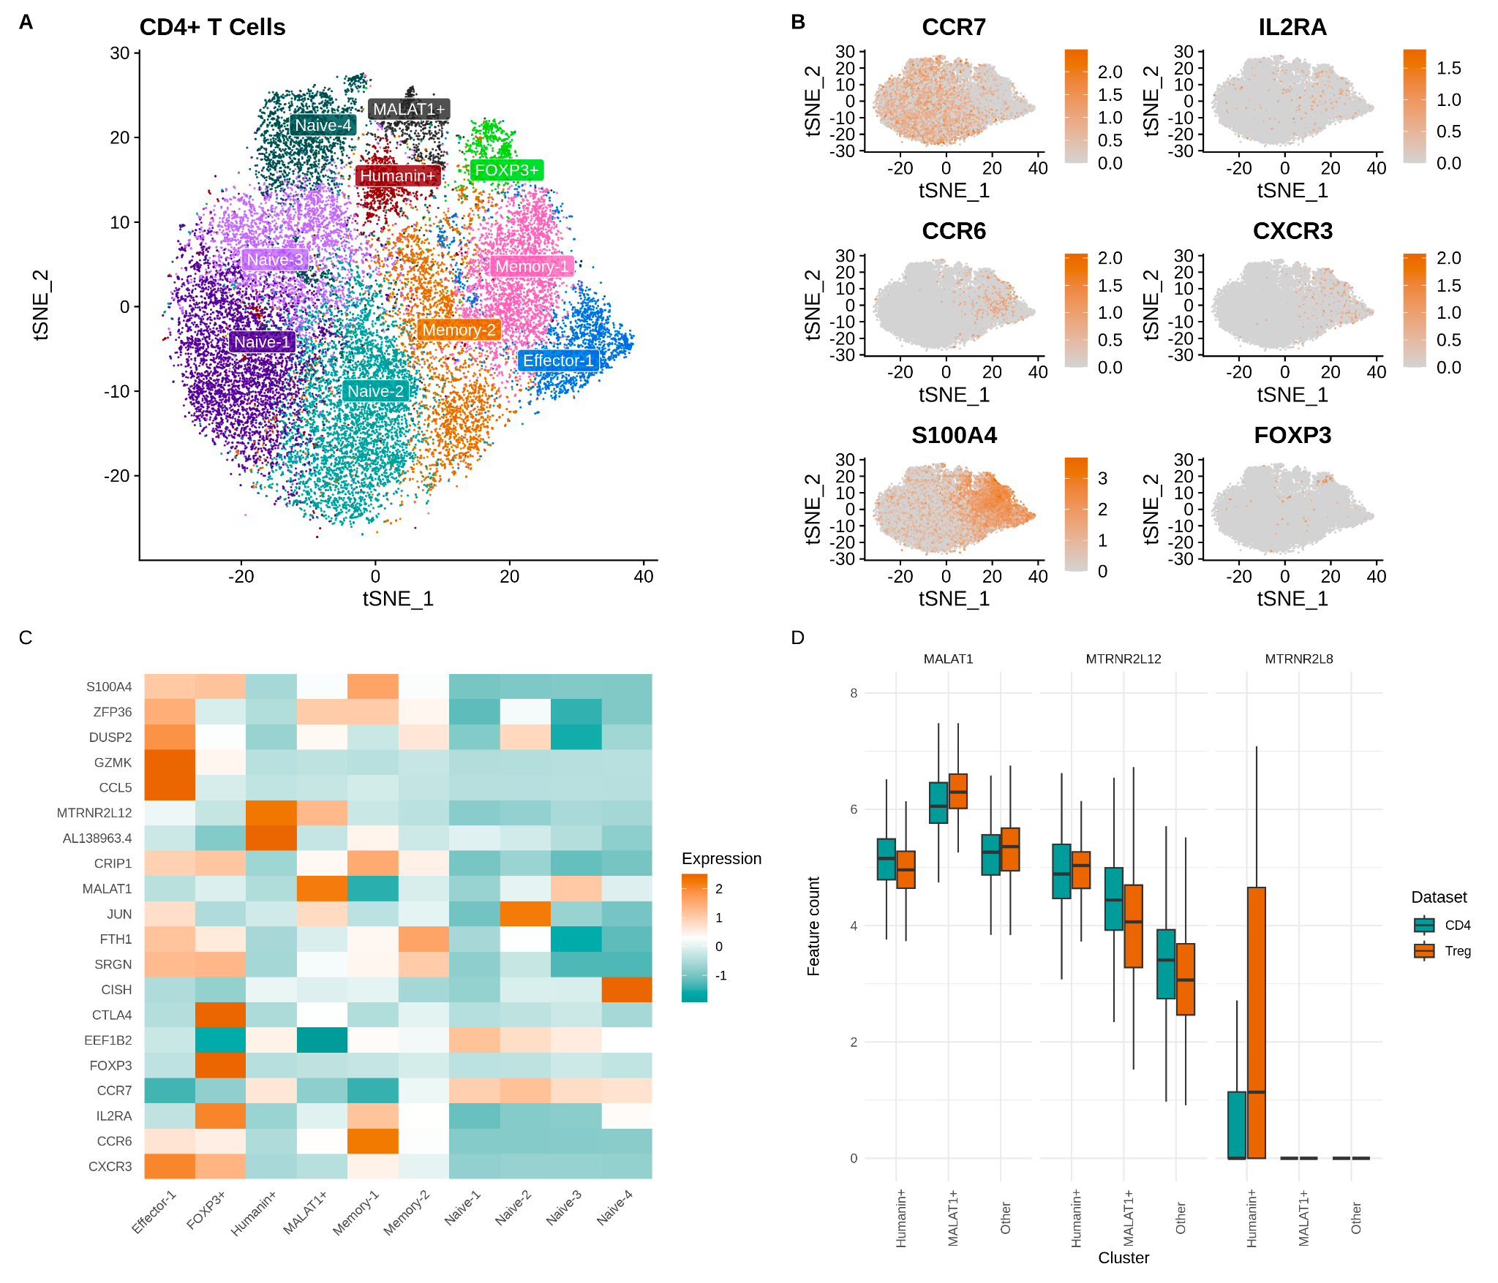
Figure S2. CD4+ T cell population clusters. A) tSNE plot of isolated CD4+ T cells and their cluster assignments based on differential gene expression. B) Markers of CD4+ T cell clusters shown against tSNE reduction. C) CD4+ T cell subtype markers. D) Humanin-positive cell marker expression in sequenced T cell populations.

Supplementary Tables
Cluster | Canonical Markers | Subset Markers (Top 3)
Naive-1 | CCR7+ | S100A4-, ZFP36-, AHNAK-
Naive-2 | CCR7+ | JUN+, EGR1+, FOSB+
Naive-3 | CCR7+ | ZFP36-, NFKBIA-, DUSP2-
Naive-4 | CCR7+ | CISH+, PIM1+, LTB+
Effector-1 | CCR7-, CXCR3+ | GZMK+, CCL5+, KLRB1+
Memory-1 | CCR7-, CCR6+ | SH3BGRL3+, S100A4+, AHNAK+
Memory-2 | CCR7-, CCR6+ | FTH1+, SRGN+, AHNAK+
Humanin+ | N/A | MTRNR2L12+, AL138963.4+ (TPT), HIST1H1E+
MALAT1+ | N/A | MALAT1+
FOXP3+ | FOXP3+ | FOXP3+, TIGIT+, CTLA4+

Table S1. CD4+ T cell subtype assignment. Clusters were assigned subtype names based on previous literature and marker genes identified by between-cluster differential expression analysis.

Gene | Source
DUSP1 | Treg subset marker
JUN | Treg subset marker
KLF6 | Treg subset marker
SH3BGRL3 | Treg subset marker
UBC | Treg subset marker
HLA-A | Treg subset marker
S100A4 | Treg subset marker
IL32 | Treg subset marker
FOS | Treg subset marker
IER2 | Treg subset marker
FOSB | Treg subset marker
TUBA1A | Treg subset marker
EGR1 | Treg subset marker
JUNB | Treg subset marker
KLF2 | Treg subset marker
BTG2 | Treg subset marker
CYTOR | Treg subset marker
HLA-DRA | Treg subset marker
HLA-DRB5 | Treg subset marker
HLA-DRB1 | Treg subset marker
HLA-DPA1 | Treg subset marker
HLA-DPB1 | Treg subset marker
DUSP4 | Treg subset marker
B2M | Treg subset marker
CD74 | Treg subset marker
LGALS1 | Treg subset marker
LGALS3 | Treg subset marker
KLRB1 | Treg subset marker
ANXA1 | Treg subset marker
CRIP1 | Treg subset marker
ANXA2 | Treg subset marker
AHNAK | Treg subset marker
VIM | Treg subset marker
EEF1B2 | Treg subset marker
GBP5 | Treg subset marker
PFN1 | Treg subset marker
ARPC1B | Treg subset marker
MTRNR2L12 | Treg subset marker
AL138963.4 | Treg subset marker
MTRNR2L8 | Treg subset marker
MALAT1 | Treg subset marker
EEF1A1 | Treg subset marker
RACK1 | Treg subset marker
EEF1G | Treg subset marker
EEF1D | Treg subset marker
EIF3L | Treg subset marker
MT-CO3 | Treg GDM differentially expressed
RPS18 | Treg GDM differentially expressed
MT-CYB | Treg GDM differentially expressed
MTRNR2L12 | Treg GDM differentially expressed
MT-CO1 | Treg GDM differentially expressed
JUN | Treg GDM differentially expressed
RPL38 | Treg GDM differentially expressed
RPL27A | Treg GDM differentially expressed
JUND | Treg GDM differentially expressed
TXNIP | Treg GDM differentially expressed
GPR183 | Treg GDM differentially expressed
KLF2 | Treg GDM differentially expressed
CD69 | Treg GDM differentially expressed
SLC2A3 | Treg GDM differentially expressed
JUNB | Treg GDM differentially expressed
FOSB | Treg GDM differentially expressed
EGR1 | Treg GDM differentially expressed
RPS26 | Treg GDM differentially expressed
RPS29 | Treg GDM differentially expressed
TMSB4X | Treg GDM differentially expressed
MT-CO2 | Treg GDM differentially expressed
H3F3B | Treg GDM differentially expressed
IER2 | Treg GDM differentially expressed
ANXA1 | Treg GDM differentially expressed
MT-ND5 | Treg GDM differentially expressed
MT-ATP8 | Treg GDM differentially expressed
DUSP1 | Treg GDM differentially expressed
TUBA1A | Treg GDM differentially expressed
ID3 | Treg GDM differentially expressed
KLF6 | Treg GDM differentially expressed
FOS | Treg GDM differentially expressed
HIST1H1E | Treg GDM differentially expressed
H1FX | Treg GDM differentially expressed
IFITM2 | Treg GDM differentially expressed
TIMP1 | Treg GDM differentially expressed
DDX5 | Treg GDM differentially expressed
HIST1H4C | Treg GDM differentially expressed
HLA-DRB5 | Treg GDM differentially expressed
HLA-DRB1 | Treg GDM differentially expressed
MTRNR2L8 | Treg GDM differentially expressed
AL138963.4 | Treg GDM differentially expressed
CD74 | Treg GDM differentially expressed
RPL13A | Treg GDM differentially expressed
TMSB10 | Treg GDM differentially expressed
ACTB | Treg GDM differentially expressed
IL32 | Treg GDM differentially expressed
CYBA | Treg GDM differentially expressed
TCF7 | Treg GDM differentially expressed
RPL21 | Treg GDM differentially expressed
SRGN | Treg GDM differentially expressed
EEF2 | Treg GDM differentially expressed
RPL37A | Treg GDM differentially expressed
RPS25 | Treg GDM differentially expressed
RPL23 | Treg GDM differentially expressed
RPL34 | Treg GDM differentially expressed
RPL36 | Treg GDM differentially expressed
RPL32 | Treg GDM differentially expressed
RPL28 | Treg GDM differentially expressed
RPS27 | Treg GDM differentially expressed
RPL36AL | Treg GDM differentially expressed
RPL13 | Treg GDM differentially expressed
RPL27 | Treg GDM differentially expressed

Table S2. Marker genes used to model GDM status from single cell and bulk RNA. Markers are derived from cluster marker genes or within-cluster GDM Treg marker genes.

