Supplementary Materials
Model Equations
The model is made up of a set of differential equations that determine transmission between compartments.

$$\frac{dX}{dt} = µ - (λ_{A}+λ_{B}+µ)X + ω(X_{A}+X_{B})$$
$$\frac{dP_{A}}{dt}= λ_{A}X - (ν+µ)P_{A}$$
$$\frac{dP_{B}}{dt}= λ_{B}X - (ν+µ)P_{B}$$
$$\frac{dX_{A}}{dt}=ν {(P}_{B}+Y_{B}) - (σ_{ho}λ_{A}+σ_{he}λ_{B}+ω+μ)X_{A}+{ωX}_{AB}$$
$$\frac{dX_{B}}{dt}=ν {(P}_{B}+Y_{B}) -(σ_{he}λ_{A}+σ_{ho}λ_{A}+ω+μ)X_{B}+{ωX}_{AB}$$
$$\frac{dP_{BA}}{dt}=σ_{he}λ_{A}X_{B}-(ν+μ)P_{BA}$$
$$\frac{dP_{AB}}{dt}=σ_{he}λ_{B}X_{A}-(ν+μ)P_{AB}$$
$$\frac{dY_{A}}{dt}=σ_{ho}λ_{A}X_{A}-(ν+μ)Y_{A}$$
$$\frac{dY_{B}}{dt}=σ_{ho}λ_{B}X_{B}-(ν+μ)Y_{B}$$
$$\frac{dX_{AB}}{dt}= ν(P_{AB}+P_{BA}+Y_{AB}+Y_{BA})-(σ_{he}σ_{ho}({λ_{A}+λ_{B})}_{}2{ω+μ)X}_{AB}$$
$$\frac{dY_{AB}}{dt}=σ_{he}σ_{ho}λ_{B}X_{AB}-(ν+μ)Y_{AB}$$
$$\frac{dY_{BA}}{dt}=σ_{he}σ_{ho}λ_{A}X_{BA}-(ν+μ)Y_{BA}$$
$$λ_{A}=β_{A}(P_{A}+η(P_{BA}+Y_{A}+Y_{BA}))$$
$$λ_{B}=β_{B}(P_{B}+η(P_{AB}+Y_{B}+Y_{AB}))$$
$β_{A}=ρ b_{A}(a$cos ($2π(t-ϕ))+1)$)
$$β_{B}=rβ_{A}$$

Supplementary Tables

Table S1. Model states
X | Uninfected, no immunity
P_{A} | Primary infection with subtype A
P_{B} | Primary infection with subtype B
X_{A} | Uninfected, previously infected with subtype A
X_{B} | Uninfected, previously infected with subtype B
P_{AB} | Primary infection with subtype B, previously infected with subtype A
P_{BA} | Primary infection with subtype A, previously infected with subtype B
Y_{A} | Subsequent infection with subtype A, previously infected with subtype A
Y_{B} | Subsequent infection with subtype B, previously infected with subtype B
X_{AB} | Uninfected, previously infected with subtypes A and B
Y_{AB} | Subsequent infection with subtype B, previously infected with subtypes A and B
Y_{BA} | Subsequent infection with subtype A, previously infected with subtypes A and B
$$λ_{A}$$ | Force of infection of group A acting on naive hosts
$$λ_{B}$$ | Force of infection of group B acting on naive hosts
$$β_{A}$$ | Seasonally varying transmission coefficient for group A
$$β_{B}$$ | Seasonally varying transmission coefficient for group B
$$ρ$$ | Time varying reduction in transmission coefficient due to NPIs

Table S2. Model parameters
Parameter | Definition | Estimate
$$r$$ | Subtype B transmission relative to transmission by subtype A | 0.9159
$$η$$ | Infectiousness of subsequent infections relative to primary | 0.4126
$$σ_{heterotypic}$$ | Relative susceptibility to heterologous infection | 0.8426
$$σ_{homotypic}$$ | Relative susceptibility to homologous (secondary) infection | 0.3569
$$ν$$ | Rate of recovery (1/duration of infectiousness) | 0.0247
$$ω$$ | Rate of waning of immunity (1/duration of immunity) | 0.51
$$b_{A}$$ | Average transmission coefficient of subtype A | UK | 0.312
$$b_{A}$$ | Average transmission coefficient of subtype A | Finland | 0.273
$$μ$$ | Birth/death rate | UK | 0.014
$$μ$$ | Birth/death rate | Finland | 0.012
$$ϕ$$ | Point in the year of peak transmission | UK | 0.929
$$ϕ$$ | Point in the year of peak transmission | Finland | 0.97
$$a$$ | Amplitude of transmission coefficient | UK | 0.815
$$a$$ | Amplitude of transmission coefficient | Finland | 0.347
$$s_{f}$$ | Scaling factor | UK | 397.3
$$s_{f}$$ | Scaling factor | Finland | 6.638

Supplementary Figures

Figure S1

30% results: 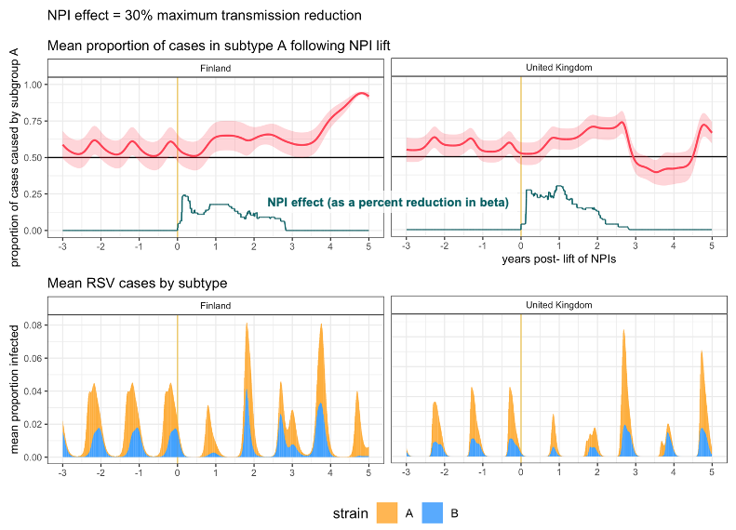

Figure S2

50% results:
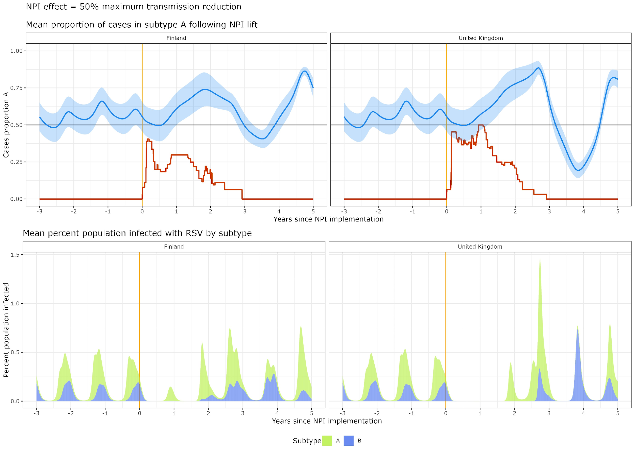

Figure S3

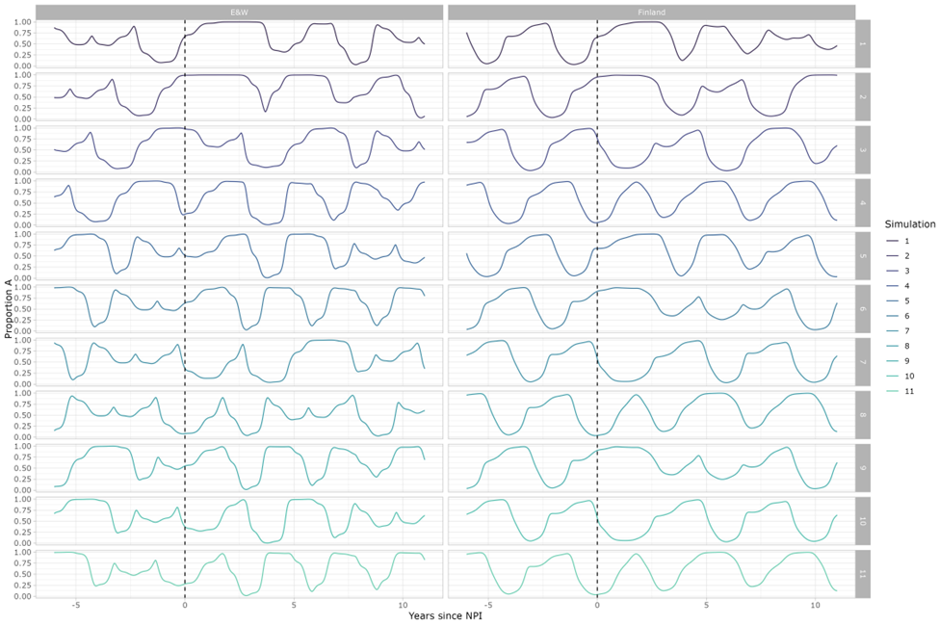

Individual simulations 1-11 showing the proportion of RSV infections that are subtype A in England & Wales and Finland.

Figure S4

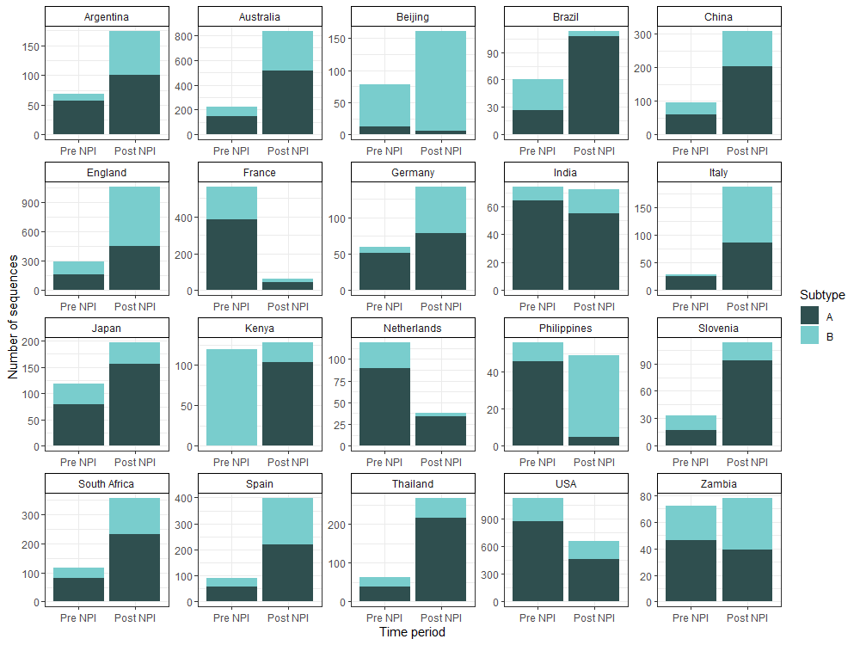
The number of RSV A and B samples reported in the GISAID data one year before the pandemic (pre NPI) and three years after the implementation of NPIs (post NPI) for each of the 20 locations included in the analysis.

