T-cell responses to ancestral SARS-CoV-2 and Omicron variant among unvaccinated pregnant and postpartum women living with and without HIV in South Africa

William C. McMahon^{1,2}, Gaurav Kwatra^{1,3,4,*}, Alane Izu^{1,5}, Stephanie A. Jones¹, Nkululeko J. Mbele¹, Nwabisa Jafta¹, Rushil Lala¹, Sharon Shalekoff^{6,7}, Caroline T. Tiemessen^{6,7}, Shabir A. Madhi^{1,5¶}, Marta C. Nunes^{1,2,8¶}

SUPPLEMENTARY INFORMATION

Supplementary figure legends

Fig. S1. Flow cytometry gating strategy and representative staining profiles.
The flow cytometry gating strategy and representative staining profiles of two plate controls (unstimulated and PHA-stimulated) using cells from a Covid-19 vaccinated donor. Firstly, a time gate was used to ensure that analysis was performed only on data with a consistent flow rate. Doublets were removed by using FSC-A against FSC-H, after which lymphocytes were gated using their FSC-A and SSC-A properties. Approximately 100,000 live CD3⁺ cells were acquired for each reaction. CD4⁺ and CD8⁺ T cells were gated and assessed for surface expression of PD-1 (histogram plots), as well as for intracellular expression of IFN-γ, TNF-α, and IL-2 (pseudocolour plots). Responses are indicated by percentages in each plot.

Fig. S2. Overall median comparisons of SARS-CoV-2-specific CD4⁺ and CD8⁺ T-cell responses in women living with and without HIV.
Direct median comparisons between CD4⁺ and CD8⁺ T-cell polyfunctionality profiles between women living with and without HIV in response to the (a) FLS and (b) N proteins on WT SARS-CoV-2. Individual points represent the median T-cell response of positive responders in each group of cytokines that were produced. CD4⁺ T-cell responses are indicated in green and blue. CD8⁺ T-cell responses are indicated in red and orange. The Wilcoxon signed-rank test was used for comparing paired CD4⁺ and CD8⁺ T-cell responses. Significant P-values are indicated in bold (p<0.05). Denotations: FLS, full-length spike glycoprotein; IFN-γ, interferon gamma; Il-2, interleukin 2; N, nucleocapsid protein; TNF-α, tumor necrosis factor alpha; WLWH, women living with HIV; WT, wild-type (ancestral) SARS-CoV-2.

Fig. S3. Maternal T-cell responses to the FLS and N proteins of WT SARS-CoV-2.
The proportion of T-cells producing IL-2, IFN-γ, or TNF-α in response to the FLS and N proteins of WT SARS-CoV-2, stratified by maternal (pregnant: n=17; postpartum: n=16; not pregnant: n=5) and HIV-status (HIV-uninfected: n=23; WLWH: n=15). SARS-CoV-2-specific CD4⁺ T-cell responses to (a) the FLS and (b) N proteins. SARS-CoV-2-specific CD8⁺ T-cell responses to (c) the FLS and (d) N proteins. Each participant is represented by an individual point, and medians in each group are represented by horizontal lines. Statistical analysis was performed using the Mann-Whitney U-test for T-cell response comparisons between unpaired (HIV-uninfected vs. WLWH) responders. Significant P-values are indicated in bold (p<0.05). Denotations: FLS, full-length spike glycoprotein; HIV-, HIV-uninfected women N, nucleocapsid protein; WLWH, women living with HIV; WT, wild-type (ancestral) SARS-CoV-2.

Fig. S4. Maternal polyfunctionality of CD4⁺ T-cells to the FLS and N proteins of WT SARS-CoV-2 in HIV-uninfected women.
(a) Comparisons of the polyfunctional profiles of CD4⁺ T cells to the FLS and N proteins of WT SARS-CoV-2 in HIV-uninfected women, stratified by maternal status. Each participant is represented by an individual point, and medians in each group are represented by horizontal lines. (b) Each responses pattern is colour-coded, and data summarized in pie charts. The Mann-Whitney U-test was used for comparing unpaired CD4⁺ T-cell responses of positive responders between pregnant and postpartum women. Only significant response differences are indicated (p<0.05). (c) Correlations between FLS- and N-specific CD4⁺ T-cell responses according to IL-2, IFN-γ, and TNF-α production. Spearman’s rank correlation coefficient (two-sided) was used to determine the P and r (correlation coefficient) values. Linear regression lines are indicated in red, together with 95% confidence interval lines. Denotations: FLS, full-length spike glycoprotein; HIV-, HIV-uninfected women; IFN-γ, interferon gamma; Il-2, interleukin 2; N, nucleocapsid protein; TNF-α, tumor necrosis factor alpha; WT, wild-type (ancestral) SARS-CoV-2.

Fig. S5. Maternal polyfunctionality of CD4⁺ T-cells to the FLS and N proteins of WT SARS-CoV-2 in women living with HIV.
(a) Comparisons of the polyfunctional profiles of CD4+ T cells to the FLS and N proteins of WT SARS-CoV-2 in WLWH, stratified by maternal status. Each participant is represented by an individual point, and medians in each group are represented by horizontal lines. (b) Each responses pattern is colour-coded, and data summarized in pie charts. The Mann-Whitney U-test was used for comparing unpaired CD4+ T-cell responses of positive responders between pregnant, postpartum, and non-pregnant women. Only significant response differences are indicated (p<0.05). (c) Correlations between FLS- and N-specific CD4+ T-cell responses according to IL-2, IFN-γ, and TNF-α production. Spearman’s rank correlation coefficient (two-sided) was used to determine the P and r (correlation coefficient) values. Linear regression lines are indicated in red, together with 95% confidence interval lines. Denotations: FLS, full-length spike glycoprotein; IFN-γ, interferon gamma; IL-2, interleukin 2; N, nucleocapsid protein; TNF-α, tumor necrosis factor alpha; WLWH, women living with HIV; WT, wild-type (ancestral) SARS-CoV-2.

Fig. S6. Maternal polyfunctionality of CD8⁺ T-cells to the FLS and N proteins of WT SARS-CoV-2 in HIV-uninfected women.
(a) Comparisons of the polyfunctional profiles of CD8⁺ T cells to the FLS and N proteins of WT SARS-CoV-2 in HIV-uninfected women, stratified by maternal status. Each participant is represented by an individual point, and medians in each group are represented by horizontal lines. (b) Each responses pattern is colour-coded, and data summarized in pie charts. The Mann-Whitney U-test was used for comparing unpaired CD8⁺ T-cell responses of positive responders between pregnant and postpartum women. Only significant response differences are indicated (p<0.05). (c) Correlations between FLS- and N-specific CD8⁺ T-cell responses according to IL-2, IFN-γ, and TNF-α production. Spearman’s rank correlation coefficient (two-sided) was used to determine the P and r (correlation coefficient) values. Linear regression lines are indicated in red, together with 95% confidence interval lines. Denotations: FLS, full-length spike glycoprotein; HIV-, HIV-uninfected women; IFN-γ, interferon gamma; IL-2, interleukin 2; N, nucleocapsid protein; TNF-α, tumor necrosis factor alpha; WT, wild-type (ancestral) SARS-CoV-2.

Fig. S7. Maternal polyfunctionality of CD8+ T-cells to the FLS and N proteins of WT SARS-CoV-2 in women living with HIV.
(a) Comparisons of the polyfunctional profiles of CD8+ T cells to the FLS and N proteins of WT SARS-CoV-2 in WLWH, stratified by maternal status. Each participant is represented by an individual point, and medians in each group are represented by horizontal lines. (b) Each responses pattern is colour-coded, and data summarized in pie charts. The Mann-Whitney U-test was used for comparing unpaired CD8+ T-cell responses of positive responders between pregnant, postpartum, and non-pregnant women. Only significant response differences are indicated (p<0.05). (c) Correlations between FLS- and N-specific CD4+ T-cell responses according to IL-2, IFN-γ, and TNF-α production. Spearman’s rank correlation coefficient (two-sided) was used to determine the P and r (correlation coefficient) values. Linear regression lines are indicated in red, together with 95% confidence interval lines. Denotations: FLS, full-length spike glycoprotein; IFN-γ, interferon gamma; IL-2, interleukin 2; N, nucleocapsid protein; TNF-α, tumor necrosis factor alpha; WLWH, women living with HIV; WT, wild-type (ancestral) SARS-CoV-2.

Supplementary figures
Fig. S1
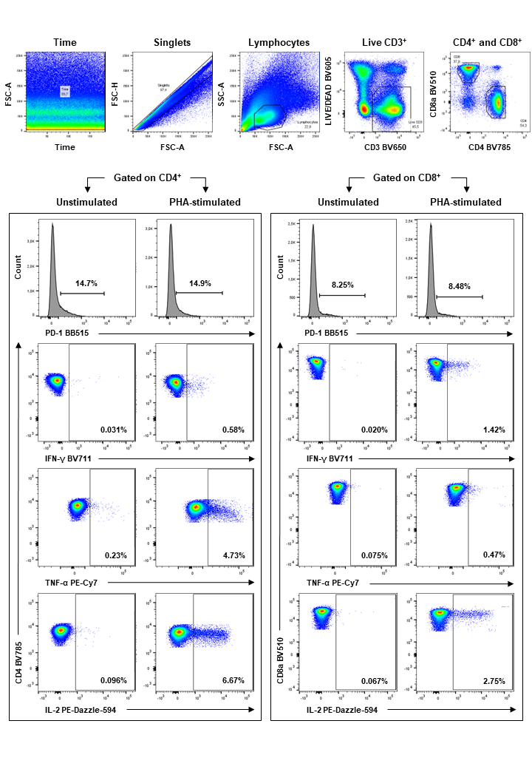
Fig. S2
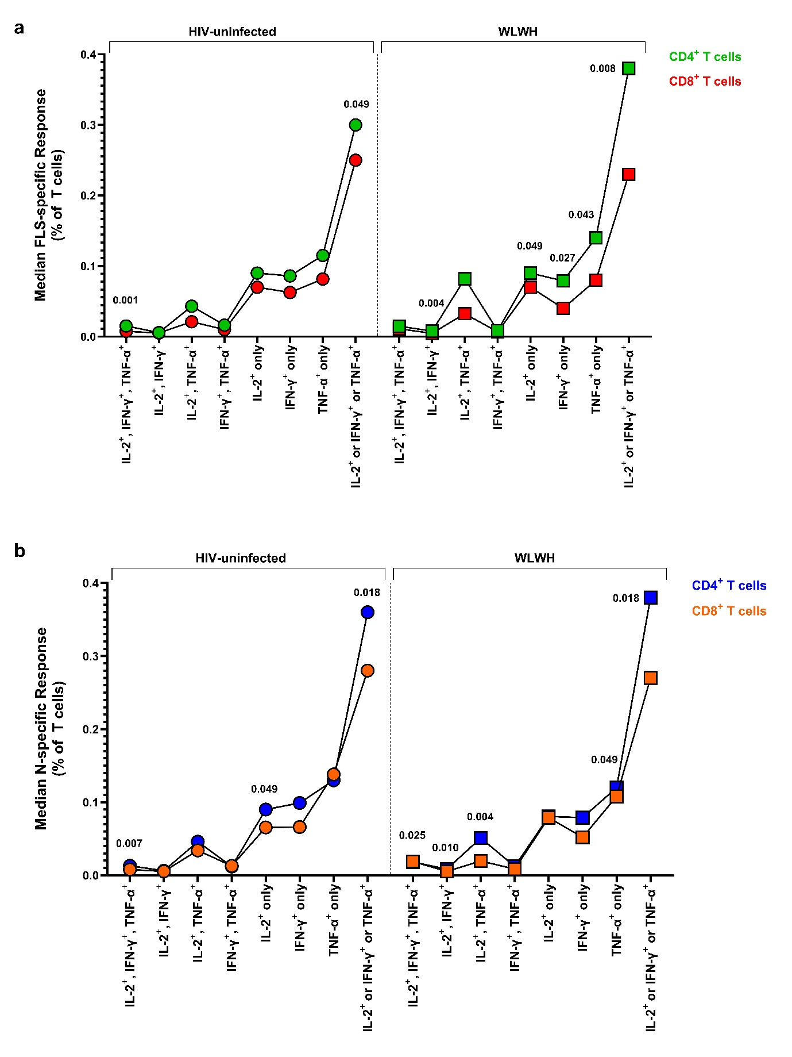
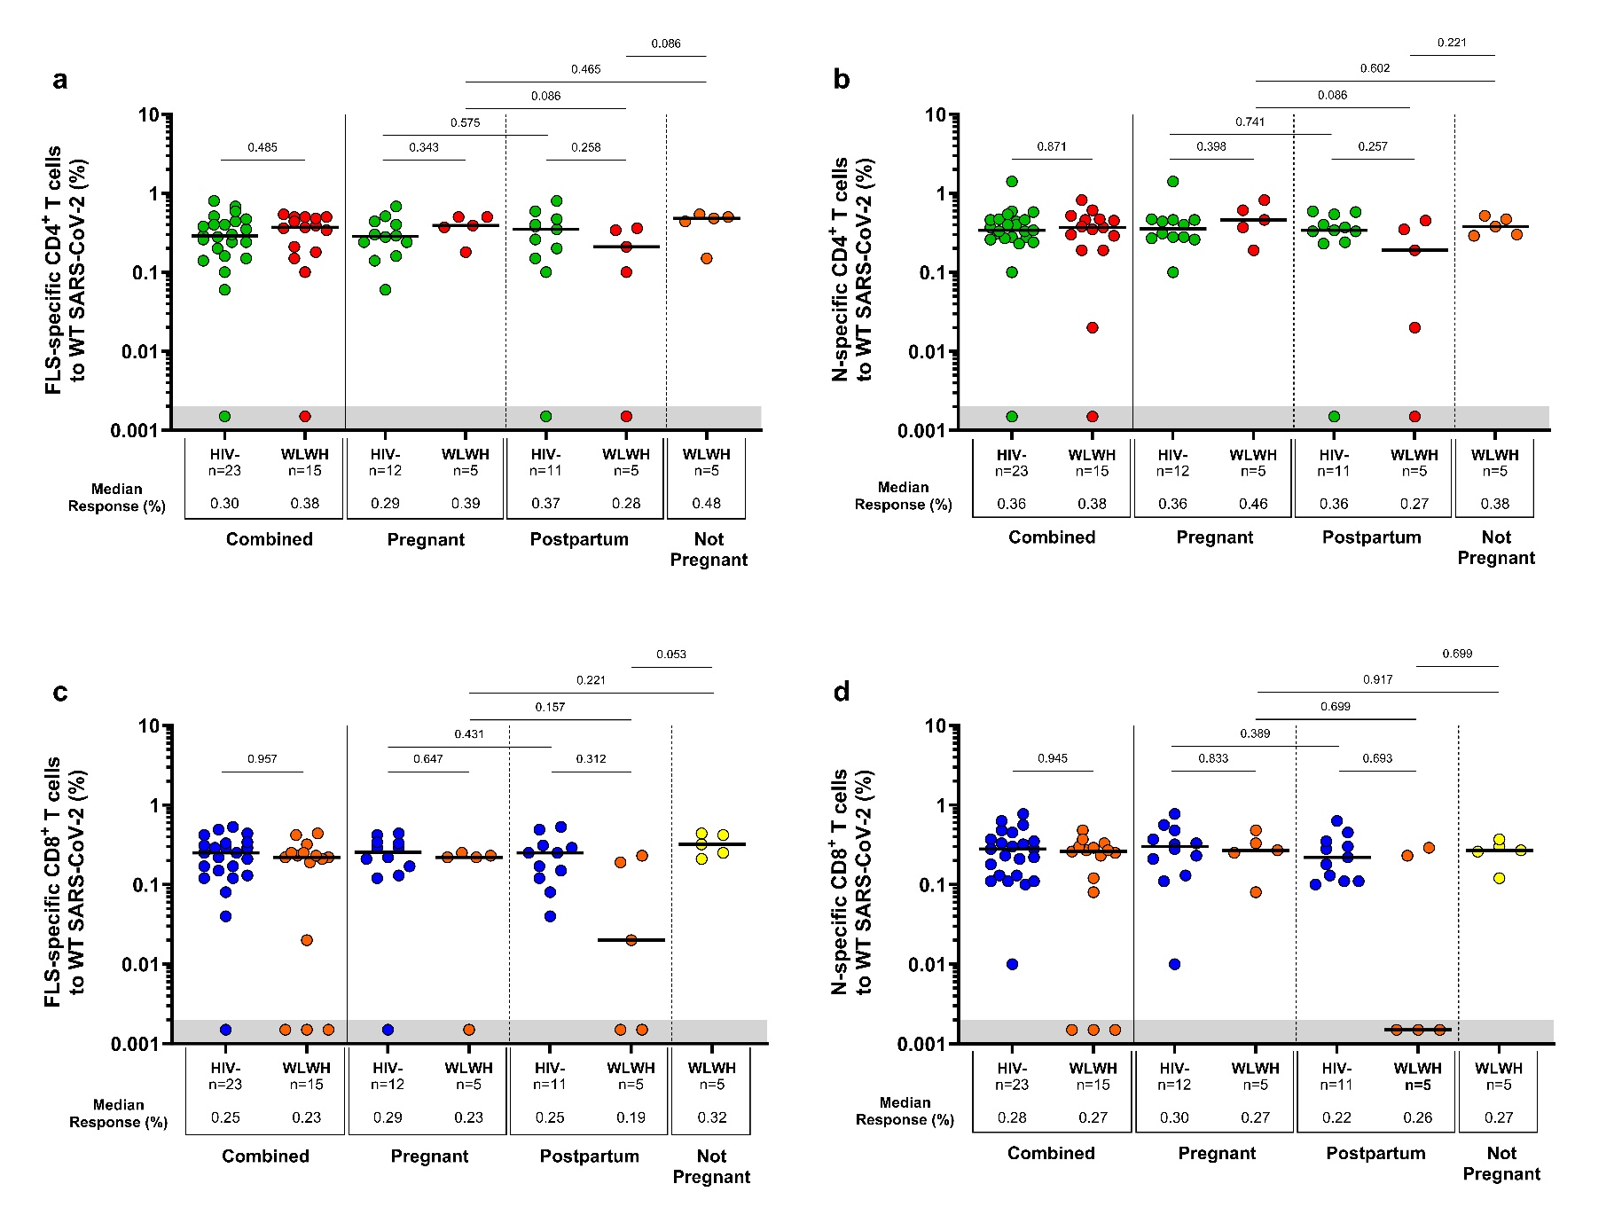
Fig. S3
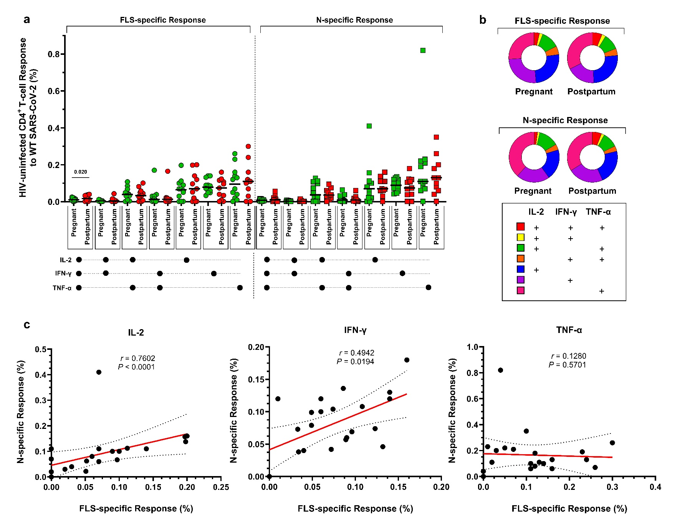
Fig. S4

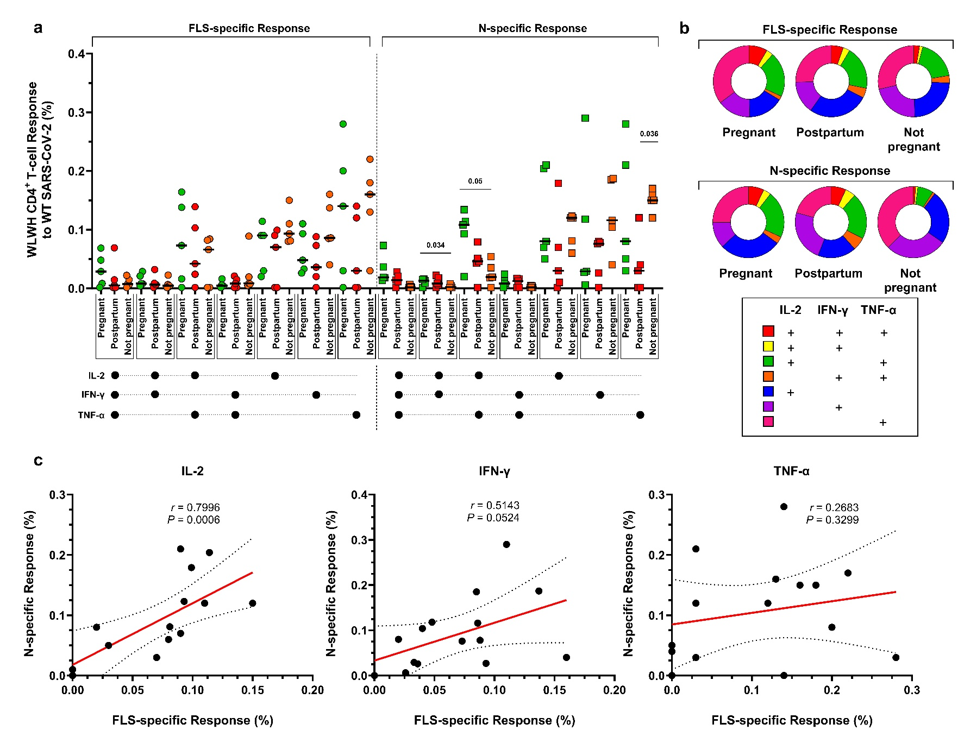
Fig. S5

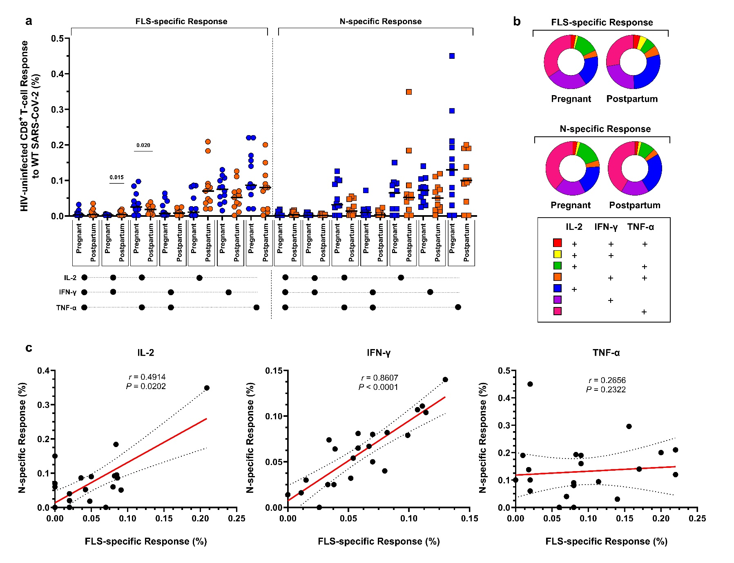
Fig. S6

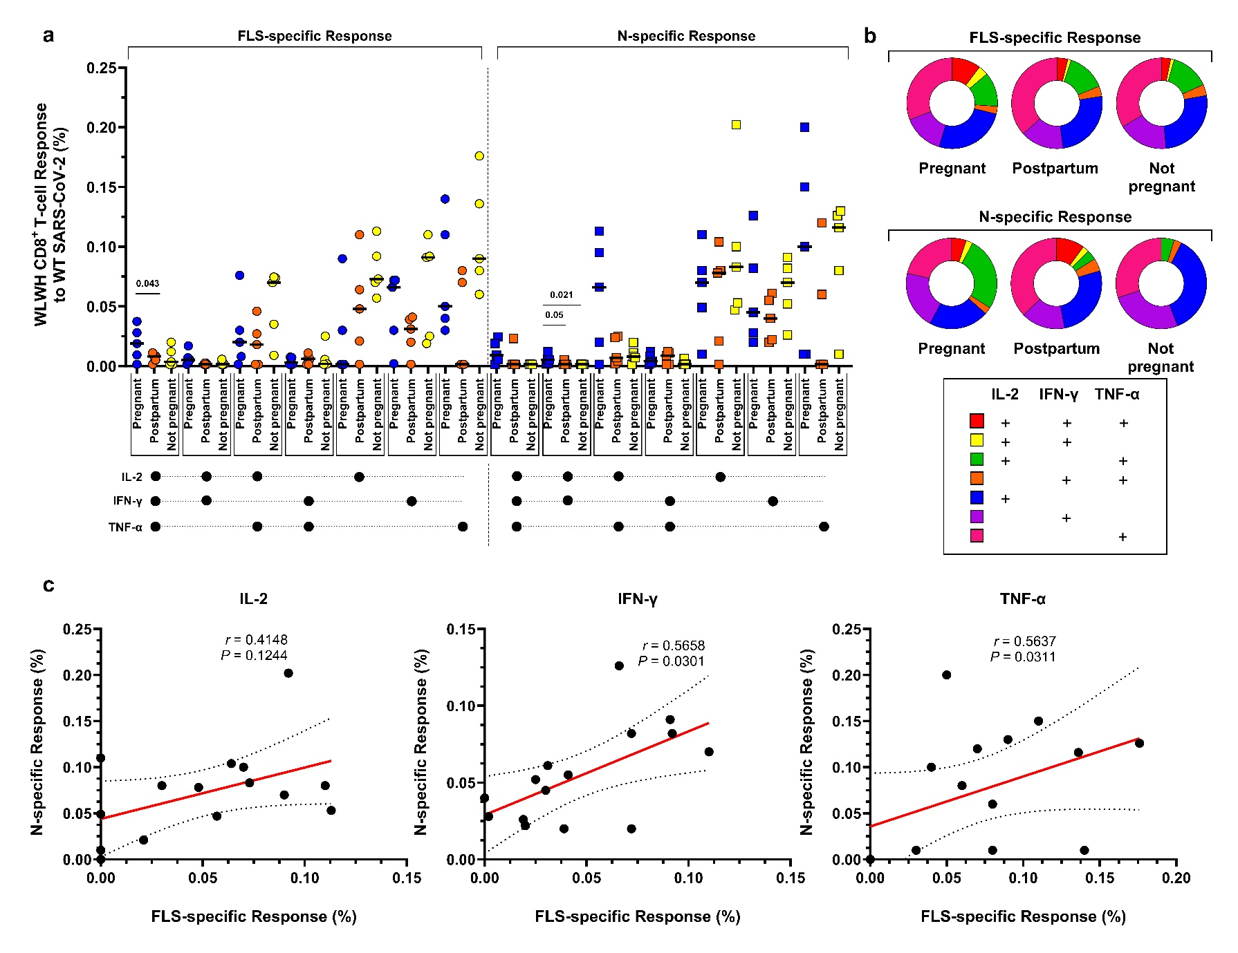
Fig. S7

