Supplementary Materials

Figure S1: Comparison of GPC and Human insulin leader sequence
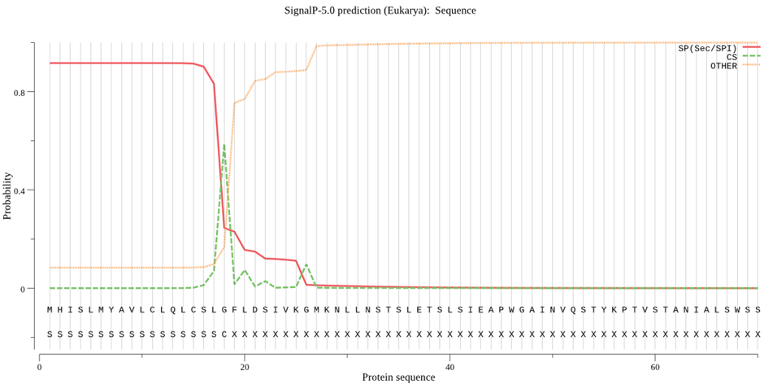

CCHFV GPC leader sequence
Prediction: Signal peptide (Sec/SPI)Cleavage site between pos. 18 and 19: SLG-FL. Probability: 0.5872

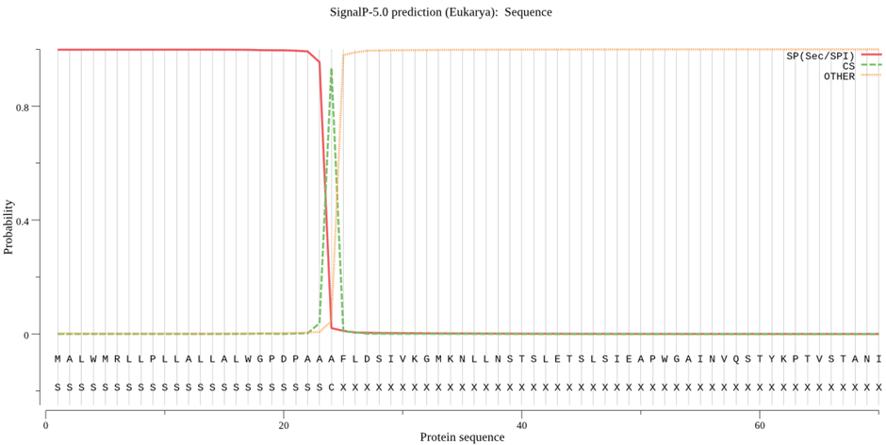

Human Insulin leader peptide
Prediction: Signal peptide (Sec/SPI)Cleavage site between pos. 24 and 25: AAA-FL. Probability: 0.9348

Figure S2: CCHFV Gc structure and estimation of molecular weight

10 20 30 40 50 60
FLDSIVKGMK NLLNSTSLET SLSIEAPWGA INVQSTYKPT VSTANIALSW SSVEHRGNKI
70 80 90 100 110 120
LVSGRSESIM KLEERTGISW DLGVEDASES KLLTVSVMDL SQMYSPVFEY LSGDRQVEEW
130 140 150 160 170 180
PKATCTGDCP ERCGCTSSTC LHKEWPHSRN WRCNPTWCWG VGTGCTCCGL DVKDLFTDYM
190 200 210 220 230 240
FVKWKVEYIK TEAIVCVELT SQERQCSLIE AGTRFNLGPV TITLSEPRNI QQKLPPEIIT
250 260 270 280 290 300
LHPRIEEGFF DLMHVQKVLS ASTVCKLQSC THGVPGDLQV YHIGNLLKGD KVNGHLIHKI
310 320 330 340 350 360
EPHFNTSWMS WDGCDLDYYC NMGDWPSCTY TGVTQHNHAS FVNLLNIETD YTKNFHFHSK
370 380 390 400 410 420
RVTAHGDTPQ LDLKARPTYG AGEITVLVEV ADMELHTKKI EISGLKFASL TCTGCYACSS
430 440 450 460 470 480
GISCKVRIHV DEPDELTVHV KSDDPDVVAA SSSLMARKLE FGTDSIFKAF SAMPKTSLCF
490 500 510 520 530 540
YIVEREHCKS CSEEDTKKCV NTKLEQPQSI LIEHKGTIIG KQNSTCTAKT SCWLESVKSF
550 560 570
FYGLKNMLSG IFGNVGLNDI FEAQKIEWHE HHHHHH

Theoretical pI/Mw (average) for the user-entered sequence: Theoretical pI/Mw: 6.03 / 64558.46

Figure S3: Predicition of N-glycosylation sites on CCHFV Gc sequence
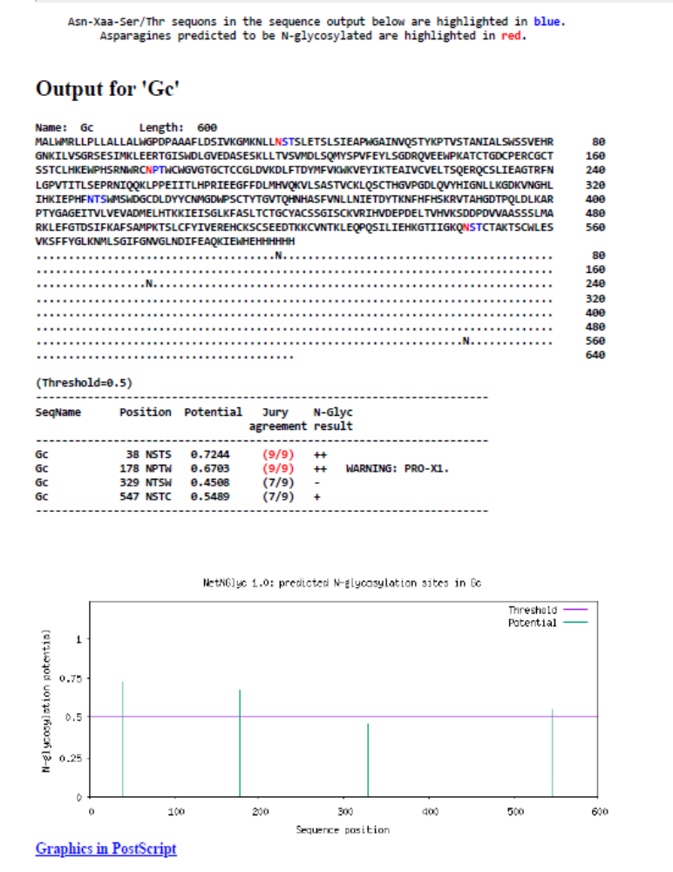

Supplementary Table S1: CCHF positive and negative samples tested by the commercial Crimean-Congo fever virus Mosaic 2 (IgG) kit (EUROIMMUN) and in this study.

Sample ID | ELISA results
66/08 | Positive
67/08 | Positive
69/08 | Positive
6/09 | Positive
30/10 | Positive
51/10 | Positive
52/10 | Positive
53/10 | Positive
6/11 | Positive
31/11 | Positive
51/11 | Positive
54/11 | Positive
41/13 | negative
42/13 | negative
43/13 | negative
45/13 | negative
46/13 | negative
47/13 | negative
49/13 | negative
50/13 | negative
51/13 | negative
52/13 | negative
53/13 | negative

Original gels/blots figure 2

Figure 2B and 2D

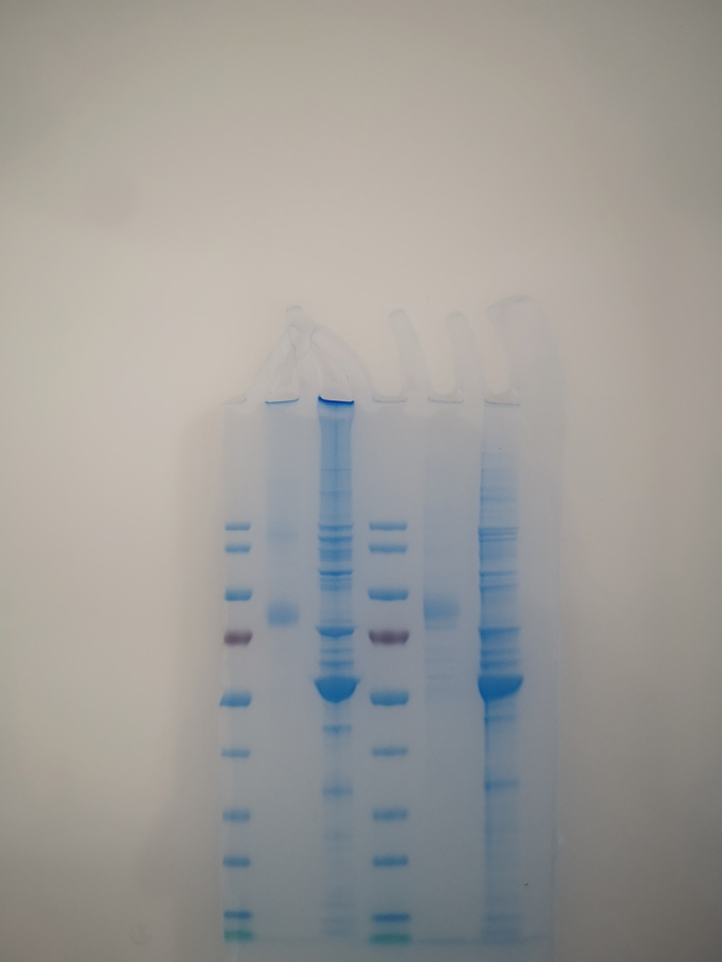

Figure 2C and 2E
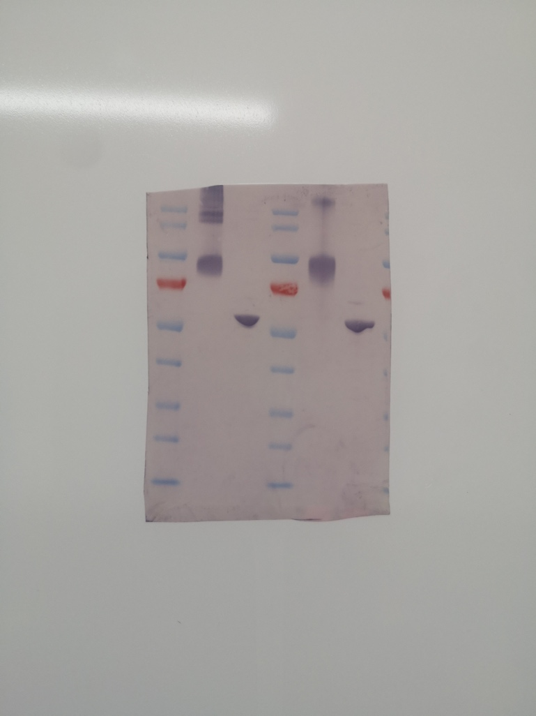

Figure 2 F: different concentrations of triton X (1%, 0.5% 0.25%)
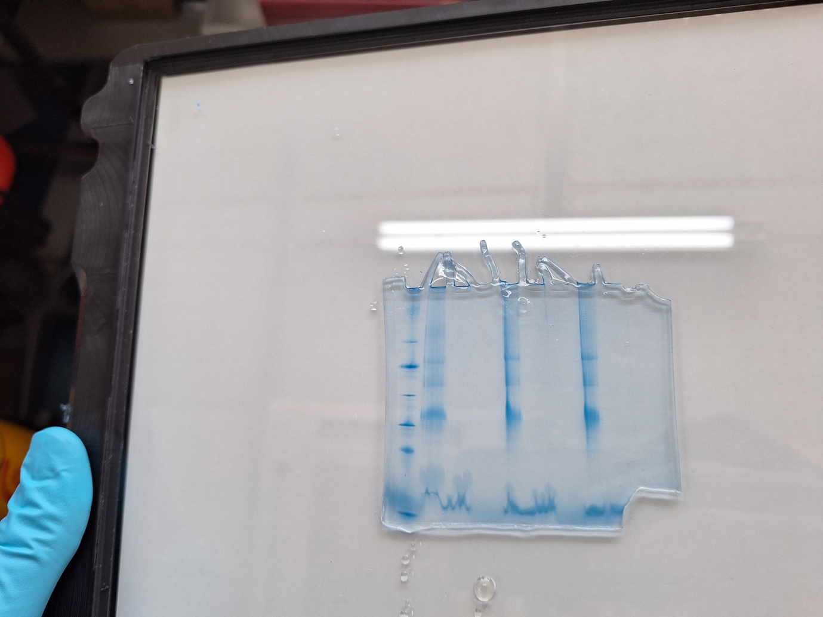

Original gels/blots figure 3

Figure 3 C
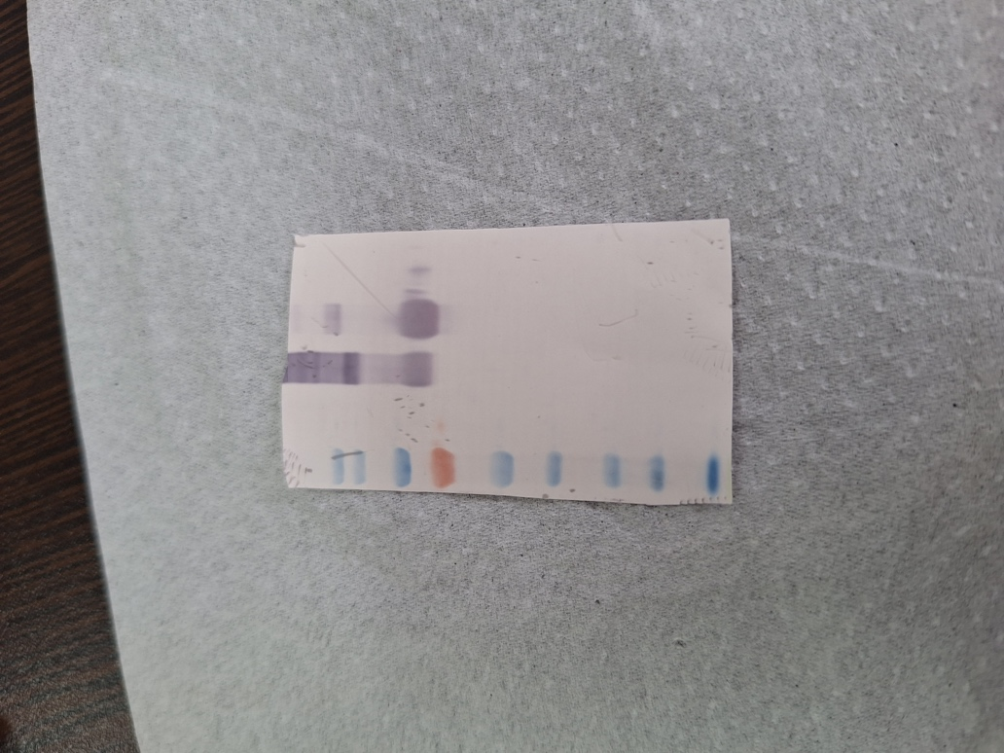

Figure 3B

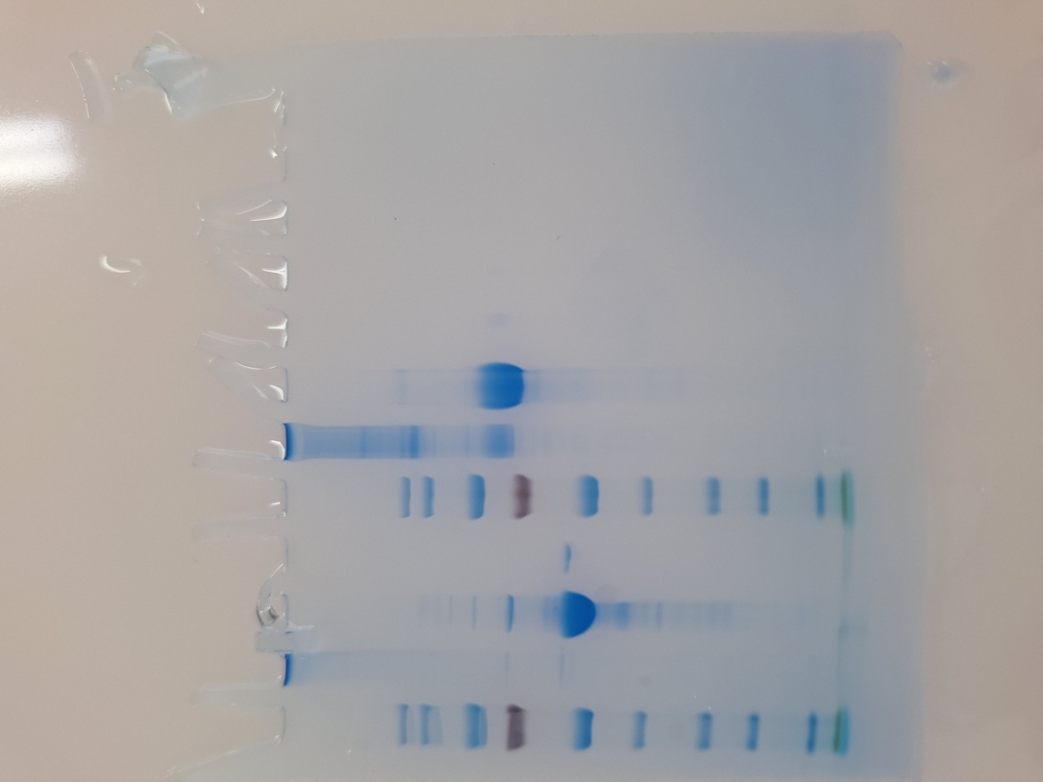

Original gels/blots figure 5

Figure 5A

