Magnetic nanoparticles composed of Fe₃(PO₄)₂·8H₂O by Burkholderia cepacia CG-1：A study of peroxidase-like activity and its application in H₂O₂ and glucose detection

Jueyu Wang^{†,1}, Mingyu Jiai^{†,1}, Yang Jinming, Daizong Cui†*, Min Zhao†,*
† College of Life Science, Northeast Forestry University, Harbin 150040, China
¹ Both authors contributed equally to this work and should be considered as co-first authors.
*Co-correspondent Authors
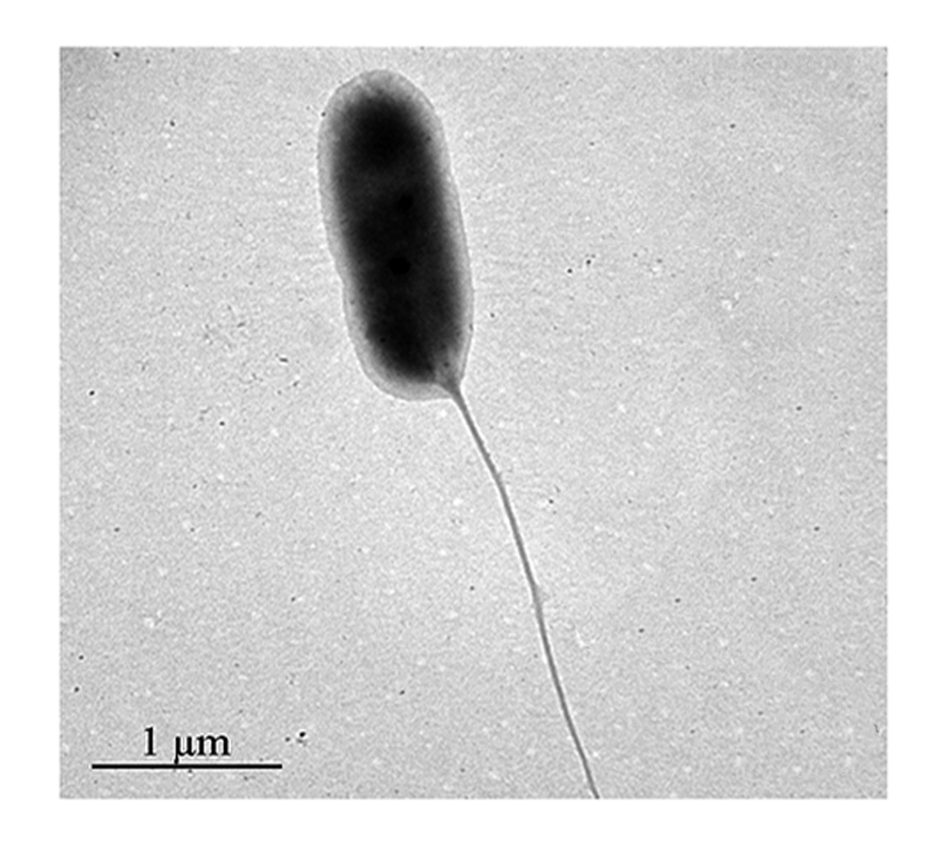
Fig S1 The TEM image of the bacteria cells of B. cepacia CG-1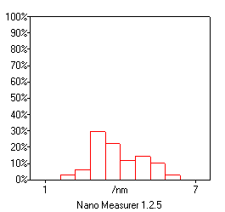
Fig S2 The size of Fe₃(PO4)₂ nanoparticles from the strain B. cepacia CG-1for 3 days

