Exploring the Cost and Emissions Impacts, Feasibility, and Scalability of Battery-Electric Ships

Contents

Contents 2
List of Acronyms 4
Supplementary Notes 5
Supplementary Note 1: Methods for Integrating Multiple Ship Databases 5
Supplementary Note 2: AIS Data Processing 12
Supplementary Note 3: Calculation of Ship Power Demand and Battery Size 13
Supplementary Note 4: Battery Degradation and Estimated Lifetime 19
Supplementary Note 5: Emission Calculation 22
Supplementary Note 6: Economic Feasibility Calculation 25
Supplementary Note 7: Weight Estimation 28
Supplementary Note 8: Life Cycle Analysis 30

Supplementary Table 1. Mapping USCG Vessel Types to Study-Specific Vessel Categories. 32
Supplementary Table 2. Mapping IHS Vessel Types to Study-Specific Vessel Categories. 36
Supplementary Table 3. Ship Statistics by Type and Source 37
Supplementary Table 4. Average GT, Main Engine Capacity, and Travel Distance by Ship Type 38
Supplementary Table 5. Data Availability in Each Ship List 39
Supplementary Table 6. Parameters for Estimating Main Engine Capacity 40
Supplementary Table 7. Parameters for Estimating Main Engine Capacity10 41
Supplementary Table 8. Parameters for Estimating Auxiliary Engine Capacity 42
Supplementary Table 9. Parameters in the Admiralty Formula 43
Supplementary Table 10. Operational Mode by SOG 44
Supplementary Table 11. Load Factor of Auxiliary Engines by Operational Mode and Ship Type (EPA, 2009) 45
Supplementary Table 12. Energy Consumption Ratio of Main Engine and Auxiliary Engine (IMO, 2020) 46
Supplementary Table 13. Efficiency of Individual Ship Components 47
Supplementary Table 14. Emission Factors for ICE Ships Fueled by ULSDa 48
Supplementary Table 15. Low-Load Adjustment Factors14 49
Supplementary Table 16. Emission Factors for BESsa 50
Supplementary Table 17. Parameters Used in Economic Feasibility Assessment 51
Supplementary Table 18. Median Battery Capacity of BESs by Ship Size, Ship Type and Capacity Tier 52

Supplementary Figure 1. Number of Ship Matches by Database and Method 53
Supplementary Figure 2. Distribution of the AIS Analyzed Subset among Top 10 States by Ship Type and Cumulative Gross Tonnage (GT) 54
Supplementary Figure 3. Count of Ships by Data Source 55
Supplementary Figure 4. Data Availability in the Domestic Fleet (6,323 ships with GT between 50-1000) 56
Supplementary Figure 5. Estimation of IHS Max Speed Based on IHS Service Speed 57
Supplementary Figure 6. Estimation of Reference Speed Based on AIS Max Speed and AIS 95th Percentile Speed 58
Supplementary Figure 7. Estimation of Main Engine Capacity Based on GT, Registered Length, and Reference Speed 59
Supplementary Figure 8. Estimation of Displacement from GT 60
Supplementary Figure 9. A Conceptual Configuration of BES and SPC 61
Supplementary Figure 10. Electricity Flow during Battery Charging at Port 62
Supplementary Figure 12. SOG of Different Ship Types: (a) Passenger, (b) Tug (Coastal-Harbor) 64
Supplementary Figure 13. Examples of Distribution of Trip Energy 65
Supplementary Figure 14. Sum of Trip Energies for Two Ships 66
Supplementary Figure 15. A Schematic Diagram of Battery Sizing with Degradation Reflected 67
Supplementary Figure 16. Effect of State of Charge on Calendar Degradation Rate 68
Supplementary Figure 17. Battery Sizing and Usable Capacity: (a) Initial Battery Composition, (b) End of Life (EoL) 69
Supplementary Figure 18. LCA of BESs 70
Supplementary Figure 19. Cumulative Distribution of Reference Trip Energy Demand 71
Supplementary Figure 20. Distribution of Ratio of Unserved Trip Energy by BES Capacity Tier (BESp99, BESp95, and BESp90) 72
Supplementary Figure 21. Distribution of Unserved Trip Ratio by Ship Type for Capacity Tier BES p95 73
Supplementary Figure 22. Average LCOT of ICE Ships and BESs in 2022 under an INT Cost Scenario 74
Supplementary Figure 23. Average LCOT for ICE Ships and BESs in 2035 under a 95% Electricity Decarbonization by 2050 (DEC) Emission Scenario and INT Cost Scenario By Capacity Tier 76
Supplementary Figure 24. Average LCOT for ICE Ships and BESs in 2035 under a 95% Electricity Decarbonization by 2050 (DEC) Emission Scenario and INT Cost Scenario By Ship Type for BESs with Capacity Tier p99 (BESp99) 77
Supplementary Figure 25. Average LCOT of ICE Ships and BESs in 2050 under a 95% Electricity Decarbonization by 2050 (DEC) Emission Scenario with (a) Intermediate (INT) and (b) Optimistic (OPT) Cost Assumptions 79
Supplementary Figure 26. Ratio of BES Weight to ICE Weight by BES Capacity Tier 81
Supplementary Figure 27. Ratio of BES p99 Weight to ICE Weight by Ship Type 82
Supplementary Figure 28. Ratio of BES p99 Weight to ICE Weight by Ship Type under Multiple Battery Weight Reduction Scenarios 83
Supplementary Figure 29. Distribution of the Ratio of CO2e Emission Decrease vs. ICE Ships with a Factor of 2 for Unserved Trips in 2035 under a 95% Decarbonization by 2050 (DEC) Scenario 84
Supplementary Figure 30. Ratio of Supplied Charging Demand under Historical Activity-Based Charging (HAC) and Trip-Based Charging (TBC) at the Illinois International Port 85
Supplementary Figure 31. Distribution of Power Requirements for SPCs under Historical Activity-based Charging (HAC) and Trip-Based Charging (TBC) at the Illinois International Port 87
Supplementary Figure 32. Distribution of Number of Required SPCs under Historical Activity-based Charging (HAC) and Trip-Based Charging (TBC) at the Illinois International Port 88
Supplementary Figure 33. Count of Ships in the AIS Analyzed Subset, by Ship Type 89
Supplementary Figure 34. Distribution of Annual Travel Distance by Ship Type in the AIS Analyzed Subset 90
Supplementary Figure 35. Locations and Domestic Commodity Shipments at 150 Major U.S. Ports 91
Supplementary Figure 36. Process for Estimating Ship Electrification Potential and GHG Emissions 92
Supplementary Figure 37. Design of the Maritime Battery Electrification Simulator (MariBES) Developed for This Study 93
Supplementary Figure 38. Illustrative Passenger Ship: (a) Speed over Ground (SOG) and Moving/Chargeable State, (b) Battery Charging, Discharging, and SOC 94
Supplementary Figure 39. Conceptual Framework for Estimating BES Grid Charging Requirements 95
Supplementary Figure 40. CO2e Emissions from ICE Ships in the AIS Analyzed Subset 96
Supplementary References 97

List of Acronyms
AC | Alternating Current
ATB | Articulated Tug Barges
AIS | Automatic Identification System
BES | Battery-Electric Ship
BOEM | Bureau of Ocean Energy Management
CO₂e | Carbon dioxide equivalent
DC | Direct Current
GHG | Greenhouse Gas
GT | Gross Tonnage
IHS | Information Handling Services
ICE | Internal Combustion Engine
IMO | International Maritime Organization
km | Kilometer
kW/GW/TW | kilowatt/Gigawatt/Terawatt(s)
kWh/GWh/TWh | kilowatt/Gigawatt/Terawatt-hour(s)
LCOT | Levelized Cost of Transportation
LCA | Life Cycle Analysis
MDO | Marine Diesel Oil
MMSI | Maritime Mobile Service Identity
NOAA | National Oceanic and Atmospheric Administration
NREL | National Renewable Energy Laboratory
NTS | National Transportation Statistics
NMC | nickel manganese cobalt oxide
NO_{x} | Nitrogen Oxides
SLB | Second-Life Battery
SPC | Shore Power Connection
SOG | Speed Over Ground
SO_{x} | Sulfur Oxides
USACE | U.S. Army Corps of Engineers
USCG | U.S. Coast Guard
ULSD | Ultra Low Sulfur Diesel

Supplementary Notes

Supplementary Note 1: Methods for Integrating Multiple Ship Databases
We utilized three types of data to analyze ship activities: 1) stock and technical specifications of vessels, 2) Automatic Identification System (AIS) vessel location data, and 3) port location data. The vessel stock and specification data were integrated from four data sources:
- U.S. Coast Guard¹
- U.S. Army Corps of Engineers²
- IHS Markit³

This integrated dataset contains multiple unique ship identifiers, gross tonnage (GT), length, main engine capacity, auxiliary engine capacity, maximum speed, and registered state where the GT is a nonlinear measurement of a ship’s internal volumes, derived from its volume rather than its weight. The second dataset, AIS data, refers to a collection of information transmitted by vessels and collected by AIS receivers in real time. Each AIS data point includes the vessel’s unique identifier, coordinates, and speed over ground (SOG), and the corresponding timestamps. The National Oceanic and Atmospheric Administration (NOAA) and Bureau of Ocean Energy Management (BOEM) have facilitated the public availability of AIS data collected through the U.S. Coast Guard’s (USCG) national network of AIS receivers.⁴ For our study, we used 2021 data from the AIS data pool and extracted AIS data for each target vessel. We combined the AIS data with port data, which includes coordinates of 150 major ports in the U.S. to analyze port activity. Detailed descriptions of each dataset are provided below.

We made a ship database containing 6,323 ships by integrating ship data from four different ship databases, each with its own limitations as follows:
- USCG: Although it provides detailed information on ship activities, it is deficient in providing ship specifications such as engine capacities and maximum speed.
- USACE: This database only classifies self-propelled and tug vessels, and the ship specifications provided are incomplete.
- IHS: This database only covers ships with GT greater than 100 and provides incomplete ship specifications.
- AIS: This database only provides activity-focused data, such as location and movement, and rarely provides ship specifications.
There were 3,323 matches between the ship list from the AIS data with the USCG-USACE-IHS integrated dataset. As shown in Supplementary Figure 1, only 1,139 ship matches (34% of all AIS matches) are based on Maritime Mobile Service Identity (MMSI) where MMSIs are a set of nine-digit numerical identifiers utilized in maritime digital selective calling, AIS, and some other equipment to distinguish and uniquely designate a ship.⁵ Beyond that, 2,183 ships (66% of all AIS matches) were matched based on ship name verified with call sign, showing the value of this approach in the absence of MMSI data.

Ships in Scope
Our study specifically targets self-propelled U.S. flag ships with GT between 50 and 1000. The ship types considered in this study encompass tankers, general cargo, and passenger ships, as well as three types of tugs: Coastal-Harbor tugs, Inland-Push Boat tugs, and articulated tug barge (ATB) tugs. Ship type mapping from initial data sources is available in Supplementary Table 1 and Supplementary Table 2 earlier in this document. Supplementary Table 3 shows number of ships by the source of ship data. In most previous emission studies, the commercially available IHS ship list serves as the initial reference due to its convenience in providing comprehensive and well-organized specifications for ships from different countries.³ However, the IHS-listed ships – 171 passenger ships and 1,501 tugs – account for less than 25% of the ships contained in other publicly available databases. According to the 50th National Transportation Statistics (NTS), there are 1,721 passenger ships and 6,203 tugs.⁶ Furthermore, when counting ships with 50-1000 GT and narrowing them to those where AIS data are available, the number of IHS-listed ships decreases further, to 108 passenger ships and 1,201 tugs – only 6.3% and 19.4% of the ships in NTS. Therefore, these limited IHS numbers are insufficient as samples to represent the entirety of U.S. ships.

To expand the pool of ships available for analysis, we conducted a comprehensive integration of four ship lists obtained from the following sources: IHS (2021)³, USACE (2021)², USCG (2021)¹, and a data set extracted from AIS⁴. Methods we used to integrate datasets are described in detail in Appendix B. The total number of ships in this integrated list amounts to 11,686. (Notably, the USCG list includes ships with GT less than 50, contributing to a higher count of ships compared to the other sources.) When comparing only tugboats, the 5,985 tugs align closely with the 6,203 tugs from NTS. Examining the integrated list further, we found a total of 5,414 passenger ships, more than three times the figure reported by NTS. This disparity can be attributed to the inclusion of small vessels with GT below 50, which number 3,610 ships (66.7% of the total). As most of these small vessels lack AIS data, ships with GT less than 50 are excluded from the analysis. Finally, the number of ships identified as targets for our battery-electric ship (BES) potential study is 2,722. These ships have annual travel distances greater than 1,500 km, based on 2021 AIS data⁴. This sample represents 43% of the total ships within the 50-1000 GT range in the integrated list and corresponds to 34% of the total ships reported by NTS.

From this point forward, the term “Integrated Ship Database” indicates the comprehensive list of 11,687 ships. “Domestic Fleet” is used to designate the 6,323 ships that have a GT ranging between 50 and 1,000. Meanwhile, “AIS Analyzed Subset” denotes the subset of 2,722 ships that traveled more than 1,500 km in 2021, based on AIS data⁴.

Supplementary Table 4 displays the average GT, main engine capacity, and travel distance of vessels included in the AIS Analyzed Subset, segmented by ship type. This table facilitates an understanding of the characteristics inherent to each ship type. General Cargo and Tanker vessels were excluded from the table because the relevant subset, 50-1000 GT, contains smaller-than-average ships for their type and is therefore not representative of those vessels.

The subtotal of the four vessel types is 2,716, with an average GT of 266, average main engine capacity of 1.9 MW, and average 2021 distance travelled of 29,835 km. Among the four ship types, the Tug (ATB) presented the most notable differences across the three categories: GT, engine capacity, and travel distance are 2.3, 2.0, and 1.8 times higher than the overall averages, respectively. The three non-ATB ship types showed more similarities across the three categories.

Supplementary Figure 2 presents a bar graph showing the distribution of GT among the 2,722 ships in the AIS Analyzed Subset, categorized by their state of registration. The graph focuses on the top 10 states, which were calculated based on their cumulative GT of these vessels. The ratio on the right axis compares the cumulative GT of the AIS Analyzed Subset vessels with the cumulative GT from the Integrated Ship Database and Domestic Fleet in each state.

On a state-by-state basis, Louisiana and Texas ranked first and second, respectively. The vessels in the AIS Analyzed Subset that are registered in Louisiana are 2.5 times larger than those in Texas. The fact that Texas and Louisiana are located at the junction of the Gulf Coast and the Mississippi River system, and that 86% of the AIS Analyzed Subset consists of Tug (Coastal-Harbor) and Tug (Inland-Push Boats) helps explain this observation.

Tugs represent the majority of GT in every state, ranging from 62% to 100%. In New York, Delaware, and California, Tug (ATB) vessels are particularly prevalent. Conversely, Tug (Inland-Push Boats) are more prevalent in inland states such as Kentucky, Tennessee, and Indiana. Among the top 10 states, California has the most passenger ships in terms of both GT (11,949) and share (37.8%). The proportion of ships in the AIS Analyzed Subset compared to the Integrated Ship Database is lowest in Delaware at 2%, and highest in Kentucky at 46%. The relatively low figure for Delaware can be attributed to the vast GT of its registered ships totaling 2,623,074, including large GT (>1000) ships such as Bulk Carriers, Tankers, Containers, and Ro-Ro ships.

As Supplementary Table 5 summarizes, the USCG, IHS, and USACE provide ship lists with their own sets of data. However, the differences in the provided data make it challenging to merge them. The desired information includes the following details for each ship:
- Maritime Mobile Service Identity (MMSI): MMSI is necessary to obtain AIS data by each ship.
- Ship specifications, especially power capacity and maximum speed: Power capacities of main and auxiliary engine and max speed are essential data for calculating the ship’s consumptions.

However, several challenges need to be addressed:
- Varying ship inclusion: The ships included in each list differ, with some ships present in multiple lists while others are only in a single list.
- Limited shared identifiers: It would be beneficial to have a shared identifier other than the ship name for ships present in multiple lists. However, many ships only have the ship name as a common identifier.
To overcome these challenges, the merging process is done using two methods:
- Identifying based on shared IDs: If ship data is found in more than one list and can be identified using the International Maritime Organization (IMO) number, MMSI, or CG number, the ship data is merged from the respective lists. However, since multiple ships may share the same call sign, ship data is not merged solely based on call sign.
- Identifying with ship name and verifying with specifications: Despite the limitations of insufficient IDs, ships lists may still share the same ship name. When multiple datasets contain the same ship name, it is crucial to consider the possibility that these vessels may be distinct vessels, especially since certain names, like “Freedom,” are quite popular. To address this, a similarity verification is conducted for ships with the same name but no unique identifiers. Factors such as call sign, GT, year of build, and length are compared. If there is a discrepancy of two years or more in the year of build, the ships are deemed separate.
The merging process starts based on the USCG data, followed by the USACE, IHS, and AIS lists. When merging the USCG and USACE lists, only the USCG number is used for the identification test because all USCG and most USACE ships’ data include the USCG number. When merging the IHS list with the USCG-USACE list, the IMO number is used initially. Subsequently, a similarity check is performed using ship name, GT, and year of build since these data are available for most ships in both datasets. Finally, the AIS data is merged based on the MMSI and IMO numbers. Further merging is then conducted based on similarity checks using ship name, call sign, and length. It is important to note that in the AIS list, ship data that do not find a match are disregarded due to the absence of nationality flags in the AIS data. This study specifically focuses on U.S. flag ships, thus ships without a match are excluded from the analysis.

Imputation of Missing Specification Data
To analyze the energy usage of each ship, the capacity of the main and auxiliary engines and the maximum speed for each vessel must be known. However, ship lists often lack completeness with these parameters. Supplementary Figure 4 shows the trend of available data in the Domestic Fleet (i.e., 6,323 ships with GT between 50-1000). Although GT and length data are widely available (100% and 96%, respectively), main engine capacity data are available for 75% of the ships, mostly from the USACE dataset. Only a small number of ships provided auxiliary engine capacity (9%) and reference speed (15%), including maximum and/or service speeds. The missing data to enable energy usage calculations are estimated as described in this subsection.

Reference Speed
Reference speed of each ship is required to estimate the propulsion power demand based on SOG. The speed data is sourced from the IHS list, which provides two types of speed: maximum speed and service speed³. Previous studies utilized maximum speed as the reference speed for each ship, if it were available^{7,8}. For ship data where maximum speed is not provided but service speed is provided, the reference speed can be estimated from the service speed⁹. In Supplementary Figure 5, each point represents the two speeds when both speed data are available. The dotted line is the linear regression line between the two speeds. The high R-squared value of 0.98, close to 1, indicates that the max speed estimated based on the service speed demonstrates a high level of accuracy. For ships where only service speed data is available, the reference speed was estimated as being approximately 1.11 times the IHS service speed.

If neither maximum nor service speed data were available, reference speed was extracted from historical AIS data, which includes SOG. Johansson et al. found that relying on the 95th percentile value of a vessel’s SOG from AIS data is a more accurate approach to estimating its maximum speed, instead of using the maximum SOG value⁹. This is because the maximum instantaneous speed may be affected by data errors and external factors such as sea currents.

Supplementary Figure 6 illustrates the estimation of reference speed based on max speed and the 95th percentile speed from AIS data. The 95th percentile speed was chosen from each ship’s SOG data from the raw AIS data, only considering values between 1 knot and 60 knots. The estimation of the reference speed using the 95th percentile speed yielded an R-squared value of 0.92, significantly higher than the R-squared value of 0.18 when estimated based on max speed, confirming the accuracy of estimating reference speed by using the 95th percentile speed. Based on these results, for ships that lack max speed and service speed data from IHS, reference speed is calculated by multiplying the 95th percentile speed by a factor of 1.1392.

Main and Auxiliary Engine Capacities
This study estimated main engine capacity by ship type when it was missing. For ship types with enough data to enable regression, namely Passenger and Tugs, an enhanced regression approach based on the IMO 4th Emission Study was utilized⁷. In that study, factors such as overall length, speed, and deadweight data were used to predict the missing values. Due to data availability in this study, registered length and GT were used as substitutes for overall length and deadweight, respectively. However, this regression yielded several instances of negative main engine capacities, an outcome that is impractical due to the presence of the constant term. Therefore, this study adopted a modified regression model which excludes the constant term and introduces a quadratic term, as defined in equation (2):

 | $${CAP}_{v,IMO}^{ME}=a_{0,{ST}_{v}}+a_{1,{ST}_{v}}GT_{ν}+a_{2,{ST}_{v}}{RL}_{ν}+a_{3,{ST}_{v}}V_{v}^{ref}$$ | (1)
 | $${CAP}_{v}^{ME}=b_{1,{ST}_{v}}GT_{ν}+b_{2,{ST}_{v}}{RL}_{ν}+b_{3,{ST}_{v}}V_{v}^{ref}+$$  $$b_{4,{ST}_{v}}GT_{ν}^{2}+b_{5,{ST}_{v}}{RL}_{ν}^{2}+b_{6,{ST}_{v}}{V_{v}^{ref}}^{2}$$ | (2)

where${CAP}_{v,IMO}^{ME}$ is the estimated main engine capacity based on the regression model (1), $a_{0,{ST}_{v}}$, $a_{1,{ST}_{v}}, a_{2,{ST}_{v}},$and $a_{3,{ST}_{v}}$ are coefficients by ship types determined by the regression model (1). ${CAP}_{v,LBL}^{ME}$ is the estimated main engine capacity based on the suggested regression model (2), $b_{0,{ST}_{v}}$, $b_{1,{ST}_{v}}, b_{2,{ST}_{v}},$and $b_{3,{ST}_{v}}$ are coefficients by ship types determined by the regression model (2). $GT_{ν}$ is GT of vessel $v$, ${RL}_{ν}$ is registered length of vessel $v$, and $V_{v}^{ref}$ is the reference speed determined as described above.
Supplementary Table 6 shows the estimation parameters and R-squared values by model and ship types. Except for Tug (Coastal-Harbor) ships, this study’s modified regression model shown in equation (2) (the “suggested model”) showed higher R-squared values, meaning it is more accurate for the selected ships. Supplementary Figure 7 shows the distribution of estimated main engine capacity compared to the main engine capacity from the Integrated Ship Database, based on the suggested model and the IMO (2020) model⁷. The two models show similar tendencies, but negative values are more common in the IMO (2020) model⁷.

Despite improvements in the suggested model, a small number of infeasible estimates (i.e., negative values) were still produced. For those cases, the model proposed by Weng et al. was used¹⁰. Although Weng et al.’s model is less accurate than the IMO model or the suggested model, it guarantees a positive estimated value and is simple to use. Additionally, for ship types such as General Cargo and Tanker, which have insufficient instances, Weng et al.’s regression approach was applied as per equation (3)¹⁰:

 | $${CAP}_{v,W}^{ME}=c_{1, {ST}_{v}} ⋅{GT}_{v}^{c_{2,{ST}_{v}}}$$ | (3)

where ${CAP}_{v,W}^{ME}$ is estimated capacity based on Weng et al.’s regression model (3), and $c_{1,{ST}_{v}}$ and$c_{2,{ST}_{v}}$ are coefficients by ship types as presented in Supplementary Table 7¹⁰.

We noted earlier that 91% of auxiliary engine capacity data are missing. To estimate the missing information, we used the ratio of auxiliary engine power to main engine power by ship type, as shown in equation (4):

 | $${CAP}_{v}^{AE}={d_{{ST}_{v}}CAP}_{v}^{ME}$$ | (4)

where$d_{{ST}_{v}}$ is the average ratio of auxiliary engine capacity over the main engine capacity as shown in Supplementary Table 8. For General Cargo, Tanker, and Passenger ship types, the ratios presented by Weng are used¹⁰. For Tugs, the ratios derived from the ship database are used.

Displacement
Displacement refers to the weight of the water displaced by a ship, representing the total weight of the vessel in metric tonnes. Although GT does not directly represent weight, it does indicate ship size. Therefore, a larger GT suggests a larger ship, which can be expected to have a heavier weight. Based on this expectation, an estimation of displacement was derived from GT. A total of 180 vessels with 50-1000 GT were analyzed, as depicted in Supplementary Figure 8. The results demonstrate that the displacement can be estimated as 1.84 times the GT, yielding a reasonably good approximation with a high R-squared value of 0.7622. Estimated displacement will be used to compare the weight of BESs with that of internal combustion engine (ICE) ships, as explained in detail in the section “Supplementary Note 7: Weight Estimation.”

Supplementary Note 2: AIS Data Processing
AIS data refer to the activity information transmitted by ships and received by shore stations. The dataset includes details such as the ship’s unique identifier (name, MMSI and IMO number), location (latitude and longitude), SOG, heading, and other navigational information. This dataset allows us to analyze historical ship activities, including trip routes, ports visited, and speed, and to estimate electric power consumption and emissions during operations.

AIS Data Extraction by Ship
Data from BOEM and NOAA⁴ provide a publicly available historical AIS data pool within U.S. territory. In this study, AIS data from 2021 was collected from this pool, which consists of multiple AIS data points transmitted from multiple vessels. To analyze the data on a per-ship basis, data for each ship was extracted using its unique MMSI number.

Data Cleaning and Preparatory Work
The dataset is vast and may contain erroneous or unreliable data points, necessitating data cleaning before analysis. The cleaning process for AIS data involves several steps, as outlined by the IMO 4th Emission Study⁷. These steps include discarding latitudes outside the typical range of -90 to +90 degrees and longitudes outside the range of -180 to +180 degrees. Moreover, to ensure accuracy, any data points with SOG exceeding 1.5 times the reference speed are replaced by interpolating the adjacent SOG values. This data cleaning procedure eliminates erroneous data points that could potentially contaminate the results of subsequent analysis. In cases where there is no available data for a period longer than 5 minutes, it is assumed the ship is not in operation. When not in operation, a ship’s SOG value is set to 0 and latitude and longitude values are assigned by the last recorded values.

AIS Data Transformation
The raw AIS data is inherently irregular, which makes it challenging to use directly for analysis. To address this issue, the raw AIS data is transformed into a more structured format. Specifically, the data is converted into 5-minute intervals for analysis purposes. Notably, previous studies estimating emissions using AIS data did not consider the data at a high time resolution, as their goal was to estimate yearly emissions from hourly emissions^{7,11}. However, for BESs, a higher time resolution is required to enable consideration of charging schedules. A time resolution of 1 hour may not capture states where ships stay at berth for less than that (and consequently need larger batteries). Because many short stops are found in the historical AIS data, we used a time resolution of 5 minutes. To achieve the 5-minute interval structure, when multiple sets of raw data exist for SOG, latitude, and longitude within each 5-minute interval, values are averaged. This process results in a dataset composed of 105,120 data points with 5-minute intervals for a single vessel for a year, enabling more consistent and manageable data for subsequent analysis.

Supplementary Note 3: Calculation of Ship Power Demand and Battery Size

Calculation of Ship Power Demand
Supplementary Figure 9 presents a single-line diagram of the BES system and the shore power connection (SPC) based on the battery propulsion for an all-electric vessel¹² and the single-line diagram of MF Ampere, an electric car ferry¹³. While the depicted topology is simplified and does not include redundancy, it is important to note that in practical applications, the system is typically divided into port and starboard sections. The configuration assumes the presence of a main switchboard that operates on direct current (DC). To facilitate voltage level conversion, there is a DC/DC converter between the switchboard and the battery pack. Since it is assumed that the propulsion and auxiliary loads operate on alternating current (AC), the power is transformed between the switchboard and the loads using DC/AC inverters. Although the AC auxiliary demand can be directly supplied from the SPC, the direct connection is not considered for the sake of simplicity. BESs in need of charging get power from charging stations in ports. As the power supplied from the grid is in AC power, it is assumed that a shoreside AC/DC converter is employed to convert the AC power into DC power for the BES.

The first step in assessing the electrification potential of a ship involves calculating its power demand. Onboard energy consumption consists of two main components: propulsion demand and auxiliary demand. The main engine provides propulsion energy, while the auxiliary engine supplies power for onboard electrical demand. The power demand of the vessel at time $t$, denoted as $P_{v,t}^{ICE,D}$, is equal to the combined power supplied from both engines, $P_{v,t}^{ICE,S}$. This supplied power is the sum of the power supplied from the main engine, $P_{v,t}^{ME}$, and the auxiliary power, $P_{v,t}^{AE}$, from the auxiliary engine, as shown in equation (5).

 | $$P_{v,t}^{ICE,D}=P_{v,t}^{ICE,S}=P_{v,t}^{ME}+P_{v,t}^{AE}$$ | (5)

The power from main engine, $P_{v,t}^{ME},$ is calculated using the Admiralty formula as shown in equations (6) and (7). The Admiralty formula is widely used for estimating required power depending on SOG (i.e., ship speed) and displacement for both international ships⁷ and domestic ships⁸. In this study, only ship speed was considered when estimating propulsion power demand, primarily due to the poor quality of draft data associated with smaller-scale vessels.

 | $$P_{v,t}^{ME}={CAP}_{v}^{ME}⋅{LF}_{v,t}^{ME}$$ | (6)
 | $${LF}_{v,t}^{ME}=\min\left\{δ_{ST_{v}}⋅{\left(\frac{{SOG}_{v,t}}{V_{v}^{ref}}\right)}^{n}⋅n_{w}^{-1}⋅n_{f}^{-1}⋅SF, \overline{LF^{ME}}\right\}$$ | (7)

${CAP}_{v}^{ME}$ is the reference power capacity of the main engine of vessel $v$. The value of the reference power capacity is given in the IHS dataset or USACE dataset and estimated as described in subsection “Main and Auxiliary Engine Capacities.”

${LF}_{v,t}^{ME}$ is the load factor of the main engine at time $t$. In some cases, the load factor exceeds 1, which is impossible in actual operation. Thus, the value is capped with $\overline{LF^{ME}}$, which is 0.98⁷. $δ$ is a speed-power correction factor, with the percentage of maximum continuous rating corresponding to the main engine load at the reference speed⁷.

${SOG}_{v,t}$ is the speed of vessel $v$ at time $t$, $V_{v}^{ref}$ is the reference speed of vessel $v$ as described in subsection “Reference Speed,” $n_{w}$ is a weather modifier to capture rough weather (e.g., waves, wind, and current) which is assumed as 0.909 and leads to 10% increased power demand, $n_{f}$ is fouling modifier to capture hull and propeller fouling, which is assumed as 0.917, 𝑛 is a speed ratio exponent, representing the power correction factor for different speeds, which is assumed as 3, and $SF$ is a safety factor accounting for any uncertainty in vessel total power demand which is assumed as 1.05. Parameters used in the Admiralty formula also can be found in Supplementary Table 9.

Based on SOG in each 5-minute interval, operational modes are defined as shown in Supplementary Table 10.

Auxiliary power demand is calculated as shown in equations (8) and (9):

 | $$P_{v,t}^{AE,OM}={CAP}_{v}^{AE}⋅{LF}_{v}^{AE} ({OM}_{v,t},{ST}_{v})$$ | (8)
 | $$P_{v,t}^{AE}=P_{v,t}^{AE,OM}⋅{\left(\sum_{t}{P_{v,t}^{AE,OM}}\right)}^{-1}⋅ R_{{ST}_{v}}^{AEME}⋅\sum_{t}{P_{v,t}^{ME}}$$ | (9)

$P_{v,t}^{AE,OM}$ is the auxiliary demand power based solely on operational mode in time $t$, ${CAP}_{v}^{AE}$ is the capacity of the auxiliary engine of vessel $v$, and ${LF}_{v,t}^{AE}$ is a function that returns the load factor of the auxiliary engine by operational mode ${OM}_{v,t}$ and ship type ${ST}_{v}$ as shown in Supplementary Table 11¹⁴. However, relying solely on the operational mode to compute the auxiliary demand can lead to excessive auxiliary power demand, especially when compared to propulsion demand for certain ships. This situation often occurs when ships remain relatively stationary with the AIS system turned on, resulting in a constant auxiliary demand, as per equation (8). To address this, the auxiliary power demand calculated in equation (8) has been adjusted to incorporate the average ratio of energy consumption in the main engine to that in auxiliary engine, as presented in the IMO 4th Emission Study⁷. Equation (9) includes the ratio denoted as $R_{ST_{v}}^{AE/ME}$, which varies by ship type as shown in Supplementary Table 12. This ratio is factored with the inverse of the sum of operational-mode-based auxiliary demand and the total propulsion demand.

Power Flow During Battery Charging and Discharging
As shown in Supplementary Figure 10, when the BES is connected to the SPC for charging, the charging power from the SPC follows a path through the AC/DC converter, main DC switchboard, and DC/DC converter to the battery. Additionally, we assumed that while the BES is connected to the SPC, the auxiliary demand is supplied from the SPC and passes through the AC/DC converter, main DC switchboard, and DC/AC converter.

Considering the power losses in each component, we calculated the efficiency from the SPC to the battery ($η_{SB}$) and to the auxiliary demand ($η_{SA}$) using equations (10) and (11).

 | $$η_{SB}=η_{ACDC}⋅η_{SWBD}⋅η_{DCDC}⋅\sqrt{η_{Bat}}$$ | (10)
 | $$η_{SA}=η_{ACDC}⋅η_{SWBD}⋅η_{DCAC}$$ | (11)

where $η_{ACDC}$, $η_{SWBD}$, $η_{DCDC}$, and $η_{Bat}$ are the efficiencies of the AC/DC converter, main DC switchboard, DC/DC converter, and battery pack, respectively. Regarding battery pack efficiency, the square root is applied to equation (10) since $η_{Bat}$ represents the round-trip efficiency of the battery pack.

As shown in Supplementary Figure 11, when the battery supplies power to the propulsion system, the power flow goes through several components: battery to DC/DC converter, to main DC switchboard, to AC/DC inverter, to propulsion electric motor. On the other hand, power for auxiliary demand is supplied from the battery through the DC/DC converter, to main DC switchboard, to DC/AC inverter. Because there is a loss of power in each component, the efficiency from battery to propulsion demand ($η_{BP}$) and auxiliary demand ($η_{BA}$) is calculated using equations (12) and (13):

 | $$η_{BP}=\sqrt{η_{Bat}}⋅η_{DCDC}⋅η_{SWBD}⋅η_{DCAC}⋅η_{Motor}⋅η_{SF}$$ | (12)
 | $$η_{BA}=\sqrt{η_{Bat}}⋅η_{DCDC}⋅η_{SWBD}⋅η_{DCAC}⋅η_{SF}$$ | (13)

Where $η_{Motor}$ and $η_{SF}$ are the efficiency of the electric motor and the efficiency safety factor, respectively. Note that the efficiency safety factor $η_{SF}$ is incorporated to account for any uncertainties in the aforementioned efficiencies.

The efficiency of each component can be found in Supplementary Table 13.

Battery Sizing Based on Trip Energy Demand
To determine BES battery size, we defined the concept of a trip as a set of consecutive times the BES is moving and cannot be charged. The motion status of a BES is therefore categorized as either “Moving” or “Chargeable.” The term “Moving” refers to a state in which the BES is in motion. During each time slot, we assign the Moving state when the operational mode of the BES falls into the categories of Maneuvering or Cruising. Conversely, the term “Chargeable” describes a stationary state where the BES can be charged using a SPC. We assign the Chargeable state when the operational mode is classified as No Activity, At Berth, or Anchored. Assignments by mode are summarized by equation (14):

 | $${MS}_{v,t}\left({OM}_{v,t}\right)=\left\{\begin{aligned}Moving, &{OM}_{v,t}∈\{Maneuvering, Cruising\} \\ Chargeable, &{OM}_{v,t}∈\{No Activity, At Berth, Anchored\}\end{aligned}\right.$$ | (14)

where ${MS}_{v,t}$ indicates motion states of vessel $v$ in time $t$. Once we assign BES motion status, we group consecutive periods of Moving states together as trips. Chargeable states of less than 5 minutes are consolidated with adjacent trips, under the assumption that charging procedures (including connecting the BES to the SPC, charging, and disconnecting) exceed a 5-minute window. “Inter-trips” refers to periods between trips of 10 minutes or more, during which the BES is deemed Chargeable.

Supplementary Figure 12 depicts example heatmaps of SOG by time for (a) Passenger ship and (b) Tug (Coastal-Harbor). The passenger ship tends to exhibit more regular and shorter trip patterns, whereas the tug displays greater variability with occasional longer trips. These tendencies are not restricted to the examples presented here and can be observed within the same ship types, albeit to potentially varying extents across different vessels.

In this context, $tr$ refers to a distinct period consisting of 5-minute time slots, classified as either a trip or an inter-trip. $T_{v,tr}$ is the set of time slots that fall within the$tr$ for vessel $v$. After categorizing each time slot as a trip or an inter-trip, we can establish two distinct sets for each vessel $v$: a set of trips, ${TR}_{v}^{T}$, and a set of inter-trips, ${TR}_{v}^{IT}$. It is crucial to note that each $tr$ period belongs solely to either the set of trips, ${TR}_{v}^{T}$, or the set of inter-trips, ${TR}_{v}^{IT}$, but not both.

Calculating the energy demand for each trip holds significant importance because battery size is based on the trip with the largest energy demand that the battery can accommodate. The energy demand for each trip or inter-trip, $E_{v,tr}^{T}$, is the sum of the energy consumption during the time in $T_{v,tr}$ as shown in equation (15):

 | $$E_{v,tr}^{T}=Σ_{t∈T_{v,tr}}\left(P_{v,t}^{ME}⋅η_{BP}^{-1}+P_{v,t}^{AE}⋅η_{BA}^{-1}\right)/12$$ | (15)

Where $T_{v, tr}$ is a set of times included in the period $tr$, $E_{v,tr}^{T}$ is the required energy during period $tr$ of vessel $v$ in kWh, and $η_{BP}$ and $η_{BA}$ are efficiencies from battery to propulsion demand and auxiliary demand, respectively. The sum of power consumption in each hourly interval is divided into 12 because the power demand in $P_{v,t}^{ME}$ and $P_{v,t}^{AE}$ is estimated at 5-minute intervals, yielding 12 data points per hour to convert from kW to kWh. From this point onwards, the term “trip energy” will specifically refer to the energy demand for each trip or inter-trip, denoted as $E_{v,tr}^{T}$.

Supplementary Figure 13 presents the trip energy distributions for two ship types: (a) Passenger and (b) Tug (Coastal-Harbor). Points p100, p99, p95, and p90 represent trip energy requirements at the 100th, 99th, 95th, and 90th percentiles, respectively. Each ship type has a unique trip energy distribution, and in some cases unusually energy demanding trips are observed. Excluding such trips and determining battery capacity based on less energy-intensive trips enables significant reductions in battery size. For example, in the two given examples, the trip energy ratio between the 99th percentile and the 100th percentile is 83% and 51%, respectively, reinforcing the idea that excluding certain trips could lead to a considerable reduction in battery size. These tendencies are not restricted to the examples presented here and can be observed within the same ship types, albeit to potentially varying extents across different vessels.

This study is based on historical activity data from ICE ships, which includes energy demanding trips. Such trips are not suitable for BESs because they would result in oversized batteries and higher costs. To address this issue, we have established four capacity tiers for BESs, expressed as “BESpX,” to represent BESs capable of accommodating X% of the total trips previously served by ICE ships. The four capacity tiers are p100, p99, p95, and p90. The notation ‘$X$’ is used to represent each capacity tier.

To determine the appropriate battery size for BESpX, we define a reference trip energy ($E_{v,pX}^{ref}$) for each capacity tier $pX$. This reference energy represents Xth percentile trip energy among all trips, as shown in equation (16):

 | $$E_{v,pX}^{ref}=percentile({\left[E_{v,tr}^{T}\right]}_{tr∈{TR}_{v}^{T}}, X\%)$$ | (16)

The battery size of BESpX (${CAP}_{v,pX}^{B}$) is determined based on the reference trip energy ($E_{v,pX}^{ref}$). The battery size ensures that even after degradation, BESpX can still meet the reference energy requirement as shown in equation (17):

 | $${CAP}_{v,pX}^{B}=E_{v,pX}^{ref}⋅DOD^{-1}⋅{SOH}_{EoL}^{-1}$$ | (17)

where $DOD$ is depth of discharge which is assumed as 80%, and $SOH_{EoL}$ is state of health of battery capacity at end of life, also assumed as 80%.

The set of trips covered by BESpX, ${TR}_{v,pX},$ and the sum of energy demand of the covered trips, $E_{v,pX}^{Cov},$ and ratio of covered energy are denoted in equations (18) and (19):

 | $${TR}_{v,pX}^{T}=\left\{tr|tr∈{TR}_{v}^{T} and E_{v,tr}^{T}≤E_{v,pX}^{ref}\right\}$$ | (18)
 | $$E_{v,pX}^{Cov}=\sum_{tr∈{TR}_{v,pX}^{T}∪{TR}_{v}^{IT}}{E_{v,tr}^{Trip}}$$ | (19)

where ${TR}_{v,pX}^{T}$ is the set of trips in which trip energy, $E_{v,tr}^{Trip},$ is less than the reference trip energy of capacity tier $pX$, $E_{v,pX}^{ref}$.

Covered trip ratio, $R_{v,pX}^{Cov}$, and uncovered trip ratio, $R_{v,pX}^{UT}$, for each capacity tier $pX$ and vessel $v$ are denoted in equations (20) and (21):

 | $$R_{v,pX}^{Cov}=E_{v,pX}^{Cov}/ E_{v,100}^{Cov}$$ | (20)
 | $$R_{v,pX}^{UT}=1-R_{v,pX}^{Cov}$$ | (21)

These two values will serve as indicators for how affordable BESs with lower capacity tiers can be in meeting historical trips. It is important to note that $R_{v,100}^{Cov}$ and $R_{v,100}^{UT}$ are consistently equal to 1 and 0, respectively.

Supplementary Figure 14 depicts the sum of energy in each interval based on the trip energy of the two vessels seen in Supplementary Figure 13, along with the covered trip ratio and reference trip energy requirement. For both ships, as the capacity tier decreases, the reference trip energy decreases, leading to a simultaneous decrease in the covered trip ratio. As the capacity tier decreases, the reduction in reference trip energy is more significant for the tug, but the covered trip ratio appears to decrease at a similar level for both vessels. These examples show that lowering the capacity tier allows for a considerable reduction in battery size; the trade-off, however, is an increasing number of uncovered trips. These tendencies are not restricted to the examples presented here and can be observed within the same ship types, albeit to potentially varying extents across different vessels.

Battery Charging Scheduling
The need for efficient charging plays a crucial role in scheduling BES charging. Charging schedules are determined based on an algorithmic approach, which charges the BES only when the state of charge (SOC) falls below a predetermined charging boundary, assumed as 70%. This ensures the BES is charged in a controlled manner and prevents the battery from being charged too frequently or charged when it is not required. At the start of the simulation, the battery SOC is set to 90%. While at port, if the battery SOC is expected to fall below 70% after the subsequent trip, the battery is charged to 90%, its upper limit. This preemptive charging ensures the battery is sufficiently charged to meet the anticipated energy demands of the upcoming trip. Furthermore, the SOC is bounded between 10% and 90% to prevent excessive charging or discharging that could lead to faster battery degradation.

Supplementary Figure 38 depicts an illustrative example of the SOC and charging/discharging scheduling for the BESp100 of a passenger ship (IMO 9607679). The figure demonstrates that the distinction between Moving and Chargeable states is determined by the ship’s SOG: when speed is below 0.5 knot, the ship is considered Chargeable; otherwise, it is Moving. Additionally, based on the Moving/Chargeable state and battery SOC, the BES’s battery is charged. Because the SOC is expected to drop below the charging boundary (70%), the ship is scheduled to charge during two specific time intervals: 13:45-14:25 and 15:15-17:00.
To compare the power requirements at ports based on ships’ different charging strategies, we will refer to the charging strategy described above as Historical Activity-based Charging since it aligns with each ship’s historical activity. We also considered an alternative charging strategy, Trip-Based Charging. Under Trip-Based Charging, we assumed the charging time to be half the duration of the previous trip, rather than the historical chargeable time. For instance, if a ship stayed at port to charge for 10 minutes after a 60-minute trip under Historical Activity-based Charging, under Trip-Based Charging the ship would charge for 30 minutes (half of the 60-minute trip). Under Trip-Based Charging, BESs would remain at port longer than ICEs have historically done; this scenario aligns with real-world conditions, due to the limited power capacity of charging facilities.

Implementing Trip-Based Charging and adjusting ship activity patterns with longer port stays may alleviate power requirements at ports. However, the Trip-Based Charging assumption of longer charging times for BESs may require ship activity adjustments that are beyond this study’s scope. Unless stated otherwise, Historical Activity-based Charging serves as our baseline strategy for BES charging.

Supplementary Note 4: Battery Degradation and Estimated Lifetime
The performance of lithium-ion batteries tends to diminish over time due to degradation, which is attributed to factors such as a loss of cyclable lithium, a loss of electrode-active materials, and an increase in cell resistance¹⁵. As a result of degradation, the energy that can be stored in the battery (i.e., battery capacity) decreases. Battery degradation can be categorized into two types: calendar degradation and cycle degradation¹⁶. Calendar degradation refers to the gradual deterioration that occurs over time, even when the battery is not in use. It tends to result in a greater loss of capacity over the same time period if the average SOC is higher and/or the temperature is higher. Cycle degradation results from battery usage: the more charging and discharging cycles, the more the battery degrades. Cycle degradation is accelerated when charging or discharging at high power.

The economic value of a BES is significantly influenced by the lifetime of its battery. In this study, battery lifetimes were calculated based on the battery schedules, utilizing the battery degradation model outlined by Hoedemaker¹⁷ as illustrated in Supplementary Figure 15.

In this study, the lifetime of a battery is calculated for each capacity tier, $pX$, of each vessel $v$, because each has different battery sizes and charging and discharging schedules. The lifetime of a battery, ${LT}_{v,pX}^{B}$, for vessel $v$ with capacity tier $pX$ is defined as in equations (22) and (23):

 | $${LT}_{v,px}^{B}∈\left\{y|SOH_{v,px,y}= SOH^{EoL}\right\}$$ | (22)
 | $$SOH_{v,px,y+1}=SOH_{v,px,y}-Q_{v,px,y}$$ | (23)

where $SOH_{v,px,y}$ is state of health (SOH) of a battery, which is the capacity of the battery in year $y$ over the initial capacity where $SOH_{v,px,0}$ is 100%. $Q_{v,px,y}$ is the degradation rate of battery capacity per year, which is expressed in percent per year. From that calculation, battery lifetime ${LT}_{v,px}^{B}$ is calculated, which is the year when $SOH_{v,px,y}$ is equal to $SOH^{EoL}$ (i.e., SOH of battery capacity at end-of-life), set at 80%.

Full Equivalent Cycles (FEC) represents the total number of cycles performed by a battery, determined by the number of full charge and discharge cycles it undergoes. A single FEC is completed when a battery is fully charged from 0% to 100%, and then fully discharged from 100% to 0%. Correspondingly, when a battery charges from 10% to 90% and discharges from 90% to 10%, that equals 0.8 FEC. The FEC during a year and until the end of a battery’s life is calculated using equations (24) and (25):

 | $${FEC}_{v,pX}^{y}=\sum_{t}{\left(ch_{v,px,t}+dch_{v,px,t}\right)/12}/2 /{CAP}_{v,pX}^{B}$$ | (24)
 | $${FEC}_{v,pX}^{EoL}={FEC}_{v,pX}^{y}⋅{LT}_{v,px}^{B}$$ | (25)

where ${FEC}_{v,pX}^{y}$ is FEC during a year, $ch_{v,px,t}$and $dch_{v,px,t}$ are charging and discharging (in MW) with a time interval of 5 minutes, and ${CAP}_{v,pX}^{B}$ is battery capacity as determined in equation (17). The FEC until the battery’s end of life,${FEC}_{v,pX}^{EoL}$, is estimated by assuming that the FEC during a year, ${FEC}_{v,pX}^{y}$, is repeated annually until end of life.

The degradation rate of battery capacity per year, $Q_{v,px,y}$, is the sum of calendar degradation rate per year and cycle degradation rate per year calculated using equation (26):

 | $$Q_{v,px,y}=\sum_{d}{Q_{d,v,px}^{Cal}}+Q_{v,px}^{Cyc}⋅{FEC}_{v,pX}^{y}$$ | (26)

where $Q_{d,v,px}^{Cal}$ is the calendar degradation rate in percentage per day, $d$ refers to each day, and $Q_{v,px}^{Cyc}$ is the cycle degradation rate in percent per FEC.

Calendar Degradation Rate
Calendar degradation rate$, Q_{d,v,px}^{Cal}$, is a measure of the rate of loss of energy capacity per day due to aging. This rate is influenced by the average state of charge$,SOC_{v,px}^{m}$, with higher average SOC leading to higher degradation rates. Calendar degradation rates decrease over time, as shown in equations (27) and (28)¹⁷:

 | $$Q_{d,v,px}^{Cal}=Q_{v,px}⋅d^{-0.5}$$ | (27)
 | $$Q_{v,px}=\left\{\begin{aligned}C_{c}+K_{1}⋅\left(SOC_{v,px}^{m}-SOC_{C}\right),&if SOC_{v,px}^{m}>65\% \\ C_{c}+K_{2}⋅\left(SOC_{v,px}^{m}-SOC_{C}\right),&else\end{aligned}\right.$$ | (28)

where $Q_{v,px}$ is loss coefficient per day considering temperature and average state of charge of battery, and $d$ is number of days from battery’s initial day. As shown in Supplementary Figure 16, $Q_{v,px}$ can be approximated by two linear functions passing the point ($SOC_{C}$, $C_{c}$) with slopes $K_{1}$ and $K_{2}$, respectively. For a nickel manganese cobalt oxide (NMC) battery, the $SOC_{C}, C_{c}$, $K_{1}$, and $K_{2}$ are 65%, 0.9, 0.002, and 0.003, respectively¹⁷.

According to this model, higher average battery SOC levels tend to result in increased degradation. But for both practical and safety reasons, maintaining sufficient SOC levels is preferable despite potentially leading to higher degradation rates. (Since BESs are unable to recharge batteries at sea, it is safer to maintain a higher SOC level.) Consequently, this study did not consider battery operating strategies that involve maintaining lower SOC levels to mitigate degradation.

Cycle Degradation Rate
The reference cycle aging coefficient, $Q_{w}$, represents the rate of loss of energy capacity per cycle and is calculated as shown in equation (29):

 | $$Q_{w}(\% FEC^{-1})=\frac{{FEC}_{EoL}^{ref}(DOD)}{1-SOH^{EoL}}$$ | (29)

where the reference FEC$, {FEC}_{EoL}^{ref}$, is the total number of cycles a battery can undergo before end of life assuming no calendar degradation and $DOD$ is the depth of discharge that reflects the proportion of the battery’s capacity that is utilized within lower and upper bounds, set at 80%. According to Woehler curve 1 with a $DOD$ set at 80%, the reference FEC until the end of life, ${FEC}_{EoL}^{ref}$, is calculated to be 6,834 FEC¹⁷.

Cycle aging is accelerated as the battery undergoes higher charging and discharging speeds (“C-rates”), represented as ${CR}_{v,px,t}^{Ch}$ and ${CR}_{v,px,t}^{Dch}$, respectively. A C-rate of 1 indicates that the battery can be fully charged within an hour, while a C-rate of 0.5 implies a charging time of two hours to reach full capacity. Accelerated cycle aging due to higher C-rates is shown in equations (30), (31), and (32) ¹⁷:

 | $$Q_{v,px}^{Cyc}=Q_{w}⋅\left(Q_{v,px}^{Ch}+Q_{v,px}^{Dch}\right)/2$$ | (30)
 | $$Q_{v,px}^{Dch}={avg}_{t}\left\{1+{\left(γ_{1}⋅{CR}_{v,px,t}^{Dch} \right)}^{2}- γ_{2}\right\}$$ | (31)
 | $$Q_{v,px}^{Ch}={avg}_{t}\left\{1+{\left(γ_{3}⋅{CR}_{v,px,t}^{Ch} \right)}^{2}- γ_{4}\right\}$$ | (32)

where $Q_{v}^{Dch}$ and $Q_{v}^{Ch}$ are dimensionless factors influencing the cycle aging rate, $Q_{v,px}^{Cyc}$, $Q_{v}^{Dch}$ and $Q_{v}^{Ch}$ are functions of charging and discharging C-rates, ${avg}_{t}$ returns average an value over t, and $γ_{1}, γ_{2}, γ_{3}¸,$and $γ_{4}$ are coefficients that fit the factors into the Woehler curve whose values are 0.08, 0.0064, 0.15, 0.0225, respectively¹⁷.

Charging and discharging C-rates are calculated as charging and discharging power over battery capacity, as shown in equations (33) and (34):

 | $${CR}_{v,px,t}^{Dch}=dch_{v,px,t}/{CAP}_{v,pX}^{BES}$$ | (33)
 | $${CR}_{v,px,t}^{Ch}=ch_{v,px,t}/{CAP}_{v,pX}^{BES}$$ | (34)

Supplementary Figure 17 provides an illustrative example of battery sizing calculations, accounting for battery capacity degradation. On the left, the total capacity of the battery is allocated with 20% for upper and lower SOC limits, 3% for a safety margin, and 20% reserved for degradation. The right side of the figure demonstrates that even after degradation, the available capacity at end of life can still serve energy requirements.

Supplementary Note 5: Emission Calculation
Emissions can be calculated using two approaches: the energy-based approach and the fuel-based approach⁷. This study uses the energy-based approach, which calculates emissions based on the output of each engine and its corresponding emission factor in grams per kilowatt-hour (g/kWh). This facilitates the calculation of emissions from both ICEs and BESs using identical energy consumption data. Five types of air emissions, CH₄, N₂O, CO₂, Nitrogen Oxides (NO_{x}), and Sulfur Oxides (SO_{x}), are estimated based on the energy consumption calculated in subsection “Calculation of Ship Power Demand” and considering their respective 100-year global warming potentials¹⁸. For Carbon dioxide equivalent (CO₂e), an LCA-based approach is used, which is detailed in section “Supplementary Note 8: Life Cycle Analysis”; conversely, NO_{x} and SO_{x} emissions are estimated only during the activity of ICE and during electricity generation for BESs.

Internal Combustion Engine (ICE) Ships
U.S. domestic vessels usually use non-road, locomotive, and marine diesel that is required to be ultra-low sulfur diesel (ULSD) with a 15-ppm sulfur limit¹⁹. To consider this, emission factors for ULSD are derived based on the “Greenhouse gases, Regulated Emissions, and Energy use in Technologies” (GREET) model as shown in Supplementary Table 14²⁰. Based on the GREET model, CO₂e emissions at the feedstock and conversion stages are counted in well-to-tank emissions (${EM}_{e, v,t}^{WtT}$), while the combustion stage for both main and auxiliary engines is counted as combustion emissions (${EM}_{e, v}^{Cbst}$). The emissions of an ICE ship,${EM}_{e, v}^{ICE}$, are equal to the sum of the emissions from well-to-tank (${EM}_{e, v,t}^{WtT}$) and engine combustion (${EM}_{e, v}^{Cbst}$), as shown in equations (35) through (39):

 | $${EM}_{e, v}^{ICE}={EM}_{e, v}^{WtT}+{EM}_{e, v}^{Cbst}$$ | (35)
 | $${EM}_{e, v}^{WtT}=\sum_{t}{\left({EF}_{e}^{WtT}⋅(P_{v,t}^{ME}+P_{v,t}^{AE})/12\right)}$$ | (36)
 | $${EM}_{e, v}^{Cbst}={EM}_{e, v}^{ME}+{EM}_{e, v}^{AE}$$ | (37)
 | $${EM}_{e, v}^{ME}=\sum_{t}{\left({EF}_{e}^{ME}⋅P_{v,t}^{ME}/12 ⋅LLA_{e}({LF}_{v,t}^{ME})\right)}$$ | (38)
 | $${EM}_{e, v,t}^{AE}=\sum_{t}{\left({EF}_{e}^{AE}⋅P_{v,t}^{AE}/12\right)}$$ | (39)

where $P_{v,t}^{ME}$ and $P_{v,t}^{AE}$ are power demands from the main engine and auxiliary engine that are calculated in equations (6)-(7) and (8)-(9), respectively. The sum of power consumption in each hourly interval is divided into 12 because the power demand in $P_{v,t}^{ME}$ and $P_{v,t}^{AE}$ is estimated at 5-minute intervals (so that 12 data points per hour can convert from kW to kWh). ${EF}_{e}^{WtT}$ is the well-to-tank emission factor, which is the sum of emissions in the feedstock and conversion stages.

Emissions from the combustion stage, ${EM}_{e, v}^{Cbst}$, are the sum of emissions from main engine, ${EM}_{e, v}^{ME}$, and auxiliary engine, ${EM}_{e, v}^{AE}$. Emission factors vary by emission type, $e$, and source. Emission factors are calculated based on GREET. For the IMO NO_{x} regulation, Tier III is assumed²⁰. We also assumed a 65% reduction in the NO_{x} emission factor by 2035, which aligns with Proposed Amendments by the California Air Resources Board²¹. Additionally, we considered the impact of stricter regulations on NO_{x} and SO_{x} emissions, assuming zero emissions for these pollutants by 2050 for NO_{x} and by 2035 for SO_{x}.

For emissions from the main engine, low-load adjustments, $LLA_{e}$, are considered when the load factor for vessel $v$ and time $t$, ${LF}_{v,t}^{ME}$, is below 20% as shown in Supplementary Table 15. The application of low-load adjustments is considered in both international shipping studies⁷ and domestic commercial marine vessels⁸.

Battery-Electric Ships (BESs)
Emissions from BESs, ${EM}_{e, v}^{BES}$, are the sum of emissions from the well-to-tank phase$, {EM}_{e, v,pX}^{WtT,BES}$, power generators on the electricity grid, ${EM}_{e, v,pX,sc}^{Grid}$, and battery manufacturing, ${EM}_{e, v,pX,sc}^{Batt}$. Emission credits from second-life battery (SLB) use after BES use, ${EM}_{e, v,pX,sc}^{SLB}$, are also considered because this study assumes end-of-life batteries can still be used for other purposes. Emissions are represented by equations (40) through (44):

 | $${EM}_{e,v,pX,sc}^{BES}={EM}_{e,v,pX}^{WtT,BES}+{EM}_{e,v,pX,sc}^{Grid}+{EM}_{e,v,pX,sc}^{Batt}-{EM}_{e,v,pX,sc}^{SLB}$$ | (40)
 | $${EM}_{e,v,pX}^{WtT,BES}={EF}_{e}^{WtT,BES}⋅E_{v,pX}^{Cov}⋅η_{SB}^{-1}$$ | (41)
 | $${EM}_{e,v,pX,sc}^{Grid}={EF}_{e,sc}^{Grid}⋅E_{v,pX}^{Cov}⋅η_{SB}^{-1}$$ | (42)
 | $${EM}_{e,v,pX,sc}^{Batt}={EF}_{e,sc}^{BM}⋅{CAP}_{v,pX}^{B} /{LT}_{v,pX}^{B}$$ | (43)
 | $${EM}_{e,v,pX,sc}^{SLB}={EM}_{e,v,pX,sc}^{Batt}⋅F^{SLB}$$ | (44)

where ${EF}_{e}^{WtT,BES}$ is the emission factor considering emissions from fuel extraction and production with the U.S. average power mix, $E_{v,pX}^{Cov}$ is the energy demand of covered trips for vessel $v$ with capacity tier $pX$, and $η_{SB}$ is the efficiency from the SPC to the battery.

${EF}_{e,sc}^{Grid}$ is the emission factor applicable when grid-supplied power is consumed, assuming the U.S. average power mix. We estimated emissions under two emission scenarios and three representative years: 2022, 2035, and 2050. We also assessed life cycle energy demands and greenhouse gas (GHG) emissions of electricity generation by modeling two projected generation scenarios for all U.S. states through 2050 and combining those scenarios with life cycle emission factors. We modeled these projections using the National Renewable Energy Laboratory (NREL)’s Cambium modelfor a “Business as Usual (BAU)” scenario (defined by NREL as the “Mid-case”) and a “95% Electricity Decarbonization by 2050 (DEC)” scenario (defined by NREL as “Mid-case with 95% decarbonization by 2050 ”)²². We used GREET’s electricity generation model to develop energy and GHG impacts for different generation technologies, and then applied the most relevant emission factors to the projected generation scenarios to obtain life cycle energy and GHG emission factors for each U.S. state through 2050²⁰. NO_{x} and SO_{x} emissions are not considered with BESs, as we assumed they would only apply to ships’ operational stage.

Emissions from battery manufacturing, ${EM}_{e,v,pX,sc}^{Batt}$, are calculated as the product of the emission factor for battery manufacturing,${EF}_{e,sc}^{BM},$ and battery capacity, ${CAP}_{v,pX}^{B}$. The emissions from battery manufacturing is annualized by dividing by lifetime of battery ${LT}_{v,pX}^{B}$. ${EF}_{e,sc}^{BM}$ comprises the emission factors involved throughout the battery manufacturing process, from the extraction of raw materials to the final manufacturing stage. When estimating the emissions from battery manufacturing, average emission factors in Kansas, North Carolina, Ohio, and Tennessee are utilized as production is assumed to occur in these states based on their concentration of battery manufacturing capacity²³. Specific values for BES emission factors are provided in Supplementary Table 16.

In this study, we assume that a battery is considered to reach its end of life when its maximum state of health (SOH) drops to 80%. However, after its initial use in a BES, the battery can still be repurposed and utilized as a SLB . According to Sathre et al.²⁴, the share of energy delivered during the first life of the battery (i.e., until it experiences a 20% capacity decrease) is 28%, while the remaining 72% is delivered as an SLB (i.e., when the battery is used from 80% to 40% SOH). Based on this, the emissions from battery manufacturing are allocated to the SLB, ${EM}_{e,v,pX,sc}^{SLB}$, with a factor (denoted as $F^{SLB}$) of 72%²⁴.

Supplementary Note 6: Economic Feasibility Calculation
To establish an economic comparison between continuing to utilize ICEs vs. retrofitting them with BES technology, we conducted a comprehensive analysis of the total costs associated with each approach. Our analysis encompassed various factors, including operational costs and emission costs related to ICE technology as well as battery system costs, operational costs, and emission costs specific to BES technology. For ICE ships, the total cost includes that for fuel (ultra-low sulfur diesel, or ULSD), the social cost of CO₂ equivalent, and air pollution (NO_{x} and SO_{x}). For BESs, the total cost comprises costs for the battery, operations and maintenance (O&M), charging infrastructure, GHGs²⁵, and air pollution (NO_{x} and SO_{x})²⁶. Emissions for both ICEs and BESs are derived from the calculation in section “Supplementary Note 5: Emission Calculation.”

The costs of both ICEs and BESs include a significant share of operational costs, and vessels covering greater distances therefore result in higher annual costs. However, the influence of historical travel distance on costs presents a challenge when interpreting the impact of cost parameters. To address this challenge, we calculate the levelized cost of transportation (LCOT) in USD/km. This calculation involves dividing the total costs for both ICE and BES technologies by the travel distance. Lower LCOT values indicate that less expense is incurred to cover the same distance²⁷.

LCOT does not account for factors such as the quantity of shipments delivered or the relative efficiency in transporting passengers, vehicles, cargo, or other vessels. But because the purpose of estimating costs is to compare maintaining vessels as ICEs vs. retrofitting to BES and recommend the more favorable option, the presented LCOT is considered sufficient.

In this study, emission costs are estimated based on the emission results obtained from two emission scenarios as detailed in section “Supplementary Note 5: Emission Calculation.” The cost estimation is carried out for three specific years: 2022, 2035, and 2050. For BESs, three price scenarios are considered: Optimistic (OPT), Intermediate (INT), and Challenging (CHA). Each scenario is identified by a combination of year, emission scenario, and price scenario. For instance, “2035 BAU INT” refers to the results obtained for the year 2035, using the BAU emission scenario and the Intermediate price scenario.

Costs of ICE Ships
The LCOT of ICE ships, ${LCOT}_{v,sc}^{ICE}$, in USD/km, is total cost over travel distance$, TD_{v,sc}$, in scenario $sc$, as shown in equation (45):

 | $${LCOT}_{v,sc}^{ICE}=\left(C_{v,sc}^{Fuel}+C_{v,sc}^{OM,ICE}+C_{v,sc}^{EM,ICE}\right)⋅TD_{v,sc}^{-1}$$ | (45)

where the total cost is the sum of fuel cost$, C_{v}^{Fuel}$, for the ICE ship’s activity, operation and maintenance (O&M) cost,$C_{v,sc}^{OM,ICE}$ , and the cost of its emissions, $C_{v,sc}^{EM,ICE}$, including the social cost of CO₂e and damages from NO_{x} and SO_{x} air pollution²⁶. These components are calculated in equations (46) through (48):

 | $$C_{v,sc}^{Fuel}=\sum_{t}{(P_{v,t}^{ME}+P_{v,t}^{AE})/12}⋅λ_{sc}^{ULSD}⋅ {η^{E}}^{-1}$$ | (46)
 | $$C_{v,sc}^{OM,ICE}=C_{v,sc}^{Fuel}⋅ F_{ICE}^{OM}$$ | (47)
 | $$C_{v,sc}^{EM,ICE}=\sum_{e∈\left\{CO_{2}e, NOx,SOx\right\}}{{EM}_{e, v}^{ICE}⋅λ_{e,sc}}$$ | (48)

where $P_{v,t}^{ME}$ and $P_{v,t}^{AE}$ are the power demand of the main engine and auxiliary engine that are calculated in equations (6)-(7) and (8)-(9), respectively, where $λ_{sc}^{ULSD}$is the unit price of ULSD in USD/kWh, which is the diesel cost for transportation in the Reference case in Annual Energy Outlook 2023²⁸, and $η^{E}$ is engine efficiency, which is engine power output over consumed energy and assumed as 0.468²⁰. $F_{ICE}^{OM}$ is the O&M cost factor, which is assumed as 10% of the fuel cost²⁷. $λ_{e,sc}$ is the unit cost of emissions of emission $e$ under scenario $sc$ in USD/tonne.

Costs of Battery-Electric Ships
The LCOT for the BES, ${LCOT}_{v,pX,sc}^{BES}$, is the total cost of the BES over its total travel distance, and is calculated by capacity tiers $pX$ using equation (49):

 | $${LCOT}_{v,pX,sc}^{BES}=\left(\begin{aligned}C_{v,pX,sc}^{B}+C_{v,pX,sc}^{Ch}+C_{v,pX,sc}^{CI}+ \\ C_{v,sc}^{OM,BES}+C_{v, pX, sc}^{Em, BES}-V_{v,pX,sc}^{SLB}\end{aligned}\right)⋅TD_{v,pX}^{-1}$$ | (49)

where the total cost includes battery system cost$, C_{v,pX,sc}^{B}$, charging cost, $C_{v,pX,sc}^{Ch}$, charging infrastructure cost$, C_{v,pX,sc}^{CI}$, operation and maintenance cost, $C_{v,sc}^{OM,BES}$, and emission cost$, C_{v, pX, sc}^{Em, BES}$, while reimbursing for SLB value, $V_{v,pX,sc}^{SLB}$. Each cost is calculated according to equations (50) through (56):

 | $$C_{v,pX,sc}^{B}={CAP}_{v,pX}^{B}⋅λ_{sc}^{B}⋅F_{v,pX}^{Ann}$$ | (50)
 | $$F_{v,pX}^{Ann}=r^{D}⋅{\left(1+r^{D}\right)}^{{LT}_{v}^{B}}/({\left(1+r^{D}\right)}^{{LT}_{v}^{B}}-1)$$ | (51)
 | $$C_{v,pX,sc}^{Ch}=E_{v,pX}^{Cov}⋅λ_{sc}^{Ch}⋅η_{SB}^{-1}$$ | (52)
 | $$C_{v,pX,sc}^{CI}=E_{v,pX}^{Cov}⋅λ_{sc}^{CI}⋅η_{SB}^{-1}$$ | (53)
 | $$C_{v,sc}^{OM,BES}=C_{v,sc}^{OM,ICE}⋅R_{v,pX}^{Cov}⋅ F_{BES}^{OM}$$ | (54)
 | $$C_{v, pX, sc}^{Em, BES}={EM}_{CO_{2}e, v,pX,sc}^{BES}⋅λ_{CO_{2}e,sc}$$ | (55)
 | $$V_{v,pX,sc}^{SLB}=C_{v,pX,sc}^{B}⋅{\left(1- r^{B}\right)}^{{LT}_{v}^{B}}⋅F^{SLB}⋅\left(1-F^{RP}\right)$$ | (56)

where ${CAP}_{v,pX}^{B}$ is battery size of capacity tier $pX$, $λ_{sc}^{B}$ is battery system cost, $F_{v,pX}^{Ann}$ is an annualization factor, which is also known as capital recovery factor, that transform a one-time capital cost into an equivalent annual cost spread out over the duration of the battery’s lifetime, ${LT}_{v}^{B}$, considering discount rate, $r^{D}$.

$E_{v,pX}^{Cov}$ is covered energy by BESs with capacity tier $pX$, $λ_{sc}^{Ch}$ and $λ_{sc}^{CI}$ are the cost of charging and charging infrastructure, respectively, and $η_{SB}$ is the efficiency from the SPC to the battery. The charging cost is calculated based on the U.S. average generation unit cost for the transportation sector. Costs under OPT, INT, and CHA scenarios are drawn from electricity costs under Low Zero-Carbon Technology, Reference, and High Zero-Carbon Technology scenarios for the transportation sector in Annual Energy Outlook 2023, respectively²⁸. The charging infrastructure cost, $λ_{sc}^{CI}$, includes costs of electric vehicle supply equipment, grid connection, and operations and maintenance costs (Popovich et al., 2021). Supplementary Table 17 lists the parameters used for each scenario.

$R_{v,pX}^{Cov}$ is covered trip ratio calculated in equation (20), while $F_{BES}^{OM}$ is a factor from ICE O&M costs to BES O&M costs, assumed as 50%. ${EM}_{CO_{2}e, v,pX,sc}^{BES}$ is the estimated CO₂e emissions for BES, and $λ_{CO_{2}e,sc}$ is CO₂e social cost.

The value of SLBs has been discussed in several studies^{29,30}. These studies suggest SLBs can be valued like new batteries and offer equivalent performance. In this study, we considered a price discount factor, $r^{B}$, of 2.2% per year throughout the battery’s lifetime, ${LT}_{v}^{B}$, based on the observed average annual decrease in NREL’s Annual Technology Baseline report³¹. Additionally, we used two factors: $F^{SLB}$, representing the share of deliverable energy for SLBs from 80% to 40% SOH after the battery’s first life²⁴; and $F^{RP}$, representing the cost factor of re-purposing SLBs, which has a value of 15%²⁹.

Supplementary Note 7: Weight Estimation
In the context of a physical feasibility assessment, we compared the weight of BESs and ICEs. To consider the entire weight of the vessels, we estimated their displacement based on GT as explained in subsection “Displacement.” As the displacement includes the maximum fuel weight and engine weights, when estimating the weight of ICE ships corresponding to BESs with lower capacity tiers, we subtracted the maximum fuel weight for their longest trip and added the fuel weight required to serve the reference trip of capacity tier $pX$. For BES ships, we excluded the estimated weight of the main and auxiliary engines and the maximum fuel weight from the displacement, while including the estimated weight of the battery system and electric motor.

We focus on emphasizing the ship’s structural capacity to accommodate the weight of the battery system. We also highlight the practicality of implementing a battery-electric propulsion system, particularly in terms of its impact on the overall weight of the ship.

Weight of ICE Ships
The weight of ship $v$, the displacement of the ship, and the fuel weight required to serve the reference trip of BESpX are estimated as shown in equations (57) through (59):

 | $$W_{v,pX}^{ICE}=DP_{v}-W_{v,100}^{F}+W_{v,pX}^{F}$$ | (57)
 | $$DP_{v}=F^{DPGT}⋅GT_{v}$$ | (58)
 | $$W_{v,pX}^{F}=E_{v,pX}^{ref}⋅{η^{E}}^{-1}⋅{ρ_{e}^{HFO}}^{-1}$$ | (59)

where $W_{v,pX}^{ICE}$ is weight of the ICE ship, $v$, to be compared with the BES with capacity tier of $pX$, $DP_{v}$ is the estimated displacement of the ship, $GT_{v}$ is GT of the ship, $F^{DPGT}$ is a factor to estimate the displacement from GT whose value is 1.84 (see subsection “Displacement”). $W_{v,pX}^{F}$ is the fuel weight required to serve the reference trip of capacity tier $pX$, $W_{v,100}^{F}$ is the maximum fuel weight for the longest trip of the ship, $E_{v,pX}^{ref}$ is the reference trip of capacity tier $pX$, $η^{E}$ is engine efficiency (i.e., engine power output over consumed energy) whose value is assumed as 0.468, and $ρ_{e}^{HFO}$ is the energy density of heavy fuel oil which is assumed to be 11.1 kWh/kg.³²

Weight of BESs
The weight of a BES, $W_{v,pX}^{BES}$, is calculated by the capacity tier$, pX$, as shown in equations (60) through (65):

 | $W_{v,pX}^{BES}$=$DP_{v}-W_{v}^{ME}-W_{v}^{AE}-W_{v,pX}^{F}+W_{v,pX}^{B}+W_{v}^{EM}$ | (60)
 | $$W_{v}^{ME}=CAP_{v}^{ME}⋅R^{Eg}$$ | (61)
 | $$W_{v}^{AE}=CAP_{v}^{AE}⋅R^{Eg}$$ | (62)
 | $$W_{v,100}^{F}=E_{v,100}^{ref}⋅{η^{E}}^{-1}⋅{ρ_{e}^{D}}^{-1}$$ | (63)
 | $$W_{v,pX}^{B}={CAP}_{v,pX}^{B}⋅R^{B}$$ | (64)
 | $$W_{v}^{EM}=CAP_{v}^{ME}⋅R^{EM}$$ | (65)

where $W_{v}^{ME}$ and $W_{v}^{AE}$ are the estimated weights of the main and auxiliary engines, respectively, $CAP_{v}^{ME}$ and $CAP_{v}^{ME}$ are the capacities of the main and auxiliary engines, respectively, $R^{Eg}$ is the engine capacity-to-weight constant, assumed as 12.1 kg/kW, representing the small feeder vessel type²⁷. $W_{v,pX}^{B}$ is the weight of the battery system of capacity tier $pX$, ${CAP}_{v,pX}^{B}$ is the capacity of the battery system in MWh, $R^{B}$ is the specific weight of the battery system including the weight of battery cells, cooling system, and racks, assumed as 20.5 kg/kWh (i.e., the average of 11 and 30 tonnes/MWh for a heavy-duty marine battery)³³. $W_{v}^{EM}$ is the weight of the electric motor, $R^{EM}$ is the electric motor capacity-to-weight constant which is assumed as 0.11 kg/kW, taken from the average of 2016 BMW i3 radial flux motors and new axial flux motors³⁴.

Supplementary Note 8: Life Cycle Analysis
We developed a life cycle analysis (LCA) model to better account for supply chain energy demand and GHG emissions of battery-electric shipping. LCA is an analytical method that allows researchers to holistically assess the environmental impacts of a given product or process from raw materials extraction to final disposal (i.e., “cradle to grave”).

Supplementary Figure 18 shows the scope of our LCA, which includes all supply chain activities associated with vessel operations outside of fuel combustion (i.e., electricity generation for BES consumption). The final LCA model does include fuel combustion and electricity generation as optional results to provide the user with context for how other supply chain emissions fit within the total life cycle impacts. We used the Argonne National Laboratory GHGs, Regulated Emissions, and Energy in Transportation (GREET) Model for determining life cycle environmental impacts whenever possible for consistency throughout the study²⁰. Specifically, we used GREET for energy-related impacts, and the GREET2 model for battery manufacturing and recycling. The following sections detail methods and key assumptions for each part of the assessment. In all applications of the GREET and GREET2 models, we used default U.S. average assumptions and included infrastructure impacts whenever possible.

We designed the LCA model to allow a user to control key parameters, including:
- Analysis period
- Energy consumption characteristics: annual energy consumption (MWh), analysis location (U.S. state), analysis year, electricity generation scenario
- Battery capacity and performance: battery size (kWh), cycles per day
- Emissions characteristics: global warming potential

Battery Manufacturing
The battery manufacturing component of the LCA model considered all supply chain inputs (materials and energy) and final manufacturing of a lithium-ion (li-ion) battery. Dai et al. provided full life cycle energy impacts separated into primary (direct fossil fuels) and secondary (electricity) energy for a NMC Li-ion battery³⁵. We combined data from Dai et al. with the GREET2 methodology to model manufacturing emissions from both primary fuel combustion and electricity generation. Our LCA of battery manufacturing assesses energy and GHG emissions based on kWh of battery size. Total battery manufacturing impacts are based on the user-selected battery size and battery replacement needs over the analysis period.

Battery Recycling
We used the GREET2 model to assess total energy demand and GHG emissions from the GREET2 direct recycling pathway, which incorporates all supply chain inputs and final outputs in process materials and energy use. Final results modeled with GREET2 include primary and secondary energy use and GHG emissions.

Electricity Generation
We assessed life cycle energy demands and GHG emissions of electricity generation by modeling two projected generation scenarios for all U.S. states through 2050 and combining those generation scenarios with life cycle emission factors. We modeled the projected scenarios using NREL’s Cambium model²² for a “Business as Usual (BAU)” scenario (defined by NREL as the “Mid-case”) and a “95% electricity decarbonization by 2050 (DEC)” scenario (defined by NREL as “Mid-case with 95% decarbonization by 2050”). The BAU scenario assumes no new carbon policies after June 2021 leading to only 63% decarbonization until 2050. Furthermore, to consider the Biden-Harris administration’s goal of 100% power sector decarbonization by 2035, we used “Mid-case with 95% decarbonization by 2035” scenario in the Cambium model. We used GREET’s electricity generation model to develop energy and GHG impacts for different generation technologies, and then applied the most relevant emission factors to the projected generation scenarios to obtain life cycle energy and GHG emission factors for each state through 2050.²⁰

Fuel Production and Consumption
To assess how a BES compares to a fossil fuel ICE vessel, we modeled the life cycle impacts of ULSD against other clean energies available in the GREET model with U.S. average inputs. We did not include any other vessel infrastructure when generating this comparison, and generated the fossil fuel ICE vessel results to benchmark our own results and provide context for the model user.
For additional context, we also included energy consumption and emissions from ULSD and other alternative fuels listed in GREET, estimating the required energy at end point (e.g., for propulsion and/or hoteling demand) based on user inputs and the engine efficiencies from GREET. GREET includes estimates for both main and auxiliary engine efficiencies, which we adjusted by weighting based on each engine’s energy consumption.

Battery Operation
The energy consumption of BESs and ICEs, calculated from AIS data as described in subsection “Calculation of Ship Power Demand,” is brought into the LCA model. For BESs, the battery’s capacity, energy consumption, and lifetime are also provided as inputs. To account for the different capacity tiers of BESs, inputs are selected based on corresponding capacity tiers.

Supplementary Table 1. Mapping USCG Vessel Types to Study-Specific Vessel Categories.
We merged ship lists from the U.S. Coast Guard¹, IHS Markit³, and U.S. Army Corps of Engineers² into a single integrated ship list. Among these lists, USCG¹ and IHS³ lists have their own way of categorizing ships, while USACE² does not include detailed ship categorization. To make an integrated ship list, we mapped the ship types in each list into nine ship types as shown in this table.
Vessel Type in USCG* | Vessel Type in This Study
Passenger Ship-Attraction Vessel-General (12 or Fewer, GT ≥ 100) | Passenger
Passenger Ship-Attraction Vessel-General (6 or Fewer, GT < 100) | Passenger
Passenger Ship-Attraction Vessel-General (More Than 12, GT ≥ 100) | Passenger
Passenger Ship-Attraction Vessel-General (More Than 6, GT < 100) | Passenger
Passenger Ship-Balloon Support Vessel-General (More Than 6, GT < 100) | Passenger
Passenger Ship-Cruise Ship Launch/Tender-General (More Than 12, GT ≥ 100) | Passenger
Passenger Ship-Cruise Ship Launch/Tender-General (More Than 6, GT < 100) | Passenger
Passenger Ship-Diving Vessel (Recreational)-General (6 or Fewer, GT < 100) | Passenger
Passenger Ship-Diving Vessel (Recreational)-General (More Than 12, GT ≥ 100) | Passenger
Passenger Ship-Diving Vessel (Recreational)-General (More Than 6, GT < 100) | Passenger
Passenger Ship-Excursion/Tour Vessel-General (6 or Fewer, GT < 100) | Passenger
Passenger Ship-Excursion/Tour Vessel-General (More Than 12, GT ≥ 100) | Passenger
Passenger Ship-Excursion/Tour Vessel-General (More Than 6, GT < 100) | Passenger
Passenger Ship-Ferry-General (6 or Fewer, GT < 100) | Passenger
Passenger Ship-Ferry-General (More Than 12, GT ≥ 100) | Passenger
Passenger Ship-Ferry-General (More Than 6, GT < 100) | Passenger
Passenger Ship-Ferry-Non Ro-Ro (More Than 12, GT ≥ 100) | Passenger
Passenger Ship-Ferry-Non Ro-Ro Ferry (6 or Fewer, GT < 100) | Passenger
Passenger Ship-Ferry-Non Ro-Ro Ferry (More Than 6, GT < 100) | Passenger
Passenger Ship-Ferry-Ro-Ro (More Than 12, GT ≥ 100) | Passenger
Passenger Ship-Ferry-Ro-Ro Ferry (6 or Fewer, GT < 100) | Passenger
Passenger Ship-Ferry-Ro-Ro Ferry (More Than 6, GT < 100) | Passenger
Passenger Ship-Gaming Vessel-General (More Than 12, GT ≥ 100) | Passenger
Passenger Ship-Gaming Vessel-General (More Than 6, GT < 100) | Passenger
Passenger Ship-General-General (12 or Fewer, GT ≥ 100) | Passenger
Passenger Ship-General-General (6 or Fewer, GT < 100) | Passenger
Passenger Ship-General-General (More Than 12, GT ≥ 100) | Passenger
Passenger Ship-General-General (More Than 6, GT < 100) | Passenger
Passenger Ship-Harbor Cruise Vessel-General (6 or Fewer, GT < 100) | Passenger
Passenger Ship-Harbor Cruise Vessel-General (More Than 12, GT ≥ 100) | Passenger
Passenger Ship-Harbor Cruise Vessel-General (More Than 6, GT < 100) | Passenger
Passenger Ship-Ocean Cruise Vessel-General (More Than 12, GT ≥ 100) | Passenger
Passenger Ship-Ocean Cruise Vessel-General (More Than 6, GT < 100) | Passenger
Passenger Ship-Parasailing Vessel-General (6 or Fewer) | Passenger
Passenger Ship-Parasailing Vessel-General (More Than 6) | Passenger
Passenger Ship-Party/Head Boat (other than fish)-General (6 or Fewer, GT < 100) | Passenger
Passenger Ship-Party/Head Boat (other than fish)-General (More Than 6, GT < 100) | Passenger
Passenger Ship-River Cruise Vessel-General (6 or Fewer, GT < 100) | Passenger
Passenger Ship-River Cruise Vessel-General (More Than 12, GT ≥ 100) | Passenger
Passenger Ship-River Cruise Vessel-General (More Than 6, GT < 100) | Passenger
Passenger Ship-Special Purpose Ship-General (6 or Fewer, GT < 100) | Passenger
Passenger Ship-Special Purpose Ship-General (More Than 6, GT < 100) | Passenger
Passenger Ship-Submersible-Fully submersible (More Than 6) | Passenger
Passenger Ship-Submersible-Semisubmersibles (glass bottom/sides) (More Than 6) | Passenger
Passenger Ship-Water Taxi-General (6 or Fewer) | Passenger
Passenger Ship-Water Taxi-General (More Than 6) | Passenger
Passenger Ship-Waterskiing Vessel-General (More Than 6) | Passenger
Ro-Ro Cargo Ship-General-General | Ro-Ro
Ro-Ro Cargo Ship-Ro-Ro/Container-General | Ro-Ro
Ro-Ro Cargo Ship-Vehicle Carrier-General | Ro-Ro
Tank Ship-Chemical Tank Ship-Chemical Tank Ship | Tanker
Tank Ship-Chemical Tank Ship-Oil & Chemical Tank Ship | Tanker
Tank Ship-General-General | Tanker
Tank Ship-Petroleum Oil Tank Ship-Crude & Products Tank Ship | Tanker
Tank Ship-Petroleum Oil Tank Ship-Crude Oil Tank Ship | Tanker
Tank Ship-Petroleum Oil Tank Ship-General | Tanker
Tank Ship-Petroleum Oil Tank Ship-Oil Products Tank Ship | Tanker
Towing Vessel-Articulated Tug and Barge (Tug)-General | Tug (ATB)
Towing Vessel-Assistance Tow-Other | Tug (Coastal-Harbor)
Towing Vessel-Emergency Assist Tow Vessel-General | Tug (Coastal-Harbor)
Towing Vessel-Fleeting-Inland Service | Tug (Inland-Push Boats)
Towing Vessel-Fleeting-Limited Geographic Area | Tug (Coastal-Harbor)
Towing Vessel-Fleeting-Other | Tug (Coastal-Harbor)
Towing Vessel-General-General | Tug (Coastal-Harbor)
Towing Vessel-Harbor/Ship Assist (Tug)-General | Tug (Coastal-Harbor)
Towing Vessel-Harbor/Ship Assist (Tug)-Harbor | Tug (Coastal-Harbor)
Towing Vessel-Integrated Tug and Barge (Tug)-General | Tug (ATB)
Towing Vessel-Other-Inland Service | Tug (Inland-Push Boats)
Towing Vessel-Other-Limited Geographic Area | Tug (Coastal-Harbor)
Towing Vessel-Other-Near Coastal/Great Lakes | Tug (Coastal-Harbor)
Towing Vessel-Other-Oceans Service | Tug (Coastal-Harbor)
Towing Vessel-Other-Other | Tug (Coastal-Harbor)
Towing Vessel-Other-Regulated Barge Service | Tug (Coastal-Harbor)
Towing Vessel-Pollution Response-Other | Tug (Coastal-Harbor)
Towing Vessel-Pushing Ahead (Towboat)-Canal | Tug (Inland-Push Boats)
Towing Vessel-Pushing Ahead (Towboat)-Fleeting | Tug (Inland-Push Boats)
Towing Vessel-Pushing Ahead (Towboat)-Fuel Barge | Tug (Inland-Push Boats)
Towing Vessel-Pushing Ahead (Towboat)-General | Tug (Inland-Push Boats)
Towing Vessel-Pushing Ahead (Towboat)-Linehaul | Tug (Inland-Push Boats)
Towing Vessel-Pushing Ahead (Towboat)-Locking River | Tug (Inland-Push Boats)
Towing Vessel-Pushing Ahead (Towboat)-Passenger Barge | Tug (Inland-Push Boats)
Towing Vessel-Pushing Ahead/hauling alongside-Inland Service | Tug (Inland-Push Boats)
Towing Vessel-Pushing Ahead/hauling alongside-International Voyage | Tug (Inland-Push Boats)
Towing Vessel-Pushing Ahead/hauling alongside-Limited Geographic Area | Tug (Inland-Push Boats)
Towing Vessel-Pushing Ahead/hauling alongside-Near Coastal/Great Lakes | Tug (Inland-Push Boats)
Towing Vessel-Pushing Ahead/hauling alongside-Oceans Service | Tug (Inland-Push Boats)
Towing Vessel-Pushing Ahead/hauling alongside-Other | Tug (Inland-Push Boats)
Towing Vessel-Pushing Ahead/hauling alongside-Regulated Barge Service | Tug (Inland-Push Boats)
Towing Vessel-Salvage Tug-General | Tug (Coastal-Harbor)
Towing Vessel-Ship/Harbor Assist-Inland Service | Tug (Inland-Push Boats)
Towing Vessel-Ship/Harbor Assist-Limited Geographic Area | Tug (Coastal-Harbor)
Towing Vessel-Ship/Harbor Assist-Near Coastal/Great Lakes | Tug (Inland-Push Boats)
Towing Vessel-Ship/Harbor Assist-Oceans Service | Tug (Coastal-Harbor)
Towing Vessel-Ship/Harbor Assist-Other | Tug (Coastal-Harbor)
Towing Vessel-Single/Dual Mode ITB-Foreign Voyage | Tug (ATB)
Towing Vessel-Single/Dual Mode ITB-International Voyage | Tug (ATB)
Towing Vessel-Single/Dual Mode ITB-Near Coastal/Great Lakes | Tug (ATB)
Towing Vessel-Single/Dual Mode ITB-Oceans Service | Tug (ATB)
Towing Vessel-Towing Astern-Foreign Voyage | Tug (Coastal-Harbor)
Towing Vessel-Towing Astern-Inland Service | Tug (Inland-Push Boats)
Towing Vessel-Towing Astern-International Voyage | Tug (Coastal-Harbor)
Towing Vessel-Towing Astern-Near Coastal/Great Lakes | Tug (Inland-Push Boats)
Towing Vessel-Towing Astern-Oceans Service | Tug (Coastal-Harbor)
Towing Vessel-Towing Astern-Other | Tug (Coastal-Harbor)
Towing Vessel-Towing Behind (Tug)-Coastwise | Tug (Coastal-Harbor)
Towing Vessel-Towing Behind (Tug)-General | Tug (Coastal-Harbor)
Towing Vessel-Towing Behind (Tug)-Inland | Tug (Inland-Push Boats)
Towing Vessel-Towing Behind (Tug)-Oceans | Tug (Coastal-Harbor)
General Dry Cargo Ship-General-General 2 | General Cargo
General Dry Cargo Ship-Pallets Carrier-General | General Cargo
General Dry Cargo Ship-Container Ship-General Cargo/Container | Container
General Dry Cargo Ship-General-General | General Cargo
General Dry Cargo Ship-Container Ship-Bulk/Container Carrier | Container
General Dry Cargo Ship-Container Ship-General | Container
General Dry Cargo Ship-Heavy Load Carrier-General | General Cargo
Bulk Carrier-General-Self-Discharging | Bulk Carrier
Bulk Carrier-General-General | Bulk Carrier
Bulk Carrier-Ore Carrier-Self-Discharging | Bulk Carrier
* Ship types such as offshore or fishing ships that are out of scope of this study are not included in the list

Supplementary Table 2. Mapping IHS Vessel Types to Study-Specific Vessel Categories.
We merged ship lists from the U.S. Coast Guard¹, IHS Markit³, and U.S. Army Corps of Engineers² into a single integrated ship list. Among these lists, USCG¹ and IHS³ lists have their own way of categorizing ships, while USACE² does not include detailed ship categorization. To make an integrated ship list, we mapped the ship types in each list into nine ship types as shown in this table.

Ship Type Level5 in IHS List* | Vessel Type in This Study
Bulk Carrier | Bulk Carrier
Bulk Carrier, Laker Only | Bulk Carrier, Laker
Aggregates Carrier | Bulk Carrier
Bulk Carrier, Self-discharging, Laker | Bulk Carrier, Laker
Container Ship (Fully Cellular) | Container
Container Ship (Fully Cellular/Ro-Ro Facility) | Container
General Cargo Ship | General Cargo
General Cargo Ship (with Ro-Ro facility) | General Cargo
Barge Carrier | General Cargo
Heavy Load Carrier, semi submersible | General Cargo
Passenger/Cruise | Passenger
Passenger Ship | Passenger
Passenger/Ro-Ro Ship (Vehicles) | Passenger
Passenger/Ro-Ro Ship (Vehicles/Rail) | Passenger
Refrigerated Cargo Ship | General Cargo
Landing Craft | Ro-Ro
Ro-Ro Cargo Ship | Ro-Ro
Vehicles Carrier | Ro-Ro
Cruise Ship, Inland Waterways | Passenger
Passenger Ship, Inland Waterways | Passenger
Passenger/Ro-Ro Ship (Vehicles), Inland Waterways | Passenger
Towing/Pushing, Inland Waterways | Tug (Inland-Push Boats)
Articulated Pusher Tug | Tug (ATB)
Pusher Tug | Tug (Coastal-Harbor)
Tug | Tug (Coastal-Harbor)
Molten Sulphur Tanker | Tanker
Chemical/Products Tanker | Tanker
Vegetable Oil Tanker | Tanker
Crude Oil Tanker | Tanker
Crude/Oil Products Tanker | Tanker
Products Tanker | Tanker
* Ship types such as offshore or fishing ships that are out of scope of this study are not included in the list

Supplementary Table 3. Ship Statistics by Type and Source
 | Number of ships
Source | USCG¹, USACE², and IHS³ |  |  | IHS³ |  |  | 50th NTS⁶
Ships Categories | Integrated Ship Database |  |  | Total |  |  | Total
Ships Categories | Integrated Ship Database | Domestic Fleet (50<GT<1000) |  | Total | GT<1000 |  | Total
Ship type | Integrated Ship Database | Domestic Fleet (50<GT<1000) | AIS Analyzed Subset (annual travel > 1,500 km) | Total | GT<1000 | with AIS | Total
Bulk Carrier | 45 | 1 | 0 | 41 | 1 | 1 | 5 (GT>1000)
General Cargo | 150 | 51 | 2 | 44 | 6 | 2 | 21 (GT>1000)
Tanker | 135 | 18 | 4 | 67 | 3 | 2 | 63 (GT>1000)
Container | 69 | 0 | 0 | 67 | 0 | 0 | 65 (GT>1000)
Ro-Ro | 90 | 14 | 0 | 161 | 52 | 40 | 28 (GT>1000)
Passenger | 5,213 | 1,439 | 306 | 174 | 143 | 108 | 1,721  (all GT)
Tug (Coastal-Harbor) | 3,647 | 2,846 | 1,395 | 1,297 | 1,275 | 1,051 | 6,203  (all GT)
Tug (Inland-Push-Boats) | 2,168 | 1,817 | 935 | 166 | 134 | 114 | 6,203  (all GT)
Tug (ATB) | 170 | 137 | 80 | 38 | 38 | 36 | 6,203  (all GT)
Sum | 11,687 | 6,323 | 2,722 | 2,055 | 1,652 | 1,354 | 8,106

Supplementary Table 4. Average GT, Main Engine Capacity, and Travel Distance by Ship Type
Ship type | # of ships | Average gross tonnage [GT] | Average main engine capacity* [MW] | Average annual travel distance [km]
Passenger | 306 | 221 | 1.3 | 28,963
Tug (Coastal-Harbor) | 1,395 | 251 | 2.1 | 28,823
Tug (Inland-Push Boats) | 935 | 272 | 1.8 | 29,641
Tug (ATB) | 80 | 618 | 4.0 | 53,071
Sub-Total | 2,716 | 266 | 1.9 | 29,835
* For ships where the main engine capacity data is unavailable, estimated values are used as described in subsection “Imputation of Missing Specification Data.”

Supplementary Table 5. Data Availability in Each Ship List
 |  | Data Source
Data Class | Data Item | USCG  (2021)¹ | IHS  (2021)³ | USACE  (2021)² | AIS  (BOEM and NOAA 2021)⁴
Number of Ships |  | 11,269 | 2,055 | 10,273 | 82,030
Identification | Ship Name | All | All | All | All
Identification | Call Sign | Most | Most | - | Few
Identification | IMO Number | Some | All | - | Some
Identification | MMSI Number | - | Most | - | All
Identification | CG Number | All | - | Most | -
Registry | Flag | US flagged | US flagged | US flagged | -
Registry | Type | All | All | All but categorized by only two types (Self-propelled & tugs) | 31, 32 (Tows), 52 (Tug), 60s (Passengers), 70s (General Cargos), 80s (Tankers)
Registry | Build of Year | Most | Most | Most | -
Registry | State | - | Most | Most | -
Registry | Port | All (CG office) | Most | Most | -
Specification | GT | Most | All | - | -
Specification | Power [unit] | - | Most [kW] | Most [HP] | -
Specification | Speed Max | - | Some | - | -
Specification | Length [unit] | Most [ft] | Most [m] | Most [ft] | Some [m]
Specification | Breadth [unit] | - | Some [m] | Most [ft] | Some [m]
Specification | Draft [unit] (type) | - | Most [m] | Most ships [ft] | Some [m]

Supplementary Table 6. Parameters for Estimating Main Engine Capacity
Ship Type (${ST}_{v}$) | # of ships used for parameter estimation | Estimated parameters |  | R-squared
Ship Type (${ST}_{v}$) | # of ships used for parameter estimation | Suggested model  [b₁, b₂, b₃,  b₄, b₅, b₆] | IMO (2020)⁷  [a₀, a₁, a₂, a₃] | Suggested model | IMO (2020)⁷
Passenger | 382 | [1.18, 0.372, -27.95,  -0.0004, 0.410, 2.949] | [-1650, 0.874, 32.6, 103] | 0.680 | 0.666
Tug (Coastal-Harbor) | 1496 | [6.683, -4.62, -16.9,  -0.0022, 0.0616, 6.68] | [-1130, 4.73, 11.5, 154] | 0.657 | 0.659
Tug (Inland-Push Boats) | 994 | [1.06, 40.7, -62.0,  0.0016, 0.434, 4.98] | [-846, 2.87, 57.5, 35.5] | 0.887 | 0.880
Tug (ATB) | 92 | [-0.815, 149, -85.7,  0.005, -1.50, 0.594] | [-1090, 4.80, 59.6, -0.821] | 0.725 | 0.693

Supplementary Table 7. Parameters for Estimating Main Engine Capacity¹⁰
Ship Type (${ST}_{v}$) | $$c_{1, {ST}_{v}}$$ | $$c_{2,{ST}_{v}}$$
General Cargo | 8.832 | 0.678
Tanker | 13.386 | 0.634
Passenger | 22.256 | 0.659
Tugs | 45.305 | 0.651

Supplementary Table 8. Parameters for Estimating Auxiliary Engine Capacity
Ship Type (${ST}_{v}$) | $$d_{{ST}_{v}}$$ | Sources
General Cargo | 0.191 | Weng (2020)¹⁰
Tanker | 0.211 | Weng (2020)¹⁰
Passenger | 0.278 | Weng (2020)¹⁰
Tug (Coastal-Harbor) | 0.074 | Authors’ work
Tug (Inland-Push Boats) | 0.074 | Authors’ work
Tug (ATB) | 0.098 | Authors’ work

Supplementary Table 9. Parameters in the Admiralty Formula
Parameter | Symbol | Value | Reference
Load factor cap | $$\overline{LF^{ME}}$$ | 0.98 | IMO (2020)⁷
Speed-power  correction factor | $$δ_{Passenger}$$ | 0.7 | IMO (2020)⁷
Speed-power  correction factor | $$δ_{Tugs}$$ | 1 | IMO (2020)⁷
Speed-power  correction factor | $δ_{Tanker}$ and  $$δ_{General Cargo}$$ | 0.75 | IMO (2020)⁷
Speed exponent | $$n$$ | 3 | IMO (2020)⁷
Weather modifier | $$n_{w}$$ | 0.909 | IMO (2020)⁷
Fouling modifier | $$n_{f}$$ | 0.917 | IMO (2020)⁷
Safety Factor | $$SF$$ | 1.05 | Authors’ assumption

Supplementary Table 10. Operational Mode by SOG
Speed Over Ground (${SOG}_{t}$) | Operational Mode (${OM}_{t}$)
No data | No Activity
${SOG}_{t}<0.1$ knot | At Berth
$0.1 knot≤{SOG}_{t}<0.5$ knot | Anchored
$0.5 knot≤{SOG}_{t}<5$ knot | Maneuvering
$$5 knot≤{SOG}_{t}$$ | Cruising

Authors’ assumptions based on IMO (2020) and expert opinions.

Supplementary Table 11. Load Factor of Auxiliary Engines by Operational Mode and Ship Type (EPA, 2009)
Ship Type (${ST}_{v}$) | Operational Mode (${OM}_{v,t}$)
Ship Type (${ST}_{v}$) | No Activity | At Berth | Anchored | Maneuvering | Cruising
Passenger | 0 | 0.64 | 0.64 | 0.8 | 0.8
Tugs | 0 | 0.22 | 0.22 | 0.45 | 0.17
Container | 0 | 0.17 | 0.17 | 0.5 | 0.13
Tanker | 0 | 0.67 | 0.67 | 0.45 | 0.13

Supplementary Table 12. Energy Consumption Ratio of Main Engine and Auxiliary Engine (IMO, 2020)
Ship Type (${ST}_{v}$) | Energy Consumption Ratio |  | $R_{ST_{v}}^{AE/ME}$ [B]/[A]
Ship Type (${ST}_{v}$) | Main Engine [A] | Auxiliary Engine* [B] | $R_{ST_{v}}^{AE/ME}$ [B]/[A]
Passenger | 48.2% | 51.8% | 107%
Tugs | 74.4% | 25.6% | 34%
Container | 85.3% | 14.7% | 17%
Tanker | 66.9% | 33.1% | 50%

Supplementary Table 13. Efficiency of Individual Ship Components
Components | Symbol | Efficiency*
Battery round trip efficiency | $$η_{Bat}$$ | 98.0%
Efficiency of DC/DC converter | $$η_{DCDC}$$ | 97.5%
Efficiency of DC switchboard | $$η_{SWBD}$$ | 99.5%
Efficiency of DC/AC inverter | $$η_{DCAC}$$ | 97.5%
Efficiency of propulsion electric motor | $$η_{Motor}$$ | 97.0%
Efficiency of AC/DC converter | $$η_{ACDC}$$ | 99.5%
Efficiency of uncertainty | $$η_{SF}$$ | 98.0%
* Authors’ assumptions based on Ghimire et al.³⁶ and expert interviews.

Supplementary Table 14. Emission Factors for ICE Ships Fueled by ULSDª
 | Year | Emission Factors by Emission $e$ (in g/kWh)
 | Year | CH₄ | N₂O | CO₂ | CO₂e | NO_{x} ^{b} | SO_{x}
Ultra Low Sulfur Diesel (ULSD)^{c}
Well-to-Tank (${EF}_{e}^{WtT,ICE}$) | - | 0.828 | 0.0014 | 98.4 | 121.9 | 0 | 0
Main Engine (${EF}_{e}^{ME}$) | 2022 | 0.012 | 0.0310 | 583.8 | 592.6 | 3.40 | 0.0054
Main Engine (${EF}_{e}^{ME}$) | 2035 |  |  |  |  | 1.19^{d} | 0e
Main Engine (${EF}_{e}^{ME}$) | 2050 |  |  |  |  | 0e | 0e
Auxiliary Engine (${EF}_{e}^{AE}$) | 2022 | 0.014 | 0.0364 | 684.7 | 695.1 | 3.99 | 0.0064
Auxiliary Engine (${EF}_{e}^{AE}$) | 2035 |  |  |  |  | 1.40^{d} | 0e
Auxiliary Engine (${EF}_{e}^{AE}$) | 2050 |  |  |  |  | 0e | 0e
a Authors’ work based on GREET²⁰.
b Tier III for IMO NO_{x} regulation is selected in GREET.
c Based on GREET, emission factors for ULSD and Marine Diesel Oil with sulfur 0.0015% are calculated from heavy fuel oil with sulfur 0.0015% and marine gasoline oil with sulfur 0.0015%.
d To decrease 65% by 2035²¹.
e Authors’ assumptions.

Supplementary Table 15. Low-Load Adjustment Factors¹⁴
Main Engine Load Factor ${LF}_{v,t}^{ME}$ | CH₄ | N₂O | CO₂ | NO_{x} | SO_{x}
$≤$2% | 21.18 | 4.63 | 1 | 4.63 | 1
10% | 2.18 | 1.22 | 1 | 1.22 | 1
$≤$ 20% | 1 | 1 | 1 | 1 | 1

Supplementary Table 16. Emission Factors for BESsª
Parameters | Year | Decarb. Scenario^{b} | Emission Factors by Emission ($e$) in g/kWh
Parameters | Year | Decarb. Scenario^{b} | CH₄ | N₂O | CO₂ | CO₂e | NO_{x} | SO_{x}
Well-to-Tank (${EF}_{e,sc}^{WtT}$) | 2022 | - | 0.9 | 0.0 | 24.8 | 49.9 | - | -
Well-to-Tank (${EF}_{e,sc}^{WtT}$) | 2035 | - | 0.7 | 0.0 | 19.9 | 40.1 | - | -
Well-to-Tank (${EF}_{e,sc}^{WtT}$) | 2050 | - | 0.7 | 0.0 | 20.0 | 39.6 | - | -
Grid (${EF}_{e,sc}^{Grid}$) | 2022 | - | 0.78 | 0.0071 | 400.2 | 423.8 | 0.116 | 0.066
Grid (${EF}_{e,sc}^{Grid}$) | 2035 | BAU | 0.59 | 0.0049 | 275.6 | 293.3 | 0.069 | 0.034
Grid (${EF}_{e,sc}^{Grid}$) | 2035 | DEC | 0.52 | 0.0042 | 235.0 | 250.6 | 0.054 | 0.025
Grid (${EF}_{e,sc}^{Grid}$) | 2050 | BAU | 0.49 | 0.0032 | 203.7 | 218.1 | 0.039 | 0.015
Grid (${EF}_{e,sc}^{Grid}$) | 2050 | DEC | 0.18 | 0.0014 | 64.3 | 69.8 | 0.006 | 0
Battery Manufacturing (${EF}_{e}^{BM}$) | 2022 | - | 232.9 | 2.2 | 107,346 | 114,447 | - | -
Battery Manufacturing (${EF}_{e}^{BM}$) | 2035 | BAU | 207.6 | 1.9 | 87,630 | 93,933 | - | -
Battery Manufacturing (${EF}_{e}^{BM}$) | 2035 | DEC | 205.3 | 1.8 | 85,604 | 91,835 | - | -
Battery Manufacturing (${EF}_{e}^{BM}$) | 2050 | BAU | 201.8 | 1.7 | 77,311 | 83,393 | - | -
Battery Manufacturing (${EF}_{e}^{BM}$) | 2050 | DEC | 163.0 | 1.5 | 58,534 | 63,479 | - | -
a Authors’ work based on GREET²⁰ and Cambium²² models.
b Using the National Renewable Energy Laboratory’s Cambium model²² for a “Business as Usual (BAU)” scenario (defined by NREL as the “Mid-case”) and a “95% electricity decarbonization by 2050 (DEC)” scenario (“Mid-case with 95% decarbonization by 2050 ”).

Supplementary Table 17. Parameters Used in Economic Feasibility Assessment
Parameters (Unit) | Symbol | Scenario ($sc$) |  |  |  | Notes
Parameters (Unit) | Symbol | Year* | Optimistic (OPT) | Intermediate (INT) | Challenging (CHA) | Notes
Fuel cost ($/kWh) | $$λ_{sc}^{ULSD}$$ | 2022 | 0.081 |  |  | Diesel fuel cost for transportation in Reference case in Annual Energy Outlook 2023²⁸
Fuel cost ($/kWh) | $$λ_{sc}^{ULSD}$$ | 2035 | 0.093
Fuel cost ($/kWh) | $$λ_{sc}^{ULSD}$$ | 2050 | 0.097
Charging cost ($/kWh) | $$λ_{sc}^{Ch}$$ | 2022 | 0.133 |  |  | Costs under Optimistic, Intermediate, and Challenging scenarios are from electricity costs under Low Zero-Carbon Technology, Reference case, and High Zero-Carbon Technology scenarios for the transportation sector in Annual Energy Outlook 2023, respectively²⁸
Charging cost ($/kWh) | $$λ_{sc}^{Ch}$$ | 2035 | 0.138 | 0.140 | 0.142
Charging cost ($/kWh) | $$λ_{sc}^{Ch}$$ | 2050 | 0.136 | 0.142 | 0.144
Charging infra cost ($/kWh) | $$λ_{sc}^{CI}$$ |  | 0.042 |  |  | Sum of costs of electric vehicle supply equipment, grid connection, and operations and maintenance costs for Tens-MW scale charging facility³⁷
Battery system cost ($/kWh) | $$λ_{sc}^{B}$$ | 2022 | 377.5 |  |  | - $151/kWh battery pack cost³⁸  - 40% of battery pack share in battery system cost³³  - Cost projection of 1-hour commercial battery storage from Annual Technology Baseline, NREL³¹
Battery system cost ($/kWh) | $$λ_{sc}^{B}$$ | 2035 | 173.7 | 253.5 | 319.8
Battery system cost ($/kWh) | $$λ_{sc}^{B}$$ | 2050 | 139.0 | 202.8 | 319.8
CO₂e social cost ($/CO₂e tonnes) | $$λ_{CO_{2}e,sc}$$ | 2022 | 190 |  |  | Social cost of CO₂ under a 2% interest rate²⁵
CO₂e social cost ($/CO₂e tonnes) | $$λ_{CO_{2}e,sc}$$ | 2035 | 250 |  |  | Social cost of CO₂ under a 2% interest rate²⁵
CO₂e social cost ($/CO₂e tonnes) | $$λ_{CO_{2}e,sc}$$ | 2050 | 310 |  |  | Social cost of CO₂ under a 2% interest rate²⁵
NO_{x} emission cost  ($/NO_{x} tonnes) | $$λ_{NO_{x}}$$ |  | 13,000 |  |  | Average marginal damages per tonnes of emissions²⁶
SO_{x} emission cost  ($/SO_{x} tonnes) | $$λ_{SO_{x}}$$ |  | 24,000 |  |  | Average marginal damages per tonnes of emissions²⁶
Discount rate | $$r^{D}$$ |  | 2.0 |  |  | Authors’ assumption
ICE O&M cost factor | $$F_{ICE}^{OM}$$ |  | 10% |  |  | O&M cost ratio to ICE fuel cost. The ratio is from that of small feeder ships²⁷
O&M for Electric Ship as Percent of ICE | $$F_{BES}^{OM}$$ |  | 50% |  |  | Authors’ assumption
Battery system cost decrease rate | $$r^{B}$$ |  | 2.2 % |  |  | Average cost decrease rate of battery system is extracted from Annual Technology Baseline, NREL³¹
Factor of delivered energy for SLB | $$F^{SLB}$$ |  | 72% |  |  | Assuming the battery, at end of life, can be used for second-life usage from a state of health of 80% to 40%²⁴
Factor of re-purposing cost of SLB | $$F^{RP}$$ |  | 15% |  |  | Re-purposing cost of SLB²⁹
* All costs by year are in 2022

Supplementary Table 18. Median Battery Capacity of BESs by Ship Size, Ship Type and Capacity Tier
 | GT |  | Ship Count | Capacity Tier
 | Min | Max | Ship Count | BESp100 | BESp99 | BESp95 | BESp90
Median Battery Capacity [MWh]
(Percentage Reduction Below BESp100)
Passenger | 50 | 500 | 272 | 6.2 | 1.5(77%) | 0.8(87%) | 0.6(90%)
Passenger | 500 | 1000 | 34 | 62.9 | 11.1(82%) | 5.0(92%) | 3.5(94%)
Tug (Coastal-Harbor) | 50 | 500 | 1311 | 30.2 | 8.2(73%) | 2.9(91%) | 1.4(95%)
Tug (Coastal-Harbor) | 500 | 1000 | 84 | 98.5 | 35(64%) | 13.3(87%) | 5.8(94%)
Tug (Inland-Push Boats) | 50 | 500 | 776 | 19 | 5.8(69%) | 2.0(90%) | 1.0(95%)
Tug (Inland-Push Boats) | 500 | 1000 | 159 | 118.4 | 24.5(79%) | 8.2(93%) | 4.1(97%)
Tug (ATB) | 50 | 500 | 30 | 165.2 | 61.7(63%) | 28.5(83%) | 11.4(93%)
Tug (ATB) | 500 | 1000 | 50 | 289.6 | 124.7(57%) | 53.0(82%) | 26.8(91%)

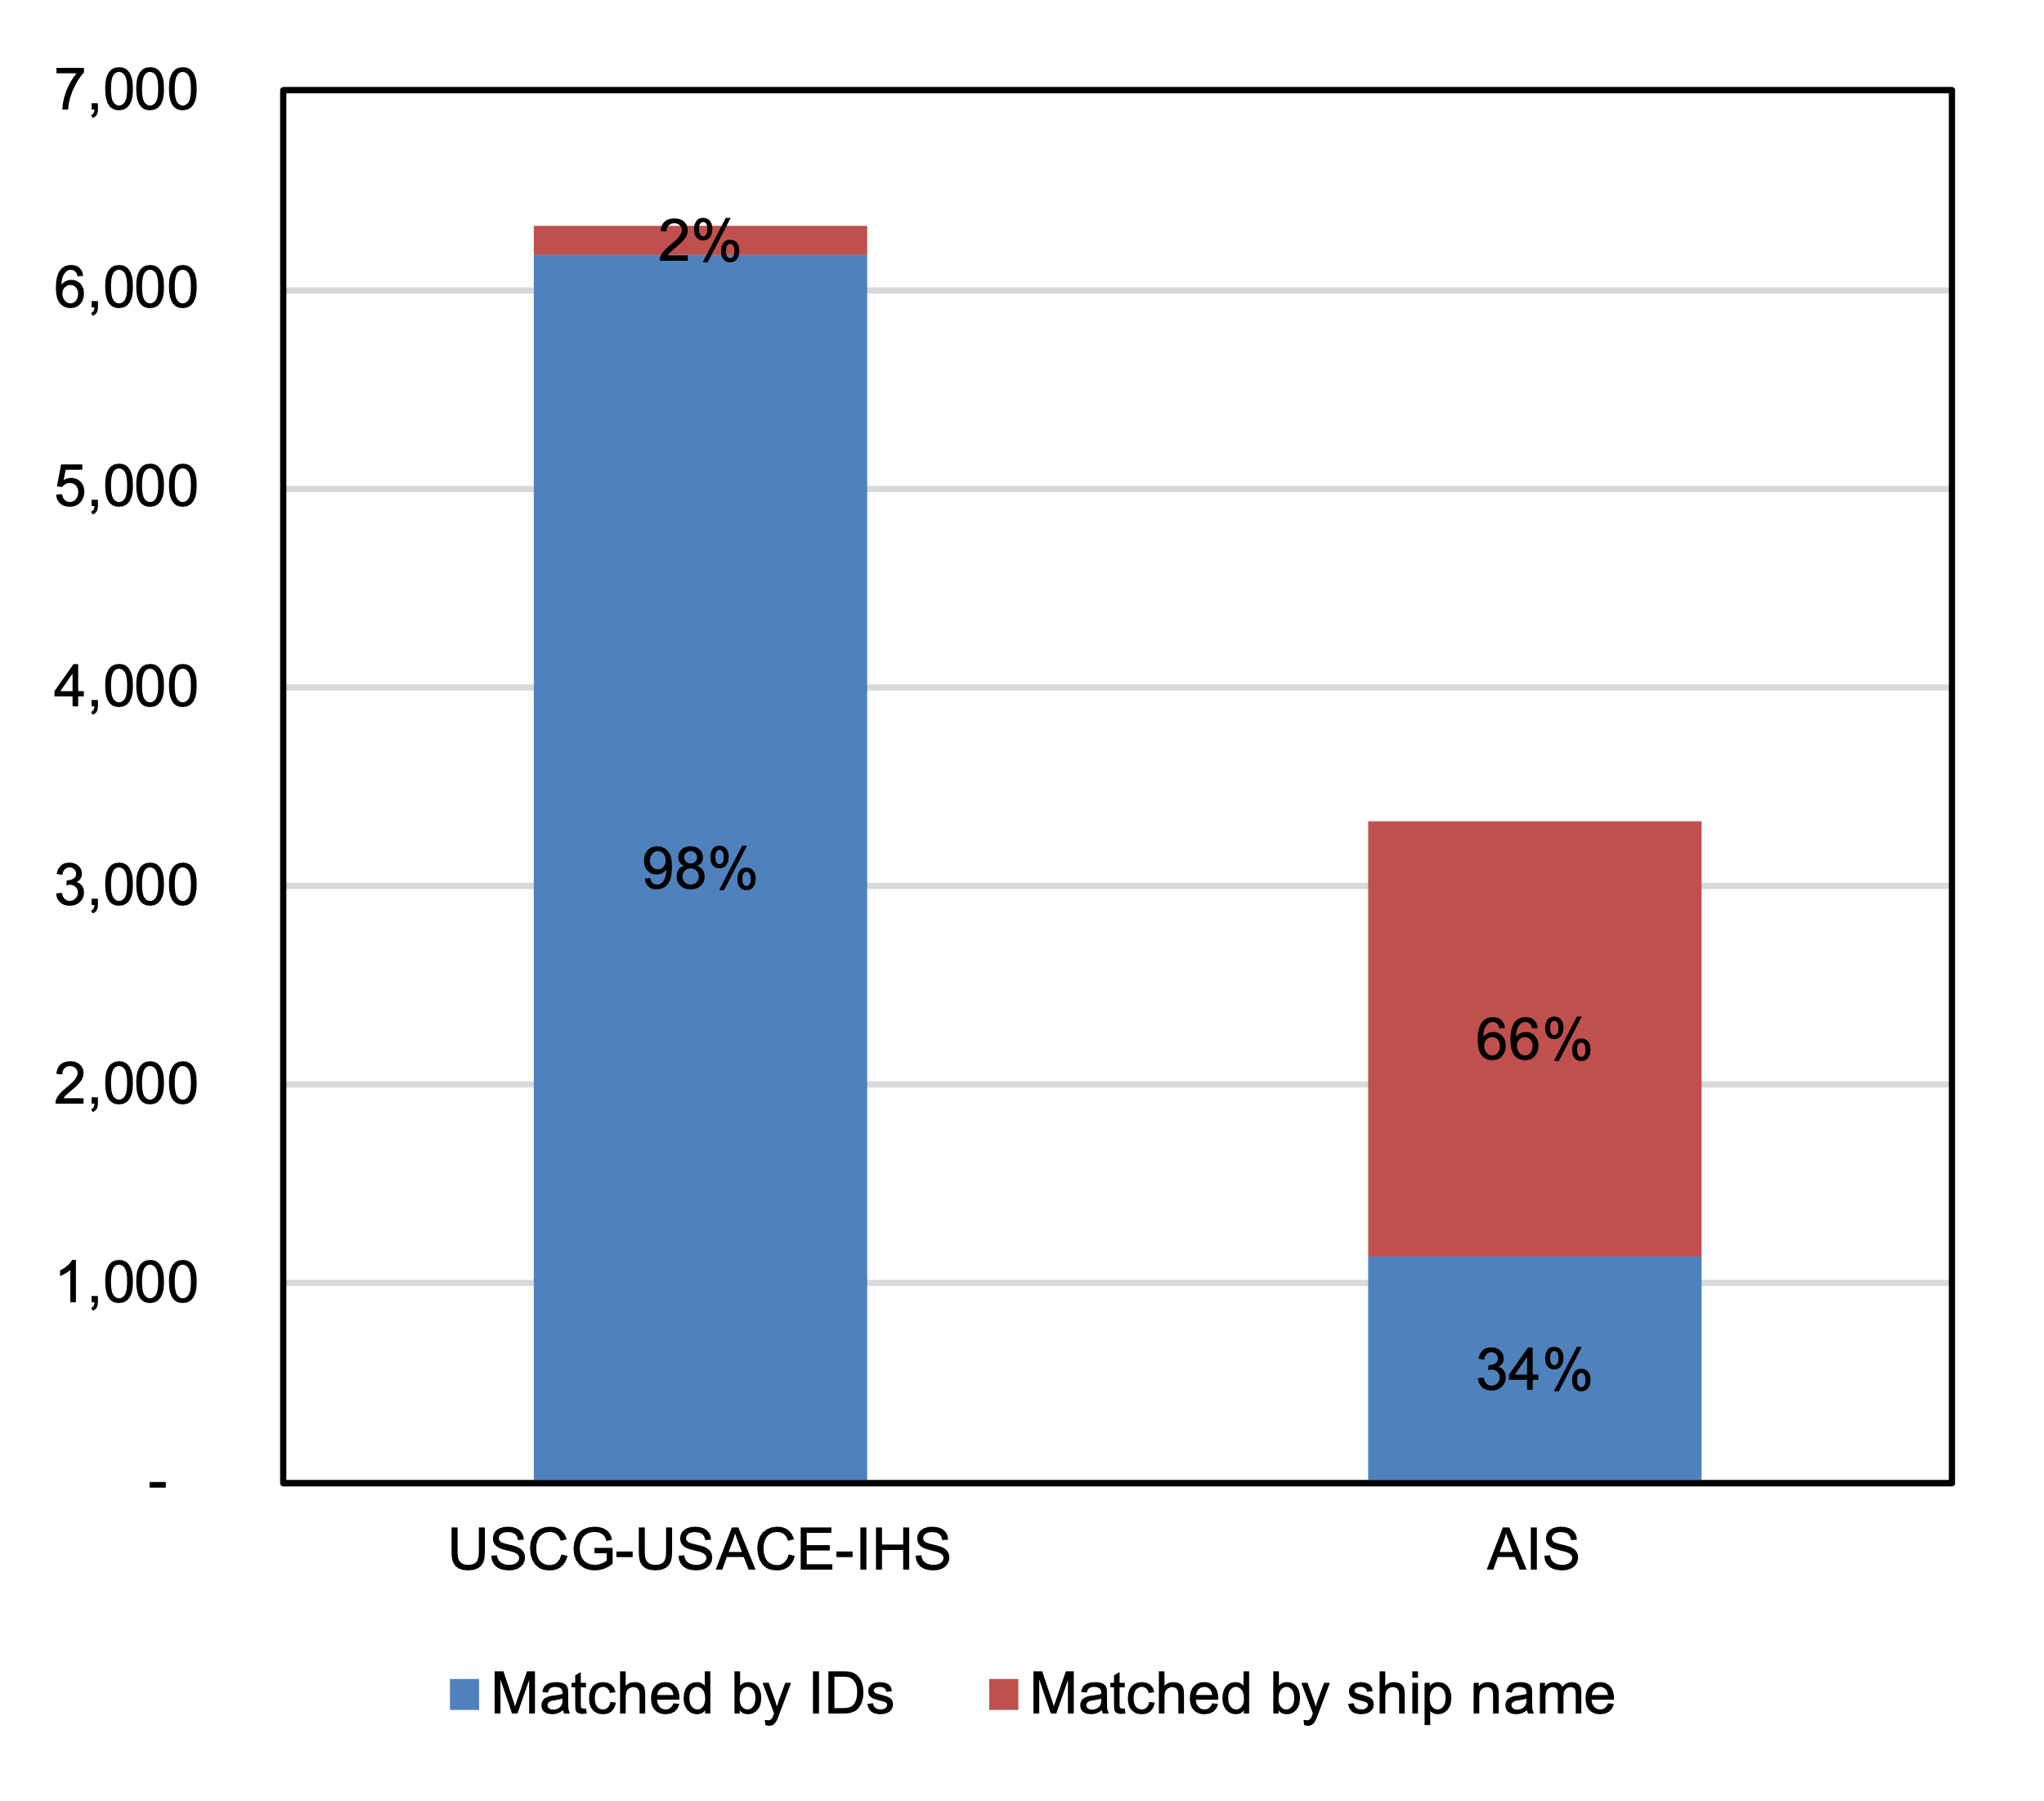
Supplementary Figure 1. Number of Ship Matches by Database and Method

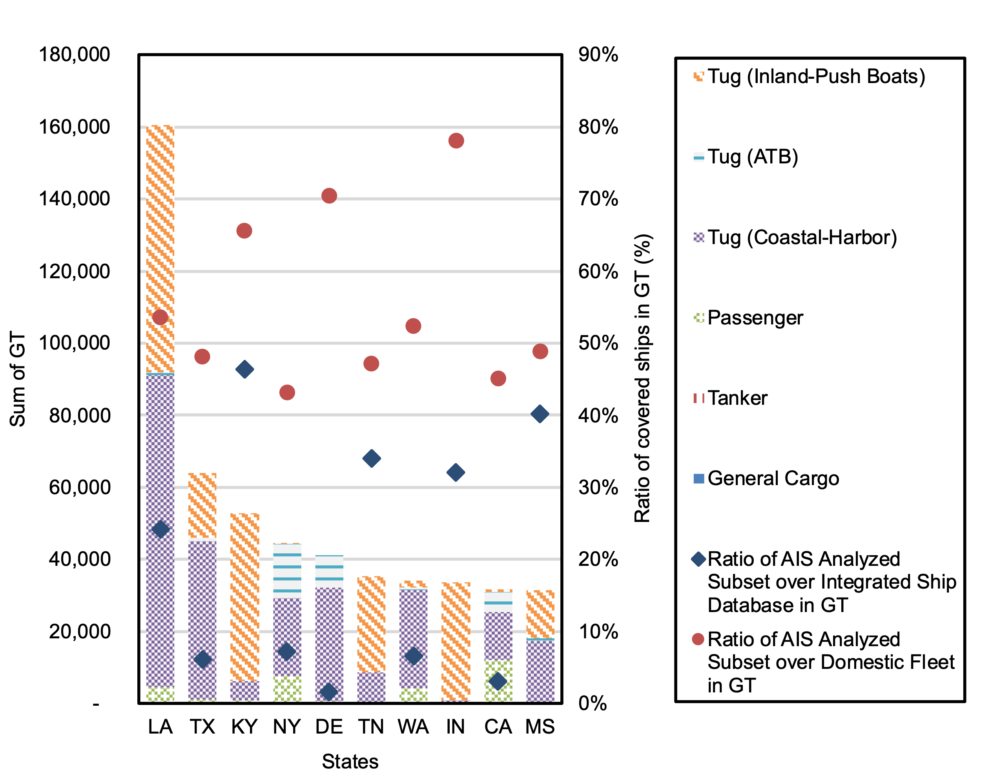
Supplementary Figure 2. Distribution of the AIS Analyzed Subset among Top 10 States by Ship Type and Cumulative Gross Tonnage (GT)

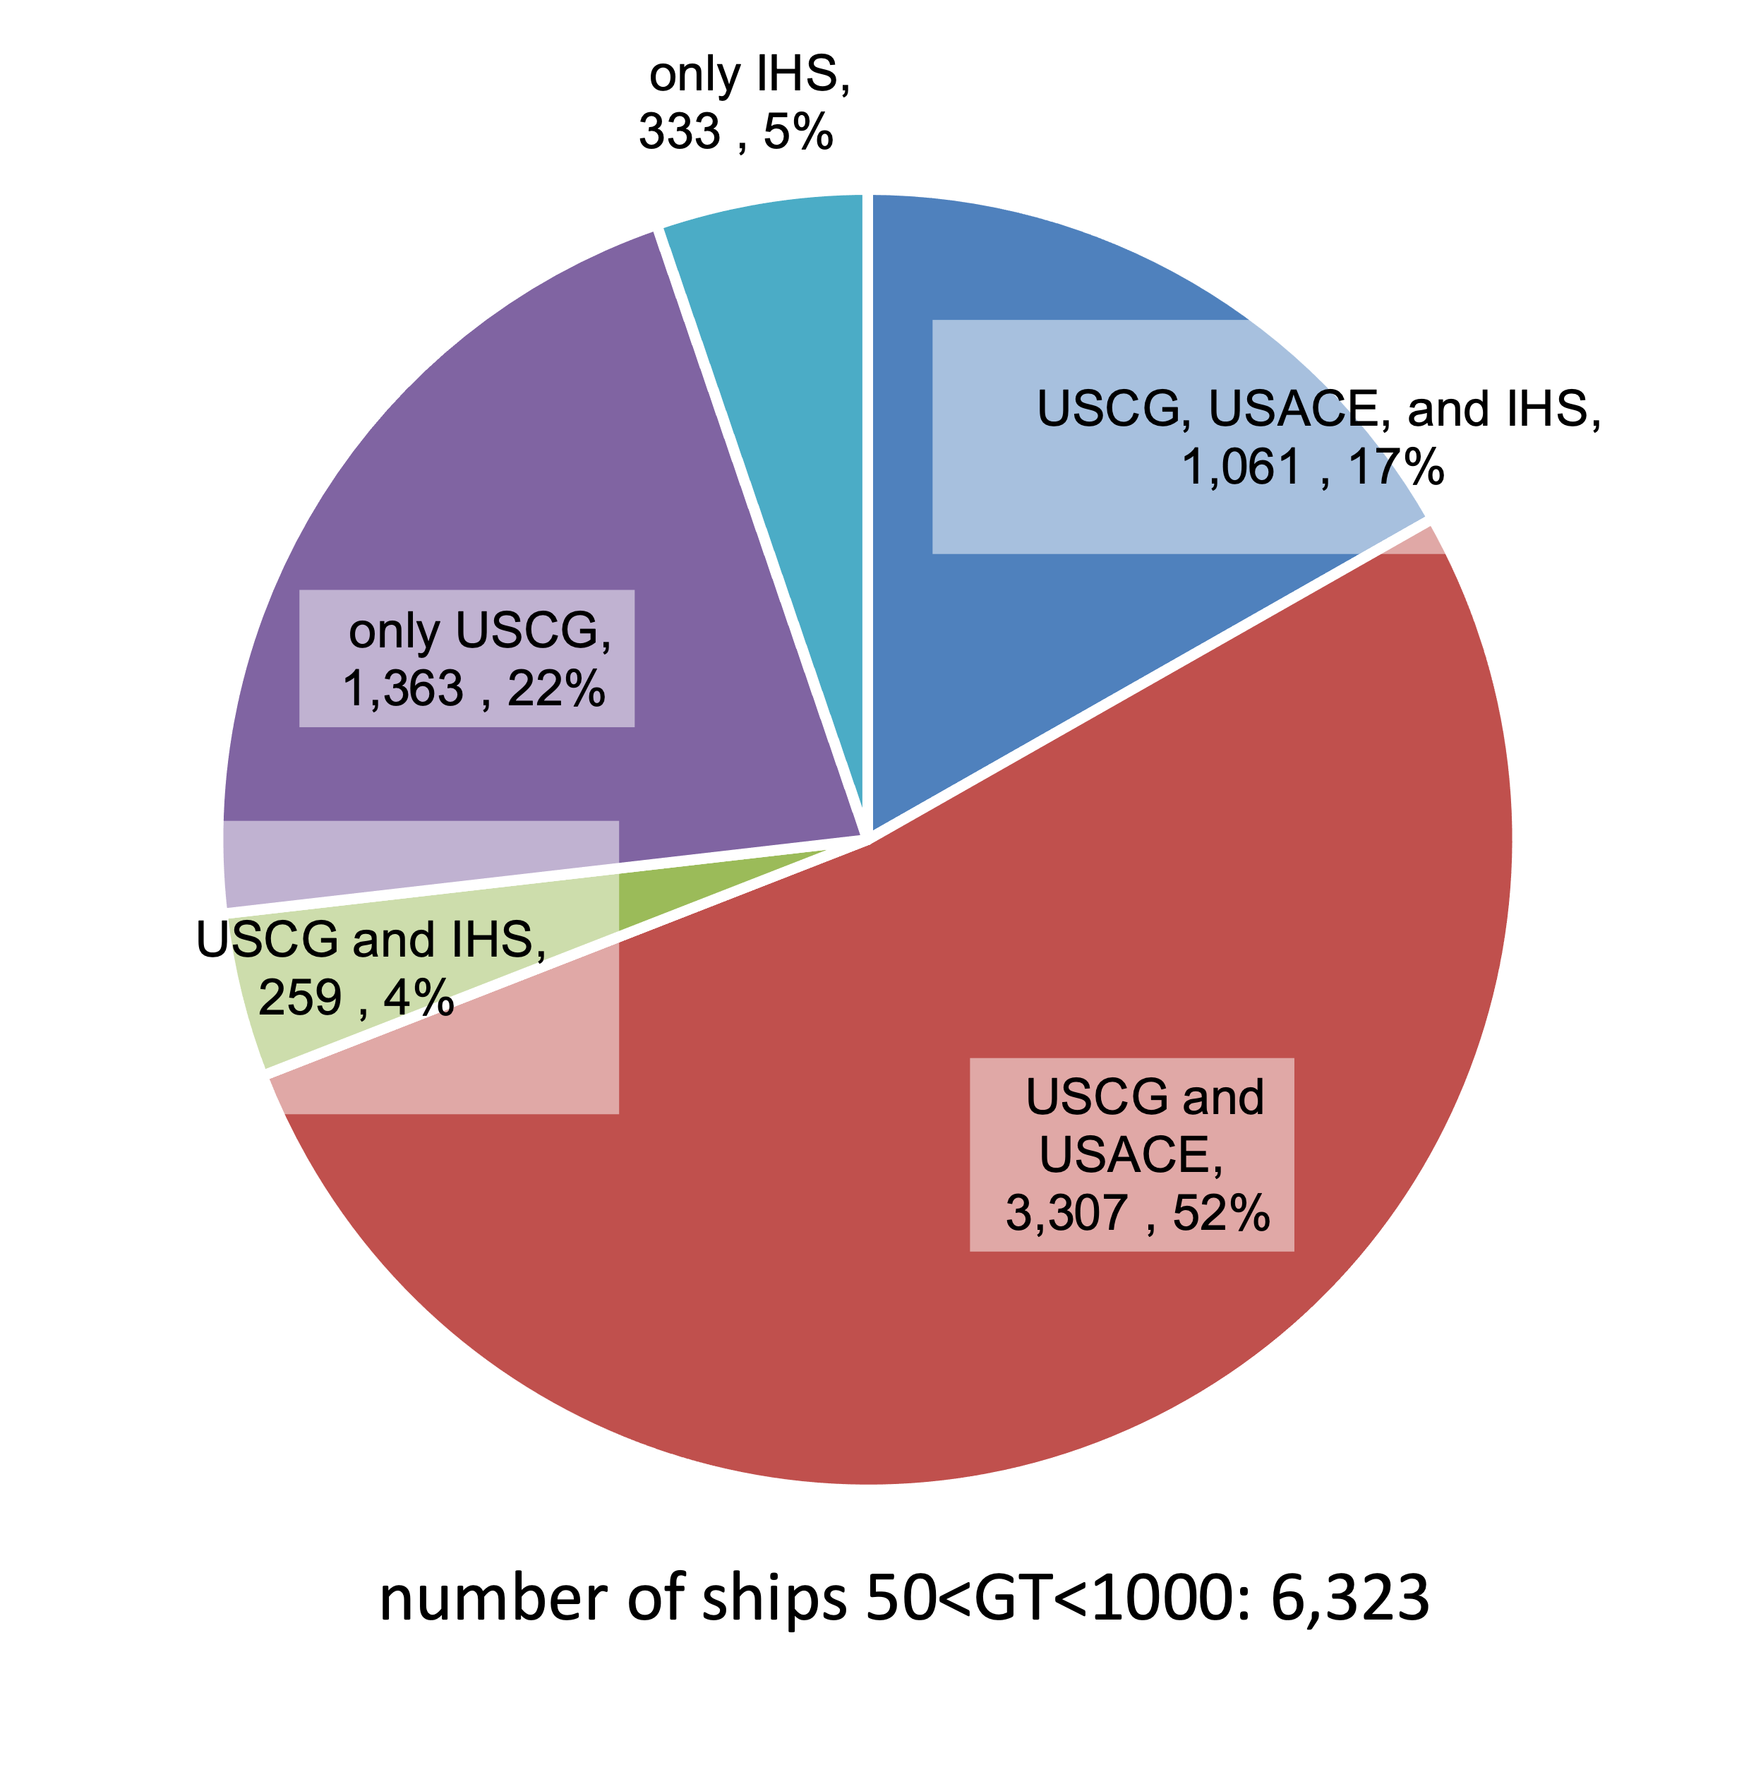
Supplementary Figure 3. Count of Ships by Data Source

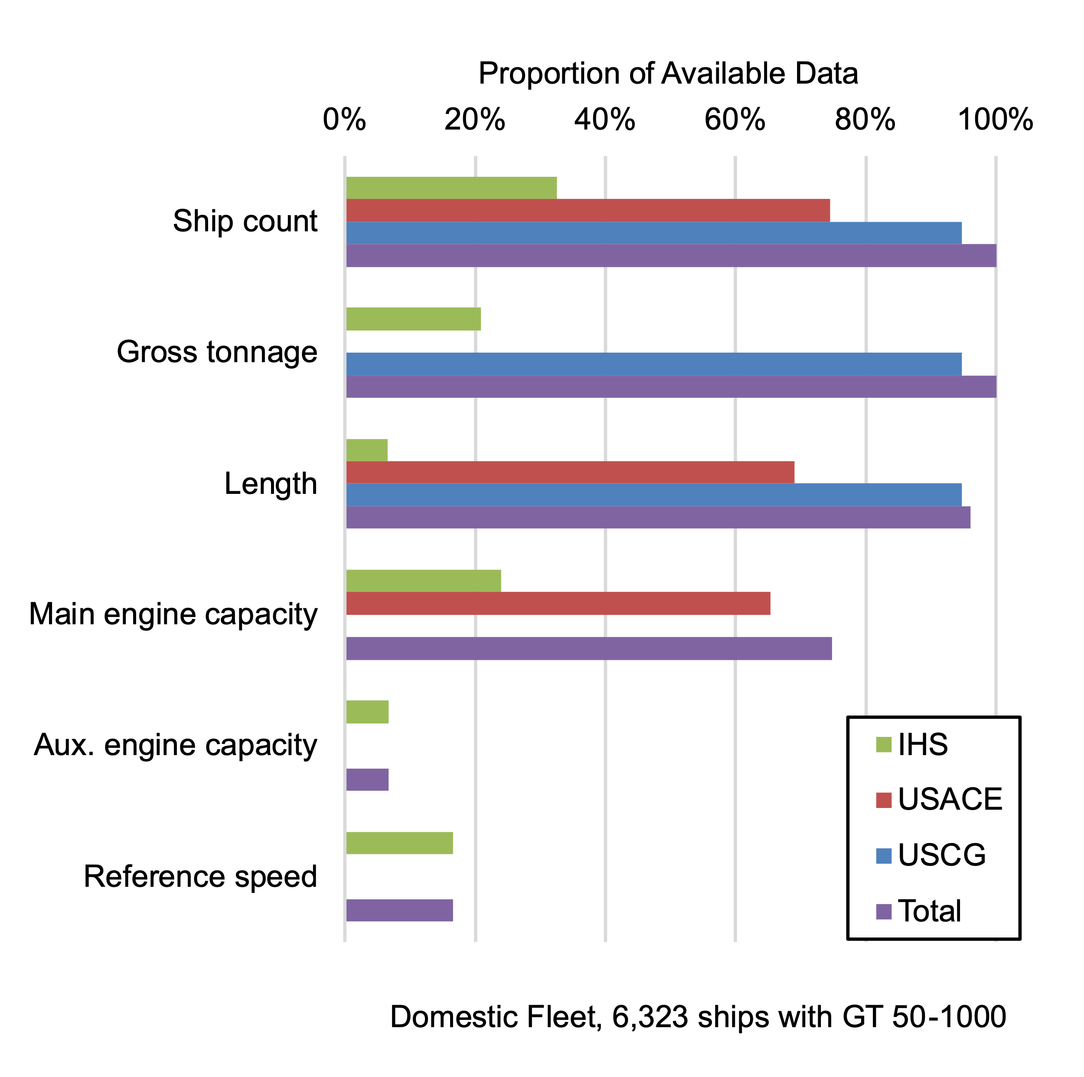
Supplementary Figure 4. Data Availability in the Domestic Fleet (6,323 ships with GT between 50-1000)

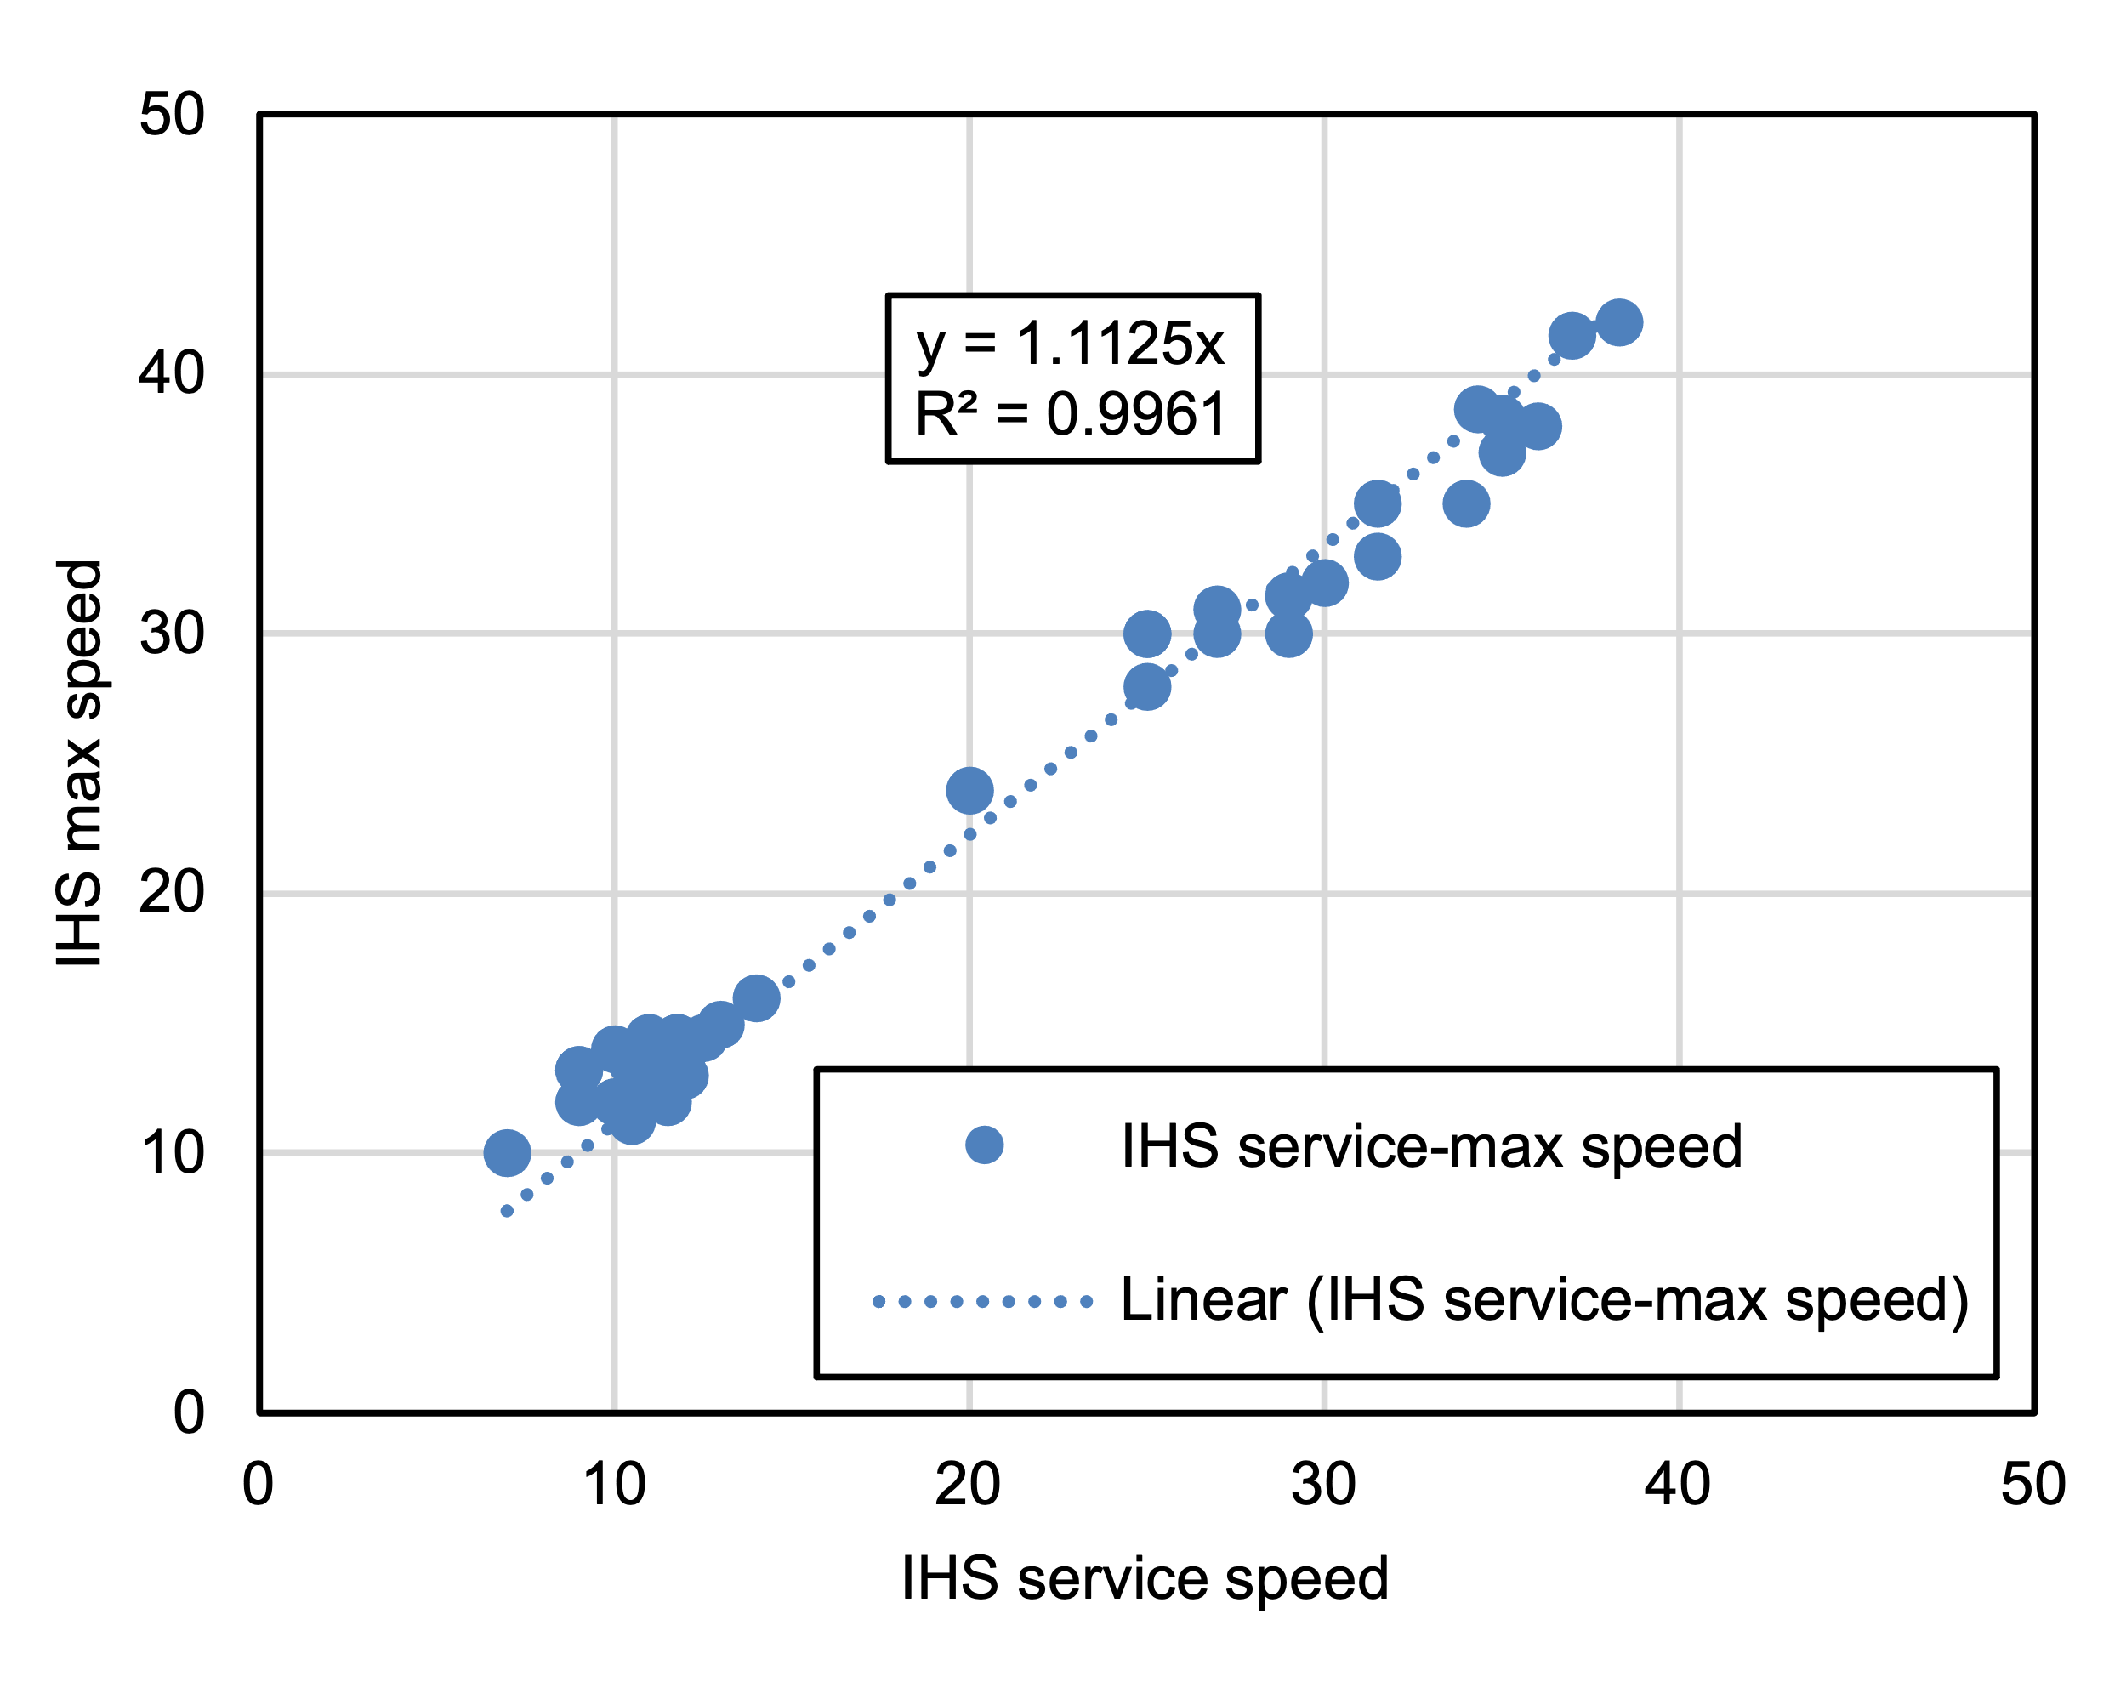
Supplementary Figure 5. Estimation of IHS Max Speed Based on IHS Service Speed

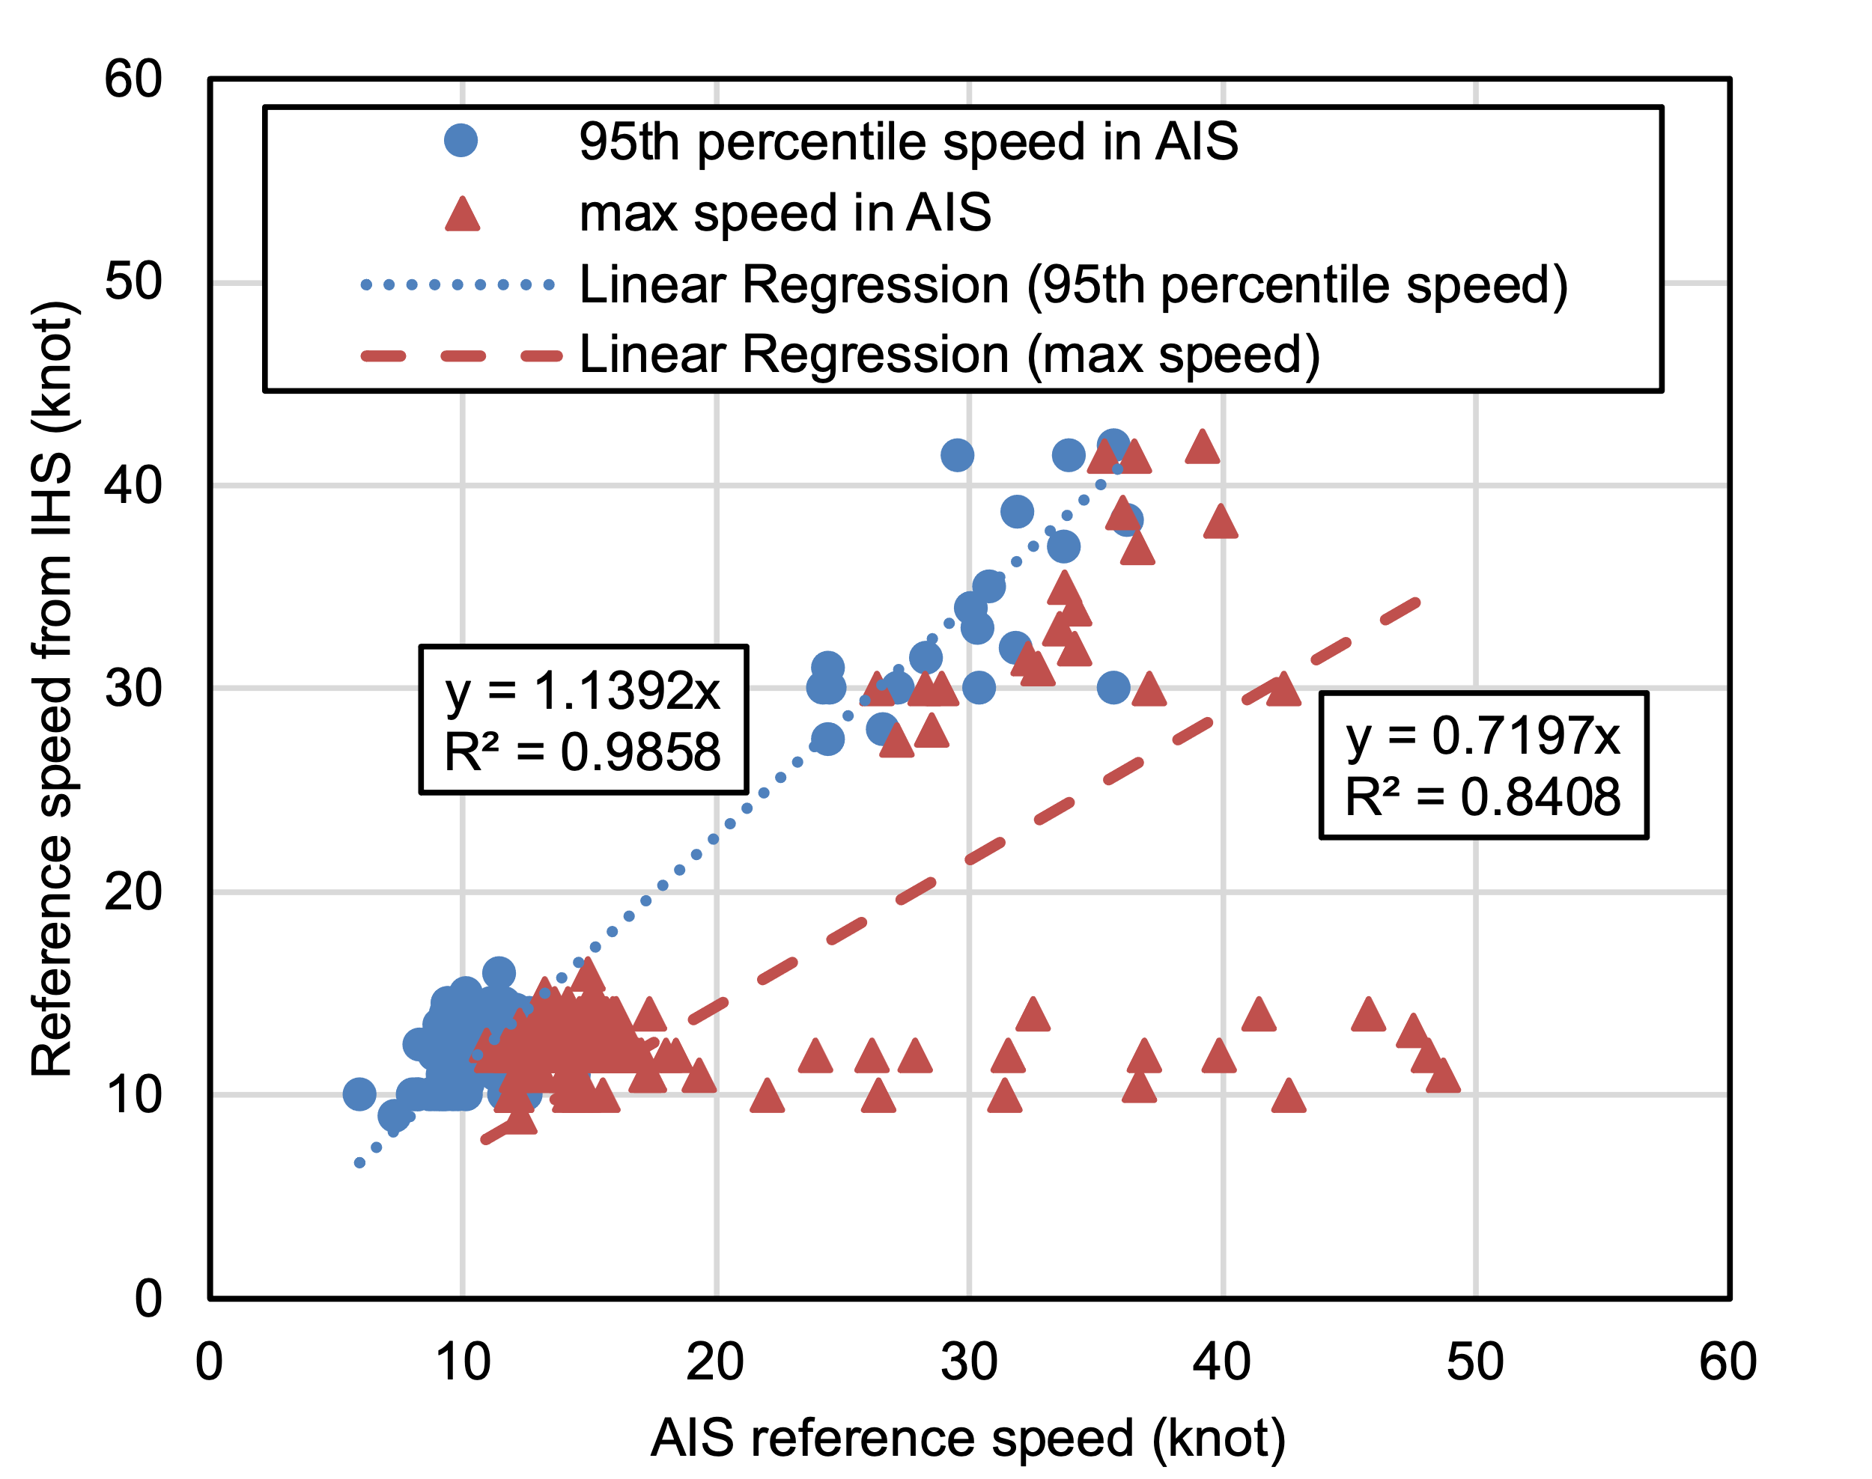
Supplementary Figure 6. Estimation of Reference Speed Based on AIS Max Speed and AIS 95th Percentile Speed

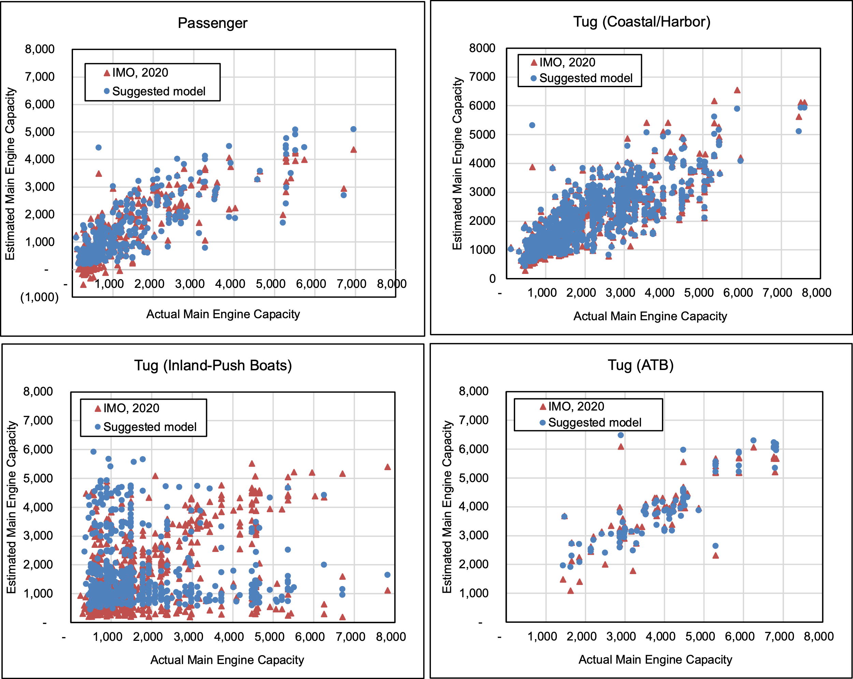
Supplementary Figure 7. Estimation of Main Engine Capacity Based on GT, Registered Length, and Reference Speed

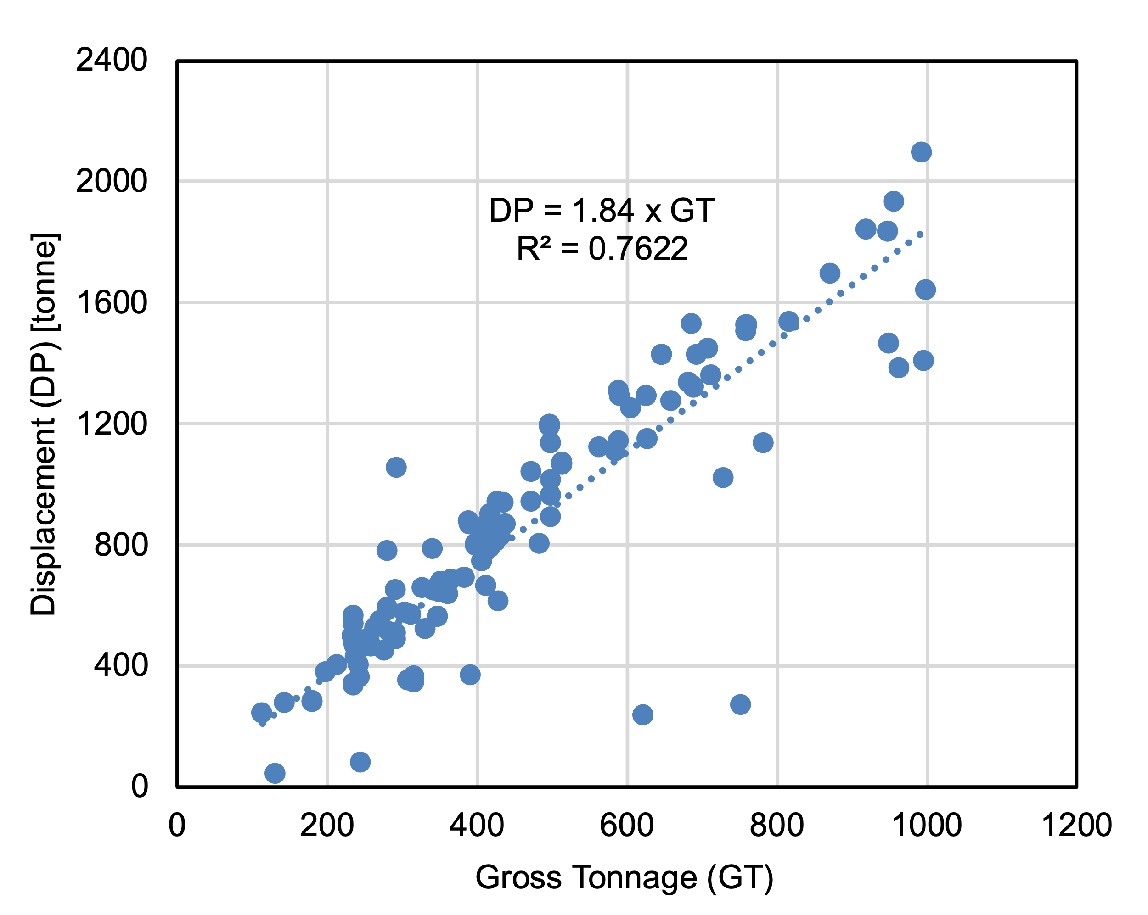
Supplementary Figure 8. Estimation of Displacement from GT

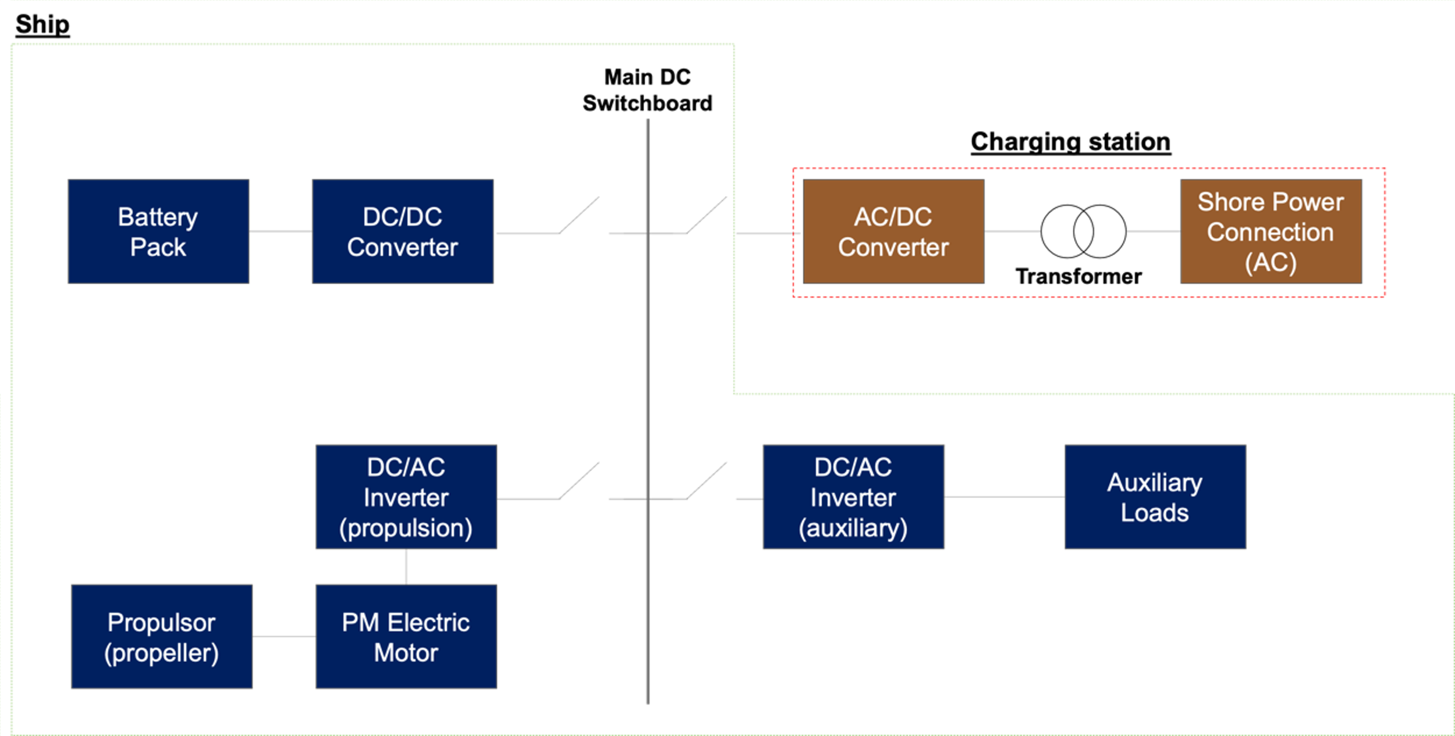
We assume no AC switchboard for the auxiliary loads.
Supplementary Figure 9. A Conceptual Configuration of BES and SPC

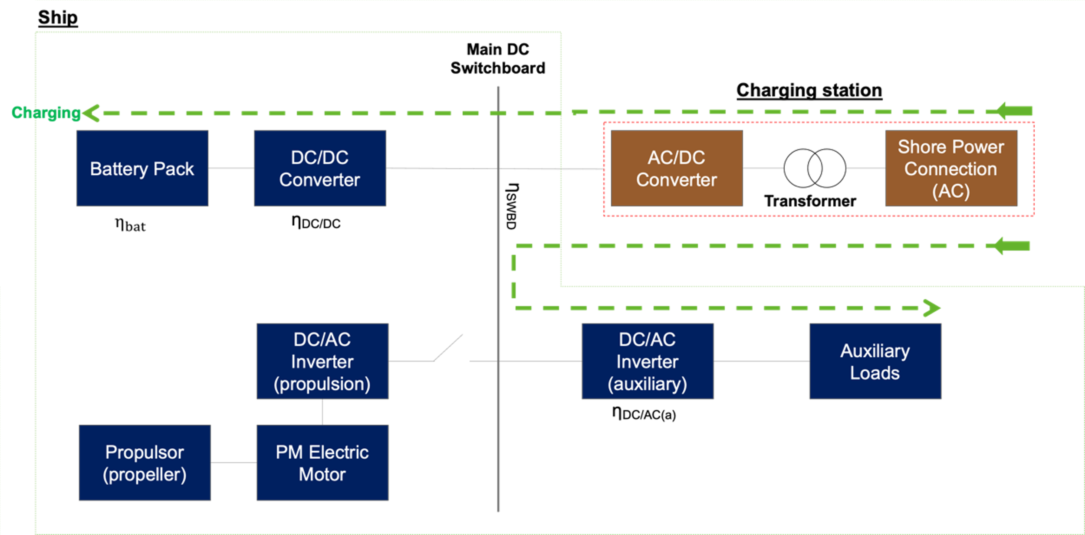
Supplementary Figure 10. Electricity Flow during Battery Charging at Port

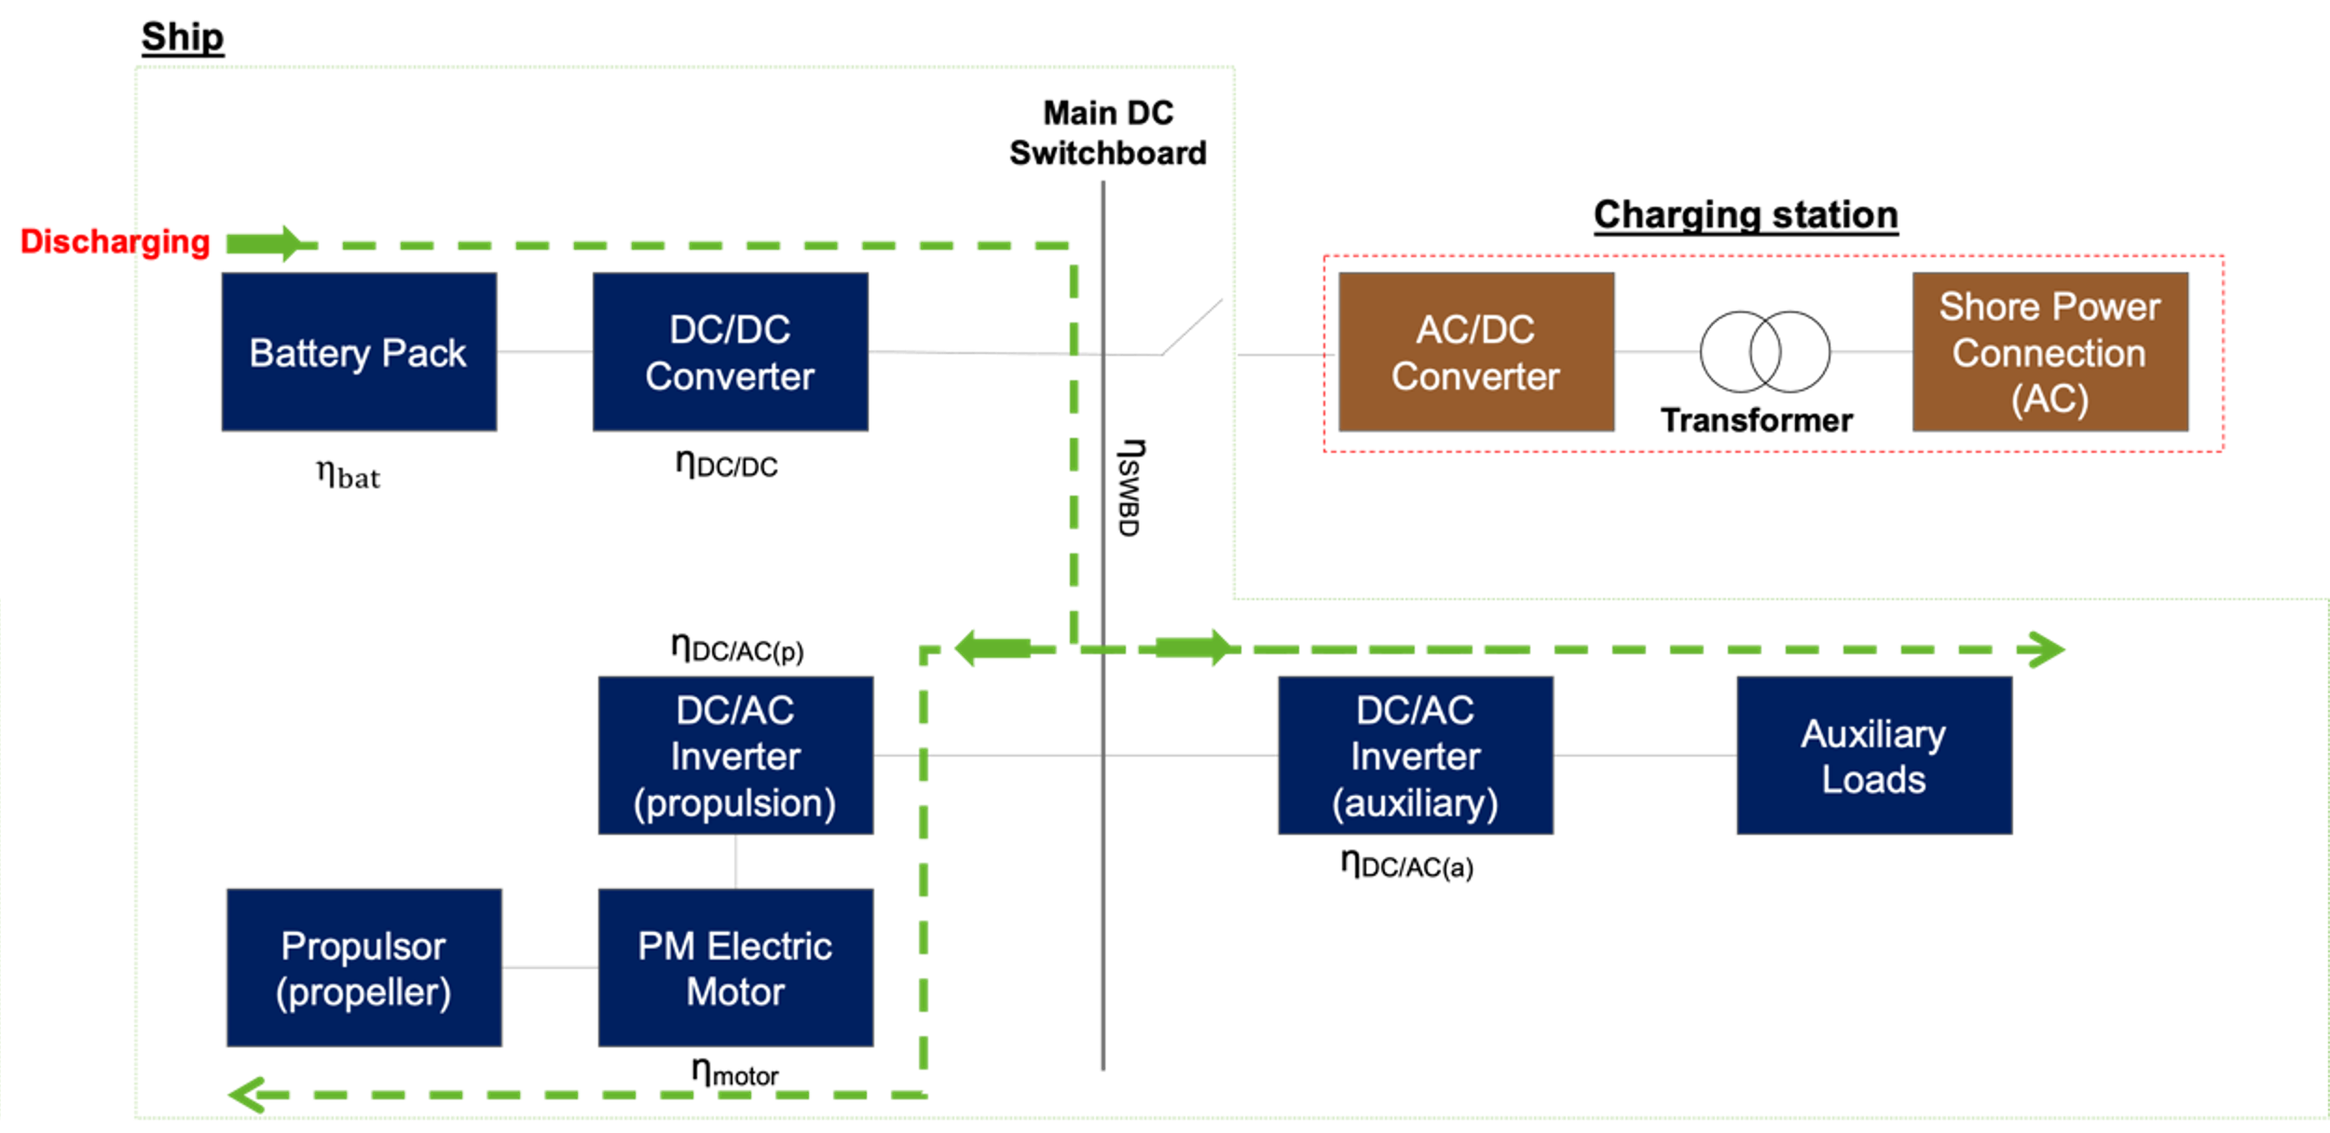
Supplementary Figure 11. Electricity Flow in Battery Discharging During Ship Activity

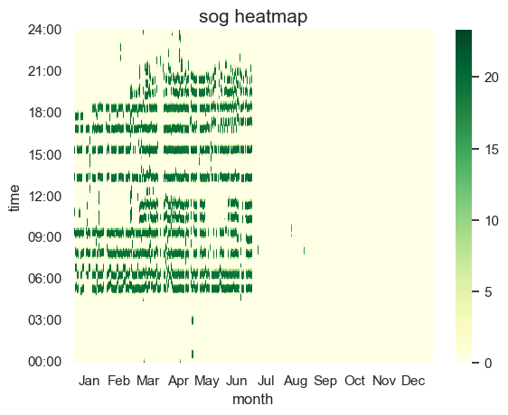
(a)
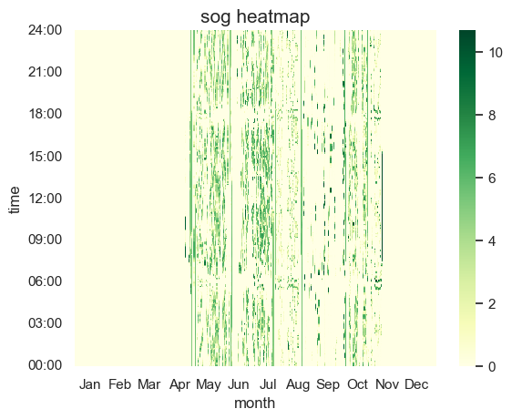
(b)
Greener shades indicate higher speeds, while yellow regions indicate no motion. Connected green dots can be considered as trips or periods of Moving, while the yellow regions correspond to Chargeable or inter-trip periods. Ship details: (a) Passenger (MMSI 367618070, 735 GT); (b) Tug (Coastal-Harbor) (MMSI 368004190, 148 GT).
Supplementary Figure 12. SOG of Different Ship Types: (a) Passenger, (b) Tug (Coastal-Harbor)

(a)
(b)
Points p100, p99, p95, and p90 refer to 100th, 99th, 95th, and 90th percentile trip energy requirements, respectively.
Ship details: (a) MMSI 367026710, Passenger; (b) MMSI 367673660, Tug (Coastal-Harbor).
Supplementary Figure 13. Examples of Distribution of Trip Energy

(a)
(b)
Points p100, p99, p95, and p90 refer to 100th, 99th, 95th, and 90th percentile energy, respectively. Ship details:
(a) MMSI 367026710, Passenger; (b) MMSI 367673660, Tug (Coastal-Harbor).
Supplementary Figure 14. Sum of Trip Energies for Two Ships

Different types of lines are used to visually separate them from overlapped lines.
Supplementary Figure 15. A Schematic Diagram of Battery Sizing with Degradation Reflected

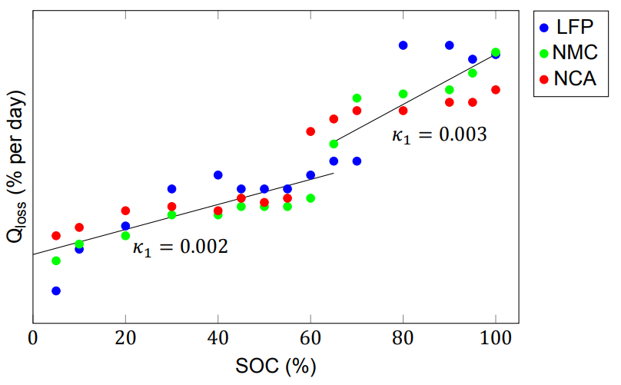
Source: Hoedemaker (2017)
Supplementary Figure 16. Effect of State of Charge on Calendar Degradation Rate

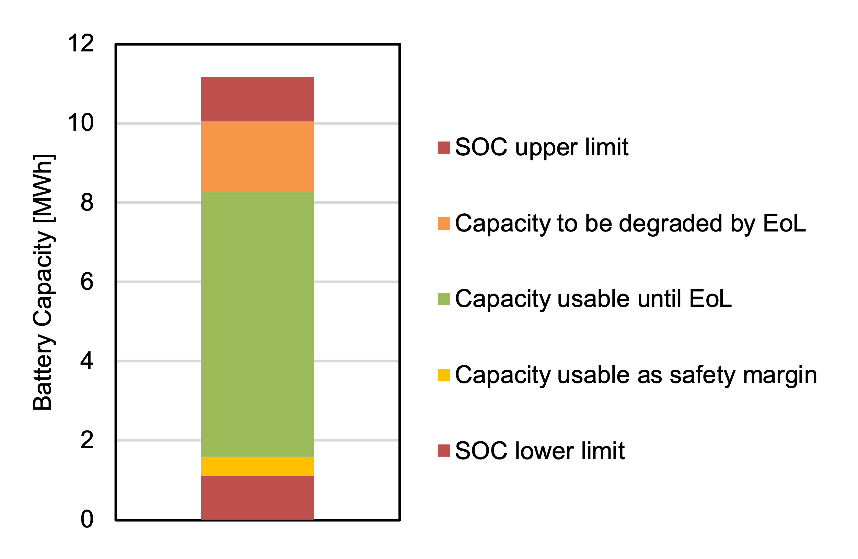
(a)
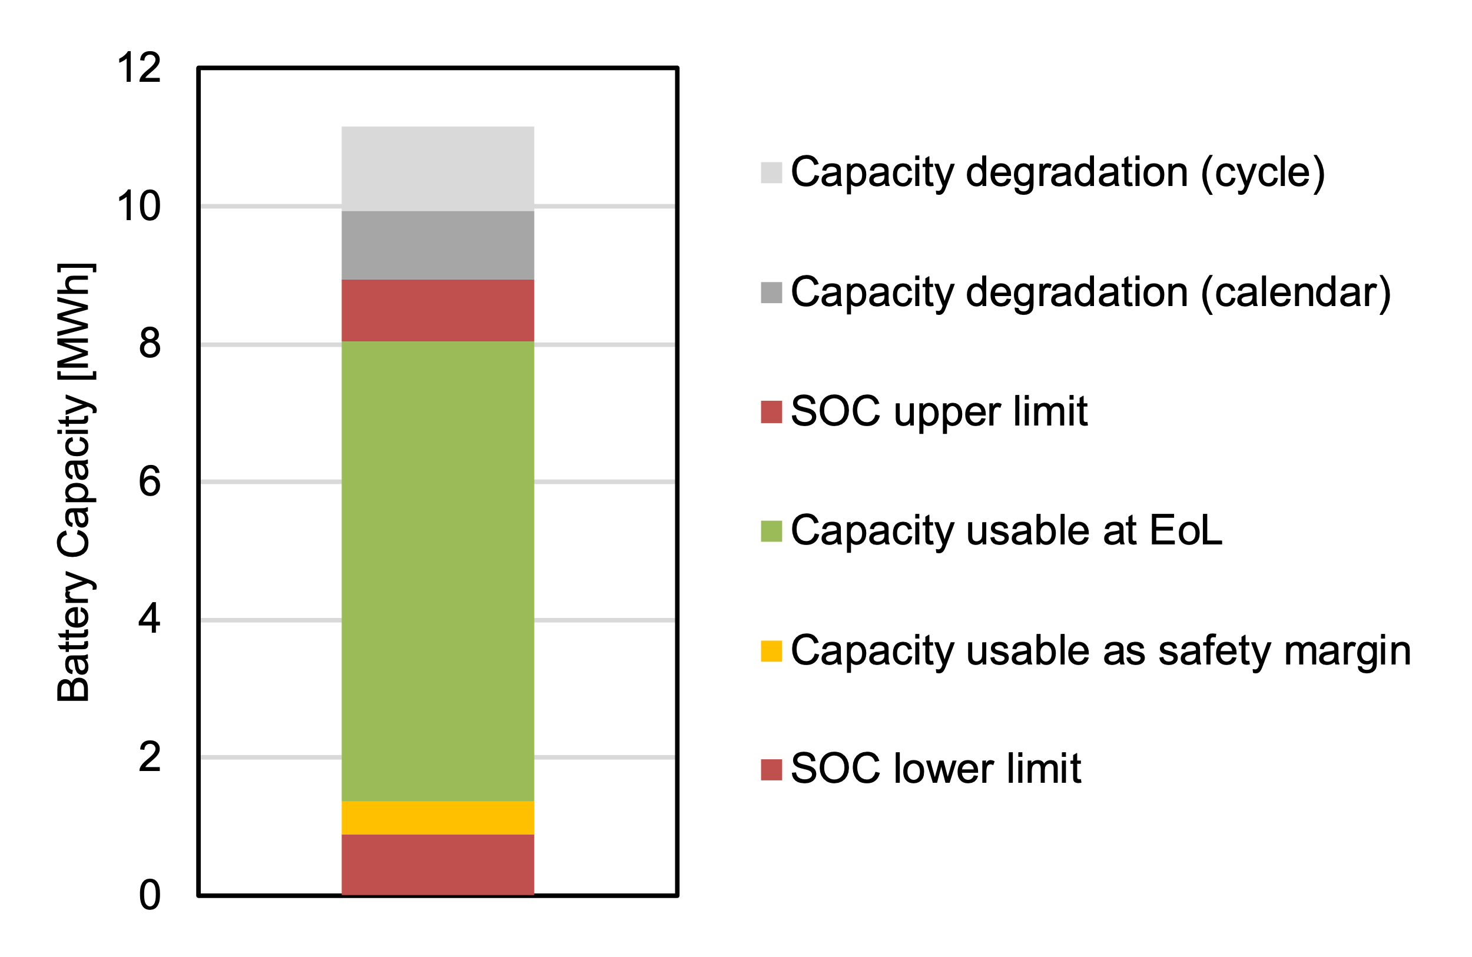
(b)
(a) At Year 0, the usable energy (orange + green + yellow), or 80% of DoD is greater than the energy required for one mission. (b) At EoL, the usable energy (orange + yellow), or 80% of DoD is equivalent to the energy required for one mission.
Supplementary Figure 17. Battery Sizing and Usable Capacity: (a) Initial Battery Composition, (b) End of Life (EoL)

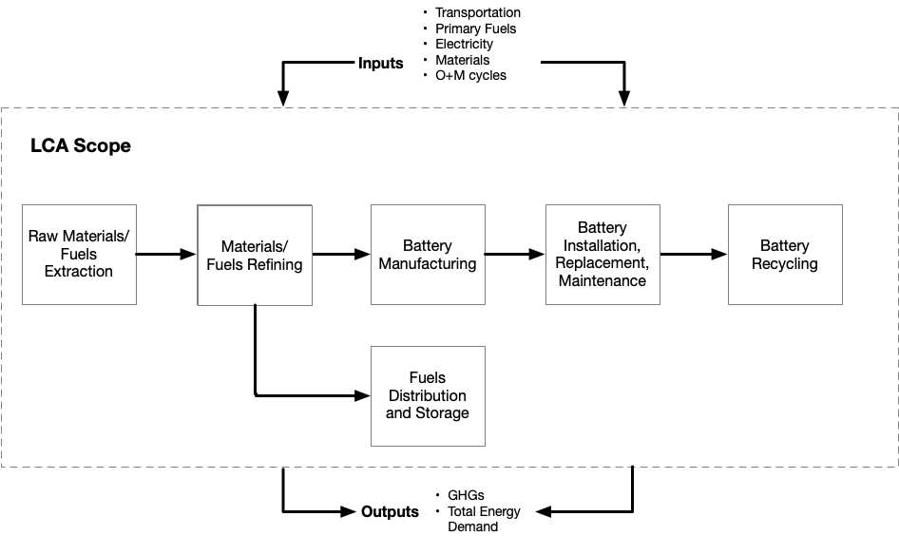
Supplementary Figure 18. LCA of BESs

Supplementary Figure 19. Cumulative Distribution of Reference Trip Energy Demand

Supplementary Figure 19 illustrates the cumulative distribution of the energy demand for the reference trip of each ship. The curves, such as the “100th Percentile Trip” and the “95th Percentile Trip,” represent the cumulative distribution of energy consumption for the largest trip and the 95th largest percentile trip, respectively, for each ship. As the percentile gets lower, the trip energy required by the selected reference trip gets smaller. This trend was also shown in our earlier observation that BESs with lower capacity tiers have smaller batteries, and that battery sizes are determined based on the size of reference trips.

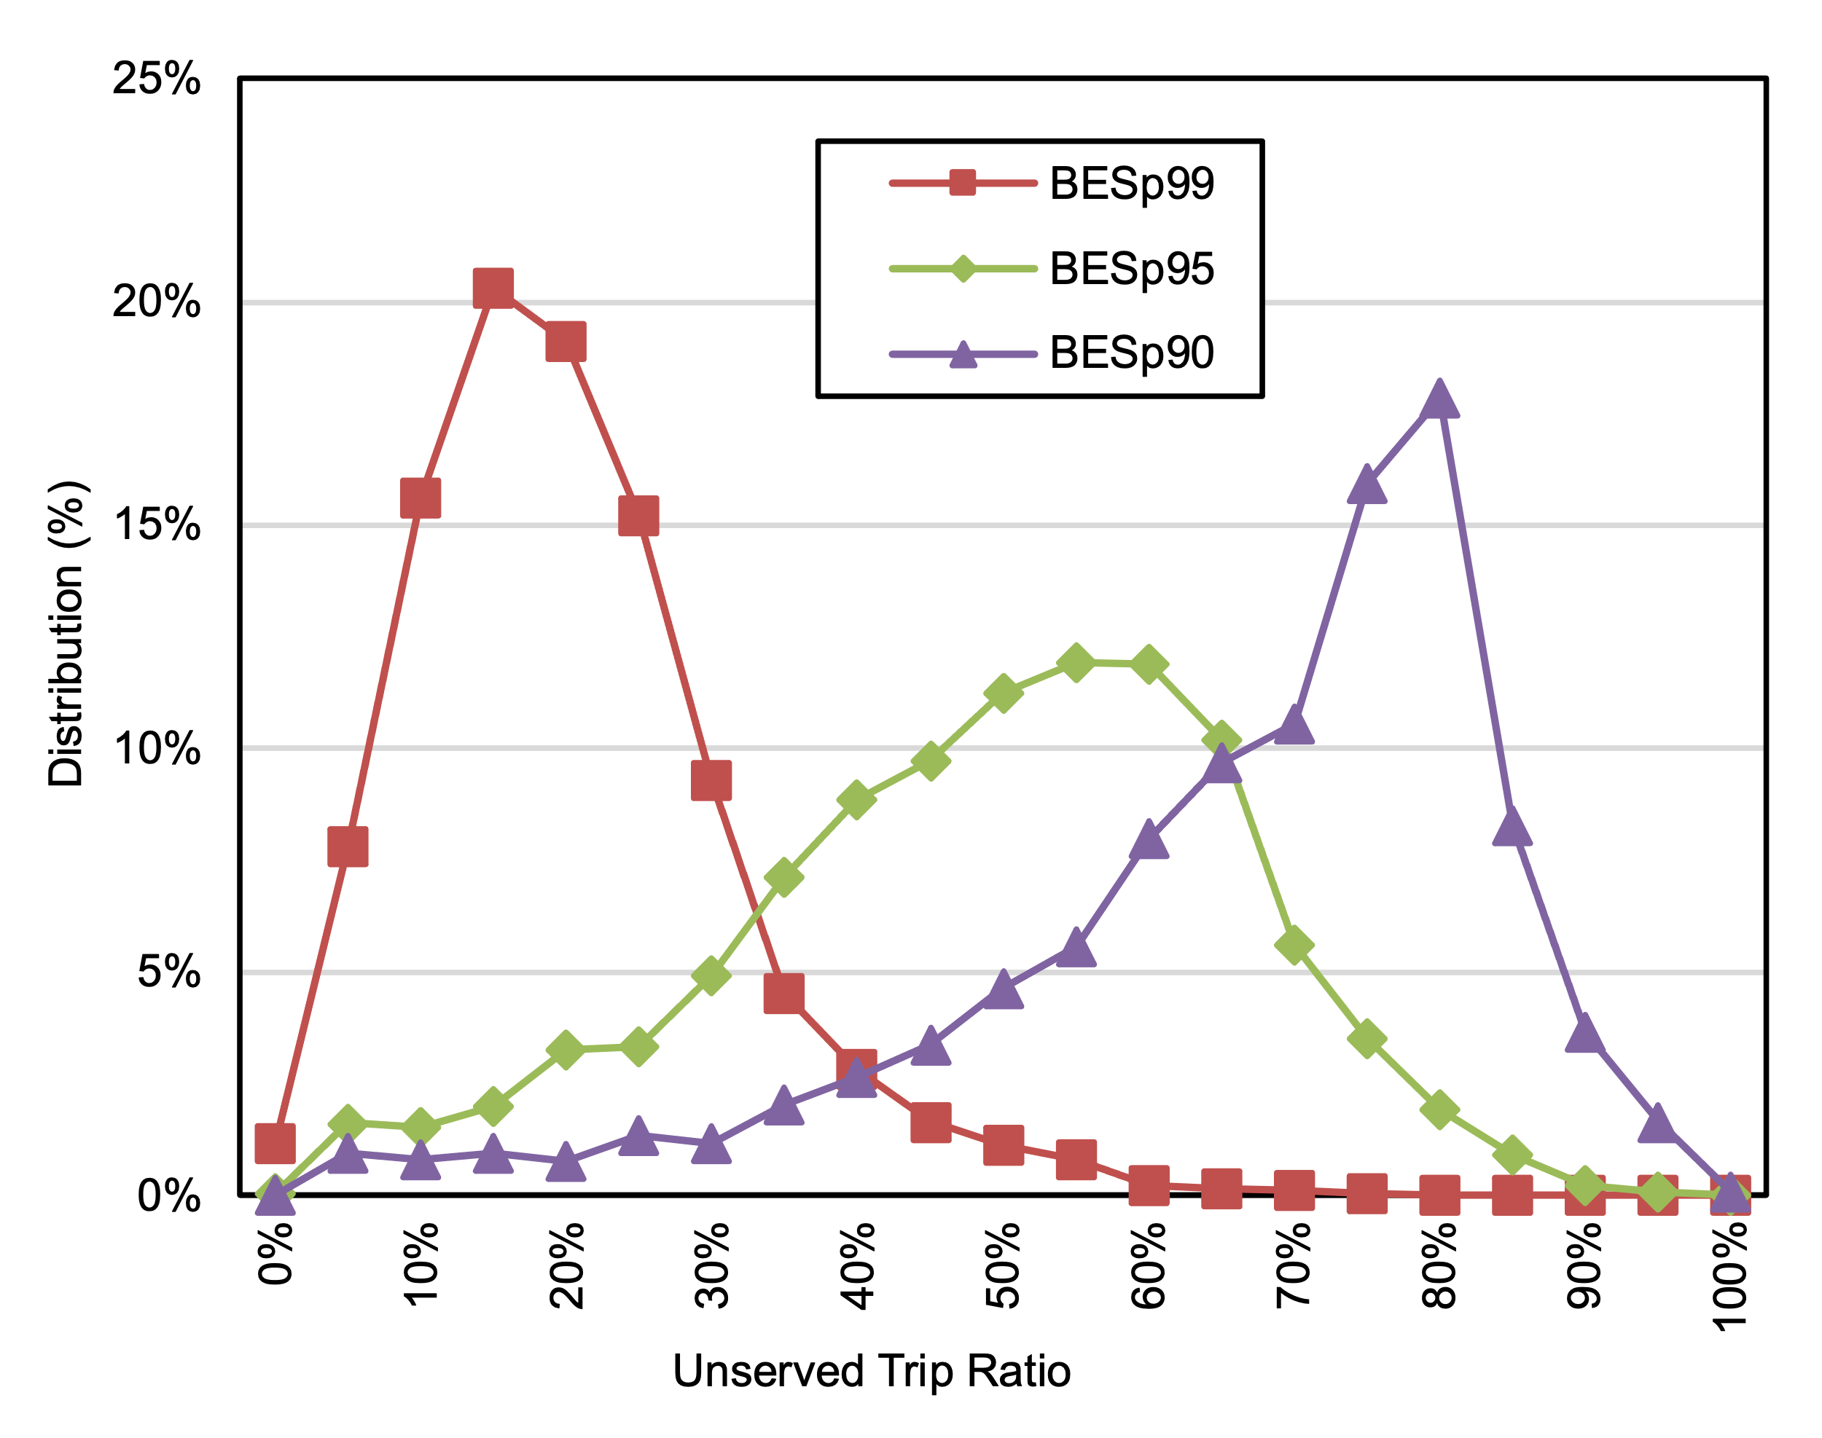
Supplementary Figure 20. Distribution of Ratio of Unserved Trip Energy by BES Capacity Tier (BESp99, BESp95, and BESp90)

Despite the potential decrease in battery size associated with decreasing capacity tiers, BESp99, BESp95, and BESp90 exhibit a trade-off wherein the reduced battery capacity leads to an increase in the sum of energy from unserved trips. Supplementary Figure 20 displays the distribution of unserved trip ratios for BES capacity tiers below p100. (The figure presents the distribution for BESp99, BESp95, and BESp90, as BESp100 covers all historical trips.) The unserved trip ratio is calculated by dividing the sum of energy for unserved trips by the sum of energy for all trips. As the capacity tier decreases from BESp99 to BESp90, the number of ships with higher unserved trip ratios increases. Specifically, for BESp99, approximately 78% of ships have an unserved ratio of less than 25%, whereas around 81% of BESp90s have a ratio of unserved trips exceeding 50%.

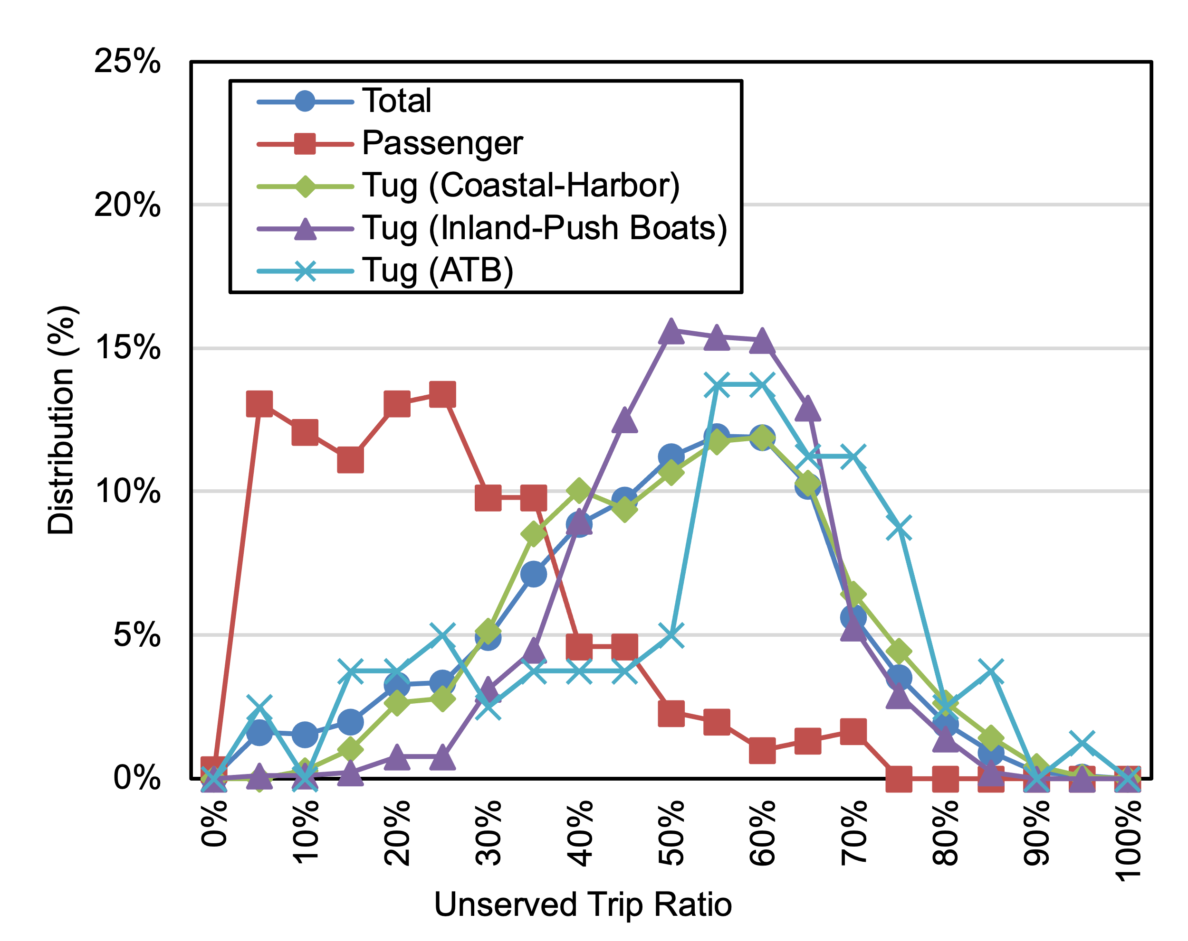
Supplementary Figure 21. Distribution of Unserved Trip Ratio by Ship Type for Capacity Tier BES p95

The unserved trip ratio exhibits different trends across different ship types. Supplementary Figure 21 illustrates the unserved trip ratios of BESp95, demonstrating a clear disparity of the distribution among ship types. Passenger ships tend to display a smaller unserved energy ratio, with approximately 63% of ships having an unserved trip ratio below 25%. On the other hand, Tug (ATB) exhibits the highest unserved trip ratio compared to other vessel types, with around 66% of ships having an unserved trip ratio exceeding 50%. Tug (Coastal-Harbor) and Tug (Inland-Push Boats) types show similar distributions. Based on these results, it is appropriate to replace ICEs with BESs when the unserved trip ratio is lower. Thus, these findings indicate a highest to lowest suitability ranking for retrofitting ICEs to BESs as follows: Passenger ships, Tug (Coastal-Harbor), Tug (Inland-Push Boats), and finally Tug (ATB).

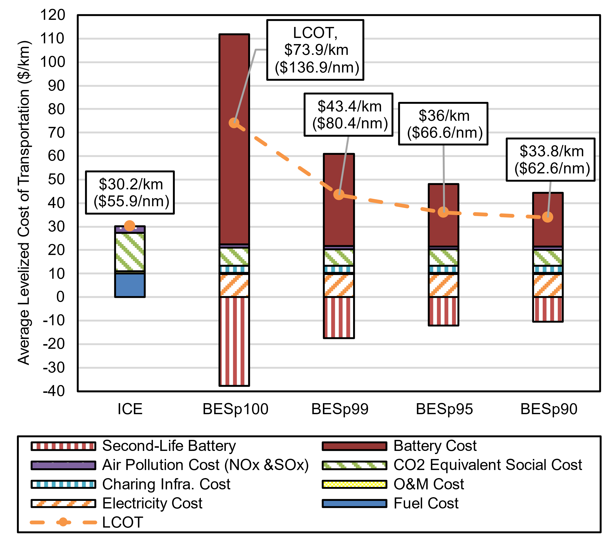
Supplementary Figure 22. Average LCOT of ICE Ships and BESs in 2022 under an INT Cost Scenario

Supplementary Figure 22 shows the average LCOT breakdown for 2022. ICE ships have the lowest LCOT, followed by BESp90, BESp95, BESp99, and BESp100. For ICE ships, the emission cost accounts for 63% of the total LCOT, with 54% attributed to CO₂e social cost and 9% to air pollution cost (NO_{x} and SO_{x}). Direct costs, excluding emissions, make up only 37% of the total LCOT.

BESs exhibit a clear decreasing cost trend as the capacity tier decreases, while average cost in every tier is still more expensive than that of ICE. This trend is primarily driven by battery cost reductions resulting from smaller battery sizes. For instance, for BESp100, the combined battery cost and net battery cost after SLB reimbursements are $51.5/km ($95.5/nm) – 64% of BESp100 costs – whereas for BESp90 this cost is significantly lower at $12.3/km ($22.8/nm). Reimbursements from SLBs substantially alleviate the burden of battery cost, making BESs more economically viable. Initially, battery cost represented a substantial portion of the total LCOT, ranging from 121% to 68%. However, after factoring in SLB reimbursements, this proportion decreases to a range of 71% to 38%, where SLB values account for approximately 42% to 46% of the battery system cost. The variation in the proportion of SLB values to battery cost is attributed to the fact that lower capacity tiers tend to have shorter lifespans, resulting in less of a decrease in battery system costs (and higher SLB values). As the capacity tier decreases, other costs such as CO₂e social cost, electricity cost, and O&M cost do not vary significantly since they are proportional to energy consumption, which remains relatively constant on a per-kilometer basis. Further, as the capacity tier decreases, overall BES costs decline, and the above-mentioned costs represent an increasingly larger proportion of total LCOT.
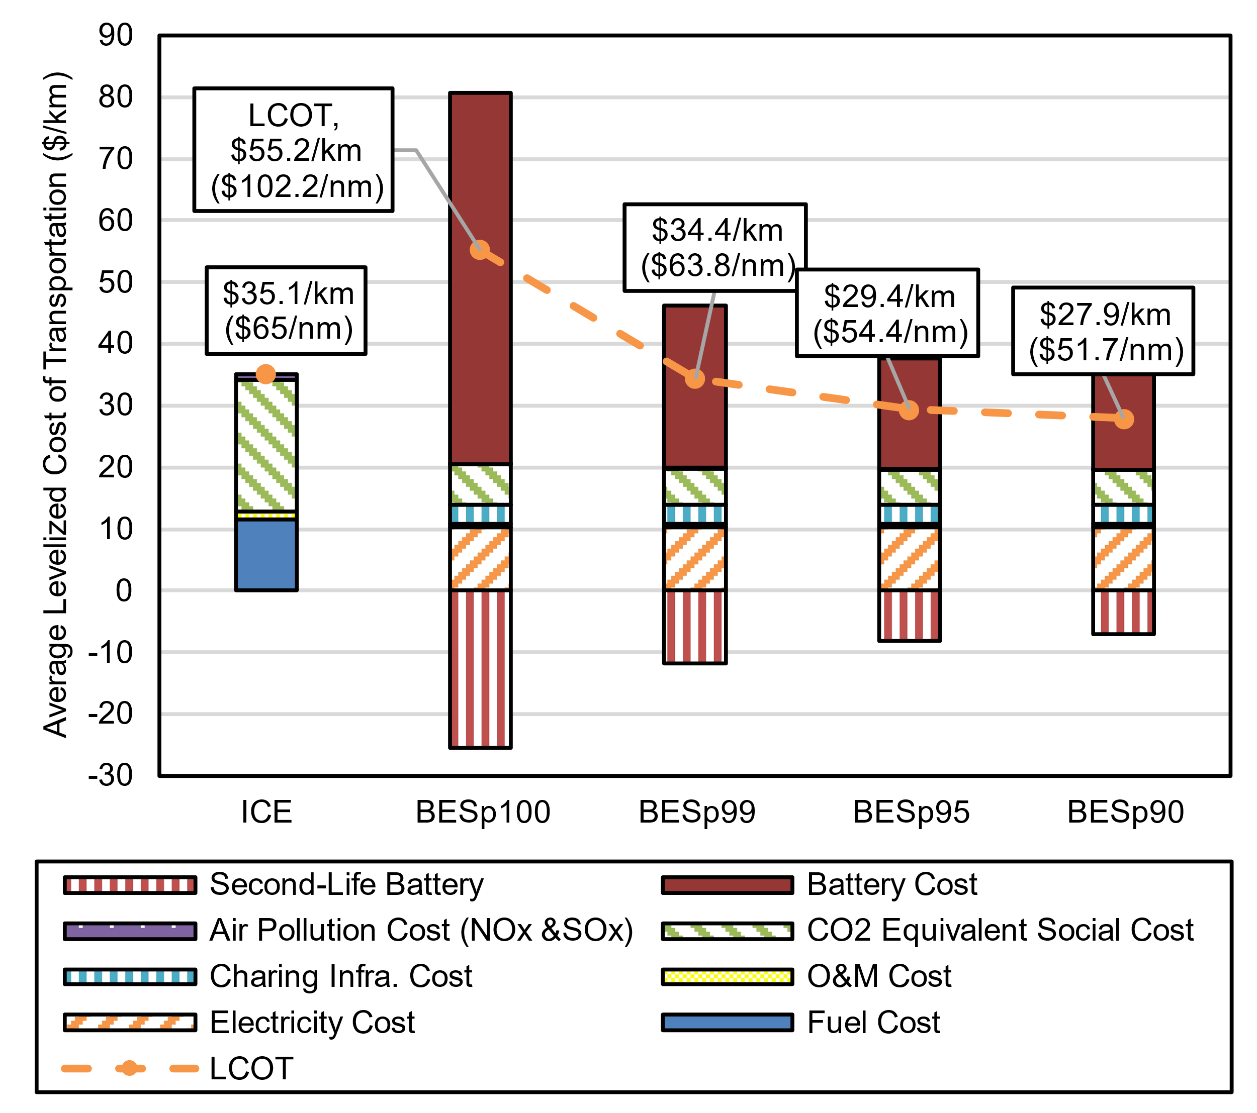

Supplementary Figure 23. Average LCOT for ICE Ships and BESs in 2035 under a 95% Electricity Decarbonization by 2050 (DEC) Emission Scenario and INT Cost Scenario By Capacity Tier

Supplementary Figure 23 illustrates the LCOT comparison between ICEs and BESs in 2035 under the INT cost scenario and the 95% Electricity Decarbonization by 2050 scenario. In 2035, all BES capacity tiers, except for BESp100, showed lower costs than ICEs in average. Compared to 2022, ICE average costs increased by $4.9/km ($9.1/nm), with the most significant driver being CO₂e social costs. However, ICE’s air pollution costs decreased due to an assumed 65% reduction in NO_{x} emissions and zero SO_{x} emissions in 2035. On the other hand, BES costs decreased across the board, with BESp100, BESp99, BESp95, and BESp90 cost reductions of $18.7/km ($34.7/nm), $9.0/km ($16.6/nm), $6.6/km ($12.2/nm), and $5.9/km ($10.9/nm), respectively.

Interestingly, other costs, excluding the battery cost, remained stable at around $20/km ($37/nm), indicating minimal variation across different BES capacity tiers and no significant deviation from the 2022 scenario by 2035. Despite a 30% increase in CO₂e social costs, the overall impact was modest due to a substantial 59% reduction in the emission factor in the 2035 DEC scenario, compared to 2022. Notably, even under BAU, the emission factor decreased by 69% in 2035 compared to 2022, suggesting that BESs can offset increasing social costs of carbon through improvements in grid carbon emissions intensity.

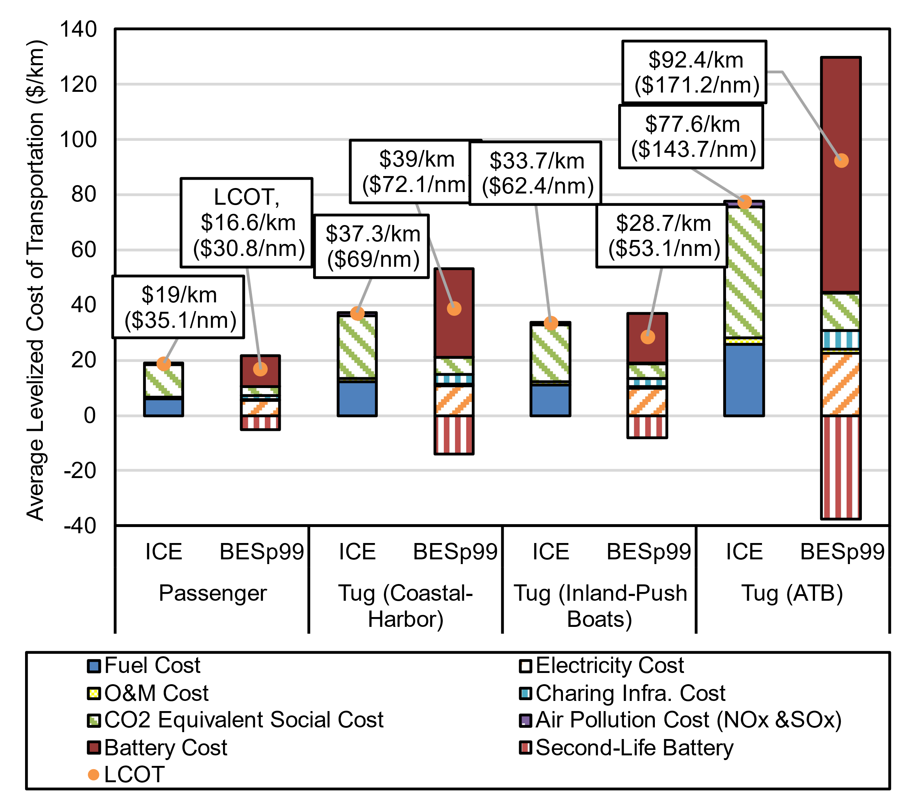

Supplementary Figure 24. Average LCOT for ICE Ships and BESs in 2035 under a 95% Electricity Decarbonization by 2050 (DEC) Emission Scenario and INT Cost Scenario By Ship Type for BESs with Capacity Tier p99 (BESp99)

In 2035, different cost trends were observed among ship types in Supplementary Figure 24. ICE costs were lowest for Passenger ships, followed by Tug (Inland-Push Boats), Tug (Coastal-Harbor), and Tug (ATB). Tug (ATB) had the highest costs at $77.6/km ($143.7/nm), which were four times higher than the $19.0/km ($35.1/nm) for Passenger ICEs. This difference can be attributed to larger ships consuming more energy per traveled distance. Despite variations among ship types, emission costs accounted for approximately 64-65% of total costs for all ship types, while fuel costs represented 32-33% of total costs. This is because most cost items are proportional to energy consumption, except in cases of low load factors.

Comparing BESp99s to ICEs for each ship type, Tug (ATB) and Tug (Coastal-Harbor) showed 19% and 5% increases in LCOT, respectively. On the other hand, Passenger and Tug (Inland-Push Boats) experienced reductions of 12% and 15%, respectively, below the LCOT of ICE ships. Based on ship-to-ship comparisons, 90%, 76%, 89%, and 44% of BESp99s in Passenger, Tug (Coastal-Harbor), Tug (Inland-Push Boats), and Tug (ATB), respectively, are cost-effective compared to ICEs. Notably, despite higher average costs compared to ICEs, 44% of BESp99 of Tug (ATB) are considered cost-effective. This highlights the importance of finding ships with higher BES potential through ship-to-ship comparisons.

When comparing BESs with capacity tier p99, cost shares varied among ship types. Tug (Inland-Push Boats) had the lowest average battery system cost share at 63%, followed by Passenger with 68%, Tug (Coastal-Harbor) with 82%, and Tug (ATB) with 92%. Conversely, electricity cost shares were lowest for Tug (ATB) at 25%, followed by Tug (Coastal-Harbor), Passenger, and Tug (Inland-Push Boats). This indicates that Tug (ATB) in capacity tier p99 had relatively lower electricity usage compared to its significant battery size. Conversely, this also implies that Passenger and Tug (Inland-Push Boats) have higher battery utilization rates.

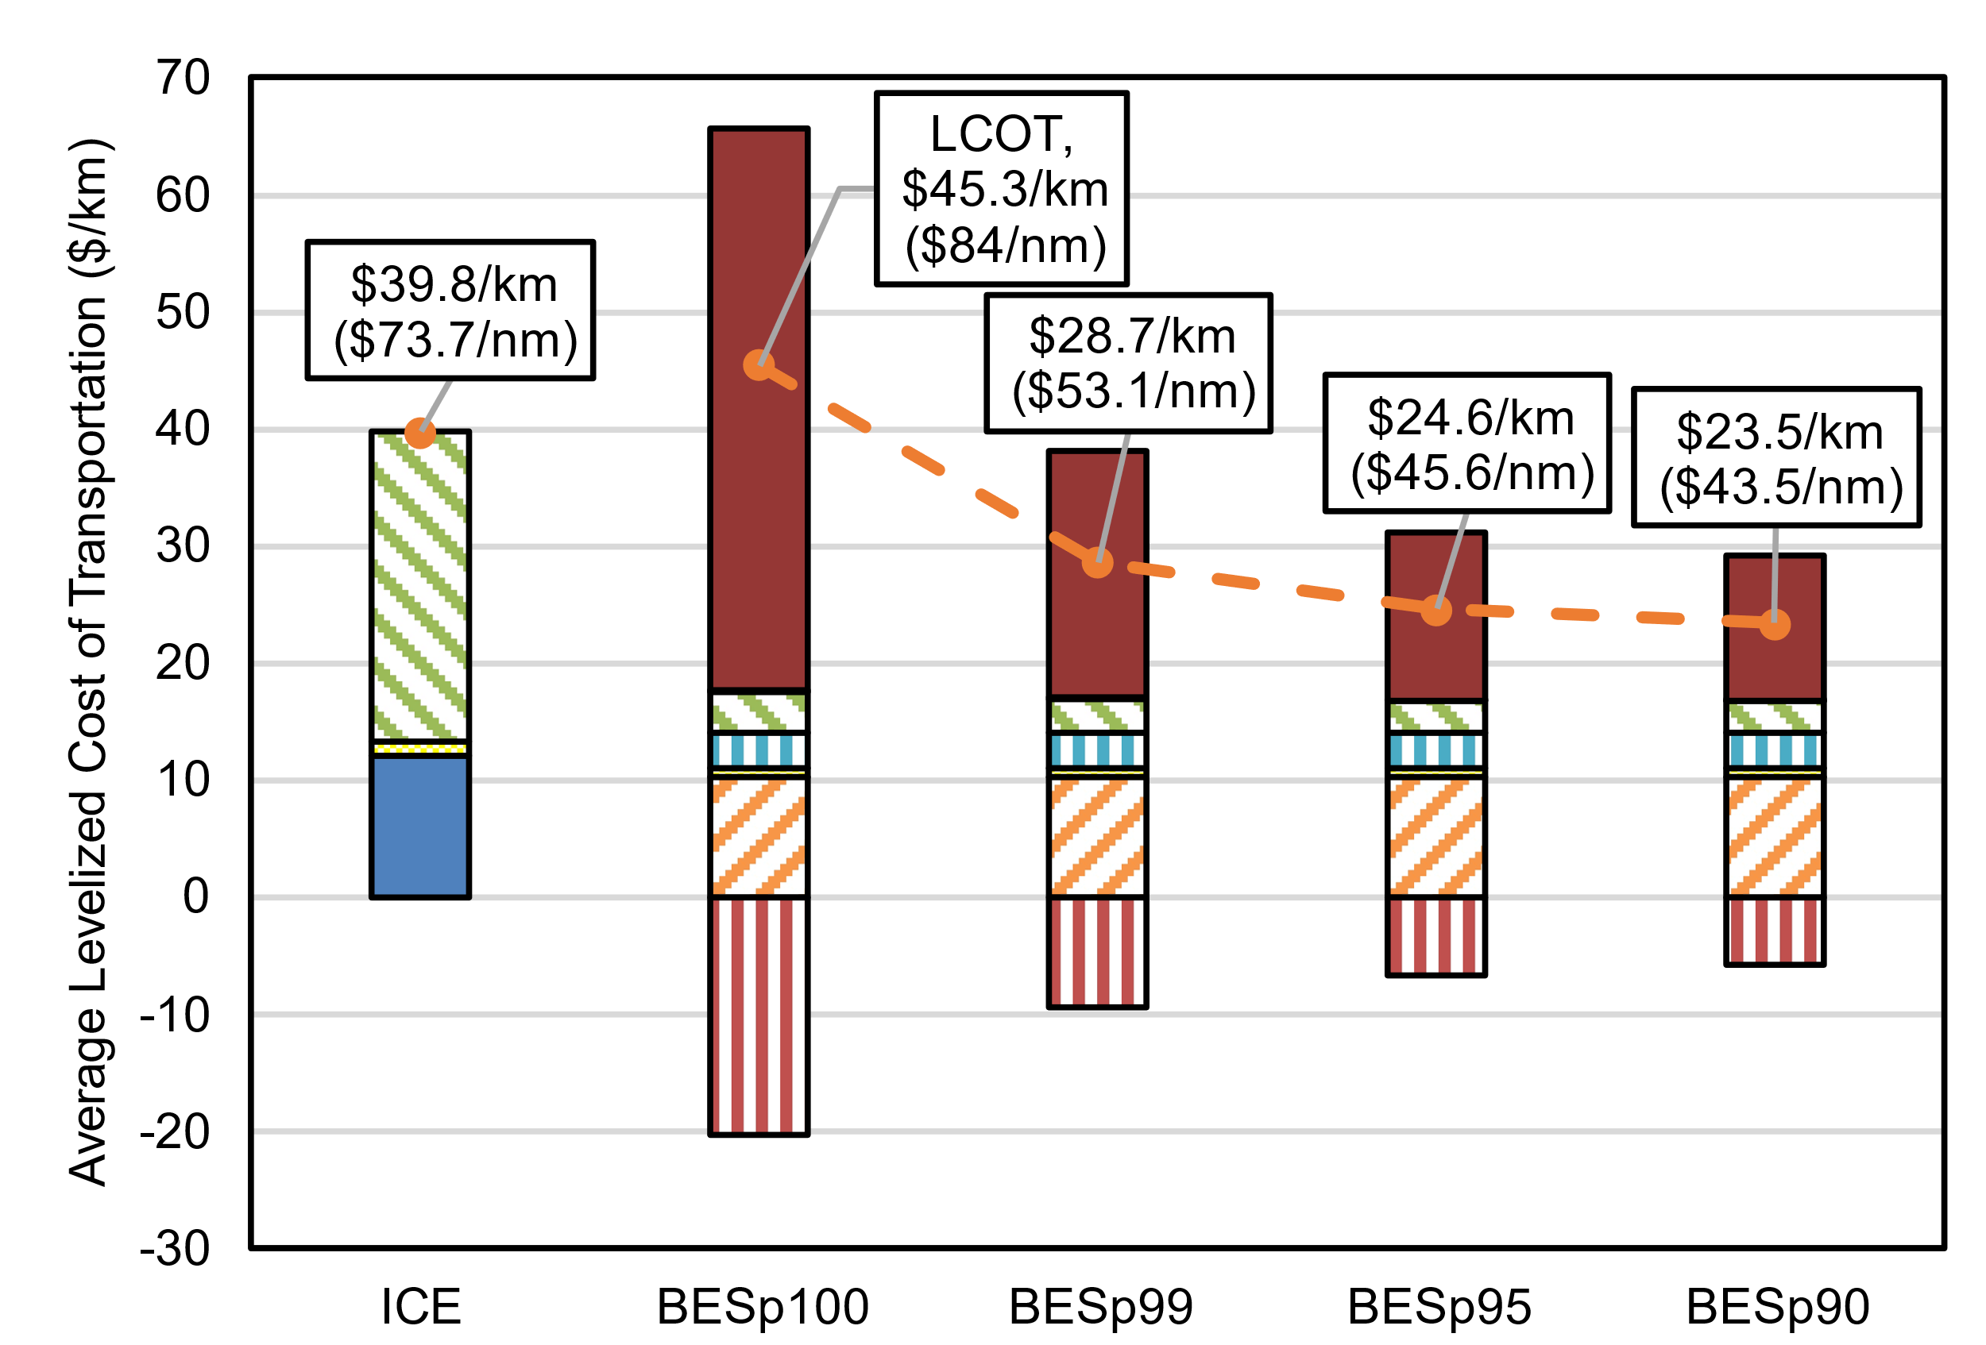
(a)
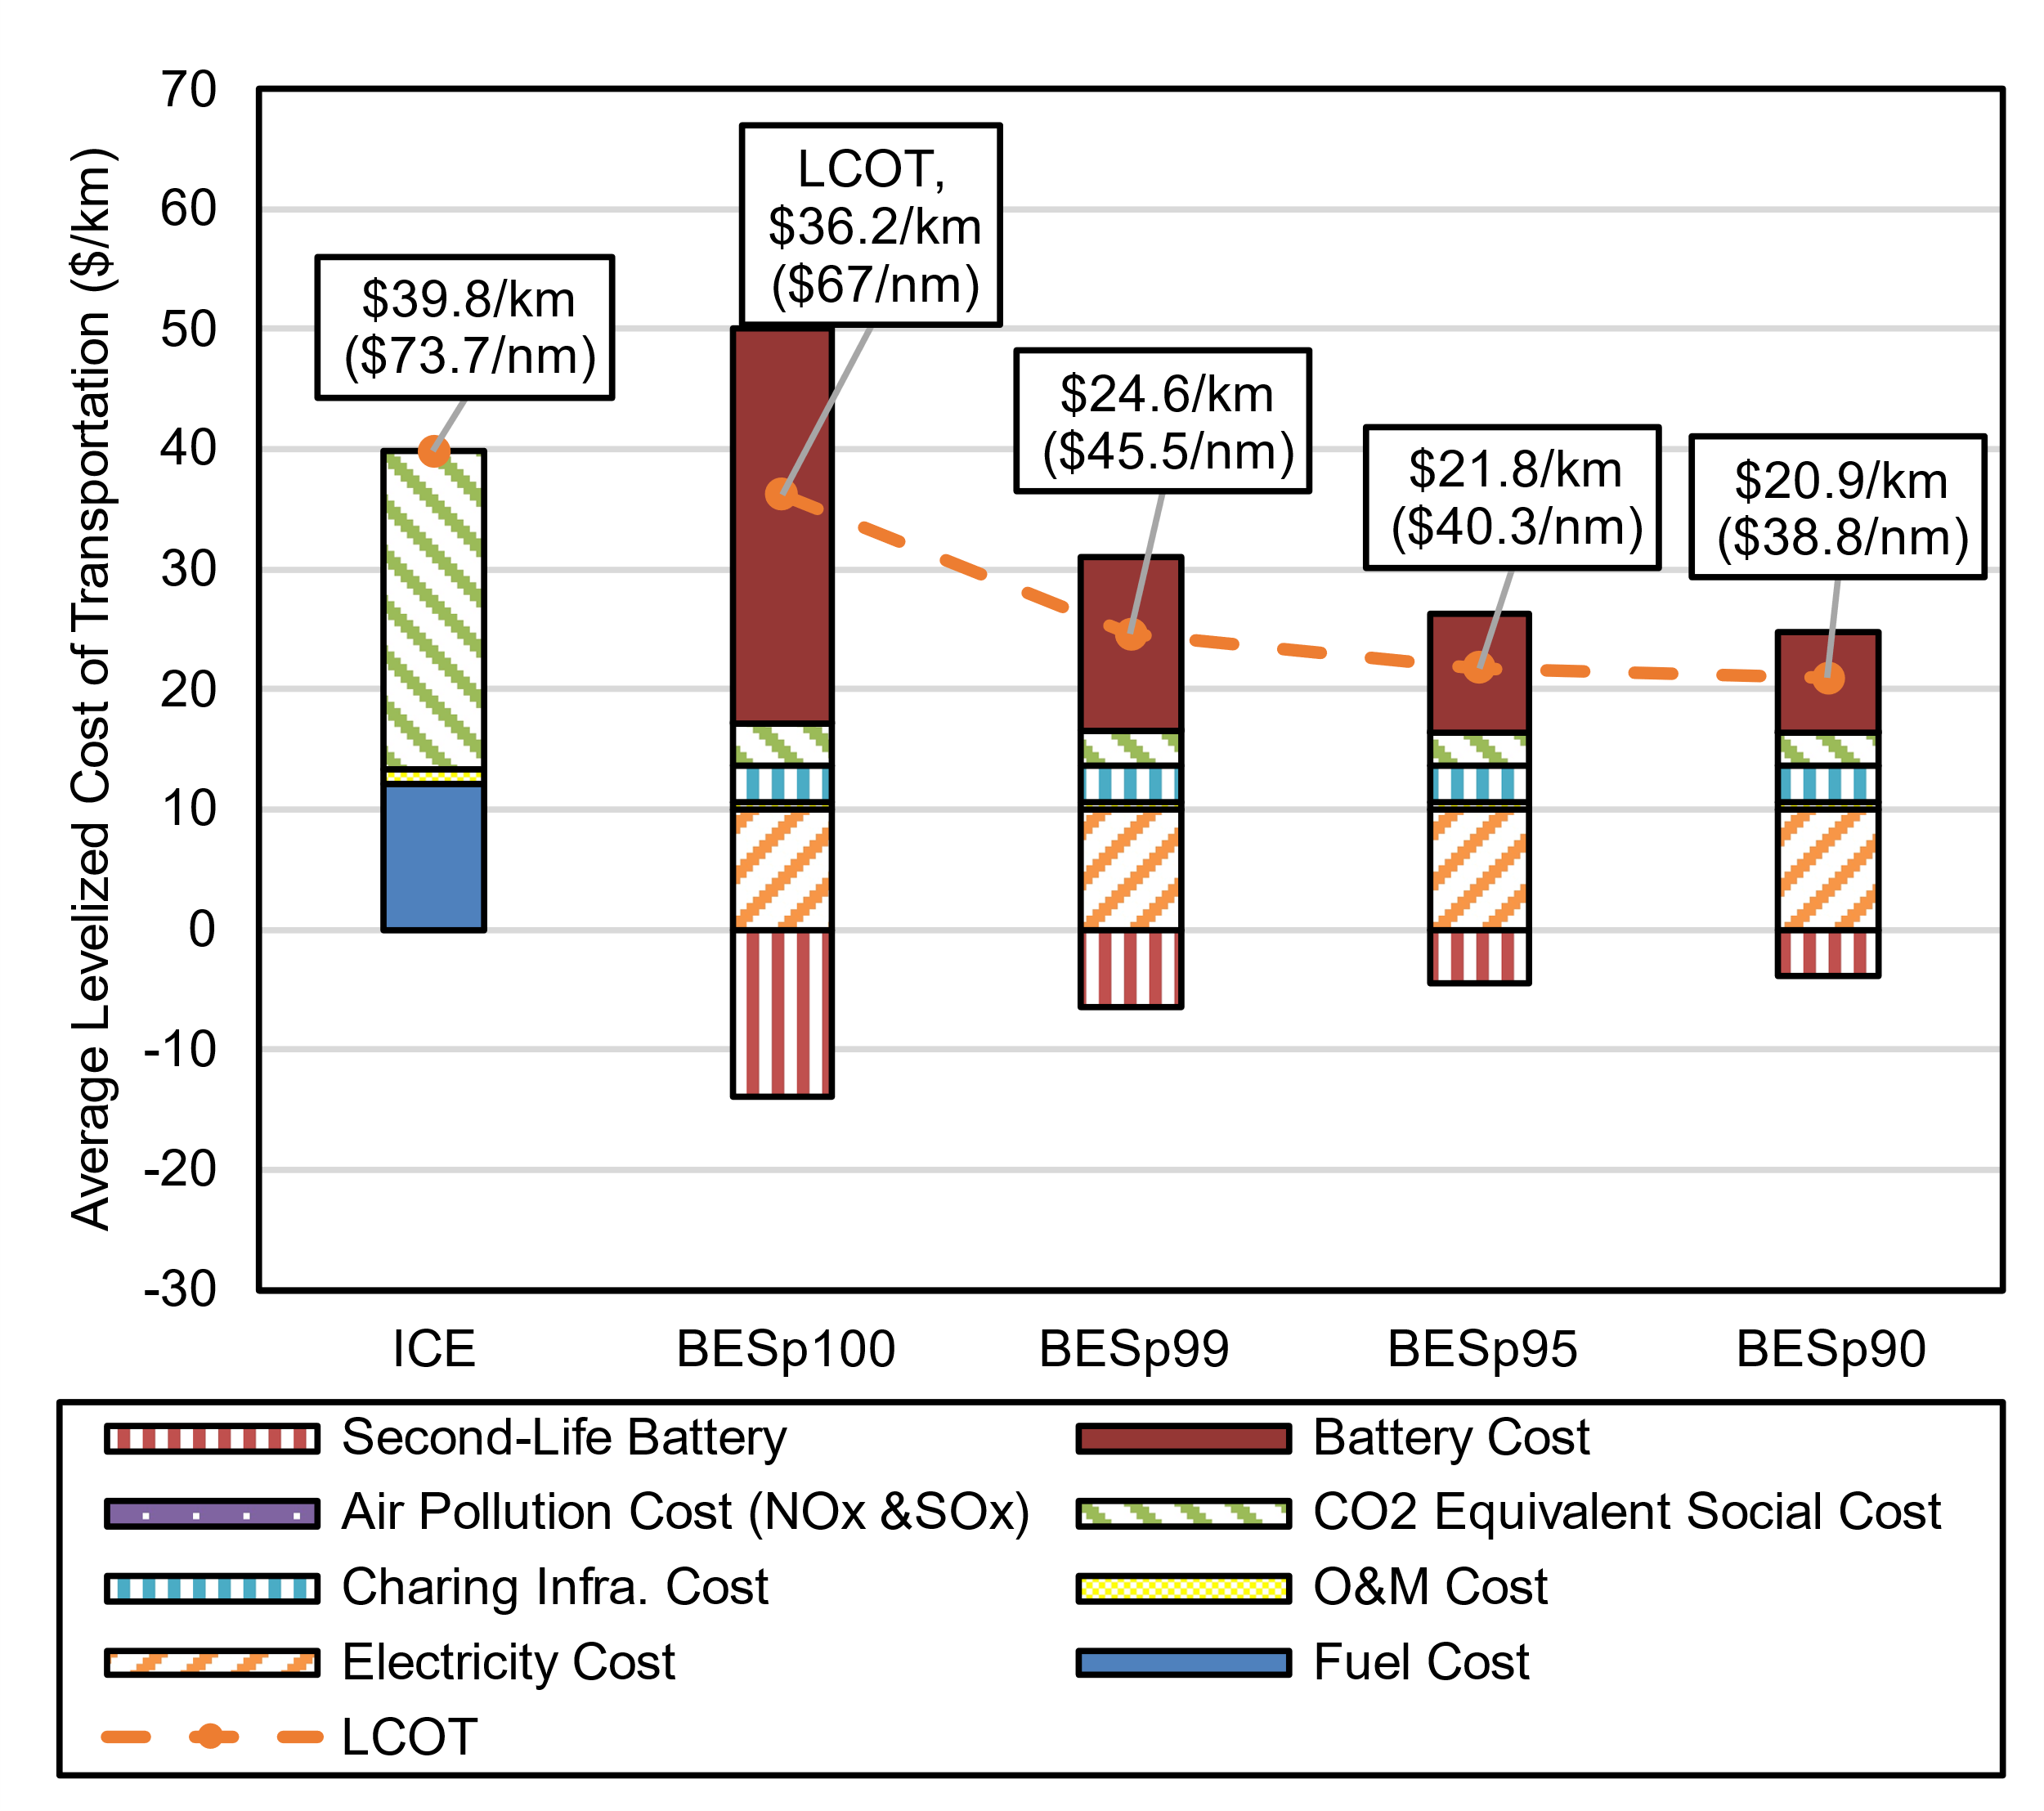
(b)
Supplementary Figure 25. Average LCOT of ICE Ships and BESs in 2050 under a 95% Electricity Decarbonization by 2050 (DEC) Emission Scenario with (a) Intermediate (INT) and (b) Optimistic (OPT) Cost Assumptions

Supplementary Figure 25 (a) and (b) illustrate the trends in average costs for ICEs and BESs under a 95% Electricity Decarbonization by 2050 (DEC) Scenario and both Intermediate (INT) and Optimistic (OPT) cost assumptions. Average costs for ICEs increase from $35.1/km ($65/nm) to $39.8/km ($73.7/nm), a 13.4% increase from 2035 levels. This can be attributed to a 24% increase in the per CO₂e emission cost between 2035 and 2050.

In 2050, the average cost of BESp100 is still higher than ICEs under the INT scenario, but it falls below ICE costs under the OPT scenario. Specifically, the average cost for BESp100 under the OPT scenario is $36.2/km ($67.0/nm), or 9% below the average cost for ICEs. This highlights the improved cost-effectiveness of BES in Optimistic scenario, making BESp100 potentially cost-competitive with ICEs without needing to lower the capacity tier. It is essential to consider the reimbursement from the value of SLB in this context, as it plays a vital role in making BES more economically viable. If this value is not factored in, the average cost of BESp100 would be significantly higher under the Optimistic scenario – $50.1/km ($92.8/nm) more expensive than ICEs – while BESp99 or lower capacity tiers would demonstrate lower costs than ICE. Hence, capturing the value of SLBs after their initial use in BESs is crucial for enhancing BES cost-competitiveness.

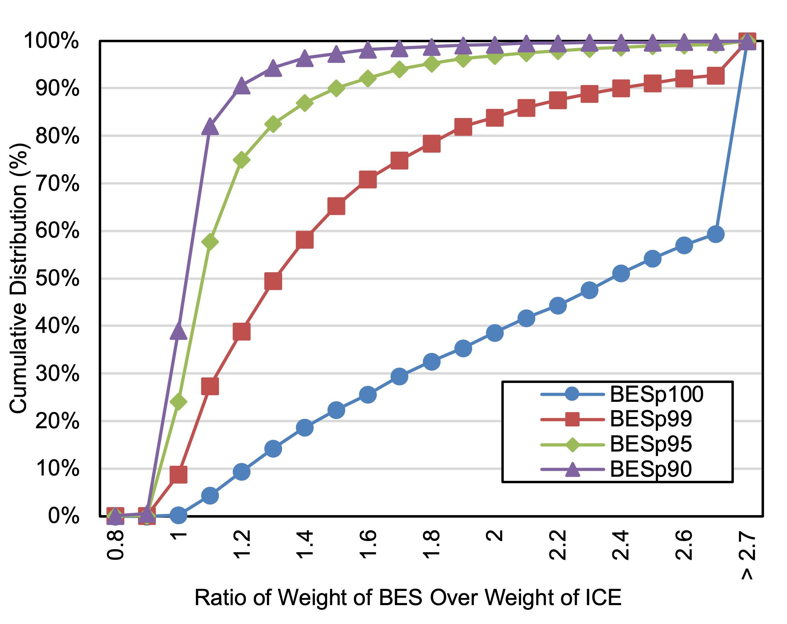
Supplementary Figure 26. Ratio of BES Weight to ICE Weight by BES Capacity Tier

As shown in Supplementary Figure 26, the weight increase of BESs relative to their ICE counterparts tends to exhibit variations among different capacity tiers, with a decreasing trend observed for lower capacity tiers. The median BES weight increases are 137%, 30%, 8%, and 2% for capacity tiers BESp100, BESp99, BESp95, and BESp90, respectively. For BESp100, 41% of vessels had a weight increase of over 100% (i.e., were more than twice as heavy as their ICE counterparts), highlighting significant weight increases for a considerable portion of these ships. In contrast, BESp99 showed more modest weight impacts, with 65% of vessels having a weight increase of 50% or less relative to ICEs. For BESp95, 69% of vessels had a weight increase of 20% or less, while BESp90 had a striking 91% of vessels with a weight increase of 20% or less, highlighting the weight reduction trend seen in lower capacity tiers. This result indicates that adopting battery-electric propulsion systems with lower capacity tiers can lead to modest increase of weights, making them potentially attractive options from a weight perspective.

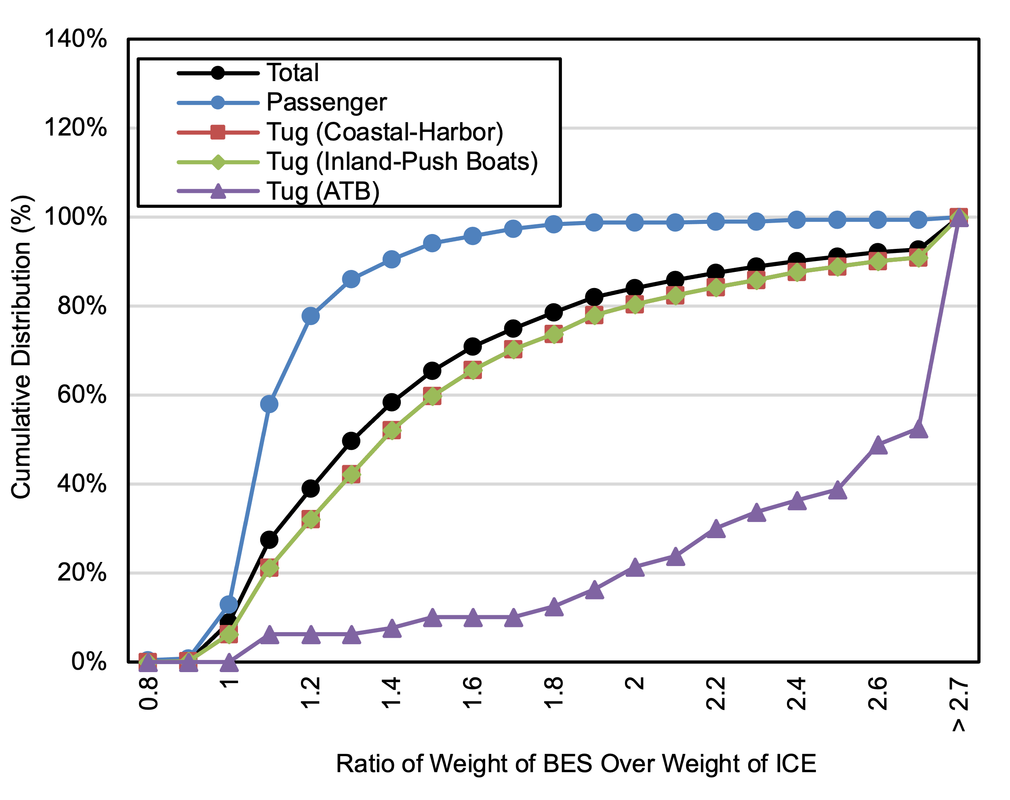
Supplementary Figure 27. Ratio of BES p99 Weight to ICE Weight by Ship Type

Beyond capacity tiers, the analysis also reveals significant variations in weight increase trends depending on ship type (Supplementary Figure 27). Specifically, for BESp99, we found that passenger ships displayed the least weight increase, with 94% having a weight ratio of 1.5 or less compared to ICEs. In contrast, for two types of tugs, coastal-harbor and inland-push boats, 60% and 69% experienced a weight ratio of 1.5 or less, respectively, compared to ICE ships. ATB tugs exhibited the largest weight increase, with only 10% of ships experiencing a weight ratio of 1.5 or less. Given the patterns of weight increase based on ship types, it is crucial to consider the specific ship type when contemplating retrofitting ICE to BES.

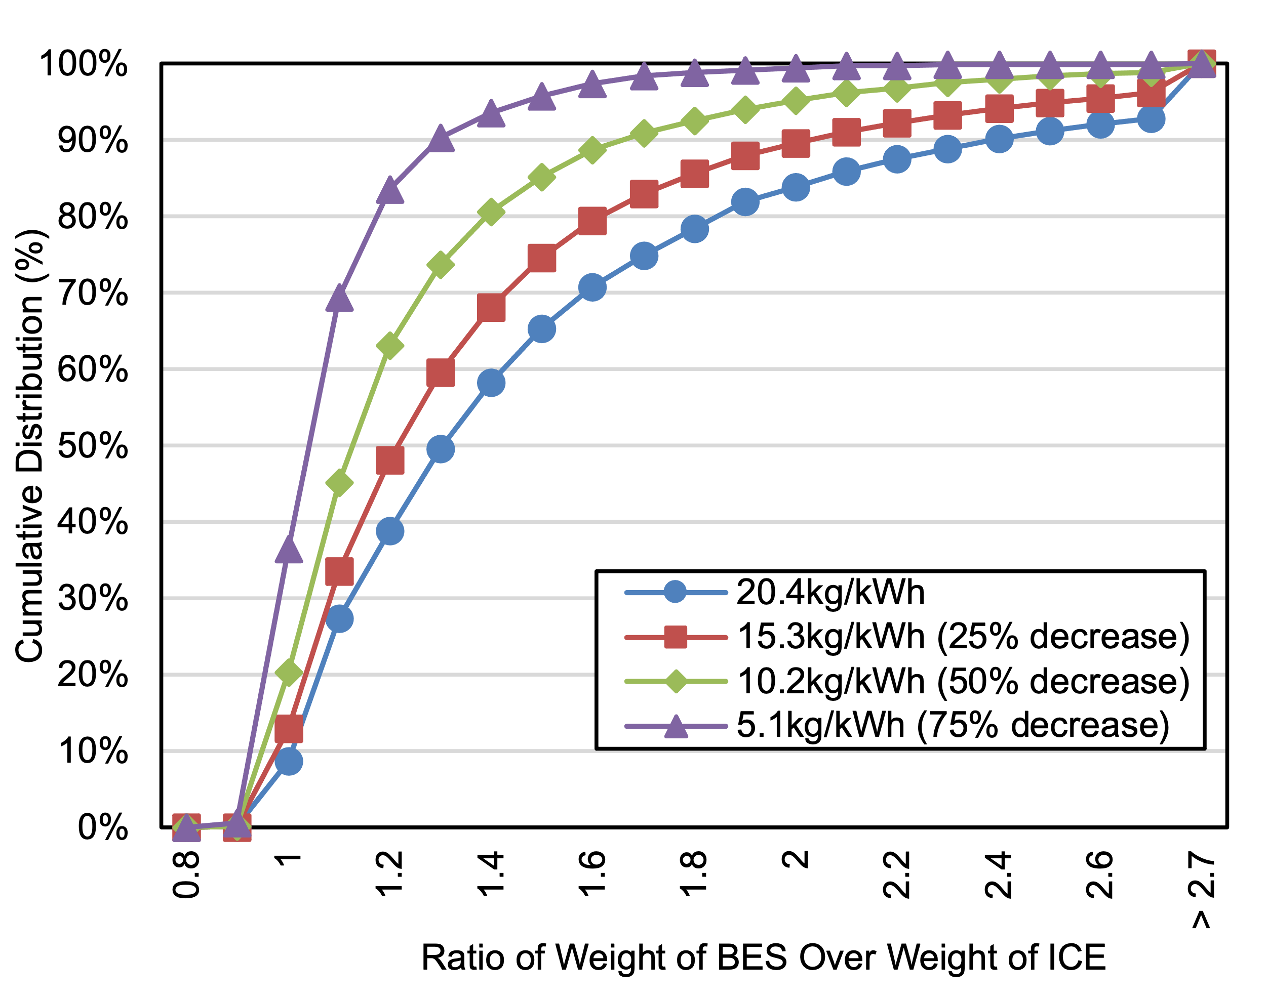
Supplementary Figure 28. Ratio of BES p99 Weight to ICE Weight by Ship Type under Multiple Battery Weight Reduction Scenarios

Supplementary Figure 28 shows that improvements in battery system weight can reduce the BES-to-ICE weight ratio. The figure shows this ratio using the BESp99 capacity tier. Using the assumed 20.4 kg/kWh battery weight as baseline, BES-to-ICE weight ratios are calculated for per kWh battery system weight reductions of 0% (baseline), 25%, 50%, and 75%. The median weight ratio for each battery weight reduction scenario are 1.30, 1.21, 1.13, and 1.04. Among all BESs, 39%, 48%, 63%, and 84%, respectively, have a weight ratio of 1.2 or less under each respective battery weight reduction scenario. Passenger vessels show the most significant weight improvements. For BESp99, the median weight ratio under each battery weight reduction scenario is 1.08, 1.04, 1.00, and 0.99, indicating that battery weight improvements lead to overall weight improvements, with potentially more significant effects in certain vessel types.

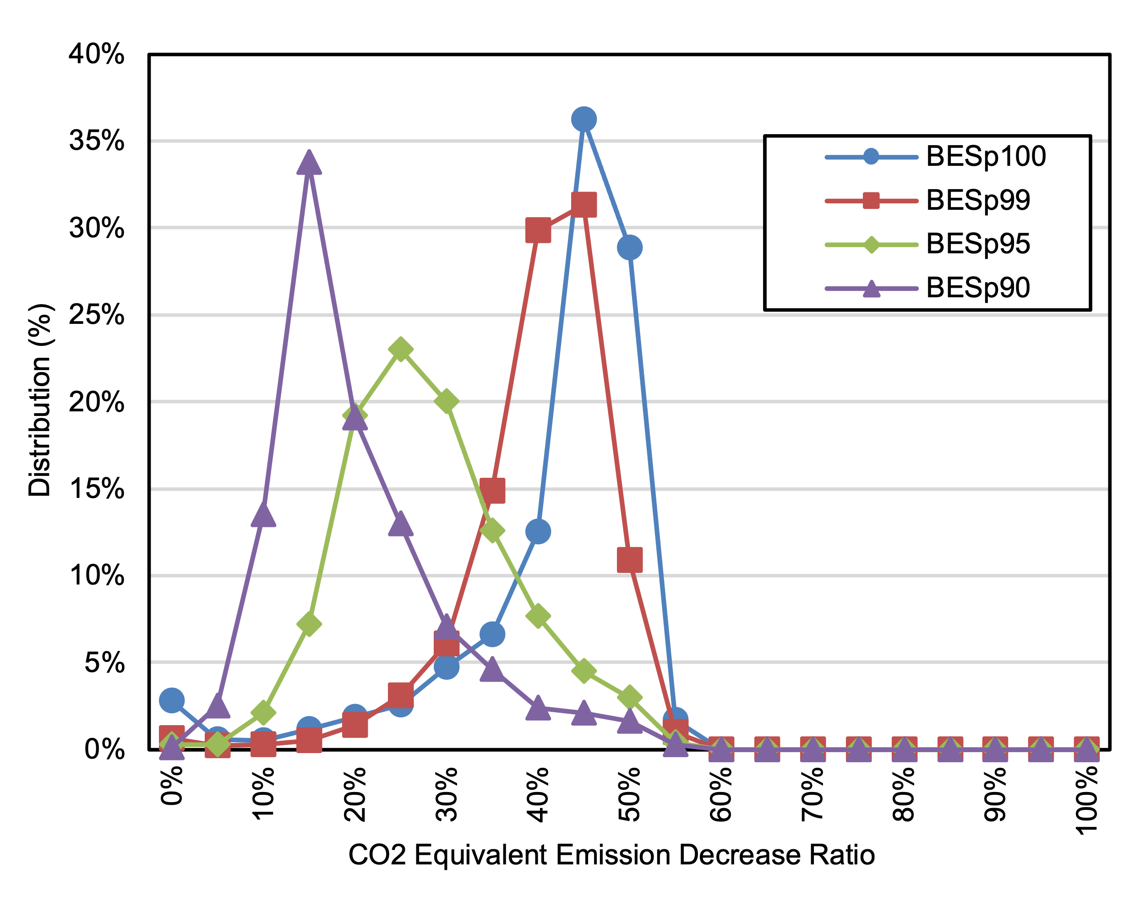
Supplementary Figure 29. Distribution of the Ratio of CO₂e Emission Decrease vs. ICE Ships with a Factor of 2 for Unserved Trips in 2035 under a 95% Decarbonization by 2050 (DEC) Scenario

As the capacity tier decreases and the battery size becomes smaller, more unserved trips occur. However, these unserved trips can be addressed by dividing them into smaller trips, which can be beneficial from an emissions perspective. To figure out this beneficial, we estimated emissions including the emissions from unserved trips that were not included in prior analysis. Assuming vessels with lower capacity tiers could perform the unserved trips with the factor of 2 to CO₂e emissions. Supplementary Figure 29 shows the distribution of the ratio of CO₂e emission decrease by capacity tiers. Despite the applied factor, it is observed that almost all vessels with lower capacity tiers showed a decrease in CO₂e emissions compared to ICEs. The average reduction rates are 40%, 38%, 26%, and 18% for p100, p99, p95, and p90, respectively. Therefore, dividing longer trips into multiple shorter trips may offer CO₂e emission benefits compared to traditional ICE ships.

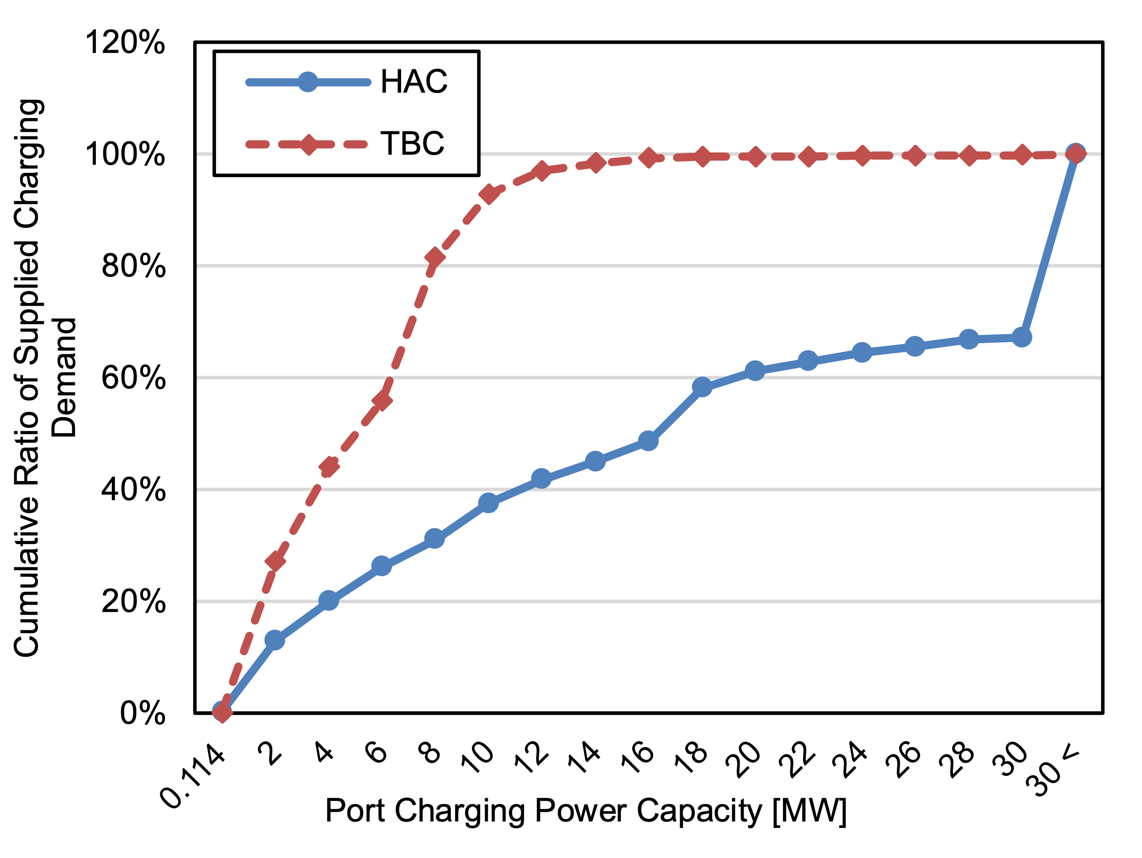
Supplementary Figure 30. Ratio of Supplied Charging Demand under Historical Activity-Based Charging (HAC) and Trip-Based Charging (TBC) at the Illinois International Port

Additional electricity demand varies by state, but in most cases it is less than 1% of 2021 statewide electricity demand, indicating that this is an achievable expansion of electricity supply. However, the concentrated charging needs for BESs at specific port locations is likely to create a significant burden on ports’ existing power systems. For example, according to a recent survey by GSGP and ABS (2022), the existing power capacity at the Illinois International Port, a large port in the Great Lakes region, is 700 kW, perhaps suggesting that existing power facilities could be sufficient to power BES charging. Using a simple calculation (700 kW $×$ 24 h $×$ 365 days), we see that this port can consume 6.1 GWh annually. However, the port’s SPC capacity is 300 A with 480 V, which is 144 kW, and thus the port’s SPC can only supply a maximum of 1.3 GWh per year.

Based on our analysis, charging demand at this port will be 15.4 GWh per year, which is 2.5 times its theoretical maximum consumption of 6.1 GWh and 12 times its actual maximum supply of 1.3 GWh. This indicates that the port will require significant additional capacity, both in terms of power and charging facilities, to supply electrified ships. While this need may vary by port, our analysis reveals that there are 76 ports with even greater charging requirements than the Illinois International Port.

Supplementary Figure 30 shows the ratio of supplied electricity at the Illinois International Port under Historical Activity-based Charging and Trip-Based Charging by charging capacity. Again, Historical Activity-based Charging is a charging strategy that aligns with each ship’s historical activity, while Trip-Based Charging involves charging for a longer duration than the ship actually stayed at port. It is shown that the existing 114 kW of its SPC could only cover 0.3% of charging demand, which is 52 MWh under Historical Activity-based Charging. To meet 50% of charging demand under Historical Activity-based Charging, a substantially greater power capacity of 17 MW is required. However, this requirement can be significantly alleviated with the implementation of Trip-Based Charging, which only needs 4.9 MW of capacity.

With a capacity of 10.8 MW, 95% of charging needs can be met under Trip-Based Charging, whereas only 33.8% of needs are met under Historical Activity-based Charging. These results indicate that adjusting ship activity can help alleviate charging power requirements. Nevertheless, despite the benefits of Trip-Based Charging in serving a larger share of charging demand with less power capacity, the port would still need to add a substantial amount of power infrastructure to meet overall BES charging demand. In this regard, other potential solutions – such as installation of a port microgrid with renewable energy generation and storage around the port site, or implementation of a battery swapping-based BES-SPC system – could be considered³⁹.

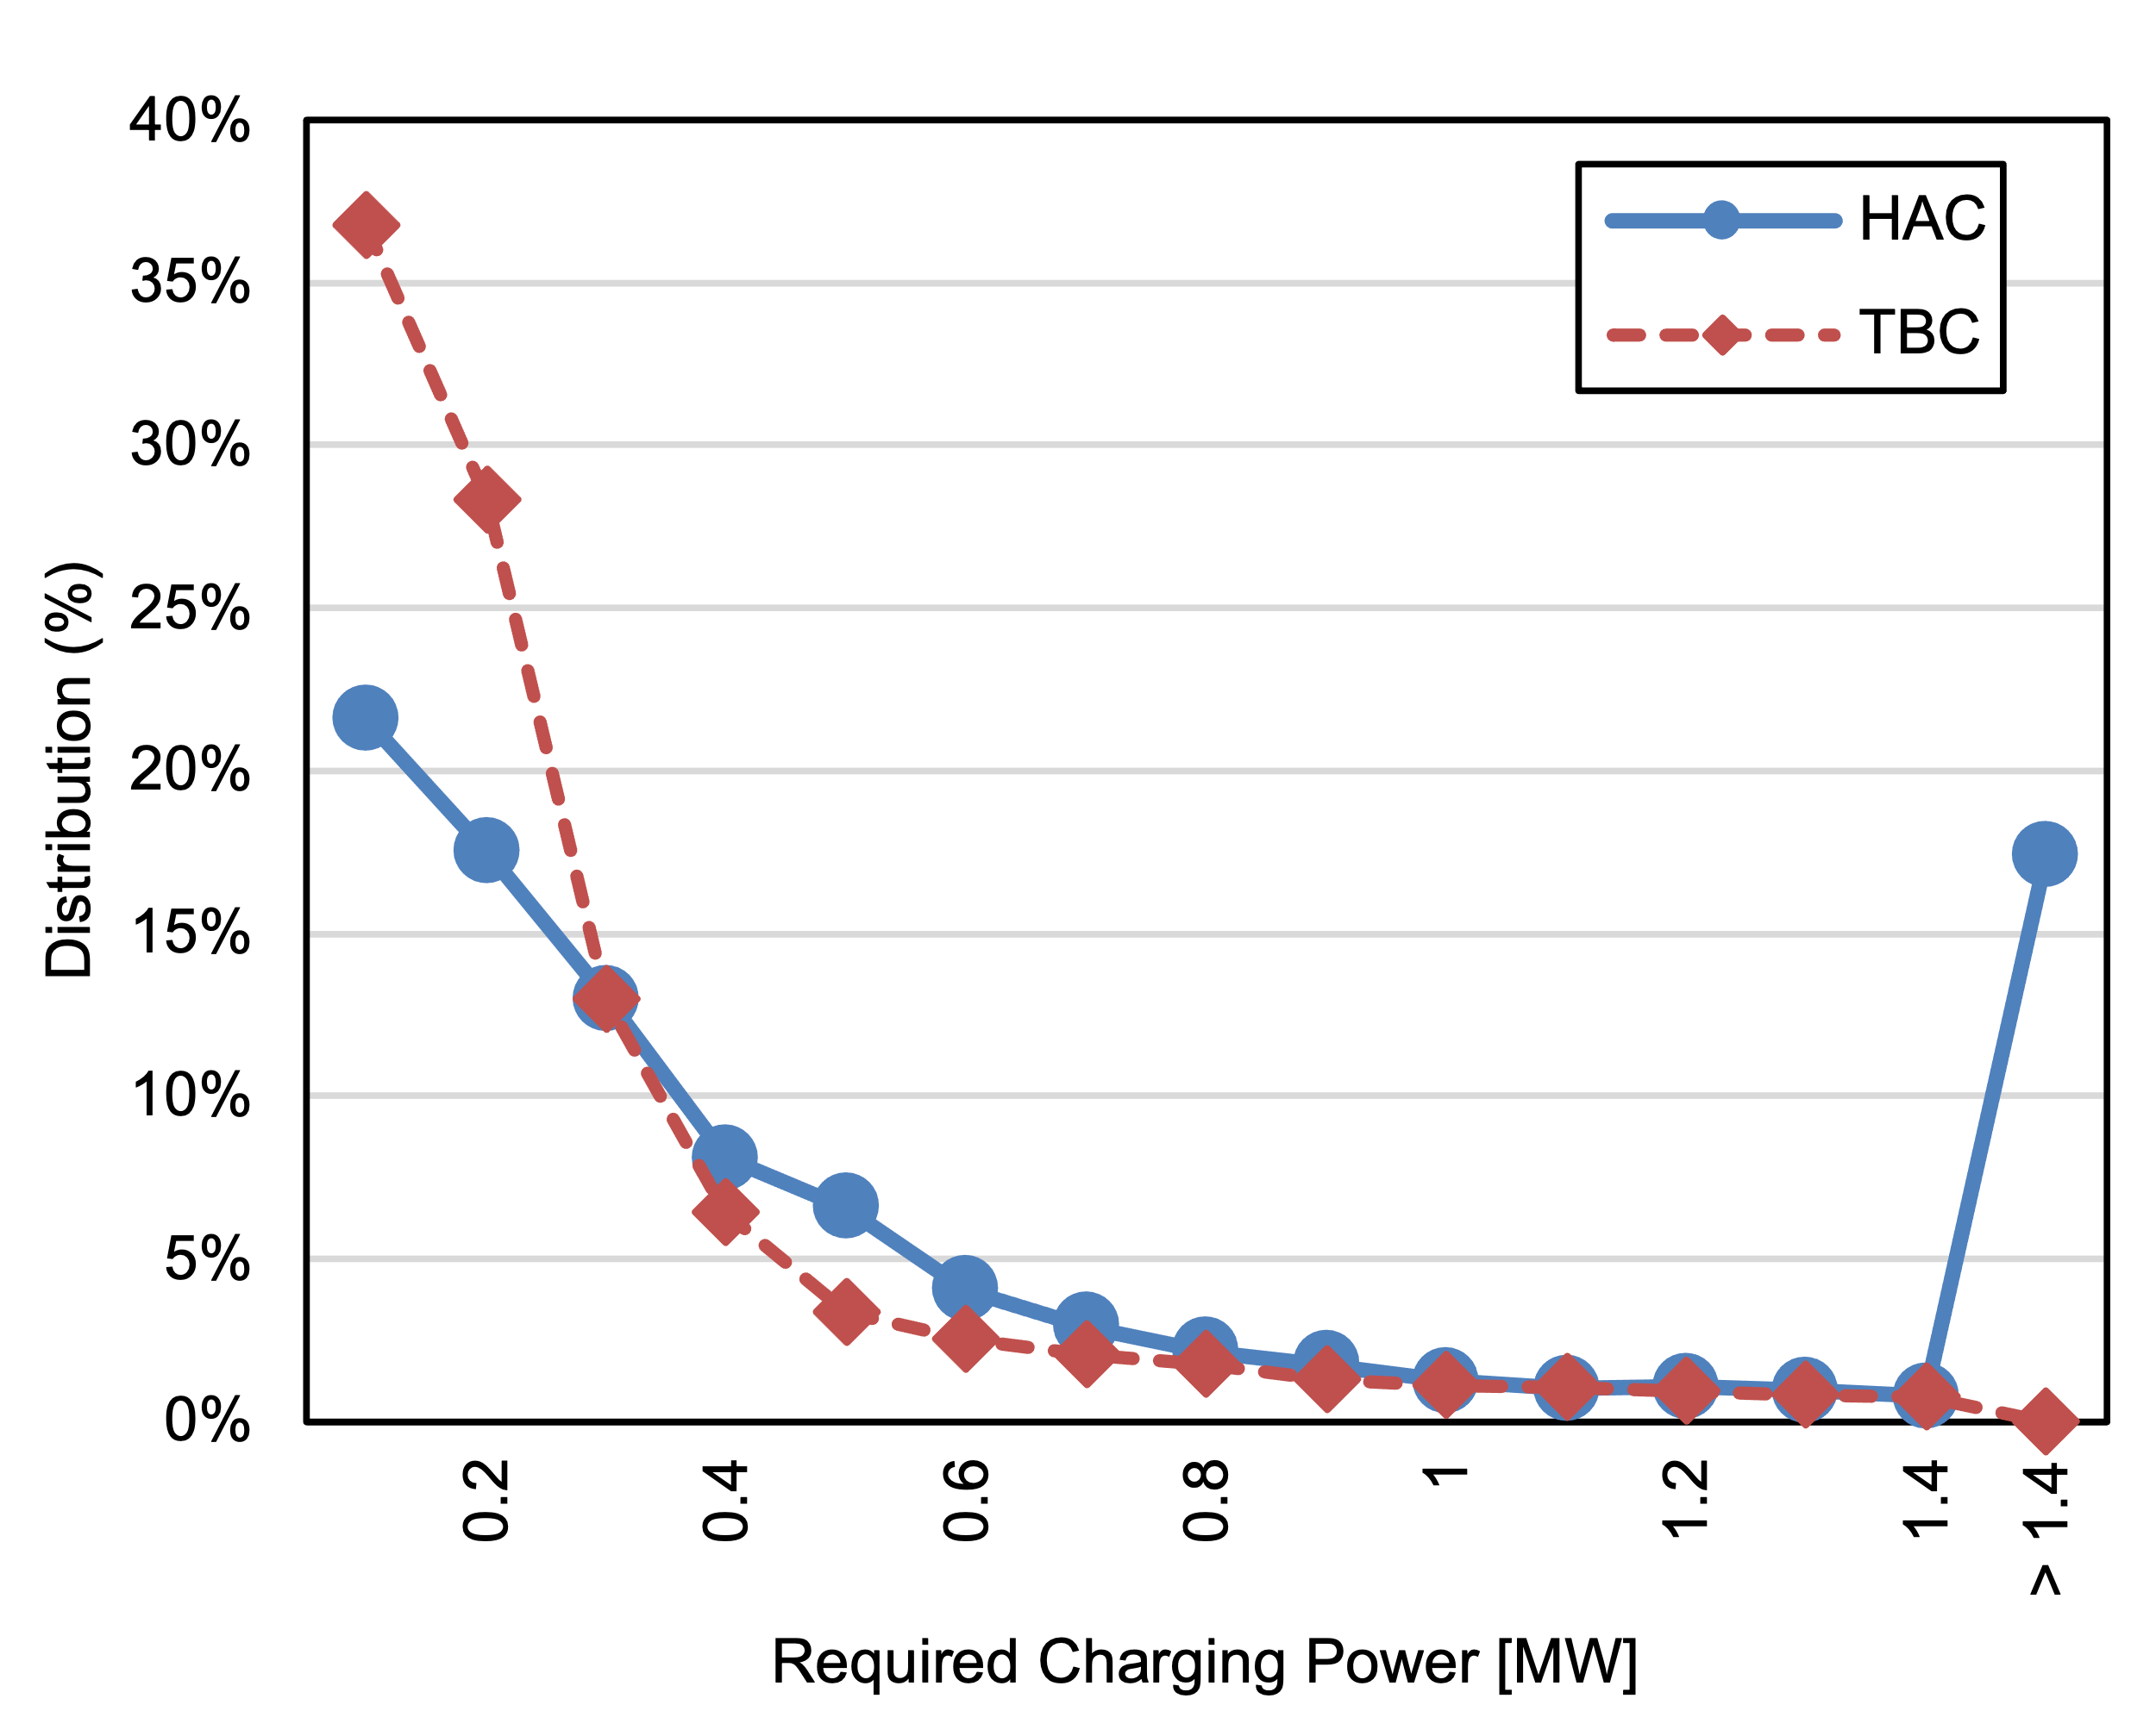
Supplementary Figure 31. Distribution of Power Requirements for SPCs under Historical Activity-based Charging (HAC) and Trip-Based Charging (TBC) at the Illinois International Port

Commercial shore power systems in the U.S. can be broadly classified into two categories⁴⁰:
- High voltage shore connection (HVSC): 6,600 or 11,000 V, >1 MVA equipment primarily used to service large cruise, container, and reefer vessels.
- Low voltage shore connection (LVSC): 220-480 V, < 1 MVA equipment typically used to service smaller ships such as fishing, tug, workboat, ferry, and service vessels.
Shore power systems primarily cater to hotel loads; however, they can serve as an initial benchmark for comparing existing facilities with future requirements. Supplementary Figure 31 illustrates the power requirements distribution per SPC under both Historical Activity-based Charging and Trip-Based Charging at the Illinois International Port. Again, Historical Activity-based Charging is a charging strategy that aligns with each ship’s historical activity, while Trip-Based Charging involves charging for a longer duration than the ship actually stayed at port.

Trip-Based Charging enables greater coverage of charging demand with a lower power capacity requirement for SPCs. Specifically, with a maximum power capacity of 1 MW for the LVSC, Trip-Based Charging fulfills 96% of charging requirements, whereas Historical Activity-based Charging only satisfies 79%. This finding highlights the advantage of Trip-Based Charging compared to Historical Activity-based Charging in relieving power requirements for SPCs.
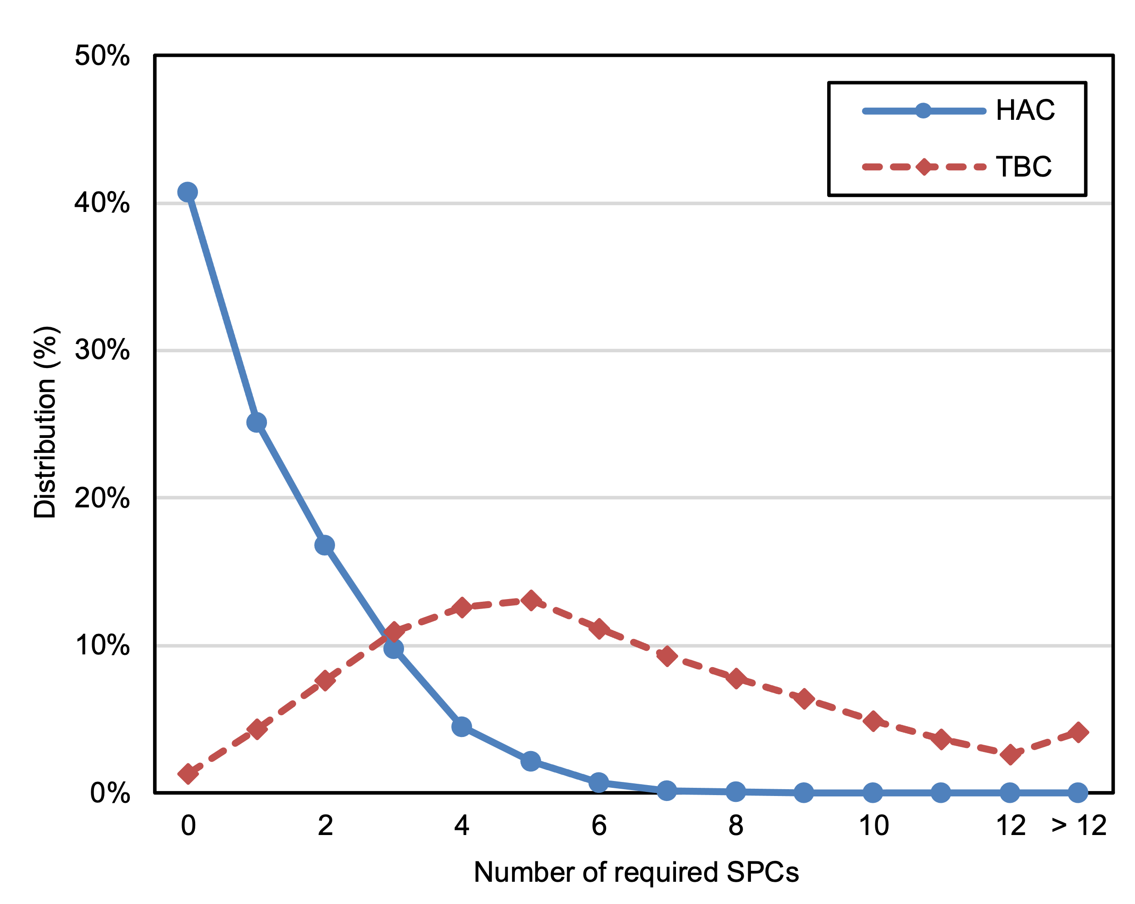
Supplementary Figure 32. Distribution of Number of Required SPCs under Historical Activity-based Charging (HAC) and Trip-Based Charging (TBC) at the Illinois International Port

Implementing Trip-Based Charging comes with a tradeoff. In Supplementary Figure 32, the distribution of the number of charging ships shows how many SPCs will be required at the Illinois International Port. This distribution reveals that under Historical Activity-based Charging, only 2 SPCs could supply charging demand during 66% of the hours in a year; under Trip-Based Charging, 7 SPCs would be required for the same coverage. Furthermore, to satisfy charging requirements 95% of the time, 4 SPCs are needed under Historical Activity-based Charging, while Trip-Based Charging requires 12. The New York port, which has the highest charging demand, would require 46 SPCs to serve requirements 50% of the time under Historical Activity-based Charging, and 72 under Trip-Based Charging. The increased need for SPCs under Trip-Based Charging results from longer charging times compared to Historical Activity-based Charging.

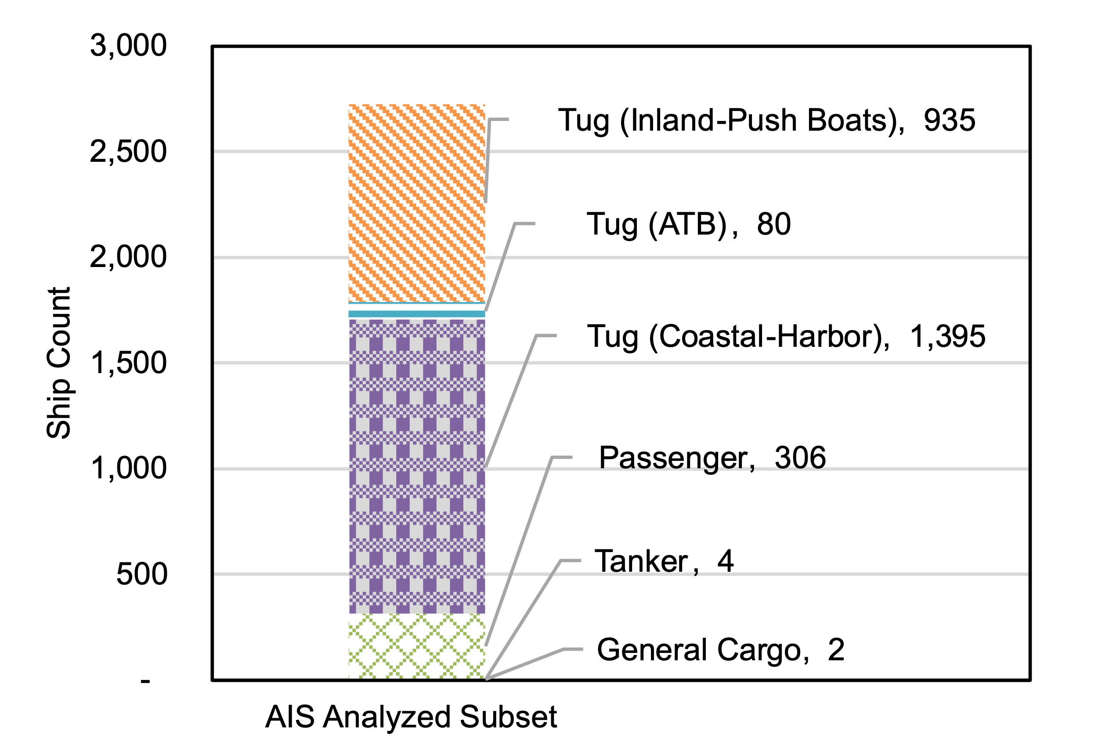
Supplementary Figure 33. Count of Ships in the AIS Analyzed Subset, by Ship Type

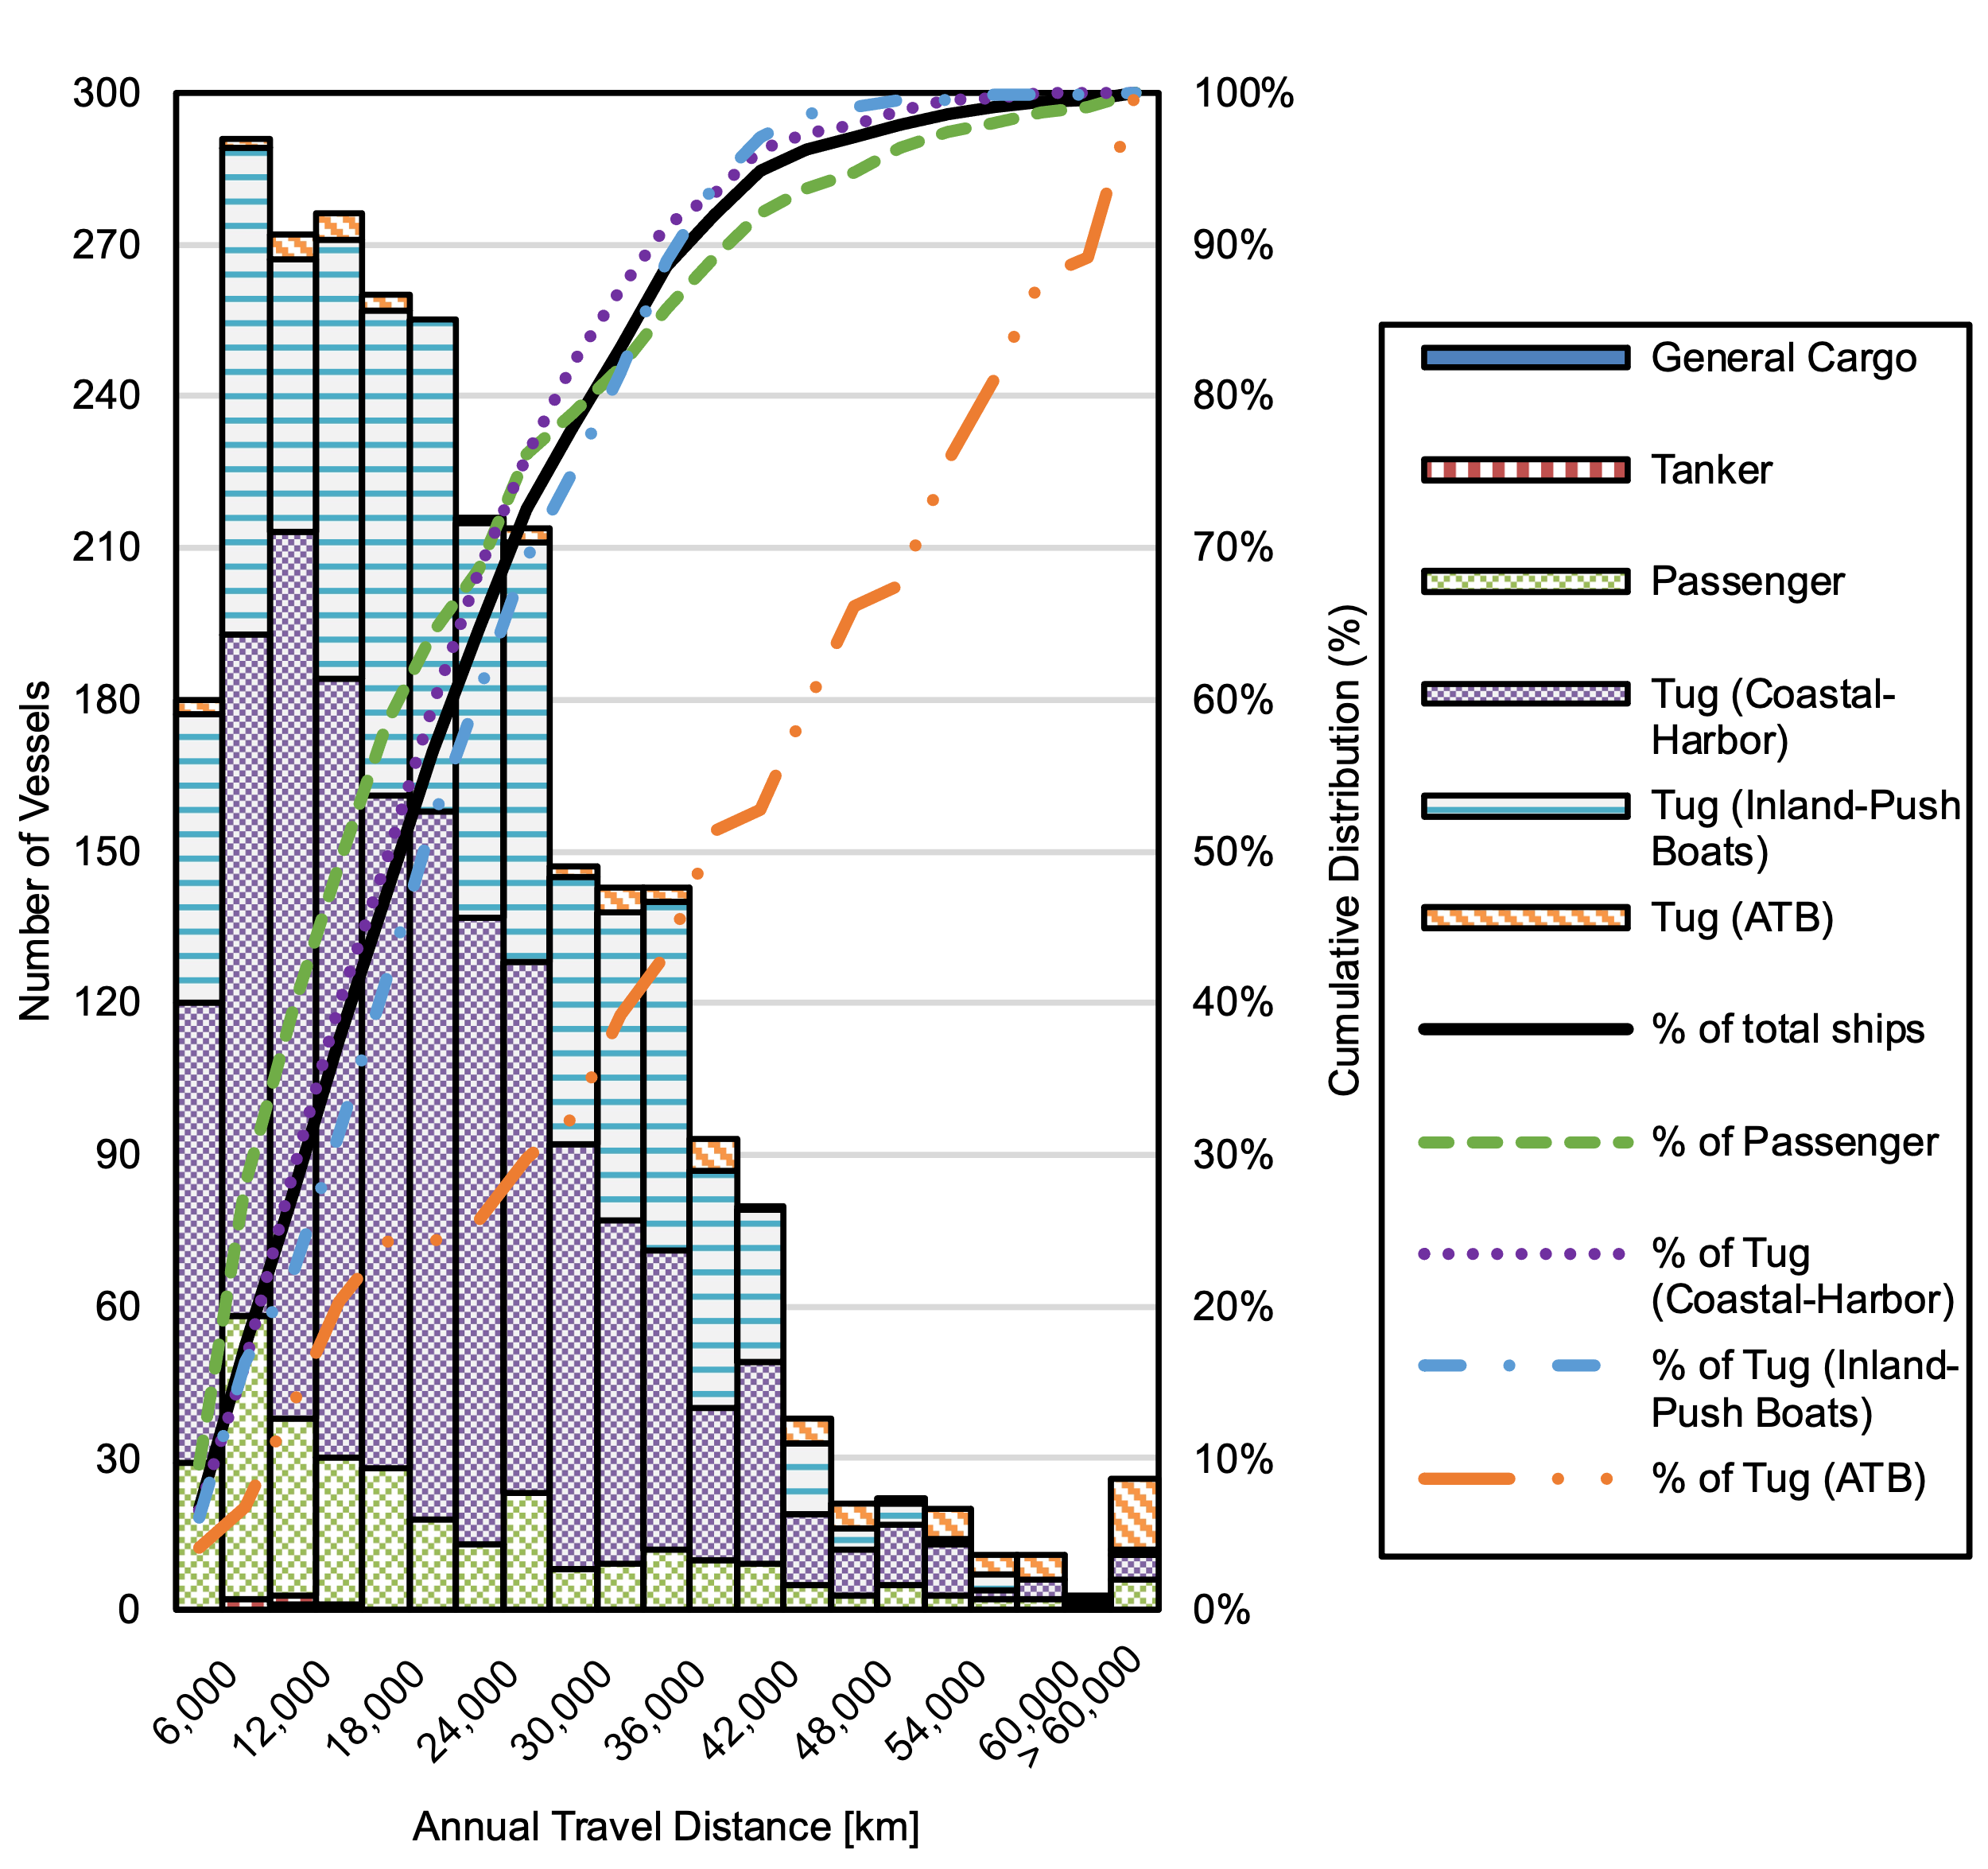
Supplementary Figure 34. Distribution of Annual Travel Distance by Ship Type in the AIS Analyzed Subset

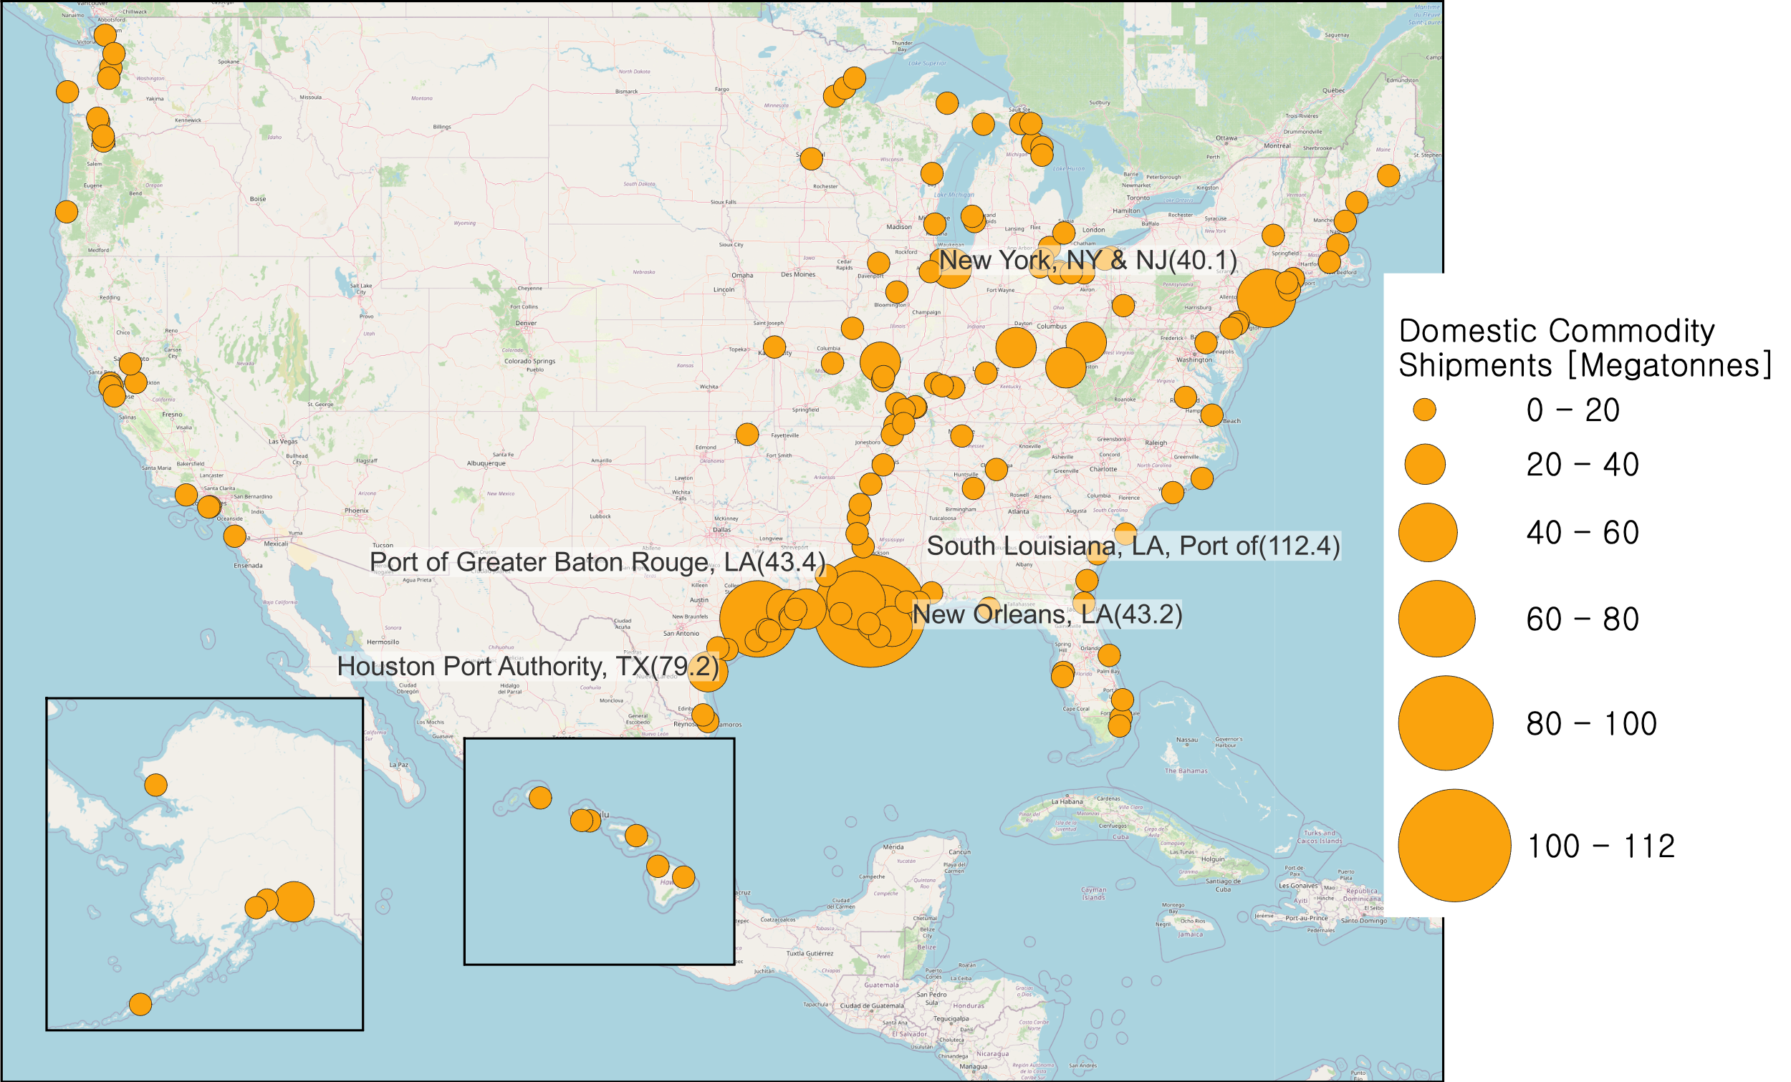
Authors’ work based on USDOT shipment data^{41,42}.
Supplementary Figure 35. Locations and Domestic Commodity Shipments at 150 Major U.S. Ports

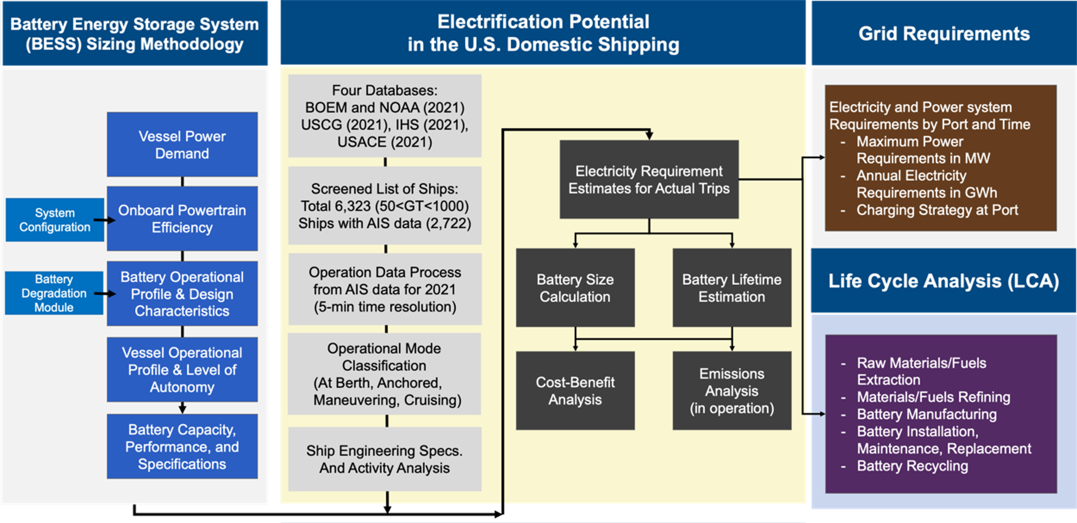
Supplementary Figure 36. Process for Estimating Ship Electrification Potential and GHG Emissions

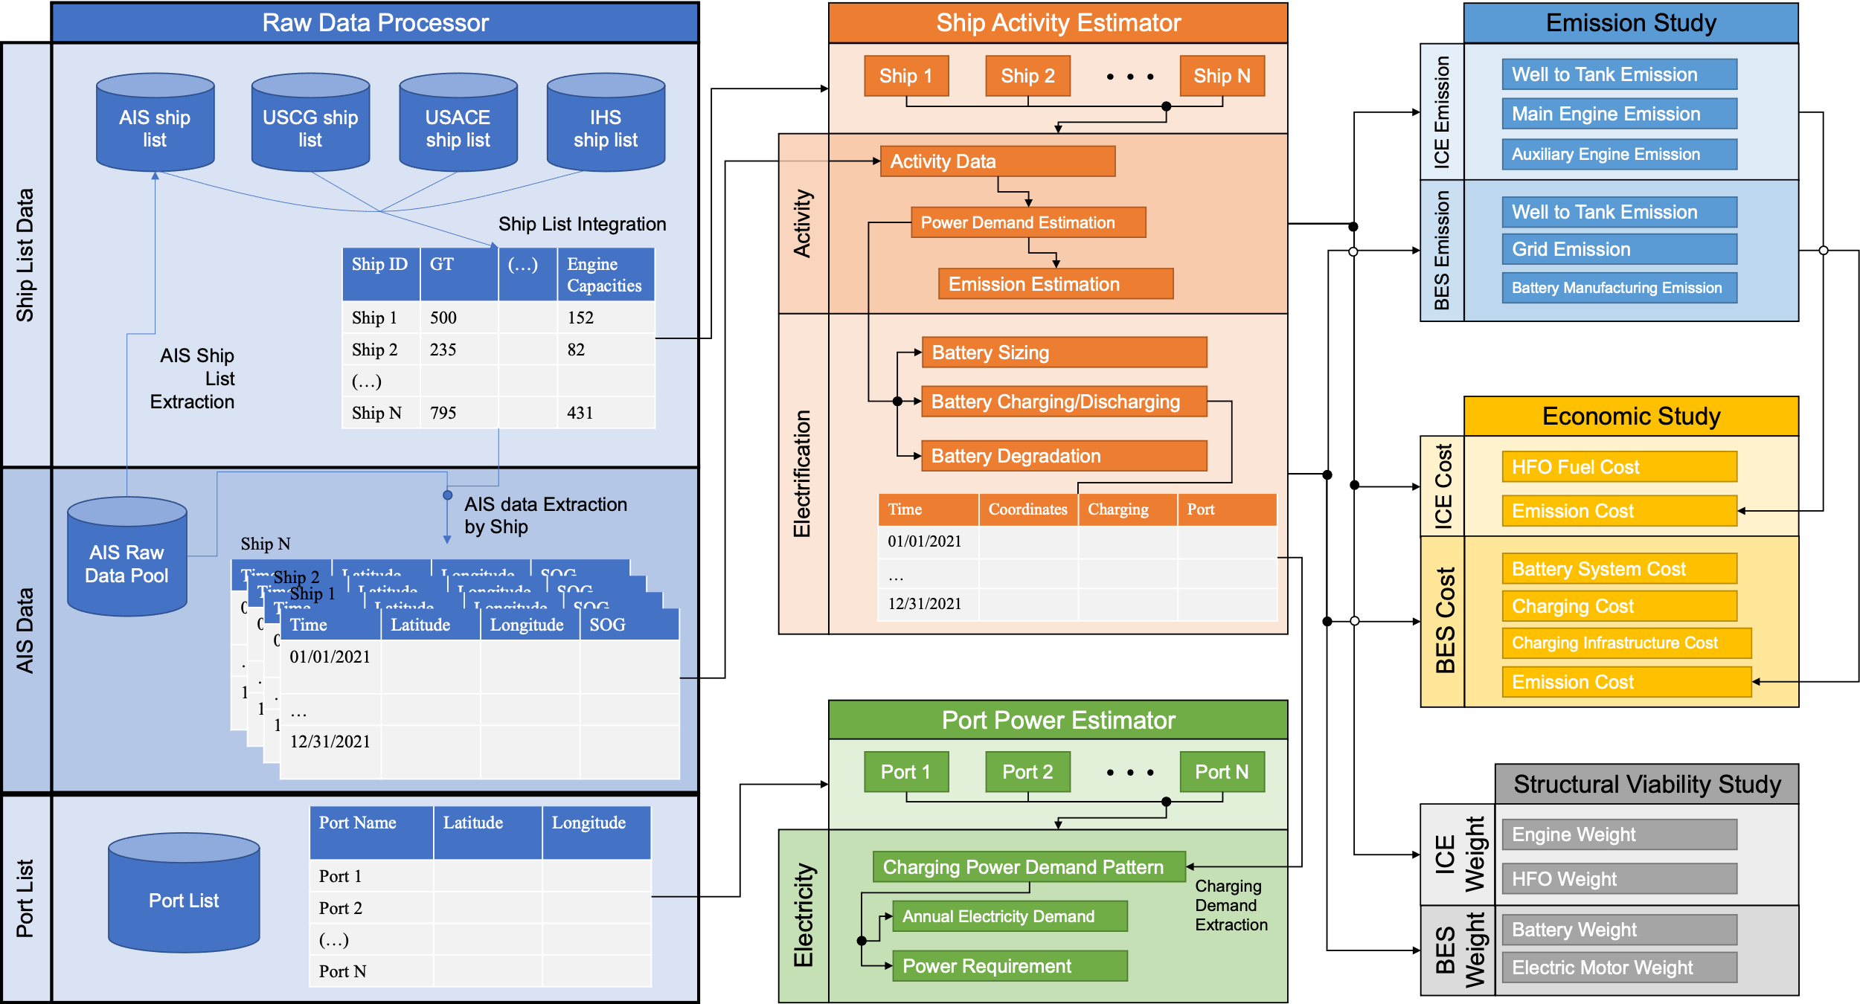
Supplementary Figure 37. Design of the Maritime Battery Electrification Simulator (MariBES) Developed for This Study

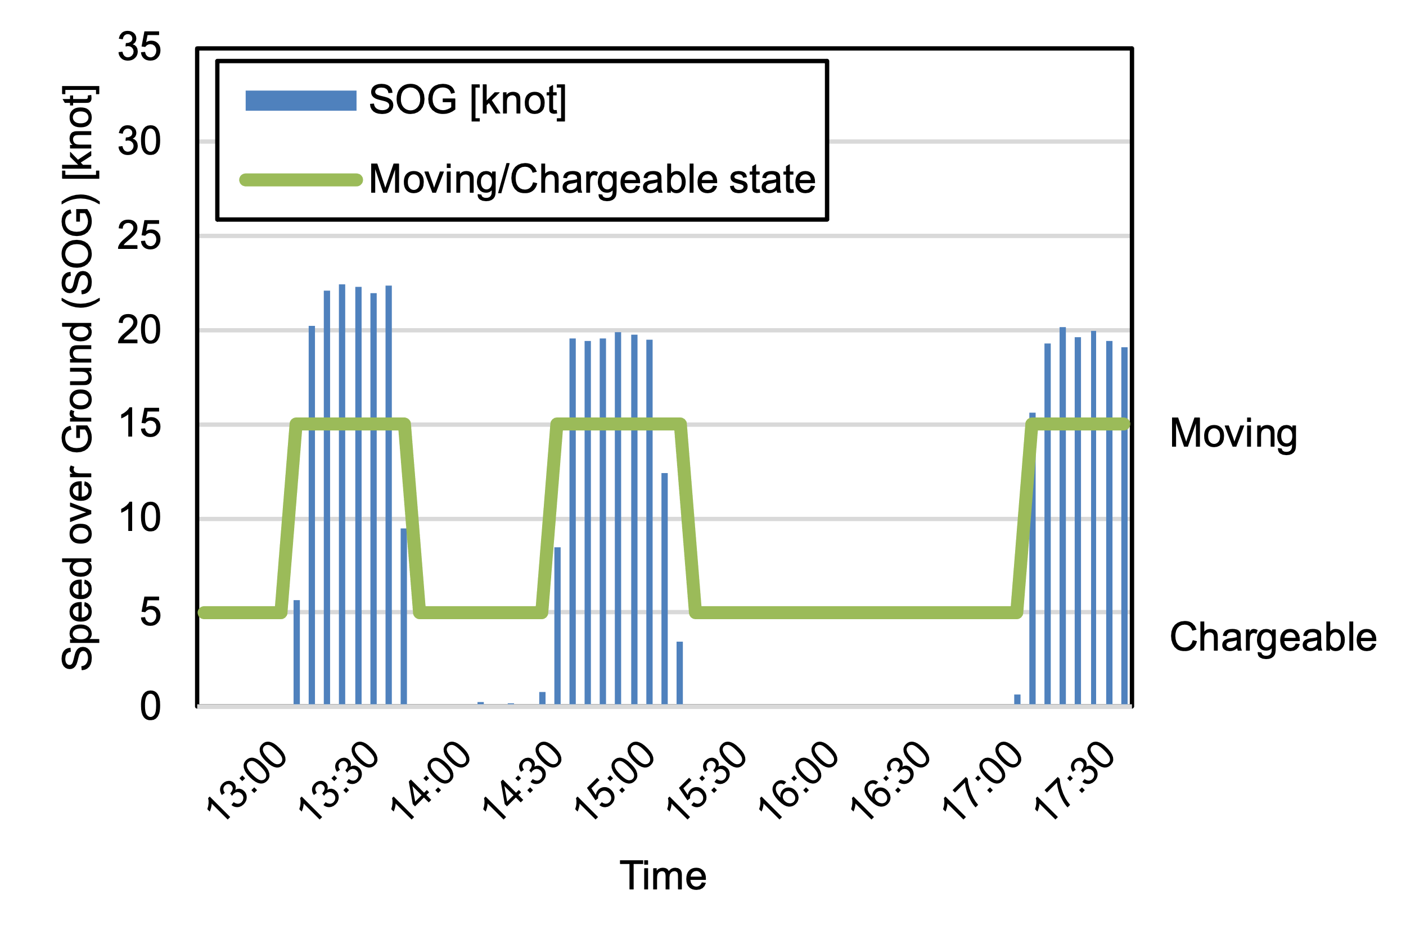
(a)
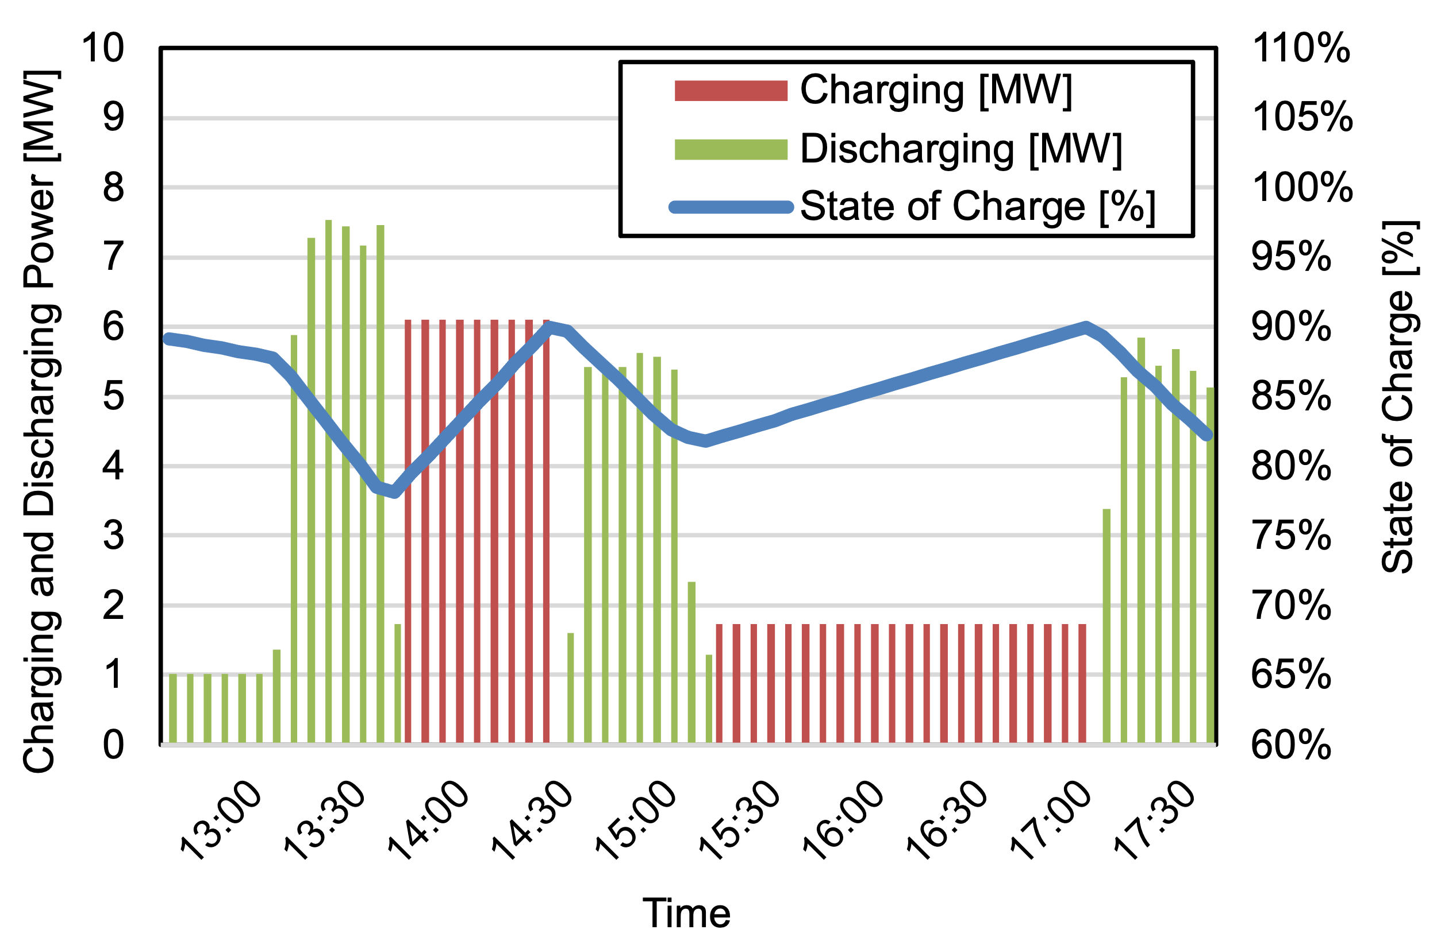
(b)
Supplementary Figure 38. Illustrative Passenger Ship: (a) Speed over Ground (SOG) and Moving/Chargeable State, (b) Battery Charging, Discharging, and SOC

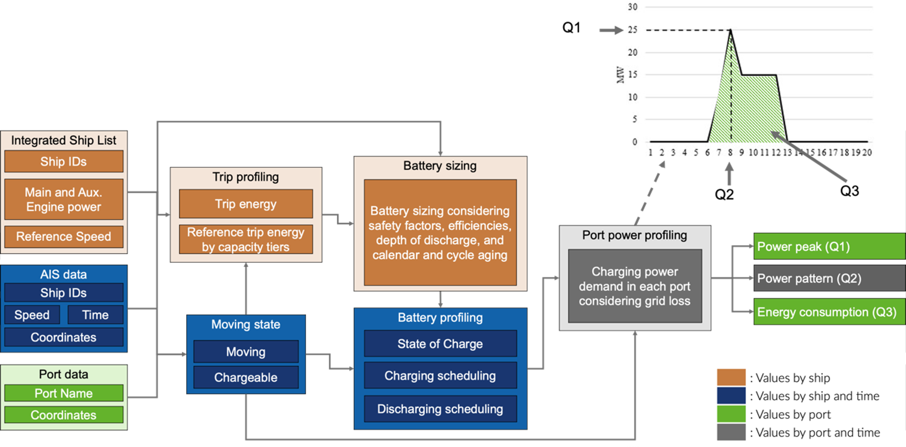
Q1 (far right) will answer how much maximum power will be needed by the port.
Q2 will answer when and how often power will be required during the year.
Q3 will answer how much energy will be required for BESs during the year.
Supplementary Figure 39. Conceptual Framework for Estimating BES Grid Charging Requirements

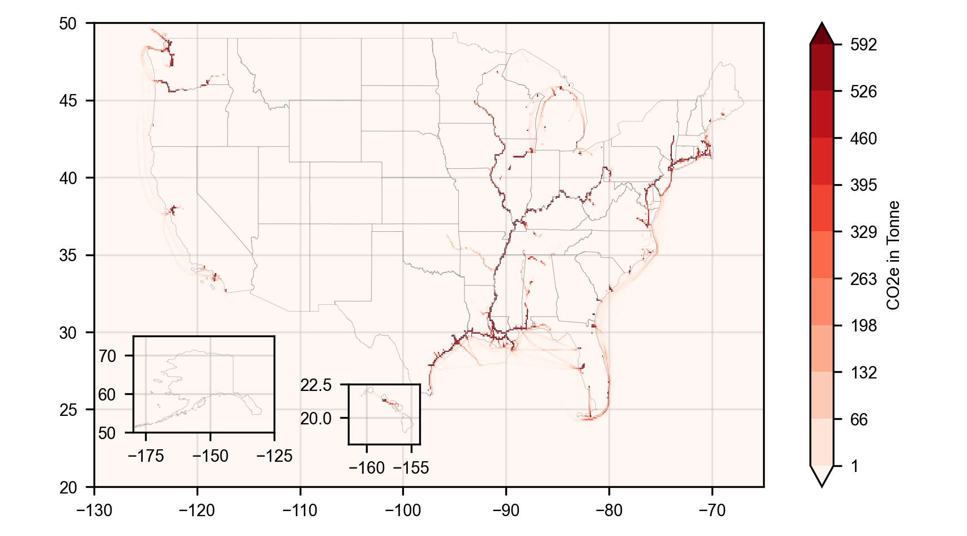
Supplementary Figure 40. CO₂e Emissions from ICE Ships in the AIS Analyzed Subset

Supplementary References
1. U.S. Coast Guard. Annual Vessel Statistics. U.S. Coast Guard https://www.dco.uscg.mil/Our-Organization/Assistant-Commandant-for-Prevention-Policy-CG-5P/Commercial-Regulations-Standards-CG-5PS/Office-of-Standards-Evaluation-and-Development-CG-REG/Annual-Vessel-Statistics/ (2021).
2. U.S. Army Corps of Engineers. Vessel Company Summary and Vessel Characteristics in 2020. U.S. Army Corps of Engineers https://usace.contentdm.oclc.org/utils/getfile/collection/p16021coll2/id/7440 (2021).
3. IHS Markit. Lloyd’s Register of Ships. https://www.spglobal.com/marketintelligence/en/mi/products/maritime-ships-register.html (2021).
4. Bureau of Ocean Energy Management & National Oceanic and Atmospheric Administration. Vessel Traffic Data in 2021. https://marinecadastre.gov/ais/ (2022).
5. Federal Communications Commission. Maritime Mobile Service Identities - MMSI. Federal Communications Commission https://www.fcc.gov/wireless/bureau-divisions/mobility-division/maritime-mobile/ship-radio-stations/maritime-mobile (2022).
6. U.S. Department of Transportation. 50th Anniversary Edition of the National Transportation Statistics. https://www.bts.gov/sites/bts.dot.gov/files/2021-12/NTS-50th-complete-11-30-2021.pdf (2021).
7. International Maritime Organization. Fourth IMO GHG Study 2020. https://www.imo.org/en/OurWork/Environment/Pages/Fourth-IMO-Greenhouse-Gas-Study-2020.aspx (2020).
8. Eastern Research Group, Inc. Category 1 and 2 Commercial Marine Vessel 2020 Emissions Inventory. https://gaftp.epa.gov/air/nei/2020/doc/supporting_data/nonpoint/CMV/2020NEI_C1C2_Documentation.pdf (2022).
9. Johansson, L., Jalkanen, J.-P. & Kukkonen, J. Global assessment of shipping emissions in 2015 on a high spatial and temporal resolution. Atmospheric Environment 167, 403–415 (2017).
10. Weng, J., Shi, K., Gan, X., Li, G. & Huang, Z. Ship emission estimation with high spatial-temporal resolution in the Yangtze River estuary using AIS data. Journal of Cleaner Production 248, 119297 (2020).
11. Olmer, N., Comer, B., Roy, B., Mao, X. & Rutherford, D. Greenhouse gas emissions from global shipping, 2013–2015. (2017).
12. European Maritime Safety Agency. Study on Electrical Energy Storage for Ships. https://www.emsa.europa.eu/publications/item/3895-study-on-electrical-energy-storage-for-ships.html (2020).
13. Hansen, S. MF Ampere, An Ocean of Opportunities. Corvus Energy https://corvusenergy.com/an-ocean-of-opportunities/ (2016).
14. U.S. Environmental Protection Agency. Proposal to Designate an Emission Control Area for Nitrogen Oxides, Sulphur Oxides and Particulate Matter: Technical Support Document. https://nepis.epa.gov/Exe/ZyNET.exe/P10081MU.TXT?ZyActionD=ZyDocument&Client=EPA&Index=2006+Thru+2010&Docs=&Query=&Time=&EndTime=&SearchMethod=1&TocRestrict=n&Toc=&TocEntry=&QField=&QFieldYear=&QFieldMonth=&QFieldDay=&IntQFieldOp=0&ExtQFieldOp=0&XmlQuery=&File=D%3A%5Czyfiles%5CIndex%20Data%5C06thru10%5CTxt%5C00000019%5CP10081MU.txt&User=ANONYMOUS&Password=anonymous&SortMethod=h%7C-&MaximumDocuments=1&FuzzyDegree=0&ImageQuality=r75g8/r75g8/x150y150g16/i425&Display=hpfr&DefSeekPage=x&SearchBack=ZyActionL&Back=ZyActionS&BackDesc=Results%20page&MaximumPages=1&ZyEntry=1&SeekPage=x&ZyPURL (2009).
15. Barré, A. et al. A review on lithium-ion battery ageing mechanisms and estimations for automotive applications. Journal of Power Sources 241, 680–689 (2013).
16. Pelletier, S., Jabali, O., Laporte, G. & Veneroni, M. Battery degradation and behaviour for electric vehicles: Review and numerical analyses of several models. Transportation Research Part B: Methodological 103, 158–187 (2017).
17. ten Cate Hoedemaker, S. An assessment of the relationship between battery size, charging strategy and battery lifetime. (2017).
18. Intergovernmental Panel On Climate Change. Climate Change 2021 – The Physical Science Basis: Working Group I Contribution to the Sixth Assessment Report of the Intergovernmental Panel on Climate Change. (Cambridge University Press, 2023). doi:10.1017/9781009157896.
19. U.S. Environmental Protection Agency. Nonroad Diesel Fuel Standards. https://www.epa.gov/diesel-fuel-standards/diesel-fuel-standards-and-rulemakings (2022).
20. Wang, M. et al. Summary of Expansions and Updates in GREET® 2021. https://www.osti.gov/biblio/1824336 (2021) doi:10.2172/1824336.
21. California Air Resources Board. CHC Fact Sheet: Tugboats (Towing Vessels). https://ww2.arb.ca.gov/resources/fact-sheets/chc-fact-sheet-tugboats-towing-vessels (2021).
22. Gagnon, P., Frazier, W., Cole, W. & Hale, E. Cambium Documentation: Version 2021. Renewable Energy (2021).
23. Gohlke, D., Zhou, Y., Wu, X. & Courtney, C. Assessment of Light-Duty Plug-in Electric Vehicles in the United States, 2010 – 2021. https://www.osti.gov/biblio/1898424 (2022) doi:10.2172/1898424.
24. Sathre, R., Scown, C. D., Kavvada, O. & Hendrickson, T. P. Energy and climate effects of second-life use of electric vehicle batteries in California through 2050. Journal of Power Sources 288, 82–91 (2015).
25. U.S. Environmental Protection Agency. Report on the Social Cost of Greenhouse Gases: Estimates Incorporating Recent Scientific Advances. U.S. Environmental Protection Agency https://cfpub.epa.gov/si/si_public_record_report.cfm?Lab=NCEE&dirEntryId=356357 (2022).
26. Goodkind, A. L., Tessum, C. W., Coggins, J. S., Hill, J. D. & Marshall, J. D. Fine-scale damage estimates of particulate matter air pollution reveal opportunities for location-specific mitigation of emissions. Proceedings of the National Academy of Sciences 116, 8775–8780 (2019).
27. Kersey, J., Popovich, N. D. & Phadke, A. A. Rapid battery cost declines accelerate the prospects of all-electric interregional container shipping. Nat Energy 7, 664–674 (2022).
28. U.S. Energy Information Administration. Annual Energy Outlook 2022.
29. Shahjalal, M. et al. A review on second-life of Li-ion batteries: prospects, challenges, and issues. Energy 241, 122881 (2022).
30. Martinez-Laserna, E. et al. Battery second life: Hype, hope or reality? A critical review of the state of the art. Renewable and Sustainable Energy Reviews 93, 701–718 (2018).
31. National Renewable Energy Laboratory. 2022 Annual Technology Baseline.
32. Comer, B. Transitioning away from heavy fuel oil in Arctic shipping. (2019).
33. MAN Energy Solutions. Batteries on Board Ocean-Going Vessels. https://www.man-es.com/docs/default-source/marine/tools/batteries-on-board-ocean-going-vessels.pdf (2020).
34. Katalenich, S. M. & Jacobson, M. Z. Toward battery electric and hydrogen fuel cell military vehicles for land, air, and sea. Energy 254, 124355 (2022).
35. Dai, Q., Kelly, J. C., Gaines, L. & Wang, M. Life Cycle Analysis of Lithium-Ion Batteries for Automotive Applications. Batteries 5, 48 (2019).
36. Ghimire, P., Zadeh, M., Thorstensen, J. & Pedersen, E. Data-Driven Efficiency Modeling and Analysis of All-Electric Ship Powertrain: A Comparison of Power System Architectures. IEEE Transactions on Transportation Electrification 8, 1930–1943 (2022).
37. Popovich, N. D., Rajagopal, D., Tasar, E. & Phadke, A. Economic, environmental and grid-resilience benefits of converting diesel trains to battery-electric. Nat Energy 6, 1017–1025 (2021).
38. Gordon, O. Lithium-ion Battery Pack Prices Rise for First Time to an Average of $151/kWh. BloombergNEF https://about.bnef.com/blog/lithium-ion-battery-pack-prices-rise-for-first-time-to-an-average-of-151-kwh/ (2022).
39. Zhang, Y., Sun, L., Fan, T., Ma, F. & Xiong, Y. Speed and energy optimization method for the inland all-electric ship in battery-swapping mode. Ocean Engineering 284, 115234 (2023).
40. U.S. Environmental Protection Agency. Shore Power Technology Assessment at U.S. Ports. https://www.epa.gov/ports-initiative/shore-power-technology-assessment-us-ports (2022).
41. U.S. Department of Transportation. Principal Ports. U.S. Department of Transportation https://data-usdot.opendata.arcgis.com/datasets/usdot::principal-ports/about (2022).
42. U.S. Army Corps of Engineers. Principal Ports of the United States. Waterborne tonnage for principal U.S. ports and all 50 states and U.S. territories. U.S. Army Corps of Engineers https://usace.contentdm.oclc.org/digital/collection/p16021coll2/id/7447 (2023).

Some ships experienced MMSI changes during the selected year.

