Supplementary material
Our data showed that there was a correlation between HPV16, HPV18, HPV33 and HPV58 and high-grade squamous intraepithelial lesions of the cervix or cervical cancer, whereas there was an insignificant correlation between HPV6, HPV11, HPV31, HPV35, HPV39, HPV42, HPV43, HPV44, HPV45, HPV51, HPV52, HPV53, HPV56, HPV59, HPV66, HPV68, and high-grade squamous intraepithelial lesions of the cervix or cervical cancer, although there was a certain correlation between the above HPV infections and age as well.

1、HPV6 vs. AGE
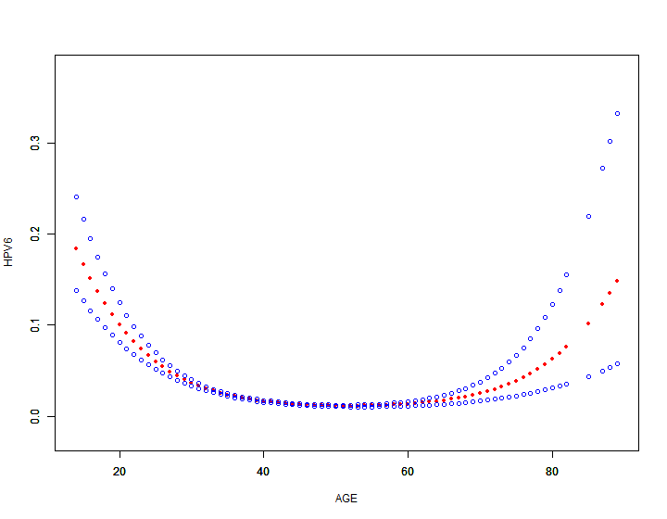
2、HPV11 vs. AGE
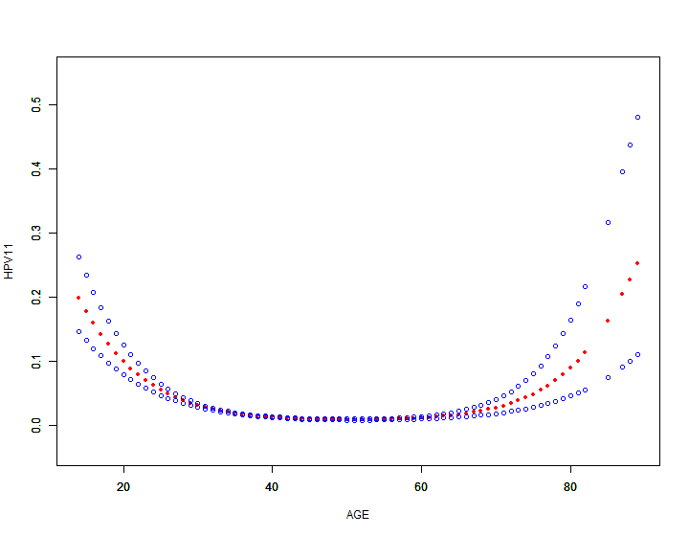
3、HPV31 vs. AGE
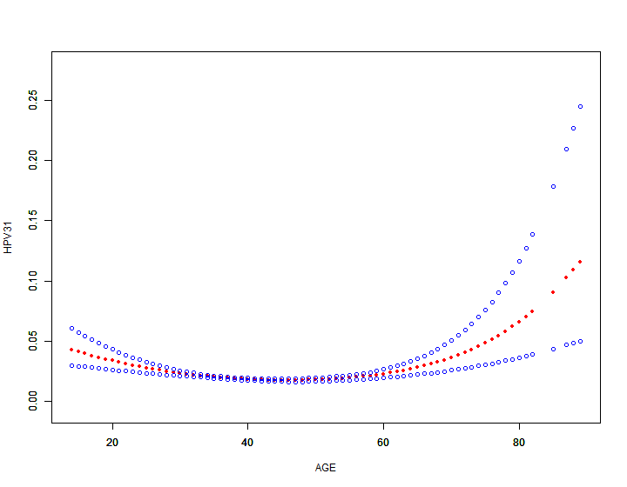
4、HPV35 vs. AGE
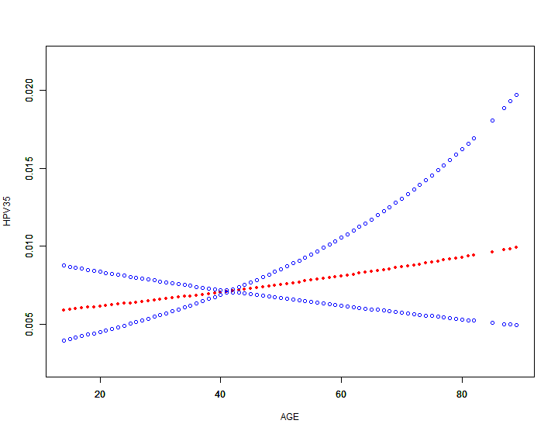
5、HPV39 vs. AGE
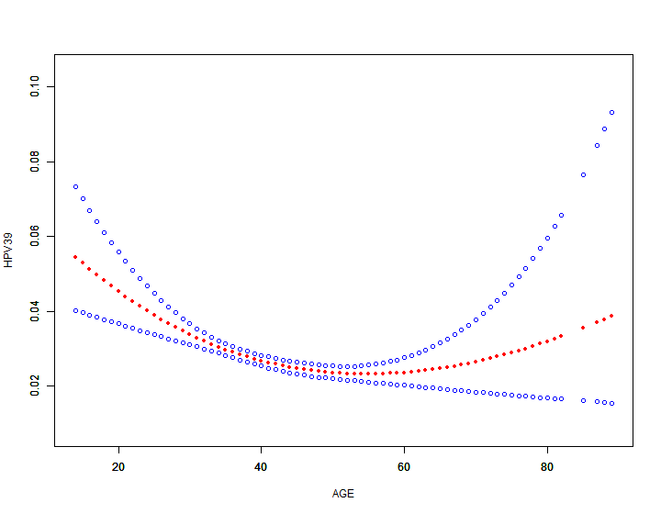
6、HPV42 vs. AGE
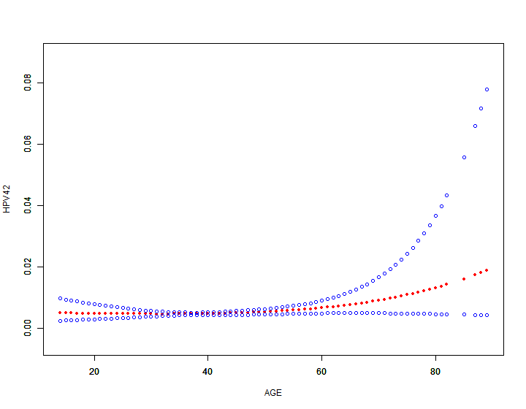
7、HPV43 vs. AGE
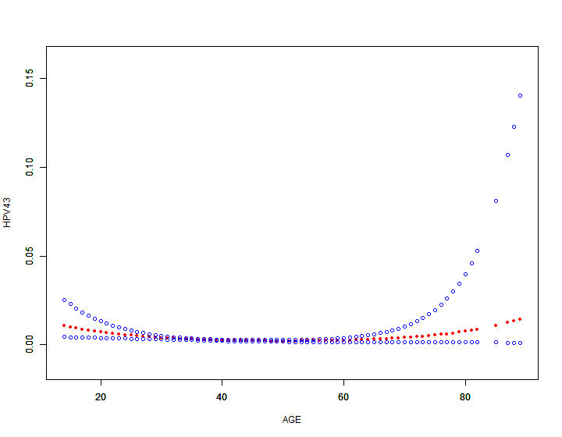
8、HPV44 vs. AGE
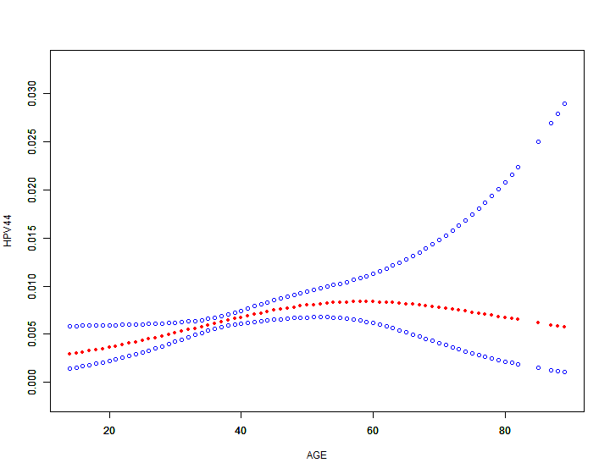
9、HPV45 vs. AGE
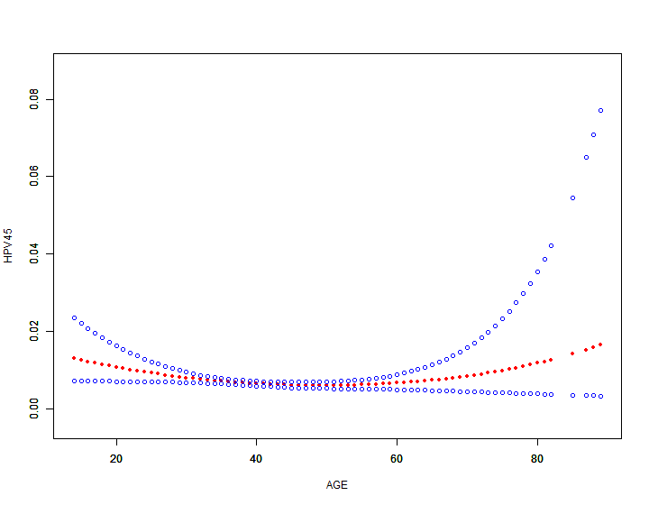
10、HPV51 vs. AGE
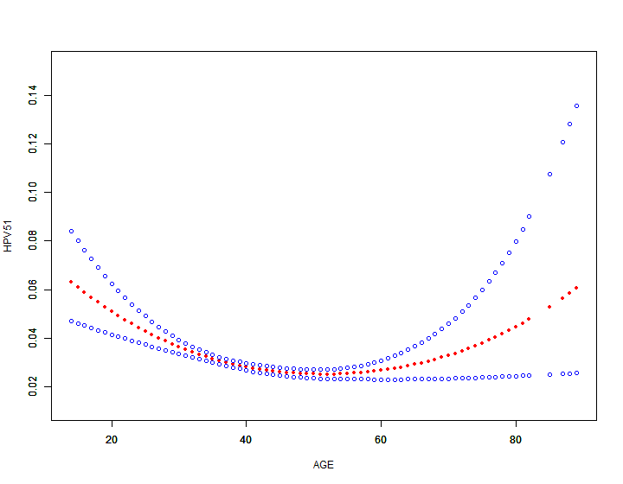
11、HPV52 vs. AGE
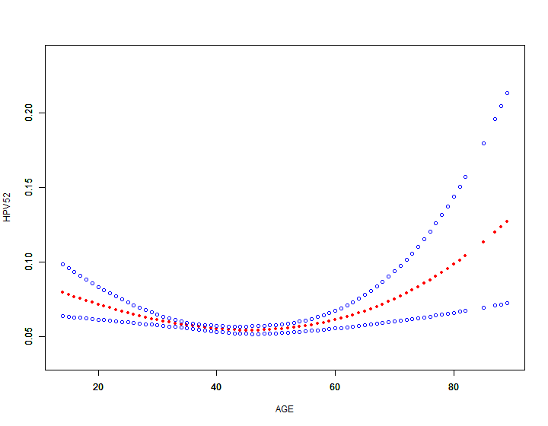
12、HPV53 vs. AGE
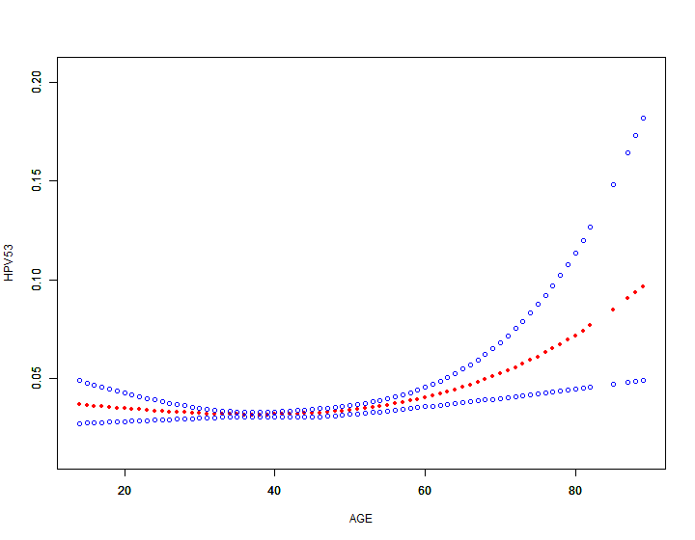
13、HPV56 vs. AGE
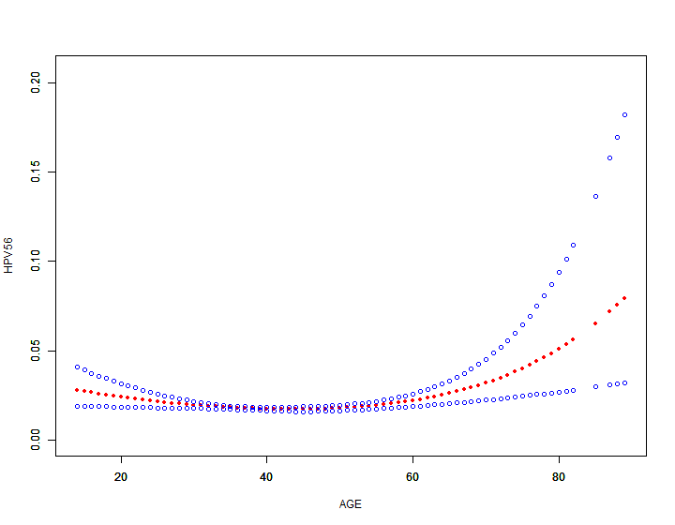
14、HPV59 vs. AGE
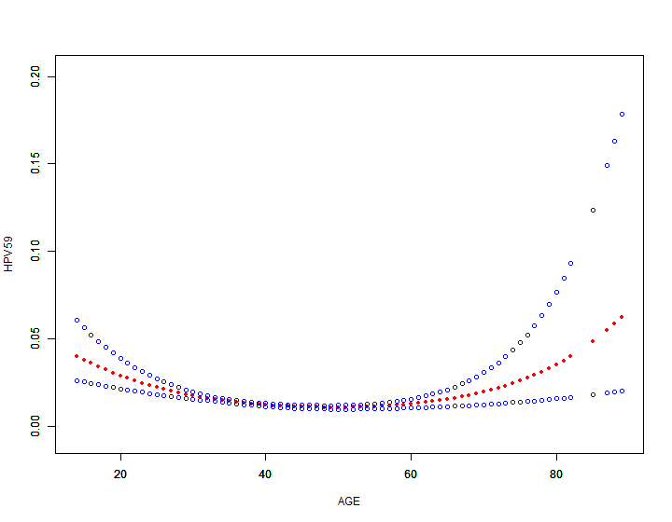
15、HPV66 vs. AGE
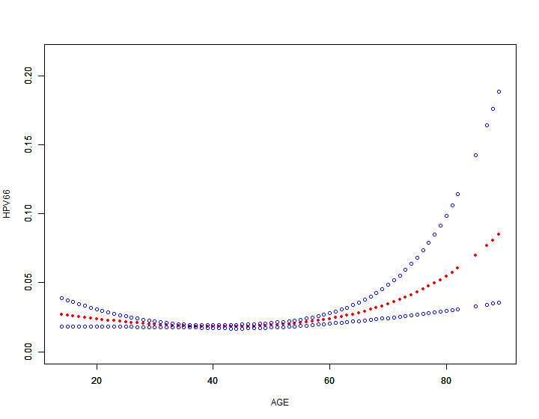
16、HPV68 vs. AGE
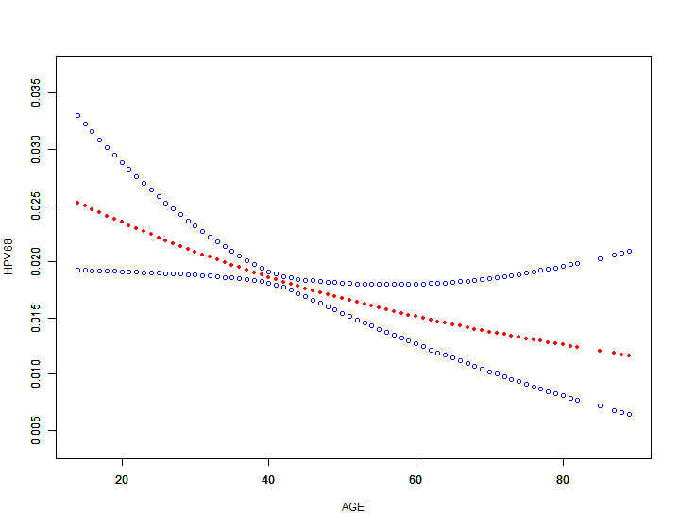
Fig. 2 1:Threshold nonlinear association between HPV6 and age observed in a generalized additive model (GAM). The red dashed line represents a smooth curve fit between the variables. The blue band represents the 95% confidence interval of the fit; 39 is its inflection point (K). 2: A similar curve was found between HPV11 and age, where 30 was identified as the inflection point (K). :3 similar curve was found between HPV31 and age, where 46 was identified as the inflection point (K). 4: A linear relationship between HPV35 infection and age, with no inflection point. 5: A similar curve was found between HPV39 and age, where 27 was identified as the inflection point (K).6: A similar curve was found between HPV42 and age, where 34 was identified as the inflection point (K).7: A similar curve was found between HPV43 and age, where 26 was identified as the inflection point (K).8: A similar curve was found between HPV44 and age, where 49 was identified as the inflection point (K).9: A similar curve was found between HPV45 and age, where 26 was identified as the inflection point (K).10: A similar curve was found between HPV51 and age, where 32 was identified as the inflection point (K).11: A similar curve was found between HPV52 and age, where 36 was identified as the inflection point (K).12: A similar curve was found between HPV53 and age, where 42 was identified as the inflection point (K).13: A similar curve was found between HPV56 and age, where 31 was identified as the inflection point (K).14: A similar curve was found between HPV59 and age, where 31 was identified as the inflection point (K).15: A similar curve was found between HPV66 and age, where 26 was identified as the inflection point (K).16: A linear relationship between HPV68 infection and age, with no inflection point.
Generalize additive modelsOutcome: HPV6
Exposure: AGE
Linear terms effect
 | Estimate | Std. Error | z value | Pr(>|z|) | exp(est) | 95%CI low | 95%CI upp
(Intercept) | -4.0593 | 0.0568 | -71.4217 | 0 | 0.0173 | 0.0154 | 0.0193
Approximate significance of smooth terms
 | edf | Ref.df | Chi.sq | p-value
s(AGE) | 1.9858 | 1.9998 | 196.6525 | 0
Model statistics
N: | 20648
Adj. r-square: | 0.013
Deviance explained: | 0.0442
UBRE score (sp.criterion): | -0.8101
Scale estimate: | 1
family: | binomial
link function: | logit
Outcome: HPV11
Exposure: AGE
Linear terms effect
 | Estimate | Std. Error | z value | Pr(>|z|) | exp(est) | 95%CI low | 95%CI upp
(Intercept) | -4.3017 | 0.0643 | -66.9495 | 0 | 0.0135 | 0.0119 | 0.0154
Approximate significance of smooth terms
 | edf | Ref.df | Chi.sq | p-value
s(AGE) | 1.9823 | 1.9997 | 208.9721 | 0
Model statistics
N: | 20648
Adj. r-square: | 0.0186
Deviance explained: | 0.0544
UBRE score (sp.criterion): | -0.8391
Scale estimate: | 1
family: | binomial
link function: | logit

Outcome: HPV31
Exposure: AGE
Linear terms effect
 | Estimate | Std. Error | z value | Pr(>|z|) | exp(est) | 95%CI low | 95%CI upp
(Intercept) | -3.8656 | 0.0494 | -78.2875 | 0 | 0.021 | 0.019 | 0.0231
Approximate significance of smooth terms
 | edf | Ref.df | Chi.sq | p-value
s(AGE) | 1.9453 | 1.997 | 20.8995 | 0
Model statistics
N: | 20648
Adj. r-square: | 8e-04
Deviance explained: | 0.0047
UBRE score (sp.criterion): | -0.7978
Scale estimate: | 1
family: | binomial
link function: | logit
Outcome: HPV35
Exposure: AGE
Linear terms effect
 | Estimate | Std. Error | z value | Pr(>|z|) | exp(est) | 95%CI low | 95%CI upp
(Intercept) | -4.9407 | 0.083 | -59.5186 | 0 | 0.0071 | 0.0061 | 0.0084
Approximate significance of smooth terms
 | edf | Ref.df | Chi.sq | p-value
s(AGE) | 1.0064 | 1.0129 | 0.8717 | 0.3513
Model statistics
N: | 20648
Adj. r-square: | 0
Deviance explained: | 5e-04
UBRE score (sp.criterion): | -0.9153
Scale estimate: | 1
family: | binomial
link function: | logit
Outcome: HPV39
Exposure: AGE
Linear terms effect
 | Estimate | Std. Error | z value | Pr(>|z|) | exp(est) | 95%CI low | 95%CI upp
(Intercept) | -3.5647 | 0.0428 | -83.2645 | 0 | 0.0283 | 0.026 | 0.0308
Approximate significance of smooth terms
 | edf | Ref.df | Chi.sq | p-value
s(AGE) | 1.8293 | 1.9709 | 22.9479 | 1e-04
Model statistics
N: | 20648
Adj. r-square: | 0.0011
Deviance explained: | 0.004
UBRE score (sp.criterion): | -0.7457
Scale estimate: | 1
family: | binomial
link function: | logit
Outcome: HPV42
Exposure: AGE
Linear terms effect
 | Estimate | Std. Error | z value | Pr(>|z|) | exp(est) | 95%CI low | 95%CI upp
(Intercept) | -5.2676 | 0.0977 | -53.8979 | 0 | 0.0052 | 0.0043 | 0.0062
Approximate significance of smooth terms
 | edf | Ref.df | Chi.sq | p-value
s(AGE) | 1.5463 | 1.7941 | 2.2196 | 0.1931
Model statistics
N: | 20648
Adj. r-square: | 1e-04
Deviance explained: | 0.0028
UBRE score (sp.criterion): | -0.9351
Scale estimate: | 1
family: | binomial
link function: | logit
Outcome: HPV43
Exposure: AGE
Linear terms effect
 | Estimate | Std. Error | z value | Pr(>|z|) | exp(est) | 95%CI low | 95%CI upp
(Intercept) | -5.889 | 0.1346 | -43.7511 | 0 | 0.0028 | 0.0021 | 0.0036
Approximate significance of smooth terms
 | edf | Ref.df | Chi.sq | p-value
s(AGE) | 1.808 | 1.9631 | 9.3746 | 0.0178
Model statistics
N: | 20648
Adj. r-square: | 7e-04
Deviance explained: | 0.0106
UBRE score (sp.criterion): | -0.9604
Scale estimate: | 1
family: | binomial
link function: | logit
Outcome: HPV44
Exposure: AGE
Linear terms effect
 | Estimate | Std. Error | z value | Pr(>|z|) | exp(est) | 95%CI low | 95%CI upp
(Intercept) | -5.0533 | 0.0885 | -57.0798 | 0 | 0.0064 | 0.0054 | 0.0076
Approximate significance of smooth terms
 | edf | Ref.df | Chi.sq | p-value
s(AGE) | 1.6203 | 1.8558 | 6.9268 | 0.0591
Model statistics
N: | 20648
Adj. r-square: | 3e-04
Deviance explained: | 0.0042
UBRE score (sp.criterion): | -0.9218
Scale estimate: | 1
family: | binomial
link function: | logit
Outcome: HPV45
Exposure: AGE
Linear terms effect
 | Estimate | Std. Error | z value | Pr(>|z|) | exp(est) | 95%CI low | 95%CI upp
(Intercept) | -4.9766 | 0.0846 | -58.791 | 0 | 0.0069 | 0.0058 | 0.0081
Approximate significance of smooth terms
 | edf | Ref.df | Chi.sq | p-value
s(AGE) | 1.7281 | 1.9261 | 4.8916 | 0.1272
Model statistics
N: | 20648
Adj. r-square: | 2e-04
Deviance explained: | 0.0029
UBRE score (sp.criterion): | -0.9173
Scale estimate: | 1
family: | binomial
link function: | logit
Outcome: HPV51
Exposure: AGE
Linear terms effect
 | Estimate | Std. Error | z value | Pr(>|z|) | exp(est) | 95%CI low | 95%CI upp
(Intercept) | -3.487 | 0.0413 | -84.4575 | 0 | 0.0306 | 0.0282 | 0.0332
Approximate significance of smooth terms
 | edf | Ref.df | Chi.sq | p-value
s(AGE) | 1.9049 | 1.991 | 26.6339 | 0
Model statistics
N: | 20648
Adj. r-square: | 0.0015
Deviance explained: | 0.0045
UBRE score (sp.criterion): | -0.7302
Scale estimate: | 1
family: | binomial
link function: | logit
Outcome: HPV52
Exposure: AGE
Linear terms effect
 | Estimate | Std. Error | z value | Pr(>|z|) | exp(est) | 95%CI low | 95%CI upp
(Intercept) | -2.7868 | 0.0298 | -93.5213 | 0 | 0.0616 | 0.0581 | 0.0653
Approximate significance of smooth terms
 | edf | Ref.df | Chi.sq | p-value
s(AGE) | 1.9105 | 1.992 | 9.816 | 0.0081
Model statistics
N: | 20648
Adj. r-square: | 4e-04
Deviance explained: | 0.0011
UBRE score (sp.criterion): | -0.5562
Scale estimate: | 1
family: | binomial
link function: | logit
Outcome: HPV53
Exposure: AGE
Linear terms effect
 | Estimate | Std. Error | z value | Pr(>|z|) | exp(est) | 95%CI low | 95%CI upp
(Intercept) | -3.3624 | 0.0387 | -86.7734 | 0 | 0.0347 | 0.0321 | 0.0374
Approximate significance of smooth terms
 | edf | Ref.df | Chi.sq | p-value
s(AGE) | 1.8329 | 1.9721 | 8.8707 | 0.0076
Model statistics
N: | 20648
Adj. r-square: | 3e-04
Deviance explained: | 0.0017
UBRE score (sp.criterion): | -0.7057
Scale estimate: | 1
family: | binomial
link function: | logit
Outcome: HPV56
Exposure: AGE
Linear terms effect
 | Estimate | Std. Error | z value | Pr(>|z|) | exp(est) | 95%CI low | 95%CI upp
(Intercept) | -3.9533 | 0.0513 | -77.0251 | 0 | 0.0192 | 0.0174 | 0.0212
Approximate significance of smooth terms
 | edf | Ref.df | Chi.sq | p-value
s(AGE) | 1.8926 | 1.9885 | 9.132 | 0.0085
Model statistics
N: | 20648
Adj. r-square: | 3e-04
Deviance explained: | 0.0025
UBRE score (sp.criterion): | -0.8121
Scale estimate: | 1
family: | binomial
link function: | logit
Outcome: HPV59
Exposure: AGE
Linear terms effect
 | Estimate | Std. Error | z value | Pr(>|z|) | exp(est) | 95%CI low | 95%CI upp
(Intercept) | -4.3024 | 0.0614 | -70.1135 | 0 | 0.0135 | 0.012 | 0.0153
Approximate significance of smooth terms
 | edf | Ref.df | Chi.sq | p-value
s(AGE) | 1.9368 | 1.996 | 24.9736 | 0
Model statistics
N: | 20648
Adj. r-square: | 0.0014
Deviance explained: | 0.0077
UBRE score (sp.criterion): | -0.8552
Scale estimate: | 1
family: | binomial
link function: | logit

Outcome: HPV66
Exposure: AGE
Linear terms effect
 | Estimate | Std. Error | z value | Pr(>|z|) | exp(est) | 95%CI low | 95%CI upp
(Intercept) | -3.9127 | 0.0503 | -77.7354 | 0 | 0.02 | 0.0181 | 0.0221
Approximate significance of smooth terms
 | edf | Ref.df | Chi.sq | p-value
s(AGE) | 1.8854 | 1.9869 | 9.7348 | 0.0057
Model statistics
N: | 20648
Adj. r-square: | 3e-04
Deviance explained: | 0.0026
UBRE score (sp.criterion): | -0.806
Scale estimate: | 1
family: | binomial
link function: | logit
Outcome: HPV68
Exposure: AGE
Linear terms effect
 | Estimate | Std. Error | z value | Pr(>|z|) | exp(est) | 95%CI low | 95%CI upp
(Intercept) | -3.9839 | 0.0522 | -76.3912 | 0 | 0.0186 | 0.0168 | 0.0206
Approximate significance of smooth terms
 | edf | Ref.df | Chi.sq | p-value
s(AGE) | 1.0959 | 1.1827 | 5.9332 | 0.026
Model statistics
N: | 20648
Adj. r-square: | 2e-04
Deviance explained: | 0.0015
UBRE score (sp.criterion): | -0.8166
Scale estimate: | 1
family: | binomial
link function: | logit
This table was generated using the Empowerstats software (www.empowerstats.com) and the R software.

Table 5: Association between other types of HPV infection and age analyzed by threshold effect.
For exposure: AGE
Outcome: | HPV6 | HPV11 | HPV31 | HPV35 | HPV39 | HPV42 | HPV43 | HPV44 | HPV45
Model I
A linear inflection | 0.9 (0.9, 1.0) <0.001 | 0.9 (0.9, 1.0) <0.001 | 1.0 (1.0, 1.0) 0.450 | 1.0 (1.0, 1.0) 0.348 | 1.0 (1.0, 1.0) <0.001 | 1.0 (1.0, 1.0) 0.173 | 1.0 (1.0, 1.0) 0.068 | 1.0 (1.0, 1.0) 0.029 | 1.0 (1.0, 1.0) 0.236
Model II
Inflection point (K) | 39 | 30 | 46 | 36 | 27 | 34 | 26 | 49 | 26
< K | 0.9 (0.9, 0.9) <0.001 | 0.8 (0.8, 0.8) <0.001 | 1.0 (1.0, 1.0) <0.001 | 1.0 (0.9, 1.0) 0.238 | 0.9 (0.8, 0.9) <0.001 | 0.9 (0.9, 1.0) 0.015 | 0.7 (0.6, 0.8) <0.001 | 1.0 (1.0, 1.1) 0.004 | 0.8 (0.7, 0.9) <0.001
> K | 1.0 (1.0, 1.0) 0.110 | 1.0 (1.0, 1.0) 0.299 | 1.0 (1.0, 1.1) <0.001 | 1.0 (1.0, 1.0) 0.077 | 1.0 (1.0, 1.0) 0.042 | 1.0 (1.0, 1.1) 0.004 | 1.0 (1.0, 1.0) 0.561 | 1.0 (0.9, 1.0) 0.273 | 1.0 (1.0, 1.0) 0.593
Difference between the effects of < K and > K | 1.1 (1.1, 1.2) <0.001 | 1.3 (1.2, 1.3) <0.001 | 1.1 (1.0, 1.1) <0.001 | 1.0 (1.0, 1.1) 0.128 | 1.1 (1.0, 1.2) <0.001 | 1.1 (1.0, 1.2) 0.005 | 1.4 (1.3, 1.6) <0.001 | 0.9 (0.9, 1.0) 0.044 | 1.3 (1.1, 1.4) <0.001
Predicted value of the equation at the folding point | -4.5 (-4.7, -4.4) | -4.3 (-4.5, -4.1) | -4.2 (-4.4, -4.0) | -5.1 (-5.4, -4.9) | -3.5 (-3.6, -3.3) | -5.7 (-6.0, -5.3) | -6.1 (-6.6, -5.6) | -4.7 (-5.0, -4.4) | -5.1 (-5.4, -4.8)
Log Likelihood Ratio Test | <0.001 | <0.001 | <0.001 | 0.135 | 0.002 | 0.007 | <0.001 | 0.036 | <0.001

Outcome: | HPV51 | HPV52 | HPV53 | HPV56 | HPV59 | HPV66 | HPV68
Model I
A linear inflection | 1.0 (1.0, 1.0) <0.001 | 1.0 (1.0, 1.0) 0.614 | 1.0 (1.0, 1.0) 0.037 | 1.0 (1.0, 1.0) 0.517 | 1.0 (1.0, 1.0) 0.004 | 1.0 (1.0, 1.0) 0.220 | 1.0 (1.0, 1.0) 0.019
Model II
Inflection point (K) | 32 | 36 | 42 | 31 | 31 | 26 | 36
< K | 0.9 (0.9, 0.9) <0.001 | 1.0 (1.0, 1.0) <0.001 | 1.0 (1.0, 1.0) 0.008 | 0.9 (0.9, 0.9) <0.001 | 0.9 (0.8, 0.9) <0.001 | 0.8 (0.8, 0.9) <0.001 | 1.0 (0.9, 1.0) 0.016
> K | 1.0 (1.0, 1.0) 0.374 | 1.0 (1.0, 1.0) 0.012 | 1.0 (1.0, 1.0) <0.001 | 1.0 (1.0, 1.0) <0.001 | 1.0 (1.0, 1.0) 0.542 | 1.0 (1.0, 1.0) 0.007 | 1.0 (1.0, 1.0) 0.769
Difference between the effects of < K and > K | 1.1 (1.1, 1.1) <0.001 | 1.0 (1.0, 1.1) <0.001 | 1.0 (1.0, 1.1) <0.001 | 1.1 (1.1, 1.2) <0.001 | 1.1 (1.1, 1.2) <0.001 | 1.2 (1.1, 1.3) <0.001 | 1.0 (1.0, 1.1) 0.091
Predicted value of the equation at the folding point | -3.6 (-3.8, -3.5) | -2.9 (-3.0, -2.8) | -3.6 (-3.7, -3.4) | -4.3 (-4.5, -4.1) | -4.5 (-4.7, -4.2) | -4.2 (-4.3, -4.0) | -4.0 (-4.2, -3.9)
Log Likelihood Ratio Test | <0.001 | <0.001 | <0.001 | <0.001 | <0.001 | <0.001 | 0.094
Data in table:β (95%CI) Pvalue / OR (95%CI) Pvalue
Outcome variables: HPV6; HPV11; HPV31; HPV35; HPV39; HPV42; HPV43; HPV44; HPV45; HPV51; HPV52; HPV53; HPV56; HPV59; HPV66; HPV68;
Exposure variable: AGE
Adjustment variable: None
This table was generated using the Empowerstats software (www.empowerstats.com) and the R software.

Smoothed curve fitting and threshold effect analysis revealed that HPV6、HPV11、HPV31、 HPV39、HPV42、HPV43、HPV44、HPV45、 HPV51、 HPV52、HPV53、 HPV56、 HPV59、 HPV66, had threshold ages (fold K) of 39 years (HPV6),30 years (HPV11), 46 years (HPV31), 27 years (HPV39),34 years (HPV42), 26 years (HPV43), 49 years(HPV44) and 26 years (HPV45),32years (HPV51),36 years (HPV52), 42 years (HPV53), 31 years (HPV56),31 years (HPV59), 26years (HPV66). This suggested that there was a non-linear relationship between the above HPV infection types and age Instead, there was a specific age below which the risk of HPV infection significantly decreases with increasing age. All p values were less than 0.05, indicating the high significance of this relationship. In contrast, there was a linear relationship between HPV35 and HPV68 infections and age, with no inflection point.

