Supplementary Information
Enabling cation-exchange-based sorbents for high-capacity and efficient moisture-swing direct air capture of CO₂
Xueru Wang ^{a, b}, Yan Chen ^{a,} ∗, Arne Lindbråthen ^{b}, Hang Xiao ^{c}, Xi Chen ^{c}, Liyuan Deng ^{b, *}
ª Laboratory for multiscale mechanics and medical science, SV LAB, School of Aerospace, Xi'an Jiaotong University, Xi'an 710049, China
^{b} Department of Chemical Engineering, Norwegian University of Science and Technology Trondheim, 7034, Norway
^{c} School of Interdisciplinary Studies, Lingnan University, Tuen Mun, Hong Kong, 0000, China

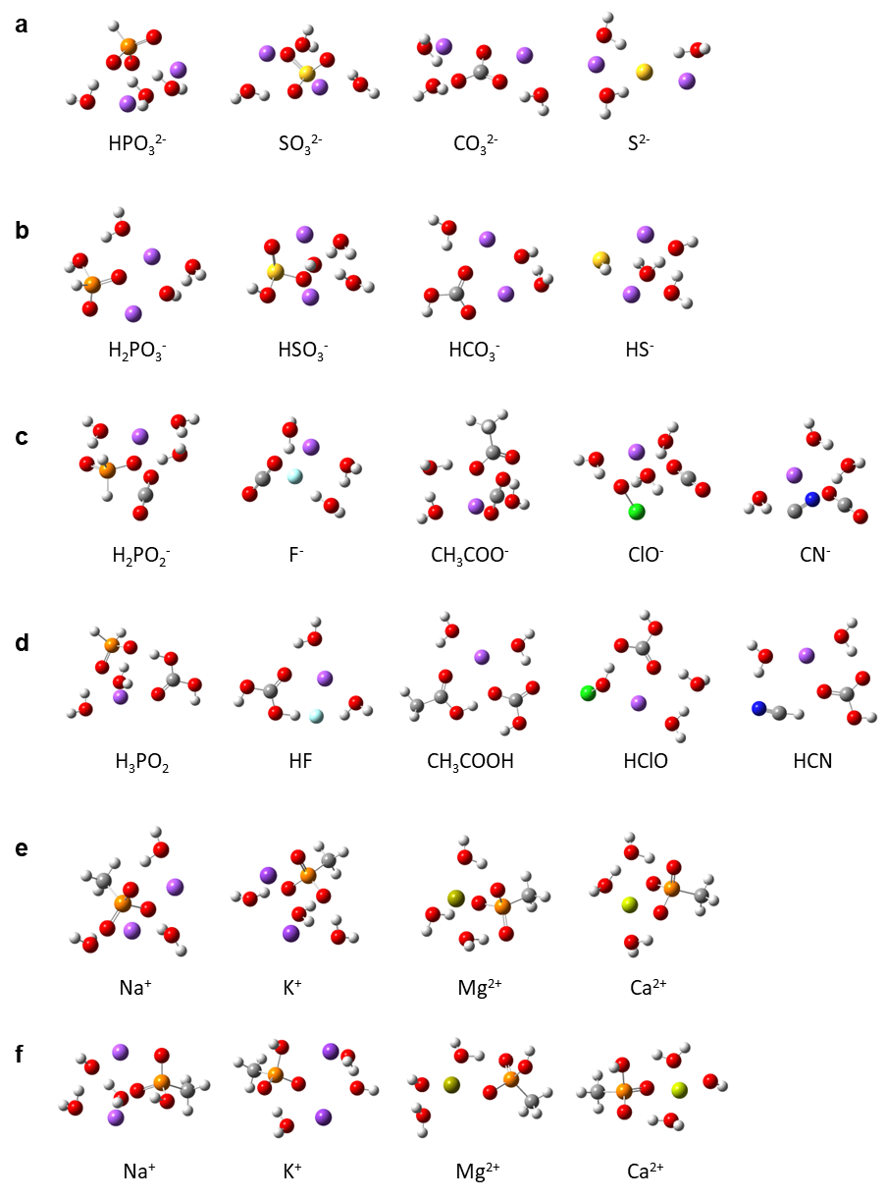
Supplementary Fig. 1 | The geometrical configurations of the reactants and products in the reversible hydrolysis reactions of fundamental ions investigated in this study. a–b Geometrical configurations for the reactants (a) and products (b) of the reversible hydrolysis reactions of divalent basic ions (HPO₃²⁻, SO₃²⁻. CO₃²⁻, and S²⁻) when the number of water molecules in reactants is three. Red, white, purple, orange, yellow, and gray balls represent O, H, Na, P, S, and C atoms respectively. c–d Geometrical configurations for the reactants (c) and products (d) of the reversible hydrolysis reactions of monovalent basic ions (H₂PO₂⁻, F⁻. CH3COO⁻, ClO⁻ and CN⁻) when the number of water molecules in reactants is three. Red, white, purple, orange, light blue, gray, green, and dark blue balls represent O, H, Na, P, F, C, Cl, and N atoms respectively. e–f Geometrical configurations for the reactants (e) and products (f) of the reversible hydrolysis reactions of CH₃PO₃²⁻ with K⁺. Na⁺, Mg²⁺, and Ca²⁺ when the number of water molecules in reactants is three. Red, white, gray, orange, light purple, dark purple, dark green, and light green balls represent O, H, C, P, Na, K, Mg, and Ca atoms respectively.
Supplementary Table 1 | Elemental contents of D201 AER and D402 CER rinsed with tap water for different times
 | D201 |  |  |  | D402
 | C (wt%) | N (wt%) | O (wt%) | Cl (wt%) | Na (wt%) | Ca (wt%) | Mg (wt%)
0 min | 90.62 | 1.68 | 0.82 | 5.38 | 5.16 | 6.11 | 0.10
1 min | 88.42 | 3.02 | 1.45 | 6.05 | 0.11 | 8.85 | 0.003
5 min | 87.79 | 3.39 | 3.01 | 4.28 | 0.01 | 10.79 | 0.03
10 min | 85.27 | 5.19 | 5.10 | 2.47 | 0.13 | 9.46 | 0.05
Overnight | 81.94 | 5.87 | 10.22 | 0.88 | 0.15 | 10.39 | 0.30

Supplementary Fig. 2 | CO₂ adsorption-desorption experimental system

Supplementary Note 1: Quantum chemical calculations
We conducted quantum chemical calculations to explore the effect of different cations on the CO₂ adsorption performance of CERs. Specifically, we focused on changes in the ΔG for reversible hydrolysis reactions of the D402 CER with various cations (Na⁺, K⁺, Mg²⁺, and Ca²⁺). Replacing the polymer substrate material with a methyl group can reduce computational costs¹, effectively simplifying the model while preserving the key characteristics of the resin's functional group. The computational model structures of the reactants and products corresponding to different cations are summarized in Supplementary Fig. 1e-f. The ΔG changes shown in Supplementary Fig. 3 reveal that CERs loaded with different cations can effectively regulate the transition of the ΔG from negative to positive, indicating their ability to control CO₂ adsorption and desorption via the manipulation of humidity. In particular, the ΔG of K⁺ changed from negative to positive when n increased from 1 to 2, requiring a lower n to achieve adsorption-desorption equilibrium. This finding indicates that the reversible hydrolysis reaction of K⁺ requires an extremely dry environment to be spontaneous and positive, which also explains the lowest CO₂ desorption performance of the K⁺-type CER. This finding is consistent with our experimental results.
Supplementary Fig. 3 | Changes of the ΔG of the reversible hydrolysis reactions of CH₃PO₃²⁻ with four cations under different humidity

Supplementary Note 2: Thermal behavior of resins
We investigated the thermal behavior of all resins used in this study using thermogravimetric analysis (TGA) (Supplementary Fig. 4). The TGA curves of the D201, ACD-100, D402, and D152 resins are shown in blue, purple, green, and orange solid lines, respectively. The results reveal pronounced weight loss for all the resins before the temperature reach 100 °C. This phenomenon can be attributed to the presence of hydrophilic functional groups -N⁺(CH₃)₃, -CH₂NHCH₂PO₃²⁻, -COO⁻, and -CH₂N(CH₂COO⁻)₂, that adsorb water molecules. For the D201 resin, previous research has revealed that the degradation of its functional group typically takes place around 200 °C; the release of carbonaceous substances occurs at approximately 350 °C^{2, 3}. Consequently, the 30–40% weight loss observed between 130–260 °C and between 330–460 °C can be attributed to the degradation of -N⁺(CH₃)₃ groups and carbonaceous species, respectively. For ACD-100 resin, there is a continuous and extremely heavy weight loss process (about 83.2%) when the temperature rises from 180 °C to 500 °C, which is mainly caused by the simultaneous degradation of the functional group (-CH₂N(CH₂COO⁻)₂) and benzyl.
In the case of the D402 CER, significant weight loss of approximately 50% occurred a temperature range of 340–460 °C. The -CH₂NHCH₂PO₃²⁻ grafted on the polymer typically degrades at 400 °C⁴. Considering the resin's ion exchange capacity and the relative molecular mass of each substance components (e.g., -CH₂NHCH₂PO₃²⁻, benzyl), it is possible to infer the mass proportion of each component. We concluded that the weight loss was primarily caused by the simultaneous degradation of the -CH₂NHCH₂PO₃²⁻ and benzyl. Given that the D152 CER is prepared based on an acrylic acid copolymer, its TGA curve closely aligns with the TGA results of polyacrylic acid reported in other studies^{5, 6}. The initial ~40% weight loss of the D152 CER occurs over the temperature range of 390–490 °C, which corresponds to the degradation of oxygen-containing groups. Furthermore, the carbonaceous materials of resins decomposed as the temperature continued to rise above 750℃, which triggered a second round of weight loss. Compared with the D201 AER, the two D402 and D152 CERs exhibited increased thermal stability, which rendered them more suitable for operation in high-temperature environments. The weight loss of each stage for the above resins as well as ACD-500 (green solid line) and D113 (orange solid line) resins is summarized in Supplementary Table 1.
Supplementary Fig. 4 | Thermal stabilities of D201, ACD-100, D402, ACD-500, D152, and D113 resins
Supplementary Table 1 | The decomposition temperature and weight loss during the thermogravimetric analysis of D201, ACD-100, D402, ACD-500, D152, and D113 resins
Sample | Temperature range  ($\text{∆T}\text{, ℃}$) | Weight loss  ($\text{∆W}\text{, \%}$) | Degradation
D201 | 25-100 | 8.8 | Water
D201 | 130-260 | 28.9 | Functional amine groups
D201 | 330-460 | 41.5 | Benzyl and carbon matrix
ACD-100 | 25-100 | 0.8 | Water
ACD-100 | 180-500 | 83.2 | Functional groups and benzyl
ACD-100 | 500-1100 | 2.4 | carbon matrix
D402 | 25-100 | 5.0 | Water
D402 | 340-460 | 46.9 | Functional groups and benzyl
D402 | 840-1100 | 27.3 | carbon matrix
ACD-500 | 25-100 | 6.4 | Water
ACD-500 | 180-470 | 39.6 | Functional groups and benzyl
ACD-500 | 880-1100 | 28.7 | carbon matrix
D152 | 25-100 | 6.4 | Water
D152 | 390-490 | 36.5 | Functional groups
D152 | 750-1100 | 44.3 | carbon matrix
D113 | 25-100 | 4.9 | Water
D113 | 190-470 | 57.2 | Functional groups and benzyl
D113 | 670-1100 | 21.9 | carbon matrix

Reference
1. Wang T, Ge K, Chen K, Hou C, Fang M. Theoretical studies on CO2 capture behavior of quaternary ammonium-based polymeric ionic liquids. Physical Chemistry Chemical Physics 18, 13084-13091 (2016).
2. Matsuda M, Funabashi K, Nishi T, Yusa H, Kikuchi M. Decomposition of ion exchange resins by pyrolysis. Nuclear Technology 75, 187-192 (1986).
3. Amphlett JT, Ogden MD, Foster RI, Syna N, Soldenhoff K, Sharrad CA. Polyamine functionalised ion exchange resins: Synthesis, characterisation and uranyl uptake. Chemical Engineering Journal 334, 1361-1370 (2018).
4. Galhoum AA, et al. Synthesis of polyaminophosphonic acid-functionalized poly (glycidyl methacrylate) for the efficient sorption of La (III) and Y (III). Chemical Engineering Journal 375, 121932 (2019).
5. Chen Y, Qi Y, Liu B. Polyacrylic acid functionalized nanographene as a nanocarrier for loading and controlled release of doxorubicin hydrochloride. Journal of Nanomaterials 2013, 16-16 (2013).
6. Tai Z, Yang J, Qi Y, Yan X, Xue Q. Synthesis of a graphene oxide–polyacrylic acid nanocomposite hydrogel and its swelling and electroresponsive properties. Rsc Advances 3, 12751-12757 (2013).

∗ Corresponding author. yanchen@xjtu.edu.cn (Y. Chen); Liyuan.Deng@ntnu.no (L. Deng)

