Supporting Information
Propeller Induced Complete Transformation of the Secondary Structure of a Dipeptide on Water Surface Controlled by Chiral Supramolecular Assembly
Sandip Biswas,^{1,#} Umesh,^{1,#} Bidisa Das,² Pradyot Koley,¹ Somobrata Acharya^{1,}* and Santanu Bhattacharya^{1,3,4,}*
¹School of Applied & Interdisciplinary Sciences (SAIS), Indian Association for the Cultivation of Science, Jadavpur, Kolkata–700032, India.
²Research institute of Sustainable Technology (RISE). TCG-CREST, Sector V, Salt lake, Kolkata -700091, India.
³Indian Institute of Science, Department of Organic Chemistry, Bangalore 560012, India.
⁴Department of Chemistry, Indian Institute of Science Education and Research, Tirupati 517619, India.
(# = contributed equally in this manuscript)
*Corresponding Authors: e-mails: camsa2@iacs.res.in; sb@iisc.ac.in

Experimental section: UV grade chloroform (spectrochem) was used without further purification for the optical characterizations and experiments on the water surface of a Langmuir-Blodgett (LB) trough. Freshly Milli-Q water (resistivity 18.2 MΩ-cm) was used for the experiments on water surface. Langmuir trough from Nima Technologies was used for all the experiments done on water surface. TPE-FF/Perylene-FF/ TPE-AA were dissolved in chloroform at a concentration of 1 mg mL⁻¹ from which 150 μL was spread on milli-Q water subphase and the barrier was compressed at a speed of 10 cm² min⁻¹ to record the surface pressure-area isotherms. All the depositions on mica and quartz substrates were done by LB deposition by using a dipper at a speed of 2 mm min⁻¹. Photoluminescence (PL) spectra were recorded using a Jobin Yvon NanoLog spectrophotometer. AFM imaging of the samples were performed with an Asylum Research MFP-3D AFM in tapping mode using AC160TS silicon probes, with nominal tip radii ˂10 nm. XRDs were measured using Rigaku smartLab diffractometer having Cu Kα radiation source (α = 0.15406 nm) operating at a voltage and current 60 kV and 60 mA respectively. ¹H and ¹³C NMR studies were carried out on a Bruker DPX 400/500 MHz NMR spectrometer. Mass spectra were recorded on a QTOF Micro YA263 spectrometer. Fourier transform infrared spectroscopy (FTIR) spectra were measured using a Perkin Elmer UATR Two FTIR spectrometer. FTIR data are obtained at room temperature in UATR (Universal Attenuated Total Reflection) set up of Perkin–Elmer FTIR Frontier instrument using Mercury-Cadmium-Telluride (MCT) detector. Circular dichroism (CD) spectra were recorded by a JASCO J-810 spectropolarimeter. Confocal laser microscopy images were captured using confocal laser scanning microscope (Leica TCS SP8) with a UV laser as excitation source. Here, two objectives, 40×/1.30 NA oil objective and 63×/1.4 with oil objective, were used.
Theoretical calculations: All Density Functional (DFT) calculations are performed using GAUSSIAN 09 suite of ab initio quantum chemistry programs.¹ Structural optimizations are performed for TPE-FF molecules followed by vibrational frequency calculations (using the same methods), to ascertain the stable isomers. Symmetry constraints were not imposed and default self-consistency and geometry convergence criteria were used for all studies. We used a variety of DFT functionals such as TPSSh (hybrid meta-GGA), M06 (hybrid meta-GGA) and B3LYP (hybrid GGA) with the double-zeta 6-31G** basis sets, to evaluate the structures of the monomers for the study initially.^{2, 3, 4, 5} We further carried out all the DFT studies using M06 (hybrid meta-GGA) functional for better comparison with experimental results. We calculated the energy gaps between highest occupied molecular orbital (HOMO) and lowest unoccupied molecular orbital (LUMO) using the methods stated above.
The present study deals with assembly of TPE-FF molecules and it is important to calculate the binding energies of the assembly formation at different levels to look into the assembling tendency. Estimation of binding energy of the aggregates is done systematically from the energy of TPE-FF molecules using the following method.
The binding energy of the dimer is
E_{binding} = 2×(E_{monomer}) - (E_{dimer}).
The binding energy of the tetramer is calculated from dimer, as we consider the dimer as unit that forms aggregates giving sheet like structures.
E_{binding} = 2×(E_{dimer}) - (E_{tetramer}).
The results obtained using various functionals show identical trends while showing somewhat different numbers for energies and HOMO-LUMO energy gaps. We have included the results obtained using M06 functional in the main manuscript, while other results have been included in Table S1. We have carried out studies in which the dimer is considered to form the unit cell by repetition under periodic boundary conditions using Chemcraft software.⁶
Table S1. Calculated energy values of TPE-FF assemblies using M06/6-31G** basis set. Energy of the assembly is given in Hartree, the HOMO-LUMO gaps are given in eV, while binding energies are given in kcal.
 | Functional,  Basis-set | Energy (H) | HOMO-  LUMO gap (eV) | Binding  Energy (kcal)
Monomer  Dihedral angle ǀθǀ = 111º | M06/6-31G** | -2052.791156 | 4.59 | Not applicable
Monomer  Dihedral angle ǀθǀ = 111º | B3LYP/6-31G** | -2054.287872 | 4.09 | “
Monomer  Dihedral angle ǀθǀ = 111º | TPSSh/6-31G** | -2054.437202 | 3.38 | “
Monomer  Dihedral angle ǀθǀ = 157º | M06/6-31G** | -2052.791452 | 4.62 | “
Monomer  Dihedral angle ǀθǀ = 157º | TPSSh/6-31G** | -2054.437202 | 3.38 | “
Monomer  Dihedral angle ǀθǀ = 157º | B3LYP/6-31G** | -2054.295274 | 4.09 | “
Dimer  Dihedral angle ǀθǀ = 111º | M06/6-31G** | -4105.612305 | 4.43 | 18.8
Dimer  Dihedral angle ǀθǀ = 111º | TPSSh/6-31G** | -4108.887262 | 3.31 | 8.2
Dimer  Dihedral angle ǀθǀ = 157º | M06/6-31G** | -4105.602332 | 4.52 | 12.2
Dimer  Dihedral angle ǀθǀ = 157º | TPSSh/6-31G** | -4108.886494 | 3.32 | 7.6
Tetramer  Dihedral angle ǀθǀ = 111º | M06/6-31G** | -8211.277362 | 4.27 | 33.1
Tetramer  Dihedral angle ǀθǀ = 111º | TPSSh/6-31G** | -8217.797455 | 3.30 | 30.5
Tetramer  Dihedral angle ǀθǀ = 157º | M06/6-31G** | -8211.275484 | 4.21 | 45.1
Tetramer  Dihedral angle ǀθǀ = 157º | TPSSh/6-31G** | -8217.779909 | 3.16 | 19.5
 | Functional,  Basis-set | Energy (H) | HOMO-  LUMO gap (eV) | Binding  Energy (kcal)
Monomer  Structure A  Dihedral angle (~111°) | M06/6-31G** | -2052.791156 | 4.59 | -
Monomer  Structure B  Dihedral angle (~157°) | M06/6-31G** | -2052.791452 | 4.62 | -
Dimer  Structure A Dihedral angle (~111º) | M06/6-31G** | -4105.612305 | 4.43 | 18.8
Dimer  Structure B  Dihedral angle (~157º) | M06/6-31G** | -4105.602332 | 4.52 | 12.2
Tetramer  Structure A  Dihedral angle (~111º) | M06/6-31G** | -8211.277362 | 4.27 | 33.1
Tetramer  Structure B  Dihedral angle (~157º) | M06/6-31G** | -8211.275484 | 4.21 | 45.1

Structural details of TPE-FF monomers and dimers from DFT studies:
TPE-FF molecule with the diphenylalanine backbone and the propeller shaped TPE unit at one end, has a complex conformational dependence of self-assembly formation through several weak interactions like hydrogen bonding and π-π interactions. DFT studies show that TPE-FF can exist as several stable rotational isomers (conformers) due to rotation of the phenyl rings in the propeller-like TPE side-group as well as orientation of the amide groups in the diphenylalanine backbone, which differ only slightly in energies. Our results presented in Figure 3b, c (main text) shows two equally stable TPE-FF conformations with specifically different dihedral angles between the phenyl groups of the diphenylalanine unit, which were denoted as ǀθǀ = 111º and ǀθǀ = 157°, where ǀθǀ represents dihedral angle. The single TPE-FF molecule is stabilized by two weak intra-molecular hydrogen-bonding interactions marked by dotted lines in Figure 3b and 3c. The HOMO-LUMO gap for the TPE-FF isomer is 4.6 eV. The length of the TPE-FF molecule is ~23 Å and the width of the molecule dictated by the propeller shaped TPE unit is ~12 Å. Interestingly, it is easy to modify the strength of the inter-molecular hydrogen bonding between two TPE-FF monomers by changing a particular dihedral angle which reorients the amide groups, modifies the inter-molecular hydrogen bonding strengths and thereby affects the overall assembly formation. We studied the change in electronic energy of TPE-FF molecule with respect to the change in the marked dihedral angle and resultant plot is shown in Figure 3a (main text). It is done by keeping the specified dihedral angle at fixed values and allowing all the remaining structural parameters to relax while the lowest energy structure is searched and process followed is a constrained potential energy scan. It is clearly seen that the change in energy with respect to the fixed dihedral angles of diphenylalanine unit follows a double well nature, with two dihedral angles ~111° and ~157° giving lower energies compared to other dihedral angles. We therefore found two different stable conformations from full structural optimizations, with dihedral angles 111° and 157° respectively, which have comparable energies and represents the two minima in the plot shown in Figure 3a (main text).
The aggregation of TPE-FF molecules is studied starting from dimer formation for both ǀθǀ = 111º and ǀθǀ = 157° structures. During dimerization, two TPE-FF molecules with TPE units in opposite directions are placed face-to-face so that the H atom from -NH₂ group of one TPE-FF molecule can interact with the O atom of the -CONH group of the other TPE-FF molecule, resulting in inter-molecular hydrogen bonding which stabilizes the dimeric assembly (Figure S16a, d). We observed that for smaller dihedral angles as observed in ǀθǀ = 111º conformation of TPE-FF the hydrogen-bonding interactions are strong, consequently the hydrogen-bonding distances are shorter (1.95-1.98 Å) (Figure S16b). The binding energy for the dimer is 18.8 kcal for conformer with ǀθǀ = 111º. In case of structure with dihedral angle ǀθǀ = 157º the dimerization takes place in a similar fashion, but the interactions are somewhat weaker, H-bonding distances are longer ~2.0-2.1 A and binding energy is lower, 12.2 kcal (Figure S16a). The dimeric assembly for conformation ǀθǀ = 111º with smaller dihedral angle is more stable compared to the dimeric assembly formed from ǀθǀ = 157º type TPE-FF monomers, by 6.6 kcal. Dimerization of TPE-FF is a vertical aggregation (Figure S16b, e) but a possibility exists that the dimers thus formed (in both rotational conformers) can form further side by side assembly as shown, as there may be favorable π-π interactions between the TPE groups, which are aligned in alternate fashion (Figure S16c, f). Our studies show, for such a side by side assembly formation, the binding energy is small (~4 kcal) for dimers, but may become significant for larger aggregates compared to dimers and may have high binding energies.

Synthesis of TPE-FF, Perylene-FF and TPE-AA. All the reagents and solvents used for the synthesis of the dipeptide were obtained from the Sigma-Aldrich, Alfa-Aesar and TCI chemicals. All the solvents were dried properly prior to the synthesis. Column chromatography was performed using 60-120 mesh silica gel. The peptide synthesis was carried out by the conventional solution phase method as shown in Scheme S1. Compound 1b, 3b, TPE-NH₂ and Perylene-NH₂ were synthesized following a reported procedure.⁷⁻¹¹ The final compound was fully characterized by ¹H and ¹³C NMR, mass and IR spectroscopy. Spectroscopic details (¹H NMR, ¹³C NMR, ESI-MS and FTIR) for the final compounds TPE-FF (1), Perylene-FF (2) and TPE-AA (3) are shown in Figure S1-S11.

ªReagents & Conditions. (a) DCC, DMAP, HOBt, NEt₃, DCM, rt, overnight; (b) 2M NaOH, MeOH, rt, overnight; (c) DCC, DMAP, HOBt, NEt₃, DCM, rt, overnight; (d) TFA, DCM, rt, overnight; (i) K₂CO₃, DMF, 60˚C to 80˚C, overnight.

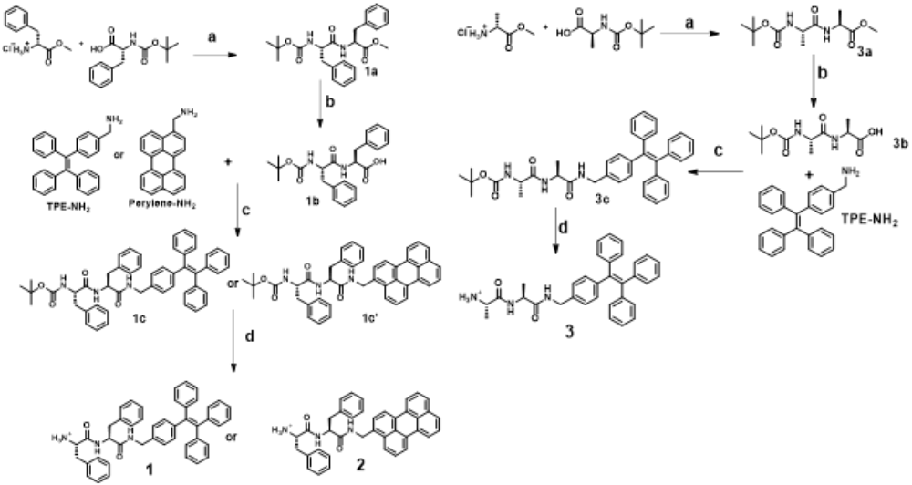

Scheme S1. Steps for synthesis of TPE-FF (1), Perylene-FF (2) and TPE-AA (3).
Synthesis for general amide coupling.
Compound 1b and 3b (1 g, 2.4 mmol) was dissolved in dry dichloromethane (DCM) followed by addition of compound TPE-NH₂ or Perylene-NH₂ (1.05 g, 2.9 mmol) and the resultant mixture was cooled in an ice bath. Then, triethylamine (0.5 mL, 3.56 mmol), N, N′-Dicyclohexylcarbodiimide (DCC) (1.25 g, 6.0 mmol), 4-Dimethylaminopyridine (DMAP) (30 mg, 0.24 mmol) and Hydroxy benzotriazole (HOBt) (0.33 g, 2.4 mmol) were added to the mixture and continuously stirred for overnight. Completion of reaction was confirmed by TLC. On completion, the reaction mixture was filtered to remove Dicyclohexylurea (DCU). Filtrate was taken in a separatory funnel, washed with 10% AcOH solution (20 mL), 5% aqueous NaHCO₃ (20 mL), water (50 mL) and saturated NaCl solution (50 mL). Then organic layer was dried over sodium sulphate and concentrated. Finally, the mixture was purified by silica gel column chromatography with chloroform/methanol (100/1, v/v) as eluent to provide white solid product 3a, 3b and 3ꞌ with 78 % yield.
Procedure for the synthesis of compound 1, 2 and 3.
Compound 1c, 1cꞌ and 3c was first dissolved in dichloromethane and then trifluoroacetic acid (0.5 mL) was added to the solution and kept for overnight at room temperature with constant stirring. Reaction was monitored by TLC and after the completion of reaction, solvent was concentrated under reduced pressure. White solid product was obtained after washing with diethyl ether in pure form.
¹H-NMR (CDCl₃) of 1, δ (ppm): 7.33 – 6.79 (m, 29H), 6.21 (d, 1H), 4.66 - 4.60 (m, 1H), 4.34 - 4.19 (m, 2H), 3.57 – 3.55 (m, 1H), 3.11 – 3.06 (m, 4H).
¹³C-NMR (CDCl₃) of 1, δ (ppm): 174.70, 170.73, 143.80, 141.26, 137.70, 135.82, 131.67, 129.39, 127.80, 126.62, 56.43, 54.60, 43.26, 40.88, 38.23, 29.84.
FTIR (cm⁻¹) of 1, 3288.30, 3032.3, 1645.32, 1515.00, 1493.55, 1442.71, 1077.30, 1028.70, 745.16, 697.30, 497.59.
¹H-NMR (CDCl₃) of 2, δ (ppm): 8.35 - 7.56 (m, 11H), 7.33 – 6.98 (m, 10H), 5.59 (d, 1H), 4.68 (m, 2H), 4.0 (m, 1H), 3.12 – 2.50 (m, 4H).
¹³C-NMR (CDCl₃) of 2, δ (ppm): 170.66, 170.33, 156.81, 137.23, 134.70, 134.59, 132.13, 130.99, 129.95, 128.55, 127.94, 126.57, 123.60, 120.89, 54.53, 53.23, 47.60, 40.12, 29.01, 25.35, 24.48, 22.09.
¹H-NMR (CDCl₃) of 3, δ (ppm): 7.26 – 6.71 (m, 19H), 6.67 (d, 1H), 4.97 (s, 1H), 4.48 - 4.31 (m, 2H), 3.57 – 3.55 (m, 1H), 1.39 (d, 3H), 1.28 (d, 3H).
¹³C-NMR (CDCl₃) of 3, δ (ppm): 173.24, 161.48, 161.04, 160.61, 160.20, 143.70, 143.61, 132.11, 131.44, 131.38, 127.93, 127.91, 127.87, 127.10, 126.78, 126.72, 50.64, 50.32, 44.43, 18.16, 17.98, 17.07, 16.93, 14.19.
ESI-MS: m/z calculated for C₄₅H₄₂N₃O₂ [M]⁺ (1), C₃₉H₃₄N₃O₂ [M]⁺ (2) and C₃₃H₃₄N₃O₂ [M]⁺ (3) is 656.8333, 576.3195, 504.3035 and found 656.8373, 576.3189 and 504.3055 respectively.

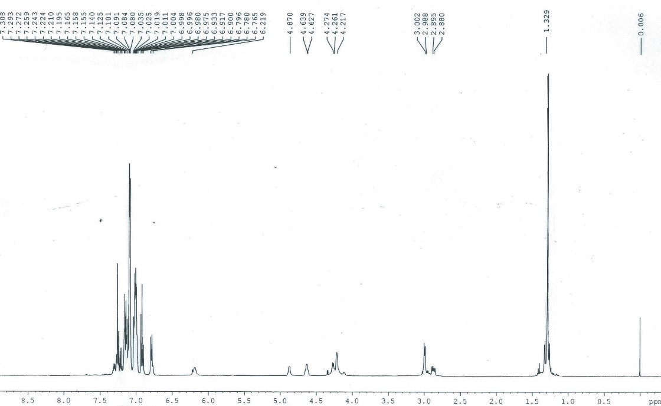
Figure S1. ¹H NMR spectrum of compound 3a.
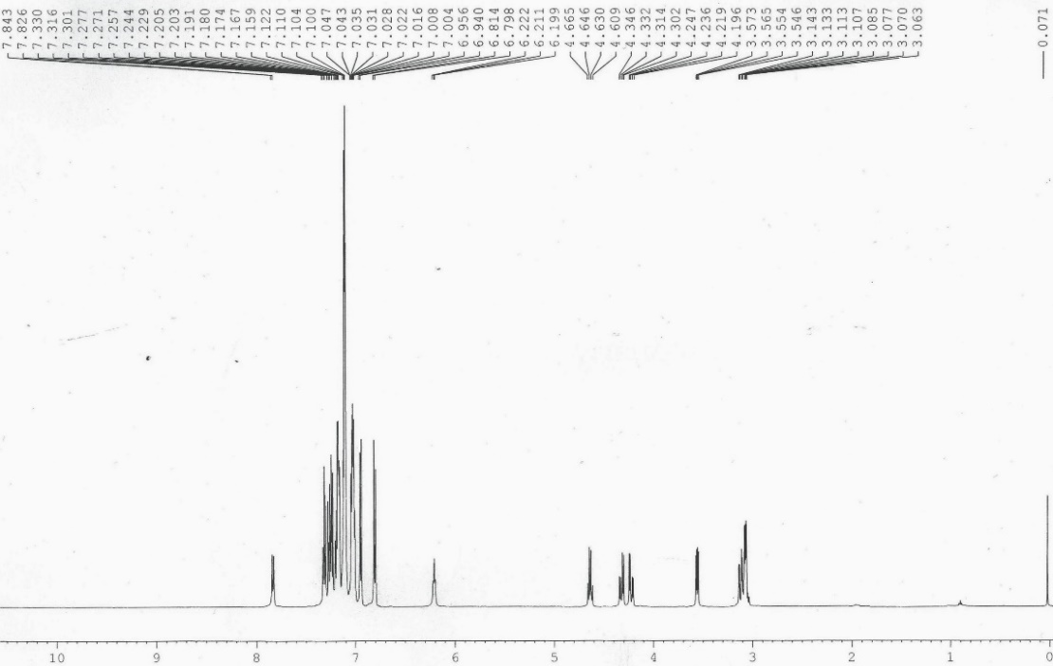
Figure S2. ¹H NMR spectrum of compound 1c.

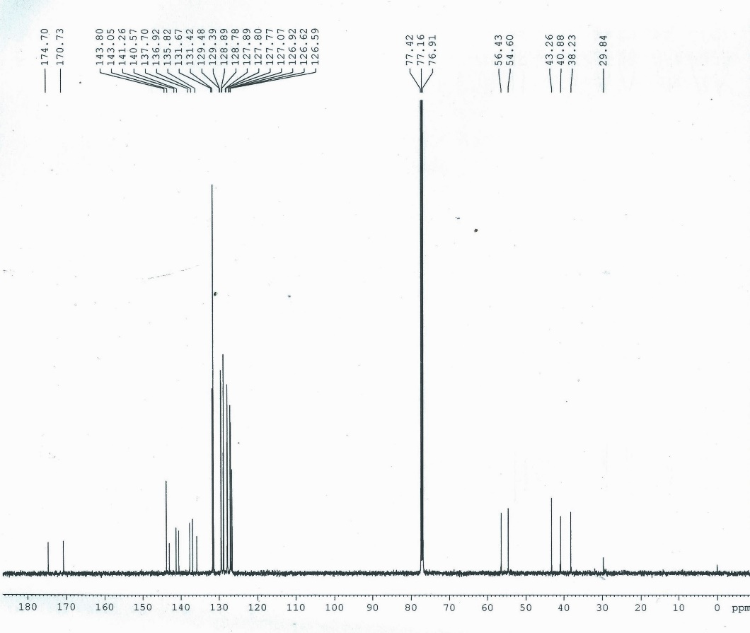
Figure S3. ¹³C NMR spectrum of compound 1.
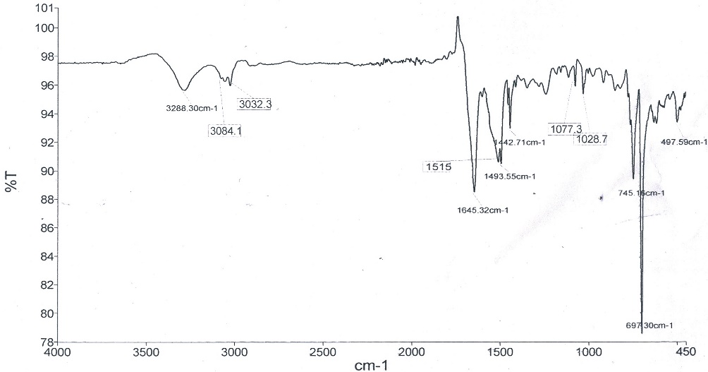
Figure S4. FTIR spectrum of compound 1.

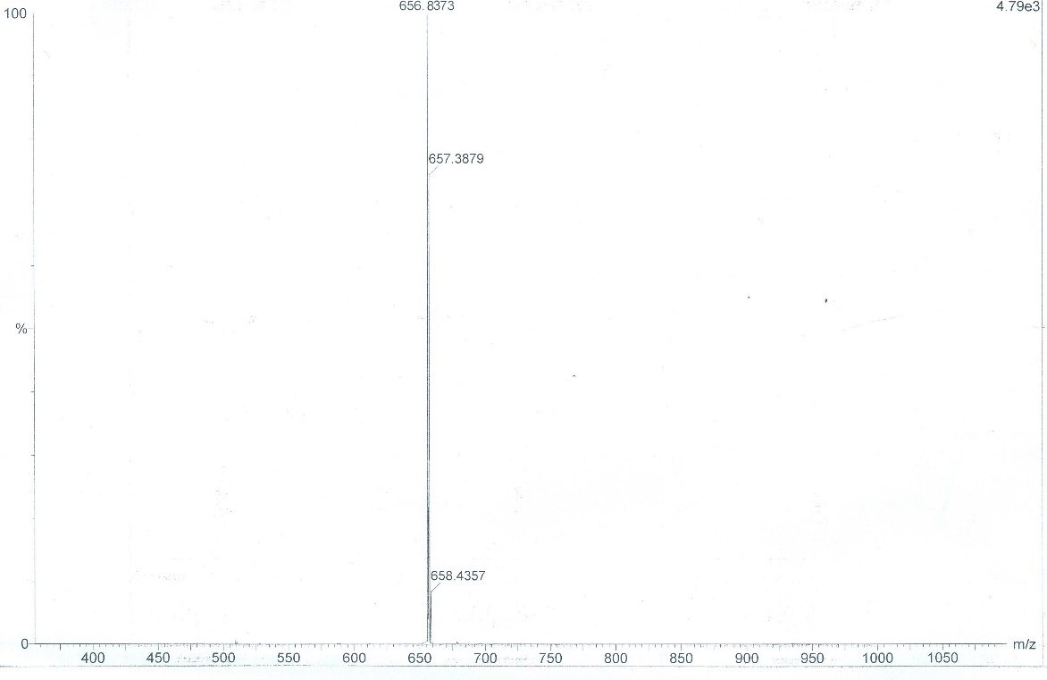
Figure S5. ESI-MS spectrum of compound 1.
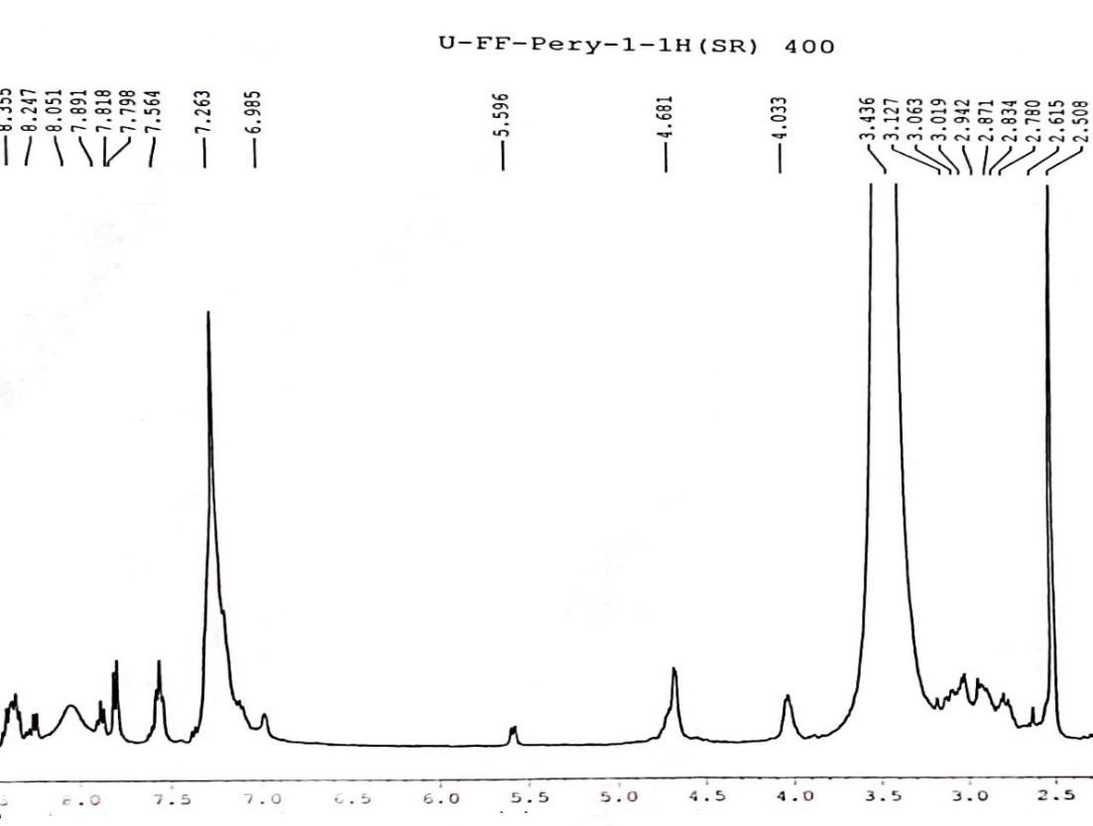
Figure S6. ¹H NMR spectrum of compound 2.
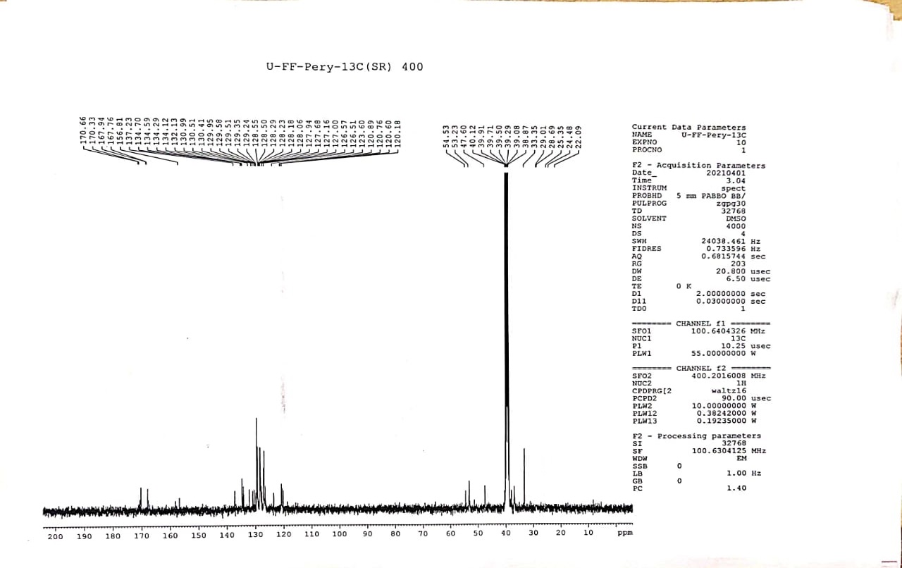
Figure S7. ¹³C NMR spectrum of compound 2.
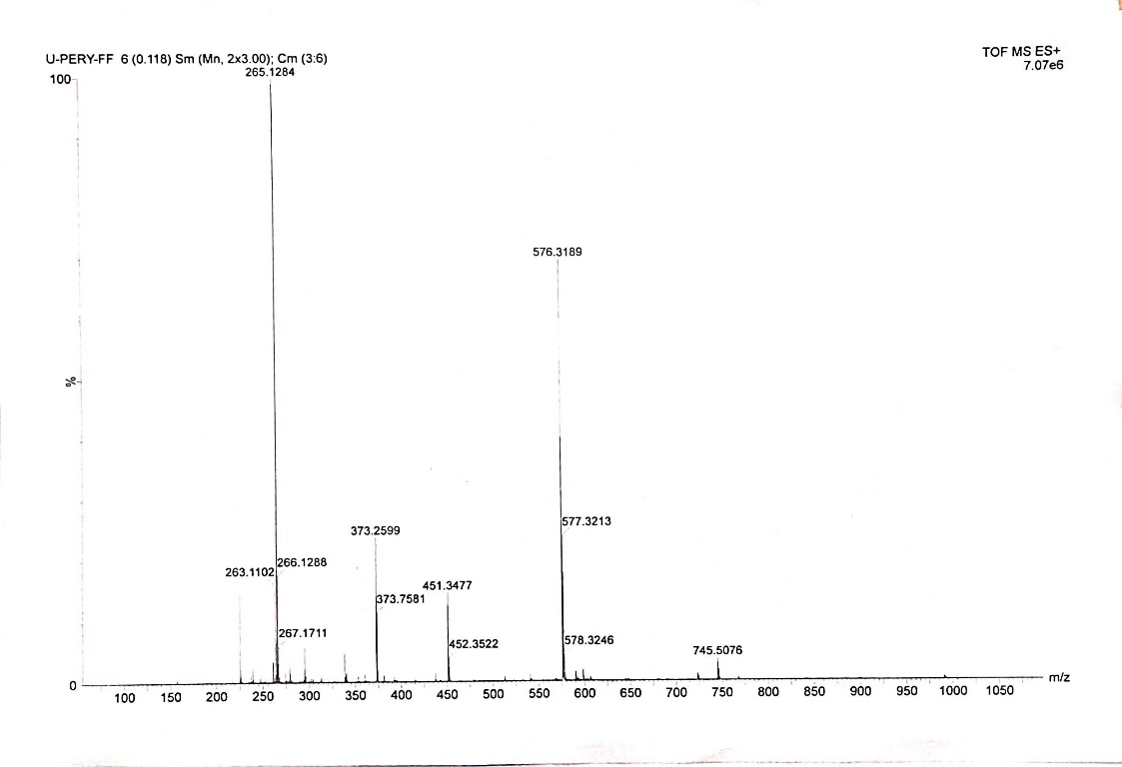
Figure S8. ESI-MS spectrum of compound 2.
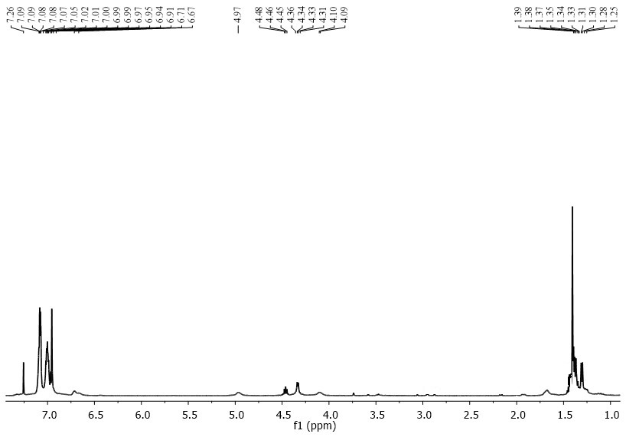
Figure S9. ¹H NMR spectrum of compound 3.
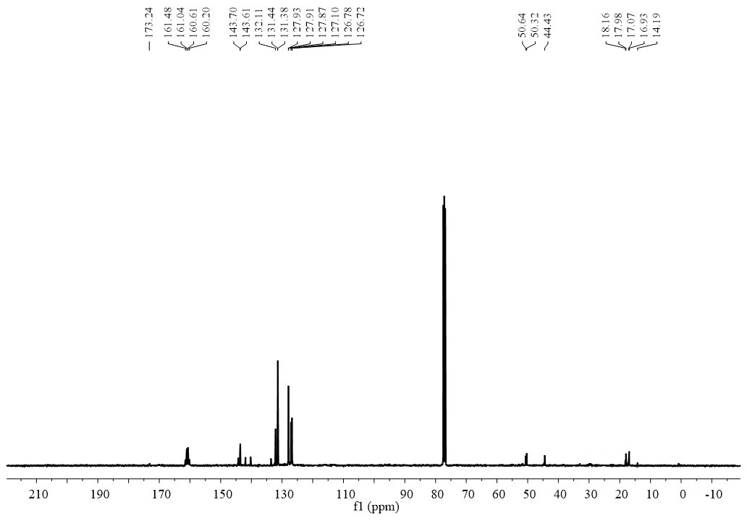
Figure S10. ¹³C NMR spectrum of compound 3.
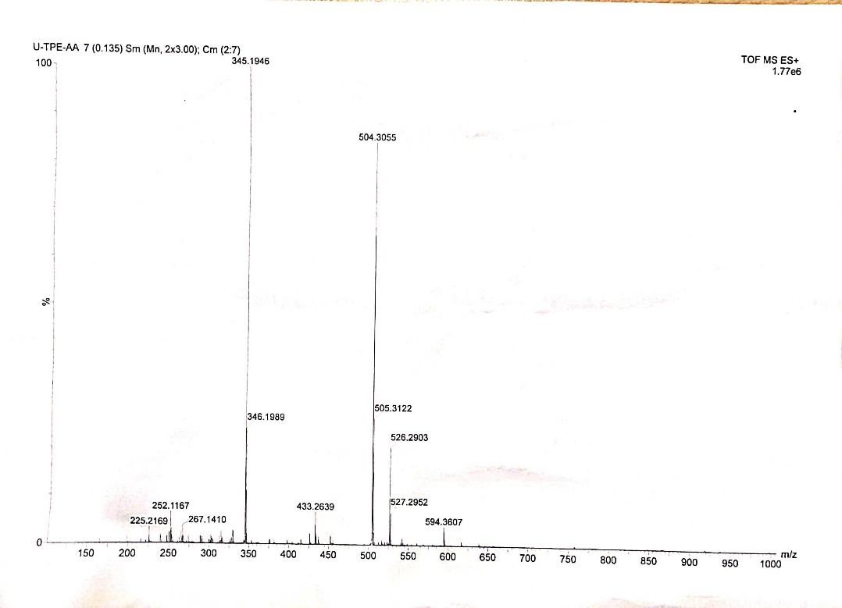
Figure S11. ESI-MS spectrum of compound 3.
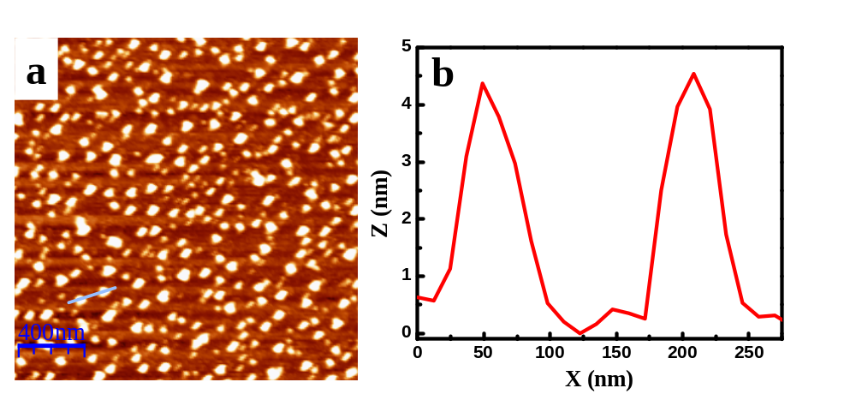
Figure S12. (a) AFM topographic image of TPE-FF at surface pressure 5 mN m⁻¹ on mica substrates showing spherical aggregates. (b) Corresponding line profile showing uniform height of 4.5 ± 0.5 nm and diameter ~75 ± 10 nm of the spherical aggregates.
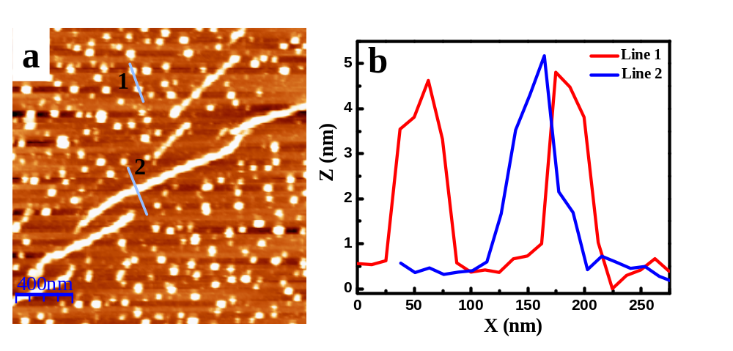
Figure S13. (a) AFM image on mica surface lifted at surface pressure 10 mN m⁻¹ showing tendency of molecular wires formation by the TPE-FF spherical aggregates. (b) Corresponding line profiles show the molecular wires with same height (4.5±0.5 nm) and diameter (75 ± 10 nm) as spherical aggregates.
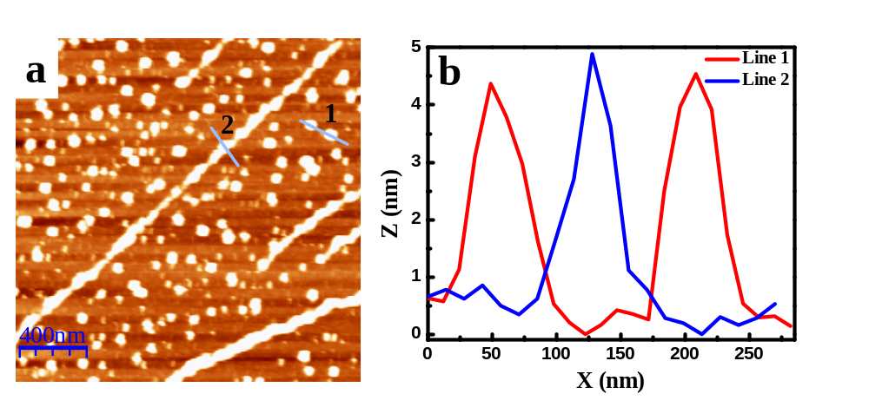
Figure S14. (a) AFM image on mica surface lifted at surface pressure 15 mN m⁻¹ showing more numbers of molecular wires along with the spherical aggregates of TPE-FF. (b) Corresponding line profiles show the molecular wires with same height (4.5±0.5 nm) and diameter (75 ± 10 nm) as spherical aggregates.

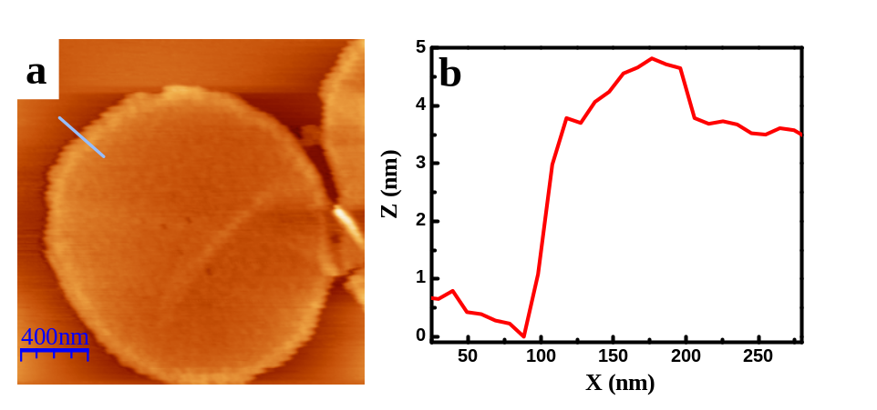
Figure S15. (a) AFM image of a 2D sheet of TPE-FF on mica surface at surface pressure 20 mN m⁻¹ showing large planar area. (b) Corresponding height profile showing a thickness of 4.5 ± 0.5 nm of the sheet.
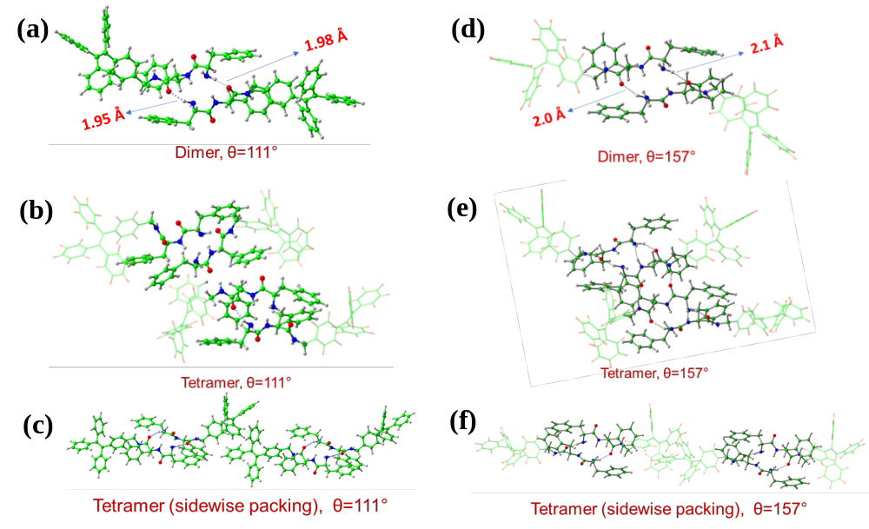
Figure S16. The energy optimized (a) dimeric structure (b) tetrameric structure and (c) tetramer via side-on overlap of dimer of TPE-FF at dihedral angle 111°. The energy optimized (d) dimeric structure (e) tetrameric structure and (f) tetramer via side-on overlap of dimer of TPE-FF at dihedral angles 157°. Green balls: C, blue balls: N, white small balls: H, and red balls: O.

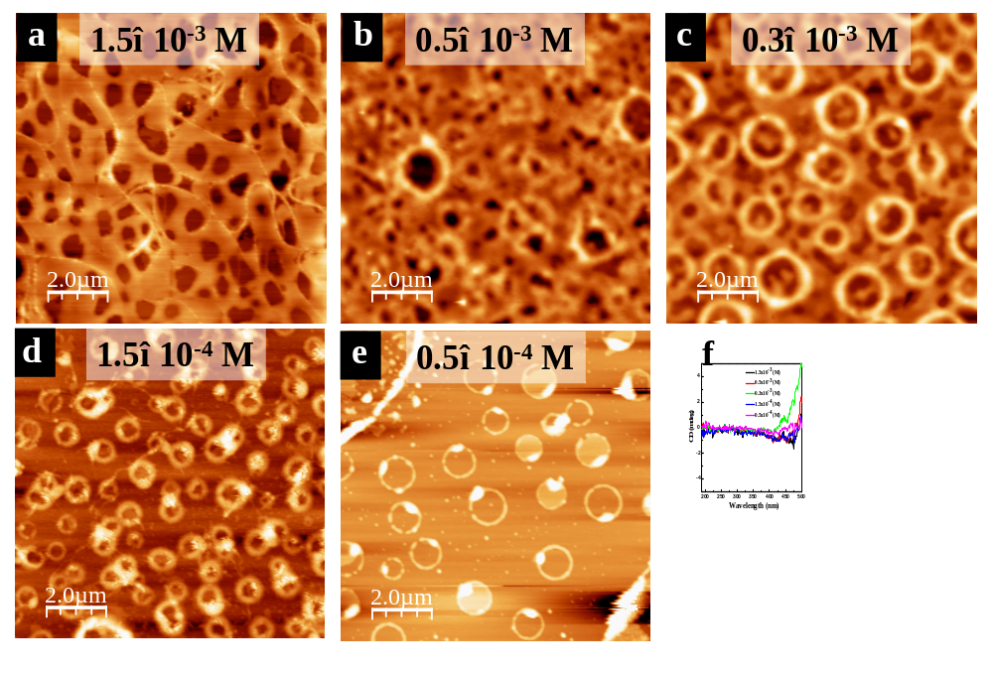
Figure S17. (a-e) AFM image of solution drop-cast TPE-FF on top of mica surface from chloroform solution with different concentration. (f) Corresponding CD spectra of drop-cast film show no CD signal due to irregular assembly formation. The concentrations of the solution are marked in the insets of the figures.
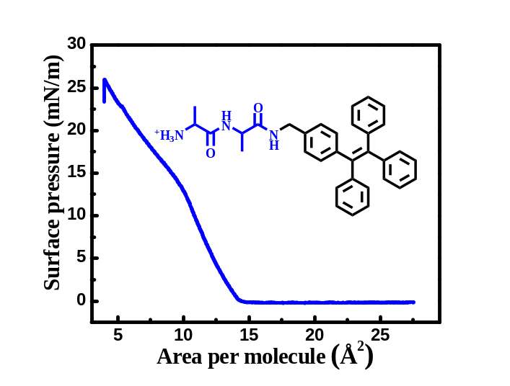

Figure S18. Surface pressure versus area per molecule isotherm of isotherm of TPE-AA on water surface showing an inflation point at 13 mNm⁻¹. Inset shows the molecular structure of TPE-AA.
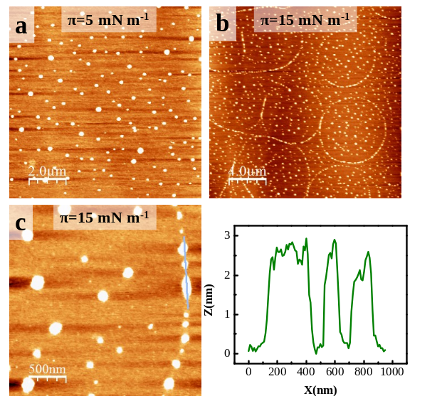
Figure S19. AFM image of TPE-AA on the water surface at compression of (a) 5 mN m⁻¹ and (b, c) 15 mN m⁻¹. (d) Corresponding height profile of TPE-AA at 15 mN m⁻¹.
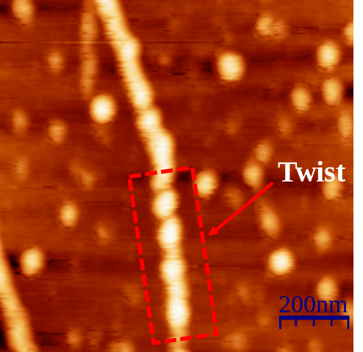
Figure S20. Higher resolution AFM image of monolayer SMW of TPE-FF at 13 mN m⁻¹ showing twisted β-sheet structure.
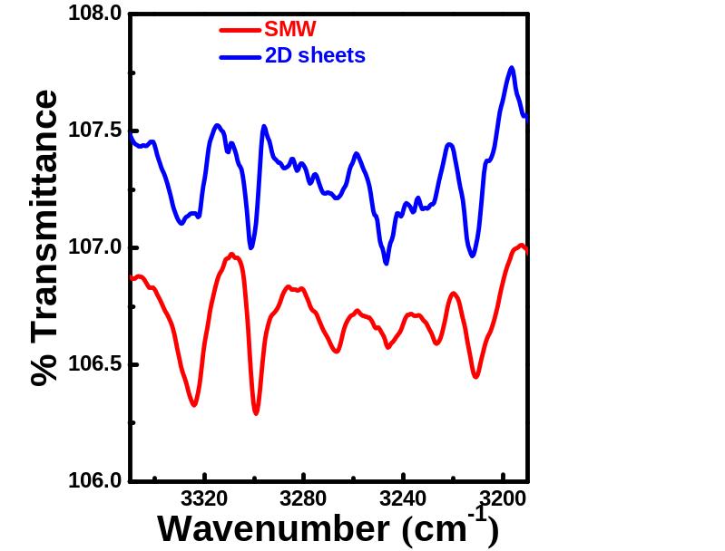
Figure S21. FTIR spectra in the amide A region of 2D sheets (blue curve) and SMW (red curve).

Table S2: Percentage calculations of β-sheet, α-helix and anti-parallel β-sheet pattern of TPE-FF SMW and 2D sheets
 | Structure | Wavenumber (cm⁻¹) | Peak (cm⁻¹) | Percent
2D sheets  (π = 20 mN/m) | β-sheet | 1600-1640 | 1602 | 0
2D sheets  (π = 20 mN/m) | α-helix | 1650-1660 | 1653 | 100 %
2D sheets  (π = 20 mN/m) | Antiparallel β-sheet | 1660-1695 | 1685 | 0
SMW  (π = 13 mN/m) | β-sheet | 1600-1640 | 1600 | 84.25 %
SMW  (π = 13 mN/m) | α-helix | 1650-1660 | 1653 | 8.55 %
SMW  (π = 13 mN/m) | Antiparallel β-sheet | 1660-1695 | 1684 | 7.12 %

DFT XYZ co-ordinates
TPE-FF structure with dihedral angle ǀθǀ = 111º
+++++++++++++++++++++++++++++++++++++++++
Optimized Electronic energy HF=-2052.7911559 H
++++++++++++++++++++++++++++++++++++++++
XYZ coordinates
91
symmetry c1
O -6.079476000 -1.287259000 1.192573000
O -2.920990000 1.685560000 -0.944383000
N -1.681570000 1.083841000 0.869171000
N -7.263390000 1.326132000 -0.974064000
H -8.069462000 1.510320000 -1.564077000
H -7.235101000 2.072584000 -0.282072000
N -5.001377000 0.200352000 -0.136014000
H -5.077977000 0.901812000 -0.867453000
C -7.421045000 0.042296000 -0.306640000
H -7.631422000 -0.701722000 -1.093246000
C -8.556703000 -0.033628000 0.722893000
H -8.516309000 -1.020653000 1.198024000
H -8.358078000 0.703878000 1.515423000
C -6.110364000 -0.412940000 0.333939000
C -3.699782000 -0.174101000 0.350774000
H -3.769747000 -0.311393000 1.439501000
C -3.230937000 -1.505857000 -0.269647000
H -4.061570000 -2.211333000 -0.144241000
H -3.077297000 -1.349525000 -1.346260000
C -2.734956000 0.958210000 0.021121000
C -9.897655000 0.218024000 0.099987000
C -10.567190000 -0.807860000 -0.571798000
H -10.121131000 -1.802374000 -0.598403000
C -11.789667000 -0.577107000 -1.190749000
H -12.299408000 -1.390254000 -1.702657000
C -12.363933000 0.690258000 -1.150785000
H -13.322874000 0.871049000 -1.630595000
C -11.707035000 1.721636000 -0.489713000
H -12.150542000 2.714049000 -0.450043000
C -10.482868000 1.485113000 0.128036000
H -9.974148000 2.292746000 0.655025000
C -1.989060000 -2.034558000 0.381656000
C -2.025915000 -2.451351000 1.717073000
C -0.772303000 -2.058149000 -0.295201000
C -0.863907000 -2.859361000 2.361602000
C 0.390455000 -2.477548000 0.341654000
C 0.348434000 -2.869021000 1.674671000
H -2.981711000 -2.455929000 2.243532000
H -0.736760000 -1.729398000 -1.333938000
H -0.904188000 -3.177550000 3.400978000
H 1.334160000 -2.483827000 -0.200811000
H 1.258498000 -3.189218000 2.179449000
H -1.537251000 0.372431000 1.575512000
H -0.655423000 2.764579000 1.581279000
C -0.664577000 2.107933000 0.700217000
H -0.993197000 2.708287000 -0.156359000
C 0.708445000 1.542723000 0.469558000
C 0.999294000 0.864393000 -0.716100000
H 0.215659000 0.756749000 -1.467143000
C 5.758950000 0.668204000 -0.142986000
C 4.629465000 -0.081957000 -0.223492000
C 7.116305000 0.066194000 -0.174272000
C 8.090230000 0.574383000 -1.041658000
C 7.465549000 -0.985945000 0.678431000
C 9.363344000 0.021097000 -1.083058000
C 8.742570000 -1.531525000 0.646386000
C 9.693648000 -1.034873000 -0.239014000
H 7.834239000 1.409582000 -1.692026000
H 6.720918000 -1.377140000 1.368987000
H 10.102646000 0.418978000 -1.774493000
H 8.996775000 -2.347739000 1.318603000
H 10.692188000 -1.464641000 -0.266482000
C 3.277259000 0.483161000 0.019862000
C 2.978064000 1.150310000 1.209060000
C 2.259130000 0.328156000 -0.931355000
H 3.755823000 1.268341000 1.961344000
H 2.475499000 -0.207983000 -1.855291000
C 4.643090000 -1.529247000 -0.551107000
C 3.916752000 -2.427148000 0.239647000
C 3.892749000 -3.783885000 -0.059418000
H 3.367484000 -2.042749000 1.099759000
H 3.322265000 -4.465219000 0.569227000
C 5.732157000 2.146940000 -0.015220000
C 6.551124000 2.782909000 0.925548000
C 4.933302000 2.939838000 -0.846616000
C 6.545639000 4.165364000 1.055405000
C 4.936064000 4.323069000 -0.724993000
C 5.737065000 4.940887000 0.230215000
H 7.193852000 2.176213000 1.561673000
H 4.306417000 2.459744000 -1.594958000
H 7.179494000 4.640003000 1.800948000
H 4.311760000 4.922747000 -1.383358000
H 5.737178000 6.024065000 0.325942000
H 1.490280000 2.189219000 2.362620000
C 1.708163000 1.670083000 1.429658000
C 5.329120000 -2.025629000 -1.664272000
C 5.300254000 -3.380756000 -1.968050000
C 4.584562000 -4.265217000 -1.166710000
H 5.890235000 -1.335662000 -2.291614000
H 5.835576000 -3.747737000 -2.840692000
H 4.561041000 -5.325116000 -1.408021000

TPE-FF structure with dihedral angle ǀθǀ = 157º
+++++++++++++++++++++++++++++++++++++++++++
HF=-2052.7914521 H
+++++++++++++++++++++++++++++++++++++++++++++++++
91
symmetry c1
O -6.145161000 -1.819908000 1.146136000
O -2.957912000 1.103772000 -1.055596000
N -1.851712000 0.745527000 0.903007000
N -7.215780000 0.102993000 -1.694766000
H -6.994047000 -0.579280000 -2.413384000
H -8.057381000 0.588178000 -1.994769000
N -5.032876000 -0.394924000 -0.231450000
H -5.105292000 0.284496000 -0.984604000
C -7.448263000 -0.552145000 -0.418253000
H -8.076273000 -1.459864000 -0.479237000
C -8.131917000 0.420359000 0.552558000
H -8.181439000 -0.075385000 1.530178000
H -7.484685000 1.303125000 0.657117000
C -6.146938000 -1.003373000 0.233381000
C -3.741302000 -0.681281000 0.336398000
H -3.854908000 -0.767603000 1.427240000
C -3.184427000 -2.016387000 -0.196161000
H -3.954338000 -2.772702000 0.001775000
H -3.068577000 -1.924335000 -1.284832000
C -2.814898000 0.476466000 -0.014933000
C -9.501759000 0.826782000 0.090569000
C -10.584265000 -0.043723000 0.242544000
H -10.427326000 -1.003284000 0.735427000
C -11.847364000 0.305423000 -0.217673000
H -12.680431000 -0.381287000 -0.085706000
C -12.048886000 1.533656000 -0.842069000
H -13.038127000 1.808329000 -1.200267000
C -10.980194000 2.407832000 -1.001279000
H -11.129498000 3.370495000 -1.484919000
C -9.716049000 2.054973000 -0.537539000
H -8.877864000 2.741637000 -0.656800000
C -1.885646000 -2.388059000 0.452646000
C -1.858088000 -2.779929000 1.795126000
C -0.680352000 -2.268763000 -0.235256000
C -0.648629000 -3.028337000 2.434826000
C 0.530598000 -2.525938000 0.397138000
C 0.549837000 -2.898782000 1.736004000
H -2.800101000 -2.890422000 2.334128000
H -0.692822000 -1.952522000 -1.278607000
H -0.641026000 -3.330815000 3.479690000
H 1.461150000 -2.423050000 -0.157438000
H 1.497074000 -3.096055000 2.235561000
H -1.711366000 0.090574000 1.662532000
H -0.905186000 2.469520000 1.603043000
C -0.882935000 1.813993000 0.722031000
H -1.243655000 2.395078000 -0.134138000
C 0.519455000 1.327408000 0.482886000
C 0.868295000 0.748194000 -0.739578000
H 0.106846000 0.654781000 -1.514531000
C 5.616453000 0.829589000 -0.111810000
C 4.545849000 0.005353000 -0.245645000
C 7.014766000 0.331869000 -0.169333000
C 7.959075000 0.981374000 -0.972732000
C 7.431695000 -0.758889000 0.600740000
C 9.271837000 0.531922000 -1.031875000
C 8.747280000 -1.201574000 0.551106000
C 9.670560000 -0.562002000 -0.269792000
H 7.649838000 1.845735000 -1.558473000
H 6.710471000 -1.260800000 1.242690000
H 9.988503000 1.041216000 -1.672124000
H 9.053795000 -2.048681000 1.160375000
H 10.699959000 -0.910216000 -0.309910000
C 3.154045000 0.456817000 0.014128000
C 2.795833000 1.016723000 1.241487000
C 2.162522000 0.304277000 -0.964906000
H 3.555367000 1.132325000 2.012596000
H 2.428105000 -0.150713000 -1.919022000
C 4.668410000 -1.417469000 -0.649915000
C 4.037861000 -2.410228000 0.108274000
C 4.114516000 -3.747518000 -0.259924000
H 3.485190000 -2.116845000 1.001234000
H 3.616599000 -4.503087000 0.344981000
C 5.476866000 2.291193000 0.110956000
C 6.233767000 2.921884000 1.105538000
C 4.628981000 3.075739000 -0.678432000
C 6.121315000 4.288237000 1.326928000
C 4.524482000 4.444095000 -0.464789000
C 5.265394000 5.054698000 0.542198000
H 6.913267000 2.324559000 1.711508000
H 4.048639000 2.601605000 -1.467256000
H 6.708420000 4.757783000 2.112900000
H 3.863465000 5.037566000 -1.092180000
H 5.181705000 6.125894000 0.709804000
H 1.230812000 1.885516000 2.431799000
C 1.493086000 1.442757000 1.471216000
C 5.366323000 -1.798975000 -1.799816000
C 5.439894000 -3.135521000 -2.172126000
C 4.816529000 -4.114400000 -1.404156000
H 5.854725000 -1.034147000 -2.400636000
H 5.983251000 -3.414061000 -3.072094000
H 4.872646000 -5.159259000 -1.699638000

References:
- Frisch, M. et al. Gaussian, Inc., Wallingford CT, 2009.
- Staroverov, V., Scuseria, G., Tao, J. & Perdew, J. Deviations of calculated properties from experiment for species of the G3/99, T-96R, and T-82F test sets. Properties of hydrogen-bonded complexes. J. Chem. Phys. 119, 12129-12137 (2003).

- Becke, A. D. Density-functional exchange-energy approximation with correct asymptotic behavior. Phys. Rev. A 38, 3098 (1988).

- Stephens, P. J., Devlin, F. J., Chabalowski, C. F. & Frisch, M. J. Ab initio calculation of vibrational absorption and circular dichroism spectra using density functional force fields. J. Phys. Chem. 98, 11623-11627 (1994).

- Zhao, Y. & Truhla, D. G. The M06 suite of density functionals for main group thermochemistry, thermochemical kinetics, noncovalent interactions, excited states, and transition elements: two new functionals and systematic testing of four M06-class functionals and 12 other functionals. Theor. Chem. Acc. 120, 215-241 (2008).
- Chemcraft - graphical software for visualization of quantum chemistry computations. Version 1.8.
- Umesh, Bera, S. & Bhattacharya, S. Dual Circularly Polarized Luminescence (CPL) and Piezoelectric Responses in Self‐Assembled Chiral Nanostructures Derived from a Dipeptide Based Piezorganogel. Small, 2308104 (2023).

- Maiti, B., Bhattacharjee, S. & Bhattacharya, S. Perfluoroarene induces a pentapeptidic hydrotrope into a pH-tolerant hydrogel allowing naked eye sensing of Ca 2+ ions. Nanoscale 11, 2223-2230 (2019).

- Moitra, P., Kumar, K., Kondaiah, P. & Bhattacharya, S. Efficacious Anticancer Drug Delivery Mediated by a pH‐Sensitive Self‐Assembly of a Conserved Tripeptide Derived from Tyrosine Kinase NGF Receptor. Angew. Chem. Int. Ed. 53, 1113-1117 (2014).
- Rao, K. et al. Transparent, flexible MAPbI 3 perovskite microwire arrays passivated with ultra-hydrophobic supramolecular self-assembly for stable and high-performance photodetectors. Nanoscale 12, 11986-11996 (2020).

- Zhao, Y., Wu, Y., Yan, G. & Zhang, K. Aggregation-induced emission block copolymers based on ring-opening metathesis polymerization. RSC Adv. 4, 51194-51200 (2014).

