Table 1 Composition of 60 tablets exposed at ISS (spacecraft) and MISSE (outer LEO space). A designed, systematic variation of excipients and selected drug, ibuprofen, provide seven (7) Case studies that are shown color-coded, namely, red, yellow, brown, green, orange, purple and blue. The total mass of all tablets is 100 mg; meaning the excipient masses are also mass-%.
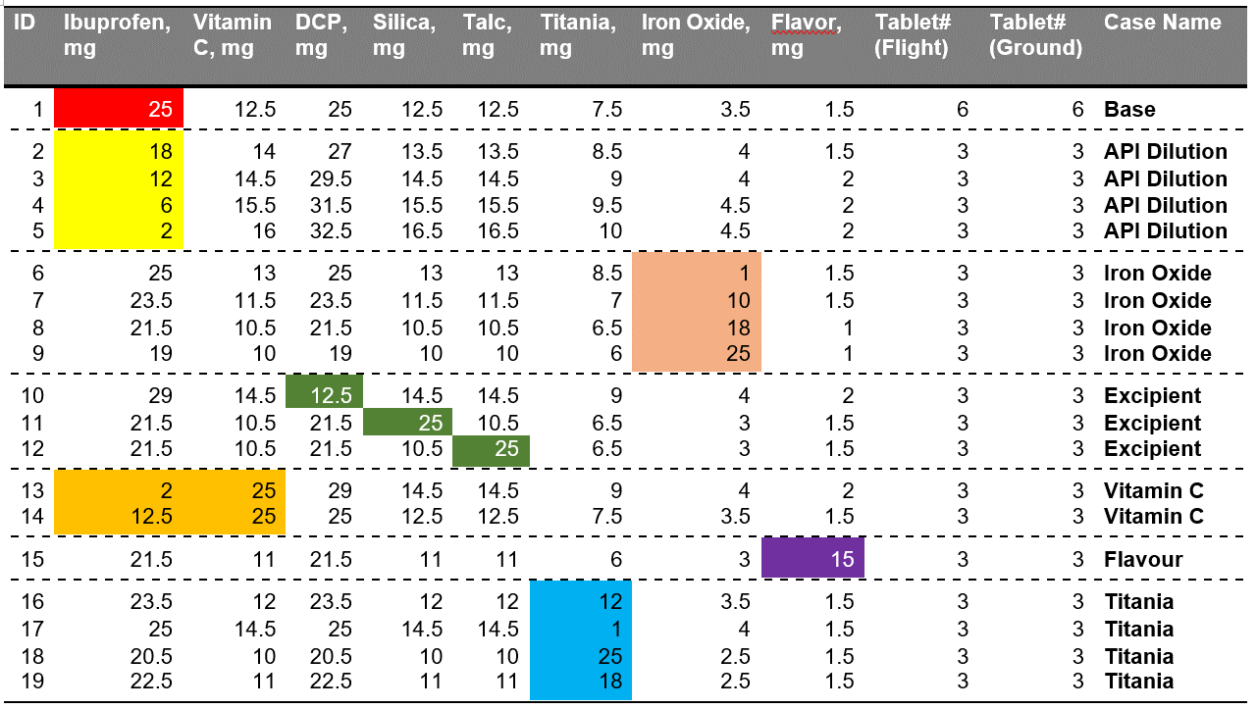

Table 2 Comparative summary of degradation of ibuprofen tablet (formulated) by gamma radiation on Earth.

Table 3 Summary of ibuprofen content for tablets exposed to cosmic-ray at ISS
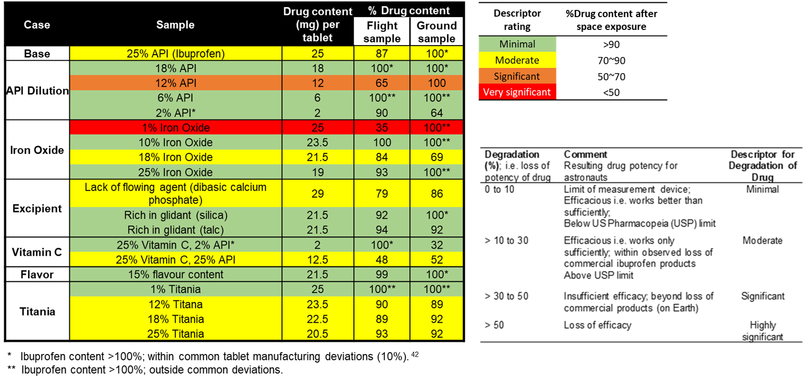

Table 4 Composition of six (6) tablets exposed at MISSE, outer LEO space. Variation of excipients and ibuprofen provide six case studies color-coded, red, yellow, brown, orange, purple and blue.
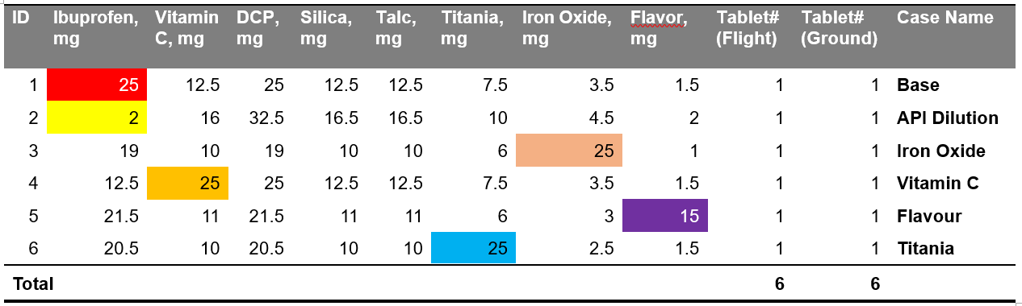

Table 5 Cosmic-ray exposure outside ISS at MISSE platform in harsh outer space.
