Supplementary Material
to manuscript “Cosmic-Ray Irradiation Study of Ibuprofen Tablet Formulation Inside and Outside the International Space Station”
Quy Don Tran^{a,b}, Nigel Spooner^{c}, Sean Geoghehan^{d}, Shanjaye Raj Thavarajahª, Shamaun Rahmanª, Nam Nghiep Tranª, Ian Fisk^{e,*}, Philip M. Williams^{e}, Sandra Martinez Jarquin^{e}, Dong-Hyun Kim^{e}, Kenneth Daveyª, Jeff Buell^{f}, Mark Shumbera ^{f}, Mark Gittleman ^{f}, Twyman Clements^{g}, Jana Stoudemire^{g}, Volker Hessel^{a,b,h}*

1 Experiment Websites and Spaceflight Certification
1.1 NASA Experiment: Evaluation of Long-Term Stability of Pharmaceutical Ingredients in an Excipient Matrix for Use in Potential Future On-Orbit Manufacturing
https://www.nasa.gov/mission_pages/station/research/experiments/explorer/Investigation.html?#id=8307
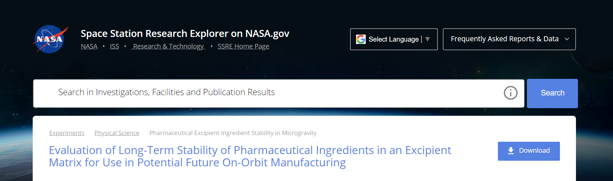
Fig. S1 NASA website of the ISS experiment in this study.
1.2 Northtrop Grumman CRS-14 mission
https://www.issnationallab.org/northrop-grumman-crs-14-mission-overview/
1.3 Spaceflight certificate (Aegis Aerospace)
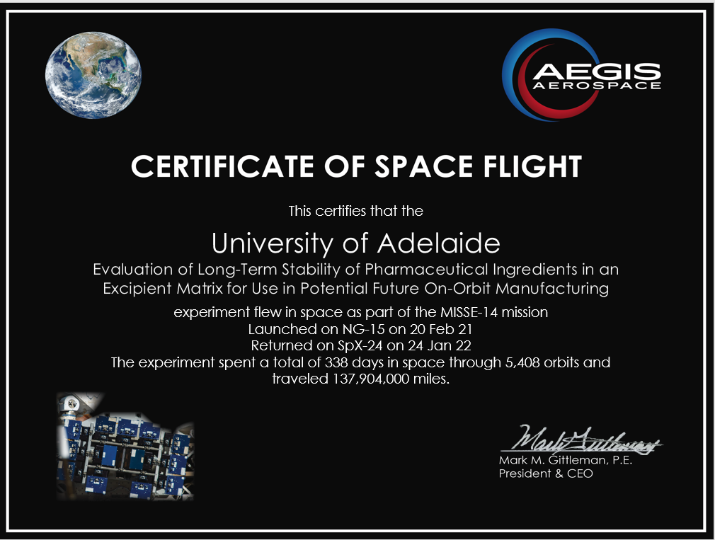
Fig. S2 Aegis Aerospace-certificate of MISSE spaceflight.

2 Launches
2.1 NG-14 and NG-15 Launches
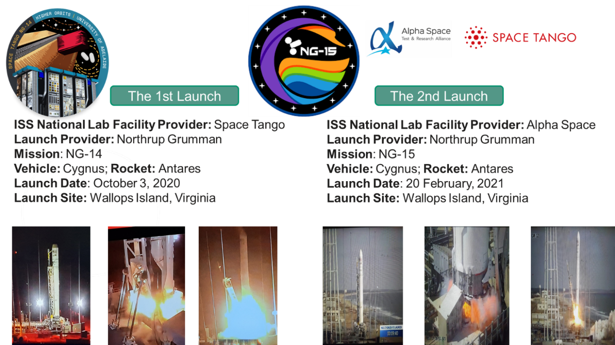
Fig. S3 Launch details.
3 Methodology of Experiments
3.1 Tablet specimen preparation
3.1.1 Materials
Chemicals used for tablet formulating were ibuprofen (Sigma-Aldrich) as medicinal drug, and as excipients 98%, L-ascorbic acid (Sigma-Aldrich), 98%, dibasic calcium phosphate, silicon dioxide (Sigma-Aldrich), 98%, talc (Sigma-Aldrich), titanium dioxide (Chem-supply), and 98%, iron (III) oxide (Sigma-Aldrich). Commercial flavour mixtures were added, including 98%, malty-biscuity 037 - 2-acetylpyridine (flavour active), acetic cider (flavour active), and 4-ethyl phenol wine flavour standard (cara technology).
3.1.2 Tablet compression
Tablets involved in this study were manufactured by direct compression in a manual single-punch tablet press (Model TDP-1.5S, Cegle). Ibuprofen and all excipients were weighted together to give 10 times mass of the tablet weight, which was mixed by a vortex mixer (VM1, Personal Vortex Mixer; Ratek) at 2700 rpm. A 10th portion of this mass is taken, and compressed in the tablet press by a single punch, to give concave-shaped tablets of specification for 100 mg weight and 6 mm diameter standard. Exact weight and thickness of tablets were monitored, and tablets meeting expectations were further processed, Supplementary Material.
After the ISS experiment, the tablet manufacturing procedure was optimized. The ISS tablets were manufactured under high time pressure, determined by proximity to launch and personnel/lab access at the maximal point of Covid outbreak in South Australia (May 2019). The post-ISS optimized procedure mixed the excipients in a first step at 100 mg-scale using the vortex mixer. This mixture was mixed with ibuprofen in a second step using the vortex mixer. This improved the compositional uniformity, Supplementary Material. The Earth-simulated space radiation experiments were done with the optimized tablet specimens.
3.1.3 Flavour additives as tablet excipients
The flavour excipient in the tablet consists of commercial flavour products, including Malty-biscuity 037 (2-acetylpyridine) from flavouractive, Acetic cider from flavoractive and wine flavour (4-ethyl phenol from cara technology blended in the ratio of 1:1:1.
- Malty-biscuity 037 - 2-acetylpyridine- (flavouractive)
- Acetic cider (flavoractive)
- 4-ethyl phenol wine flavour standard
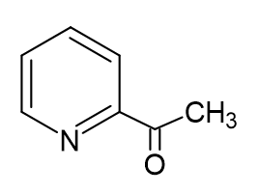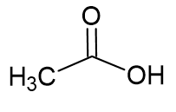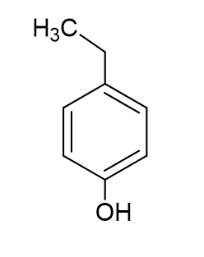
3.2 Accompanying radiation experiments on Earth
Radiation experiments simulating the space radiation were done in the Prescott Environmental Luminescence Laboratory (PELL) of the University of Adelaide; lacking the microgravity of the space experiment. For practicality, the exposure time of the space experiments (ca. 9 months) cannot be repeated in the Earth experiment, but a much shorter time (a few hours) was used, at significant higher flux to compensate for providing ‘space-equivalent’ dose.
3.2.1 Particle radiation
Alpha and beta radiation experiments were conducted using weak radioactive sources, at low Linear Energy Transfer (LET), for Americium 214 (200 mCi) and Strontium 90 (500 mCi), Figure 1. The alpha and beta sources were positioned perpendicular to the irradiated sample with a distance of 1 cm to the source, Supplementary Material. A rotating disk system was used to control the exposure time. All experiments were conducted in a dark room and calibrated using common equations of radiation physics, Supplementary Material.
3.2.2 X-ray radiation
X-ray irradiation was conducted using a medical linear acceleration (LINAC) apparatus at the Royal Adelaide Hospital, Supplementary Material. Two layers of solid water blocks (high-density polyethylene) are placed between samples to simulate the scattering of radiation mimicking space condition. LINAC generates photon beams spanning wavelengths from X-rays to gamma rays; a peak photon energy of 6 MV was used. The source-to-target (SSD) calibration of the LINAC was 70 cm, creating a uniform monochromatic photon radiation field of 40 cm x 40 cm. The output factor (OF) was 1.2, compared to the calibration field size of 10 cm x 10 cm. The SSD correction factor is 2.04. The total dose correction factor per modular unit (MU) is $1.2 × 2.04 = 2.45 (cGy/MU)$.
3.3 ISS- and Earth-irradiated tablet specimen analysis
Analysis of ibuprofen decomposition were done by ultra-high-performance liquid chromatography (UHPLC). Thin layer chromatography (TLC) experiments complemented the UHPLC decomposition analysis. The identification of the ibuprofen decomposition products was made with liquid chromatography-mass spectrometry (LC-MS); at the University of Nottingham, United Kingdom.
3.3.1 Ultra-high-performance liquid chromatography (UHPLC)
The chemical content of each tablet specimen was determined by UHPLC using the 1290 Infinity II instrument (Agilent) with the analytical column Zorbax RRHD Eclipse Plus C18 (Agilent, 2.1 mm × 50 mm, 1.8-micron). The gradient elution was employed with solutions A and B as mobile phase. Solution A contained 66 % of HPLC-grade acetonitrile (Merck) in milli-Q water (with 0.5% H₃PO₄) and solution B contained 100 % acetonitrile as the mobile phase. The flow rate of the mobile phase was set at 0.5 mL/min. The gradient program was: 0−3 min, 100 % solvent A; and 3-30 min, 15% solvent A with an injection volume of 0.7 μL. The calibration curve was established by preparing solutions of different concentrations of ibuprofen in acetonitrile solution; Supporting Material. All samples were filtered through nylon syringe filter (13 mm, 0.22 μm), obtained from Scharlab before the chromatographic analysis. As per UHPLC analysis, a very few tablets with ibuprofen content out of specs were excluded from the analysis reported in Results and Discussion; see comment above on launch- and Covid-related working restrictions, Supplementary Material. 18 out of 19 UHPLC experiments shown in this manuscript were repeated tri-fold and one, the ‘Base Case’ was repeated six-fold; Table 1.
3.3.2 Thin layer chromatography (TLC)
TLC was carried out on the RP-18, F254s aluminum sheet (20 × 20 cm, Merck, Germany). These aluminum sheets were cut to the size of the container before loading of sample. The mixture of n-hexane : ethyl acetate : glacial acetic acid in ratio 36 : 12 : 2 (v/v/v) was used as the mobile phase, as reported in ¹. The analyzed substances were dissolved in chloroform. 1 µL was transferred onto the plate using micropipette. The chromatograms were developed in the 100 ml flat-bottom bottle with screw cap and visualized with the 254 nm-UV lamps.
3.3.3 Liquid chromatography-mass spectrometry (LC-MS)
LC-MS analysis was performed on a ZIC-pHILIC column (4.6 x 150 mm, 5 µm particle size, Merck Sequant, Watford, UK). An Ultimate 3000 UHPLC coupled to Q-Exactive Plus Orbitrap mass spectrometer (MS) (Thermo Fisher Scientific, USA). The column temperature was maintained at 45 °C and with a flow rate of 300 µL/min.
The chromatographic run was performed by injecting 10 µL (4 °C) of each sample in a linear gradient of 300 µL/min of 20% A: 20 mM ammonium carbonate and 80% B: acetonitrile to 5% B for 8 min and returned to 80% B over 2 min; the flow rate was then increased to 400 µL/min to re-equilibrate the column, returning the flow rate to 300 µL/min at 14 minutes to finish at 15 minutes.
MS data was acquired simultaneously in positive and negative modes with the following parameters: spray voltage 4.0 kV (ESI+), 4.0 (ESI-), sheath, auxiliary and sweep gas flow rate were: 40, 5 and 1 (arbitrary unit), respectively, for both modes. Capillary and heater temperature were maintained at 275⁰C, respectively. Data was acquired in data dependent mode (DDA) to obtain the MS2 fragmentation. Full scan mode with 1 Microscan, 140,000 resolution, 3E6 AGC target 100 ms Max IT, scan range 50 to 750 m/z in profile mode. MS2 with 1 microscan 17,500 resolution, 1E5 AGC target, 50 ms Max IT, loop count 5, isolation window 0.5 m/z, stepped NCE 20, 30 and 40.
Data analysis was performed in Compound Discoverer 3.3 PS1, using an in-house workflow, including all preprocessing steps including peak peaking, chromatogram alignment and merging, intensities were normalised to TIC for each sample. Using the module expected compounds, Ibuprofen was detected with the standard. Modifications and decomposition products structures were included based on the literature information.
4 Radiation dose calculation
4.1 Americium-214
$$Remaining Activity\left(Bq\right)=Initial Activity \left(Bq\right)×{\left(\frac{1}{2}\right)}^{(\frac{t}{T_{half}})}=6.8 ×{10}^{9} (Bq)$$
$$Dose rate \left(\frac{Gy}{s}\right)=\frac{Activity \left(Bq\right)×0.058 (\frac{Sv}{Gy})}{4π ×{\left(1×{10}^{-2}\right)}^{2}}=3.1×{10}^{11} (Gy/s)$$
4.2 Strontium-90
$$Remaining Activity \left(Bq\right)=Initial Activity \left(Bq\right)×{\left(\frac{1}{2}\right)}^{(\frac{t}{T_{half}})}=1.8 ×{10}^{4} (Bq)$$

$$Dose rate \left(\frac{Gy}{s}\right)=\frac{Activity \left(Bq\right)×5.3 × {10}^{-12} (\frac{Sv}{Gy})}{4π ×{\left(1×{10}^{-2}\right)}^{2}}=7.8×{10}^{-5} (Gy/s)$$

5 Tablet Specimen Samples
5.1 List of tablet samples for inside ISS experiments (2U CubeLab)
Table S1 Tablet specimens for ISS experiments, compositional change and experimental scenarios (Cases; colour-coded).
ID | Ibuprofen, mg | Vitamin C, mg | DCP, mg | Silica, mg | Talc, mg | Titania, mg | Iron Oxide, mg | Flavour, mg | Tablet# (Flight) | Tablet# (Ground) | Case Name
1 | 25 | 12.5 | 25 | 12.5 | 12.5 | 7.5 | 3.5 | 1.5 | 6 | 6 | Base
2 | 18 | 14 | 27 | 13.5 | 13.5 | 8.5 | 4 | 1.5 | 3 | 3 | API Dilution
3 | 12 | 14.5 | 29.5 | 14.5 | 14.5 | 9 | 4 | 2 | 3 | 3 | API Dilution
4 | 6 | 15.5 | 31.5 | 15.5 | 15.5 | 9.5 | 4.5 | 2 | 3 | 3 | API Dilution
5 | 2 | 16 | 32.5 | 16.5 | 16.5 | 10 | 4.5 | 2 | 3 | 3 | API Dilution
6 | 25 | 13 | 25 | 13 | 13 | 8.5 | 1 | 1.5 | 3 | 3 | Iron Oxide
7 | 23.5 | 11.5 | 23.5 | 11.5 | 11.5 | 7 | 10 | 1.5 | 3 | 3 | Iron Oxide
8 | 21.5 | 10.5 | 21.5 | 10.5 | 10.5 | 6.5 | 18 | 1 | 3 | 3 | Iron Oxide
9 | 19 | 10 | 19 | 10 | 10 | 6 | 25 | 1 | 3 | 3 | Iron Oxide
10 | 29 | 14.5 | 12.5 | 14.5 | 14.5 | 9 | 4 | 2 | 3 | 3 | Excipient
11 | 21.5 | 10.5 | 21.5 | 25 | 10.5 | 6.5 | 3 | 1.5 | 3 | 3 | Excipient
12 | 21.5 | 10.5 | 21.5 | 10.5 | 25 | 6.5 | 3 | 1.5 | 3 | 3 | Excipient
13 | 2 | 25 | 29 | 14.5 | 14.5 | 9 | 4 | 2 | 3 | 3 | Vitamin C
14 | 12.5 | 25 | 25 | 12.5 | 12.5 | 7.5 | 3.5 | 1.5 | 3 | 3 | Vitamin C
15 | 21.5 | 11 | 21.5 | 11 | 11 | 6 | 3 | 15 | 3 | 3 | Flavour
16 | 23.5 | 12 | 23.5 | 12 | 12 | 12 | 3.5 | 1.5 | 3 | 3 | Titania
17 | 25 | 14.5 | 25 | 14.5 | 14.5 | 1 | 4 | 1.5 | 3 | 3 | Titania
18 | 20.5 | 10 | 20.5 | 10 | 10 | 25 | 2.5 | 1.5 | 3 | 3 | Titania
19 | 22.5 | 11 | 22.5 | 11 | 11 | 18 | 2.5 | 1.5 | 3 | 3 | Titania
Total |  |  |  |  |  |  |  |  | 60 | 60
5.2 List of tablet samples for MISSE platform, outside ISS experiments
Table S2 Tablet specimens for MISSE experiments, compositional change and experimental scenarios (Cases; colour-coded).
ID | Ibuprofen, mg | Vitamin C, mg | DCP, mg | Silica, mg | Talc, mg | Titania, mg | Iron Oxide, mg | Flavour, mg | Tablet# (Flight) | Tablet# (Ground) | Case Name
1 | 25 | 12.5 | 25 | 12.5 | 12.5 | 7.5 | 3.5 | 1.5 | 1 | 1 | Base
2 | 2 | 16 | 32.5 | 16.5 | 16.5 | 10 | 4.5 | 2 | 1 | 1 | API Dilution
3 | 19 | 10 | 19 | 10 | 10 | 6 | 25 | 1 | 1 | 1 | Iron Oxide
4 | 12.5 | 25 | 25 | 12.5 | 12.5 | 7.5 | 3.5 | 1.5 | 1 | 1 | Vitamin C
5 | 21.5 | 11 | 21.5 | 11 | 11 | 6 | 3 | 15 | 1 | 1 | Flavour
6 | 20.5 | 10 | 20.5 | 10 | 10 | 25 | 2.5 | 1.5 | 1 | 1 | Titania
Total 6 |  |  |  |  |  |  |  |  |  | 6

6 Packaging Information
6.1 Packaging coding for ISS-flight and ground control samples
Flight and ground control samples differ only in their colour code.
Fig. S4 Blister-contained allocation of tablet specimen samples for ISS experiments.
6.2 Packaging coding for MISSE-flight and ground control samples
Flight and ground control samples differ only in their colour code.
Fig. S5 Blister-contained allocation of tablet specimen samples for MISSE experiments.
7.3 Blister packages for ISS-flight and ground control samples
Photographs show the packages for ISS-flight (blue coded) and ground control (red coded). The blisters contain a tablet in each of their 20 sections, totalling in 60 tablets.
Fig. S6 Color-coded blister-containments of tablet specimen samples for ISS experiments (spaceflight).

Fig. S7 Color-coded blister-containments of tablet specimen samples for Earth comparison (ground control).
7.4 Blister packages for MISSE-flight and ground control samples
Photographs show the packages for ISS-flight (blue coded) and ground control (red coded). The blisters contain a tablet in each of their 6 sections, totalling in 60tablets.
Fig. S7 Color-coded blister-containments of tablet specimen samples for MISSE experiments (spaceflight).

7 Tablet Specimen Specifications
7.1 Ground flight samples specifications@mass + dimensions
Table S3 Tablet specimens for ISS experiments; mass and dimensional specifications.
Sample #no | mass 1 (g) | Dimensions | mass 2 (g) | Dimensions | mass 3 (g) | Dimensions | mass 4 (g) | Dimensions | mass 5 (g) | Dimensions | mass 6 (g) | Dimensions
1 | 0.09 | 5.98 x 1.98 | 0.09 | 5.97 x 1.98 | 0.1 | 5.98 x 2.04 | 0.11 | 5.98 x 2.09 | 0.1 | 5.98 x 2.00 | 0.9 | 5.98 x 1.98
2 | 0.09 | 5.98 x 1.97 | 0.1 | 5.98 x 2.02 | 0.1 | 5.98 x 2.00
3 | 0.09 | 5.98 x 1.98 | 0.11 | 5.98 x 2.13 | 0.1 | 5.98 x 2.03
4 | 0.1 | 5.98 x 2.00 | 0.9 | 5.98 x 1.97 | 0.1 | 5.98 x 2.00
5 | 0.11 | 5.98 x 2.15 | 0.09 | 5.98 x 1.97 | 0.1 | 5.98 x 2.05
6 | 0.09 | 5.98 x 1.96 | 0.09 | 5.98 x 1.98 | 0.1 | 5.98 x 2.04
6 | 0.09 | 5.98 x 1.95 | 0.1 | 5.98 x 2.00 | 0.1 | 5.98 x 2.00
7 | 0.09 | 5.98 x 1.98 | 0.09 | 5.98 x 1.97 | 0.1 | 5.98 x 2.00
7 | 0.1 | 5.98 x 2.00 | 0.09 | 5.98 x 1.98 | 0.1 | 5.98 x 2.00
8 | 0.1 | 5.98 x 2.01 | 0.1 | 5.98 x 2.01 | 0.1 | 5.98 x 2.01
9 | 0.1 | 5.98 x 2.00 | 0.1 | 5.98 x 2.01 | 0.1 | 5.98 x 1.99
10 | 0.1 | 5.98 x 2.00 | 0.09 | 5.98 x 1.99 | 0.1 | 5.98 x 2.01
11 | 0.11 | 5.98 x 2.13 | 0.11 | 5.98 x 2.10 | 0.1 | 5.98 x 2.00
12 | 0.1 | 5.98 x 2.01 | 0.11 | 5.98 x 2.13 | 0.1 | 5.98 x 2.03
13 | 0.09 | 5.98 x 1.96 | 0.09 | 5.98 x 1.98 | 0.1 | 5.98 x 2.05
14 | 0.09 | 5.98 x 1.97 | 0.1 | 5.98 x 2.00 | 0.1 | 5.98 x 2.00
15 | 0.1 | 5.98 x 2.01 | 0.1 | 5.98 x 1.99 | 0.1 | 5.98 x 2.02
18 | 0.11 | 5.97 x 2.09 | 0.09 | 5.98 x 1.98 | 0.1 | 5.97 x 2.01
19 | 0.1 | 5.98 x 2.03 | 0.1 | 5.96 x 2.03 | 0.1 | 5.98 x 2.00

7.2 Ground control samples specifications@mass + dimensions
Table S4 Tablet specimens for ground control samples to ISS experiments; mass and dimensional specifications.
Sample #no | mass 1 (g) | Dimensions | mass 2 (g) | Dimensions | mass 3 (g) | Dimensions | mass 4 (g) | Dimensions | mass 5 (g) | Dimensions | mass 6 (g) | Dimensions
1 | 0.09 | 5.98 x 1.98 | 0.09 | 5.97 x 1.98 | 0.1 | 5.98 x 2.04 | 0.11 | 5.98 x 2.11 | 0.1 | 5.98 x 2.00 | 0.9 | 5.98 x 1.97
2 | 0.1 | 5.98 x 2.01 | 0.1 | 5.98 x 1.99 | 0.1 | 5.98 x 2.02
3 | 0.11 | 5.97 x 2.09 | 0.09 | 5.98 x 1.98 | 0.1 | 5.97 x 2.01
4 | 0.1 | 5.98 x 2.00 | 0.09 | 5.98 x 1.98 | 0.1 | 5.98 x 2.00
5 | 0.1 | 5.98 x 2.00 | 0.09 | 5.98 x 1.99 | 0.1 | 5.98 x 2.01
6 | 0.1 | 5.98 x 2.03 | 0.1 | 5.96 x 2.03 | 0.1 | 5.98 x 2.00
7 | 0.09 | 5.98 x 1.95 | 0.1 | 5.98 x 2.00 | 0.1 | 5.98 x 2.00
8 | 0.1 | 5.98 x 2.01 | 0.1 | 5.98 x 2.01 | 0.1 | 5.98 x 2.01
9 | 0.1 | 5.98 x 2.01 | 0.11 | 5.98 x 2.13 | 0.1 | 5.98 x 2.03
10 | 0.11 | 5.98 x 2.13 | 0.11 | 5.98 x 2.10 | 0.1 | 5.98 x 2.00
11 | 0.11 | 5.98 x 2.15 | 0.09 | 5.98 x 1.97 | 0.1 | 5.98 x 2.05
12 | 0.09 | 5.98 x 1.96 | 0.09 | 5.98 x 1.98 | 0.1 | 5.98 x 2.05
13 | 0.1 | 5.98 x 2.00 | 0.1 | 5.98 x 2.01 | 0.1 | 5.98 x 1.99
14 | 0.09 | 5.98 x 1.97 | 0.1 | 5.98 x 2.00 | 0.1 | 5.98 x 2.00
15 | 0.09 | 5.98 x 1.97 | 0.1 | 5.98 x 2.02 | 0.1 | 5.98 x 2.00
16 | 0.09 | 5.98 x 1.98 | 0.11 | 5.98 x 2.13 | 0.1 | 5.98 x 2.03
17 | 0.1 | 5.98 x 2.00 | 0.9 | 5.98 x 1.97 | 0.1 | 5.98 x 2.00
18 | 0.09 | 5.98 x 1.96 | 0.09 | 5.98 x 1.98 | 0.1 | 5.98 x 2.04
19 | 0.09 | 5.98 x 1.98 | 0.09 | 5.98 x 1.97 | 0.1 | 5.98 x 2.00

7.3 MISSE flight samples specifications@mass + dimensions
Table S5 Tablet specimens for MISSE experiments; mass and dimensional specifications.
Sample | mass1 red (g) | Dimensions | mass2 blue (g) | Dimensions
1 | 0.1 | 5.98 x 2.00 | 0.1 | 5.98 x 2.01
2 | 0.1 | 5.98 x 2.01 | 0.1 | 5.98 x 2.00
3 | 0.09 | 5.98 x 1.96 | 0.11 | 5.98 x 2.08
4 | 0.1 | 5.98 x 2.00 | 0.09 | 5.98 x 2.00
5 | 0.1 | 5.98 x 2.00 | 0.1 | 5.98 x 2.01
6 | 0.1 | 5.98 x 2.00 | 0.1 | 5.98 x 2.00

7.4 Photographs of tablets without and rich in iron oxide
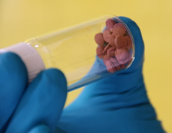
Fig. S8 Tablet specimens. Left: microscopy graph of initial tablet composition (without iron oxide);middle: photograph of initial tablet composition (without iron oxide); right: photograph of final tablet composition (with iron oxide).
8 Advanced-Manufacturing Samples for Simulated-Space Experiments at Earth Facilities
8.1 Samples for alpha- and beta irradiation
Table S6 Tablet specimens for Earth-based alpha- and beta experiments; mass and dimensional specification).
Base case |  |  | High Iron case |  |  | High titania case
Tablet weight (mg) | Tablet actual weight (mg) | Thickness (mm) | Tablet weight (mg) | Tablet actual weight (mg) | Thickness (mm) | Tablet weight (mg) | Tablet actual weight (mg) | Thickness (mm)
98.5 | 82.6 | 1.5 | 99 | 93.4 | 1.2 | 98.9 | 94.8 | 1.7
98.7 | 90 | 1.5 | 99.3 | 90.9 | 1.4 | 98.6 | 87.5 | 1.5
98.8 | 91.9 | 1.5 | 99.5 | 92.7 | 1.5 | 98.5 | 90.5 | 1.5
98.3 | 91.4 | 1.4 | 99 | 93.1 | 1.3 | 99.1 | 92.8 | 1.5
98.5 | 86.2 | 1.5 | 99.6 | 90.8 | 1.4 | 98.4 | 90.1 | 1.5
98.8 | 50.2 | 1.5 | 89.9 | 89.6 | 1.3 | 98.4 | 89.2 | 1.4
98.7 | 92.6 | 1.6 | 74.3 | 65.9 | 0.9 | 74.2 | 66 | 1
98.6 | 94.2 | 1.5 | 74.3 | 67.5 | 1 | 74 | 66.6 | 1
98.4 | 91.7 | 1.5 | 74.6 | 67.1 | 1 | 74.1 | 53.2 | 0.9
73.7 | 54.2 | 1.1 | 74.6 | 66.8 | 1 | 74.1 | 66.6 | 1
73.7 | 63.3 | 1.2 | 74.4 | 61 | 0.9 | 73.9 | 67.1 | 1
74 | 73.8 | 1.2 | 74.5 | 66.5 | 1 | 74.1 | 67.2 | 0.9
74.1 | 51.7 | 0.9 | 49.5 | 42.6 | 0.4 | 49.9 | 53.8 | 0.5
74.1 | 63.4 | 1 | 49.7 | 42.9 | 0.5 | 49.6 | 45 | 0.6
74.1 | 60.6 | 1 | 50 | 41.7 | 0.5 | 49.2 | 41.2 | 0.4
73.5 | 69.2 | 1 | 49.7 | 51 | 0.5 | 49.3 | 40.5 | 0.5
73.5 | 65.8 | 1.1 | 50.1 | 42.6 | 0.5 | 49.5 | 42.8 | 0.5
73.9 | 70 | 1 | 49.7 | 35.8 | 0.3 | 49.4 | 38 | 0.4
48.8 | 50.5 | 0.7
48.9 | 43.2 | 0.7
49.1 | 40.5 | 0.8
49.5 | 38.6 | 0.6
49.5 | 39 | 0.8
49.7 | 40.3 | 0.8
49.3 | 43.5 | 0.5
49.4 | 44 | 0.5
49.5 | 42.6 | 0.5

9 Blister-Tablet Housing in 2U CubeLab of Space Tango
9.1 Diverse steps towards encasing the bister-tablets in the 2U CubeLab

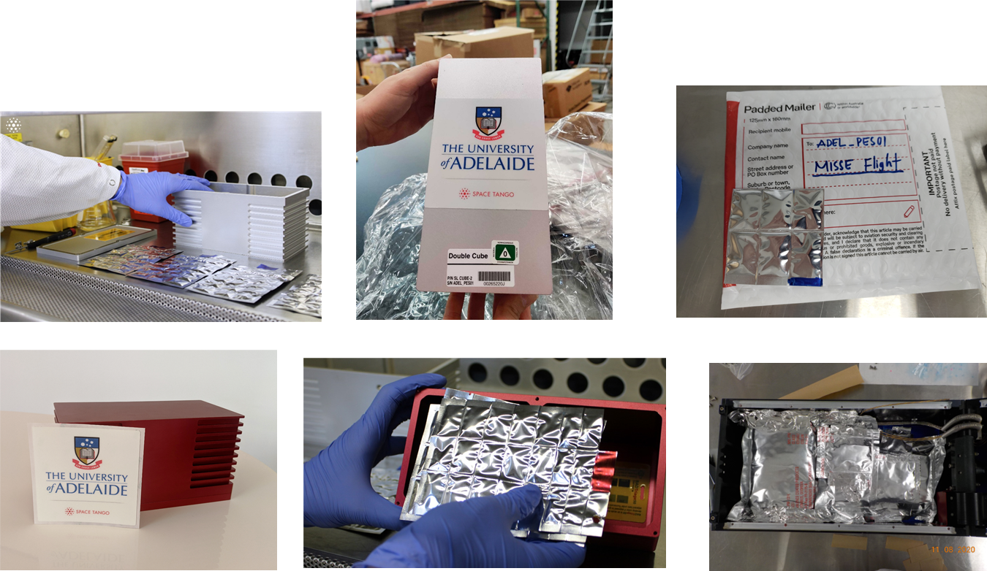
Fig. S9 Packaging and shipping of the tablet specimen samples to ISS and MISSE. Diverse consecutive steps of samples encasing are shown.

10 Radiation Doses in Space
10.1 Radiation dose in the low Earth orbit at/near the International Space Station
Table S7 Missions and radiation dose.
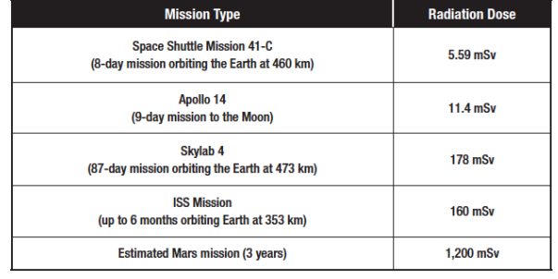
The table above is reported by a NASA study (https://www.nasa.gov/sites/default/files/atoms/files/space_radiation_ebook.pdf) is the combined dose of a mission (all radiation)
GCR (87% proton, 12% alpha, 1% heavy particle and 2% electron) dose rate to vary by a factor of about 5 going from low latitudes (dose rates of ~ 0.05 uGy/minute) to high latitudes (~ 0.25 uGy/minute); dose rates in the trapped belt (proton and electron) can exceed 10 uGy/minute. The mix of neutron and gamma radiation at ISS can be from 0.02 uGy/minute to 0.48 uGy/minute. Relativistic electrons and/or bremsstrahlung (Secondary radiation – including X-ray) in the outer radiation belt (ORB), with an average daily dose of 0.19 uGy/minutes.
10.2 Radiation dose on moon
The radiation levels on the Moon’s surface are 200- to 1,000-times more than that on Earth’s surface – and 2.6-times more than what astronauts onboard the International Space Station (ISS) are exposed to. The estimated GCR contributed to a radiation dose of 1,369 mSv/day, equivalent to 1.35 uGy/minutes on Moon surface. No Solar Particle Event (SPE) data was recorded due to the low activity of the solar cycle.
10.3 Radiation dose on Mars
Mars has a Martian atmosphere that stop most SPE particles will be stopped by the atmosphere before they reach the surface. However, neutrons can still reach the surface. The average natural radiation level on Mars is 240-300 mSv per year. This is about 40-50 times the average on Earth. Not counting the journey to Mars, the GCR dose rate can be seen to vary between 0.210 ± 0.040 mGy/day. During an SPE event, the dose of SPE is ~50 μSv = 25% of GCR/day.

11 X-Ray Irradiation Setup
11.1 Operational schematic
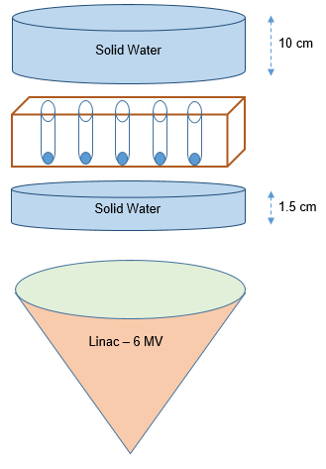
Fig. S10 Operational scheme of the X-ray experiments.
Using two high-density polyethylene blocks of solid water, the setup includes a 1.5 cm layer for bulk Dose-Volume parameter (DVP) and an additional 10 cm layer placed on top to induce backscattering, simulating scatter radiation effects similar to space conditions. The linear accelerator (LINAC) was calibrated with a source-to-target distance (SSD) of 70 cm, resulting in a uniform photon radiation field measuring 40 cm x 40 cm.
11.2 X-Ray sample Holder Box
A box made of carton paper was used as sample holder during the X-ray irradiation. The box comprises 7 rows and 5 columns to hold 35 tablet specimen samples.
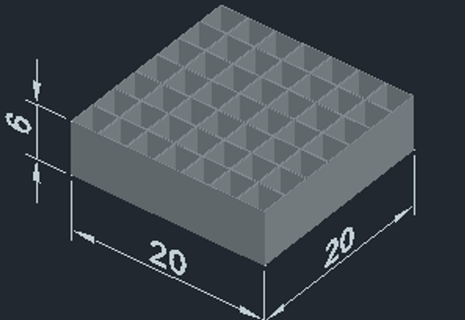
Fig. S11 Sample holder box for X-ray experiments.

11.2.1 X-ray procedure on testing samples
Below is given a typical experimental array of tablet specimen samples during the X-ray irradiation. The samples are grouped in subsets, each with an own irradiation time.
Table S8 X-ray procedure on testing samples.
#1 | 2 | 3 | 4 | 5 | Take out in 5 min
6 | 7 | 8 | 9 | 10 | Take out in 5 min
11 | 12 | 13 | 14 | 15 | Take out in 5 min
#1 | 2 | 3 | 4 | 5 | Take out in 1 h
6 | 7 | 8 | 9 | 10 | Take out in 1 h
11 | 12 | 13 | 14 | 15 | Take out in 1 h
Extreme case |  |  |  |  | Take out in 1 h

11.3 X-ray setup photograph
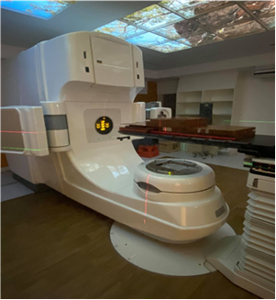

12 Tablet transfer from ISS to MISSE Platform
12.1 Discharging from ISS
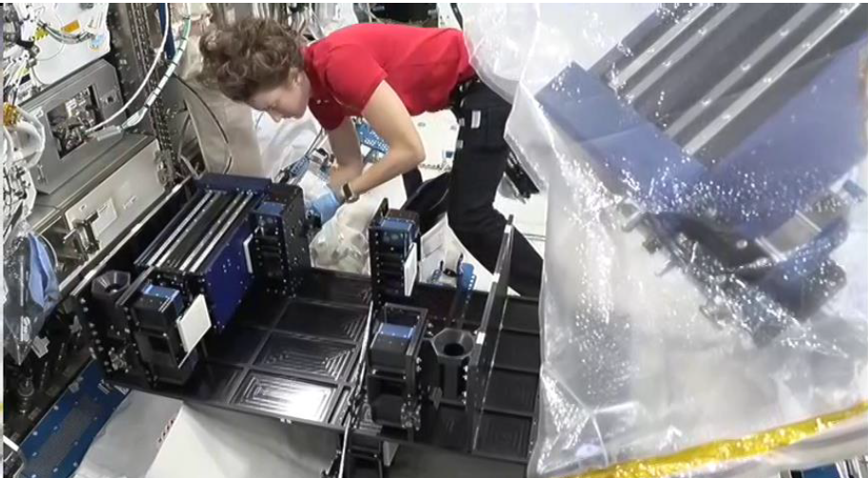
Fig. S12 Charging samples to the outer MISSE platform –from ISS.

12.2 Outside-ISS: movement to MISSE platform
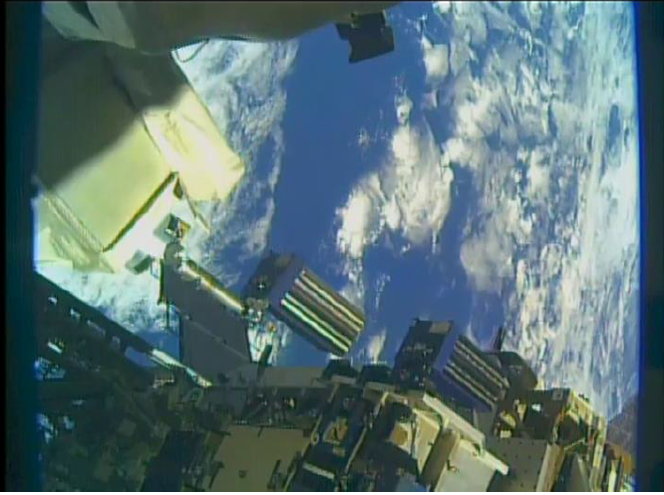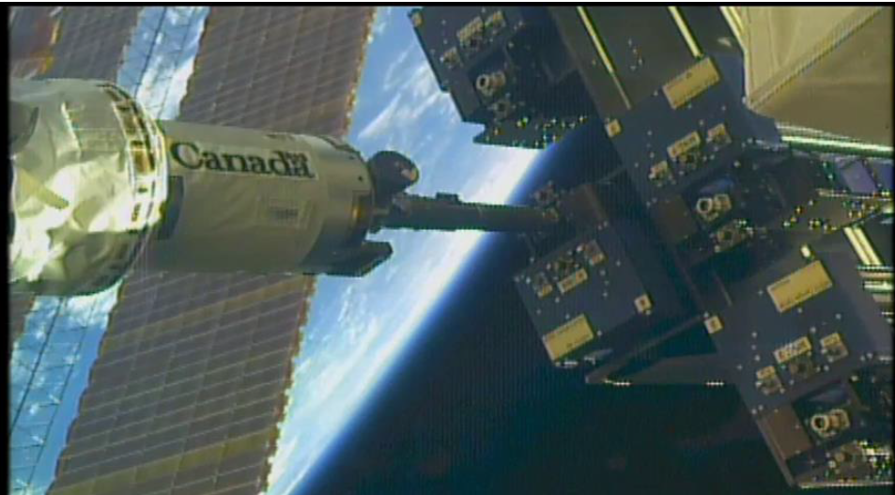
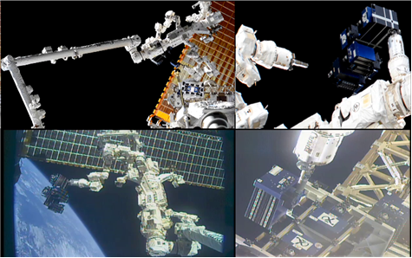
Fig. S13 Charging samples to the outer MISSE platform – outside ISS.
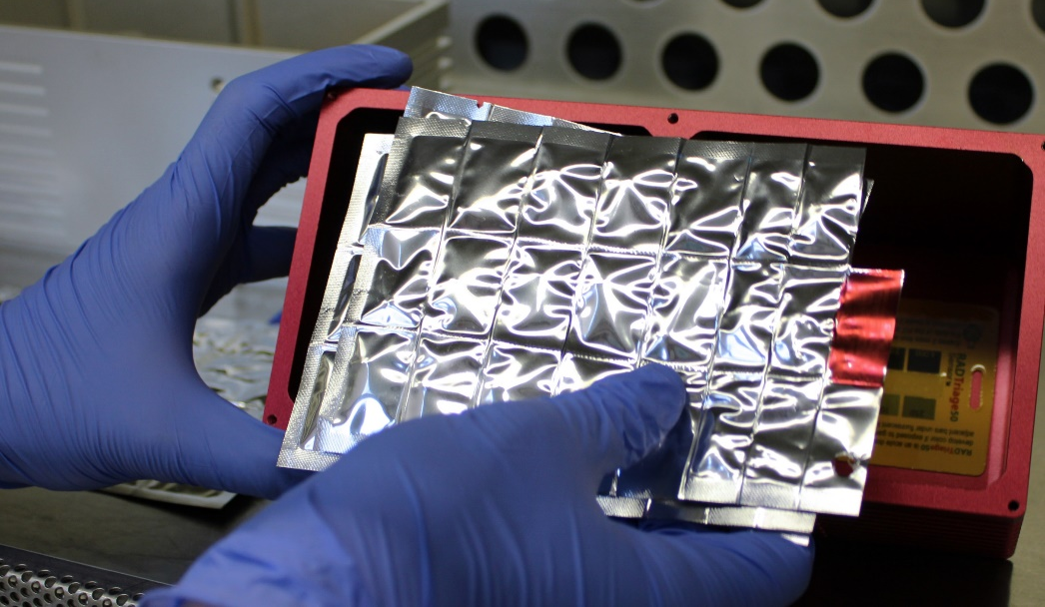
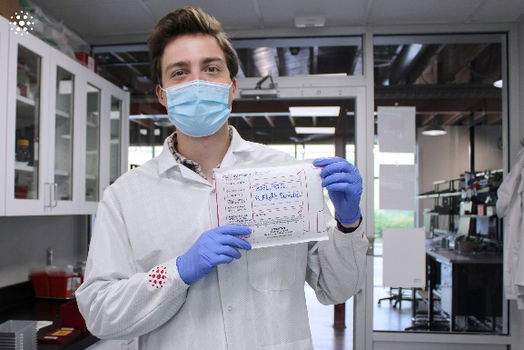

13 References
1 Jampilek, J., Dolowy, M. & Pyka-Pajak, A. Estimating limits of detection and quantification of ibuprofen by TLC-densitometry at different chromatographic conditions. Processes 8, 919 (2020).

