Supplement 1
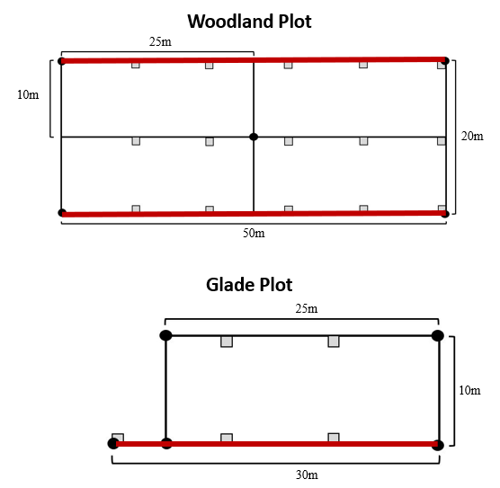
Figure S1. Orientation of 1m² quadrats in woodland and glade plots is represented by grey-filled squares. Location of herbaceous species abundance transects is designated by bold red lines.

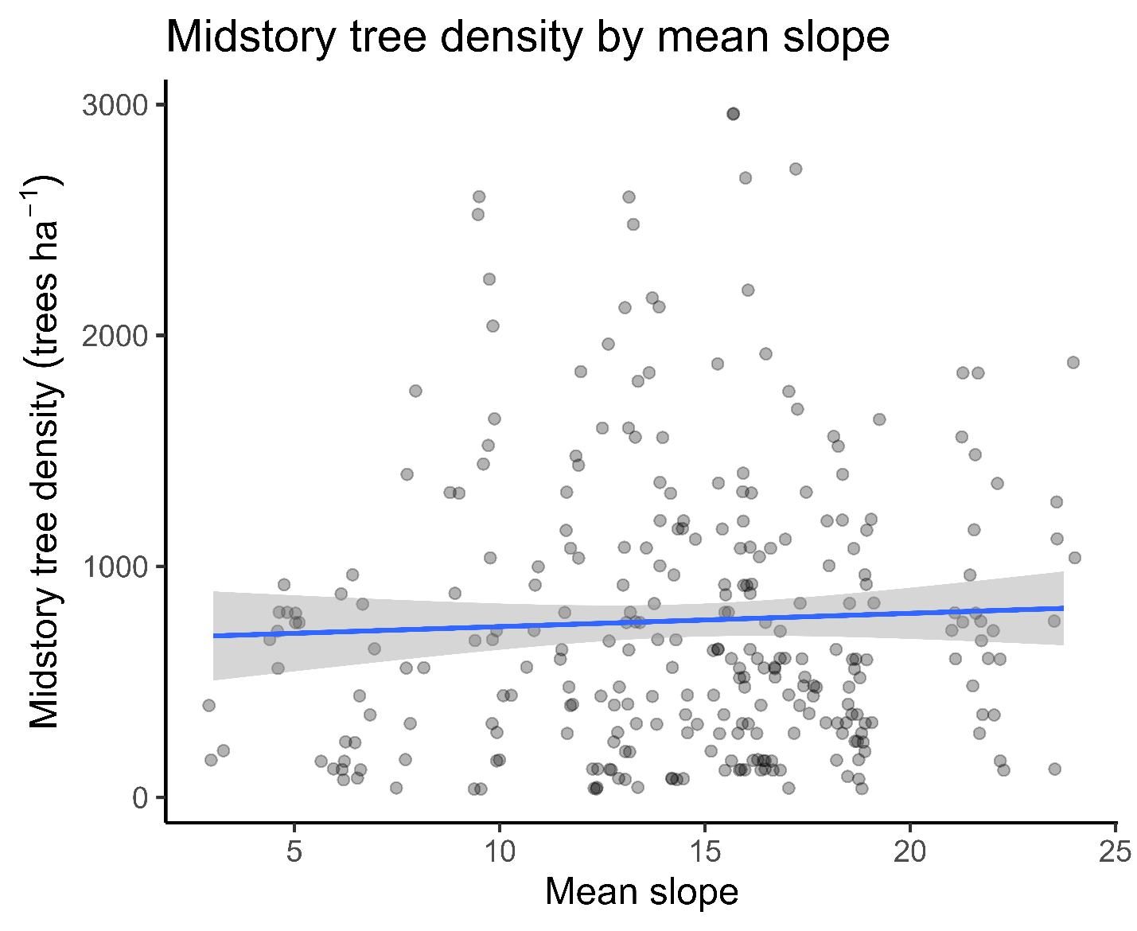
Figure S2. Midstory (2.5-14.9 cm DBH) tree density as mean plot slope increases at Ozark National Scenic Riverways. Data was collected from 1999 to 2021. Midstory tree density increased marginally with mean plot slope increasing.

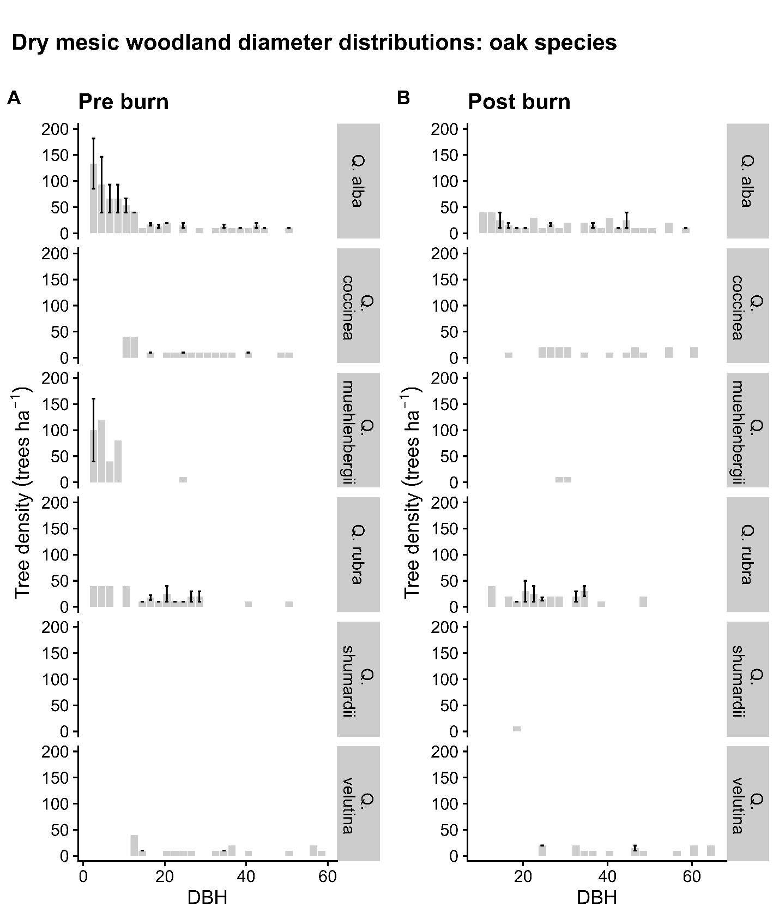
Figure S3. Dry woodland diameter distributions for oak species. Diameter distributions for dry mesic woodlands at Ozark National Scenic Riverways. Post burn data indicates data collected after 5 burns. A lack of error bar indicates that only one plot had trees in that species group for a given diameter at breast height (DBH). Data was collected in post burn years from 1999 to 2021. (A) Pre burn oak species diameter distributions. (B) Post burn oak species diameter distributions. The dominant species was Q. alba. Q. alba saw a decline in midstory trees but did not completely lose the midstory layer in post burn treatments.

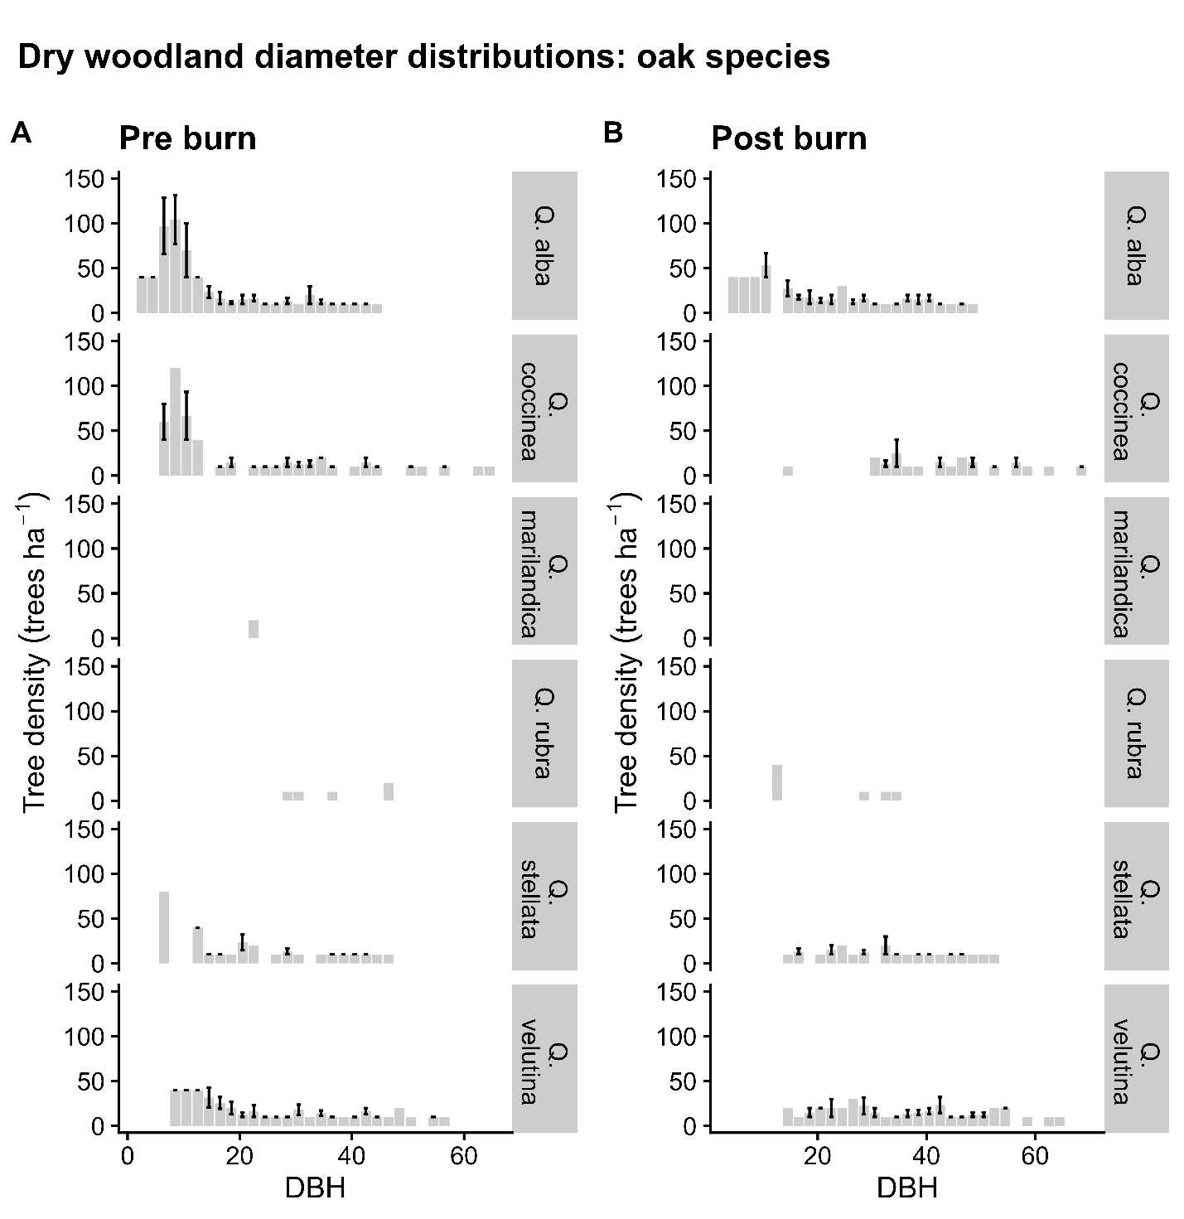
Figure S4. Dry woodland diameter distributions for oak species. Diameter distributions for dry woodlands at Ozark National Scenic Riverways. Post burn data indicates data collected after 5 burns. A lack of error bar indicates that only one plot had trees in that species group for a given diameter at breast height (DBH). Data was collected in post burn years from 1999 to 2021. (A) Pre burn species oak species diameter distributions. (B) Post burn oak species diameter distributions. All species but white oak (Q. alba) appear to lose their midstory layer, and even for Q. alba, very few to only single plots contain midstory size trees.

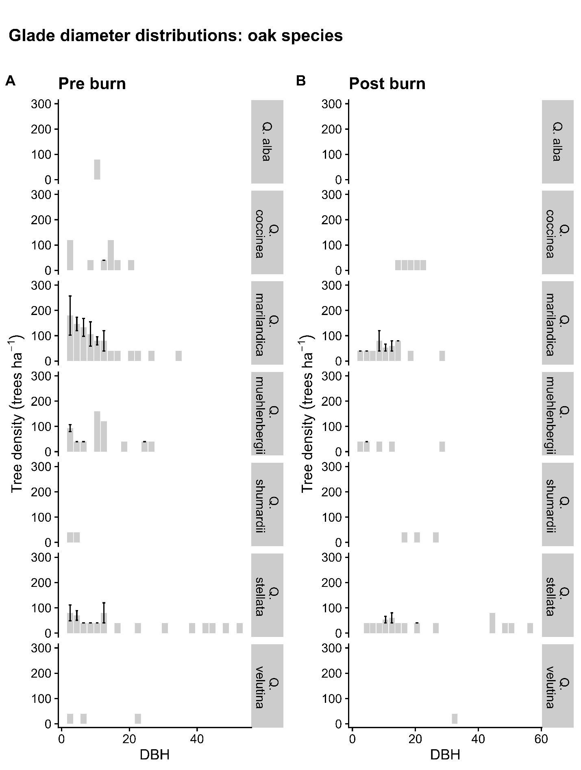
Figure S5. Glade diameter distributions for oak species. Diameter distributions for glades at Ozark National Scenic Riverways. Post burn data indicates data collected after 5 burns. A lack of error bar indicates that only one plot had trees in that species group for a given diameter at breast height (DBH). Data was collected in post burn years from 1999 to 2021. (C) Pre burn oak species diameter distributions. (D) Post burn oak species diameter distributions.

