Supporting information
S1 Table. The data are presented as mean (M), standard deviation (±SD) corresponding to the number of cells (N) (Figure 1). Values are normalized on 100% of the control group (untreated CTRL).
S2 Table. The data are presented as mean (M), standard deviation (±SD) corresponding to the number of cells (N) (Figure 2).Values are normalized on 100% of the control group (untreated CTRL) .

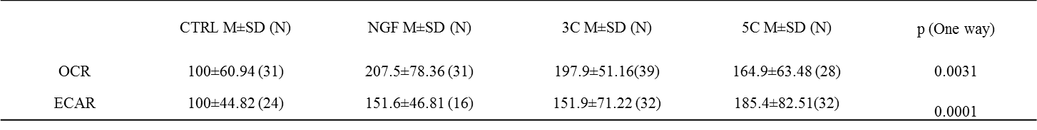
S3 Table. The data are presented as mean (M), standard deviation (±SD) corresponding to the number of cells (N) (Figure 4).Values are normalized on 100% of the control group (untreated CTRL).
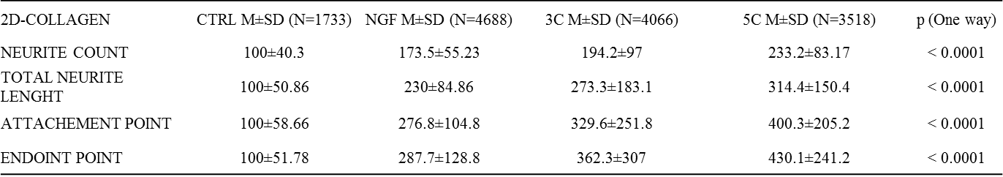
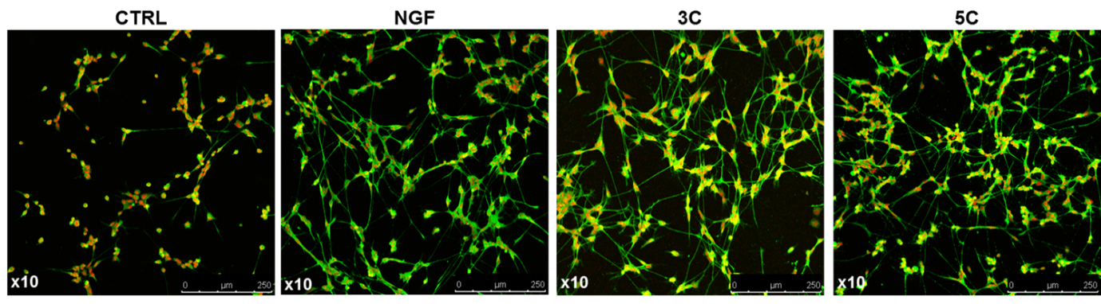S1 Figure. Original pictures (confocal microscope, x10, immunostaining (IMS) with βtubuline/Alexa488 (green) and DraQ5 (red) of a 2D cell culture used for analysis using ImageJ software (Figure 3).

