Supplementary Information
For

“An analysis of transition-resulted goal scoring patterns in football leagues: a comparison of the first 5 rounds and the last 5 rounds”

By

Pedro Eusebio, Pablo Prieto-González, Rui Marcelino

Corresponding author: eusebio.pedro@gmail.com

- Supplementary Information:
Supplementary information with the results obtained in each of the observed leagues is presented below:
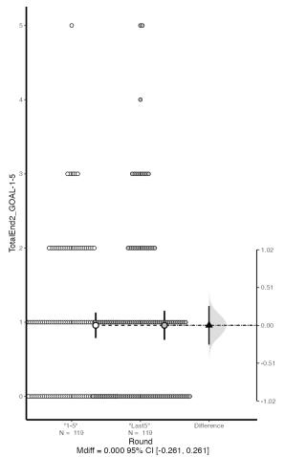
Figure S1: Estimate Independent Mean Difference –Goals by OT – Comparison between “Rounds 1 to 5” and “Rounds Last 5”
Emerging Leagues – Goal by OT
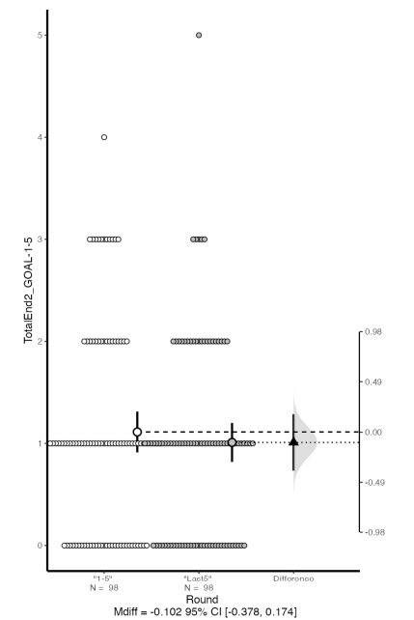
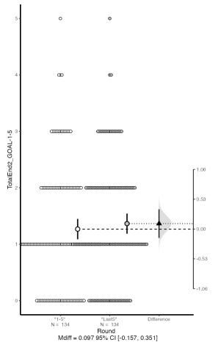
Top Leagues – Goal by OT

Marginal Leagues – Goal by OT

Figure S2: Estimate Independent Mean Difference –Goals by NT – Comparison between “Rounds 1 to 5” and “Rounds Last 5”
Top Leagues – Goal by NT

Marginal Leagues – Goal by NT

Emerging Leagues – Goal by NT
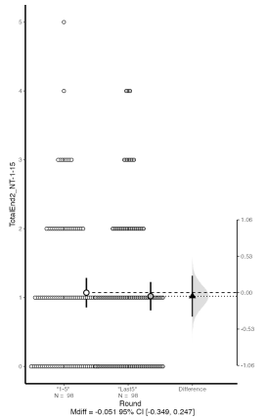
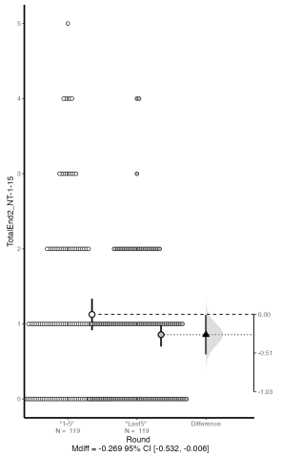
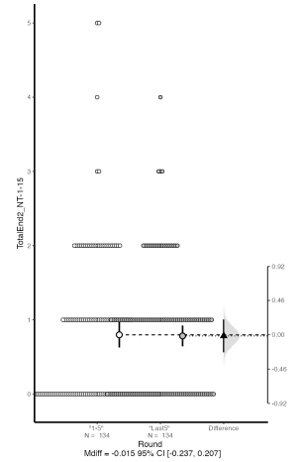

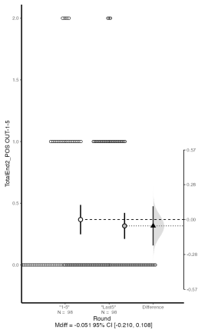
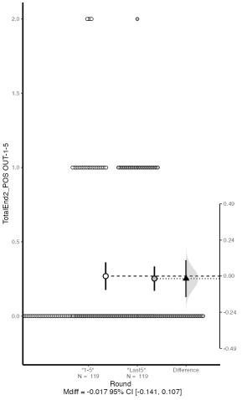
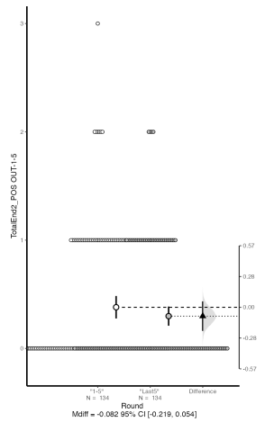
Figure S3: Estimate Independent Mean Difference –Goals by POS OUT – Comparison between “Rounds 1 to 5” and “Rounds Last 5”
Top Leagues – Goal by POS OUT

Marginal Leagues – Goal by POS OUT

Emerging Leagues – Goal by POS OUT

Figure S4: Estimate Independent Mean Difference –Goals by SP – Comparison between “Rounds 1 to 5” and “Rounds Last 5”
Emerging Leagues – Goal by SP
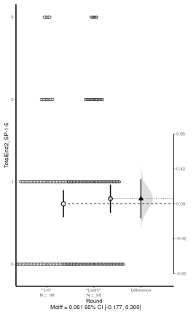
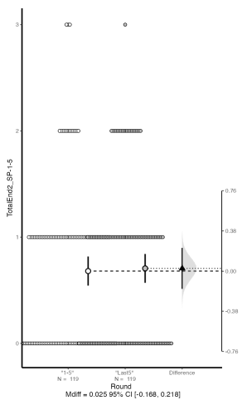
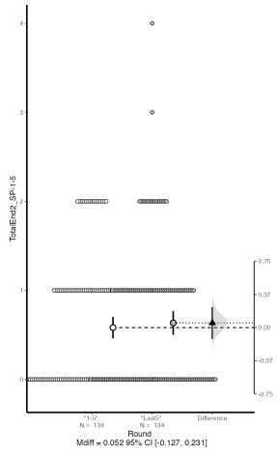
Top Leagues – Goal by SP

Marginal Leagues – Goal by SP

Supplementary information with the results obtained in each of the observed leagues is presented below:
Table S1: Distribution of the types of goals per leagues on the variables “Rounds 1 to 5” and “Rounds Last 5”.
 |  |  | Rounds - 1 to 5 |  |  |  | Rounds - Last 5
 | Games Observed with goals | Total Goals | Goals by NT | Goals by OT | Goals by SP | Goals by POS OUT | Goals by NT | Goals by OT | Goals by SP | Goals by POS OUT | % Of goals By OT + POS OUT
Qatar | 58 | 189 | 33 | 37 | 24 | 7 | 26 | 28 | 20 | 14 | 45,50%
Saudi | 72 | 218 | 29 | 39 | 24 | 14 | 40 | 35 | 27 | 10 | 44,95%
UAE | 66 | 223 | 43 | 33 | 24 | 15 | 34 | 36 | 31 | 7 | 40,80%
Portugal | 78 | 223 | 40 | 40 | 27 | 14 | 34 | 33 | 21 | 14 | 45,29%
Netherland | 86 | 281 | 59 | 42 | 34 | 10 | 44 | 54 | 28 | 10 | 41,28%
Russia | 74 | 187 | 35 | 32 | 20 | 8 | 24 | 27 | 35 | 6 | 39,04%
Germany | 86 | 281 | 39 | 65 | 29 | 13 | 29 | 65 | 26 | 15 | 56,35%
Italy | 94 | 284 | 33 | 54 | 29 | 25 | 44 | 59 | 26 | 14 | 53,52%
Spain | 88 | 254 | 35 | 51 | 20 | 13 | 32 | 59 | 33 | 11 | 52,76%
Totals | 702 | 2140 | 346 | 393 | 231 | 119 | 307 | 396 | 247 | 101

Note: NT – No Transition. OT – Offensive Transition. SP – Set Pieces. POS OUT – Positive Outcome.
OT + POS OUT – Goals obtained by Offensive transition and Positive Outcome.

Table S2: Estimate Ind. Mean Difference – Goals obtained by OT per league – Comparison between “Rounds 1 to 5” and “Rounds Last 5”.
Goals by OT |  | Rounds 1 to 5 | Rounds Last 5 | d_{unbiased}
Emerging Leagues | UAE League | 1.00 (0.65; 1.35) 33 | 1.09 (0.72; 1.46) 33 | 0.09 (-0,40; 0,58)
Emerging Leagues | Saudi League | 1.08 (0.77; 1.41) 36 | 0.97 (0.68;1.26) 36 | -0,12 (-0.60; 0.35)
Emerging Leagues | Qatar League | 1.28 (0.87; 1.69) 29 | 0.97 (0.61; 1.32) 29 | -0.30 (-0.84; 0.22)
Marginal Leagues | Netherlands League | 0.98 (0.70; 1.25) 43 | 1.26 (0.91; 1.61) 43 | 0.27 (-0.16; 0.70)
Marginal Leagues | Portugal League | 1.03 (0.67; 1.38) 39 | 0.85 (0.50; 1.19) 39 | -0.16 (-0.62; 0,29)
Marginal Leagues | Russia League | 0.87 (0.60; 1.13) 37 | 0.73 (0.42; 1.04) 37 | -0.15 (-0.62; 0.31)
Top Leagues | German League | 1.51 (1.20; 1.83) 43 | 1.51 (1.14; 1.89) 43 | 0.00 (-0,43; 0,43)
Top Leagues | Italy League | 1.15 (0.86; 1.44) 47 | 1.26 (0.98; 1.54) 47 | 0.11 (-0,30; 0,52)
Top Leagues | Spain League | 1.16 (0.82; 1.50) 44 | 1.34 (1.06; 1.62) 44 | 0.17 (-0,25; 0,60)

Note: M – Media of these events per game; S - standard deviation; 95% CI - confidence intervals (95%); N – Total number of events

Table S3: – Estimate Ind. Mean Difference – Goals obtained by NT per league – Comparison between “Rounds 1 to 5” and “Rounds Last 5”.
Goals by NT |  | Rounds 1 to 5 | Rounds Last 5 | d_{unbiased}
Emerging Leagues | UAE League | 1.37 (0.97; 1.78) 33 | 1.02 (0.76; 1.29) 33 | -0.31 (-0,75; 0,12)
Emerging Leagues | Saudi League | 1.03 (0.67; 1.38) 36 | 0.87 (0.55; 1.19) 36 | -0.14 (-0,60; 0,30)
Emerging Leagues | Qatar League | 0.95 (0.63; 1.26) 29 | 0.65 (0.43; 0.87) 33 | -0.35 (-0,83; 0,10)
Marginal Leagues | Netherlands League | 0.46 (0.22; 0.69) 43 | 0.21 (0.07; 0.36) 43 | -0,43 (-0,94; 0,05)
Marginal Leagues | Portugal League | 0.81 (0.51; 1.10) 39 | 1.11 (0.73; 1.49) 39 | 0.30 (-0,17; 0,78)
Marginal Leagues | Russia League | 1.14 (0.65; 1.62) 37 | 0.90 (0.53; 1.26) 37 | -0.21 (-0,74; 0,31)
Top Leagues | German League | 0.91 (0.56; 1.26) 43 | 0.67 (0.45; 0.90) 43 | 0.24 (-0,67; 0,19)
Top Leagues | Italy League | 0.70 (0.45; 0.95) 47 | 0.94 (0.69; 1.18) 47 | 0.27 (-0,13; 0,69)
Top Leagues | Spain League | 0.80 (0.49; 1.10) 44 | 0.73 (0.47; 0.99) 44 | -0.07 (-0,50; 0,35)

Note: M – Media of these events per game; S - standard deviation; 95% CI - confidence intervals (95%); N – Total number of events

Table S4: – Estimate Ind. Mean Difference – Goals obtained by POS OUT per league – Comparison between “Rounds 1 to 5” and “Rounds Last 5”.
Goals by POS OUT |  | Rounds 1 to 5 | Rounds Last 5 | d_{unbiased}
Emerging Leagues | UAE League | 0.46 (0.22; 0.69) 33 | 0.21 (0.07; 0.36) 33 | -0.43 (-0,94; 0,05)
Emerging Leagues | Saudi League | 0.39 (0.19; 0.59) 36 | 0.28 (0.13; 0.43) 36 | -0,21 (-0,68; 0,26)
Emerging Leagues | Qatar League | 0.24 (0.05; 0.43) 29 | 0.48 (0.23; 0.74) 29 | 0.39 (-0,12; 0,94)
Marginal Leagues | Netherlands League | 0.23 (0.07; 0.39) 43 | 0.23 (0.10; 0.36) 43 | 0.00 (-0,43; 0,43)
Marginal Leagues | Portugal League | 0.36 (0.19; 0.53) 39 | 0.36 (0.19; 0.53) 39 | -0.00 (-0,45; 0,45)
Marginal Leagues | Russia League | 0.22 (0.06; 0.37) 37 | 0.16 (0.04; 0.29) 37 | -0.12 (-0,59; 0,34)
Top Leagues | German League | 0.30 (0.13; 0.47) 43 | 0.35 (0.18; 0.52) 43 | 0.08 (-0,35; 0,51)
Top Leagues | Italy League | 0.53 (0.35; 0.71) 47 | 0.30 (0.14; 0.46) 47 | -0.40 (-0,82; 0,01)
Top Leagues | Spain League | 0.25 (0.12; 0.38) 44 | 0.30 (0.11; 0.49) 44 | -0.08 (-0,51; 0,34)
Note: M – Media of these events per game; S - standard deviation; 95% CI - confidence intervals (95%); N – Total number of events

Table S5: Estimate Ind. Mean Difference – Goals obtained by SP per league – Comparison between “Rounds 1 to 5” and “Rounds Last 5”.
Goals by SP |  | Rounds 1 to 5 | Rounds Last 5 | d_{unbiased}
Emerging Leagues | UAE League | 0.73 (0.39; 1.07) 33 | 0.94 (0.62; 1.26) 33 | 0.22 (-0,27; 0,72)
Emerging Leagues | Saudi League | 0.67 (0.43; 0.91) 36 | 0.75 (0.46; 1.04) 36 | 0.10 (-0,36; 0,58)
Emerging Leagues | Qatar League | 0.83 (0.53; 1.13) 29 | 0.69 (0.41; 0.97) 29 | -0,17 (-0,71; 0,35)
Marginal Leagues | Netherlands League | 0.79 (0.57; 1.02) 43 | 0.65 (0.42; 0.88) 43 | -0.19 (-0,62; 0,24)
Marginal Leagues | Portugal League | 0.69 (0.43; 0.96) 39 | 0.54 (0.35; 0.73) 39 | -0.21 (-0,67; 0,24)
Marginal Leagues | Russia League | 0.54 (0.31; 0.77) 37 | 0.95 (0.67; 1.22) 37 | -0.52 (0,06; 1,01)
Top Leagues | German League | 0.67 (0.46; 0.89) 43 | 0.60 (0.37; 0.85) 43 | -0.09 (-0,52; 0,33)
Top Leagues | Italy League | 0.62 (0.40; 0.84) 47 | 0.55 (0.35; 0.76) 47 | -0.09 (-0,50; 0,32)
Top Leagues | Spain League | 0.46 (0.27; 0.64) 44 | 0.75 (0.50; 1.00) 44 | 0.40 (-0,02; 0,83)

Note: M – Media of these events per game; S - standard deviation; 95% CI - confidence intervals (95%); N – Total number of events

Supplementary information with the results obtained in each of the observed leagues is presented below:
Figure S5: Estimate Independent Mean Difference –Goals by OT – Comparison between “Rounds 1 to 5” and “Rounds Last 5”
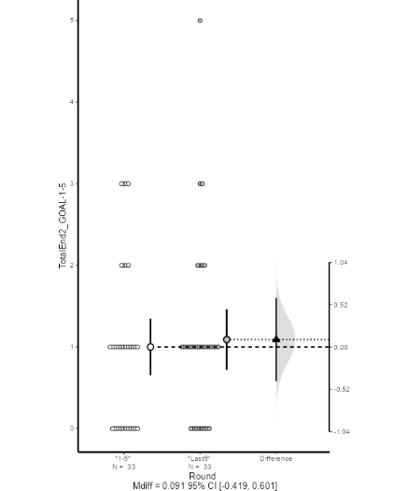
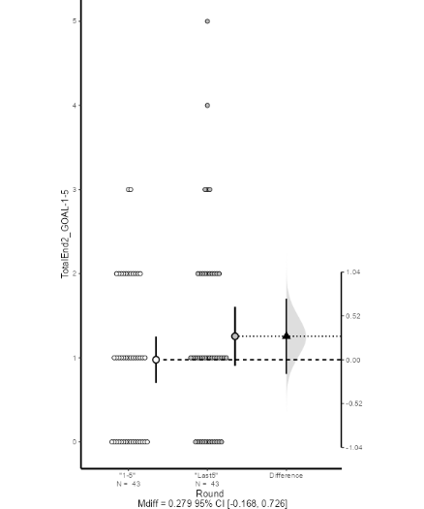
Netherlands League

UAE League
German League

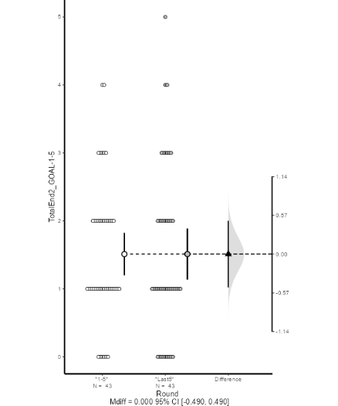
Saudi League
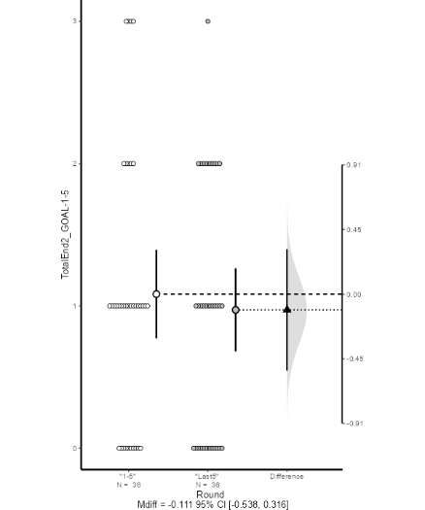
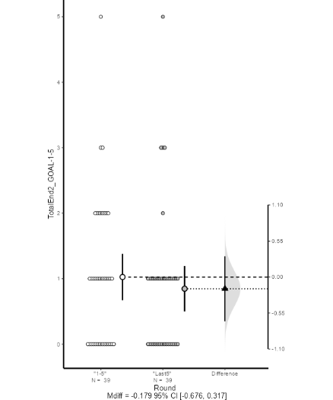
Italy League

Portugal League

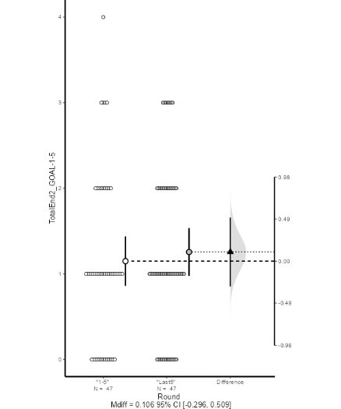
Qatar League
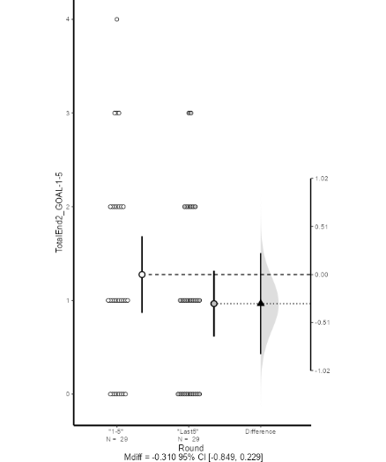
Spain League

Russia League

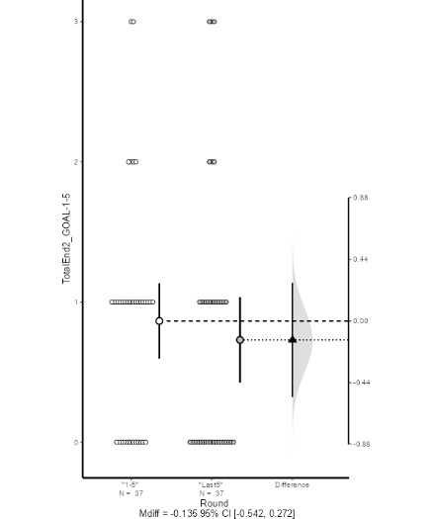
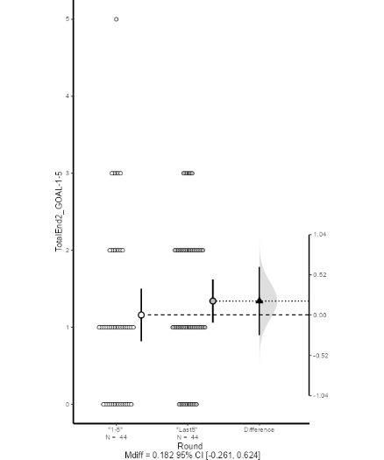
Figure S6: Estimate Independent Mean Difference –Goals by NT – Comparison between “Rounds 1 to 5” and “Rounds Last 5”
Netherlands League

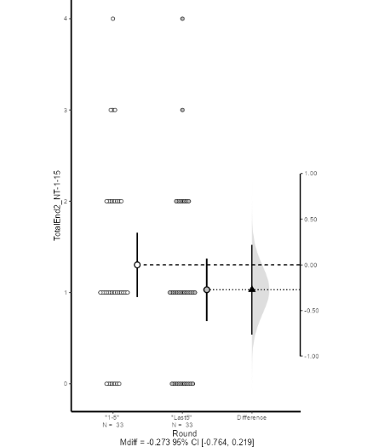
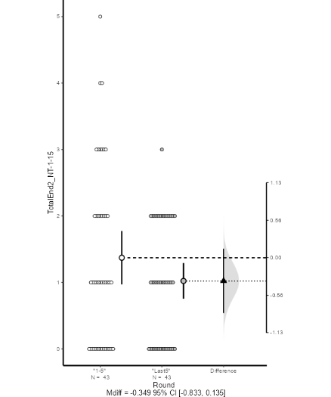
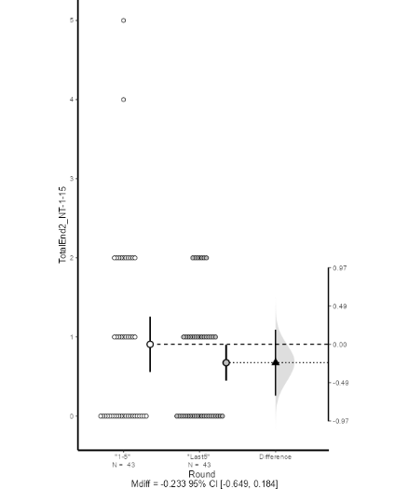
UAE League
German League

Italy League

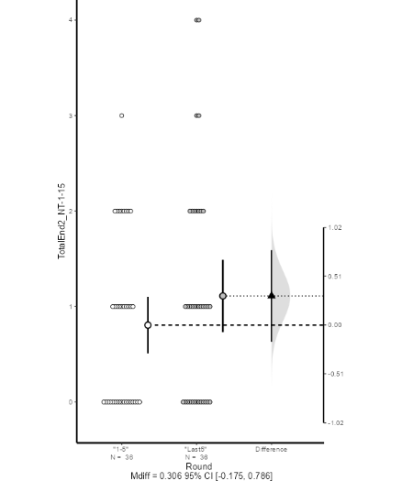
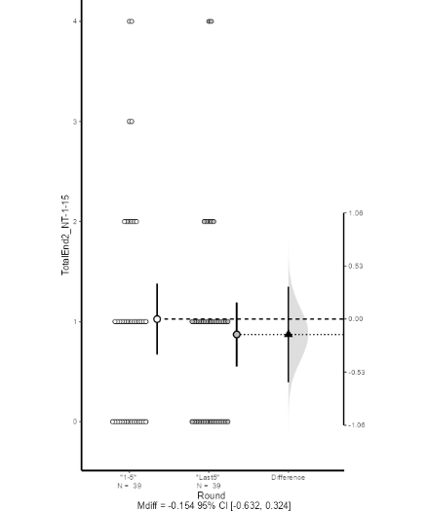
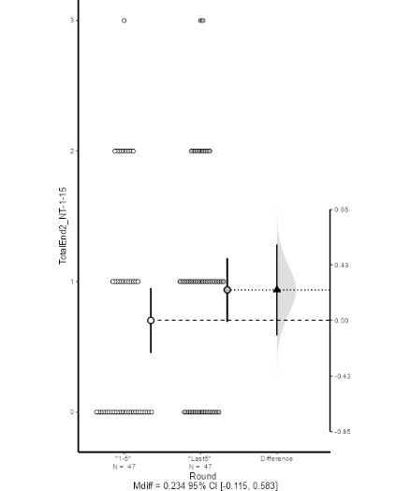
Portugal League

Saudi League
Qatar League
Spain League

Russia League

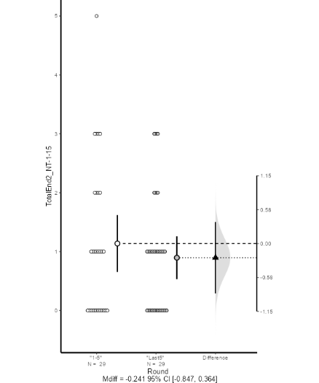
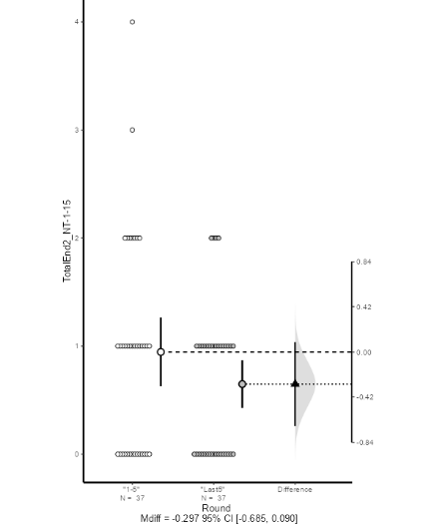
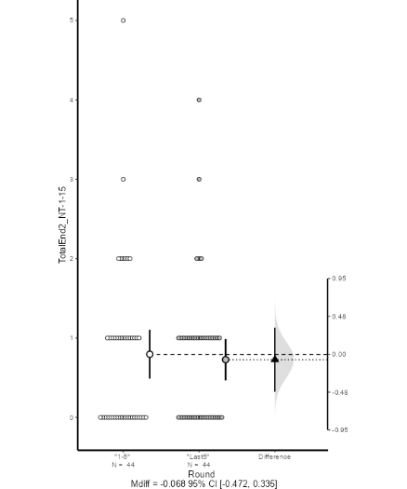

Figure S7: Estimate Independent Mean Difference –Goals by POS OUT – Comparison between “Rounds 1 to 5” and “Rounds Last 5”
Netherlands League

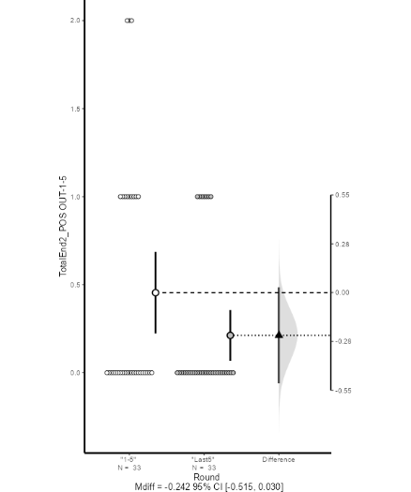
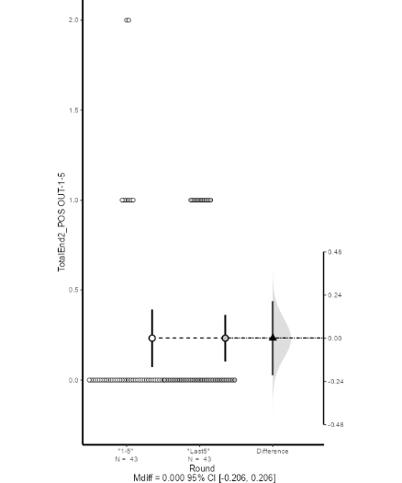
UAE League
German League

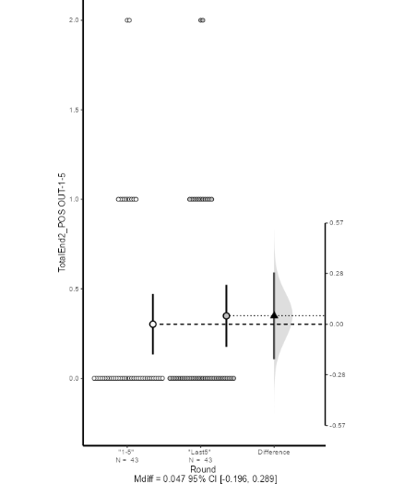
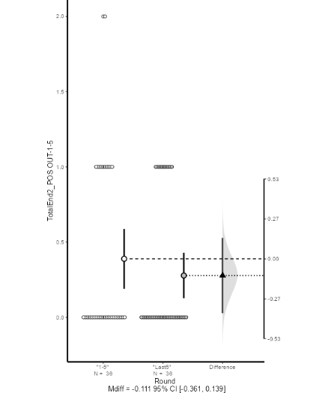
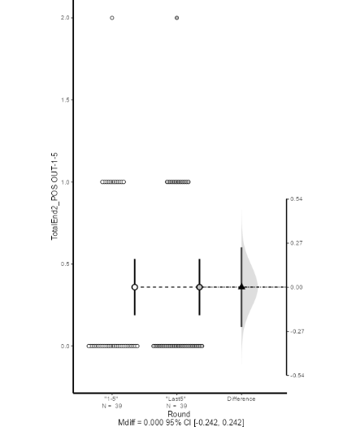
Saudi League
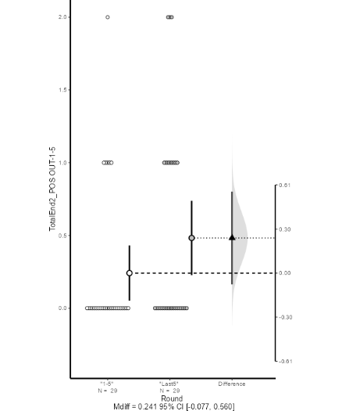
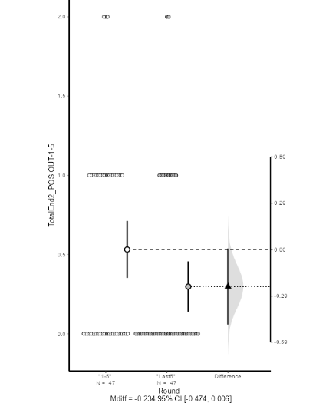
Qatar League
Russia League

Portugal League

Italy League

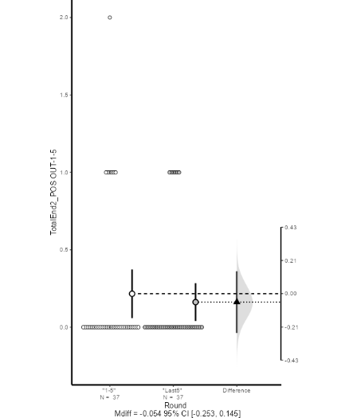
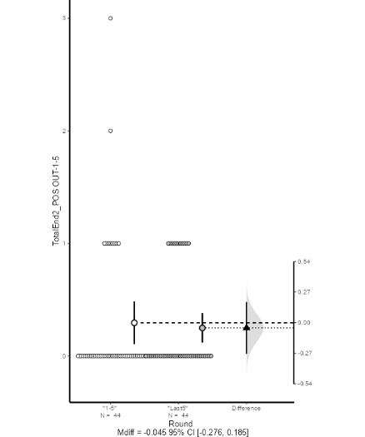
Spain League

Figure S8: Estimate Independent Mean Difference –Goals by SP – Comparison between “Rounds 1 to 5” and “Rounds Last
Netherlands League

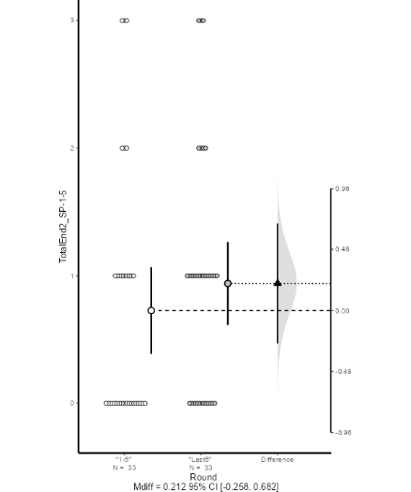
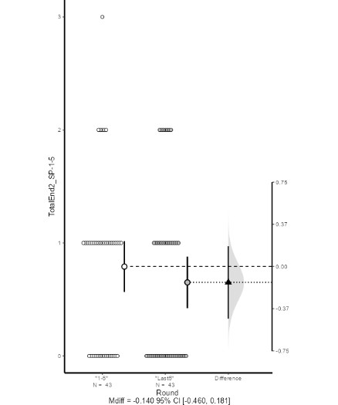
UAE League
German League

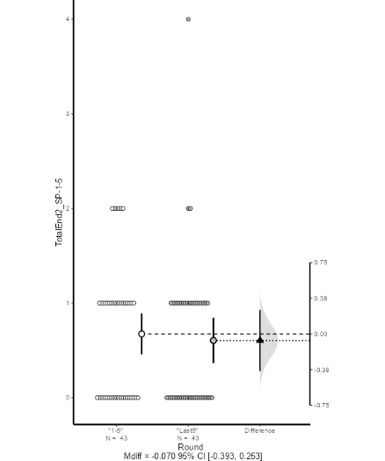
Portugal League

Italy League

Saudi League
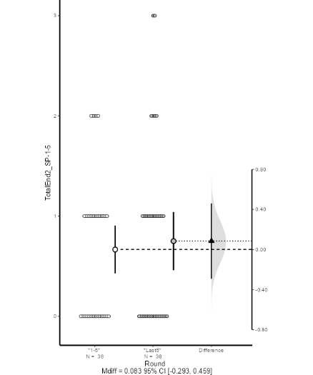
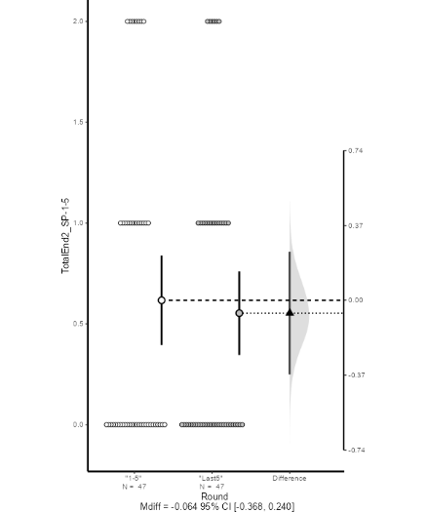
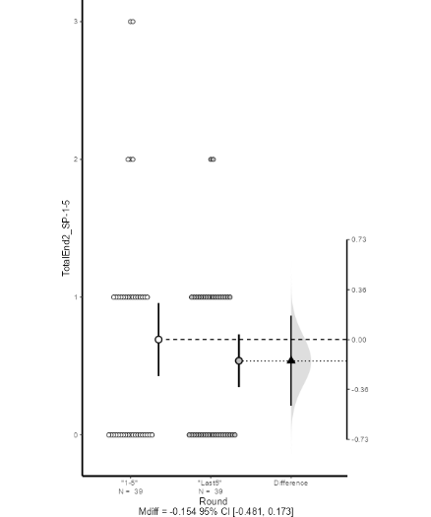
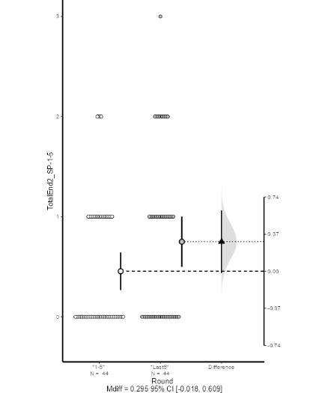
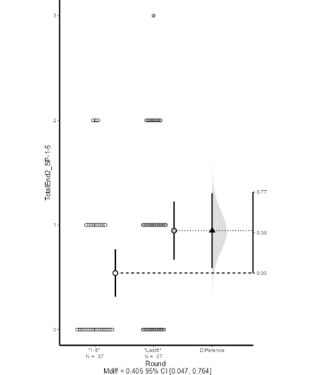
Qatar League
Russia League

Spain League

