Supplementary Table 1 Definition and incidence of each ACE
ACEs | Questionnaire items and definitions | Incidence rate
Physical abuse | When you were growing up, did your male/female guardian ever hit you?  (Often = 1,Sometimes = 1,Rarely = 0,Never = 0) | 27.79%
Household substance abuse | During the years you were growing up, did your female/male guardian ever have alcoholism or drug? (yes =1 ,no=0) | 7.41%
Domestic violence | Have your father/mother ever beat up your mother/father?  (Often = 1,Sometimes = 1,Rarely = 0,Never = 0) | 23.29%
Unsafe neighborhood | Was it safe being out alone at night in the neighborhood where you lived as a child?  (very safe = 0, somewhat safe = 0, not very safe = 1 , or not safe at all = 1 ) | 7.62%
Being bullied | 1) When you were a child, how often were you picked on or bullied by kids in your neighborhood? (Often = 1,Sometimes = 1,Rarely = 0,Never = 0) | 14.37%
Being bullied | 2) When you were a child, how often were you picked on or bullied by kids in your school? (Often = 1,Sometimes = 1,Rarely = 0,Never = 0) | 14.37%
Emotional neglect | 1) How much love and affection did your female guardian give you while you were growing up? (Often = 1,Sometimes = 1,Rarely = 0,Never = 0) | 33.15%
Emotional neglect | - How much effort did your female guardian put into watching over you?  (a lot = 0, some = 0, a little = 1 , or not at all = 1) | 33.15%
Household mental  illness | 1) Did your female/male guardian have abnormality of mind when you were young? (yes =1 ,no=0) | 14.24%
Household mental  illness | - During the years you were growing up, had your female/male guardian often showed continued signs of sadness or depression?  (during all = 1, most = 1, some =0, or only a little of the childhood =0) | 14.24%
family members imprisoned | During the years you were growing up, have your female/male guardian ever been arrested or sent to prison? (yes =1 ,no=0) | 0.31%
Parental separation or  divorce | Were your biological parents divorced (including long separation due to emotional problems) before you were 17 years? (yes =1 ,no=0) | 0.50%
death of parents | Either of the parents was dead before participant was 17 years. (yes =1 ,no=0) | 15.27%

Supplementary Table 2 Results of the mediation analysis with depressive symptom score as a continuous type variable
 | Estimate | 95% CI lower | 95% CI upper | P value
Total Effect | 1.9657 | 1.6354 | 2.2366 | <0.001***
Indirect effect | 0.0276 | 0.0066 | 0.0572 | 0.026*
Direct effect | 1.9381 | 1.639 | 2.2276 | <0.001***
Proportion mediated | 0.0140 | 0.0033 | 0.0290 | 0.026*
Note:*Signs indicate significance（*0.01＜P value＜0.05,**0.001＜P value＜0.01，***P value＜0.001）

Supplementary Table 3 Mediating Role of Unmarried Status (Divorced/Never Married) in the Association of Each ACE with Depressive Symptoms
 | Estimate | 95% CI lower | 95% CI upper | P value
Unsafe neighborhood
Total Effect | 0.0987 | 0.0612 | 0.1368 | <0.001***
Indirect effect | 0.0027 | -0.0001 | 0.0065 | 0.026*
Direct effect | 0.0960 | 0.0589 | 0.1344 | <0.001 ***
Proportion mediated | 0.0254 | -0.0012 | 0.0713 | 0.026 *
Being bullied
Total Effect | 0.1169 | 0.9111 | 0.1442 | <0.001***
Indirect effect | 0.0019 | 0.0002 | 0.0042 | 0.026 *
Direct effect | 0.1149 | 0.0892 | 0.1418 | <0.001***
Proportion mediated | 0.0157 | 0.0022 | 0.0375 | 0.026 *
Household mental illness
Total Effect | 0.2443 | 0.2148 | 0.2716 | <0.001***
Indirect effect | 0.0028 | 0.0008 | 0.0055 | <0.001***
Direct effect | 0.2416 | 0.2120 | 0.2688 | <0.001***
Proportion mediated | 0.0108 | 0.0033 | 0.0221 | <0.001***
family members imprisoned
Total Effect | 0.2644 | 0.0968 | 0.4248 | <0.001***
Indirect effect | 0.0137 | 0.0015 | 0.0384 | 0.006 **
Direct effect | 0.2507 | 0.0968 | 0.4248 | <0.001***
Proportion mediated | 0.0449 | 0.0045 | 0.1971 | 0.006 **
Note:*Signs indicate significance（*0.01＜P value＜0.05，**0.001＜P value＜0.01，***P value＜0.001）

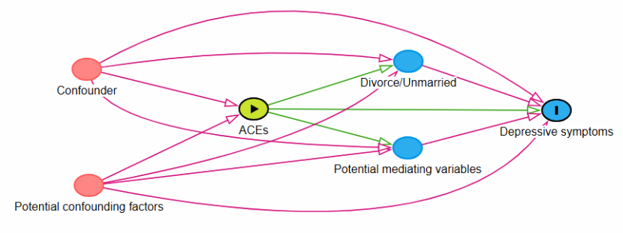
Supplementary Figure 1 DAG diagram
Notes:Confounder Including gender, age, ethnicity, and household registration type；Potential mediating variables Including education level, living situation, family per capita expenditure, participation in leisure activities, smoking history, drinking history, activities of daily life energy scale (ADL), instrumental activities of daily life (IADL), childhood socioeconomic level；Potential confounding factorsIt may be the parents' educational ideas, the community environment, etc

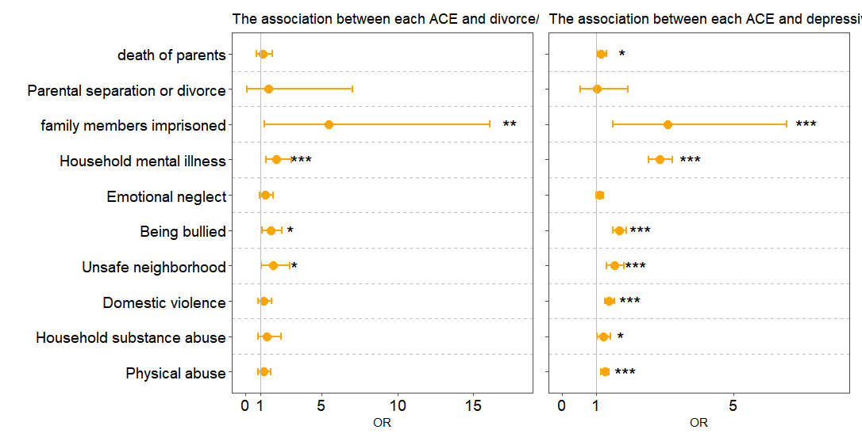
Supplementary Figure 2 Association of each ACE and marital status and depressive symptoms
Note:*Signs indicate significance（*0.01＜P value＜0.05，**0.001＜P value＜0.01，***P value＜0.001）

