Supplementary materials:

ESM 1: ARMS deployed during this study at 11 m (± 1m) depth on the outer slope of the La Saline coral reef, Reunion Island (Lat: -21.10401, Lon: 55.23598).
ARMS | Deployment | Retrieval | Immersion time (months) | Deployment season | Retrieval season
RUNA2A | 17/12/2018 | 19/12/2020 | 24 | Hot | Hot
RUNA2B | 17/12/2018 | 13/1/2021 | 24 | Hot | Hot
RUNA2C | 17/12/2018 | 13/1/2021 | 24 | Hot | Hot
CINA1A | 25/2/2020 | 27-31/08/2020 | 6 | Hot | Cool
CINA1B | 25/2/2020 | 27-31/08/2020 | 6 | Hot | Cool
CINA1C | 25/2/2020 | 27-31/08/2020 | 6 | Hot | Cool
CINA2A | 25/2/2020 | 20/2/2021 | 12 | Hot | Hot
CINA2B | 25/2/2020 | 22/2/2021 | 12 | Hot | Hot
CINA2C | 25/2/2020 | 22/2/2021 | 12 | Hot | Hot
CINA3A | 31/08/2020 | 19/2/2021 | 6 | Cool | Cool
CINA3B | 31/08/2020 | 19/2/2021 | 6 | Cool | Cool
CINA3C | 31/08/2020 | 20/2/2021 | 6 | Cool | Cool
CINA4A | 31/08/2020 | 26-30/08/2021 | 12 | Cool | Hot
CINA4B | 31/08/2020 | 26-30/08/2021 | 12 | Cool | Hot
CINA4C | 31/08/2020 | 26-30/08/2021 | 12 | Cool | Hot

ESM 2: Deployment and sequencing information of the samples included in the present study.
SampleID | ARMS | Fraction | Marker | Deployment season | Retrieval season | Immersion time | Index | Tag | PCR plate
REU_S1_100-500_COI | CINA1A | 106-500 | COI | Hot | Cool | 0.5 | 7 | 1 | 4
REU_S1_Sessile_COI | CINA1A | Sessile | COI | Hot | Cool | 0.5 | 7 | 2 | 4
REU_S1_100-500_18S | CINA1A | 106-500 | 18S | Hot | Cool | 0.5 | 7 | 1 | 4
REU_S1_Sessile_18S | CINA1A | Sessile | 18S | Hot | Cool | 0.5 | 7 | 2 | 4
REU_10_100-500_COI_doublon1 | CINA4A | 106-500 | COI | Cool | Hot | 1 | 2 | 2 | 1
REU_10_500-2000_COI_doublon1 | CINA4A | 500-2000 | COI | Cool | Hot | 1 | 2 | 3 | 1
REU_10_Sessile_COI | CINA4A | Sessile | COI | Cool | Hot | 1 | 3 | 4 | 2
REU_10_500-2000_COI_doublon2 | CINA4A | 500-2000 | COI | Cool | Hot | 1 | 3 | 5 | 2
REU_10_100-500_COI_doublon2 | CINA4A | 106-500 | COI | Cool | Hot | 1 | 4 | 5 | 2
REU_10_100-500_18S_doublon1 | CINA4A | 106-500 | 18S | Cool | Cool | 1 | 2 | 2 | 1
REU_10_500-2000_18S_doublon1_t9 | CINA4A | 500-2000 | 18S | Cool | Cool | 1 | 2 | 9 | 1
REU_10_Sessile_18S | CINA4A | Sessile | 18S | Cool | Cool | 1 | 3 | 4 | 2
REU_10_500-2000_18S_doublon2 | CINA4A | 500-2000 | 18S | Cool | Cool | 1 | 3 | 5 | 2
REU_10_100-500_18S_doublon2 | CINA4A | 106-500 | 18S | Cool | Cool | 1 | 4 | 5 | 2
REU_11_100-500_COI | CINA4B | 106-500 | COI | Cool | Hot | 1 | 2 | 4 | 1
REU_11_500-2000_COI | CINA4B | 500-2000 | COI | Cool | Hot | 1 | 2 | 5 | 1
REU_11_Sessile_COI | CINA4B | Sessile | COI | Cool | Hot | 1 | 2 | 6 | 1
REU_11_100-500_18S | CINA4B | 106-500 | 18S | Cool | Cool | 1 | 2 | 4 | 1
REU_11_500-2000_18S | CINA4B | 500-2000 | 18S | Cool | Cool | 1 | 2 | 5 | 1
REU_11_Sessile_18S | CINA4B | Sessile | 18S | Cool | Cool | 1 | 2 | 6 | 1
REU_12_100-500_COI | CINA4C | 106-500 | COI | Cool | Hot | 1 | 3 | 1 | 2
REU_12_500-2000_COI | CINA4C | 500-2000 | COI | Cool | Hot | 1 | 3 | 2 | 2
REU_12_Sessile_COI | CINA4C | Sessile | COI | Cool | Hot | 1 | 3 | 3 | 2
REU_12_100-500_18S | CINA4C | 106-500 | 18S | Cool | Cool | 1 | 3 | 1 | 2
REU_12_500-2000_18S | CINA4C | 500-2000 | 18S | Cool | Cool | 1 | 3 | 2 | 2
REU_12_Sessile_18S_t9 | CINA4C | Sessile | 18S | Cool | Cool | 1 | 3 | 9 | 2
REU_S2_100-500_COI | CINA1B | 106-500 | COI | Hot | Cool | 0.5 | 7 | 3 | 4
REU_S2_500-2000_COI | CINA1B | 500-2000 | COI | Hot | Cool | 0.5 | 7 | 5 | 4
REU_S2_Sessile_COI | CINA1B | Sessile | COI | Hot | Cool | 0.5 | 7 | 6 | 4
REU_S2_100-500_18S_t9 | CINA1B | 106-500 | 18S | Hot | Cool | 0.5 | 7 | 9 | 4
REU_S2_500-2000_18S | CINA1B | 500-2000 | 18S | Hot | Cool | 0.5 | 7 | 5 | 4
REU_S2_Sessile_18S | CINA1B | Sessile | 18S | Hot | Cool | 0.5 | 7 | 6 | 4
REU_S3_Sessile_COI | CINA1C | Sessile | COI | Hot | Cool | 0.5 | 8 | 1 | 4
REU_S3_100-500_COI | CINA1C | 106-500 | COI | Hot | Cool | 0.5 | 8 | 2 | 4
REU_S3_500-2000_COI | CINA1C | 500-2000 | COI | Hot | Cool | 0.5 | 14 | 5 | 8
REU_S3_Sessile_18S | CINA1C | Sessile | 18S | Hot | Cool | 0.5 | 8 | 1 | 4
REU_S3_100-500_18S | CINA1C | 106-500 | 18S | Hot | Cool | 0.5 | 8 | 2 | 4
REU_S3_500-2000_18S | CINA1C | 500-2000 | 18S | Hot | Cool | 0.5 | 14 | 5 | 8
REU_S4_Sessile_COI | CINA2A | Sessile | COI | Hot | Hot | 1 | 5 | 3 | 3
REU_S4_500-2000_COI | CINA2A | 500-2000 | COI | Hot | Hot | 1 | 5 | 4 | 3
REU_S4_100-500_COI | CINA2A | 106-500 | COI | Hot | Hot | 1 | 5 | 5 | 3
REU_S4_Sessile_18S_t9 | CINA2A | Sessile | 18S | Hot | Hot | 1 | 5 | 9 | 3
REU_S4_500-2000_18S | CINA2A | 500-2000 | 18S | Hot | Hot | 1 | 5 | 4 | 3
REU_S4_100-500_18S | CINA2A | 106-500 | 18S | Hot | Hot | 1 | 5 | 5 | 3
REU_S5_100-500_COI | CINA2B | 106-500 | COI | Hot | Hot | 1 | 5 | 2 | 3
REU_S5_500-2000_COI | CINA2B | 500-2000 | COI | Hot | Hot | 1 | 5 | 6 | 3
REU_S5_Sessile_COI | CINA2B | Sessile | COI | Hot | Hot | 1 | 6 | 1 | 3
REU_S5_100-500_18S | CINA2B | 106-500 | 18S | Hot | Hot | 1 | 5 | 2 | 3
REU_S5_500-2000_18S | CINA2B | 500-2000 | 18S | Hot | Hot | 1 | 5 | 6 | 3
REU_S5_Sessile_18S | CINA2B | Sessile | 18S | Hot | Hot | 1 | 6 | 1 | 3
REU_S6_500-2000_COI | CINA2C | 500-2000 | COI | Hot | Hot | 1 | 6 | 2 | 3
REU_S6_Sessile_COI | CINA2C | Sessile | COI | Hot | Hot | 1 | 6 | 4 | 3
REU_S6_100-500_COI | CINA2C | 106-500 | COI | Hot | Hot | 1 | 6 | 5 | 3
REU_S6_500-2000_18S | CINA2C | 500-2000 | 18S | Hot | Hot | 1 | 6 | 2 | 3
REU_S6_Sessile_18S | CINA2C | Sessile | 18S | Hot | Hot | 1 | 6 | 4 | 3
REU_S6_100-500_18S | CINA2C | 106-500 | 18S | Hot | Hot | 1 | 6 | 5 | 3
REU_S7_100-500_COI | CINA3A | 106-500 | COI | Cool | Cool | 0.5 | 8 | 3 | 4
REU_S7_500-2000_COI | CINA3A | 500-2000 | COI | Cool | Cool | 0.5 | 8 | 4 | 4
REU_S7_Sessile_COI | CINA3A | Sessile | COI | Cool | Cool | 0.5 | 8 | 5 | 4
REU_S7_100-500_18S_t9 | CINA3A | 106-500 | 18S | Cool | Hot | 0.5 | 8 | 9 | 4
REU_S7_500-2000_18S | CINA3A | 500-2000 | 18S | Cool | Hot | 0.5 | 8 | 4 | 4
REU_S7_Sessile_18S | CINA3A | Sessile | 18S | Cool | Hot | 0.5 | 8 | 5 | 4
REU_S8_Sessile_COI | CINA3B | Sessile | COI | Cool | Cool | 0.5 | 4 | 6 | 2
REU_S8_500-2000_COI | CINA3B | 500-2000 | COI | Cool | Cool | 0.5 | 5 | 1 | 3
REU_S8_100-500_COI | CINA3B | 106-500 | COI | Cool | Cool | 0.5 | 8 | 6 | 4
REU_S8_Sessile_18S | CINA3B | Sessile | 18S | Cool | Hot | 0.5 | 4 | 6 | 2
REU_S8_500-2000_18S | CINA3B | 500-2000 | 18S | Cool | Hot | 0.5 | 5 | 1 | 3
REU_S8_100-500_18S | CINA3B | 106-500 | 18S | Cool | Hot | 0.5 | 8 | 6 | 4
REU_S9_100-500_COI | CINA3C | 106-500 | COI | Cool | Cool | 0.5 | 4 | 1 | 2
REU_S9_Sessile_COI | CINA3C | Sessile | COI | Cool | Cool | 0.5 | 4 | 3 | 2
REU_S9_500-2000_COI | CINA3C | 500-2000 | COI | Cool | Cool | 0.5 | 4 | 4 | 2
REU_S9_100-500_18S | CINA3C | 106-500 | 18S | Cool | Hot | 0.5 | 4 | 1 | 2
REU_S9_Sessile_18S_t9 | CINA3C | Sessile | 18S | Cool | Hot | 0.5 | 4 | 9 | 2
REU_S9_500-2000_18S | CINA3C | 500-2000 | 18S | Cool | Hot | 0.5 | 4 | 4 | 2
REU_2A_100-500_COI | RUNA2A | 106-500 | COI | Hot | Hot | 2 | 10 | 6 | 5
REU_2A_500-2000_COI | RUNA2A | 500-2000 | COI | Hot | Hot | 2 | 11 | 1 | 6
REU_2A_Sessile_COI | RUNA2A | Sessile | COI | Hot | Hot | 2 | 11 | 2 | 6
REU_2A_100-500_18S | RUNA2A | 106-500 | 18S | Hot | Hot | 2 | 10 | 6 | 5
REU_2A_500-2000_18S | RUNA2A | 500-2000 | 18S | Hot | Hot | 2 | 11 | 1 | 6
REU_2A_Sessile_18S | RUNA2A | Sessile | 18S | Hot | Hot | 2 | 11 | 2 | 6
REU_2B_100-500_COI | RUNA2B | 106-500 | COI | Hot | Hot | 2 | 1 | 1 | 1
REU_2B_500-2000_COI | RUNA2B | 500-2000 | COI | Hot | Hot | 2 | 1 | 2 | 1
REU_2B_Sessile_COI | RUNA2B | Sessile | COI | Hot | Hot | 2 | 1 | 3 | 1
REU_2B_100-500_18S | RUNA2B | 106-500 | 18S | Hot | Hot | 2 | 1 | 1 | 1
REU_2B_500-2000_18S | RUNA2B | 500-2000 | 18S | Hot | Hot | 2 | 1 | 2 | 1
REU_2B_Sessile_18S_t9 | RUNA2B | Sessile | 18S | Hot | Hot | 2 | 1 | 9 | 1
REU_2C_100-500_COI | RUNA2C | 106-500 | COI | Hot | Hot | 2 | 1 | 4 | 1
REU_2C_500-2000_COI | RUNA2C | 500-2000 | COI | Hot | Hot | 2 | 1 | 5 | 1
REU_2C_Sessile_COI | RUNA2C | Sessile | COI | Hot | Hot | 2 | 1 | 6 | 1
REU_2C_100-500_18S | RUNA2C | 106-500 | 18S | Hot | Hot | 2 | 1 | 4 | 1
REU_2C_500-2000_18S | RUNA2C | 500-2000 | 18S | Hot | Hot | 2 | 1 | 5 | 1
REU_2C_Sessile_18S | RUNA2C | Sessile | 18S | Hot | Hot | 2 | 1 | 6 | 1

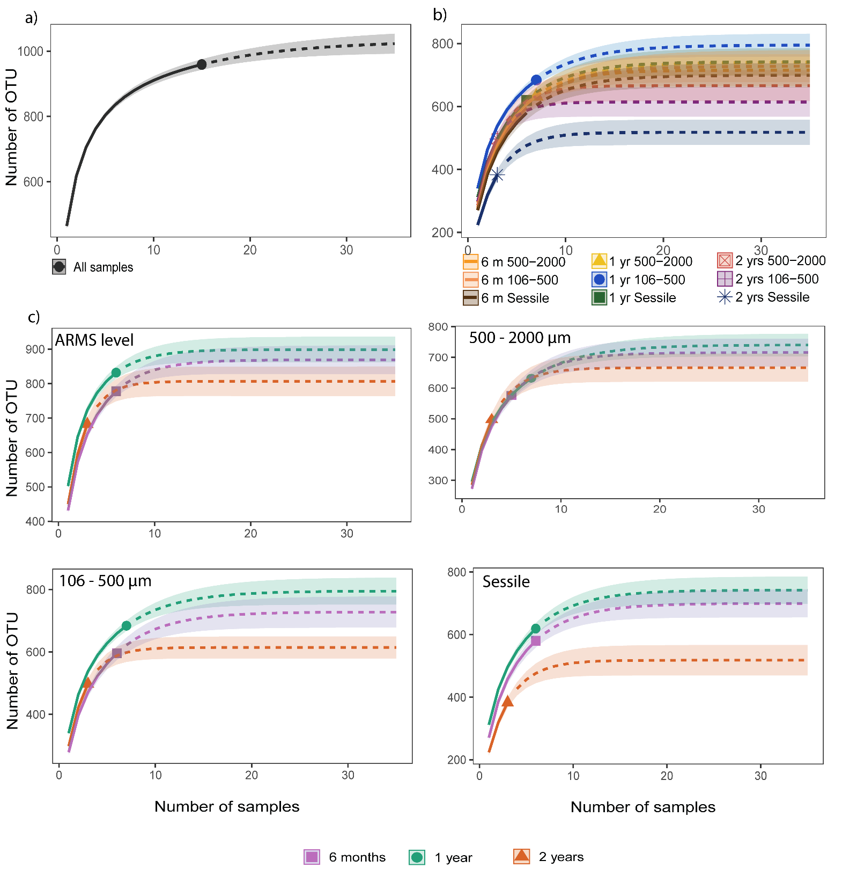
ESM 3: OTU accumulation curves for the 18S for: a) all samples; b) samples by modalities and c) samples by immersion time for each fraction.

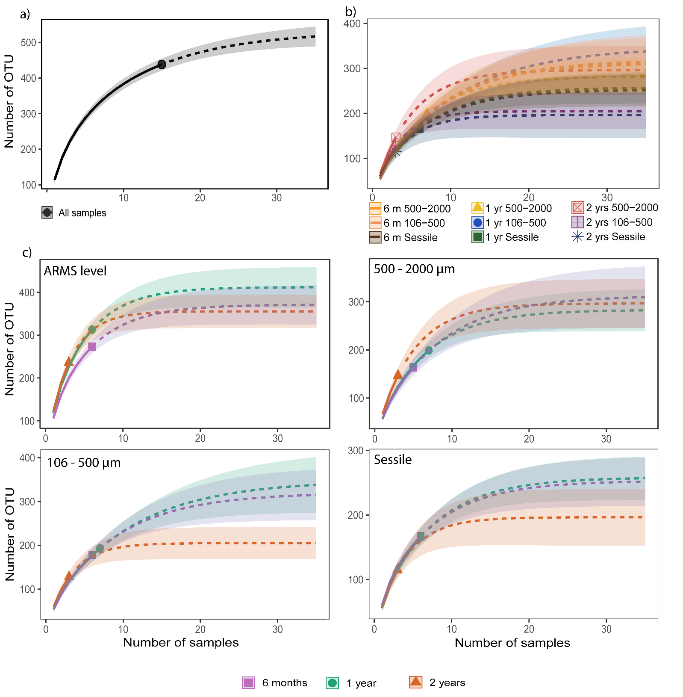
ESM 4: OTU accumulation curves for the COI OTU99% for: a) all samples; b) samples by modalities and c) samples by immersion time for each fraction.

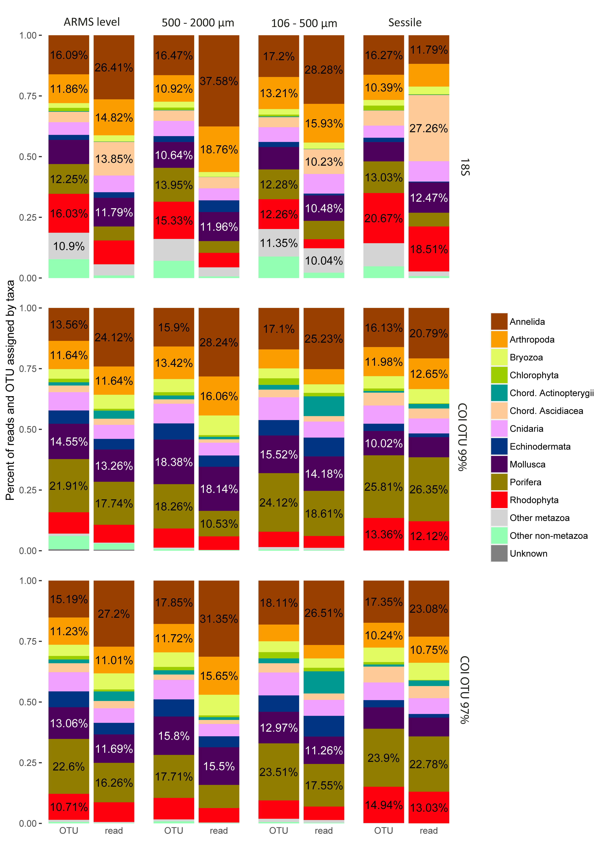

ESM 5: Percent of reads and OTUs assigned by taxa categories for each molecular marker (horizontal blocks) and each fraction (vertical blocks).

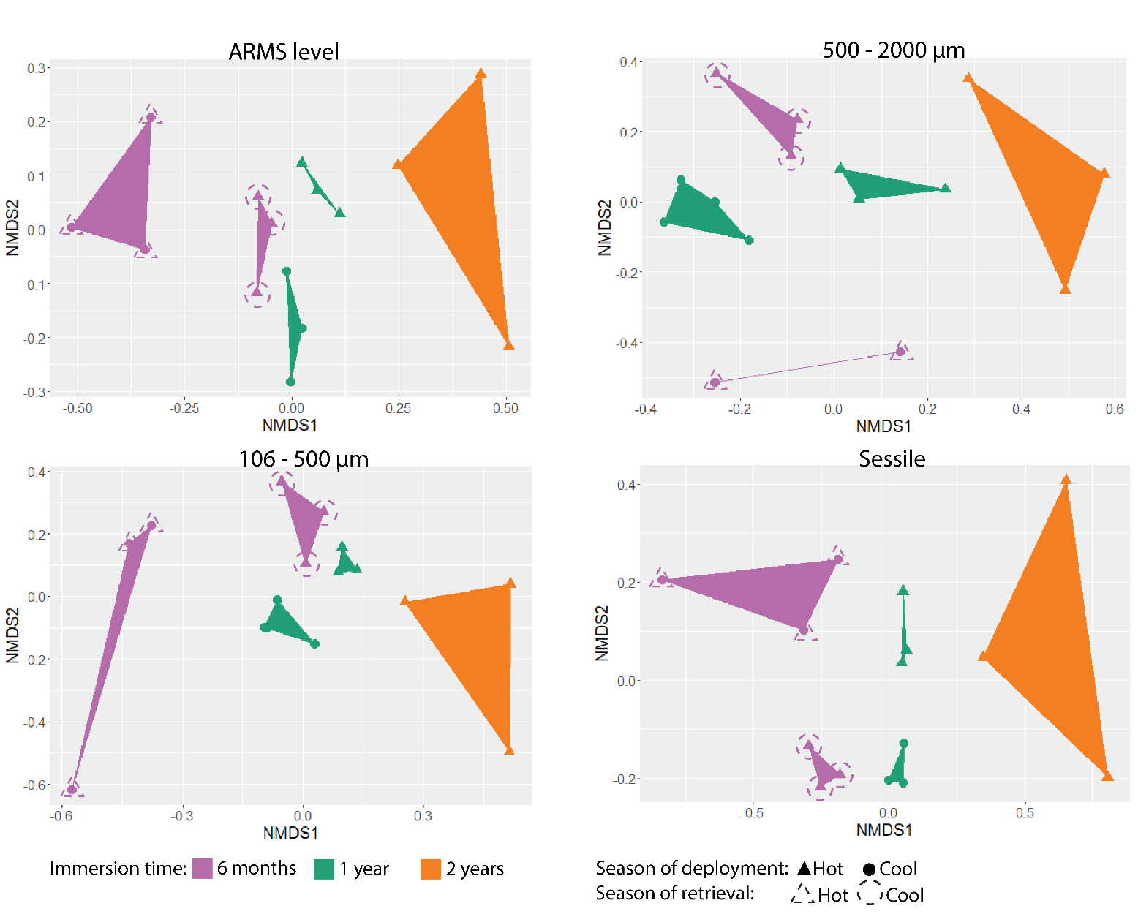
ESM 6: Non-metric multidimensional scaling (nMDS) ordination plots showing dissimilarities in community composition based Chao estimation of 18S. Analyses were made at ARMS level as well as for the different fractions (500 - 2000 μm, 106 - 500 μm, sessile). Points are coloured according the immersion time. Full symbols represent the season of deployment and dashed symbols represent the season of retrieval (for 6-months immersion).

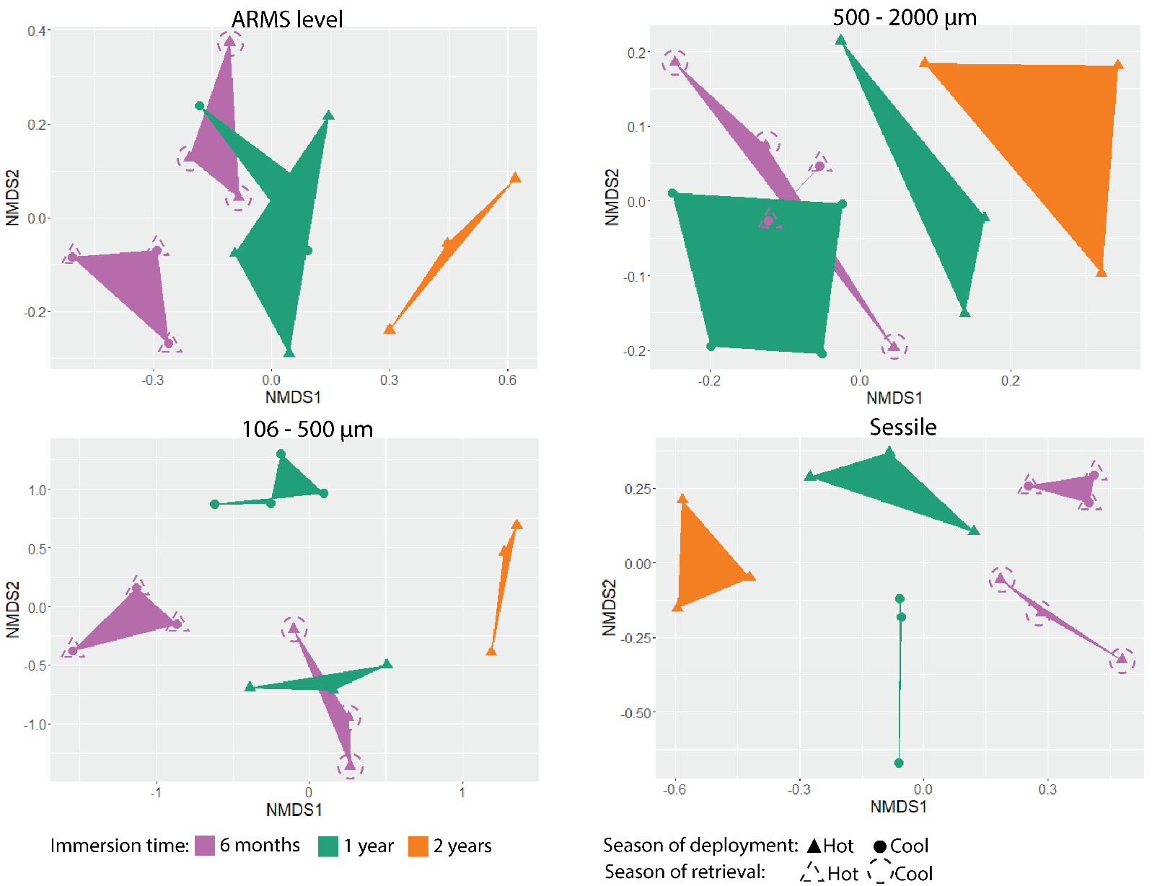
ESM 7: Non-metric multidimensional scaling (nMDS) ordination plots showing dissimilarities in community composition based Chao estimation of COI99. Analyses were made at ARMS level as well as for the different fractions (500 - 2000 μm, 106 - 500 μm, sessile). Points are coloured according the immersion time. Full symbols represent the season of deployment and dashed symbols represent the season of retrieval (for 6-months immersion).

ESM 8: Summary of the SIMPER analyses performed by marker for each comparison (in column) and for each dataset (in row). For each phylum, the number of OTU contributing to 50% of the difference is indicated. Coloured backgrounds represent the evolution of read abundance for the corresponding OTU between the two compared levels (green: increase; yellow: no distinct pattern; red: decrease).
Provided in an Excel file

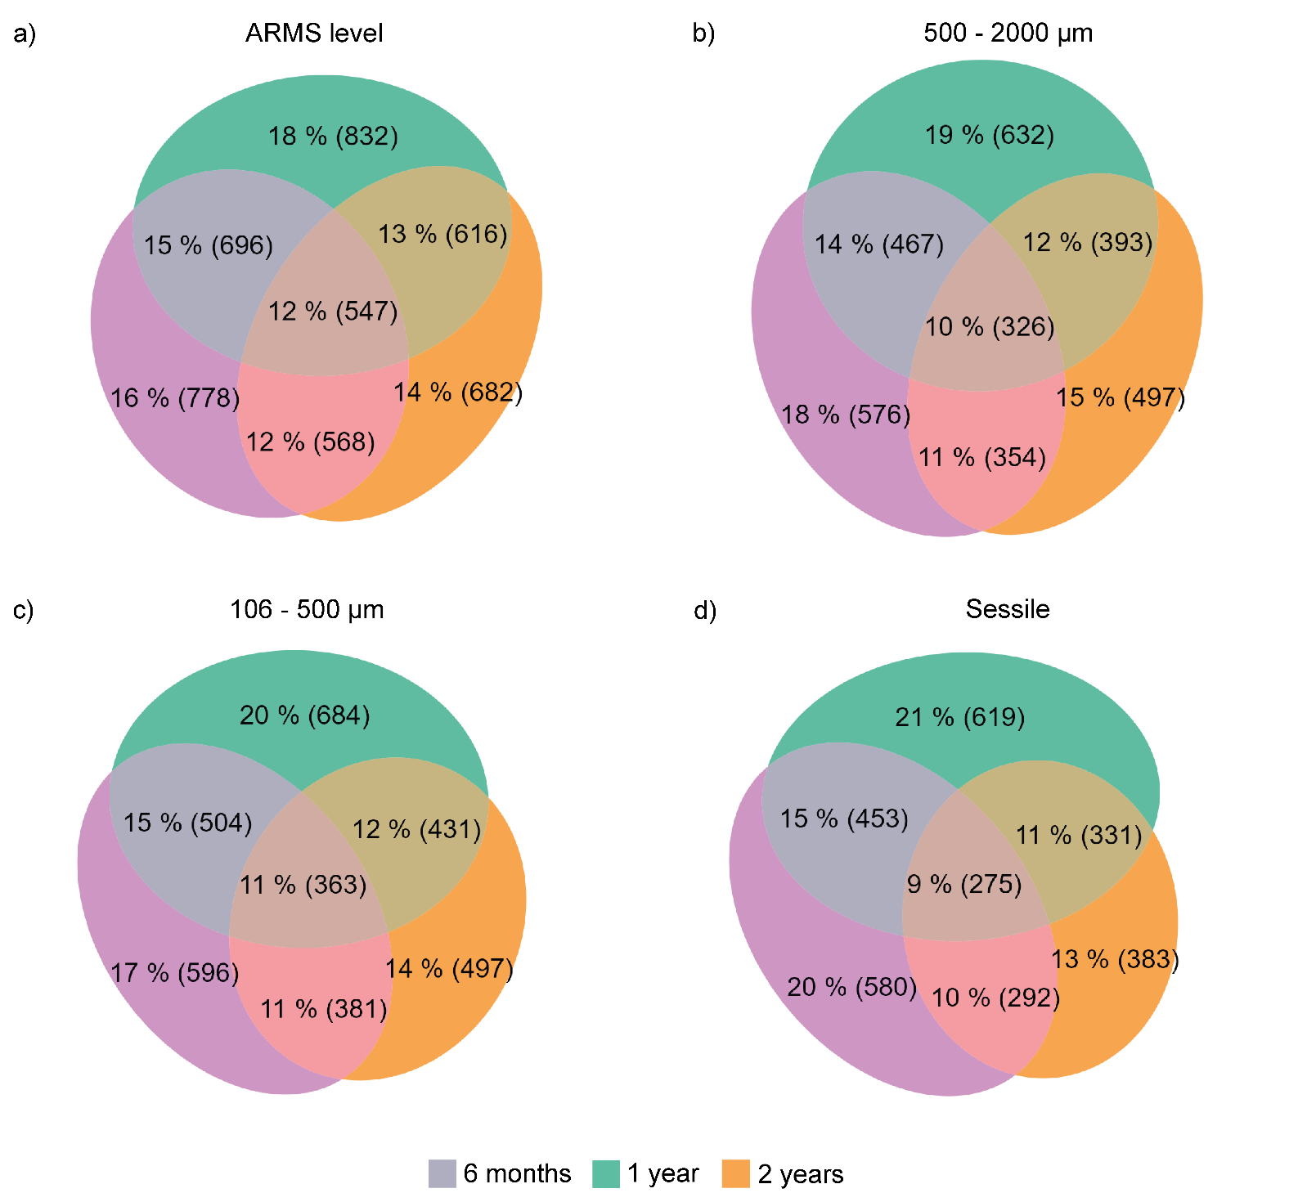
ESM 9: Number and proportion of unique and shared OTU from the 18S marker for the three immersion times at ARMS level and for the three fractions. Ellipse sizes are proportional to OTU numbers.

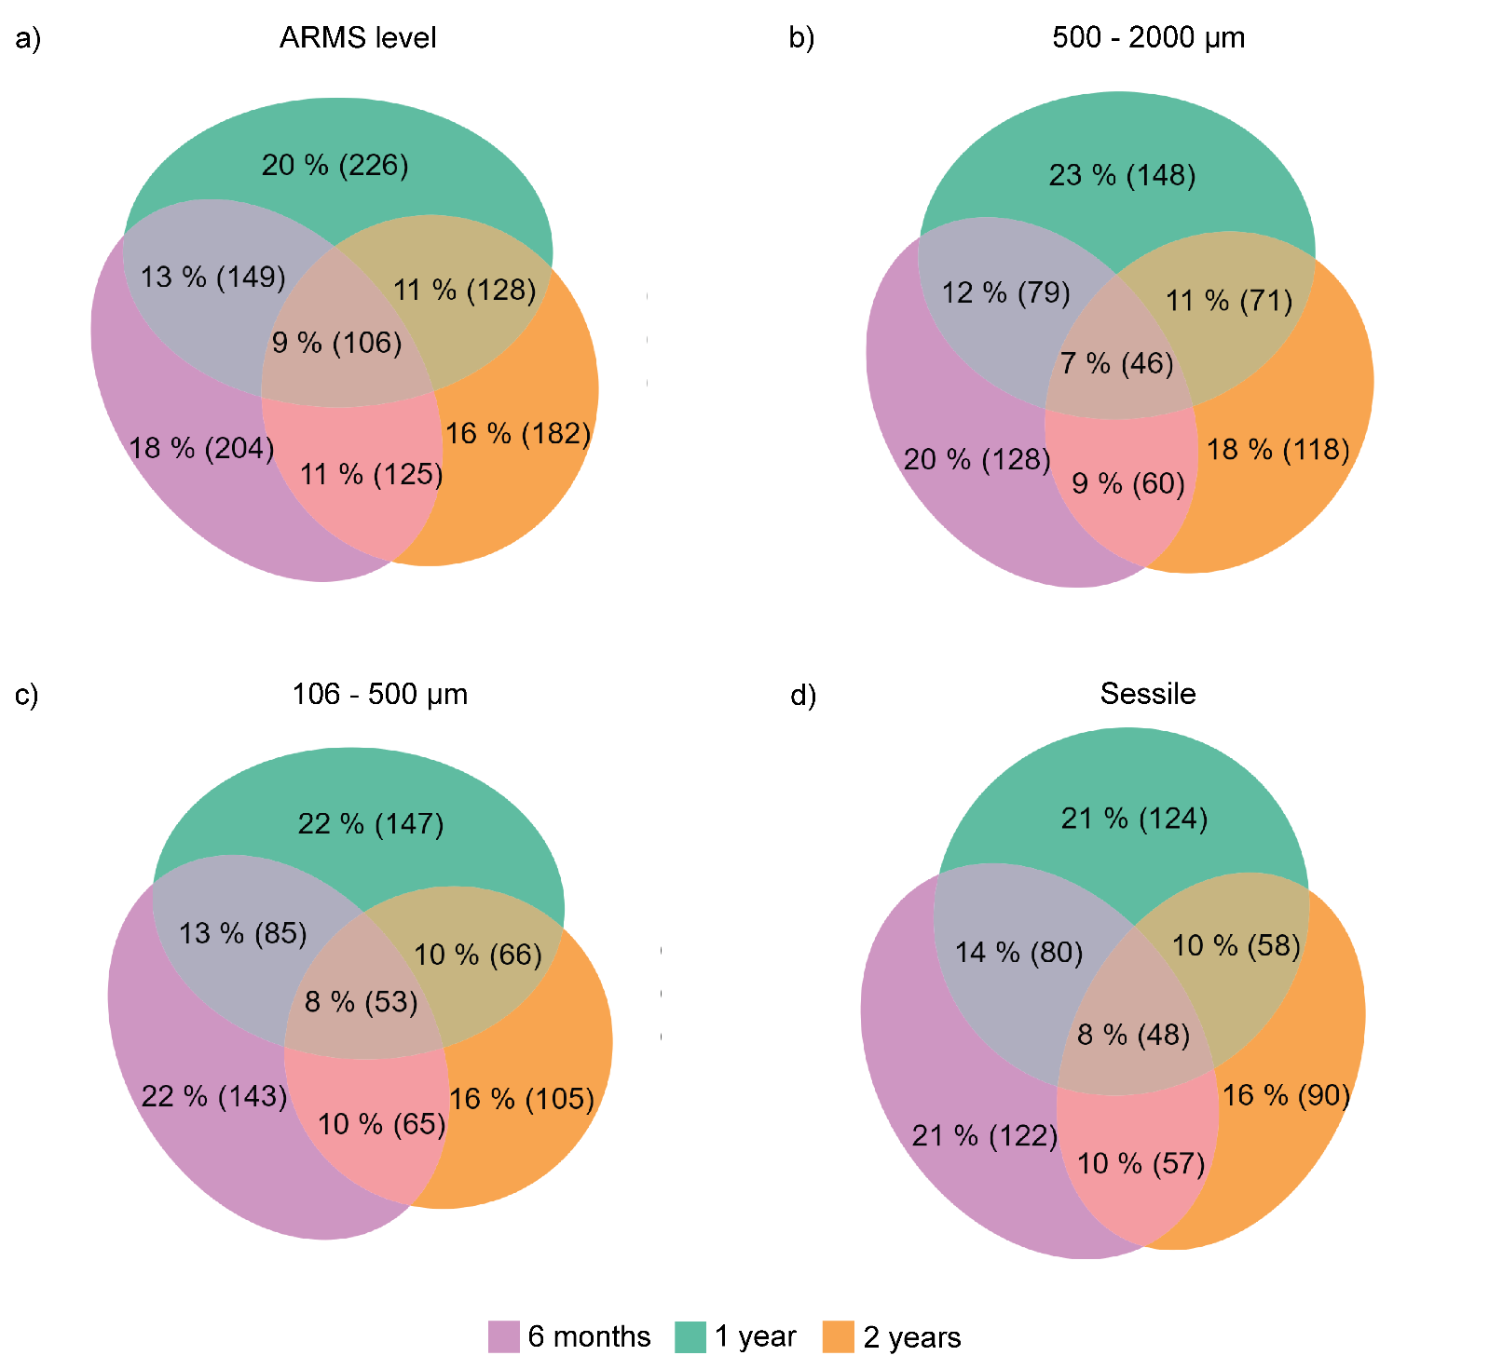
ESM 10: Number and proportion of unique and shared OTU97% from the COI marker for the three immersion times at ARMS level and for the three fractions. Ellipse sizes are proportional to OTU numbers.

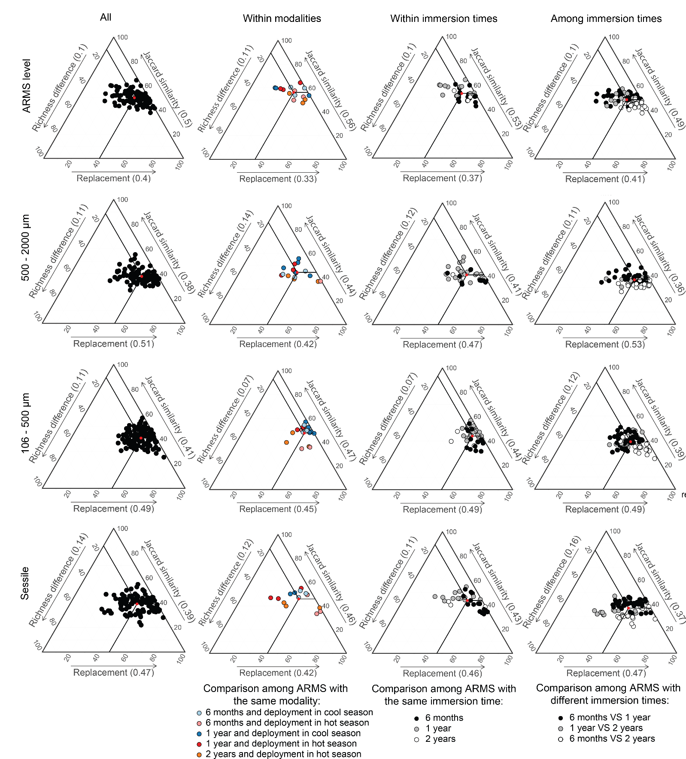
ESM 11: Ternary plots of Jaccard similarity and the partitions of beta diversity (replacement and richness difference) at ARMS level and for the three fractions obtained from the 18S marker. Ternary plots are shown for the total experiment (All) as well as within modalities and within and among immersion times. Red dot and numbers in brackets on the axis labels represent the mean value of each diversity component.

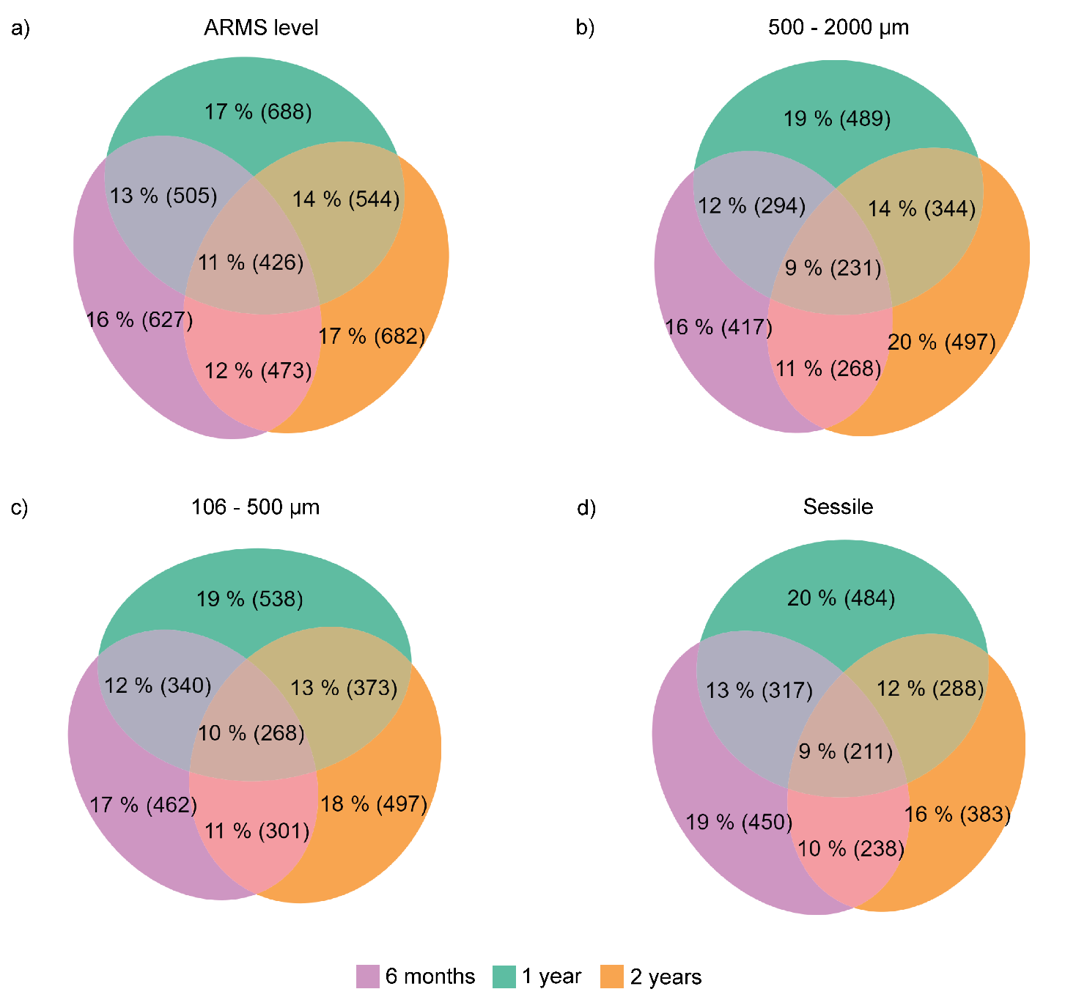
ESM 12: Number and proportion of unique and shared OTU from the 18S marker for the three immersion times of ARMS retrieved in the hot season (Dec-2020 and Jan-2021) at ARMS level dataset and for the three fractions. Ellipse sizes are proportional to OTU numbers.
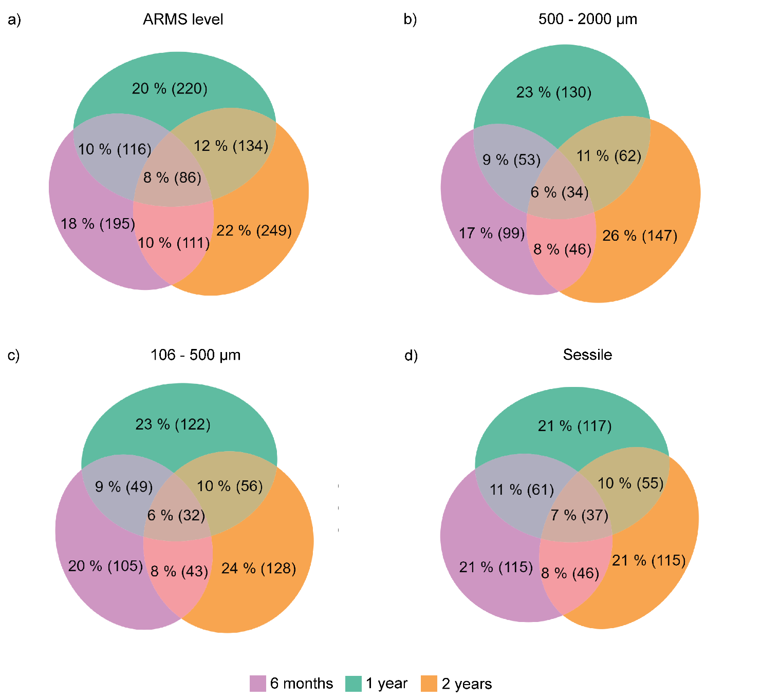
ESM 13: Number and proportion of unique and shared OTU99% from the COI marker for the three immersion times of ARMS retrieved in the hot season (Dec-2020 and Jan-2021) at ARMS level and for the three fractions. Ellipse sizes are proportional to OTU numbers.

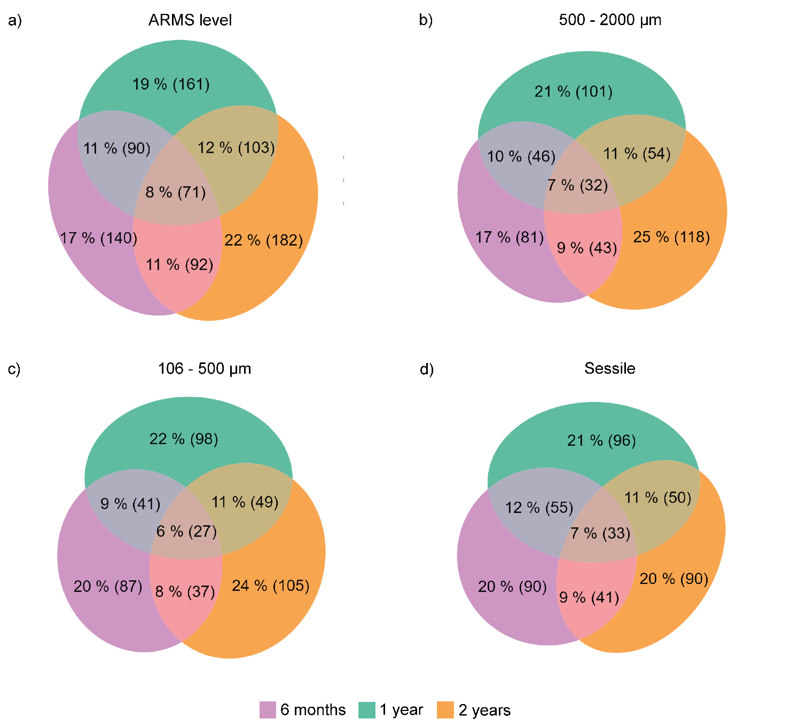
ESM 14: Number and proportion of unique and shared OTU97% from the COI marker for the three immersion times of ARMS retrieved in the hot season (Dec-2020 and Jan-2021) at ARMS level dataset and for the three fractions. Ellipse sizes are proportional to OTU numbers.

ESM 15: Jaccard similarity and the partitions of beta diversity (replacement and richness difference) at ARMS level and for the three fractions obtained from the OTU99% of the COI and 18S markers.

ESM 15.1: Table for intra-modalities comparisons
 | Immersion time | Deployment/ retrieval season | COI |  |  | 18S
 | Immersion time | Deployment/ retrieval season | Similarity | Replacement | Richness | Similarity | Replacement | Richness
ARMS level | 6 months | Cool/hot | 0.34 | 0.57 | 0.09 | 0.58 | 0.35 | 0.07
ARMS level | 6 months | Hot/cool | 0.38 | 0.48 | 0.14 | 0.53 | 0.37 | 0.09
ARMS level | 1 year | Cool | 0.37 | 0.55 | 0.08 | 0.58 | 0.27 | 0.15
ARMS level | 1 year | Hot | 0.33 | 0.57 | 0.10 | 0.61 | 0.27 | 0.12
ARMS level | 2 years | Hot | 0.29 | 0.52 | 0.19 | 0.51 | 0.40 | 0.09
500 - 2000 μm | 6 months | Cool/hot | 0.22 | 0.65 | 0.14 | 0.42 | 0.41 | 0.17
500 - 2000 μm | 6 months | Hot/cool | 0.34 | 0.59 | 0.07 | 0.37 | 0.63 | 0.01
500 - 2000 μm | 1 year | Cool | 0.24 | 0.72 | 0.04 | 0.47 | 0.40 | 0.13
500 - 2000 μm | 1 year | Hot | 0.21 | 0.70 | 0.09 | 0.46 | 0.36 | 0.18
500 - 2000 μm | 2 years | Hot | 0.20 | 0.55 | 0.25 | 0.39 | 0.47 | 0.15
106 - 500 μm | 6 months | Cool/hot | 0.21 | 0.68 | 0.11 | 0.51 | 0.44 | 0.05 ab
106 - 500 μm | 6 months | Hot/cool | 0.28 | 0.60 | 0.12 | 0.40 | 0.49 | 0.11 bc
106 - 500 μm | 1 year | Cool | 0.27 | 0.59 | 0.15 | 0.50 | 0.48 | 0.02 a
106 - 500 μm | 1 year | Hot | 0.22 | 0.69 | 0.09 | 0.52 | 0.41 | 0.07 ac
106 - 500 μm | 2 years | Hot | 0.21 | 0.62 | 0.17 | 0.41 | 0.43 | 0.16 c
Sessile | 6 months | Cool/hot | 0.228 | 0.50 | 0.22 | 0.50 | 0.42 ab | 0.08
Sessile | 6 months | Hot/cool | 0.34 | 0.60 | 0.06 | 0.39 | 0.57 b | 0.04
Sessile | 1 year | Cool | 0.25 | 0.61 | 0.14 | 0.50 | 0.39 ab | 0.11
Sessile | 1 year | Hot | 0.25 | 0.67 | 0.08 | 0.49 | 0.29 a | 0.21
Sessile | 2 years | Hot | 0.28 | 0.53 | 0.20 | 0.40 | 0.43 ab | 0.16

ESM 15.2: Table for intra-immersion time comparisons (6 months, 1 year and 2 years)
 | Immersion time | COI |  |  | 18S
 | Immersion time | Similarity | Replacement | Richness | Similarity | Replacement | Richness
ARMS level | 6 months | 0.31 | 0.60 | 0.10 | 0.51 a | 0.42 a | 0.07
ARMS level | 1 year | 0.31 | 0.61 | 0.08 | 0.56 b | 0.32 b | 0.12
ARMS level | 2 years | 0.30 | 0.52 | 0.19 | 0.51 ab | 0.40 ab | 0.09
500 - 2000 μm | 6 months | 0.25 | 0.62 | 0.14 | 0.38 a | 0.52 | 0.10
500 - 2000 μm | 1 year | 0.21 | 0.73 | 0.06 | 0.43 b | 0.44 | 0.13
500 - 2000 μm | 2 years | 0.20 | 0.55 | 0.25 | 0.39 ab | 0.47 | 0.15
106 -  500 μm | 6 months | 0.20 | 0.70 | 0.10 | 0.41 a | 0.53 a | 0.07 a
106 -  500 μm | 1 year | 0.21 | 0.68 | 0.12 | 0.47 b | 0.48 ab | 0.05 a
106 -  500 μm | 2 years | 0.21 | 0.62 | 0.17 | 0.41 ab | 0.43 b | 0.16 b
Sessile | 6 months | 0.27 | 0.61 | 0.13 | 0.41 a | 0.54 a | 0.05 a
Sessile | 1 year | 0.24 | 0.66 | 0.10 | 0.47 b | 0.39 b | 0.15 b
Sessile | 2 years | 0.28 | 0.53 | 0.20 | 0.40 ab | 0.43 ab | 0.16 ab
ESM 15.3: Table for inter-immersion time comparisons
 | Comparisons | COI |  |  | 18S
 | Comparisons | Similarity | Replacement | Richness | Similarity | Replacement | Richness
ARMS level | 6 months VS 1 year | 0.30 a | 0.61 | 0.10 | 0.51 a | 0.37 a | 0.12
ARMS level | 1 year VS 2 years | 0.27 b | 0.62 | 0.12 | 0.49 a | 0.41 a | 0.11
ARMS level | 6 months VS 2 years | 0.24 b | 0.64 | 0.13 | 0.44 b | 0.50 b | 0.07
500 - 2000 μm | 6 months VS 1 year | 0.21 a | 0.70 | 0.09 a | 0.39 a | 0.50 a | 0.11
500 - 2000 μm | 1 year VS 2 years | 0.18 b | 0.69 | 0.14 ab | 0.36 b | 0.53 ab | 0.11
500 - 2000 μm | 6 months VS 2 years | 0.17 b | 0.67 | 0.17 b | 0.33 c | 0.57 b | 0.10
106 -  500 μm | 6 months VS 1 year | 0.18 | 0.73 | 0.09 | 0.41 a | 0.46 a | 0.14
106 -  500 μm | 1 year VS 2 years | 0.17 | 0.71 | 0.12 | 0.40 a | 0.48 a | 0.12
106 -  500 μm | 6 months VS 2 years | 0.16 | 0.73 | 0.11 | 0.34 b | 0.56 b | 0.10
Sessile | 6 months VS 1 year | 0.23 a | 0.65 | 0.12 | 0.4 a | 0.48 a | 0.13 a
Sessile | 1 year VS 2 years | 0.21 ab | 0.66 | 0.13 | 0.37 b | 0.40 b | 0.23 b
Sessile | 6 months VS 2 years | 0.18 b | 0.66 | 0.16 | 0.31 c | 0.54 c | 0.15 a

ESM 15.4: Table for season of deployment comparisons
 | Comparisons | COI |  |  | 18S
 | Comparisons | Similarity | Replacement | Richness | Similarity | Replacement | Richness
ARMS level | Cool | 0.33 a | 0.58 | 0.09 | 0.55a | 0.35 | 0.11
ARMS level | Hot | 0.31 ab | 0.59 | 0.11 | 0.52 ab | 0.35 | 0.13
ARMS level | Cool VS hot | 0.29 a | 0.62 | 0.09 | 0.51 b | 0.39 | 0.11
500 - 2000 μm | Cool | 0.21 | 0.71 | 0.076 | 0.42 a | 0.46 a | 0.13
500 - 2000 μm | Hot | 0.20 | 0.66 | 0.14 | 0.37 b | 0.51 ab | 0.12
500 - 2000 μm | Cool VS hot | 0.19 | 0.69 | 0.12 | 0.37 ab | 0.52 b | 0.11
106 -  500 μm | Cool | 0.20 | 0.69 | 0.11 | 0.46 a | 0.47 | 0.07 a
106 -  500 μm | Hot | 0.18 | 0.71 | 0.10 | 0.39 b | 0.48 | 0.13 b
106 -  500 μm | Cool VS hot | 0.18 | 0.72 | 0.11 | 0.40 b | 0.50 | 0.10 a
Sessile | Cool | 0.26 a | 0.58 a | 0.16 | 0.46 a | 0.45 | 0.09 a
Sessile | Hot | 0.23 ab | 0.65 b | 0.12 | 0.37 b | 0.46 | 0.17 b
Sessile | Cool VS hot | 0.22 b | 0.66 b | 0.13 | 0.38 b | 0.48 | 0.14 ab

ESM 15.5: Table for season of retrieval
 | Comparisons | COI |  |  | 18S
 | Comparisons | Similarity | Replacement | Richness | Similarity | Replacement | Richness
ARMS level | Cool | 0.33 a | 0.56 a | 0.12 | 0.51 a | 0.36 | 0.12
ARMS level | Hot | 0.32 a | 0.60 ab | 0.08 | 0.56 b | 0.33 | 0.11
ARMS level | Cool VS hot | 0.29 b | 0.63 b | 0.09 | 0.51 a | 0.39 | 0.11
500 - 2000 μm | Cool | 0.24 a | 0.68 | 0.09 | 0.41 a | 0.50 ab | 0.09
500 - 2000 μm | Hot | 0.18 b | 0.67 | 0.14 | 0.39 ab | 0.47 a | 0.14
500 - 2000 μm | Cool VS hot | 0.20 b | 0.70 | 0.10 | 0.37 b | 0.53 b | 0.11
106 -  500 μm | Cool | 0.22 a | 0.67 a | 0.11 | 0.41 ab | 0.50 a | 0.09
106 -  500 μm | Hot | 0.19 b | 0.70 ab | 0.11 | 0.43 b | 0.45 b | 0.12
106 -  500 μm | Cool VS hot | 0.17 c | 0.73 b | 0.10 | 0.39 a | 0.51 a | 0.10
Sessile | Cool | 0.24 | 0.65 | 0.11 | 0.41 | 0.50 a | 0.09 a
Sessile | Hot | 0.22 | 0.63 | 0.15 | 0.39 | 0.43 b | 0.18 b
Sessile | Cool VS hot | 0.23 | 0.66 | 0.12 | 0.38 | 0.49 a | 0.13 ab

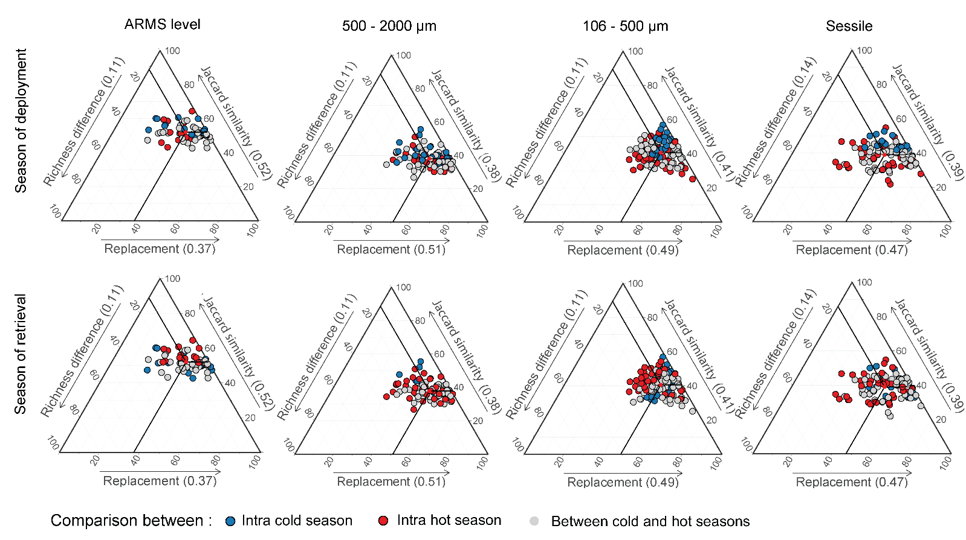
ESM 16: Ternary plots of Jaccard similarity and the partitions of beta diversity (replacement and richness) at ARMS level and for the three fractions obtained from the 18S marker. Comparisons were computed from ARMS immersed for 6 months and for 1 year. Ternary plots are shown for comparison within and among season of deployment and season of retrieval. Red dots and numbers in brackets on the axis labels represent the mean values of each diversity component.

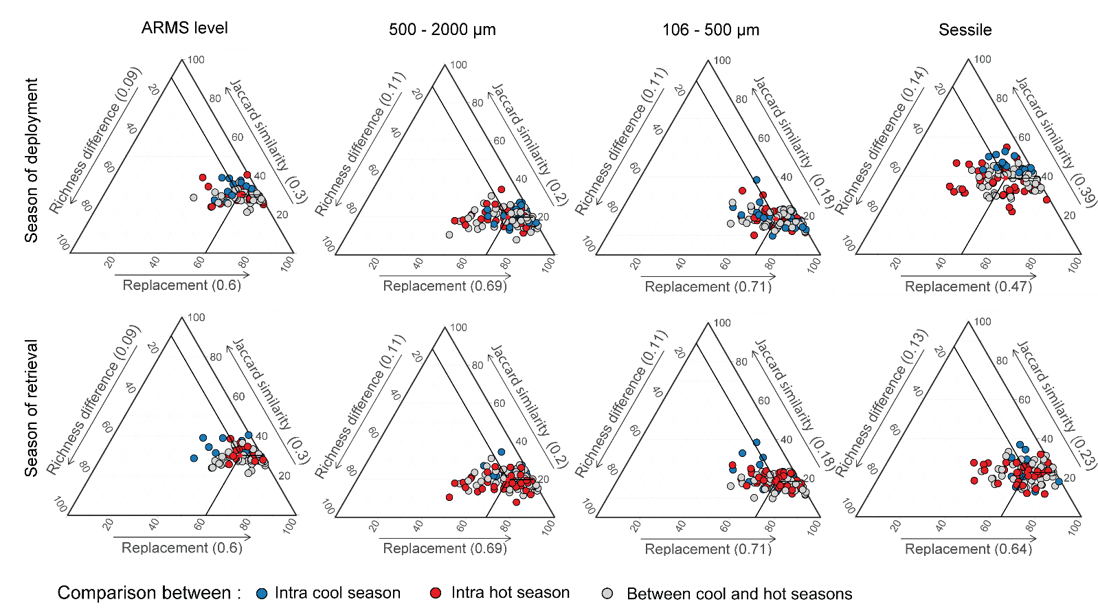
ESM 17: Ternary plots of Jaccard similarity and the partitions of beta diversity (replacement and richness) at ARMS level and for the three fractions obtained from the COI (OTU99%) marker. Comparisons were computed from ARMS immersed for 6 months and for 1 year. Ternary plots are shown for comparison within and among season of deployment and season of retrieval. Red dots and numbers in brackets on the axis labels represent the mean values of each diversity component.

ESM 18: Extended information of table 3 summarising the parameters employed for ARMS deployment and OTUs processing for reef cryptobiome studies.
Reference | Ocean / sea | Marker | Fraction | # reads | % OTU with species assignement | # phylum Metazoa | Sequencing | Database
Leray & Knowlton 2015 | Atlantic Ocean | COI | all | 409 613 | 12% | 32 (22) | Ion Torrent PMG | BOLD; Genbank
Leray & Knowlton 2015 | Atlantic Ocean | COI | all | 572 290 | 10% | 32 (22) | Ion Torrent PMG | BOLD; Genbank
Al-Rshaidat et al 2016 | Red Sea | COI | all | 152 604 | 8% | NA (15) | Ion Torrent PMG | BOLD; Genbank
Pearman et al. 2016 | Red Sea | COI | all | 69 000 | NA | 50 (NA) | Illumina MiSeq | PR2
Pearman et al. 2018 | Red Sea | COI | all | 34 000 | NA | NA | Illumina MiSeq | BOLD; MIDORI
Pearman et al. 2018 | Red Sea | 18S | all | 19 750 | NA | NA | Illumina MiSeq | Silva; PR2
Carvalho et al. 2019 | Red Sea | COI | Mobile and sessile | NA | NA | 20 (14) | Illumina MiSeq | ESM not available
Villalobos et al. 2022 | Red Sea | COI | merged mobile | NA | NA | NA | Illumina MiSeq | BOLD; MIDORI
Ransome et al. 2017 | Pacific Ocean | COI | all | 1 227 154 | 32% | 28 (17) | Ion Torrent PMG | BOLD; Genbank; Mo’orea Biocode
Casey at al. 2021 | Pacific Ocean | COI | all | 3 964 674 | NA | 38 | Illumina MiSeq | Local; Mo’orea Biocode; Genbank
Casey at al. 2021 | Pacific Ocean | 18S | all | 3 696 915 | NA | 51 | Illumina MiSeq | Silva; PR2
Nichols et al. 2021 | Pacific Ocean | COI | all | NA | NA | NA | Illumina MiSeq | Local; Mo’orea Biocode; BOLD; Genbank
Ip et al. 2022 | Indian Ocean | COI | all | 157 941 | 54.60% | -11 | Illumina HiSeq2500 and MiSeq | MIDORI
Ip et al. 2022 | Indian Ocean | 18S | all | NA | NA | 32 (13) | Illumina HiSeq2500 and MiSeq | Silva; PR2

