Supplementary information for the paper titled:
Parametric study on the decarbonization potential of structural system and concrete mix design choices for mid-rise concrete buildings
Hisham Hafez^{a*}, Petar Bajić^{b}, Stanislav Aidarov^{c}, Xhemsi Malija^{d}, Michal Drewniokª, Phil Purnellª, Nikola Tošić^{b}
ª School of Civil Engineering, University of Leeds, Leeds LS2 9JT, United Kingdom.
^{b}Universitat Politècnica de Catalunya – BarcelonaTech (UPC), Civil and Environmental Engineering Department, Jordi Girona 1–3, 08034 Barcelona, Spain
^{c}Universitat Politècnica de Catalunya – BarcelonaTech (UPC), Project and Construction Engineering Department, Av. Diagonal 647, 08028 Barcelona, Spain
^{d} Structural Concrete Laboratory, IBETON, ENAC, EPFL CH-1015 Lausanne, Switzerland

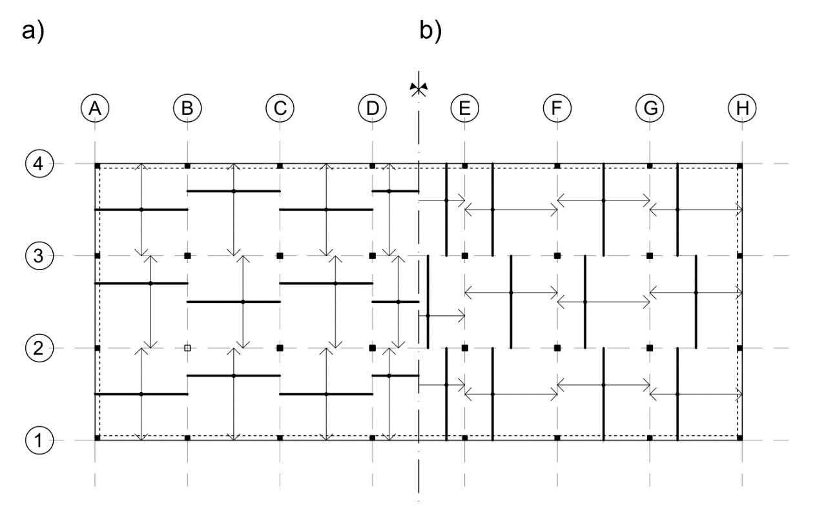
Figure SF - 1: Flexural reinforcement layout a) YLM bottom zone X direction; b) YLM bottom zone X direction

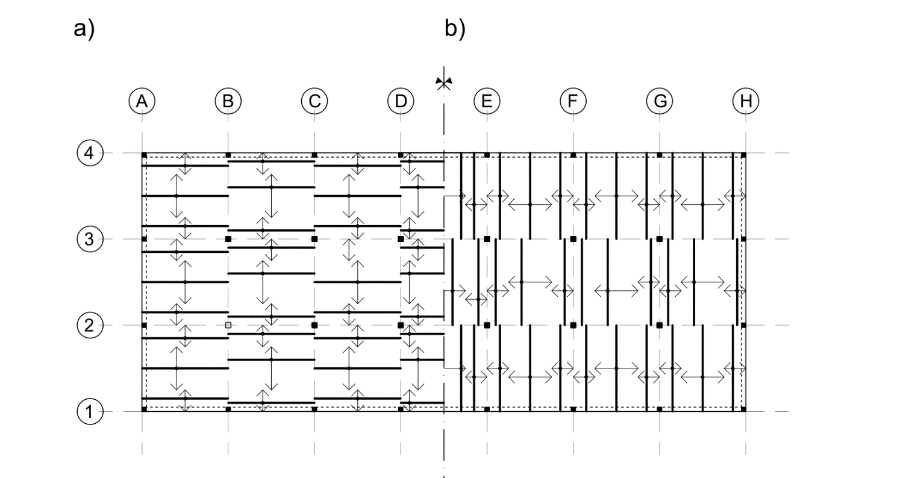

Figure SF - 2: Flexural reinforcement layout; a) optimized LEFEA X direction; b) optimized LEFEA Y direction

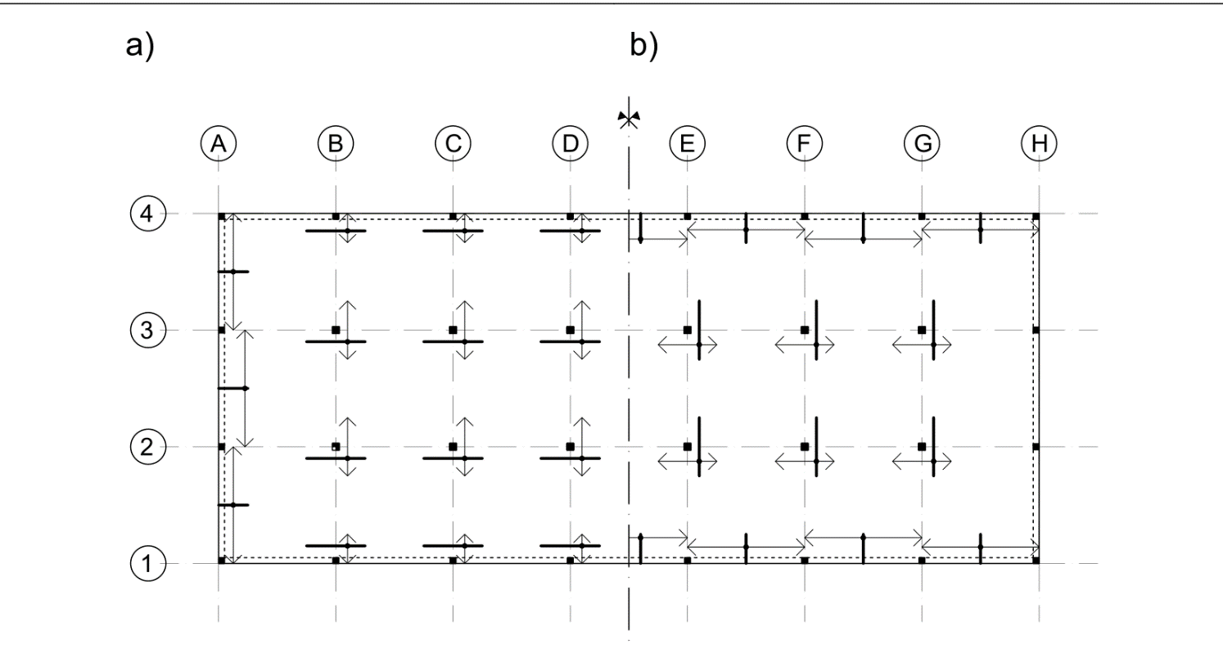

Figure SF -3: Flexural reinforcement layout a) top zone X direction; b) top zone Y direction

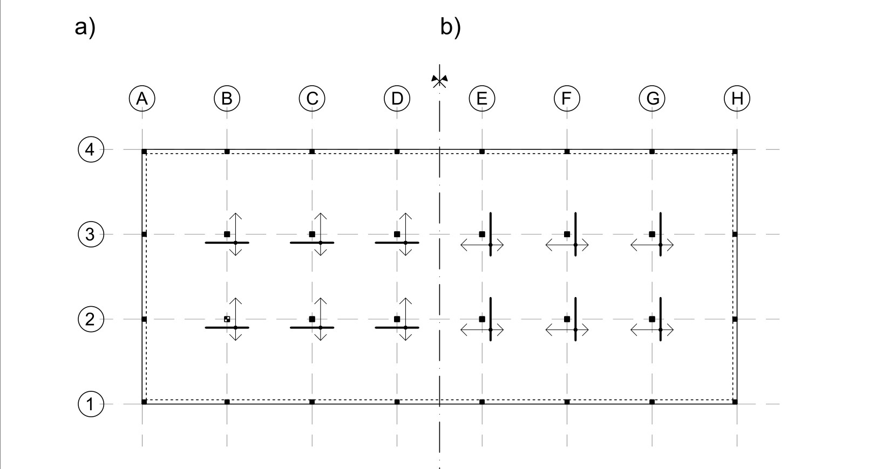
Figure SF -4: Flexural reinforcement layout a) additional for punching X direction; b) additional for punching Y direction

Table ST-1: Material quantities for alternatives considered in this study

System: Flat slab |  | Span: 5.0 m × 5.0 m |  |  | Number of stories: 5
Structural element | Concrete volume [m3] |  | Reinforcement YLM [t] | Reinforcement optimized LEFEA [t] |  | Reinforcement unoptimized LEFEA [t]
Foundation slab C30/37  400 mm | 273.60 |  | N/A | 22.57 |  | N/A
Story slab C30/37  180 mm | 94.50 |  | 5.92 | 6.35 |  | 6.71
Beam C30/37 | 10.00 |  | N/A | 0.47 |  | N/A
Columns C30/37 | 76.90 |  | N/A | 3.20 |  | N/A
Foundation slab C30/37  400 mm | 273.60 |  | N/A | 22.57 |  | N/A
Story slab C30/37  180 mm | 94.50 |  | 5.92 | 6.35 |  | 6.71
Beam C30/37 | 10.00 |  | N/A | 0.47 |  | N/A
Columns C50/60 | 76.90 |  | N/A | 3.14 |  | N/A
Foundation slab C50/60  350 mm | 239.40 |  | N/A | 23.96 |  | N/A
Story slab C50/60  160 mm | 84.00 |  | 6.30 | 7.06 |  | 7.30
Beam C50/60 | 7.50 |  | N/A | 0.49 |  | N/A
Columns C50/60 | 60.58 |  | N/A | 2.84 |  | N/A
Foundation slab C50/60  350 mm | 239.40 |  | N/A | 23.96 |  | N/A
Story slab C50/60  160 mm | 84.00 |  | 6.30 | 7.06 |  | 7.30
Beam C50/60 | 7.50 |  | N/A | 0.49 |  | N/A
Columns C70/85 | 60.58 |  | N/A | 2.68 |  | N/A
Foundation slab C70/85  350 mm | 239.40 |  | N/A | 24.83 |  | N/A
Story slab C70/85  160 mm | 84.00 |  | 6.37 | 7.22 |  | 7.46
Beam C70/85 | 7.50 |  | N/A | 0.53 |  | N/A
Columns C70/85 | 50.90 |  | N/A | 2.40 |  | N/A
System: Flat slab |  | Span: 5.0 m × 5.0 m |  |  | Number of stories: 10
Structural element | Concrete volume [m3] |  | Reinforcement YLM [t] | Reinforcement optimized LEFEA [t] |  | Reinforcement unoptimized LEFEA [t]
Foundation slab C30/37  700 mm | 560.00 |  | N/A | 40.23 |  | N/A
Story slab C30/37  180 mm | 94.50 |  | 5.92 | 6.35 |  | 6.71
Beam C30/37 | 10.00 |  | N/A | 0.47 |  | N/A
Columns C30/37 | 158.02 |  | N/A | 7.78 |  | N/A
Foundation slab C30/37  700 mm | 560.00 |  | N/A | 40.23 |  | N/A
Story slab C30/37  180 mm | 94.50 |  | 5.92 | 6.35 |  | 6.71
Beam C30/37 | 10.00 |  | N/A | 0.47 |  | N/A
Columns C50/60 | 138.35 |  | N/A | 6.47 |  | N/A
Foundation slab C50/60  550 mm | 440.00 |  | N/A | 43.88 |  | N/A
Story slab C50/60  160 mm | 84.00 |  | 6.30 | 7.06 |  | 7.30
Beam C50/60 | 7.50 |  | N/A | 0.49 |  | N/A
Columns C50/60 | 108.68 |  | N/A | 6.47 |  | N/A
Foundation slab C50/60  550 mm | 440.00 |  | N/A | 43.88 |  | N/A
Story slab C50/60  160 mm | 84.00 |  | 6.30 | 7.06 |  | 7.30
Beam C50/60 | 7.50 |  | N/A | 0.49 |  | N/A
Columns C70/85 | 108.68 |  | N/A | 6.11 |  | N/A
Foundation slab C70/85  500 mm | 400.00 |  | N/A | 41.14 |  | N/A
Story slab C70/85  160 mm | 84.00 |  | 6.37 | 7.23 |  | 7.46
Beam C70/85 | 7.50 |  | N/A | 0.53 |  | N/A
Columns C70/85 | 102.60 |  | N/A | 6.07 |  | N/A
System: Slab on beams |  | Span: 5.0 m × 5.0 m |  |  | Number of stories: 5
Structural element | Concrete volume [m3] |  | Reinforcement YLM [t] | Reinforcement optimized LEFEA [t] |  | Reinforcement unoptimized LEFEA [t]
Foundation slab C30/37  400 mm | 273.60 |  | N/A | 21.38 |  | N/A
Story slab C30/37  160 mm | 84.00 |  | 4.70 | 5.36 |  | 5.62
Beam C30/37 | 16.25 |  | N/A | 1.51 |  | N/A
Columns C30/37 | 50.44 |  | N/A | 3.16 |  | N/A
Foundation slab C30/37  400 mm | 273.60 |  | N/A | 21.38 |  | N/A
Story slab C30/37  160 mm | 84.00 |  | 4.70 | 5.36 |  | 5.62
Beam C30/37 | 16.25 |  | N/A | 1.51 |  | N/A
Columns C50/60 | 45.08 |  | N/A | 2.66 |  | N/A
Foundation slab C50/60  350 mm | 239.40 |  | N/A | 24.33 |  | N/A
Story slab C50/60  160 mm | 84.00 |  | 5.02 | 5.87 |  | 6.00
Beam C50/60 | 16.25 |  | N/A | 1.63 |  | N/A
Columns C50/60 | 43.36 |  | N/A | 2.64 |  | N/A
Foundation slab C50/60  350 mm | 239.40 |  | N/A | 24.33 |  | N/A
Story slab C50/60  160 mm | 84.00 |  | 5.02 | 5.87 |  | 6.00
Beam C50/60 | 16.25 |  | N/A | 1.63 |  | N/A
Columns C70/85 | 43.36 |  | N/A | 2.42 |  | N/A
Foundation slab C70/85  350 mm | 239.40 |  | N/A | 24.30 |  | N/A
Story slab C70/85  160 mm | 84.00 |  | 5.50 | 6.19 |  | 6.31
Beam C70/85 | 16.25 |  | N/A | 1.75 |  | N/A
Columns C70/85 | 40.07 |  | N/A | 2.39 |  | N/A
System: Slab on beams |  | Span: 5.0 m × 5.0 m |  |  | Number of stories: 10
Structural element | Concrete volume [m3] |  | Reinforcement YLM [t] | Reinforcement optimized LEFEA [t] |  | Reinforcement unoptimized LEFEA [t]
Foundation slab C30/37  600 mm | 480.00 |  | N/A | 36.65 |  | N/A
Story slab C30/37  160 mm | 84.00 |  | 4.70 | 5.36 |  | 5.62
Beam C30/37 | 16.25 |  | N/A | 1.51 |  | N/A
Columns C30/37 | 101.76 |  | N/A | 11.62 |  | N/A
Foundation slab C30/37  600 mm | 480.00 |  | N/A | 36.65 |  | N/A
Story slab C30/37  160 mm | 84.00 |  | 4.70 | 5.36 |  | 5.62
Beam C30/37 | 16.25 |  | N/A | 1.51 |  | N/A
Columns C50/60 | 84.53 |  | N/A | 7.94 |  | N/A
Foundation slab C50/60  500 mm | 400.00 |  | N/A | 40.95 |  | N/A
Story slab C50/60  160 mm | 84.00 |  | 5.02 | 5.87 |  | 6.00
Beam C50/60 | 16.25 |  | N/A | 1.63 |  | N/A
Columns C50/60 | 84.53 |  | N/A | 8.02 |  | N/A
Foundation slab C50/60  500 mm | 400.00 |  | N/A | 40.95 |  | N/A
Story slab C50/60  160 mm | 84.00 |  | 5.02 | 5.87 |  | 6.00
Beam C50/60 | 16.25 |  | N/A | 1.63 |  | N/A
Columns C70/85 | 84.53 |  | N/A | 6.39 |  | N/A
Foundation slab C70/85  450 mm | 360.00 |  | N/A | 41.70 |  | N/A
Story slab C70/85  160 mm | 84.00 |  | 5.50 | 6.19 |  | 6.31
Beam C70/85 | 16.25 |  | N/A | 1.75 |  | N/A
Columns C70/85 | 83.30 |  | N/A | 6.24 |  | N/A
System: Waffle slab |  | Span: 5.0 m × 5.0 m |  |  | Number of stories: 5
Structural element | Concrete volume [m3] |  | Reinforcement YLM [t] | Reinforcement optimized LEFEA [t] |  | Reinforcement unoptimized LEFEA [t]
Foundation slab C30/37  350 mm | 239.40 |  | N/A | 20.53 |  | N/A
Story slab C30/37  160 + 75 mm* | 78.74 |  | N/A | 6.09 |  | N/A
Beam C30/37 | N/A |  | N/A | N/A |  | N/A
Columns C30/37 | 50.48 |  | N/A | 5.00 |  | N/A
Foundation slab C30/37  350 mm | 239.40 |  | N/A | 20.53 |  | N/A
Story slab C30/37  160 + 75 mm* | 78.74 |  | N/A | 6.09 |  | N/A
Beam C30/37 | N/A |  | N/A | N/A |  | N/A
Columns C50/60 | 37.60 |  | N/A | 3.69 |  | N/A
Foundation slab C50/60  350 mm | 239.40 |  | N/A | 22.96 |  | N/A
Story slab C50/60  160 + 75 mm* | 78.74 |  | N/A | 5.99 |  | N/A
Beam C50/60 | N/A |  | N/A | N/A |  | N/A
Columns C50/60 | 37.22 |  | N/A | 3.69 |  | N/A
Foundation slab C50/60  350 mm | 239.40 |  | N/A | 22.96 |  | N/A
Story slab C50/60  160 + 75 mm* | 78.74 |  | N/A | 5.99 |  | N/A
Beam C50/60 | N/A |  | N/A | N/A |  | N/A
Columns C70/85 | 35.28 |  | N/A | 3.50 |  | N/A
Foundation slab C70/85  350 mm | 239.40 |  | N/A | 23.89 |  | N/A
Story slab C70/85  160 + 75 mm* | 78.74 |  | N/A | 5.99 |  | N/A
Beam C70/85 | N/A |  | N/A | N/A |  | N/A
Columns C70/85 | 35.28 |  | N/A | 3.50 |  | N/A
System: Waffle slab |  | Span: 5.0 m × 5.0 m |  |  | Number of stories: 10
Structural element | Concrete volume [m3] |  | Reinforcement YLM [t] | Reinforcement optimized LEFEA [t] |  | Reinforcement unoptimized LEFEA [t]
Foundation slab C30/37  500 mm | 400.00 |  | N/A | 34.16 |  | N/A
Story slab C30/37  160 + 75 mm* | 78.74 |  | N/A | 6.09 |  | N/A
Beam C30/37 | N/A |  | N/A | N/A |  | N/A
Columns C30/37 | 111.08 |  | N/A | 11.01 |  | N/A
Foundation slab C30/37  500 mm | 400.00 |  | N/A | 34.16 |  | N/A
Story slab C30/37  160 + 75 mm* | 78.74 |  | N/A | 6.09 |  | N/A
Beam C30/37 | N/A |  | N/A | N/A |  | N/A
Columns C50/60 | 84.15 |  | N/A | 8.34 |  | N/A
Foundation slab C50/60  450 mm | 360.00 |  | N/A | 38.32 |  | N/A
Story slab C50/60  160 + 75 mm* | 78.74 |  | N/A | 6.01 |  | N/A
Beam C50/60 | N/A |  | N/A | N/A |  | N/A
Columns C50/60 | 84.15 |  | N/A | 8.34 |  | N/A
Foundation slab C50/60  450 mm | 360.00 |  | N/A | 38.32 |  | N/A
Story slab C50/60  160 + 75 mm* | 78.74 |  | N/A | 6.01 |  | N/A
Beam C50/60 | N/A |  | N/A | N/A |  | N/A
Columns C70/85 | 71.83 |  | N/A | 7.12 |  | N/A
Foundation slab C70/85  450 mm | 360.00 |  | N/A | 38.23 |  | N/A
Story slab C70/85  160 + 75 mm* | 78.74 |  | N/A | 6.02 |  | N/A
Beam C70/85 | N/A |  | N/A | N/A |  | N/A
Columns C70/85 | 71.83 |  | N/A | 7.12 |  | N/A
System: Flat slab |  | Span: 7.0 m × 7.5 m |  |  | Number of stories: 5
Structural element | Concrete volume [m3] |  | Reinforcement YLM [t] | Reinforcement optimized LEFEA [t] |  | Reinforcement unoptimized LEFEA [t]
Foundation slab C30/37  650 mm | 520.00 |  | N/A | 41.58 |  | N/A
Story slab C30/37  220 mm | 126.00 |  | 11.34 | 10.61 |  | 11.57
Beam C30/37 | 12.50 |  | N/A | 0.90 |  | N/A
Columns C30/37 | 49.87 |  | N/A | 3.67 |  | N/A
Foundation slab C30/37  650 mm | 520.00 |  | N/A | 41.58 |  | N/A
Story slab C30/37  220 mm | 126.00 |  | 11.34 | 10.61 |  | 11.57
Beam C30/37 | 12.50 |  | N/A | 0.90 |  | N/A
Columns C50/60 | 49.87 |  | N/A | 2.42 |  | N/A
Foundation slab C50/60  550 mm | 440.00 |  | N/A | 41.80 |  | N/A
Story slab C50/60  200 mm | 105.00 |  | 11.60 | 10.44 |  | 11.73
Beam C50/60 | 12.50 |  | N/A | 0.94 |  | N/A
Columns C50/60 | 35.86 |  | N/A | 2.74 |  | N/A
Foundation slab C50/60  550 mm | 440.00 |  | N/A | 41.80 |  | N/A
Story slab C50/60  200 mm | 105.00 |  | 11.60 | 10.44 |  | 11.73
Beam C50/60 | 12.50 |  | N/A | 0.94 |  | N/A
Columns C70/85 | 34.97 |  | N/A | 2.59 |  | N/A
Foundation slab C70/85  500 mm | 400.00 |  | N/A | 41.76 |  | N/A
Story slab C70/85  200 mm | 105.00 |  | 11.44 | 11.72 |  | 12.65
Beam C70/85 | 10.00 |  | N/A | 1.02 |  | N/A
Columns C70/85 | 34.42 |  | N/A | 2.34 |  | N/A
System: Flat slab |  | Span: 7.0 m × 7.5 m |  |  | Number of stories: 10
Structural element | Concrete volume [m3] |  | Reinforcement YLM [t] | Reinforcement optimized LEFEA [t] |  | Reinforcement unoptimized LEFEA [t]
Foundation slab C30/37  1000 mm | 800.00 |  | N/A | 60.78 |  | N/A
Story slab C30/37  220 mm | 126.00 |  | 11.34 | 10.61 |  | 11.57
Beam C30/37 | 12.50 |  | N/A | 0.90 |  | N/A
Columns C30/37 | 101.76 |  | N/A | 14.44 |  | N/A
Foundation slab C30/37  650 mm | 800.00 |  | N/A | 60.78 |  | N/A
Story slab C30/37  220 mm | 126.00 |  | 11.34 | 10.61 |  | 11.57
Beam C30/37 | 12.50 |  | N/A | 0.90 |  | N/A
Columns C50/60 | 92.33 |  | N/A | 6.00 |  | N/A
Foundation slab C50/60  800 mm | 640.00 |  | N/A | 64.69 |  | N/A
Story slab C50/60  200 mm | 105.00 |  | 11.60 | 10.44 |  | 11.73
Beam C50/60 | 12.50 |  | N/A | 0.94 |  | N/A
Columns C50/60 | 76.91 |  | N/A | 7.26 |  | N/A
Foundation slab C50/60  550 mm | 640.00 |  | N/A | 64.69 |  | N/A
Story slab C50/60  200 mm | 105.00 |  | 11.60 | 10.44 |  | 11.73
Beam C50/60 | 12.50 |  | N/A | 0.94 |  | N/A
Columns C70/85 | 71.45 |  | N/A | 6.26 |  | N/A
Foundation slab C70/85  750 mm | 600.00 |  | N/A | 66.07 |  | N/A
Story slab C70/85  200 mm | 105.00 |  | 11.44 | 11.72 |  | 12.65
Beam C70/85 | 10.00 |  | N/A | 1.02 |  | N/A
Columns C70/85 | 70.20 |  | N/A | 6.21 |  | N/A
System: Slab on beams |  | Span: 7.0 m × 7.5 m |  |  | Number of stories: 5
Structural element | Concrete volume [m3] |  | Reinforcement YLM [t] | Reinforcement optimized LEFEA [t] |  | Reinforcement unoptimized LEFEA [t]
Foundation slab C30/37  650 mm | 520.00 |  | N/A | 38.34 |  | N/A
Story slab C30/37  220 mm | 115.50 |  | 7.72 | 7.37 |  | 8.91
Beam C30/37 | 19.50 |  | N/A | 2.13 |  | N/A
Columns C30/37 | 41.11 |  | N/A | 5.05 |  | N/A
Foundation slab C30/37  600 mm | 520.00 |  | N/A | 38.34 |  | N/A
Story slab C30/37  160 mm | 115.50 |  | 7.72 | 7.37 |  | 8.91
Beam C30/37 | 19.50 |  | N/A | 2.13 |  | N/A
Columns C50/60 | 32.42 |  | N/A | 3.40 |  | N/A
Foundation slab C50/60  550 mm | 440.00 |  | N/A | 41.11 |  | N/A
Story slab C50/60  180 mm | 94.50 |  | 9.02 | 9.38 |  | 9.73
Beam C50/60 | 17.06 |  | N/A | 2.50 |  | N/A
Columns C50/60 | 33.67 |  | N/A | 2.74 |  | N/A
Foundation slab C50/60  500 mm | 440.00 |  | N/A | 41.11 |  | N/A
Story slab C50/60  160 mm | 94.50 |  | 9.02 | 9.38 |  | 9.73
Beam C50/60 | 17.06 |  | N/A | 2.50 |  | N/A
Columns C70/85 | 28.15 |  | N/A | 2.72 |  | N/A
Foundation slab C70/85  500 mm | 400.00 |  | N/A | 37.58 |  | N/A
Story slab C70/85  160 mm | 84.00 |  | 9.10 | 9.27 |  | 9.48
Beam C70/85 | 17.06 |  | N/A | 2.84 |  | N/A
Columns C70/85 | 27.63 |  | N/A | 3.19 |  | N/A
System: Slab on beams |  | Span: 7.0 m × 7.5 m |  |  | Number of stories: 10
Structural element | Concrete volume [m3] |  | Reinforcement YLM [t] | Reinforcement optimized LEFEA [t] |  | Reinforcement unoptimized LEFEA [t]
Foundation slab C30/37  900 mm | 720.00 |  | N/A | 58.87 |  | N/A
Story slab C30/37  220 mm | 115.50 |  | 7.72 | 7.37 |  | 8.91
Beam C30/37 | 19.50 |  | N/A | 2.13 |  | N/A
Columns C30/37 | 81.72 |  | N/A | 14.50 |  | N/A
Foundation slab C30/37  600 mm | 720.00 |  | N/A | 58.87 |  | N/A
Story slab C30/37  160 mm | 115.50 |  | 7.72 | 7.37 |  | 8.91
Beam C30/37 | 19.50 |  | N/A | 2.13 |  | N/A
Columns C50/60 | 81.72 |  | N/A | 7.15 |  | N/A
Foundation slab C50/60  750 mm | 600.00 |  | N/A | 61.62 |  | N/A
Story slab C50/60  180 mm | 94.50 |  | 9.02 | 9.38 |  | 9.73
Beam C50/60 | 17.06 |  | N/A | 2.50 |  | N/A
Columns C50/60 | 75.50 |  | N/A | 6.54 |  | N/A
Foundation slab C50/60  500 mm | 600.00 |  | N/A | 61.62 |  | N/A
Story slab C50/60  160 mm | 94.50 |  | 9.02 | 9.38 |  | 9.73
Beam C50/60 | 17.06 |  | N/A | 2.50 |  | N/A
Columns C70/85 | 70.01 |  | N/A | 6.09 |  | N/A
Foundation slab C70/85  700 mm | 560.00 |  | N/A | 60.80 |  | N/A
Story slab C70/85  160 mm | 84.00 |  | 9.10 | 9.27 |  | 9.48
Beam C70/85 | 17.06 |  | N/A | 2.84 |  | N/A
Columns C70/85 | 66.51 |  | N/A | 6.0211. |  | N/A
System: Waffle slab |  | Span: 7.0 m × 7.5 m |  |  | Number of stories: 5
Structural element | Concrete volume [m3] |  | Reinforcement YLM [t] | Reinforcement optimized LEFEA [t] |  | Reinforcement unoptimized LEFEA [t]
Foundation slab C30/37  550 mm | 440.00 |  | N/A | 32.25 |  | N/A
Story slab C30/37  200 + 75 mm* | 87.96 |  | N/A | 9.91 |  | N/A
Beam C30/37 | N/A |  | N/A | N/A |  | N/A
Columns C30/37 | 35.09 |  | N/A | 3.48 |  | N/A
Foundation slab C30/37  550 mm | 440.00 |  | N/A | 32.25 |  | N/A
Story slab C30/37  200 + 75 mm* | 87.96 |  | N/A | 9.91 |  | N/A
Beam C30/37 | N/A |  | N/A | N/A |  | N/A
Columns C50/60 | 29.89 |  | N/A | 2.96 |  | N/A
Foundation slab C50/60  500 mm | 400.00 |  | N/A | 36.68 |  | N/A
Story slab C50/60  200 + 75 mm* | 87.97 |  | N/A | 9.80 |  | N/A
Beam C50/60 | N/A |  | N/A | N/A |  | N/A
Columns C50/60 | 29.89 |  | N/A | 2.96 |  | N/A
Foundation slab C50/60  500 mm | 400.00 |  | N/A | 36.68 |  | N/A
Story slab C50/60  200 + 75 mm* | 87.97 |  | N/A | 9.80 |  | N/A
Beam C50/60 | N/A |  | N/A | N/A |  | N/A
Columns C70/85 | 22.77 |  | N/A | 2.26 |  | N/A
Foundation slab C70/85  500 mm | 400.00 |  | N/A | 39.23 |  | N/A
Story slab C70/85  200 + 75 mm* | 88.01 |  | N/A | 9.45 |  | N/A
Beam C70/85 | N/A |  | N/A | N/A |  | N/A
Columns C70/85 | 22.77 |  | N/A | 2.26 |  | N/A
System: Waffle slab |  | Span: 7.0 m × 7.5 m |  |  | Number of stories: 10
Structural element | Concrete volume [m3] |  | Reinforcement YLM [t] | Reinforcement optimized LEFEA [t] |  | Reinforcement unoptimized LEFEA [t]
Foundation slab C30/37  700 mm | 560.00 |  | N/A | 44.96 |  | N/A
Story slab C30/37  200 + 75 mm* | 87.96 |  | N/A | 9.91 |  | N/A
Beam C30/37 | N/A |  | N/A | N/A |  | N/A
Columns C30/37 | 91.33 |  | N/A | 9.05 |  | N/A
Foundation slab C30/37  700 mm | 560.00 |  | N/A | 44.96 |  | N/A
Story slab C30/37  200 + 75 mm* | 87.96 |  | N/A | 9.91 |  | N/A
Beam C30/37 | N/A |  | N/A | N/A |  | N/A
Columns C50/60 | 63.75 |  | N/A | 6.32 |  | N/A
Foundation slab C50/60  650 mm | 520.00 |  | N/A | 51.80 |  | N/A
Story slab C50/60  200 + 75 mm* | 87.97 |  | N/A | 9.80 |  | N/A
Beam C50/60 | N/A |  | N/A | N/A |  | N/A
Columns C50/60 | 63.75 |  | N/A | 6.32 |  | N/A
Foundation slab C50/60  650 mm | 520.00 |  | N/A | 51.80 |  | N/A
Story slab C50/60  200 + 75 mm* | 87.97 |  | N/A | 9.80 |  | N/A
Beam C50/60 | N/A |  | N/A | N/A |  | N/A
Columns C70/85 | 52.94 |  | N/A | 5.25 |  | N/A
Foundation slab C70/85  600 mm | 480.00 |  | N/A | 52.10 |  | N/A
Story slab C70/85  200 + 75 mm* | 88.01 |  | N/A | 9.45 |  | N/A
Beam C70/85 | N/A |  | N/A | N/A |  | N/A
Columns C70/85 | 52.94 |  | N/A | 5.25 |  | N/A
*In the case of waffle slabs the first number corresponds to the height of ribs, and the second one to the height of the slab itself
N.B: The quantities for slabs and beams are provided for one storey only.

