SUPPLEMENTRY DATA
Novel design that utilizes to electron transfer and decoupling of acid components to improves performance for next generation battery technology
Abdul Qayoom Mugheri^{a,e}*, Kashif Ali^{b}, Ali Asghar sangah^{c}, Muhammad Younis Laghari^{d} Arsalan Ahmed Mugheriª
ªDr. M.A Kazi Institute of Chemistry University of Sindh Jamshoro, 76080, Sindh Pakistan ^{b}Hunan Key Laboratory for Super Microstructure and Ultrafast Process, School of Physics and Electronics, Central South University, Changsha 410083, China ^{c}Department of Basic Sciences and Related Studies, Mehran University of Engineering and Technology, Jamshoro, 76080, Pakistan ^{d}The Department of Fisheries and Aquatic Sciences University of Sindh Jamshoro, 76080, Sindh Pakistan ^{e}National center of excellence in Analytical Chemistry University of Sindh Jamshoro, 76080, Sindh Pakistan
*Corresponding author: Abdul Qayoom Mugheri, PhD Email address: a.qmugheri87@gmail.com

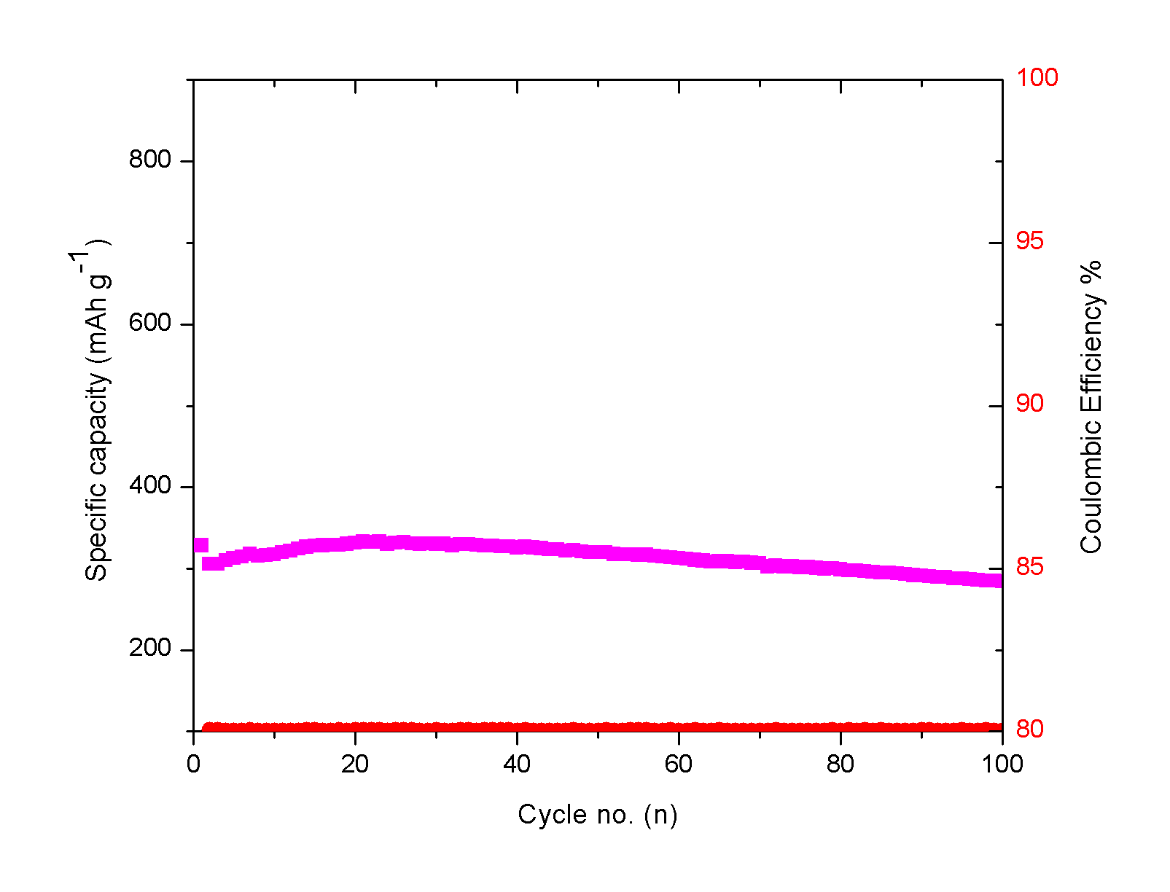
S 1Fig. Cycling performance of the Br2/ Electrodeposition electrode in 0.1 M H2SO4 + 0.1 M RbCl electrolyte at 1 A g-1. The cell was tested at 0 ~ 1 V vs. standard hydrogen electrode.
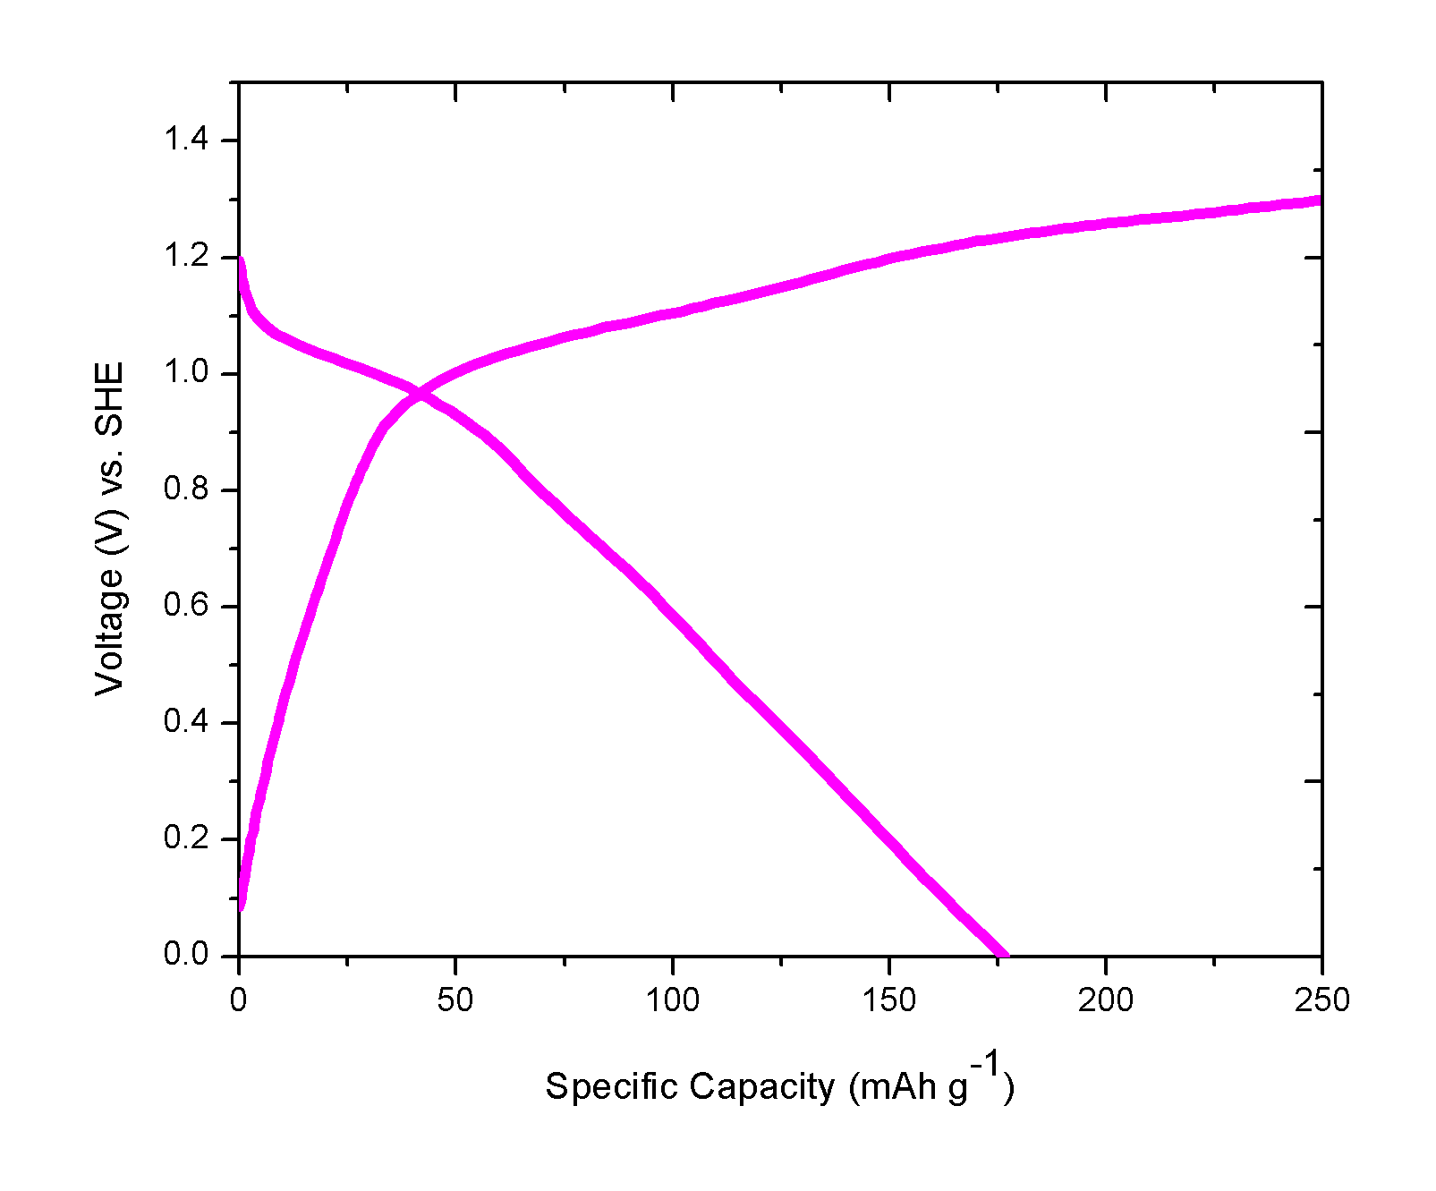
S2 Fig. Voltage of the electrodeposition electrode in electrolyte. The capacity is measured based on the mass loading of bromine (1.5 mg cm⁻²).
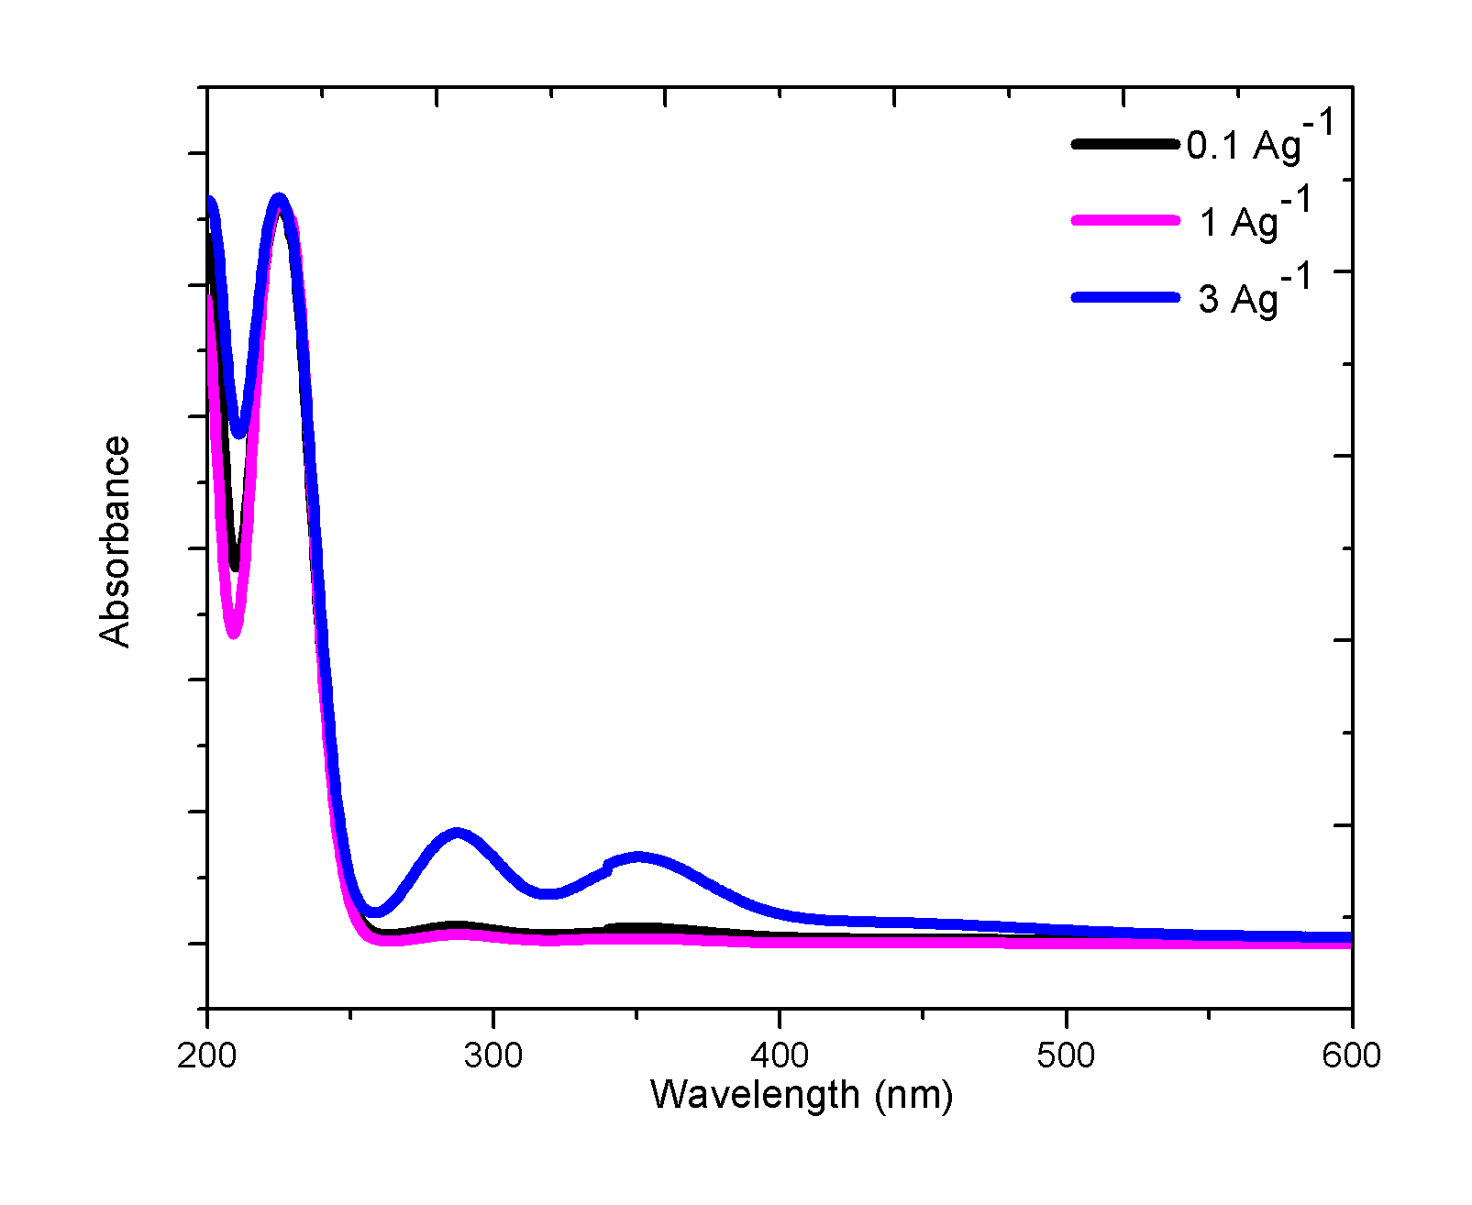
S3 Fig. The BrO₃⁻ at current densities was demonstrated by the chromogenic reaction with bromide. UV-vis spectra of the E-extracted solution at different current densities after the color titration in 0.1 M H₂SO₄ + 0.1 M RbCl electrolyte. The solution was obtained at discharge.
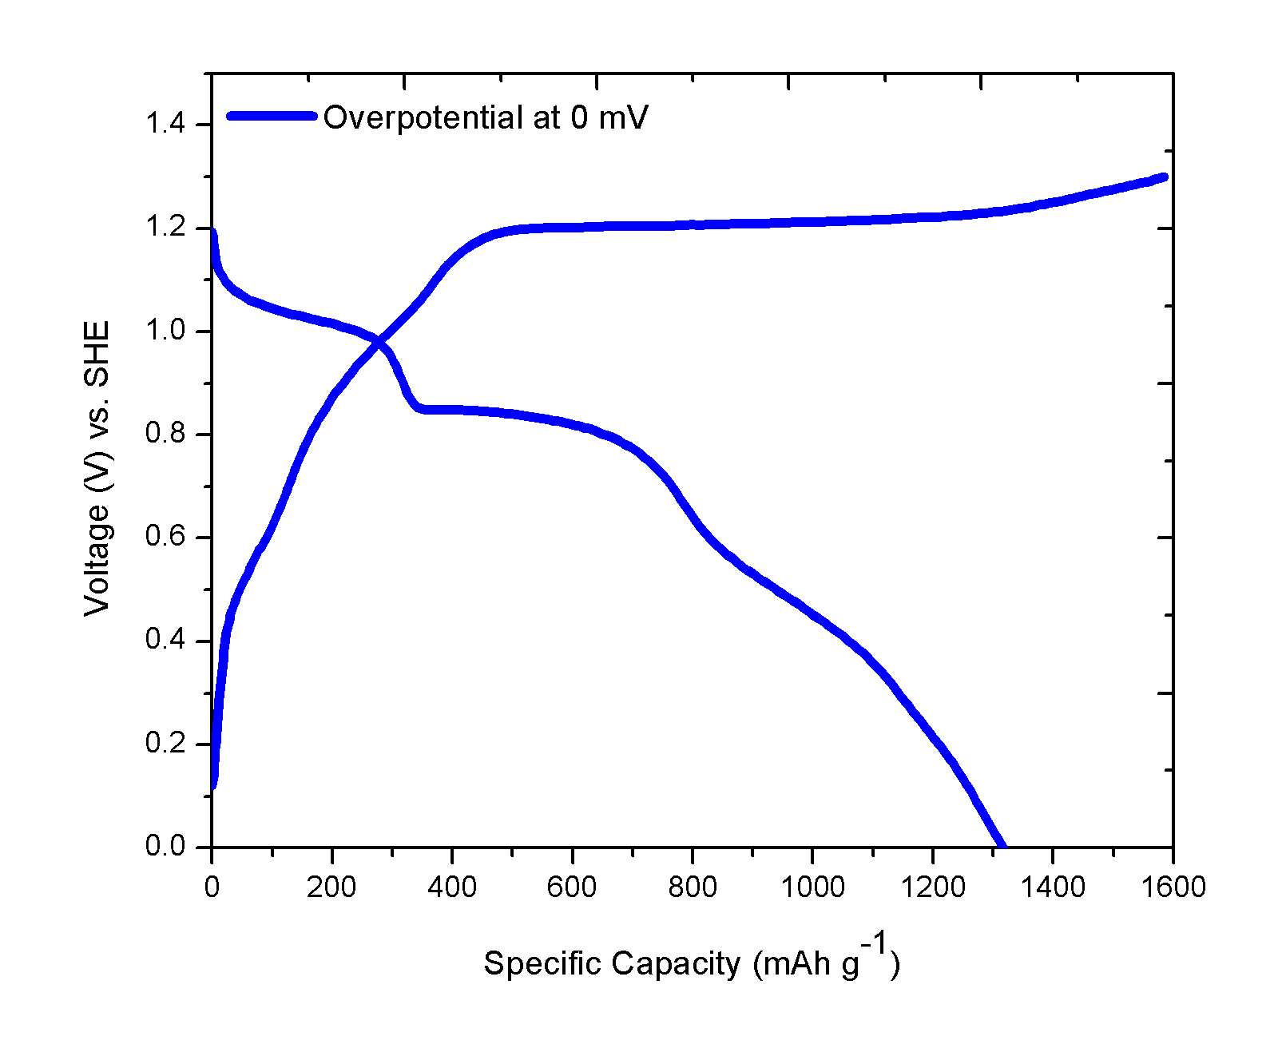
S4 Fig. The overpotential of Br₂ deposition in 0.1 M H₂SO₄ + 0.1 M RbCl electrolyte at 1 A g⁻¹.

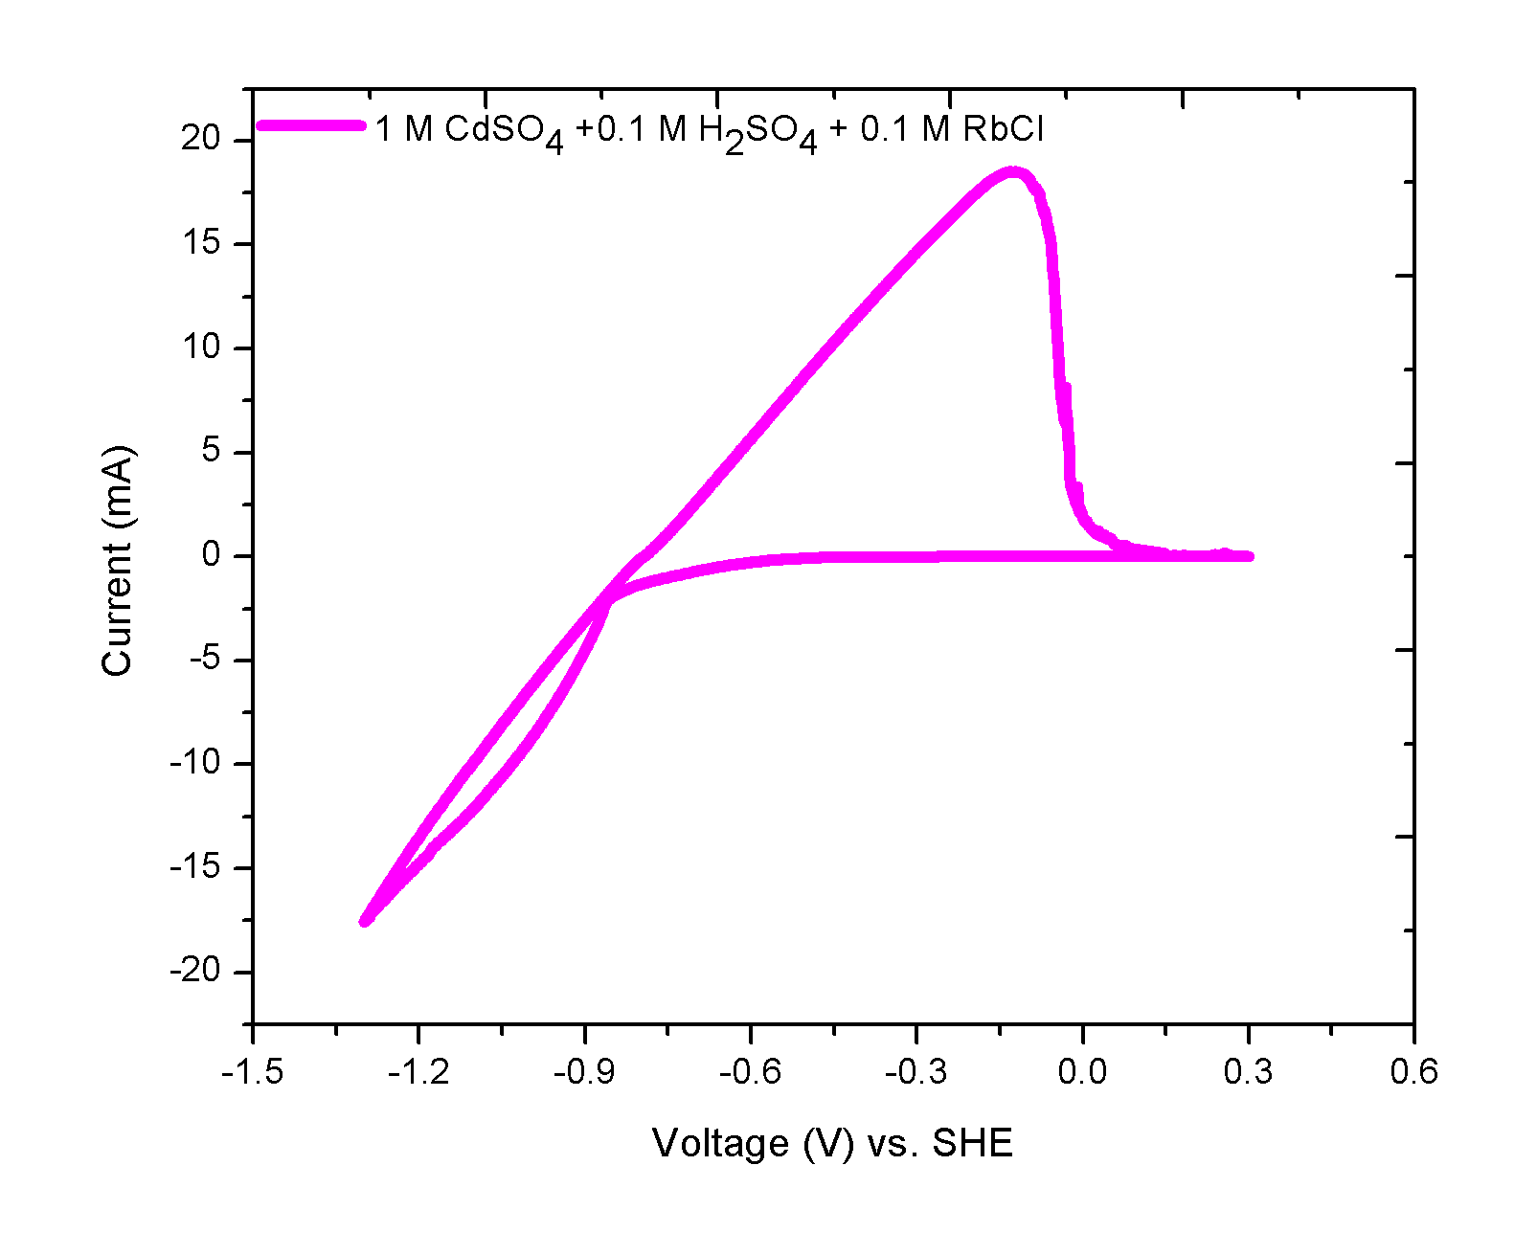 S5 Fig. Stable Cadmium plating/stripping in an acidic electrolyte CV curve of 1 M CdSO₄ + 0.1 M H₂SO₄ + 0.1 M RbCl electrolyte at a sweep rate of 0.5 mV s⁻¹. The CV curve, Al foil counter electrode and Hg/Hg₂SO₄ reference electrode.

