Supplementary Material: Variational Quantum Search with Shallow Depth for Unstructured Database Search
Junpeng Zhan
Department of Renewable Energy Engineering, Alfred University, Alfred, NY 14802, USA
Email: zhanj@alfred.edu

In this document, Fig. S1 offers the box plot results of the VQS with reduced layers for both Type-I and Type-II Ansatzes. Additionally, Fig. S2 showcases the Grover iteration, a crucial component within Grover's algorithm. Fig. S3 provides a circuit decomposition for the $C^{n}(X)$ gate. Algorithm 1 presents the Pseudo code detailing the process of determining the number of Grover iterations required for the execution of Grover's algorithm. Furthermore, Table S1 compiles a tabular representation of the circuit depth utilized by both the VQS and Grover's algorithm across varying numbers of qubits.

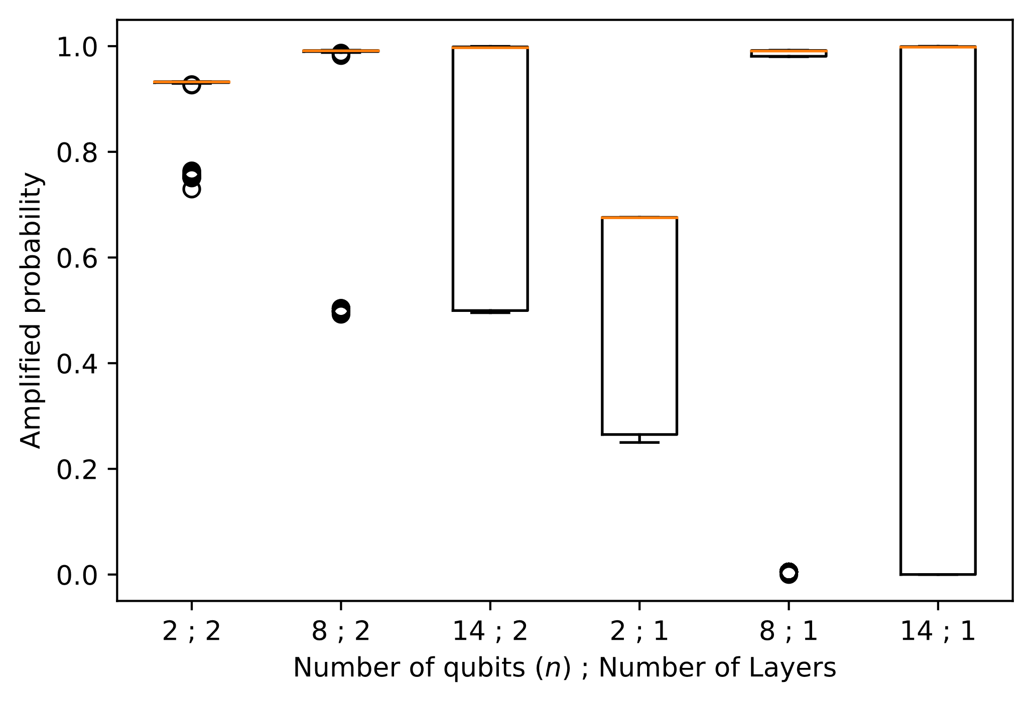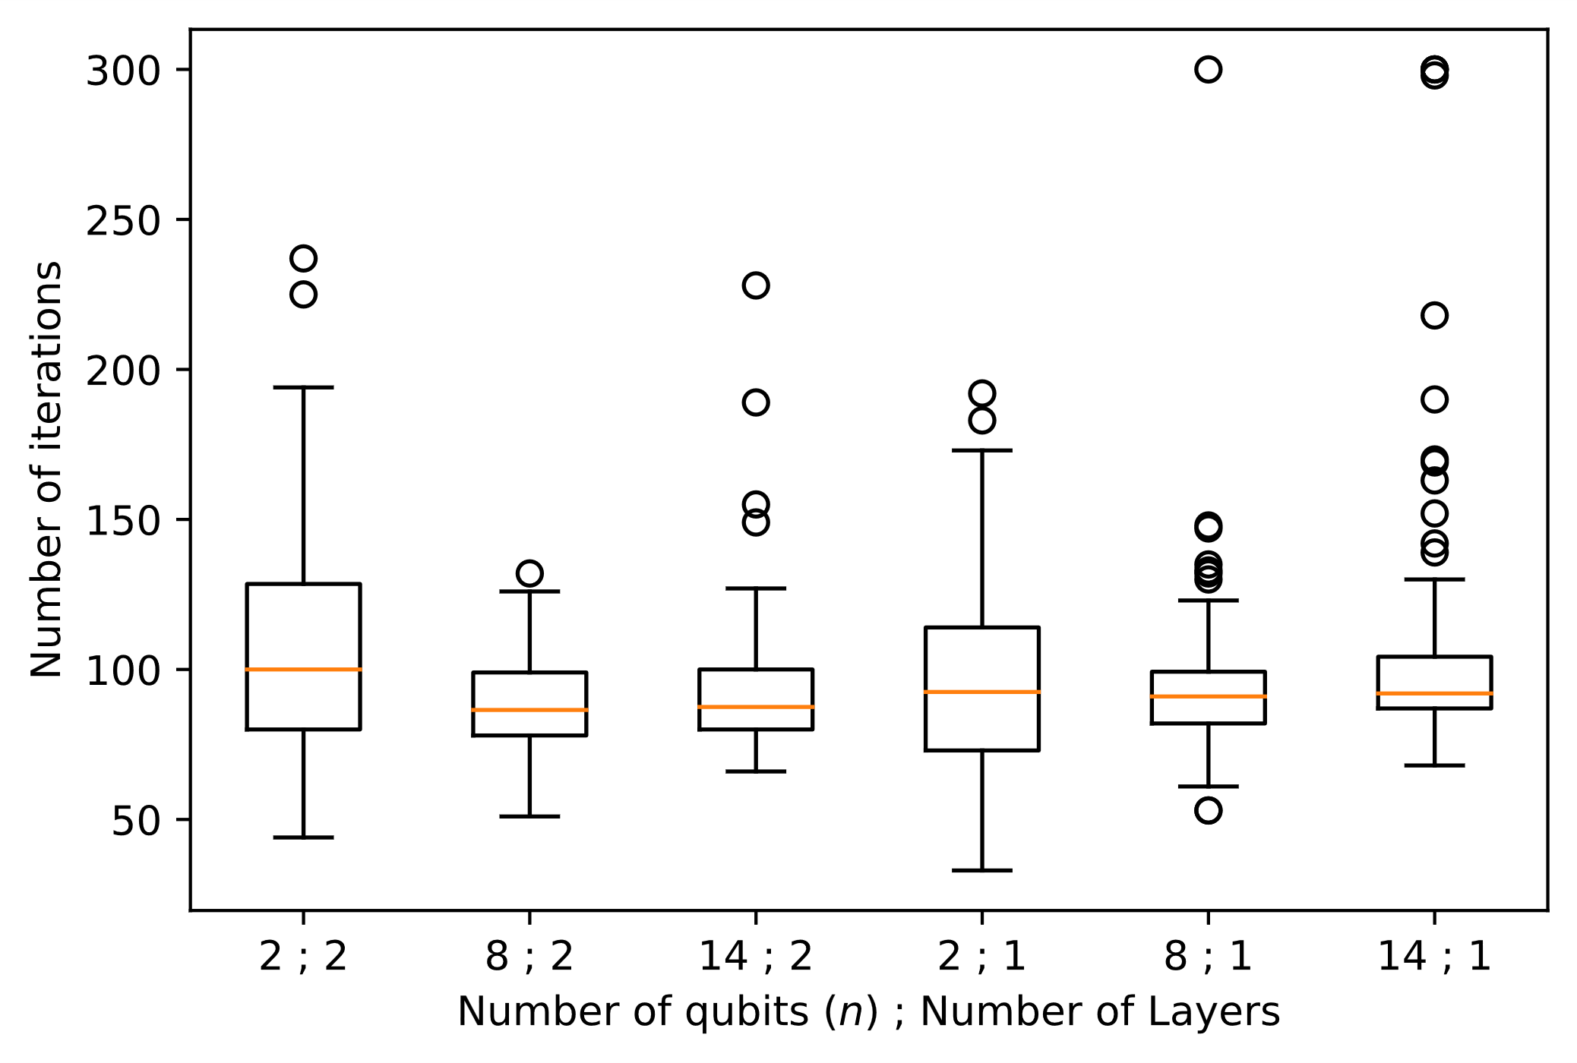
A
B
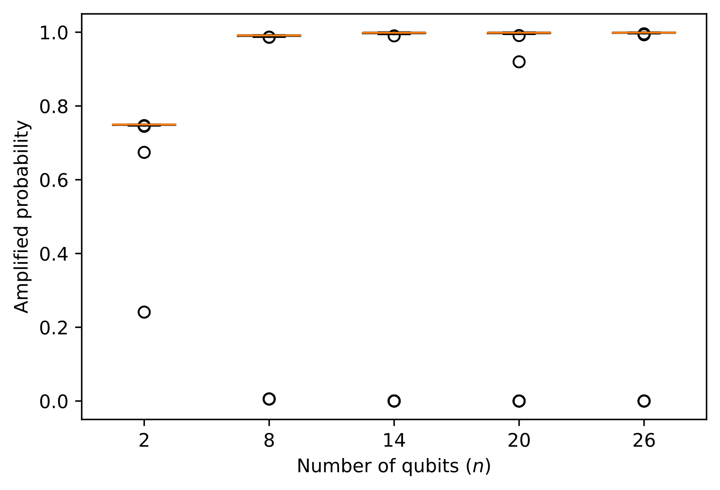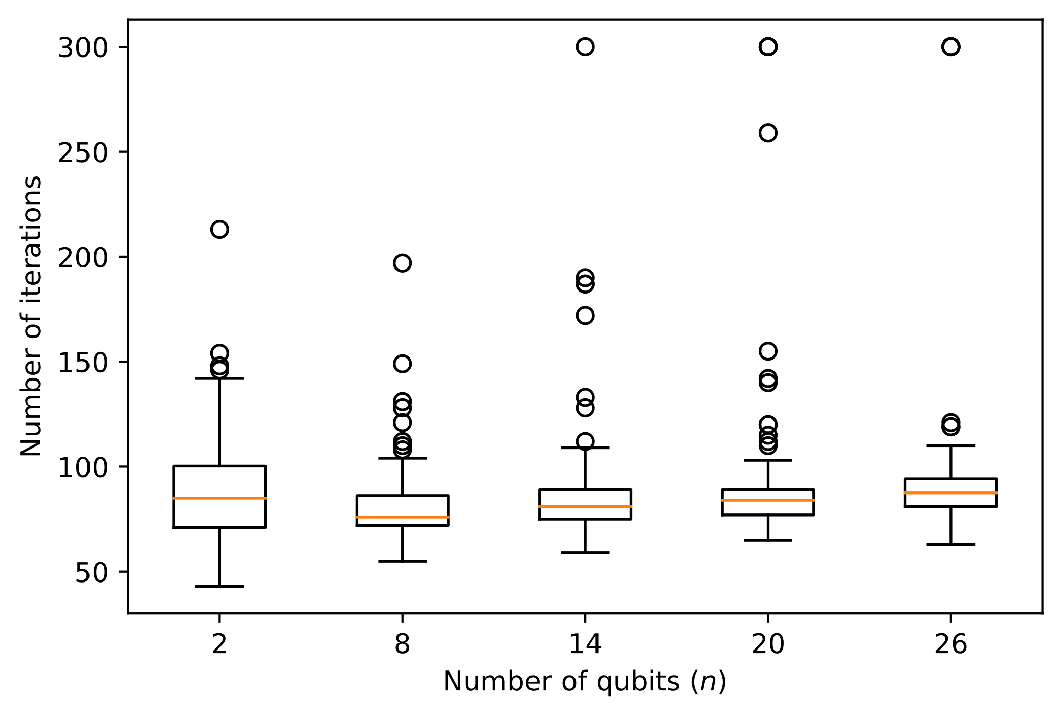
C
Dd
Fig. S1. Box plot results of the VQS using fewer layers. The VQS uses 1- and 2-layer type-I Ansatz (A),(B) and 1-layer type-II Ansatz (C),(D) to find the sole good element in an n-qubit input state, n=2,8,14,20, and 26. The VQS runs 100 times independently. (A),(C), The amplified probability of the good element, where some outliers have low or even 0 values (see the bottom of both panels). (B),(D), The number of iterations used when a termination criterion is met.

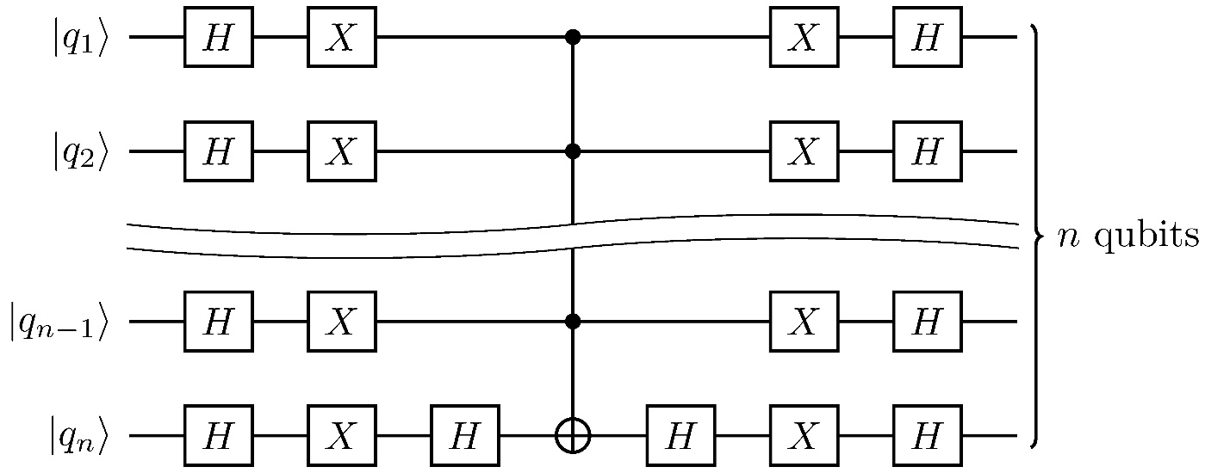
Fig. S2. Grover iteration. Grover’s algorithm consists of repeated application of the Grover iteration. The (n−1)-qubit-controlled one-target CNOT gate, denoted as $C^{n-1}(X)$, has a depth of 2n−3 (see Fig. S3). Then the circuit depth of the Grover iteration is 2n+1, which is calculated from 2n−3+4, where the 4 means the two left-most layers together with the two right-most layers; the two Hadamard gates beside $C^{n-1}(X)$ are not counted (except for the case of n=2,3) as each shares a layer with the neighboring Toffoli gate.

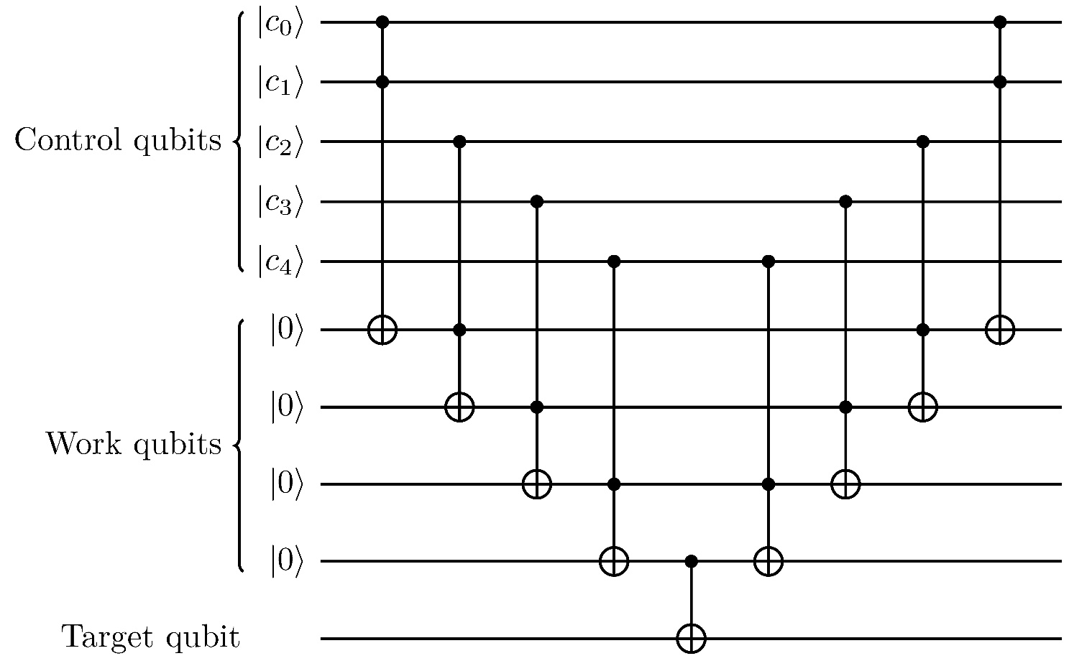
Fig. S3. Circuit decomposition for $C^{n}(X)$. It is decomposed into a depth-(2n−1) circuit consisting of (2n−2) Toffoli gates and a CNOT gate, for the case of n=5.

Algorithm 1. Pseudo code for calculating the number of Grover iterations† needed by Grover’s algorithm.
Input: the amplitude of each element, denoted as $α_{x}$. Let i=0.
Output: the number of Grover iterations ($n_{G}$).
1 | while $i≤1×{10}^{8}$
2 | Change the sign of the amplitude of good element, i.e., $α_{x}^{g} ← -α_{x}^{g}$, where superscript $g$ indicates that element x is a good element.
3 | Obtain the average amplitude, denoted as m, of all elements, i.e., $m=\sum_{x∈X}{α_{x}}/N$.
4 | Change the amplitude of element x from $α_{x}$ to 2m−$α_{x}$.
5 | i ← i+1
6 | If ${\left(α_{x}^{g}\right)}^{2}≥p_{s}$‡: record $n_{G}$=i and terminate.
†The Grover iteration is given in Fig. S2.
‡$p_{s}$ is the success probability, that is, when the probability of the good element is higher than $p_{s}$, the while loop in Table S1 terminates.

Table S1.
Circuit depth used by VQS and Grover’s search algorithm.
n | 2 | 8 | 14 | 20 | 26
Circuit depth of VQS (8n+4) | 20 | 68 | 116 | 164 | 212
$n_{G}$ ($p_{s}$=0.5)* | 1 | 6 | 50 | 402 | 3,215
Circuit depth† of Grover’s ($p_{s}$=0.5)‡ | 7 | 102 | 1,450 | 16,482 | 170,395
$n_{G}$ ($p_{s}$=0.9) | 1 | 10 | 80 | 639 | 5,113
Circuit depth of Grover’s ($p_{s}$=0.9) | 7 | 170 | 2,320 | 26,199 | 270,989
*The number of Grover iterations ($n_{G}$) is obtained by running the method described in Table S1.
‡The $p_{s}$ is defined at be bottom of Table S1.
†The circuit depth is calculated from (2n+1) multiplied by the corresponding $n_{G}$. For example, the last number 270,989 is obtained from 5,113×(2×26+1).

