Supplementary Material for The Effects of Chromium on the High Temperature Corrosion of Ni-Cr Alloys Exposed to Calcium Sulfate
Nicholas Ury¹, Vilupanur Ravi¹

¹California State Polytechnic University, Pomona 3801 W. Temple Ave. Pomona, CA 91768

*Corresponding author: Vilupanur Ravi; Email: vravi@cpp.edu

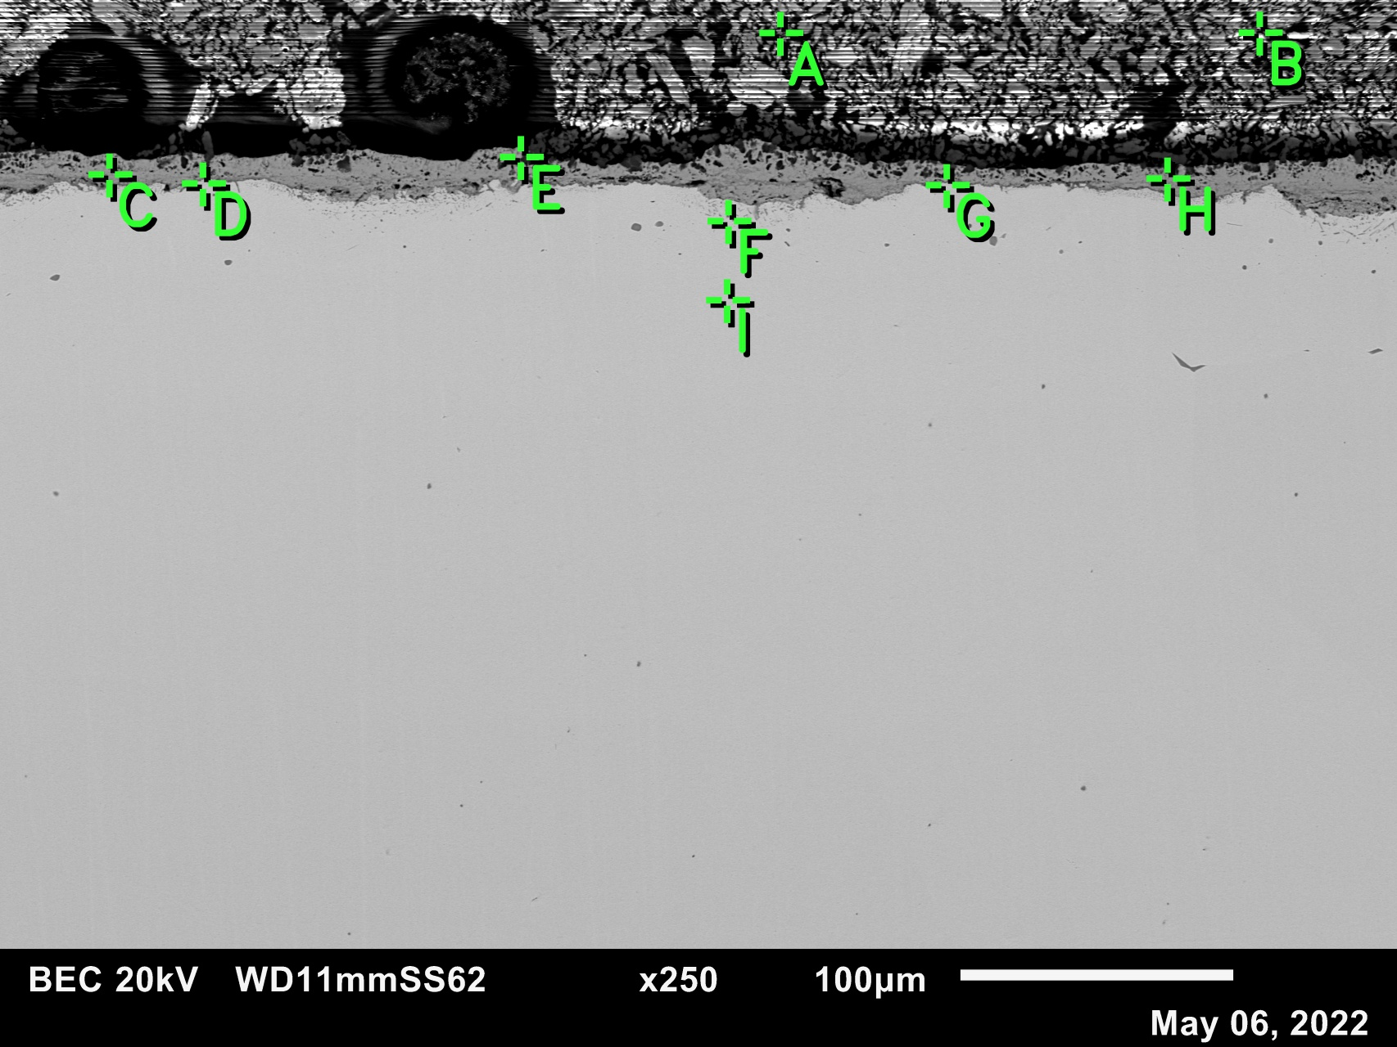
Figure S1: EDS locations on Ni5Cr exposed to CaSO₄ at 900 °C for 50 hours.
Table S1: Composition of corresponding EDS points shown in Figure S1
Element | Ni | Cr | Ca | O | S
A | 0.05 | 0.00 | 7.74 | 82.41 | 9.81
B | 0.06 | 0.03 | 11.53 | 74.70 | 13.67
C | 39.36 | 4.60 | 0.23 | 55.80 | 0.02
D | 94.86 | 2.03 | 0.20 | 2.83 | 0.08
E | 2.11 | 0.23 | 14.70 | 69.38 | 13.58
F | 96.79 | 1.79 | 0.14 | 1.17 | 0.12
G | 97.18 | 1.06 | 0.19 | 1.57 | 0.00
H | 39.52 | 5.46 | 0.56 | 54.05 | 0.41
I | 93.29 | 5.95 | 0.00 | 0.74 | 0.02

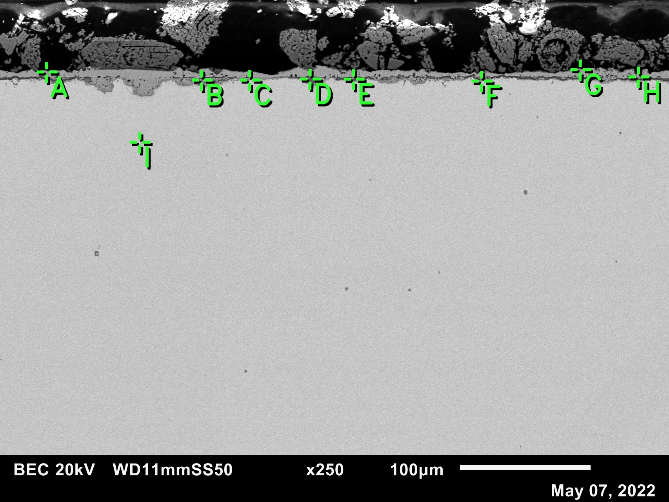
Figure S2: EDS locations on Ni10Cr exposed to CaSO₄ at 900 °C for 50 hours.
Table S2: Composition of corresponding EDS points shown in Figure S2
Element | Ni | Cr | Ca | O | S
A | 45.83 | 0.68 | 0.22 | 53.20 | 0.07
B | 24.55 | 16.59 | 4.16 | 54.55 | 0.15
C | 92.92 | 5.91 | 0.17 | 0.96 | 0.04
D | 37.05 | 1.35 | 0.60 | 60.96 | 0.04
E | 11.53 | 26.51 | 1.15 | 60.77 | 0.04
F | 93.19 | 5.50 | 0.19 | 1.08 | 0.04
G | 47.47 | 0.44 | 0.24 | 51.79 | 0.06
H | 50.95 | 15.06 | 0.74 | 33.12 | 0.13
I | 88.72 | 10.38 | 0.00 | 0.88 | 0.02

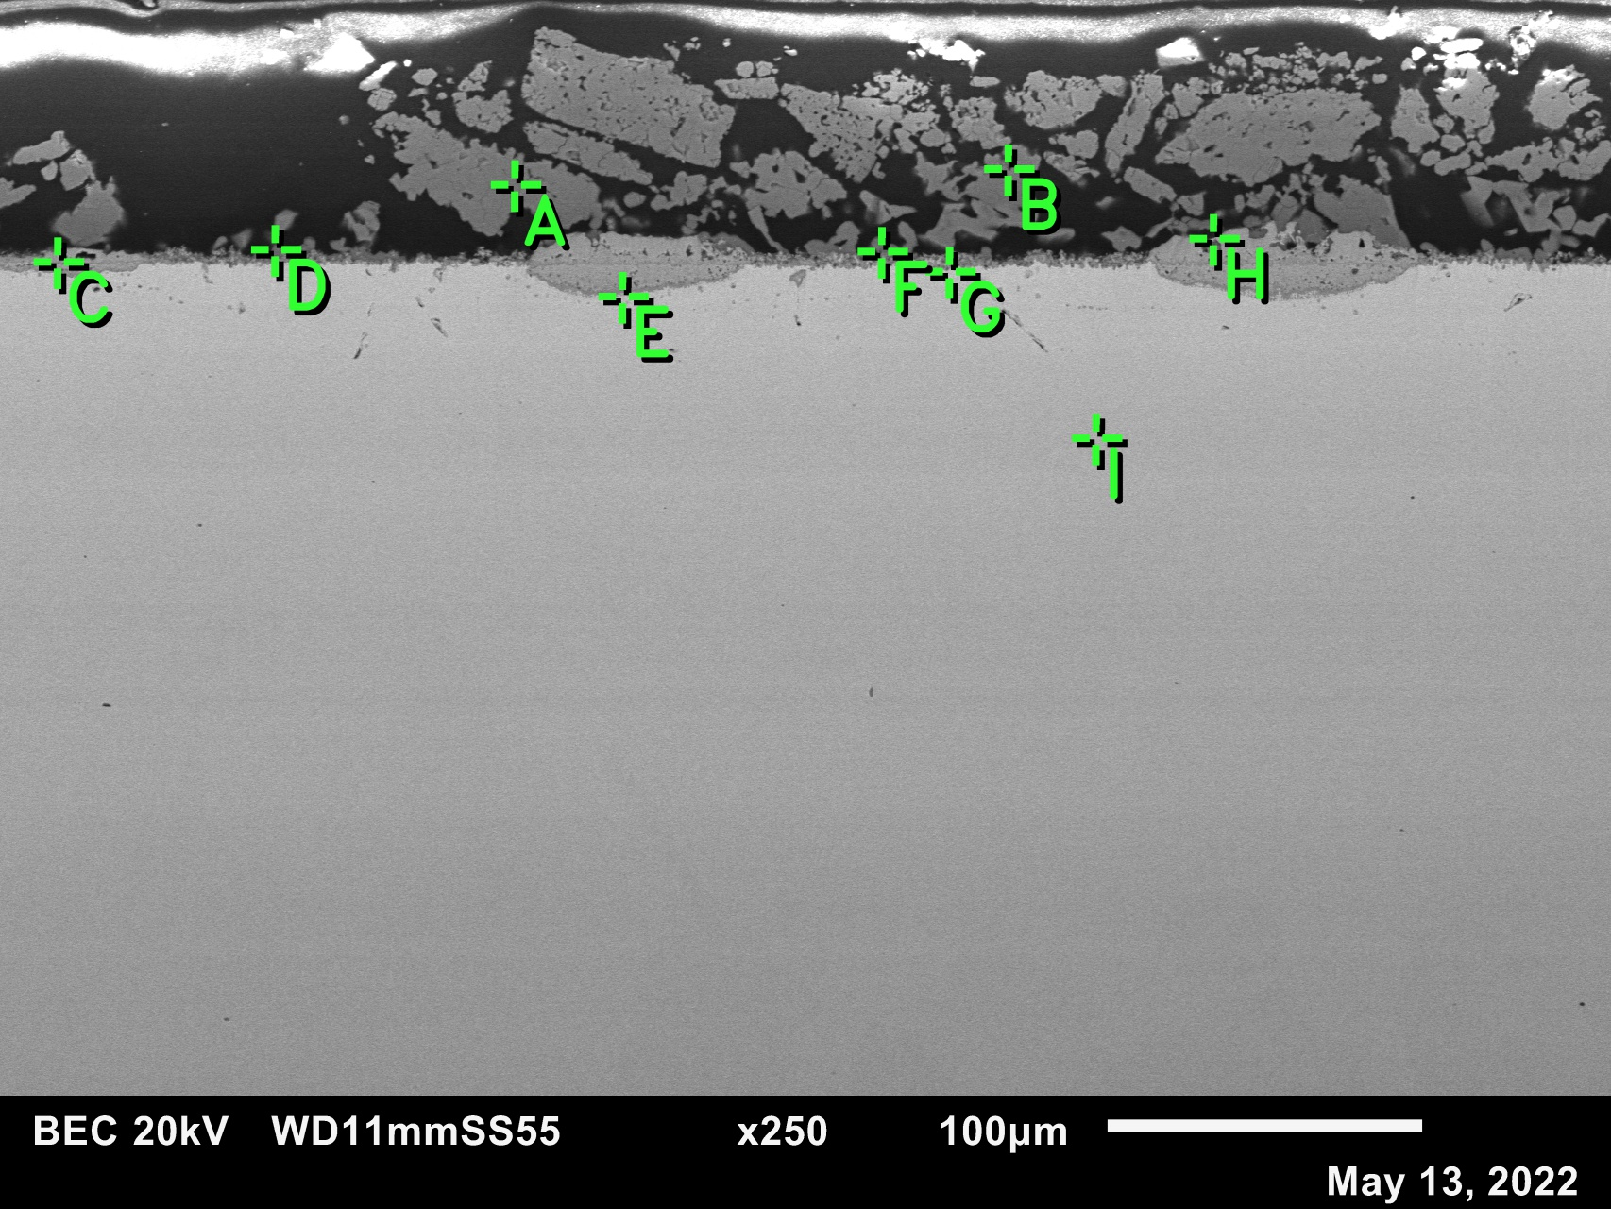
Figure S3: EDS locations on Ni18Cr exposed to CaSO₄ at 900 °C for 50 hours.
Table S3: Composition of corresponding EDS points shown in Figure S3
Element | Ni | Cr | Ca | O | S
A | 0.07 | 2.17 | 9.38 | 79.53 | 8.86
B | 0.12 | 2.05 | 9.16 | 79.69 | 8.98
C | 36.77 | 10.35 | 0.19 | 52.65 | 0.04
D | 10.92 | 24.97 | 12.93 | 50.85 | 0.33
E | 86.36 | 12.80 | 0.00 | 0.84 | 0.00
F | 8.33 | 31.38 | 16.69 | 43.10 | 0.50
G | 89.44 | 9.73 | 0.12 | 0.70 | 0.00
H | 51.10 | 1.08 | 0.77 | 46.56 | 0.48
I | 80.02 | 19.79 | 0.00 | 0.19 | 0.00

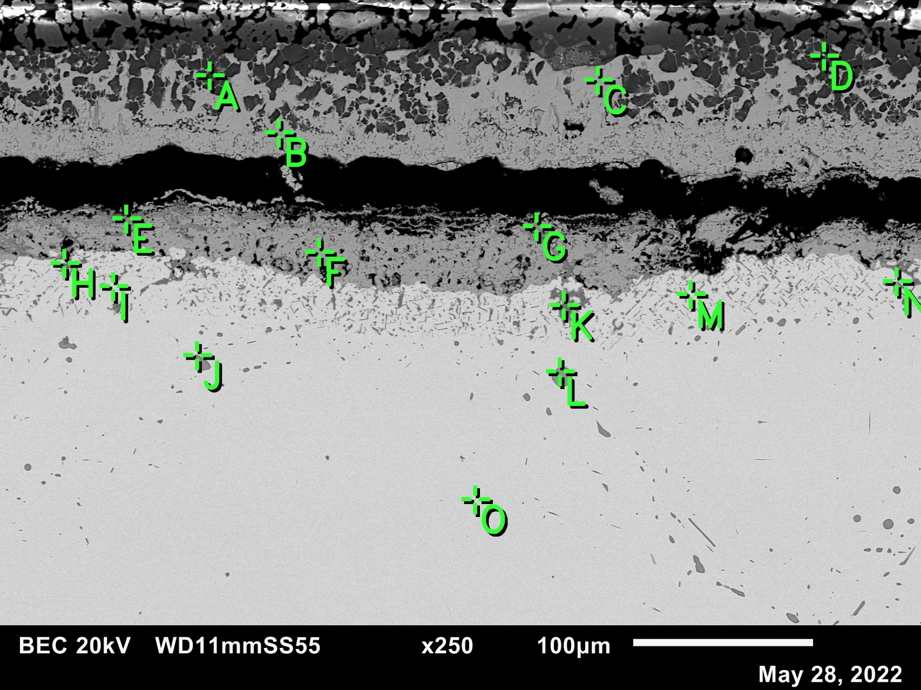
Figure S4: EDS locations on Ni5Cr exposed to CaSO₄ at 1000 °C for 50 hours.
Table S4: Composition of corresponding EDS points shown in Figure S4
Element | Ni | Cr | Ca | O | S
A | 1.17 | 1.07 | 13.10 | 71.78 | 12.89
B | 45.83 | 0.54 | 0.10 | 53.51 | 0.01
C | 45.87 | 0.13 | 0.47 | 53.51 | 0.02
D | 0.33 | 1.17 | 13.62 | 71.27 | 13.61
E | 17.00 | 21.06 | 0.16 | 61.78 | 0.00
F | 34.00 | 9.03 | 0.00 | 56.96 | 0.01
G | 11.54 | 27.63 | 0.25 | 60.52 | 0.06
H | 2.43 | 32.11 | 0.03 | 65.38 | 0.06
I | 98.43 | 0.61 | 0.00 | 0.94 | 0.02
J | 81.60 | 6.46 | 0.01 | 0.41 | 11.52
K | 2.21 | 30.83 | 0.06 | 66.64 | 0.27
L | 9.47 | 34.21 | 0.01 | 0.00 | 56.31
M | 91.56 | 4.54 | 0.03 | 3.87 | 0.00
N | 73.79 | 7.12 | 0.00 | 19.09 | 0.00
O | 92.68 | 6.12 | 0.05 | 1.16 | 0.00

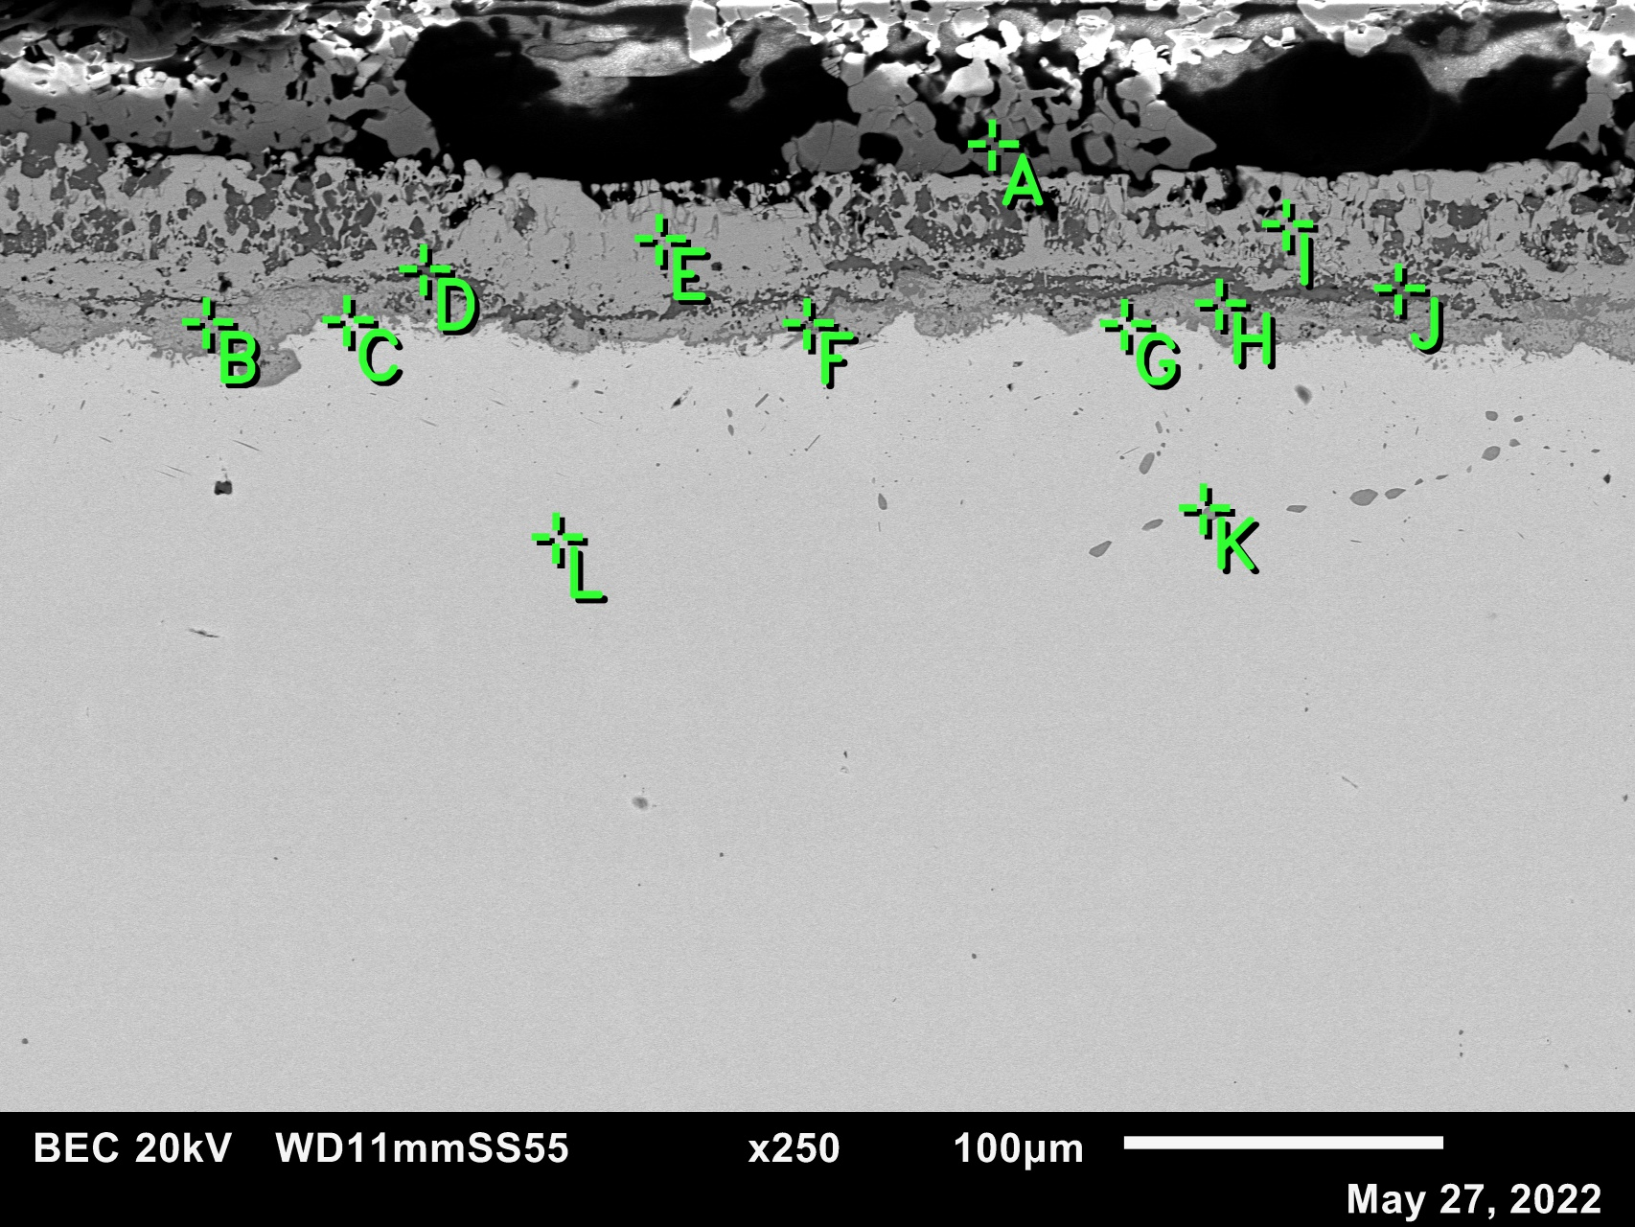
Figure S5: EDS locations on Ni10Cr exposed to CaSO₄ at 1000 °C for 50 hours.
Table S5: Composition of corresponding EDS points shown in Figure S5
Element | Ni | Cr | Ca | O | S
A | 0.15 | 3.43 | 12.56 | 73.60 | 10.25
B | 33.13 | 6.56 | 0.08 | 60.20 | 0.03
C | 93.89 | 2.84 | 0.03 | 3.23 | 0.02
D | 17.69 | 15.39 | 12.56 | 53.80 | 0.56
E | 46.30 | 0.38 | 0.10 | 53.19 | 0.02
F | 76.18 | 9.04 | 0.15 | 14.59 | 0.03
G | 94.05 | 3.49 | 0.06 | 2.40 | 0.00
H | 22.21 | 17.57 | 0.27 | 59.90 | 0.04
I | 47.37 | 0.51 | 0.12 | 51.99 | 0.01
J | 11.75 | 12.53 | 12.20 | 62.82 | 0.70
K | 63.86 | 17.24 | 0.06 | 1.43 | 17.41
L | 87.74 | 10.41 | 0.02 | 1.82 | 0.02

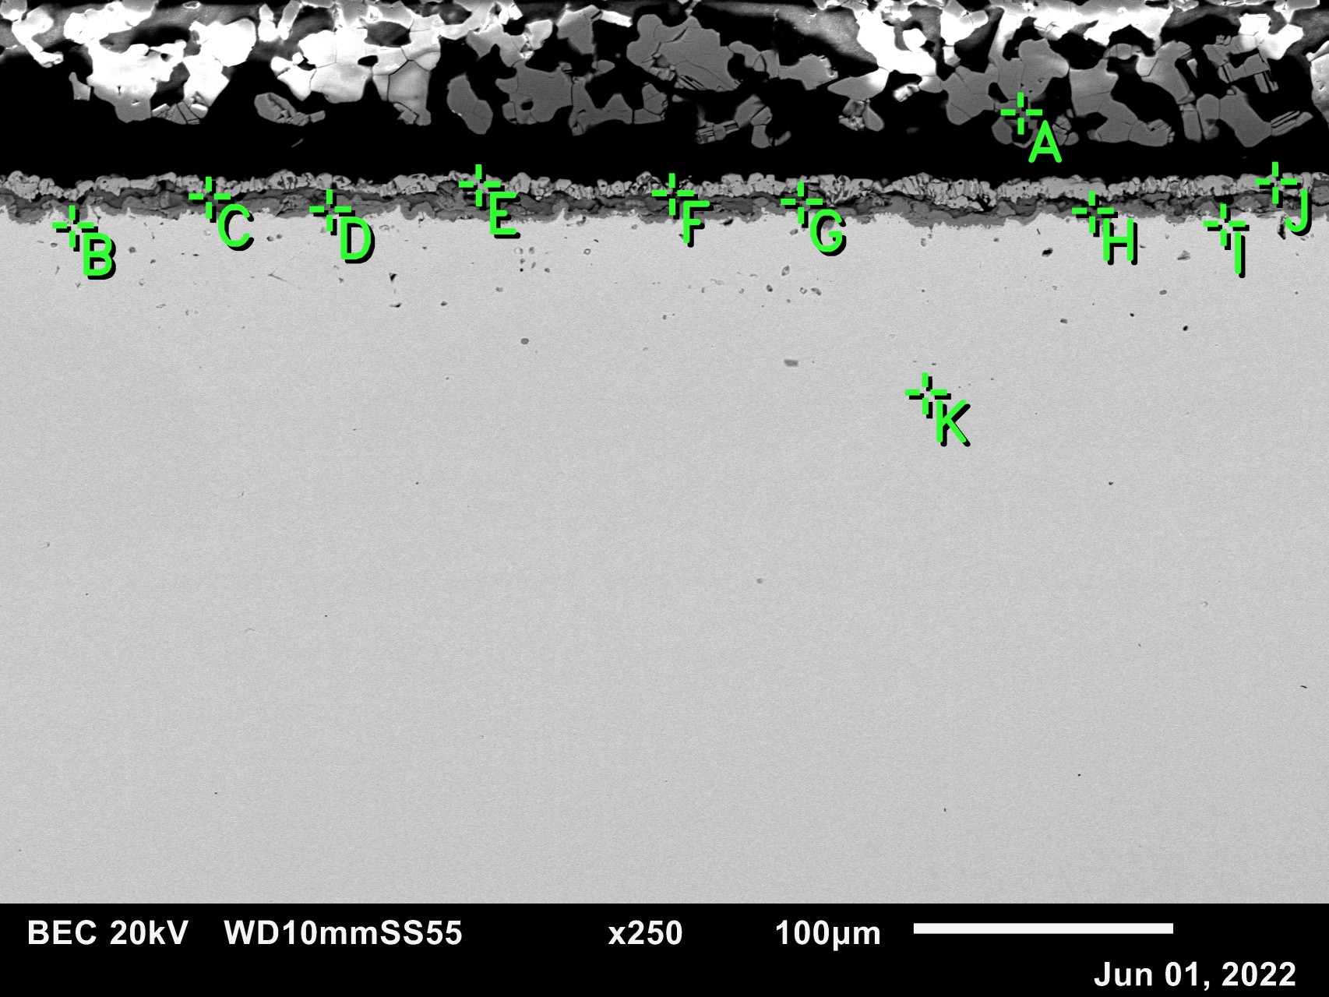
Figure S6: EDS locations on Ni18Cr exposed to CaSO₄ at 1000 °C for 50 hours.
Table S6: Composition of corresponding EDS points shown in Figure S6
Element | Ni | Cr | Ca | O | S
A | 0.06 | 3.06 | 9.55 | 79.78 | 7.55
B | 91.75 | 7.34 | 0.11 | 0.77 | 0.04
C | 43.01 | 7.24 | 7.62 | 41.68 | 0.45
D | 16.31 | 22.62 | 0.82 | 60.21 | 0.04
E | 51.43 | 0.88 | 0.31 | 47.35 | 0.04
F | 72.00 | 4.18 | 2.95 | 20.73 | 0.14
G | 0.96 | 30.57 | 14.76 | 53.65 | 0.07
H | 7.94 | 17.37 | 17.79 | 56.05 | 0.85
I | 92.05 | 6.54 | 0.22 | 1.15 | 0.04
J | 20.12 | 7.15 | 10.58 | 61.73 | 0.41
K | 80.02 | 19.57 | 0.05 | 0.34 | 0.02

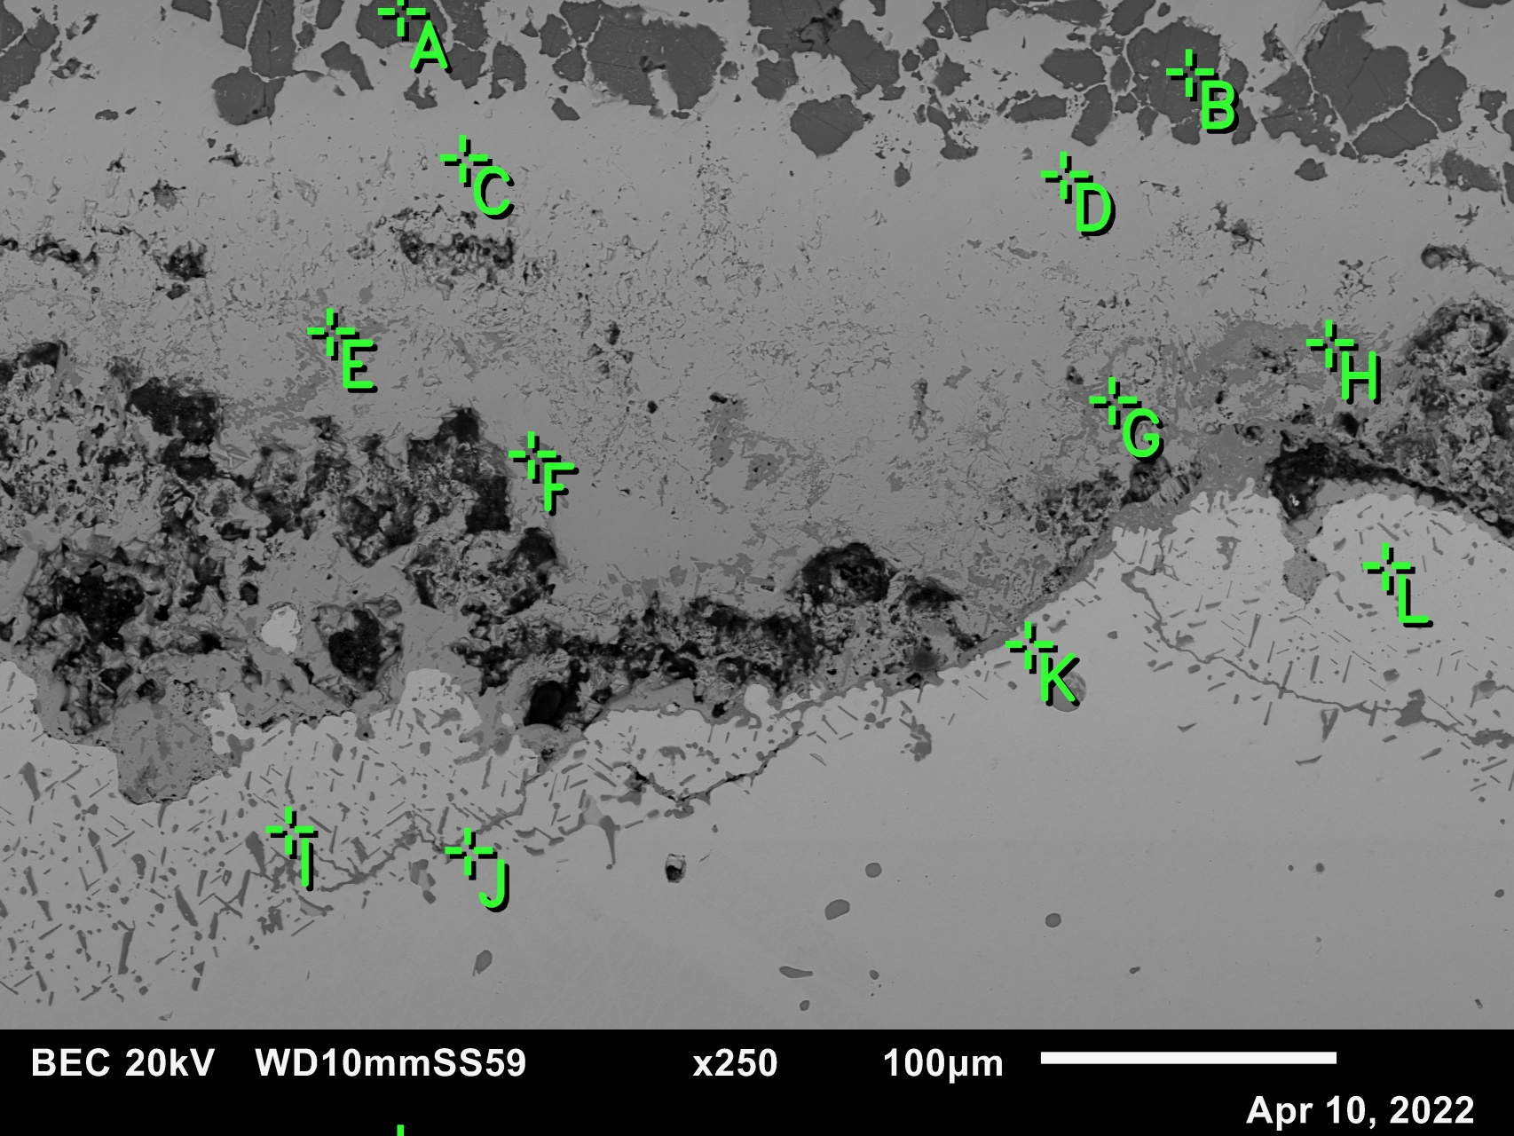
Figure S7: EDS locations on Ni5Cr exposed to CaSO₄ at 1100 °C for 50 hours.
Table S7: Composition of corresponding EDS points shown in Figure S7
Element | Ni | Cr | Ca | O | S
A | 0.70 | 0.40 | 14.55 | 68.92 | 15.44
B | 0.57 | 0.20 | 12.94 | 72.17 | 14.13
C | 45.93 | 0.37 | 1.38 | 52.24 | 0.07
D | 47.30 | 0.32 | 0.25 | 52.08 | 0.05
E | 7.95 | 19.76 | 10.59 | 60.81 | 0.89
F | 7.59 | 20.94 | 10.63 | 60.83 | 0.01
G | 6.50 | 22.08 | 11.50 | 59.88 | 0.06
H | 0.91 | 29.38 | 9.86 | 59.79 | 0.06
I | 98.11 | 0.99 | 0.00 | 0.90 | 0.00
J | 98.08 | 1.29 | 0.05 | 0.59 | 0.00
K | 97.95 | 1.23 | 0.00 | 0.74 | 0.08
L | 98.09 | 0.46 | 0.02 | 1.44 | 0.00

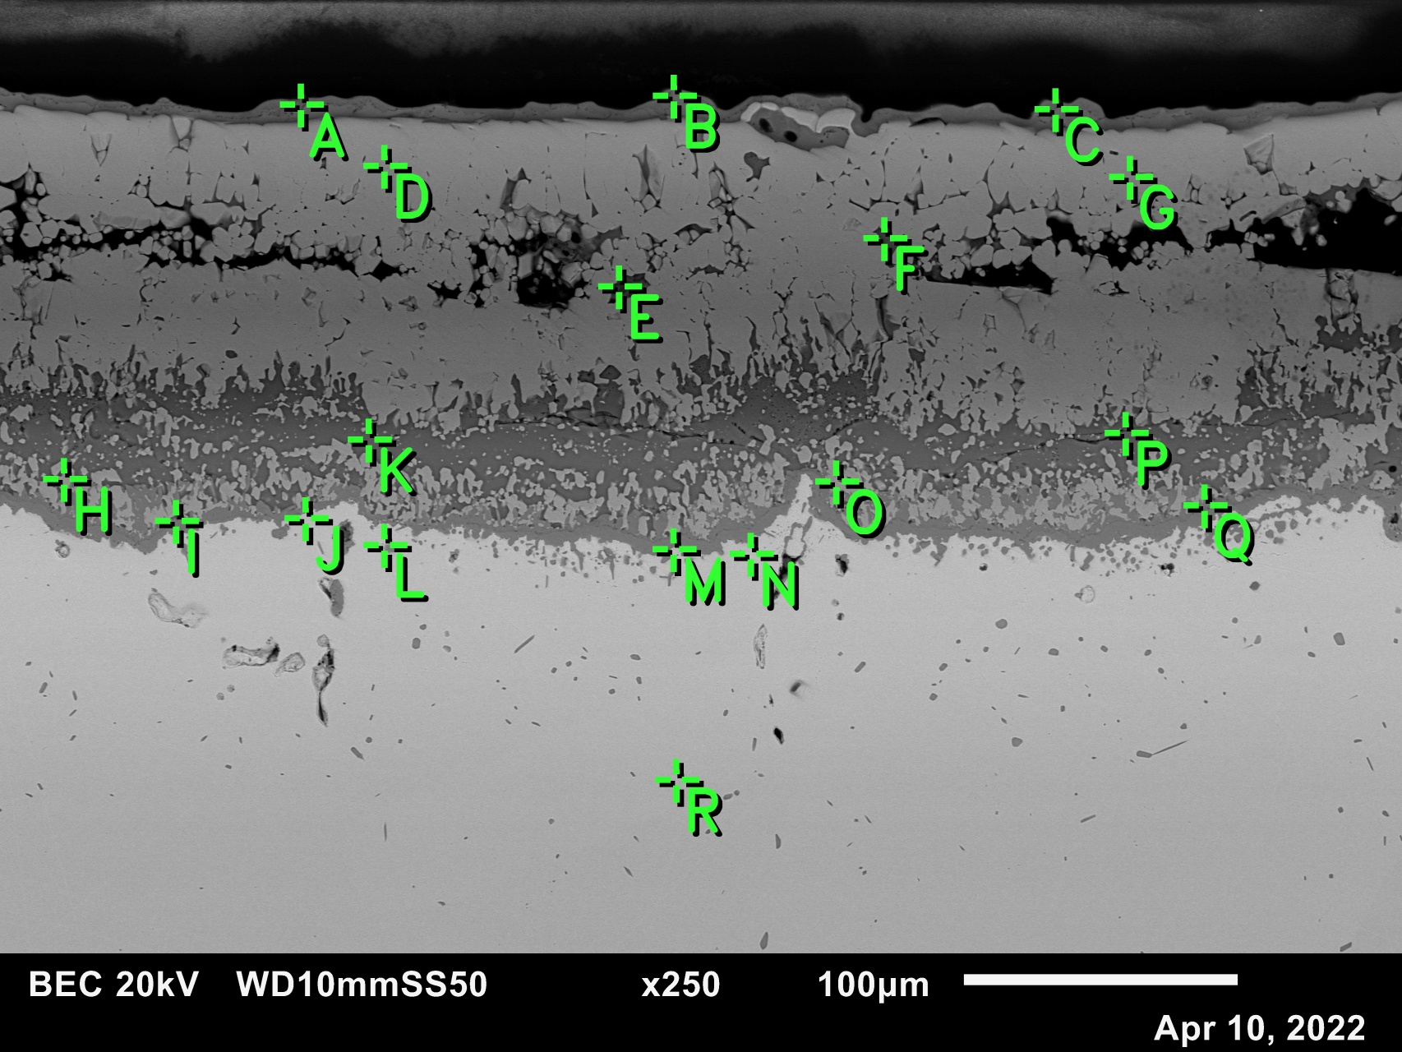
Figure S8: EDS locations on Ni10Cr exposed to CaSO₄ at 1100 °C for 50 hours.
Table S8: Composition of corresponding EDS points shown in Figure S8
Element | Ni | Cr | Ca | O | S
A | 0.47 | 13.99 | 21.00 | 62.90 | 1.64
B | 0.36 | 12.37 | 18.91 | 66.67 | 1.70
C | 0.47 | 13.00 | 20.28 | 64.42 | 1.82
D | 47.15 | 0.13 | 0.84 | 51.85 | 0.04
E | 4.46 | 4.70 | 15.94 | 65.15 | 9.75
F | 9.90 | 13.13 | 18.40 | 57.21 | 1.37
G | 46.74 | 0.11 | 0.83 | 52.32 | 0.00
H | 46.82 | 2.41 | 0.96 | 49.80 | 0.01
I | 1.23 | 24.41 | 11.93 | 62.43 | 0.01
J | 95.55 | 3.72 | 0.14 | 0.59 | 0.00
K | 0.90 | 13.34 | 20.94 | 62.91 | 1.90
L | 39.39 | 26.44 | 0.05 | 34.09 | 0.03
M | 5.02 | 31.99 | 0.09 | 62.91 | 0.00
N | 96.10 | 3.54 | 0.05 | 0.28 | 0.04
O | 4.00 | 20.58 | 10.22 | 65.21 | 0.00
P | 0.66 | 12.46 | 19.93 | 65.07 | 1.88
Q | 0.70 | 33.37 | 0.76 | 65.16 | 0.00
R | 89.85 | 9.33 | 0.00 | 0.78 | 0.04

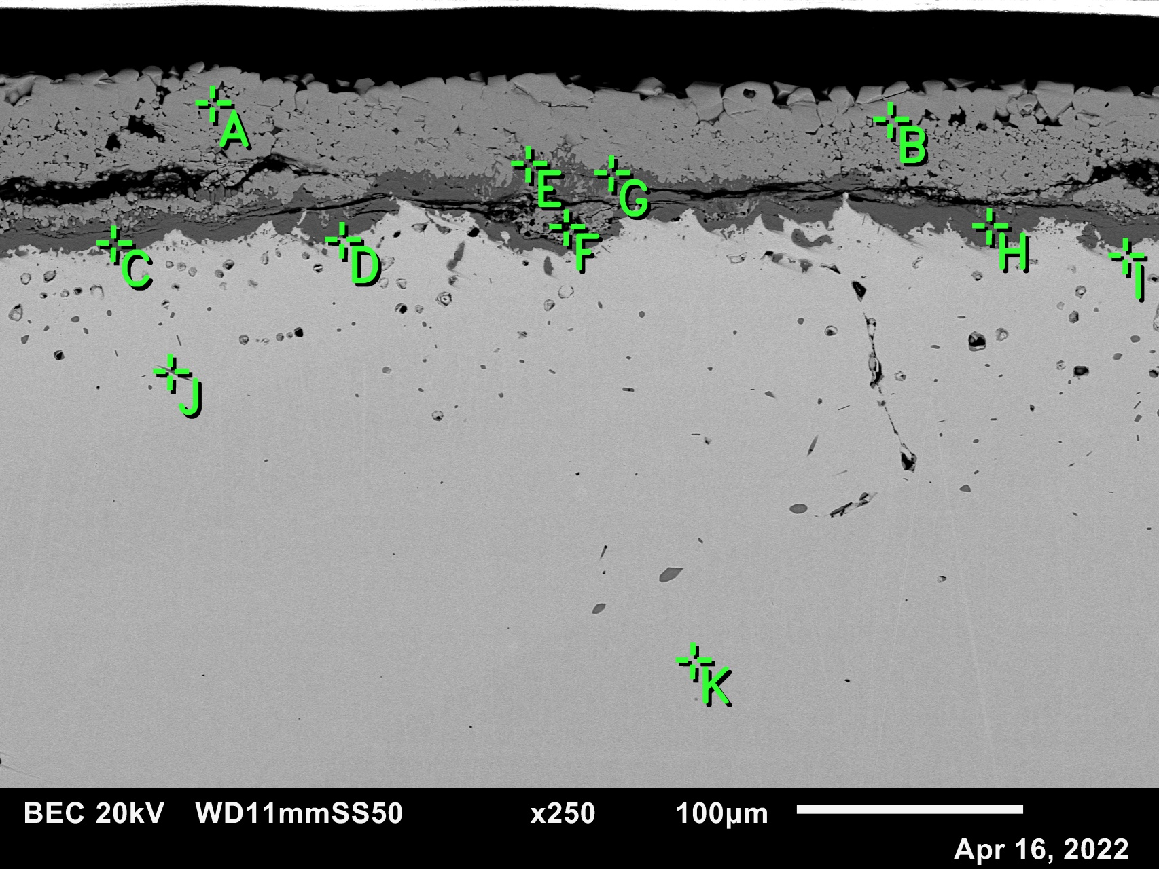
Figure S9: EDS locations on Ni18Cr exposed to CaSO₄ at 1100 °C for 50 hours.
Table S9: Composition of corresponding EDS points shown in Figure S9
Element | Ni | Cr | Ca | O | S
A | 42.92 | 1.09 | 0.11 | 55.83 | 0.05
B | 43.23 | 1.19 | 0.01 | 55.53 | 0.05
C | 1.66 | 28.68 | 0.06 | 69.58 | 0.03
D | 92.51 | 7.30 | 0.00 | 0.16 | 0.04
E | 8.41 | 21.18 | 9.94 | 60.46 | 0.02
F | 33.50 | 3.42 | 0.03 | 63.05 | 0.00
G | 3.28 | 23.47 | 11.56 | 61.69 | 0.00
H | 0.50 | 32.00 | 0.12 | 67.38 | 0.01
I | 93.04 | 6.38 | 0.14 | 0.44 | 0.00
J | 78.78 | 17.69 | 0.00 | 0.39 | 3.14
K | 79.94 | 19.78 | 0.03 | 0.12 | 0.13

