Appendix. A: Supplementary Information
Heavy Metal Pollution in Street Dust: A Comprehensive Study on Risk Assessment and Source Identification in a Highly Industrialized Area of Bangladesh
Md. Hasibur Rahaman^{1,2*}, Md. Alinur Rahman ^{1,3}, Rahamoni Khanam¹, Minhaz Ahmed⁴, Md. Sayedul Islam⁵, Md. Akteruzzaman¹, Fahim Muntasir Rabbi¹, Md. Kamrul Hasan¹, Sohely Asharof¹, Nahid Hasan¹, Towhida Jahan¹, Pragga Chowdhury¹, Partha Chandra Debnath¹, Tusar Kumar Das¹, Mohammad Mahfuzur Rahman¹

¹ Department of Environmental Science and Technology, Jashore University of Science and Technology, Jashore-7408, Bangladesh
² Institute for Smart City of Chongqing University in Liyang, Jiangsu, 213300, PR China
³ Department of Chemistry and Physics, College of Science and Technology, Southeastern Louisiana University, Hammond, LA-70401, USA
⁴ Department of Agroforestry and Environment, Bangabandhu Sheikh Mujibur Rahman Agricultural University, Gazipur-1706, Bangladesh
⁵ Department of Microbiology and Public Health, Bangabandhu Sheikh Mujibur Rahman Agricultural University, Gazipur 1706, Bangladesh

* Corresponding Author: Md. Hasibur Rahaman; hasib.est@just.edu.bd

Summary: This supplementary document contains four tables and two figures

Table S1 Sampling location along with the sample ID
Street location | Sample id | Latitude | Longitude
Shampur govt. school & college | N1 | 23.6811 | 90.441
Resident Stil area | N2 | 23.68337 | 90.45242
Pagla Bazar | N3 | 23.66197 | 90.45635
Fertilizer Industry | N4 | 23.66818 | 90.4694
Dying Textile Idustry | N5 | 23.65285 | 90.47658
Madrasa | N6 | 23.62207 | 90.46268
BISIC/Shamgonj | N7 | 23.62495 | 90.47679
Kasimpur govt. primary School | N8 | 23.60162 | 90.48668
Shanta feeling station | N9 | 23.60132 | 90.49534
Primier cement | N10 | 23.59661 | 90.49826
Sukum potti mosjid | N11 | 23.60916 | 90.51535
N. cc + Vc hospital | N12 | 23.60786 | 90.50264
New metro cinema | N13 | 23.62435 | 90.50504
Gudara ghat | N14 | 23.63271 | 90.51375
Pathantuli garments | N15 | 23.63767 | 90.51028
2 no. Dhakeshori | N16 | 23.65751 | 90.51191
Spinning mills | N17 | 23.67316 | 90.49909
Jalkuri Madbor bazar | N18 | 23.66432 | 90.49797
EPZ | N19 | 23.67807 | 90.51684
Chittagong bisso road | N20 | 23.69799 | 90.5094
Mouchak feeling station | N21 | 23.69551 | 90.49608
Matuail Ahsan uddin | N22 | 23.67945 | 90.46721
Signboard | N23 | 23.69315 | 90.48124
Shibu market | N24 | 23.675 | 90.48315
Shantinagar Jame mosjid | N25 | 23.64907 | 90.50541
DC office | N26 | 23.63343 | 90.49585
Narayongonj Govt. High School | N27 | 23.62225 | 90.48588
West majdair Jame mosqe | N28 | 23.61815 | 90.49284
Jatrabari | N29 | 23.70966 | 90.43497
Donia | N30 | 23.70367 | 90.44771

Table S2 Descriptive statistics for overall heavy metals on street dust in Narayanganj.
 | Parameters (mg/kg)
 | Cr | Cu | Ni | Cd | Pb | Fe | Mn | Na | Ca | Mg
Max | 491.06 | 261.25 | 90.25 | 11.75 | 177.23 | 462.5 | 271.25 | 108.68 | 5002.5 | 82.68
Min | 112.46 | 138.13 | 14.28 | 1.78 | 10.53 | 419.5 | 94.73 | 93.08 | 4227.5 | 75
Median | 314.72 | 258.88 | 51.76 | 2.86 | 46.4 | 444.63 | 234.83 | 102.5 | 4906.25 | 79.68
Mean | 317.25 | 247.86 | 53.26 | 3.53 | 56.35 | 443.94 | 227.18 | 101.74 | 4842.33 | 79.46
Stdev. | 62.25 | 25.77 | 16.76 | 2.03 | 31.76 | 6.48 | 33.86 | 3.79 | 203.90 | 1.70
S. Variance | 3875.78 | 663.93 | 281.05 | 4.12 | 1008.55 | 42.02 | 1146.3 | 14.41 | 41575.83 | 2.89
S. Error | 11.36 | 4.70 | 3.06 | 0.37 | 5.80 | 1.18 | 6.18 | 0.69 | 37.23 | 0.31
Kurtosis | 4.96 | 11.21 | 0.88 | 8.82 | 6.80 | 8.43 | 8.02 | -0.35 | 5.44 | 0.76
Skewness | -0.71 | -3.11 | 0.58 | 2.70 | 2.21 | -1.20 | -2.42 | -0.45 | -2.53 | -0.59
95% UCL | 23.24 | 9.62 | 6.26 | 0.76 | 11.86 | 2.42 | 12.64 | 1.42 | 76.14 | 0.64
BV-China CNEMC* | 62.5 | 21.4 | 28.9 | 0.11 | 21.4 | 22322.5 | 557 | - | - | -
PTE- (CEPA, 1995) ** | 200 | 100 | 50 | 0.3 | 300 | - | - | - | - | -
SI-TRV MPC (USEPA, 1999) *** | 0.2 | 32 | 100 | 10 | 100 | - | - | - | - | -
Max=Maximum, Min=Minimum, Stdev. = Standard Deviation, S. Variance = Sample Variance, S. Error = Standard Error
*BV-China CNEMC Soil background value
**PTE-MPC CEPA potentially toxic elements for agricultural soils
***SI-TRV USEPA soil invertebrate toxicity reference values

Table S3.
Non -Carcinogenic Risk and Carcinogenic Risk Values for the heavy metal Contamination in street dust in Narayanganj Sadar.
Metal |  |  | ADD_{ing} | ADD_{inh} | ADD_{dermal} | HQ_{ing} | HQ_{inh} | HQ_{dermal} | HI | CR_{ing} | CR_{inh}
Cr | Child | Max | 3.23E-03 | 9.02E-08 | 9.04E-05 | 1.08E+00 | 3.15E-03 | 1.51E+00 | 2.59E+00 | - | -
Cr | Child | Min | 7.39E-04 | 2.07E-08 | 2.07E-05 | 2.46E-01 | 7.22E-04 | 1.37E-05 | 2.47E-01 | - | -
Cr | Child | Mean | 2.09E-03 | 5.83E-08 | 5.84E-05 | 6.95E-01 | 2.04E-03 | 9.73E-01 | 1.67E+00 | 1.04E-03 | 2.39E-08
Cr | Child | 95% UCL | 1.53E-04 | 4.27E-09 | 4.28E-06 | 5.09E-02 | 1.49E-04 | 7.13E-02 | 1.22E-01 | - | -
Cr | Adult | Max | 3.46E-04 | 5.09E-08 | 1.38E-05 | 1.15E-01 | 1.78E-03 | 2.30E-01 | 3.47E-01 | - | -
Cr | Adult | Min | 7.92E-05 | 1.17E-08 | 3.16E-06 | 2.64E-02 | 4.07E-04 | 5.26E-02 | 7.94E-02 | - | -
Cr | Adult | Mean | 2.24E-04 | 3.29E-08 | 8.92E-06 | 7.45E-02 | 1.15E-03 | 1.49E-01 | 2.24E-01 | 1.12E-04 | 1.34E-08
Cr | Adult | 95% UCL | 1.64E-05 | 2.41E-09 | 6.53E-07 | 5.46E-03 | 8.42E-05 | 1.09E-02 | 1.64E-02 | - | -
Cu | Child | Max | 1.72E-03 | 4.80E-08 | 4.81E-05 | 4.30E-02 | 1.19E-06 | 4.01E-03 | 4.70E-02 | - | -
Cu | Child | Min | 9.08E-04 | 2.54E-08 | 2.54E-05 | 2.27E-02 | 6.32E-07 | 2.12E-03 | 2.48E-02 | - | -
Cu | Child | Mean | 1.63E-03 | 4.55E-08 | 4.56E-05 | 4.08E-02 | 1.13E-06 | 3.80E-03 | 4.46E-02 | - | -
Cu | Child | 95% UCL | 6.33E-05 | 1.77E-09 | 1.77E-06 | 1.58E-03 | 4.40E-08 | 1.48E-04 | 1.73E-03 | - | -
Cu | Adult | Max | 1.84E-04 | 2.71E-08 | 7.34E-06 | 4.60E-03 | 6.74E-07 | 6.12E-04 | 5.21E-03 | - | -
Cu | Adult | Min | 9.73E-05 | 1.43E-08 | 3.88E-06 | 2.43E-03 | 3.56E-07 | 3.23E-04 | 2.76E-03 | - | -
Cu | Adult | Mean | 1.75E-04 | 2.57E-08 | 6.97E-06 | 4.38E-03 | 6.39E-07 | 5.81E-04 | 4.96E-03 | - | -
Cu | Adult | 95% UCL | 6.78E-06 | 9.97E-10 | 2.70E-07 | 1.70E-04 | 2.48E-08 | 2.25E-05 | 1.92E-04 | - | -
Ni | Child | Max | 5.93E-04 | 1.52E-01 | 1.66E-05 | 2.97E-02 | 7.38E+00 | 3.07E-03 | 7.41E+00 | - | -
Ni | Child | Min | 9.39E-05 | 2.62E-09 | 2.63E-06 | 4.70E-03 | 1.27E-07 | 4.87E-04 | 5.18E-03 | - | -
Ni | Child | Mean | 3.50E-04 | 9.79E-09 | 9.81E-06 | 1.75E-02 | 4.75E-07 | 1.82E-03 | 1.93E-02 | 3.19E-04 | 8.22E-09
Ni | Child | 95% UCL | 4.12E-05 | 1.15E-09 | 1.15E-06 | 2.06E-03 | 5.58E-08 | 2.13E-04 | 2.27E-03 | - | -
Ni | Adult | Max | 6.36E-05 | 9.35E-09 | 2.54E-06 | 3.18E-03 | 4.54E-07 | 4.70E-04 | 3.65E-03 | - | -
Ni | Adult | Min | 1.01E-05 | 1.48E-09 | 4.01E-07 | 5.05E-04 | 7.18E-08 | 7.43E-05 | 5.79E-04 | - | -
Ni | Adult | Mean | 3.75E-05 | 5.52E-09 | 1.50E-06 | 1.88E-03 | 2.68E-07 | 2.78E-04 | 2.15E-03 | 3.41E-05 | 4.64E-09
Ni | Adult | 95% UCL | 4.42E-06 | 6.50E-10 | 1.76E-07 | 2.21E-04 | 3.16E-08 | 3.26E-05 | 2.54E-04 | - | -
Cd | Child | Max | 7.73E-05 | 2.16E-09 | 2.16E-06 | 7.73E-02 | 2.16E-06 | 2.16E-01 | 2.93E-01 | - | -
Cd | Child | Min | 1.17E-05 | 3.27E-10 | 3.28E-07 | 1.17E-02 | 3.27E-07 | 3.28E-02 | 4.45E-02 | - | -
Cd | Child | Mean | 2.32E-05 | 6.49E-10 | 6.50E-07 | 2.32E-02 | 6.49E-07 | 6.50E-02 | 8.82E-02 | 3.48E-05 | 4.09E-09
Cd | Child | 95% UCL | 5.00E-06 | 1.40E-10 | 1.40E-07 | 5.00E-03 | 1.40E-07 | 1.40E-02 | 1.90E-02 | - | -
Cd | Adult | Max | 8.28E-06 | 1.22E-09 | 3.30E-07 | 8.28E-03 | 1.22E-06 | 3.30E-02 | 4.13E-02 | - | -
Cd | Adult | Min | 1.25E-06 | 1.84E-10 | 5.00E-08 | 1.25E-03 | 1.84E-07 | 5.00E-03 | 6.25E-03 | - | -
Cd | Adult | Mean | 2.49E-06 | 3.66E-10 | 9.92E-08 | 2.49E-03 | 3.66E-07 | 9.92E-03 | 1.24E-02 | 3.74E-06 | 2.31E-09
Cd | Adult | 95% UCL | 5.35E-07 | 7.87E-11 | 2.14E-08 | 5.35E-04 | 7.87E-08 | 2.14E-03 | 2.68E-03 | - | -
Pb | Child | Max | 1.17E-03 | 3.26E-08 | 3.26E-05 | 3.34E-01 | 9.26E-06 | 6.21E-02 | 3.96E-01 | - | -
Pb | Child | Min | 6.92E-05 | 1.93E-09 | 1.94E-06 | 1.98E-02 | 5.48E-07 | 3.70E-03 | 2.35E-02 | - | -
Pb | Child | Mean | 3.71E-04 | 1.04E-08 | 1.04E-05 | 1.06E-01 | 2.95E-06 | 1.98E-02 | 1.26E-01 | 3.15E-06 | 4.37E-10
 |  | 95% UCL | 7.80E-05 | 2.18E-09 | 2.18E-06 | 2.23E-02 | 6.19E-07 | 4.15E-03 | 2.64E-02 | - | -
 | Adult | Max | 1.25E-04 | 1.84E-08 | 4.98E-06 | 3.57E-02 | 5.23E-06 | 9.49E-03 | 4.52E-02 | - | -
 | Adult | Min | 7.42E-06 | 1.09E-09 | 2.96E-07 | 2.12E-03 | 3.10E-07 | 5.64E-04 | 2.68E-03 | - | -
 | Adult | Mean | 3.97E-05 | 5.84E-09 | 1.58E-06 | 1.13E-02 | 1.66E-06 | 3.01E-03 | 1.44E-02 | 3.37E-07 | 2.45E-10
 | Adult | 95% UCL | 8.36E-06 | 1.23E-09 | 3.33E-07 | 2.39E-03 | 3.49E-07 | 6.34E-04 | 3.02E-03 | - | -
Mn | Child | Max | 1.78E-03 | 4.57E-01 | 4.99E-05 | 3.87E-02 | 3.20E+04 | 2.71E-02 | 3.20E+04 | - | -
Mn | Child | Min | 6.23E-04 | 1.74E-08 | 1.74E-05 | 1.35E-02 | 1.22E-03 | 9.46E-03 | 2.42E-02 | - | -
Mn | Child | Mean | 1.49E-03 | 4.17E-08 | 4.18E-05 | 3.24E-02 | 2.92E-03 | 2.27E-02 | 5.80E-02 | - | -
Mn | Child | 95% UCL | 8.32E-05 | 2.32E-09 | 2.33E-06 | 1.81E-03 | 1.62E-04 | 1.27E-03 | 3.24E-03 | - | -
Mn | Adult | Max | 1.91E-04 | 2.81E-08 | 7.62E-06 | 4.15E-03 | 1.97E-03 | 4.14E-03 | 1.03E-02 | - | -
Mn | Adult | Min | 6.67E-05 | 9.81E-09 | 2.66E-06 | 1.45E-03 | 6.86E-04 | 1.45E-03 | 3.58E-03 | - | -
Mn | Adult | Mean | 1.60E-04 | 2.35E-08 | 6.39E-06 | 3.48E-03 | 1.64E-03 | 3.47E-03 | 8.59E-03 | - | -
Mn | Adult | 95% UCL | 8.91E-06 | 1.31E-09 | 3.56E-07 | 1.94E-04 | 9.16E-05 | 1.93E-04 | 4.79E-04 | - | -
The average daily dose (ADD) of each heavy metal (mg kg⁻¹ day⁻¹):
ADD_{ing}=Average daily dose from ingestion
ADD_{inh}= Average daily dose from inhalation
ADD_{derm}= Average daily dose from dermal contact
HQ_{ing}= Hazard quotient from ingestion
HQ_{inh}= Hazard quotient from inhalation
HQ_{derm}= Hazard quotient from derma
HI= Hazard index
CR_{inh}= Carcinogenic risk from inhalation

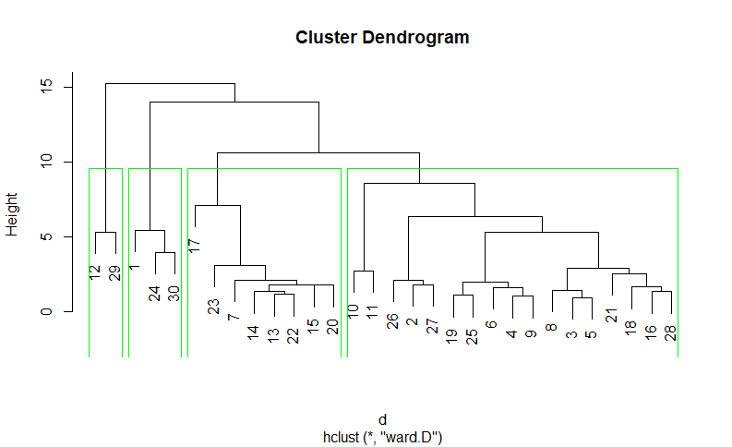
Fig. S1.
Dendrogram represent the major cluster depending on the similarities (The numbers indicate sampling location ID).
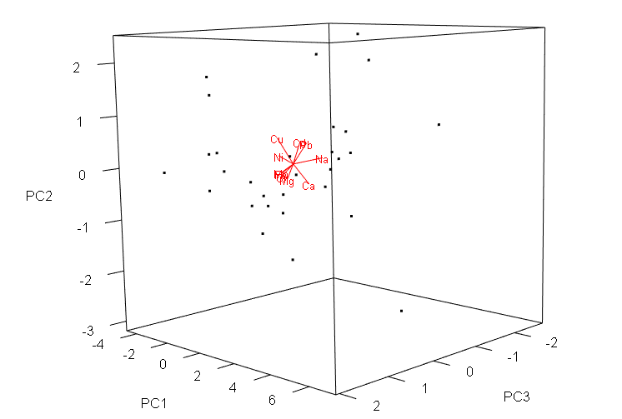

Fig. S2.
3D PCA plot indicates the contribution of the components segregating into three major components (PC1, PC2 and PC3). Those three components can describe 73.95% proportion of variance.

Table S4.
Standard deviation and cumulative proportion of variance of the principal components and their loadings
Components | PC1 | PC2 | PC3
Cr | -0.416 | -0.246 | 0.104
Cu | -0.176 | 0.532 | 0.273
Ni | -0.397 | 0.166 | 0.1691
Cd | -0.307 | 0.387 | -0.283
Pb | -0.281 | 0.343 | -0.418
Fe | -0.417 | -0.189 | 0.114
Mn | -0.420 | -0.169 | 0.105
Na | -0.045 | 0.024 | -0.685
Ca | -0.054 | -0.449 | -0.367
Mg | -0.327 | -0.303 | 0.013
Eigenvalue | 4.69 | 1.38 | 1.33
Standard deviation | 2.16 | 1.17 | 1.15
Proportion of variance (%) | 46.89% | 13.77% | 13.29%
Cumulative proportion of variance (%) | 46.89% | 60.66% | 73.95%

