Supplementary material
Matching of participants across the two different stimulus dimensions
AR | NT | ASC | p (NT vs. ASC)
Number of participants | 20 | 19 | -
Male / Female number | 11/9 | 11/8 | ns (p=0.94)
Age (years) | 29.55 (±8.62) | 33.30 (±9.25) | ns (p=0.20)
Left / Right-handed | 4/16 | 4/15 | ns (p=0.91)
Intelligence Quotient (FSIQ) | 111.5 (±14.87) | 108.79 (±15.80) | ns (p=0.58)
CR | NT | ASC | p (NT vs. ASC)
Number of participants | 18 | 19 | -
Male / Female number | 9/9 | 10/9 | ns (p=0.70)
Age (years) | 28.34 (±7.70) | 31.93 (±9.57) | ns (p=0.22)
Left / Right-handed | 1/17 | 3/16 | ns (p=0.41)
Intelligence Quotient (FSIQ) | 113.39 (±11.61) | 105.82 (±17.26) | ns (p=0.13)
 | p (AR vs. CR) | p (AR vs. CR)
Number of participants | - | -
Male / Female number | ns (p=0.43) | ns (p=0.75)
Age (years) | ns (p=0.65) | ns (p=0.64)
Left / Right-handed | ns (p=0.37) | ns (p=0.75)
Intelligence Quotient (FSIQ) | ns (p=0.66) | ns (p=0.67)
Table S1. Participants’ demographics matched across the two stimulus dimensions. Group means (± standard deviations). Results of t-tests and chi-square test: ns: non-significant (p>0.05).

Assessing potential learning effect in the discrimination task (accuracy and RT across blocks)
For accuracy, we found a significant main effect of block (F(3,516.06)=18.85, p<0.001, η²=0.10, 95% CI: [0.06, 1.00]), assessment moment (F(1,516.06)=70.72, p<0.001, η²=0.12, 95% CI: [0.08, 1.00]) and group (F(1,74.00)=22.27, p<0.001, η²=0.23, 95% CI: [0.10, 1.00]). In addition, we found a significant interaction effect of block x assessment moment (F(3,516.06)=5.05, p=0.002, η²=0.03, 95% CI: [0.01, 1.00]), which points to the accuracy increasing significantly more during the discrimination task before training as compared to after training. This indicates a learning effect for both groups pre-training. No other interaction effects were present (p>0.1). For RTs, we also found a significant main effect of block (F(3,507.46)=45.32, p<0.001, η²=0.21, 95% CI: [0.16, 1.00]), assessment moment (F(1, 507.34)=188.51, p<0.001, η²=0.27, 95% CI: [0.22, 1.00]) and an interaction effect of block x assessment moment (F(3,507.34)=3.92, p=0.009, η²=0.02, 95% CI: [0.00, 1.00]. This interaction effect with decreasing RTs across the different blocks before training is in line with the same effect of increasing accuracy, again pointing to a learning effect pre-training. No main effect of group was present (F(1,73.25)=0.05, p=0.82). However, a marginal interaction effect of blocks x assessment moment x group (F(3, 507.34)= 2.18, p=0.09, η²=0.01, 95% CI: [0.00, 1.00]) revealed that the RTs for NT participants significantly decreased before training (as compared to after training) across the different subblocks, which could specifically pinpoint to the implicit learning (of the underlying dimension) by the NT participants. No other interaction effects were present (p>0.1).
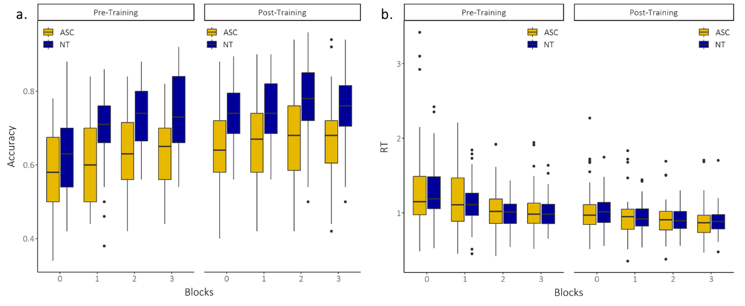
Figure S1. Assessing potential learning effect in the discrimination task. (a) Accuracy and (b) RT across blocks.
Bayesian approach for categorization training
Using a Bayesian approach of the categorization training, a logit link function was used to model the sigmoidal pattern of the psychometric function on the stimulus levels. A Student-t prior was put on all regression weights, and an inverse-gamma prior on the parameters capturing the random effects. The fitted model was the following: 𝑝𝑒𝑟𝑐𝑒𝑝𝑡 ~ 1+ level ∗ stimulus dimension ∗ block ∗ group + (1+level|subject). The variable percept corresponds to the proportion of one percept and/or respective category group and variable level corresponds to the level along the stimulus dimension (indicative for the respective category). As outlined in Knoblauch and Maloney et al. (2012), the location, which corresponds to the 50% thresholds or point of subjective equality (PSE), can be derived as follows: 𝑙𝑜𝑐𝑎𝑡𝑖𝑜𝑛=−(𝐼𝑛𝑡𝑒𝑟𝑐𝑒𝑝𝑡⁄𝑆𝑙𝑜𝑝𝑒). Next to the PSE, which indicates the perceived category boundary, we were also interested in the steepness of the slope at this category boundary, which indicates the precision of the learned category boundary. We found an effect of level (estimate: 0.04, 95% HDI: [0.03,0.05], an interaction of level x block (estimate: 0.01, 95% HDI: [0.00,0.01]). No other effects were found.
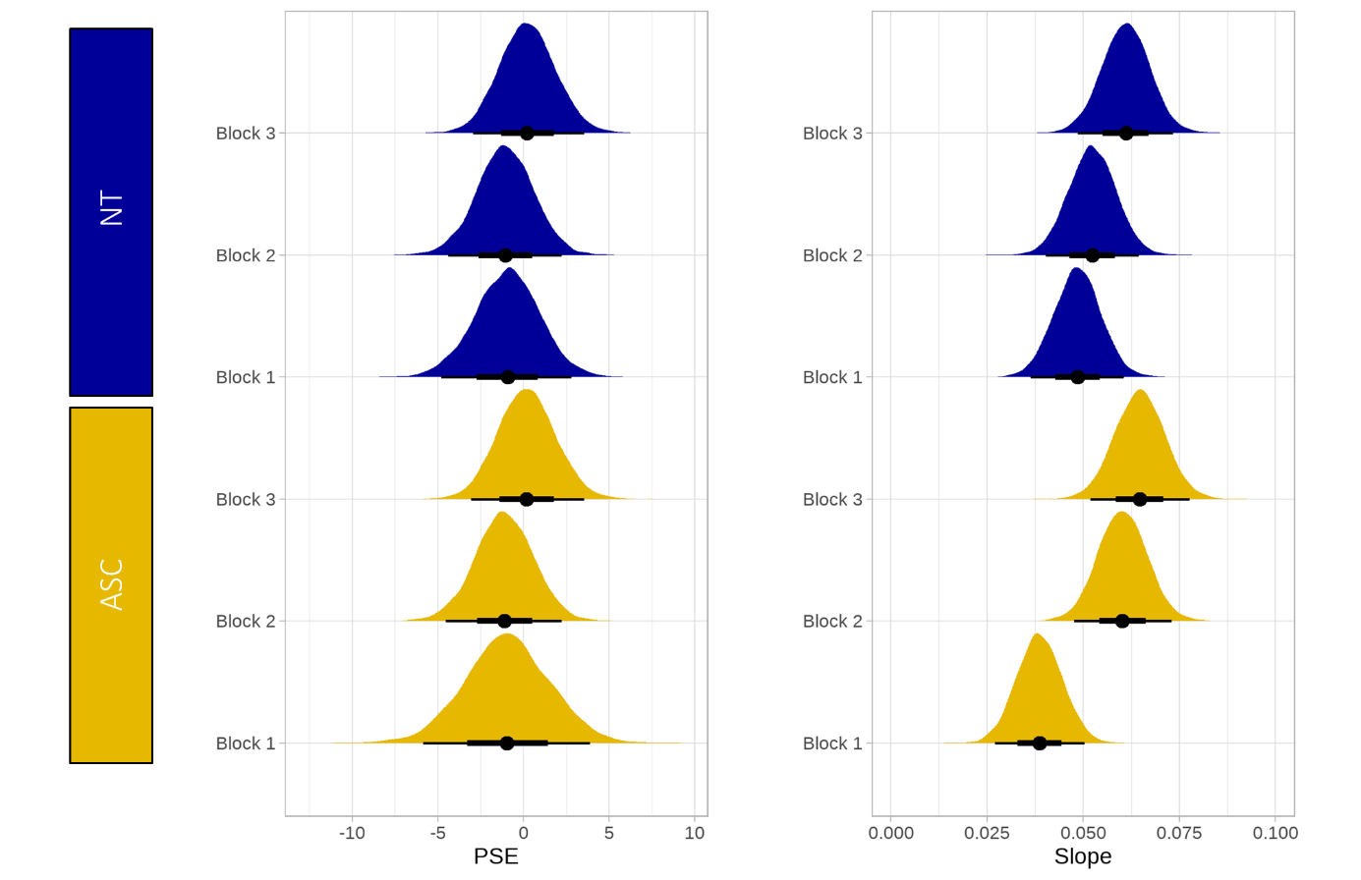
Figure S2. Bayesian posterior distribution of PSE (left panel) and slope (right panel) values.
Bayesian approach for discrimination task
For the Bayesian approach of the discrimination task, a probit link function was used, and the fitted model was the following: 𝑟𝑒𝑠𝑝𝑜𝑛𝑠𝑒 ~ type ∗ comparison ∗ stimulus dimension ∗ assessment moment ∗ group + (type| subject). Here the variable response corresponds to the response given by the participant (same or different) and the variable type refers to whether the stimuli of the pair were the same or different. From this model we evaluated the response criterion c, which corresponds to -β0, and d prime, reflected in the other effect parameters. We found a main effect of type (i.e., same versus different pairs, estimate 0.90, 95% HDI: [0.68,1.12]), of assessment moment (estimate: -0.16, 95% HDI: [-0.27,-0.05]), an interaction effect of type x assessment moment (estimate: 0.46, 95% HDI: [0.31,0.61]) and comparison x assessment moment (estimate: 0.20, 95% HDI: [0.00,0.39]). More importantly, we found a clear interaction effect of comparison x assessment moment x group x stimulus dimension (estimate: 0.41, 95% HDI: [0.04,0.78]). This interaction effect indicates that NT participants spontaneously picked up the underlying categorical dimension (and therefore already showed a categorical perception effect) before training in comparison to ASC who only showed a categorical perception effect after training. This effect seems to be mainly driven by the AR stimuli. This is confirmed by the interaction of comparison x assessment moment x stimulus dimension (estimate: -0.37, 95% HDI: [-0.65,-0.09]). No other effects were found.
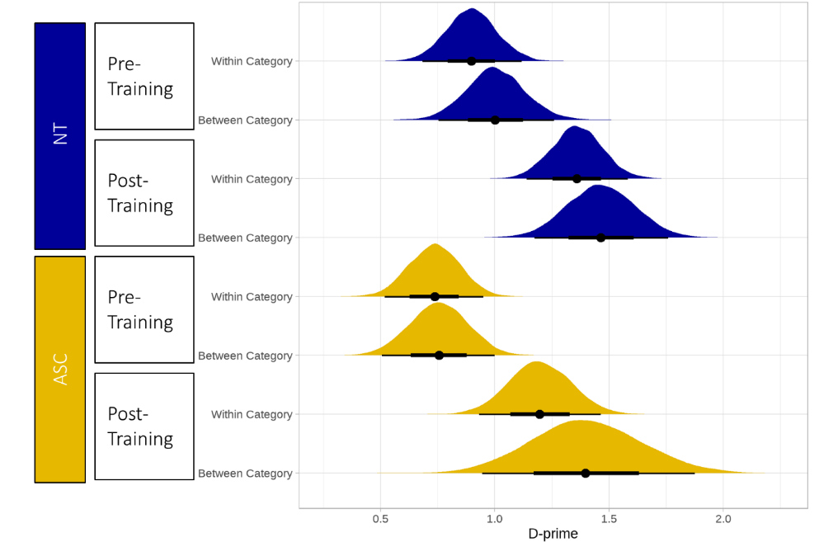
Figure S3. Bayesian posterior distribution of D-prime values.
Results for the different stimulus dimensions separately
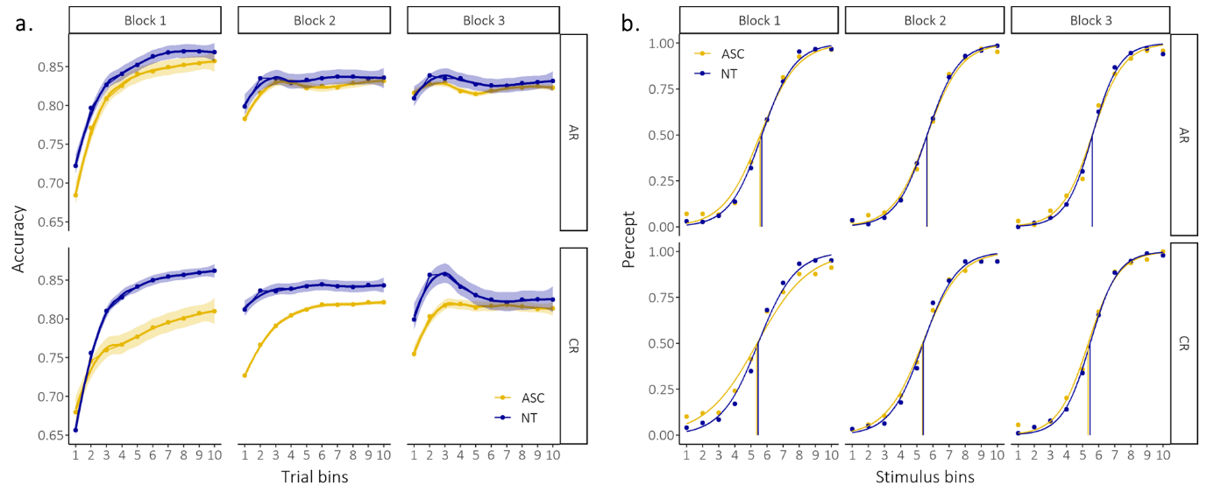
Figure S4. Results during the category training. (a) ASC participants were slower in learning the categories. Accuracy differences between group (ASC and NT) were specifically present at the initial block of category learning of the CR dimension. *Mean values are plotted with 95% confidence interval. (b) The obtained category boundary in the first block did not significantly change in subsequent blocks. Participants did learn to be more precise in their assignment to the two different categories. Precision of category boundary was more variable across the different ASC participants, as evidenced by the larger variability in slope, especially in the initial first block. *Mean values are plotted with participants’ individual curves.

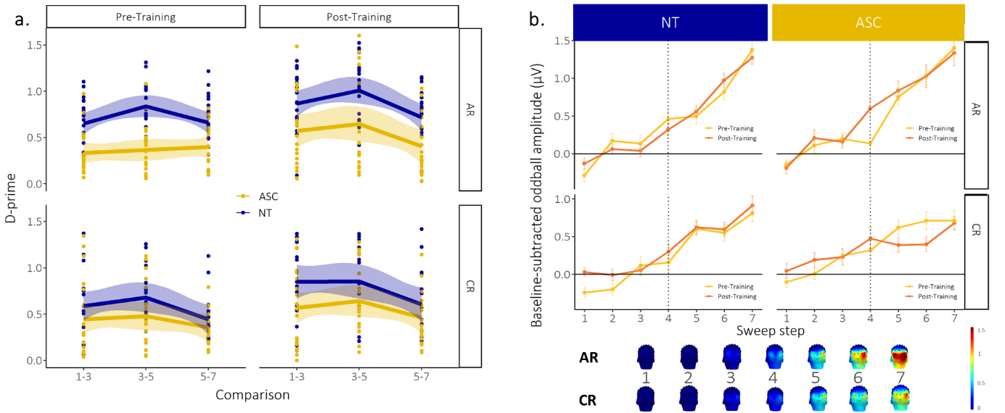
Figure S5. Results for the discrimination sensitivity. (a) Behavioral discrimination sensitivity. Left panel: NT participants implicitly pick up the underlying AR dimension (and therefore already show a categorical perception effect) before training in comparison to ASC participants. Right panel: ASC participants only show a categorical perception effect after training. *Mean values (lines) are plotted with 95% confidence interval and participants’ individual values (dots). (b) Neural discrimination sensitivity. Left panel: Analyses revealed that the neural sensitivity at the category boundary (see dashed line, i.e., hallmark of categorical perception) did not significantly differ after explicit category learning (compared to before) for NT participants. Right panel: We did find a significant increase in neural sensitivity at the category boundary after explicit category learning (compared to before) for the ASC participants, especially in the AR dimension. *Error bars correspond to standard errors of the mean.

