Supplementary Information

Thermoregulatory integration in hand prosthesis and humanoid robots through blood vessel simulation

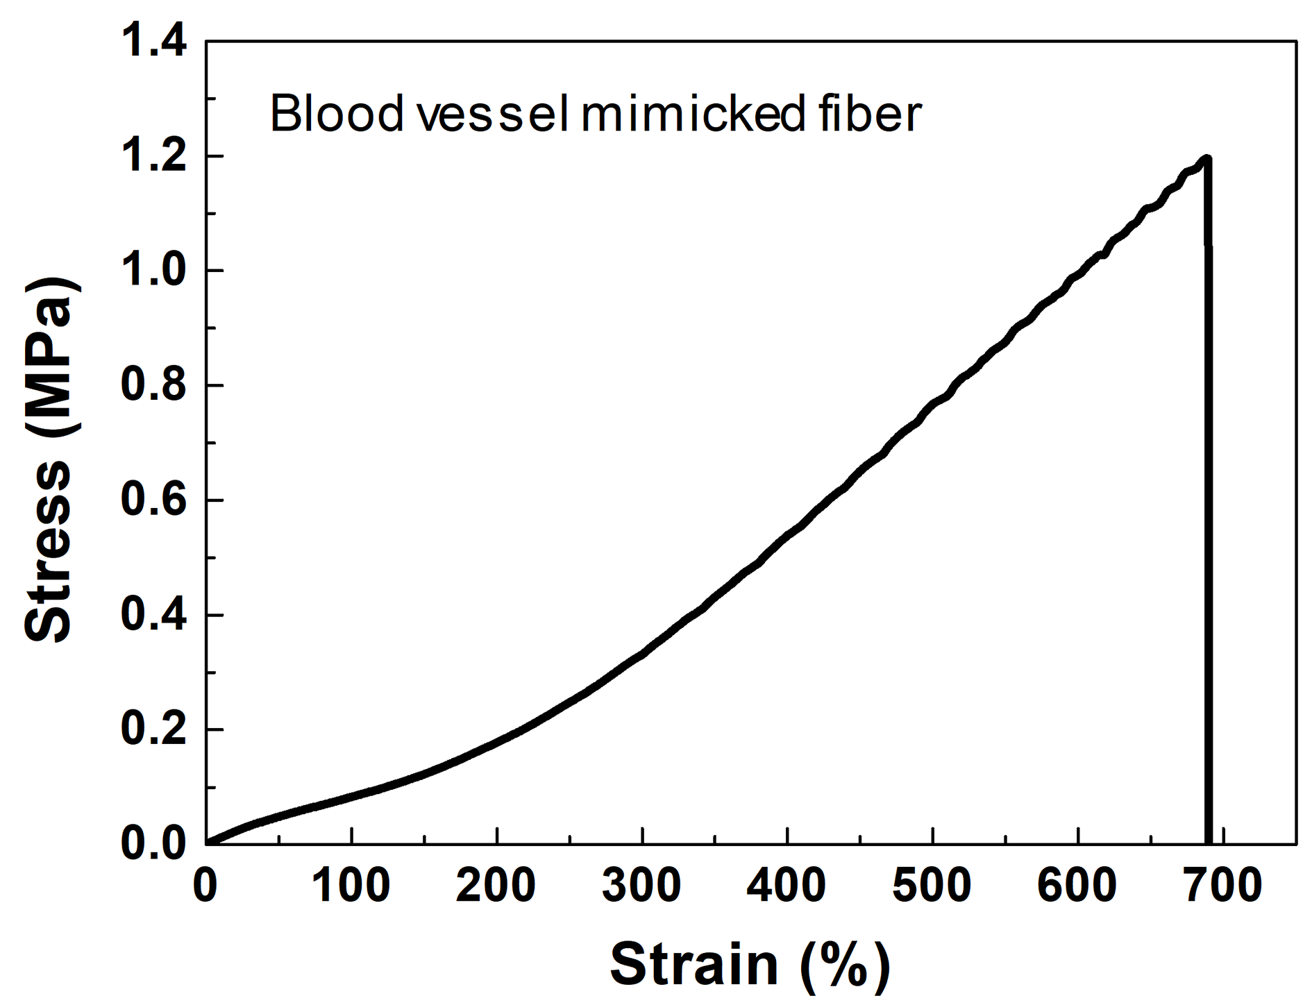
Supplementary Fig. 1. Stress-strain curve of blood vessel mimicked fiber.

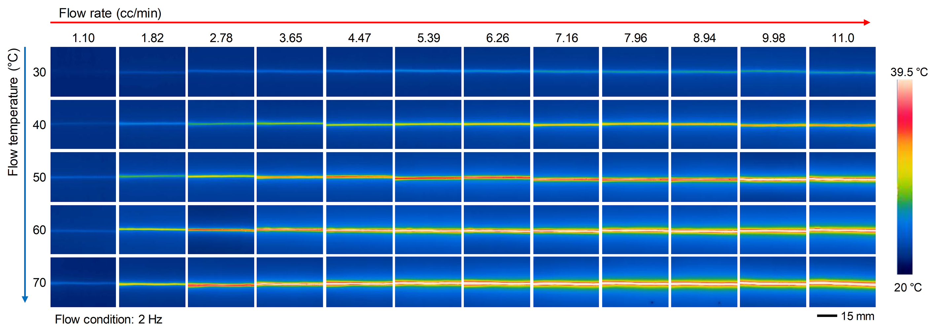
Supplementary Fig. 2. Infrared image of blood vessel-mimicked fiber according to water temperature and flow rate control.

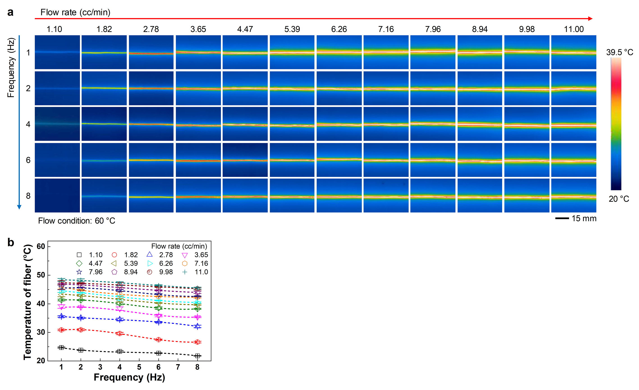
Supplementary Fig. 3. (a) Infrared image and (b) temperature characteristics of blood vessel mimicked fiber according to water flow rate and frequency.

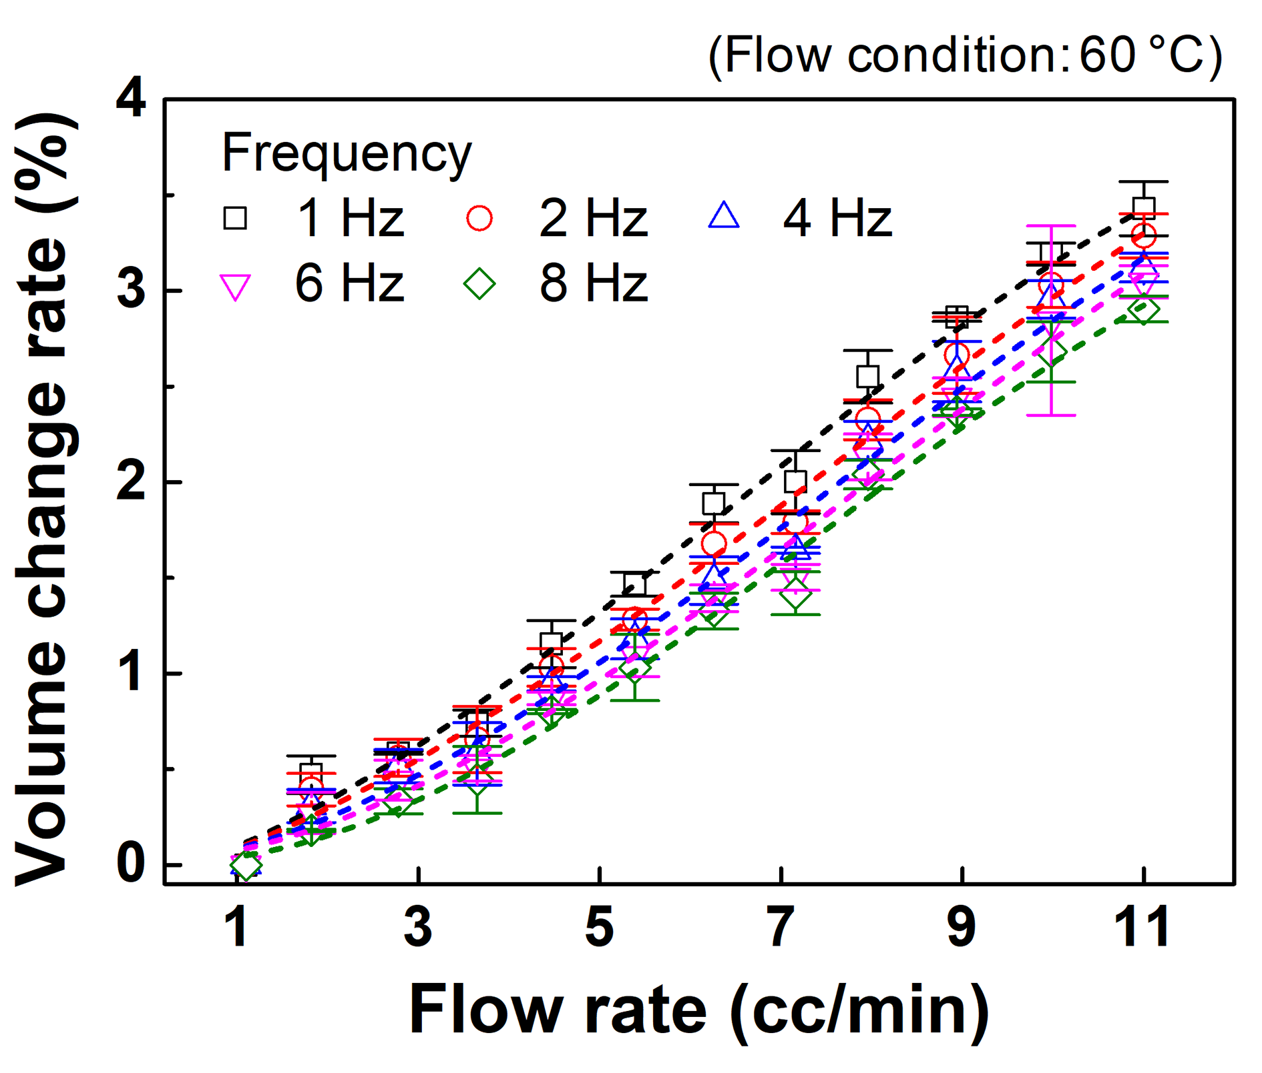
Supplementary Fig. 4. Fiber volume change graph according to flow rate and frequency condition change.

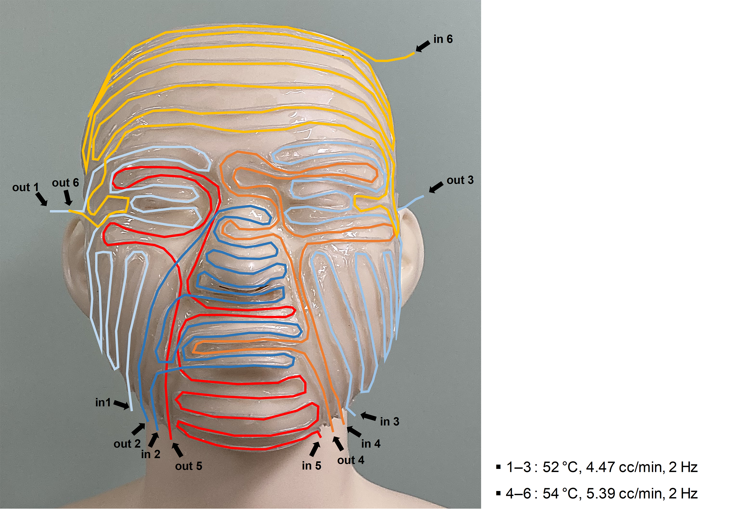
Supplementary Fig. 5. Photo image of blood vessel mimicked fiber placed on a mannequin face.

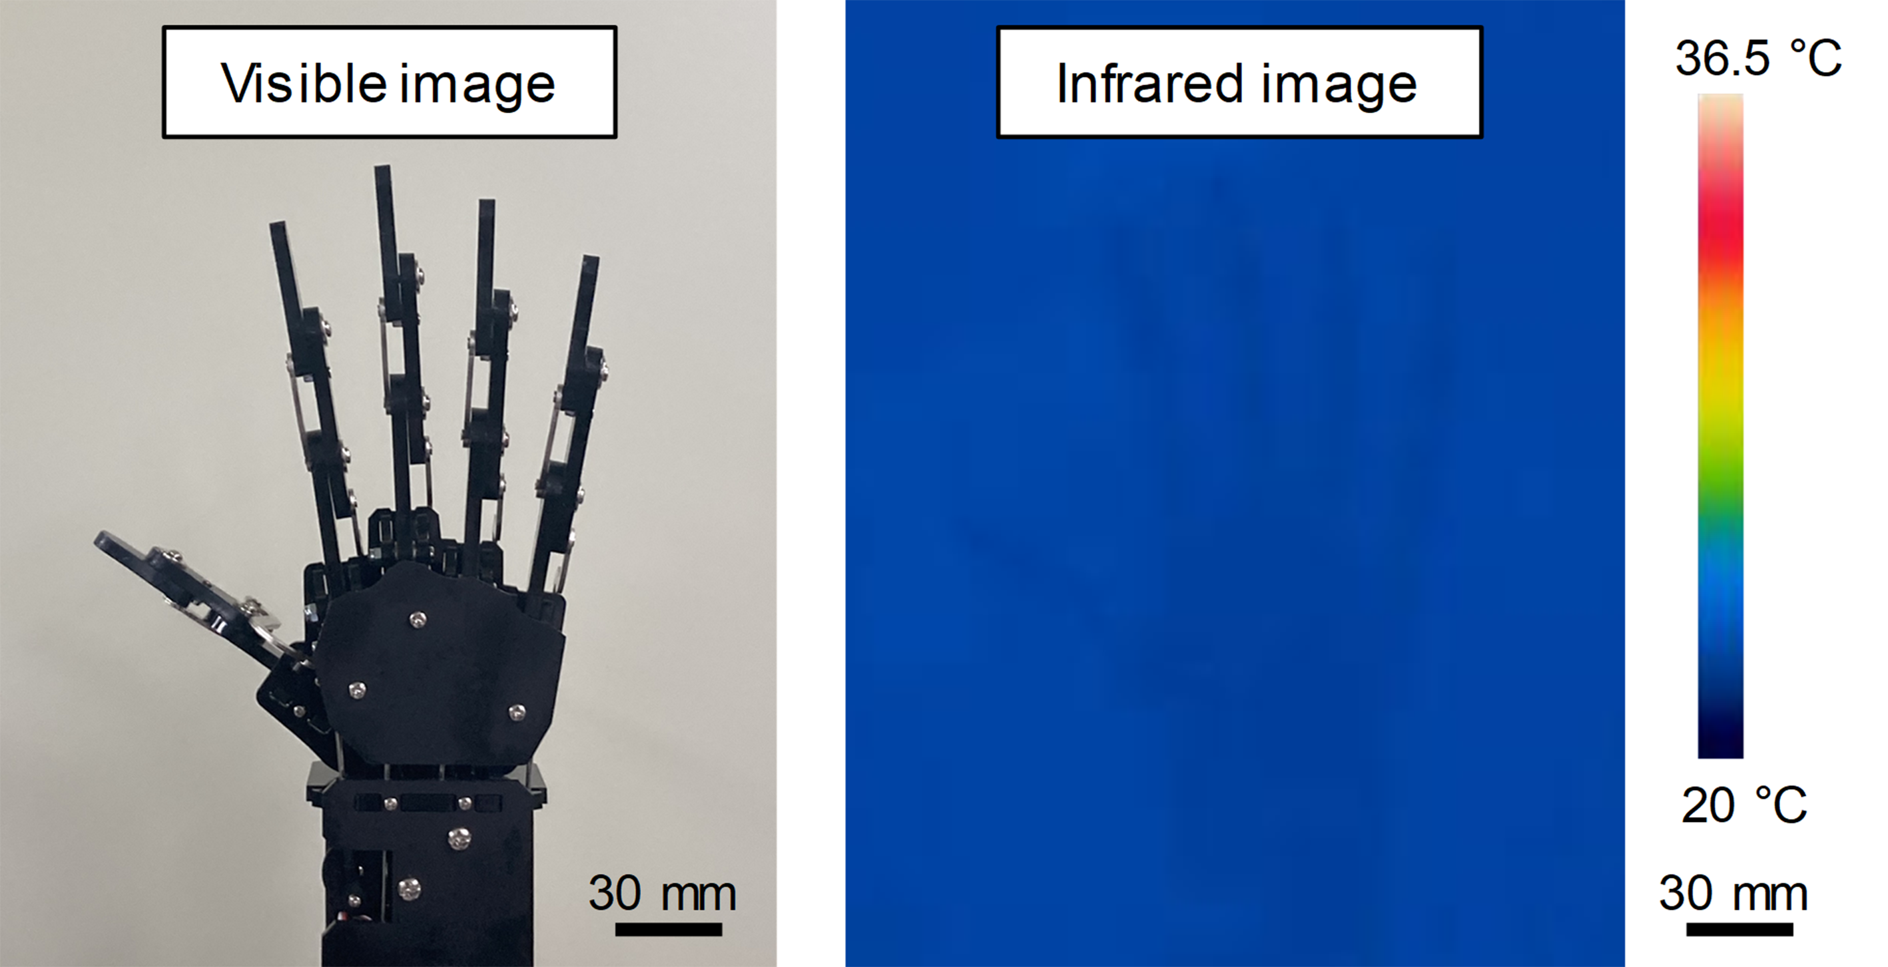
Supplementary Fig. 6. Photo and thermal infrared image of Bare robot’s hand.

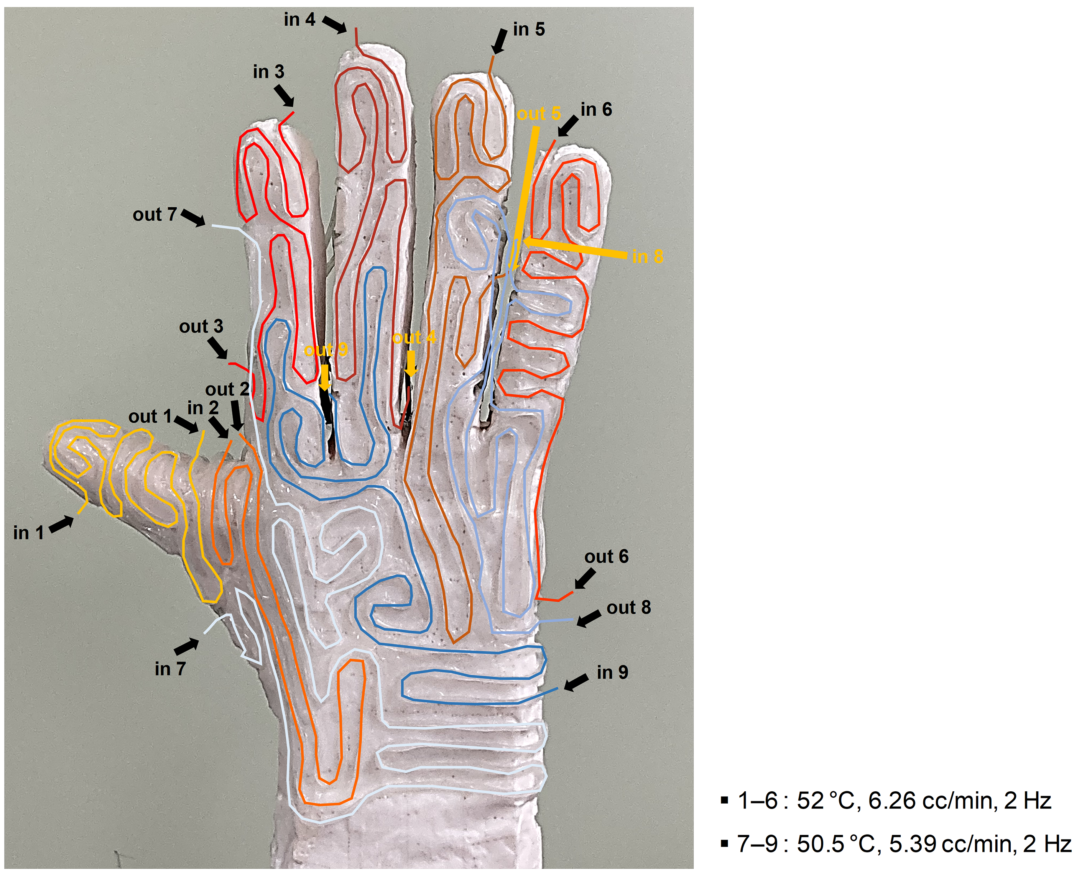
Supplementary Fig. 7. Photo image of blood vessel mimicked fiber placed on the robot hand.

