Supplement
 | SIGNA Pioneer  (GE Healthcare) |  |  | MAGNETOM Vida  (Siemens Healthcare) |  |  | MAGNETOM Verio  (Siemens Healthcare) |  |  | uMR790  (United Imaging Healthcare)
 | T2W | T2W Flair | T1W Flair | T2W | T2W Flair | T1W Flair | T2W | T2W Flair | T1W Flair | T2W | T2W Flair | T1W Flair
TR(ms) | 5073 | 9000 | 2507 | 5000 | 8600 | 1900 | 5000 | 8500 | 1900 | 4724 | 8000 | 1800
TE(ms) | 130 | 95 | 24 | 105 | 90 | 7.3 | 96 | 94 | 9 | 128.24 | 122.56 | 7.56
TI(ms) | / | 2469 | 792 | / | 2450 | 860 | / | 2439 | 823 | / | 2420 | 795
flip angle | 142 | 160 | 111 | 110 | 120 | 110 | 150 | 150 | 150 | 90 | 90 | 90
FOV(mm²) | 240×240 | 240×216 | 240×180 | 230×216 | 230×194 | 230×218 | 230×184 | 230×184 | 220×198 | 230×200 | 230×200 | 230×200
plane resolution | 0.5×0.5 | 0.9×1.2 | 0.8×1.2 | 0.5×0.5 | 0.4 ×0.4 | 0.8×0.8 | 0.7×0.7 | 1.1×0.9 | 1.0×0.7 | 0.57×0.57 | 0.86×0.68 | 0.69×0.63
slice thickness(mm) | 6 | 6 | 6 | 6 | 6 | 6 | 6 | 6 | 6 | 6 | 6 | 6
gap(mm) | 1.2 | 1.2 | 1.2 | 1.2 | 1.2 | 1.2 | 1.2 | 1.2 | 1.2 | 1.2 | 1.2 | 1.2
NEX/  Averages | 1 | 1 | 1 | 1 | 1 | 1 | 1 | 1 | 1 | 2 | 1.8 | 1.2
ASSET/iPAT/ACS | 2 | 2.5 | / | 2 | 2 | 3 | 2 | 2 | 2 | 2.25 | 2.5 | 2.25
acquisition time | 0:46 | 1:57 | 1:28 | 0:55 | 2:00 | 1:24 | 0:57 | 1:59 | 1:16 | 1:02 | 2:08 | 1:37
Scanning parameters of different MR scanners were listed as follows：
Automatic segmentation network of white matter hyperintensities detailed construction information
A large MR dataset of 1,045 WMH subjects was collected; these subjects had WMH of any degree and exhibited a wide range of demographic characteristics. The MR images were acquired by seven different scanners (3 T or 1.5 T), and each subject had T1-weighted, T2-weighted, and FLAIR images. We first proposed a series of semi-automated labeling protocols for manually labeling WMH and other intracranial lesions based on multi-modality images. We then presented a novel 2D CNN named 2D VB-Net that incorporates the advantages of an efficient encoder-decoder framework for feature embedding, residual connections for information flow, and bottleneck layers for model compression. The input to the network combined the T1-weighted, T2-weighted, and FLAIR images because clinically these three MRI modalities were jointly recommended to determine the territory of WMH and differentiate WMH from other cerebral lesions, such as lacunes, PVS and large infarctions. The adjustments of the network are listed as follows.
- 2D convolutional kernels replace 3D kernels since the MR images were acquired using the 2D protocol with a layer thickness of no less than 5 mm and the number of slices in a series was usually 16～20.
- The number of bottleneck structures of the high levels was reduced. Here, we referred to the vertical depth as the level, with the original input and output depth as level 1; after down-sampling 4 times as level 5, the lower the level was, the higher the spatial resolution was but with fewer feature maps, and vice versa. Because the number of segmentation categories is relatively small, reduction of the bottleneck structure would not impact the segmentation accuracy but would help reduce the model parameters and hence improve the robustness.
- The output block was adjusted, and two convolutional layers were added to the original basis to generate the segmentation probability map.

Automatic segmentation network of white matter hyperintensities training and performance Results
The proposed 2D VB-Net fully convolutional network was implemented in the PyTorch DL framework, with weighted Dice loss as the loss function. To handle the variations in pixel spacing among scanners, the images and labeled regions were uniformly resampled in both the x- and y-directions to a spacing of 0.5. The pixel spacing in the z-direction remained intact. The input 2D patches for training were 256 × 256 and randomly sampled from the image volume. The initialization of weights used the Kaiming initialization strategy, and the optimizer was adaptive moments estimation with the first moment coefficient = 0.9, second moment coefficient = 0.999, learning rate = 0.001, and mini-batch size = 48. The training was carried out on 2 NVIDIA Titan Xp 12 GB graphics processing units.
In the validated analysis, the proposed method was well hick-svalidated on two independent datasets with tlice MR images and the 2017 MICCAI WMH Segmentation Challenge dataset with a thin layer slice of 3 mm. In addition, in terms of correlation to Fazekas scores, our algorithm showed excellent consistency with the manual delineations and overall correlated better with the visual rating scores than other competing methods, highlighting the robustness and clinical value of our algorithm. The performance of the top 4 algorithms in the 2017 MICCAI WMH Segmentation Challenge is listed in (Supplementary Table 1). The proposed 2D VB-Net algorithm also showed good performance (Dice = 0.789, lesion F1 = 0.764) on this small dataset with thin-slice MR images.

Supplementary Figure 1： Example of Original T2 Flair images and automatic segmentation of ROI
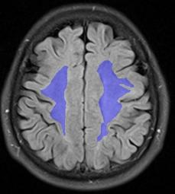
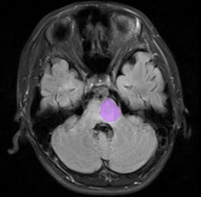
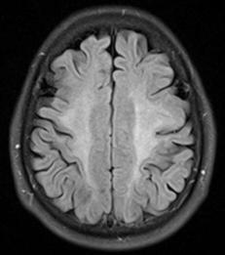
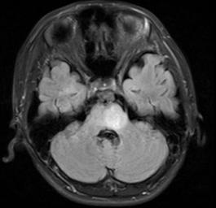
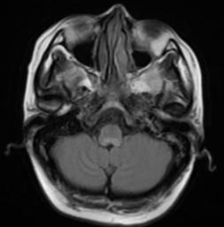
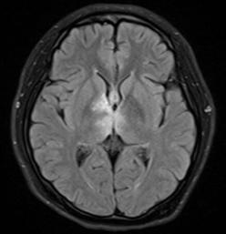
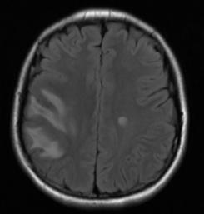
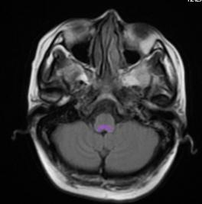
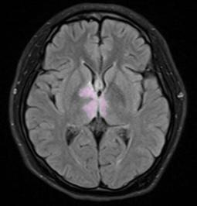
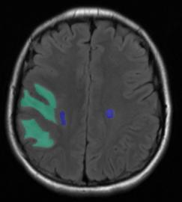
Supplementary Table 1 Performance of the algorithms for WMH segmentation on the challenge public dataset.
Team | Method | Dice | Recall | Precision | Hausdorff | AVD | Lesion recall | Lesion F1
Our method | 2D VB-Net | 0.789 | 0.792 | 0.805 | 4.946 | 18.106 | 0.807 | 0.764
sysu media (Kuijf et al., 2019) | CNN | 0.8 | – | – | 6.3 | 21.88 | 0.84 | 0.76
cian (Kuijf et al., 2019) | MDGRU | 0.78 | – | – | 6.82 | 21.72 | 0.83 | 0.7
nlp logix (Kuijf et al., 2019) | CNN | 0.77 | – | – | 7.16 | 18.37 | 0.73 | 0.78
nic-vicorob (Kuijf et al., 2019) | CNN | 0.77 | – | – | 8.28 | 28.54 | 0.75 | 0.71
The table shows the performance of our method and the algorithms ranked in the top 4 for WMH segmentation on the 2017 MICCAI WMH Segmentation Challenge public dataset, as reported by Kuijf et al. (2019). Lower Hausdorff and AVD values indicate better performance of the algorithm.

