Combining movement ecology and genetics to understand the ecology and evolution of northern pike (Esox lucius) living in brackish lagoons in the southern Baltic Sea: implications for fisheries management and conservation

Olga Lukyanova, Félicie Dhellemmes, Stefan Dennenmoser, Arne W. Nolte, Robert Arlinghaus

Supplementary material

Supplementary methods
Table S1: Annual mean hydrochemical conditions from 2010 to 2020 (data source: LUNG, reproduced from (Arlinghaus et al. 2023).
Parameter | BAT | WRB | NRBC | S | GB | PS
Chlorophyll a (mg/m3) | 27.7 ± 19.6 | 7.9 ± 6.9 | 16.8 ± 12 | 15 ± 9.1 | 14.6 ± 13.6 | 63.6 ± 48.1
Total phosphorus (µmol/l) | 1.8 ± 0.7 | 1.3 ± 0.6 | 1.8 ± 1.1 | 1.6 ± 0.6 | 1.5 ± 0.7 | 3.2 ± 1.9
Salinity (PSU) | 8.3 ± 1.6 | 8.7 ± 1.1 | 8.3 ± 1 | 7.8 ± 1.1 | 7.2 ± 0.9 | 3.2 ± 2.1
Secchi depth (m) | 1 ± 0.8, | 1.9 ± 0.8 | 1.4 ± 0.7 | 1.4 ± 0.6 | 1.7 ± 0.8 | 0.7 ± 0.5
Water (°C) | 11.5 ± 6.6 | 11.6 ± 6.7 | 12.5 ± 6.5 | 11.9 ± 7 | 11.7 ± 6.8 | 11.9 ± 6.7
Mean depth (m) | 2 | 1.8 | 3.5 | 3.9 | 5.8 | 2.6
Max depth (m) | 16.5 | 7.6 | 10.3 | 16 | 13.5 | 16
Catchment area (km2) | 1.578 | NA | 312 | 238 | 665 | 5.772
Area (km2) | 59.8 | 231 | 132.9 | 47.6 | 540.1 | 181.9
Macrophyte coverage | Low-Medium | Medium | Medium-High | Low-Medium | Low-Medium | Low

BAT: Barther Bodden
WRB: Western Rügen Bodden
NRBC: Northern Rügen Bodden chain S: Strelasund
GB: Greifswalder Bodden PS: Peenestrom
Values after ± represent standard deviations.
The macrophyte coverage represents expert judgement at the time of study as there is no objective data.

Acoustic data processing
When a tagged fish occurred within the detection range of a receiver, its ID and the date and time were recorded. Data was stored on the receivers and downloaded annually in winter, and processed in Fathom (Innovasea Systems Inc., Massachusetts, U.S.A.) to correct for clock drift (Dhellemmes et al., 2023). The data was then filtered using ATfiltR (Dhellemmes et al. 2023a). We first trimmed the detections to keep only detections that were collected after the deployment and before the retrieval of receivers (i.e., removing detections potentially obtained when a receiver was being serviced on a boat or on land), and of transmitters (i.e., removing data from transmitters that aren’t implanted in a fish). We then removed detections from tags that were detected only once on a given receiver in a 48h window. Then, to filter out impossible movements between our study areas, we identified any group of 5 or less detections that occurred alone in a given lagoon, and filtered them out as ghost detections. Finally, since the average pulse rate of the transmitters used in this study was 120 seconds, any detection of a given ID that occurred within 120 seconds of the previous one was regarded as a duplicate and removed. We assumed that this would reduce the number of detections in locations with a high receiver density and would not have a significant effect on connectivity between the areas considered for the analysis described below. Throughout our filtering protocol we visually checked the data by comparing individual detections network created in R package igraph (Csárdi and Nepusz 2006) before and after each filtering step.
Null model
To test whether the observed patterns of movement differed from random, the observed networks were compared to those generated from null models, i.e., randomised movement networks. Random networks were constructed as random walks according to the method developed by (Lea et al. 2016). To create such random walks, the first detection at the first receiver was retained from the observed track of each individual. Then a movement distance was calculated based on the time elapsed before each next detection and the predetermined swimming speed of the animal. The swimming speed of each pike was calculated as 0.019 x Body-Length^{0,75} in accordance with (Wolter and Arlinghaus 2003). For each step of the random walk, receivers were selected at random until two were found within range of the swim distance and the closest of them was then chosen as the next position in the random track. If no receiver met the criteria after 100 random selections, then no movement was deemed to occur, and the current station was assigned. This procedure was carried on for the whole duration of the track, generating a random walk through the receiver array, constrained by the observed detection intervals and individual animal characteristics. This was repeated 100 times for each individual, thus producing 100 random tracks per fish. The random walks were created in Python 3.8.10 via the Anaconda 3 distribution (2020) in the Spyder environment (Raybaut 2009) using the pandas (McKinney 2010) and NumPy (Harris et al. 2020) software libraries. To test whether empirical individual networks were different from random, edge density (proportion of edges present in a network, out of the total number of edges possible in it (Jacoby et al. 2012)) was derived from observed network and tested against the same metric of random networks for each individual with Wilcoxon one-sample signed rank test (Lea et al. 2016).

Population genetics and its link to ecological connectivity, geographical distance, and salinity gradients
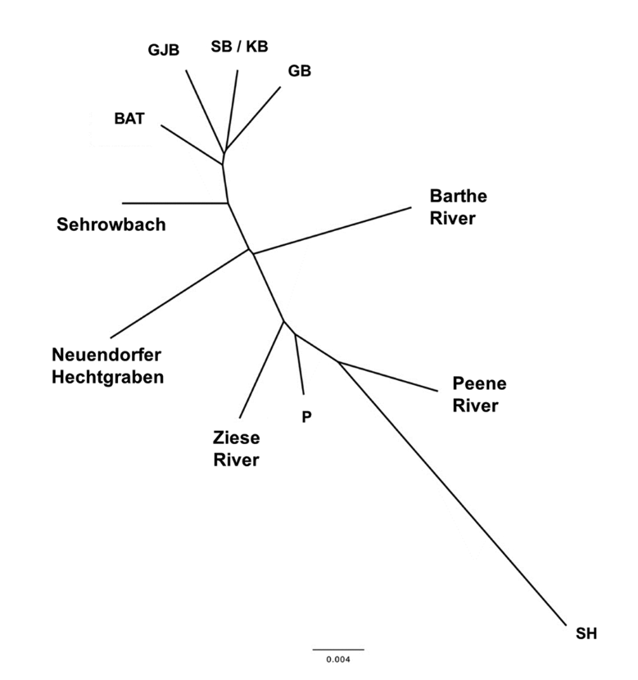
Fig. S1. Neighbor-Joining distance tree based on 1.190.970 SNPs from whole-genome sequences of pooled individuals from different study sites. In the tree, pike populations from brackish-water Bodden areas form one cluster including Barther Bodden, Schaproder/Kubitzer Bodden (SB/KB), Großer Jasmunder Bodden (GJB) and Greifswalder Bodden (GB). Freshwater populations from rivers Barthe and Peene and the oligohaline lagoons Peenestrom (P), and Stettiner Haff form a cluster with a notably higher among-population divergence than the mesohaline brackish water populations (BAT, GJB, SB/KB, GB). Putative anadromous populations are given by Sehrowbach, Neuendorfer Hechtgraben, and Ziese River. River Ziese is however part of the cluster including freshwater populations and oligohaline lagoons (SH, P) of the river Oder estuary. Importantly, Neuendorfer Hechtgraben and Sehrowbach show less divergence from the brackish-water populations than pure freshwater populations (rivers Barthe and Peene). Taken together, the tree demonstrates divergence of putative anadromous population samples at a level that is comparable with what is observed among pure freshwater populations and suggests genetic divergence of anadromous pike from brackish water pike as well as from populations from different freshwater sites. Figure from (Roser 2023).
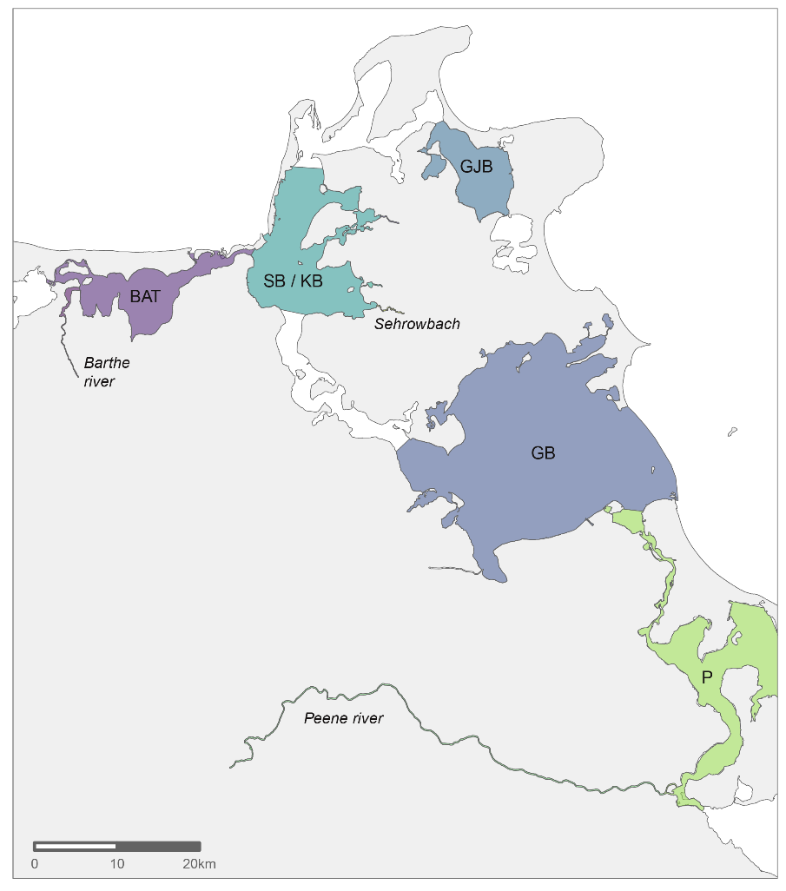
Fig. S2. Map displaying section of the study area where both genetic and telemetry data was available and which, therefore, were used for models assessing the links between population genetics and ecological connectivity, geographical distance, and salinity gradients. The locations included mesohaline brackish-water (Barther Bodden (BAT), Kubitzer/Schaproder Bodden (KB / SB), Großer Jasmunder Bodden (GJB), Greifswalder Bodden (GB)), possibly resident freshwater (Barthe and Peene river), oligohaline brackish (Peenestrom (P)) and a putative anadromous population (Sehrowbach).

Supplementary results
Seasonal movement networks
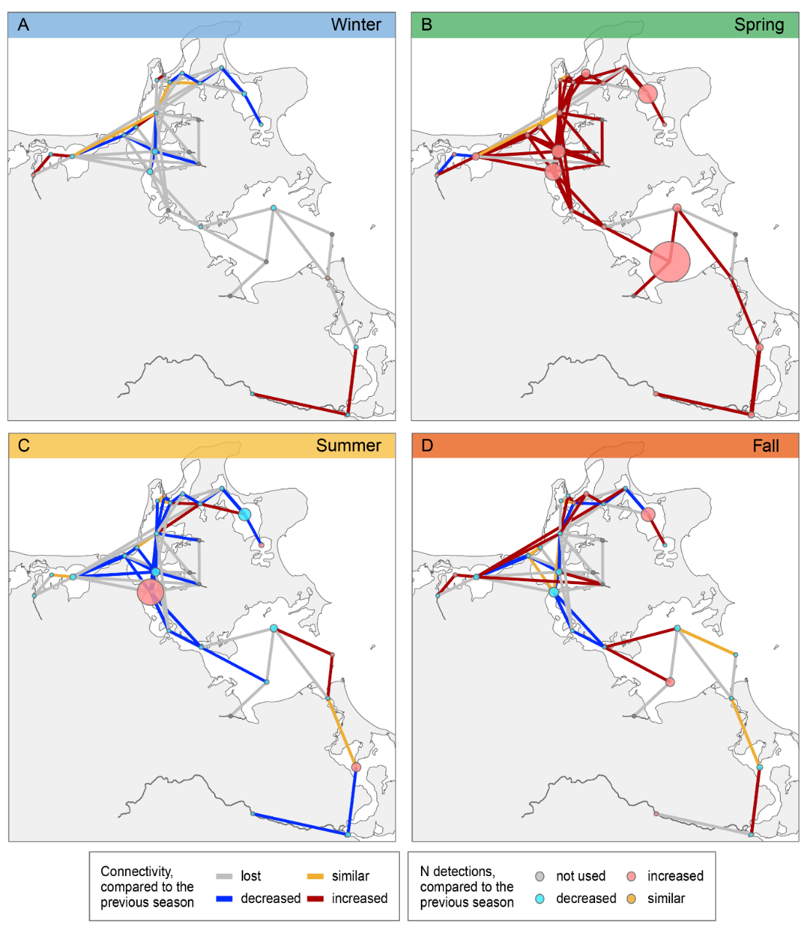
Fig. S3. Seasonal changes in pike movements across the lagoons, freshwater tributaries, and “gates”. (A-C) Seasonal movement networks. Colours show the differences in metrics compared to the previous season (e.g., winter to fall), where: node colours reflect changes in the total number of daily detections in each area (node strength) and colours of the edges reflect the change in connectivity between areas (frequency of internodal movements; edge weight). The size of nodes and the edge line thickness correspond to the absolute values of respective metrics
Population genetics and its link to ecological connectivity, geographical distance, and salinity gradients
Table S2: Identification of the explanatory variables that improved model fit bases on the AIC of the full model and the AIC of stepwise simplified models
linFST ~ scaledEdgeWeight + scaledMeanDist + scaledSalinityDiff + Freshwater
 | Df | AIC
- scaledEdgeWeight | 1 | -452.84
<none> |  | -451.43
- Freshwater | 2 | -435.81
- scaledMeanDist | 1 | -421.61
- scaledSalinityDiff | 1 | -418.58

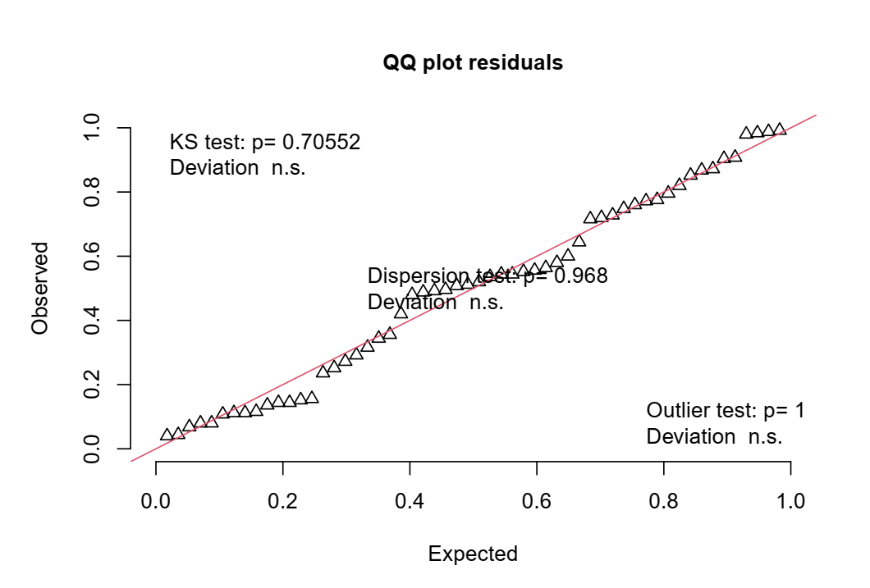
Fig. S4. Assessment of the fit of the obtained most parsimonious model

References
Arlinghaus R, Rittweg T, Dhellemmes F, et al (2023) A synthesis of a coastal northern pike (Esox lucius) fishery and its social-ecological environment in the southern Baltic Sea: Implications for the management of mixed commercial-recreational fisheries. Fish Res 263:106663. https://doi.org/10.1016/j.fishres.2023.106663
Csárdi G, Nepusz T (2006) The igraph software package for complex network research
Dhellemmes F, Aspillaga E, Monk CT (2023a) ATfiltR: A solution for managing and filtering detections from passive acoustic telemetry data. MethodsX 10:102222. https://doi.org/10.1016/j.mex.2023.102222
Dhellemmes F, Aspillaga E, Rittweg T, et al (2023b) Body size scaling of space use in coastal pike (Esox lucius) in brackish lagoons of the southern Baltic Sea. Fish Res 260:106560. https://doi.org/10.1016/j.fishres.2022.106560
Harris CR, Millman KJ, van der Walt SJ, et al (2020) Array programming with NumPy. Nature 585:357–362. https://doi.org/10.1038/s41586-020-2649-2
Jacoby DMP, Brooks EJ, Croft DP, Sims DW (2012) Developing a deeper understanding of animal movements and spatial dynamics through novel application of network analyses. Methods Ecol Evol 3:574–583. https://doi.org/10.1111/j.2041-210X.2012.00187.x
Lea JSE, Humphries NE, von Brandis RG, et al (2016) Acoustic telemetry and network analysis reveal the space use of multiple reef predators and enhance marine protected area design. Proc R Soc B Biol Sci 283:. https://doi.org/10.1098/rspb.2016.0717
McKinney W (2010) Data Structures for Statistical Computing in Python. In: Walt S van der, Millman J (eds) Proceedings of the 9th Python in Science Conference. pp 56–61
Raybaut P (2009) Spyder-documentation. Available Online Pythonhosted Org
Roser P (2023) Synthesizing historic and current evidence for anadromy in a northern pike (Esox lucius L.) meta-population inhabiting brackish lagoons of the southern Baltic Sea, with implications for management
Wolter C, Arlinghaus R (2003) Navigation impacts on freshwater fish assemblages: the ecological relevance of swimming performance. Rev Fish Biol Fish 13:63–89. https://doi.org/10.1023/A:1026350223459

