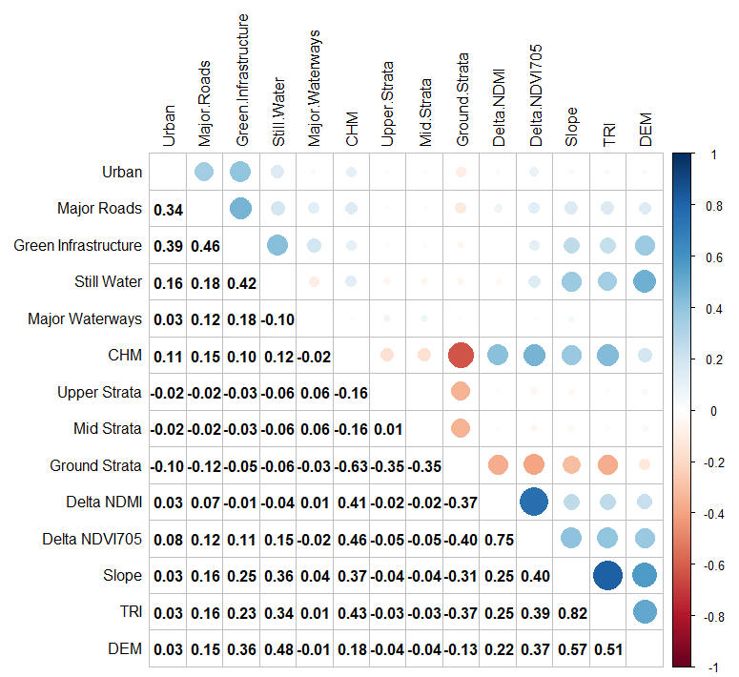
Supplementary Material - 1: Heatmap distribution of initial landscape structures used within landscape genetic analysis. Pearson correlation values are displayed to suggest collinearity between variables and are depicted from red (negative collinearity) to blue (positive collinearity)

 | Buderim | Chevallum  A | Chevallum  B | Conondale | Landsborough  B | Landsborough  A | Mount  Coolum | Ninderry | Sippy  Downs | Tewantin | Twin  Waters | Weyba  Downs
Buderim | 0 | 0.004 | 0.001 | 0.001 | 0.003 | 0.001 | 0.001 | 0.001 | 0.001 | 0.001 | 0.001 | 0.001
Chevallum  A | 0.103 | 0 | 0.088* | 0.001 | 0.003 | 0.001 | 0.001 | 0.001 | 0.002 | 0.004 | 0.001 | 0.001
Chevallum  B | 0.09 | 0.035 | 0 | 0.001 | 0.008 | 0.001 | 0.001 | 0.001 | 0.002 | 0.006 | 0.001 | 0.001
Conondale | 0.145 | 0.151 | 0.122 | 0 | 0.001 | 0.001 | 0.001 | 0.001 | 0.001 | 0.001 | 0.001 | 0.001
Landsborough  B | 0.081 | 0.1 | 0.064 | 0.12 | 0 | 0.358* | 0.001 | 0.001 | 0.007 | 0.001 | 0.001 | 0.001
Landsborough  A | 0.08 | 0.096 | 0.066 | 0.108 | 0.001 | 0 | 0.001 | 0.001 | 0.003 | 0.001 | 0.001 | 0.001
Mount  Coolum | 0.121 | 0.092 | 0.089 | 0.147 | 0.105 | 0.098 | 0 | 0.002 | 0.001 | 0.003 | 0.023 | 0.001
Ninderry | 0.12 | 0.093 | 0.084 | 0.141 | 0.102 | 0.092 | 0.061 | 0 | 0.001 | 0.009 | 0.001 | 0.005
Sippy  Downs | 0.083 | 0.102 | 0.075 | 0.127 | 0.061 | 0.053 | 0.117 | 0.105 | 0 | 0.001 | 0.001 | 0.001
Tewantin | 0.135 | 0.115 | 0.092 | 0.148 | 0.124 | 0.108 | 0.09 | 0.078 | 0.13 | 0 | 0.001 | 0.012
Twin  Waters | 0.155 | 0.142 | 0.134 | 0.173 | 0.138 | 0.127 | 0.023 | 0.099 | 0.145 | 0.13 | 0 | 0.001
Weyba  Downs | 0.127 | 0.112 | 0.098 | 0.137 | 0.107 | 0.09 | 0.072 | 0.059 | 0.11 | 0.078 | 0.1 | 0
Supplementary Material - 2: Raw F_{ST} matrix with genetic differentiation values on the lower diagonal (light grey), and p-values on the upper diagonal (dark grey). Insignificant values are described in bold with an asterisk.

