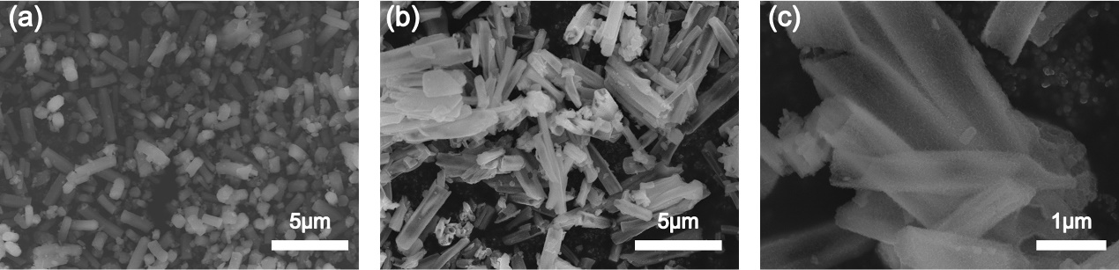
Fig. S1 SEM images of MIL-68 (In) MOF (a) and In₂S₃-8h (b, c).

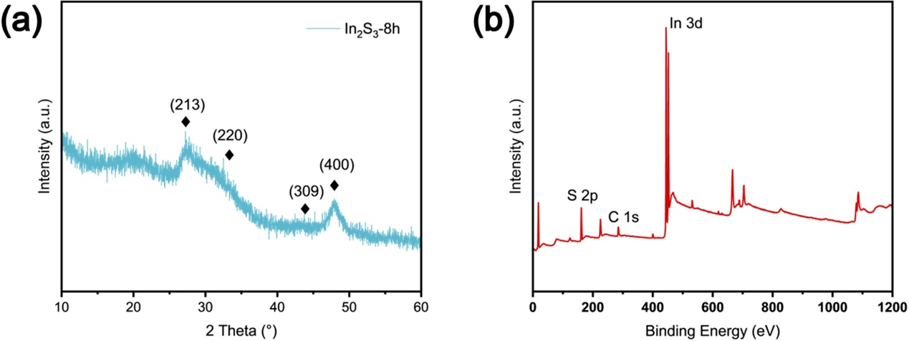
Fig. S2 XRD pattern of In₂S₃-8h (a). The full XPS spectrum of In₂S₃/C (b).

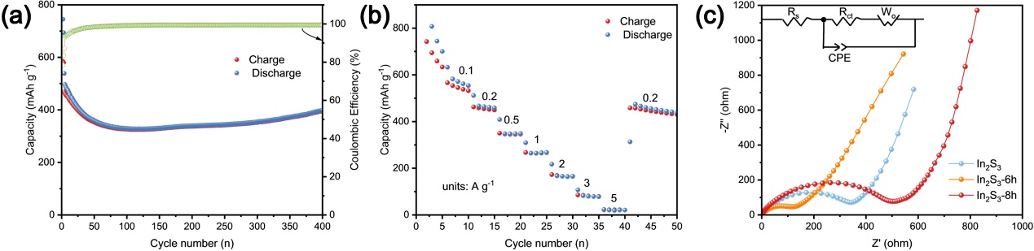
Fig. S3 The cycling performance of In₂S₃-8h at the current density of 0.5 A·g⁻¹ (b). Rate performance of In₂S₃-8h at different current densities (b). The Nyquist plots of In₂S₃/C, In₂S₃-8h and commercial In₂S₃ (c).

