Supplementary Information

Muscle-to-Bone Mass Ratio: A Novel Biomarker for Osteoporosis Screening and Fracture Risk Assessment in the Elderly

Jingqi Zeng¹, Xiaobin Jia^{1,2}*
1 School of Traditional Chinese Pharmacy, China Pharmaceutical University, Nanjing 211198, PR China
2 State Key Laboratory of Natural Medicines, China Pharmaceutical University, Nanjing 210009, PR China
* Corresponding author: E-mail address: jiaxiaobin2015@163.com (Xiaobin Jia).

Table of Contents

Figure S1. Dataset Demographics and Baseline Attributes 2
Figure S2. Indicator Discrimination for Fat-to-BMC Weight Ratios 3
Figure S3. Proportional Correlations of Muscle, BMC, and Fat 4
Figure S4. Proportional Correlations of ECF, ICF, and Protein 5
Figure S5. ROC Analysis of BMC and Muscle Relative to MBR 6

Figure S1. Dataset Demographics and Baseline Attributes
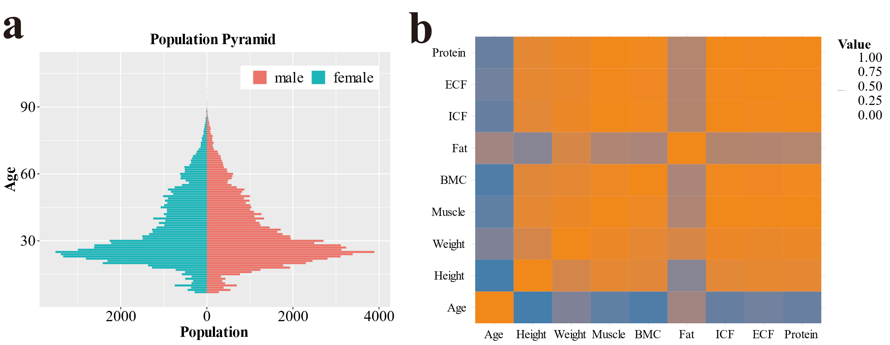
(a)Demographics of survey participants. (b)Pearson correlation coefficients of various components. An extensive assessment of body composition was conducted on 152,449 Chinese citizens, comprising 80,241 males (52.6%) and 72,208 females (47.4%). Of these, 27,327 individuals were aged 50 and above, making up 18.0% of the sample. Except for fat, all components exhibited strong positive correlations.

Figure S2. Indicator Discrimination for Fat-to-BMC Weight Ratios
The ability of the weight ratio of fat to BMC to differentiate between the elderly population and the overall age group was evaluated. Clearly, it does not possess characteristics similar to MBR, and cannot accurately segment the population.

Figure S3. Proportional Correlations of Muscle, BMC, and Fat
(a) For all age groups, the coloring of the dots is based on age. The coloring of the dots is based on MBR for all age groups (b) and the elderly population (c). Emphasizes the discriminative effect when MBR≥16. Fat has a minor influence on the proportion of muscle to BMC. MBR≥16 exhibits significant differentiation abilities in both males and females.

Figure S4. Proportional Correlations of ECF, ICF, and Protein
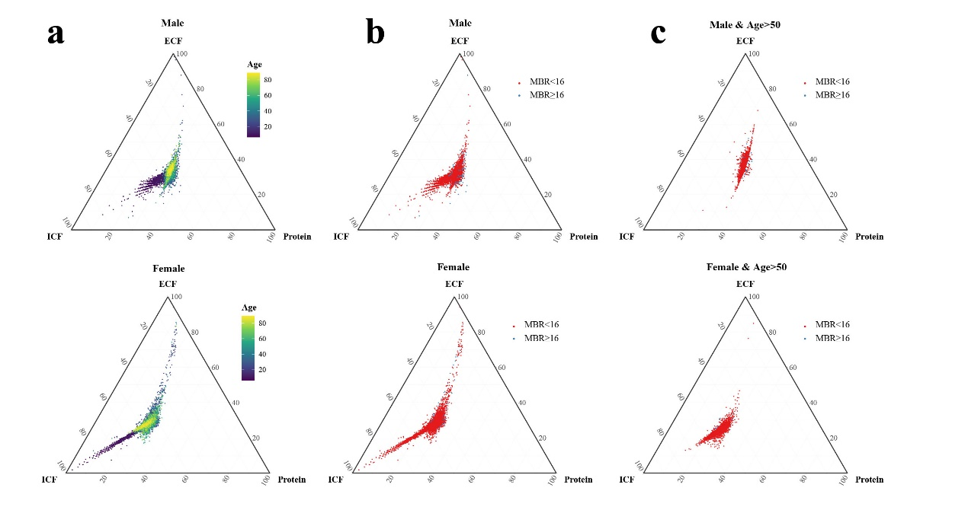
(a) For all age groups, the coloring of the dots is based on age. The coloring of the dots is based on MBR for all age groups (b) and the elderly population (c).Dividing populations based on MBR≥16, the proportions of these three components show no significant difference among different groups.

Figure S5. ROC Analysis of BMC and Muscle Relative to MBR
The AUC values for BMC weight, proportion, and index in males are 0.89, 0.95, and 0.95 respectively, while for females, they are 0.98, 0.99, and 0.99. In contrast, the association between MBR and muscle indicators is weaker. The AUC values for muscle weight, ratio, and index in males are 0.59, 0.51, and 0.62, whereas for females, they are 0.75, 0.72, and 0.78.

