Sporosarcina siccatus sp. nov., isolated from coastal sediment of the Great Wall Station, Antarctica
Hongmei Mu • Yuchun Xie • Peiqiang Jiang • Lukuan Liu • Jing Li *
College of Marine Life Sciences, Ocean University of China, Qingdao, Shandong, 266003, P.R. China
Archives of Microbiology
*Corresponding author: Jing Li
Tel: +86-532-82032266
Fax: +86-532-82032266
E-mail: lijing313@ouc.edu.cn
ouclijing@gmail.com
Running title: “Sporosarcina siccatus sp. nov.”
Subject category: New taxa –Firmicutes

Supplementary Materials
Table S1 AntiSMASH annotation results of strain GW1-11^{T} and the two most closely related type strains of the genus Sporosarcina
Sporosarcina siccatus GW1-11^{T}
Type | Most similar known cluster | Strains | Similarity
beta lactone
ectoine | ectoine | Sporosarcina pasteurii | 100%
Sporosarcina ureae DSM 2281^{T}
Type | Most similar known cluster | Strains | Similarity
beta lactone | NRP | Bacillus velezensis FZB42 | 40%
ectoine | ectoine | Sporosarcina pasteurii | 100%
NRP-metallophore | NRP | Bacillus sp. WMMC1349 | 70%
Sporosarcina newyorkensis 2681^{T}
Type | Most similar known cluster | Strains | Similarity
beta lactone
ectoine | ectoine | Sporosarcina pasteurii | 100%
Sporosarcina globispora DSM 4^{T} (X68415)
Sporosarcina psychrophile IAM 12468^{T} (D16277)
Filibacter tadaridae TB-66^{T} (MK290395)
Sporosarcina limicola DSM 13886^{T} (AJ292316)
Sporosarcina siberiensis 1111S-42^{T} (KF258678)
Sporosarcina soli I80^{T} (DQ073394)
Sporosarcina contaminans CCUG 53915^{T} (FN298444)
Sporosarcina koreensis F73^{T} (DQ073393)
Sporosarcina saromensis HG645^{T} (AB243859)
Sporosarcina thermotolerans CCUG 53480^{T} (FN298445)

Sporosarcina luteola Y1^{T} (AB473560)
Sporosarcina aquimarina SW28^{T} (HM245317)
Sporosarcina newyorkensis 6062^{T} (GU994085)
Sporosarcina siccatus GW1-11^{T} (MN658328)
Sporosarcina ureae DSM 2281^{T} (AF202057)
Bacillus subtilis ATCC 6051^{T} (AB042061)
95
99
98
50
99
85
97
60
68
68
66
0.010

Fig. S1 Neighbour-joining phylogenetic tree based on 16S rRNA gene sequences of GW1-11^{T} and closely related species. Bootstrap values (expressed as percentages of 1000 replications) greater than 50 % are shown at branch points
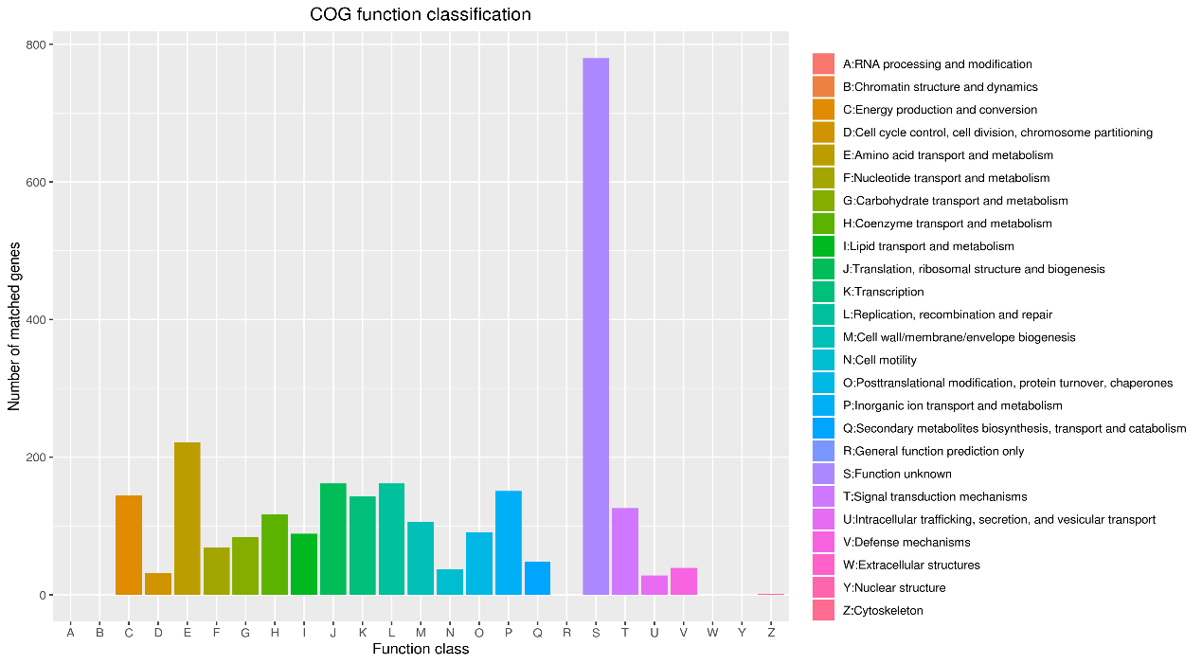
a
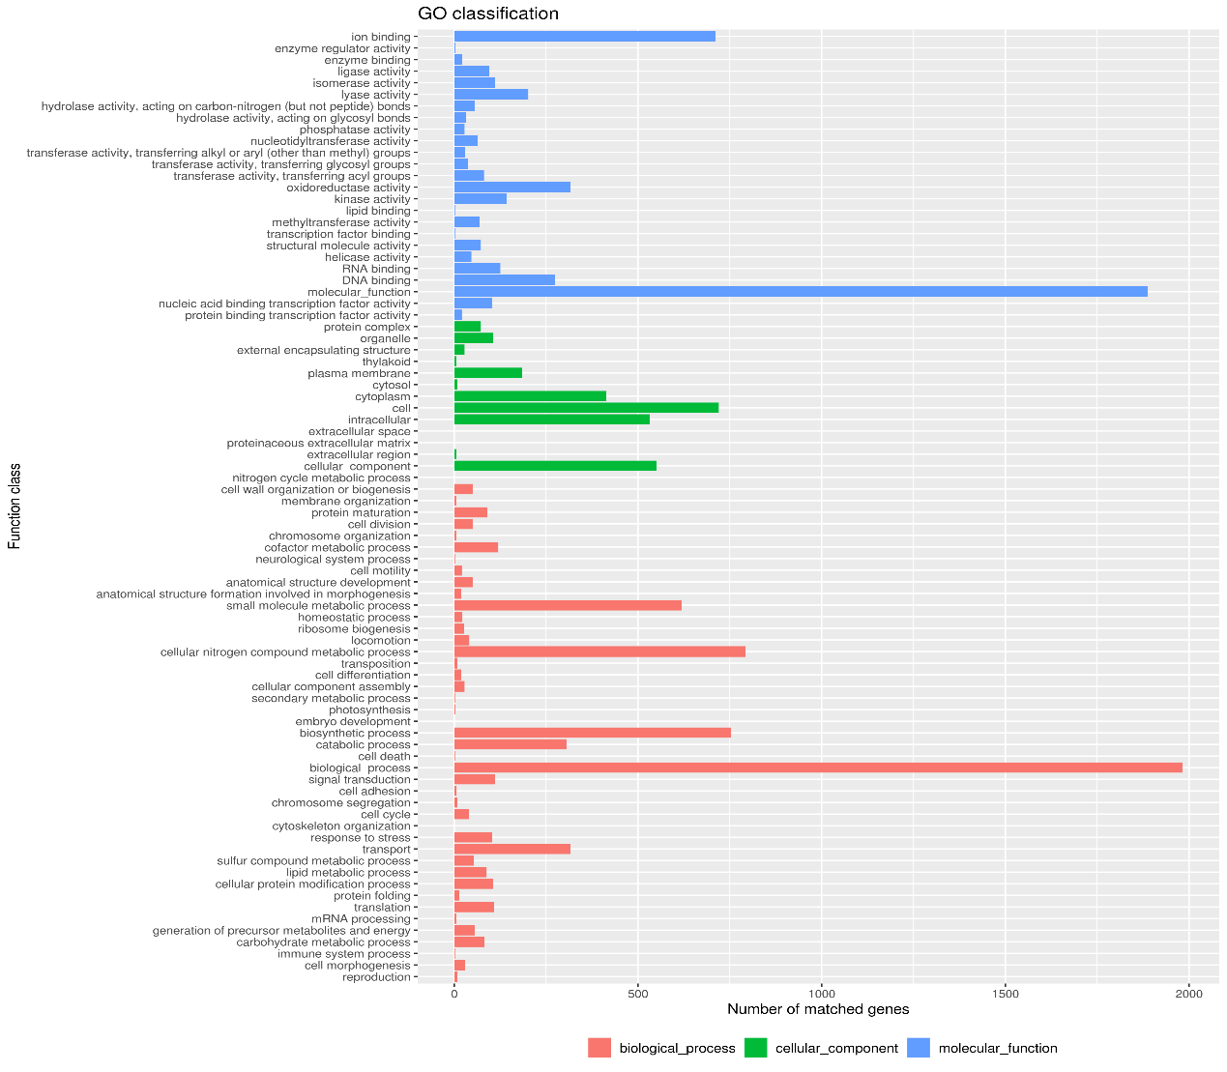
b
Fig. S2 Functional annotation and analysis of the GW1-11^{T} genome. Gene Ontology (COG) for (a), Clusters of Orthologous Groups (GO) for (b)
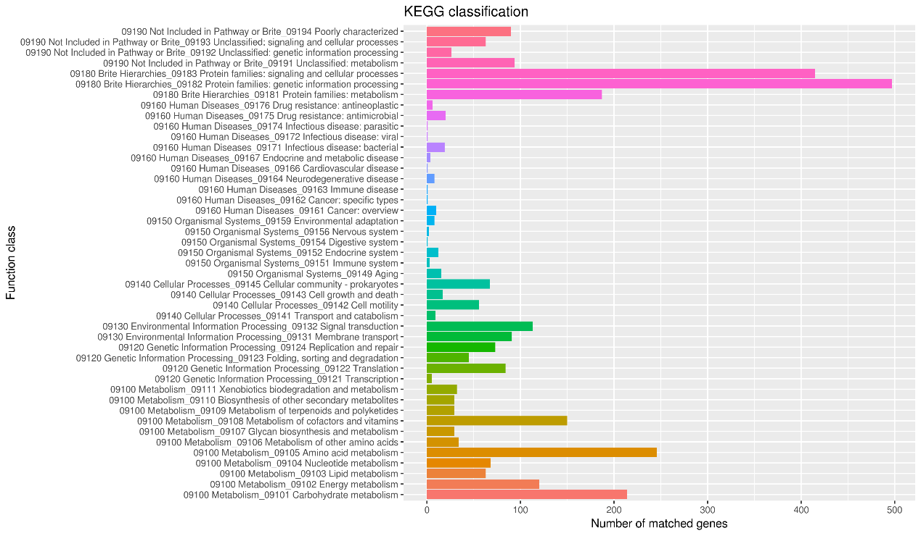
Fig. S3 Results of Kyoto Encyclopedia of Genes and Genomes (KEGG) function annotation of GW1-11^{T}

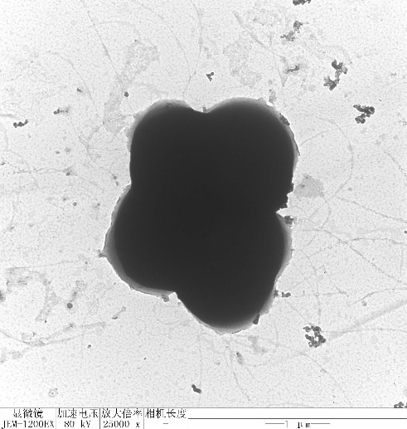
Fig. S4 Transmission electron micrographs of strain GW1-11^{T} cultivated on TSA ager plates for 3 days at 28°C

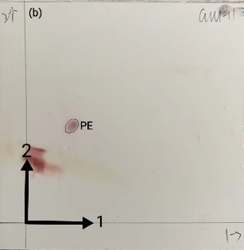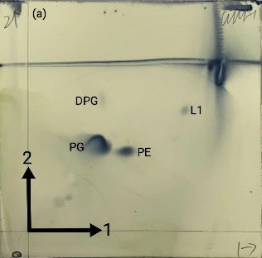
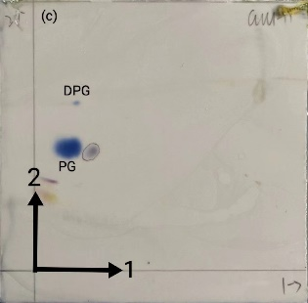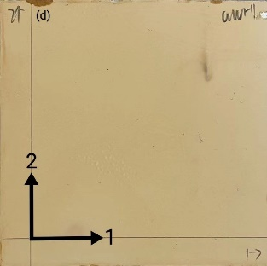
Fig. S5 A polar lipid thin-layer chromatogram sprayed with reagent of strain GW1-11^{T} following separation by 2D TLC. (chloroform/methanol/water (65:25:4) was used in the first direction, followed by chloroform/acetic acid/methanol/water (60:11.25:9:3 by vol.) in the second direction)
Note: PG, phosphatidylglycerol; DPG, diphosphatidylglycerol; PE, phosphatidylethanolamine; L, unidentified lipids. (a), staining with molybdatophosphoric acid; (b), staining with ninhydrin; (c), staining with zinzadze reagent; (d), staining with α-naphthol-vitriol

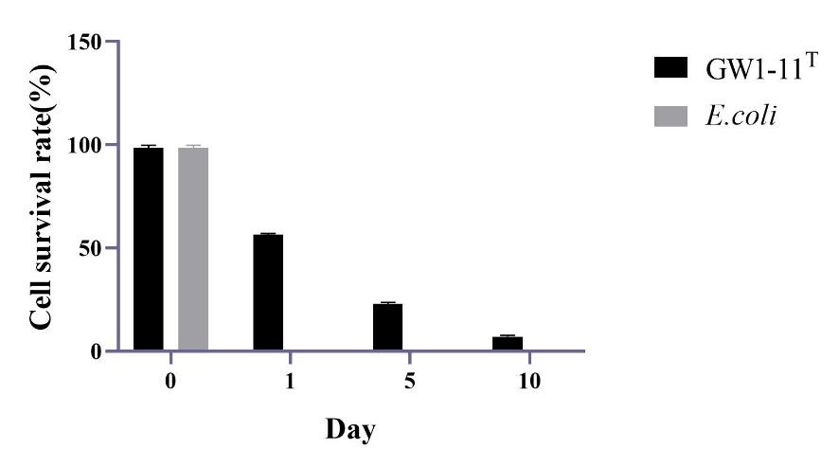
Fig. S6 Desiccation resistance ability of GW1-11^{T}

