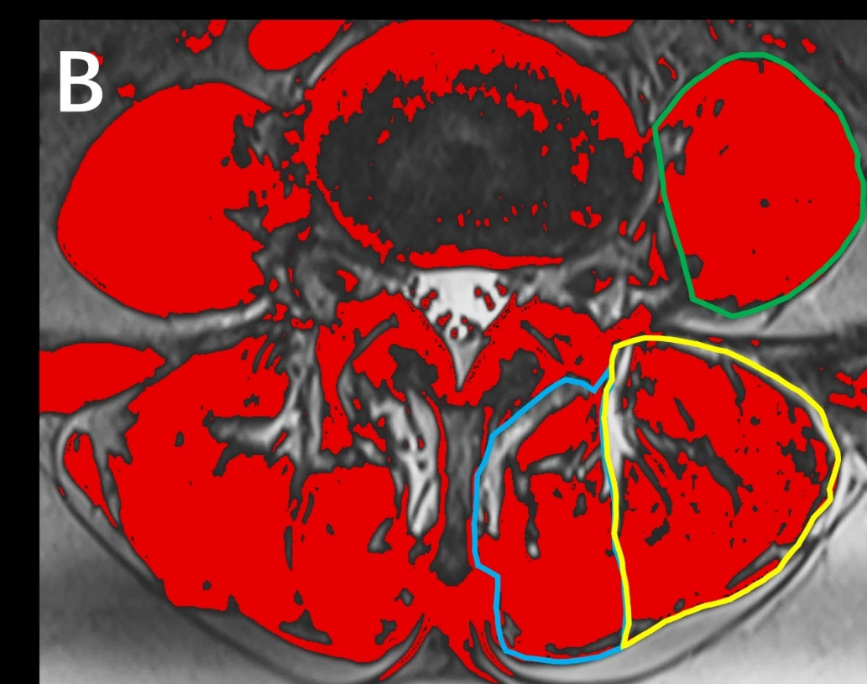
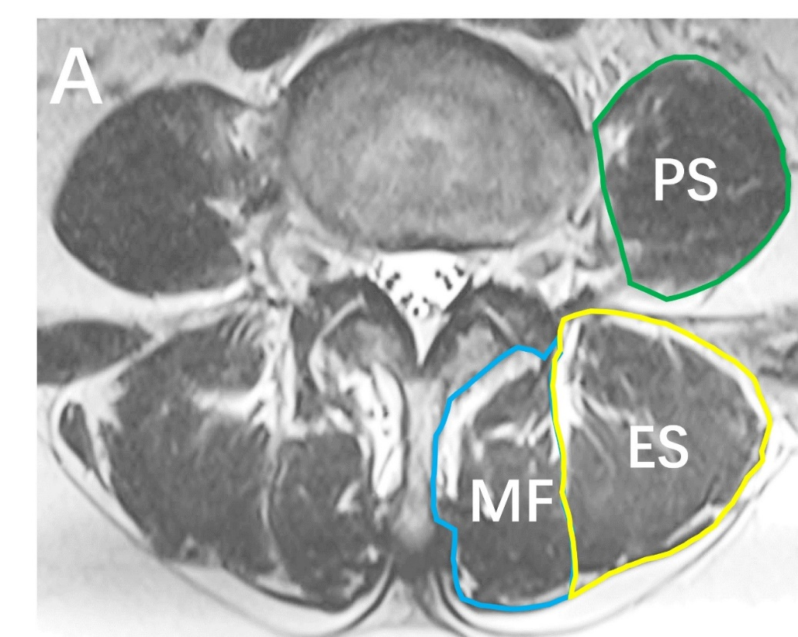
Fig.1 Paraspinal Muscles at the L4/5 Level. A) T2-weighted image illustrating the multifidus muscle (MF), erector spinae muscle (ES), and psoas muscle (PS); B) Image J analysis depicting the cross-sectional area of paraspinal muscles and the extent of fatty infiltration.

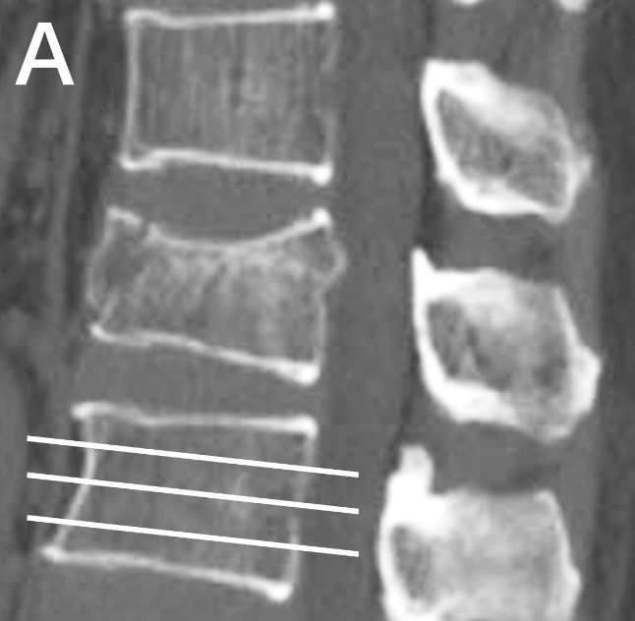
Fig.2 The Hounsfield unit of the vertebra in the segment adjacent to the fractured vertebra. A) Trisecting the vertebral body in the sagittal plane using three-dimensional CT reconstruction of the spine; B) Three-dimensional CT reconstruction of the transverse section of the spine.
